Charting an Aquaculture Future for the Caribbean

Lennon Thomas, Tyler Clavelle, Dane Klinger, and Sarah Lester

09 March, 2018

Table of Contents

# Abstract

The development of marine aquaculture in the Caribbean has been identified as an avenue to stimulate local economies, increase employment opportunities, and improve seafood supply and food security. However, when located close to shore, aquaculture’s environmental impacts can jeopardize valuable habitats (e.g., mangroves, coral reefs, seagrass beds) and competition for coastal space can lead to conflicts with fisheries, tourism, and other uses. Farming further offshore is a possible option for alleviating these stresses. Using high-resolution environmental and economic data, we develop a spatial bio-economic model to identify suitable areas throughout the Caribbean for offshore finfish aquaculture, parameterized based on cobia (*Rachycentron canadum*), and to estimate potential outcomes in terms of yields and profits under different market scenarios. We find that 50,373.35 km2 (1.7%) of marine space in the Caribbean is technically feasible for cobia aquaculture. Of this area, 24,046.47 km2 (0.81%) is economically viable and capabale of producing 78.7 million metric tons (MMT) of seafood annually, an amount roughly equal to the total global production from capture fisheries (~80 MMT). Even accounting for spatial differences in cobia growth and production costs, we estimate the Caribbean could produce 40.7 MMT of cobia annualy. Areas associated with the highest relative economic potential were Jamaica, Trinidad and Tobago, and Haiti. The variability of farm-scale production and NPV differed across EEZs, suggesting importance of site selection depends on EEZ. Offshore aquaculture is a capital intensive activity mediated by socioeconomic conditions, such as foreign investment risk and XX. Accounting for these risk factors considerably lowered production in our analysis and may help explain the current lack of commercial offshore aquaculture in the Caribbean despite the favorable conditions demonstrated in this analysis. The results of this research can be used to help prioritize areas for offshore cobia aquaculture development and serve as a framework for identifying priority areas for offshore aquaculture of other species. Additionally, we discuss the future potential of the development of offshore aquaculture in the Caribbean.

# Introduction

Global fish production is expected to exceed 151 million tons by 2030 to meet growing demands, a 10% increase over current levels (Kobayashi et al. 2015; FAO 2016), and the vast majority of new production must come from aquaculture given only modest potential increases from capture fisheries (Costello et al. 2016). Aquaculture seems poised to meet this challenge as the fastest growing food production sector globally, surpassing wild fisheries production for the first time in 2014 (FAO 2016). Marine aquaculture, or mariculture, is seen as having particularly strong growth potential (Merino et al. 2012). And as mariculture technology advances, production from offshore mariculture, generally defined as occurring more than three nautical miles offshore and/or in depths of greater than 30 m (Froehlich et al. 2017), is expected to increase (FAO 2016). By moving to deeper waters further from the coast, offshore aquaculture could be a viable strategy to minimize aquaculture’s adverse environmental and socioeconomic consequences (Holmer 2009; Froehlich et al. 2017), and production potential in the offshore realm far exceeds seafood demand for the foreseeable future (Kapetsky, Aguilar-Manjarrez, and Jenness 2013; Gentry, Froehlich, et al. 2017). Despite strong arguments for offshore aquaculture development, how this growth can and should be realized requires an understanding of the sustainable and economically-viable production potential at the regional level, along with an identification of hurdles impeding development.

In recent years, there has been a growing interest in aquaculture development in the Caribbean to increase food security and economic development (Van Wyk and Davis 2006; Creswell 5AD–2007; CRFM 2014; Pérez-Ramírez 2017). In 2014, the Caribbean produced 330,704 MT of seafood, 89.95% of which came from capture fisheries. In contrast, only 33,226.79 MT was produced from aquaculture, accounting for < 0.1 % of the global total.

Currently, over 88% of seafood consumed in the Caribbean is from wild capture fisheries (FAO 2016). To meet seafood demand in the region, over 144,000 mt of seafood, valued at XX $USD, is imported annually (FAO 2016). Furthermore, seafood consumption per capita in the Caribbean is projected to increase rapidly (22%) over the next decade (FAO 2016). Wild fisheries production in the region is unlikely to play a meaningful role in decreasing exports and/or meeting growth in demand because of overfishing, degradation of coral ecosystems, and climate change (Burke et al. 2011; Pérez-Ramírez 2017). Aquaculture development could be an opportunity for Caribbean countries to diversify their economic activities, reduce reliance on foreign imports, provide jobs and economic security to local residents (**FAO 2002**), and to promote a seafood industry that is more resilient to the effects of climate change (Pérez-Ramírez 2017).

Most aquaculture efforts in the Caribbean have been directed towards land-based aquaculture of tilapia (*Oreochromis sp.*) and coastal pond aquaculture of white-legged shrimp (*Litopenaeus vannamei*) (Lovatelli et al. 2013). However, the potential for increased production of land-based aquaculture in the Caribbean is extremely limited due to the requirements of land space, freshwater, and energy resources (Alvarez-Lajonchère and Ibarra-Castro 2013). Similarly, expanded development of coastal aquaculture in the region is likely not sustainable and difficult due to conflicts over space in highly utilized and ecologically sensitive coastal areas (Gentry, Lester, et al. 2017). For example, coastal aquaculture can harm mangroves and coral reefs by increasing nutrient loads and causing physical damage to the habitat from farm infrastructure (Benetti et al. 2006; Gentry, Lester, et al. 2017), with cascading effects on marine-based tourism, the backbone of many Caribbean island economies (Benetti et al. 2006). Offshore aquaculture could be a promising alternative (D. D. Benetti, Benetti, et al. 2010; Gentry, Froehlich, et al. 2017), and recently developed submersible cages will allow aquaculture to be developed in areas that were previously considered unsuitable due to waves, depth and/or high risk of damage from large storms and hurricanes (D. D. Benetti, Benetti, et al. (2010)).

Environmental conditions in the Caribbean such as relatively small seasonal fluctuations in ocean temperature and a stable water column provide ideal conditions for the offshore culture of a number of species (**???**). Small-scale trials raising cobia (*Rachycentron canadum*), pompano (*Carangidae sp*), and red drum (*Sciaenops ocellatus*) in offshore environments were successful in the Bahamas and Puerto Rico (Benetti et al. 2010). Cobia in particular has been identified as an ideal candidate species for aquaculture in tropical and subtropical regions because of its relatively fast growth rates, high market value, and tolerance for variations in salinity and temperature (Alvarez-Lajonchère and Ibarra-Castro 2013; D. D. Benetti, O’Hanlon, et al. 2010; Estrada et al. 2016). The largest open ocean mariculture farm in the world, Open Blue, has been successfully culturing cobia off the Caribbean coast of Panama since 2007.

*I think we need to explain here how are study is novel.* The global aquaculture potential for aquaculutre is large in terms of suitable area (Gentry, Froehlich, et al. 2017) and previous studies ahve examined the economic feasablity of offshore aquaculture for individual farms in specific locations using bioeconomic modelling (eg. (**???**)). Here, we present a framework that incorporates socioeconoomic, biololgical, and environemtnal factors to estimate potential of offshore aquaculture at a reiongal scale using the Caribbean, a politically and economically diverse region. Using high resolution spatial data, we develop a bioeconomic model to : 1) estimate the bioeconomic offshore mariculture production capacity of the Caribbean region (CRFM 2015), 2) examine the impact of farm site selection both across EEZs and withing EEZ on economic outcomes, and 3) identify factors are currently most likely limiting offshore mariculture development (e.g., biophysical conditions, regulatory environment, capital investment, expertise, etc.). estimate the total production potential (in terms of weight and revenue) of offshore cobia aquaculture in the Caribbean. We examine the spatial distribution of offshore aquaculture potential to identify ‘hotspot’ locations for future development. We examine the variation of individual farm profitability between and across EEZs to determine the importance of site selection in aquaculture development and to quantify the potential benefits of strategic spatial planning. We explore these results under several scenarios to identify limiting factors. Our approach could be applied to other farmed species or applied to other regions, and our results can help to chart a course for a sustainable and economically prosperous offshore mariculture industry in the Caribbean.

# Methods

## Description of Study Region

Our study domain includes the territorial waters and Exclusive Economic Zones (EEZs) surrounding the 28 island countries that comprise the Greater and Lesser Antilles of the Caribbean Sea (Figure 1). All analyses are performed at a 1 km2 spatial resolution. We do not consider the potential of offshore aquaculture development in the high seas or disputed waters. A shapefile from VLIZ (**???**) is used to define the maritime boundaries for all island countries.

## Overview

We develop a spatial bioeconomic model to estimate the production potential (in terms of biomass (*t*) and Net Present Value (NPV)) for offshore cobia mariculture in the Caribbean region (Figure 1). The first steps of our analysis are to identify 1 km2 sites throughout the study region that would be suitable for mariculture development and create a hypothetical farm design to apply to all suitable sites. Next, we apply a temperature performance curve (TPC) to predict temperature-dependent growth of cobia at each farm and we establish supply curves to determine national and Caribbean-wide cobia production that would be achieved under several scenarios of cobia price and production costs. We also consider a scenario where Caribbean production affects the global price of cobia. Finally, we use our production model and estimated economic parameters to calculate NPV over a 10 year time horizon. We assume that only farms that have a positive NPV will be developed.

## Suitability Assessment

The first step in our analysis identifies areas that are potentially suitable for the development of offshore mariculture in the Caribbean by considering factors related to technical feasibility, enviornmental impacts, and current ocean use, Suitable thresholds are defined for each factor and hiigh resolution spatial data are used in a Boolean overlay using all data layers to identify areas 1 km2 areas in our stury region that are poteniially suitable for offshore maricuutlure developmetn given our defined thresholds.

We use physical specifications listed by the manufactor of SeaStation cages to define our thresholds for areas that are technically feasible for offshore maricuture. SeaStation cages are submersible, self-tensioned, single rim cages and are currently the most widely used offshore mariculture cages in the U.S. (Loverich 2010); Open Blue 2016). The minimum site depth for installation of a SeaStation cage is 25 m and the cages are not recommended for areas that experience current velocities exceeding 1 m/s (OceanSpar 2013). We assume the maximum depth threshold for suitable areas is 100 m because cage installation and inspection of mooring and anchoring systems becomes more difficult and costly in depths > 100 **scott_offshore_2000**; (Kapetsky, Aguilar-Manjarrez, and Jenness 2013). We use spatial bathymetry data from XX and determine the absolute maximum zonal and meridional current velcocity using data on daily averages over a 10 year period (2005 - 2015) from XX to identify areas that are techinically feasible for offshore maricuture development in our study area.

Offshore mariculture farms can be associated with increased nutrient levels in the water column from fish waste in the vicinity of the cages (REF). Increased nutrient levels are associated with increased algal production, which can grow over and damage coral reef habitat that are essential components to marine ecosystems in the Caribbean (Ref). Data from XX on location of coral reef habitat to represent areas to exclude from offshore mariciulture development to migitage any potential negative ecosystem impacts. Additionally, we excluded any areas that fall within designatied MPAs and conservation priority areas as suitable for offshore mariculture developement.

A large advantage of offshore mariculture is that it can be developed away from coastal areas that are often heavily used for other purposes especially in the Caribbean, where many island economies rely heavily on coastal areas tos upport activities that attract tourists (REF_). However, there is some ocean use of waters offshore, which will likely only increase with time. We consider shipping, stuctures used for oil drilling and areas licesnced for deep sea mining exploration as potential offshore activities that may conflict with aquaculture development. We exclude areas that fall within 10% of the highest relative shipping activity, areas with benthic oil structures, and areas permitted for deep sea bed mining exploration as suitabile for offshore mariculture development.

## Growth Potential

Temperature is one of the primary abiotic factors controlling growth in ecotherms, including cobia (Brett 1979), and is a factor that cannot be easily controlled in offshore mariculture grow-out settings (Tidwell 2012). To reflect spatial differences in productivity across farms attributed to temperature variations, we use 10 years of remotely-sensed sea surface temperature (SST) data (NASA 2014) to calculate 1 km2 resolution spatial data layers of average monthly SST. We then use a thermal performance curve (TPC) to model temperature dependent individual somatic growth (, kg per month) of cobia for each farm site (**???**).

### Thermal Performance Curve

The TPC is a temperature-dependent piecewise linear function defined as follows:

where is sea surface temperature in degrees C, is the optimal temperature for cobia growth in C, and and are slope parameters (kg per month per degree C), and , and are intercept parameters (kg per month). At temperatures below the minimum temperature for growth () and above the maximum temperature for growth (), is forced to 0 to reflect the absence of growth. Where is negative, . Our temperature-growth components of cobia are presented in Table S2 and were adopted from Klinger, Levin, and Watson (2017), who also used a TPC to model cobia growth.

Individual cobia growth at month for site () is estimated using the TPC for all 120 months in the SST timeseries. The 10 year () average individual growth (${G}_{i,t} $) at site is then calculated for each calendar month :

## Bioeconomic Model

We model future offshore aquaculture potential in the Caribbean by coupling site specific estimates of average monthly cobia growth with a detailed farm design and economic model parameterized with values from the literature and technical reports. For each site, we calculate the projected net present value (NPV) over a 10 year period from the discounted stream of costs and revenues. We then limit our discussion of results to only include farms (cells) with a positive NPV under the assumption that only profitable farm locations would be developed.

### Farm Design

To estimate production, we assume a conservative fixed farm design, per 1 km2 site, across our study region. SeaStation cages are typically configured using a mooring system that includes a grid, anchor, and mooring lines secured at varying distances from the cages (**???**; Xu, Zhu, and Miao 2015). The cages are held in position by the mooring system at depths of 15-20 m below the surface(Loverich 2010). We develop a hypothetical farm design for a 1 km2 cell using the total total cage volume to farm area ratio of offshore mariculture farms currently operating off the coast of Kona, Hawaii (Sims, n.d.) and the Gulf of Maine (**???**). Our hypothetical farm has 16 SeaStation cages (each 6,400 m3) configured in two eight-cell grid mooring systems, a total cage volume of 102,400 m3 per individual farm. The infrastructure of the farm has a footprint of ~ 0.48 km2, which meets the guidelines issued in NOAA’s Fishery Management Plan (FMP) for offshore aquaculture development in the Gulf of Mexico that specifies the total mariculture farm area should be twice the size of the total area occupied by farm infrastructure (GMFMC (Gulf of Mexico Fishery Management Council) and NOAA (National Oceanic and Atmospheric Administration) 2009).

### Growth Model

Individual cobia growth at month for site () is modeled using the previously calculated 10 year () average individual growth (${G}_{i,t} $) at site for calendar month . Fingerlings are stocked at an initial weight of 15 grams and fish weight () in month at site is calculated as the cumulative growth since the stocking month ():

We apply an instantaneous mortality rate of 0.024, which we adopt from previous studies that have estimated a total 12 month survival rate of 75% for cobia raised in offshore cages in the Caribbean ((**???**; Huang et al. 2011)). A cage at site is harvested when individual fish have grown to a harvestable size of 5 - 6 kg.

#### Stocking Density

Benetti et al. 2010 suggest as a target harvest density for sustainable offshore mariculture. Because growth rates vary across farm sites and all sites are assumed to experience an instantaneous mortality rate of 0.024, we calculate the optimal initial number of stocked fingerlings ().The number of fingerlings stocked in each cage is optimized at the level that achieves the target harvest density () at the time fish reach the final harvest weight of 5 kg, or 19,200 fish per cage.

The optimal stocking number () for each site is estimated using the historical SST timeseries. The number of hypothetical completed grow out cycles (), wherein a cobia is raised from an initial stocking weight of 0.15 g to a final harvest weight of 5 kg, is calculated for each site by first dividing the cumulative individual growth over the 120 month timeseries by the target harvest weight.

The average number of months per grow out cycle () is then calculated as . Given and the target harvest of 19,200 5 kg fish, the optimal number of fingerlings () to stock can be estimated for each site as follows:

For a farm with a 12 month average harvest cycle (), is 25,600.

#### Total Biomass

Total site biomass in each month () is a function of the number of stocked cages , initial stocking number , and the instantenous mortality rate (**???**).

Where is the number of stocked cages at site , is the weight of individual fish in cage in month , and is the initial number of fish stocked per cage at site .

### Economic Model

#### Costs

The total cost of production for each farm consists of start up costs () plus the sum of operating costs (). Cost parameters were obtained from published literature or from personal communication with industry experts. Some parameters were fixed across our study region (Table S3a) while others are a function of EEZ (Table S3b).

Costs of aquaculture infrastructure and installation increase with depth and distance from shore (**???**). Start-up costs are therefore include initial capital expenditures () and installation costs (), both as a function of average site depth in meters , and EEZ-specific permit and/or lease cost :

Initial capital expenditures () include the cost of 16 SeaStation fish cages ($269,701 each) plus the cost of one 16-m-long support vessel and two 7-m-long motorboats. Installation costs include the labor costs for installation of the culture system. A 10% increase in cage and installation costs are assinged to sites with depths greater than 50 m (**???**). Operating costs are organized in two main categories; farm labor and maintenance costs as a function of site depth and EEZ-specific hourly salary and fuel costs (), and costs associated with purchasing and feeding stocked fish .

Labor and maintenance costs () at site in month are modeled as follows:

Where 2,720 is the total monthly labor hours required at site (17 full time workers); is the EEZ-specific hourly salary; is distance from shore (in meters); 3,219 is average fuel efficiency (meters per gallon); 60 is the number of one-way trips required per month for running the farm; and is the per-gallon cost of fuel as a function of EEZ.

Fingerling and feed costs () at site in month include the cost of an individual fingerling ($2.58) times the number of fingerlings stocked in month (). Feed costs are calculated based on a constant feeding strategy of 2% of total biomass and a feed price of $1.68 per kg. Because our model operates at monthly, not daily, timesteps, we calculate total feed based on the average total biomass during month .

#### Production & Revenue

Farms earn revenue by harvesting market weight (5 kg) cobia. Thus, farms only earn revenue in months where individual fish weight () reaches 5 kg. In these harvest months, farm revenue is simply a function of harvest biomass (, kg) and cobia price (), , otherwise . Cobia farms in the Caribbean are assumed to be price takers and thus production in month does not affect price in month . Total farm profit () is simply the sum of revenues less total farm costs.

Harvested biomass (in metric tons) and profit over a 10-year period is calculated for each farm across a range of prices ($1-$12 per kg).

### Net Present Value

Net present value (NPV) is the generally accepted measure of a long-term investment’s economic validity and accounts for the time value of money by discounting future cashflows. Central to the NPV caluclation is the discount rate, which controls how valuable future cashflows are relative to today. Defining appropriate discount rates in economic models is often difficult and depends on many factors, namely the cost of capital and project risk [REF]. As a result, we run our bioeconomic model under two different discount rate assumptions. In the first scenario, we assume a fixed disocunt rate of 10% across all farms, which is based on the average discount rate of 10.6% found in a meta-analysis of literature on bioeconomic modelling in aquaculture from the last 25 years (**???**). However, lack of foreign investment due to financial risk has been identfied as a major barrier to aquaculture development in the Caribbean. Risk of investment is often factored into the decision of selecting an appropariate discount rate when estimating returns on an investment. Therefore, our second scenario attempts to capture the financial risk of investing in offshore aquaculture by estimating EEZ-specific discount rates.

Foreign investment is an artifact of both political and economic risk in a country, which can be calculated into a single risk score using economic and socioeconomic indicators (**???**). (1983) developed the Foreign Investment Risk Matrix (FIRM) to assist investors in classifying the political and economic risks associated with investing in different countries using discrete risk categories. An expanded version of FIRM was developed by McGowan and Moeller (2009) that utilizes three political and three economic continuous risk variables that are readily available for most countries. We adopt this framework to calculate a score representing the investment risk for each country (Table X). Risk scores are then scaled to EEZ-specific discount rates (Table X) ranging from 10% to 25%, which aligns with the range of discount rates found in the literature of bioeconomic modelling of aquaculture (**???**).

##   
## ---------------------------------------------------------------  
## Country Risk score Discount rate (%)   
## ------------------------------ ------------ -------------------  
## Cayman Islands 0.53 10   
##   
## Aruba 1.2 10   
##   
## Martinique 1.38 10   
##   
## United States Virgin Islands 1.5 10   
##   
## Anguilla 1.75 12.5   
##   
## Puerto Rico 1.87 13.7   
##   
## British Virgin Islands 1.98 14.8   
##   
## Sint-Maarten 2.19 16.9   
##   
## Saint-Barthélemy 2.2 17   
##   
## Bahamas 2.21 17.1   
##   
## Barbados 2.25 17.5   
##   
## Antigua and Barbuda 2.27 17.7   
##   
## Sint-Eustatius 2.29 17.9   
##   
## Trinidad and Tobago 2.3 18   
##   
## Saba 2.49 19.9   
##   
## Turks and Caicos Islands 2.49 19.9   
##   
## Saint Kitts and Nevis 2.5 20   
##   
## Guadeloupe 2.62 21.2   
##   
## Bonaire 2.67 21.7   
##   
## Saint Lucia 2.69 21.9   
##   
## Dominica 2.73 22.3   
##   
## Curaçao 2.75 22.5   
##   
## Collectivity of Saint Martin 2.79 22.9   
##   
## Grenada 2.87 23.7   
##   
## Jamaica 2.92 24.2   
##   
## Dominican Republic 2.98 24.8   
##   
## Montserrat 3.28 25   
##   
## Saint Vincent and the 3.69 25   
## Grenadines   
##   
## Cuba 3.85 25   
##   
## Haiti 4.03 25   
## ---------------------------------------------------------------  
##   
## Table: Investment risk scores and discount rates by country. A risk score of 1.5 (US Virgin Islands) is used as a baseline for scaling discount rates between 10%-20%

For both discount rate scenarios, we calculate the 10-year net present value (NPV) for each farm:

Where is the discount rate (10% or EEZ-specific). Lastly, only farms with a positive 10-year NPV are considered feasible for development.

# Results

Based on the factors we considered and thresholds we defined, there is 50,373.35 km2 (1.7% our study region) potentially suitable for the development of offshore mariculture. Depth was the largest constraining factor in the suitability analysis, XX% of our study area fell outside the depth range (25 - 100 m) considered techinically feasible for offshore mariculture farm infrastructure. By comparison, our second largest constriaining factor in the suitability analysiswas shipping activity, which only excluded XX% of our study area as suitable for offshore mariculture development (Table S4).

There is considerable variability in the amount and distribution of suitable area for offshore mariculture in the Caribbean (Table XX). The Bahamas, Trinidad and Tobago, and Jamaica are the top three countries in terms of suitable area, and the spatial distribution of suitable areas differs considerable between them (Figure 1).

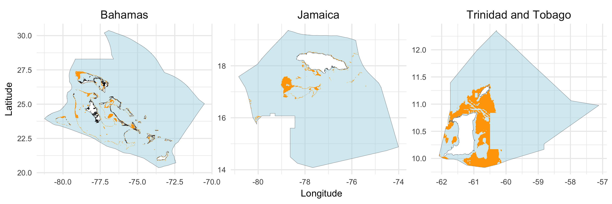

Figure 1. Results of our suitability analysis for the Bahamas, Jamaica, and Trinidad and Tobago. The orange areas represent areas that are potentially suitable for offshore mariculture

Both the Bahamas and Trinadad and Tobago have more than twice the suitable area of the country with the next largest amound of suitable area (Jamaica; Table 1). No suitable areas were found in Martinque, St. Martin, and Guadeloupe because of the conservation status of waters falling within their EEZs. The large suitable area in the Bahamas can be attributed to its relatively large EEZ (Table 1; Figure 1). Overall, Trinidad and Tobago had the largest percentage of their EEZ identified as suitable (13.31%), followed by Saba (11.07%). Suitable areas acoounted for < 5% of total EEZ area for all other Caribbean islands (Table 1).

Estimated suitable area (km2 by EEZ)

|  |  |  |  |
| --- | --- | --- | --- |
| Country | Total EEZ area (km^2) | Suitable area (km^2) | % suitable |
| Bahamas | 615,628 | 14,311 | 2.32 |
| Trinidad and Tobago | 76,273 | 10,186 | 13.35 |
| Jamaica | 256,647 | 4,720 | 1.84 |
| Dominican Republic | 349,786 | 3,290 | 0.94 |
| Cuba | 350,483 | 2,474 | 0.71 |
| Antigua and Barbuda | 111,358 | 1,949 | 1.75 |
| Haiti | 102,801 | 1,779 | 1.73 |
| Puerto Rico | 154,335 | 1,515 | 0.98 |
| Saint Vincent and the Grenadines | 36,132 | 1,415 | 3.92 |
| British Virgin Islands | 81,383 | 1,271 | 1.56 |
| Anguilla | 90,017 | 1,221 | 1.36 |
| Grenada | 25,492 | 1,142 | 4.48 |
| Saba | 9,472 | 1,050 | 11.08 |
| Turks and Caicos Islands | 90,765 | 1,028 | 1.13 |
| Aruba | 29,898 | 946 | 3.16 |
| United States Virgin Islands | 38,130 | 814 | 2.13 |
| Saint Lucia | 15,354 | 285 | 1.86 |
| Saint Kitts and Nevis | 9,450 | 256 | 2.71 |
| Dominica | 28,495 | 242 | 0.85 |
| Cayman Islands | 118,125 | 114 | 0.10 |
| Barbados | 184,865 | 84 | 0.05 |
| Montserrat | 7,172 | 74 | 1.03 |
| Curaçao | 25,315 | 71 | 0.28 |
| Sint-Eustatius | 2,166 | 65 | 3.01 |
| Bonaire | 12,955 | 43 | 0.33 |
| Sint-Maarten | 452 | 20 | 4.32 |
| Saint-Barthélemy | 4,147 | 7 | 0.18 |

### Suitable Farm Production and NPV

If economic constraints are ignored and all suitable farm sites are developed regardless of profitability, the Caribbean’s potential to produce cobia from mariculture is extremely large, with an approximate annual production of XXX MT (XXX% of total current seafood production in the region). Variability between average annual production of EEZs is largely driven by the amount of area that was identified as suitable within each EEZ.

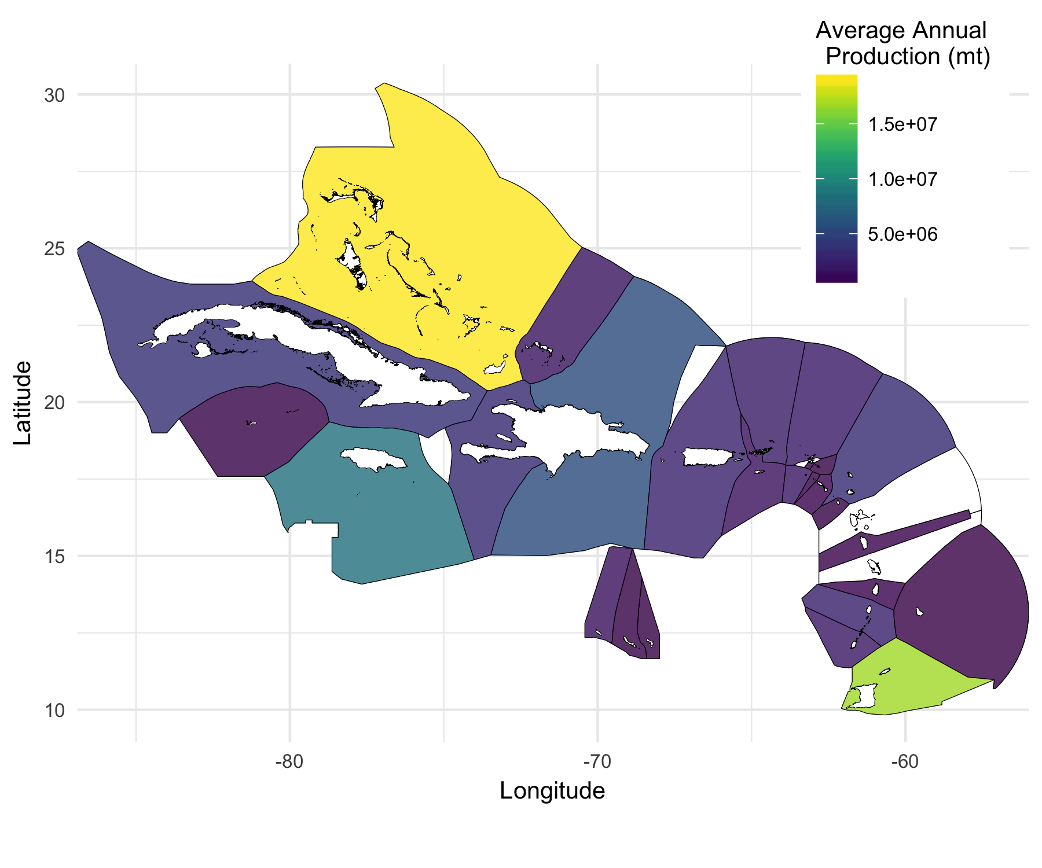

Estimated total production of cobia (mt) using if all suitable areas are developed as offshore mariculture farms

## Bioeconomic Model Results

At the farm level, the median NPV of a cobia farm in the Caribbean was 972,992.4, driven primarily by the large number of farms in Trinidad and Tobago and high NPV farms in several other countries (Figure X).

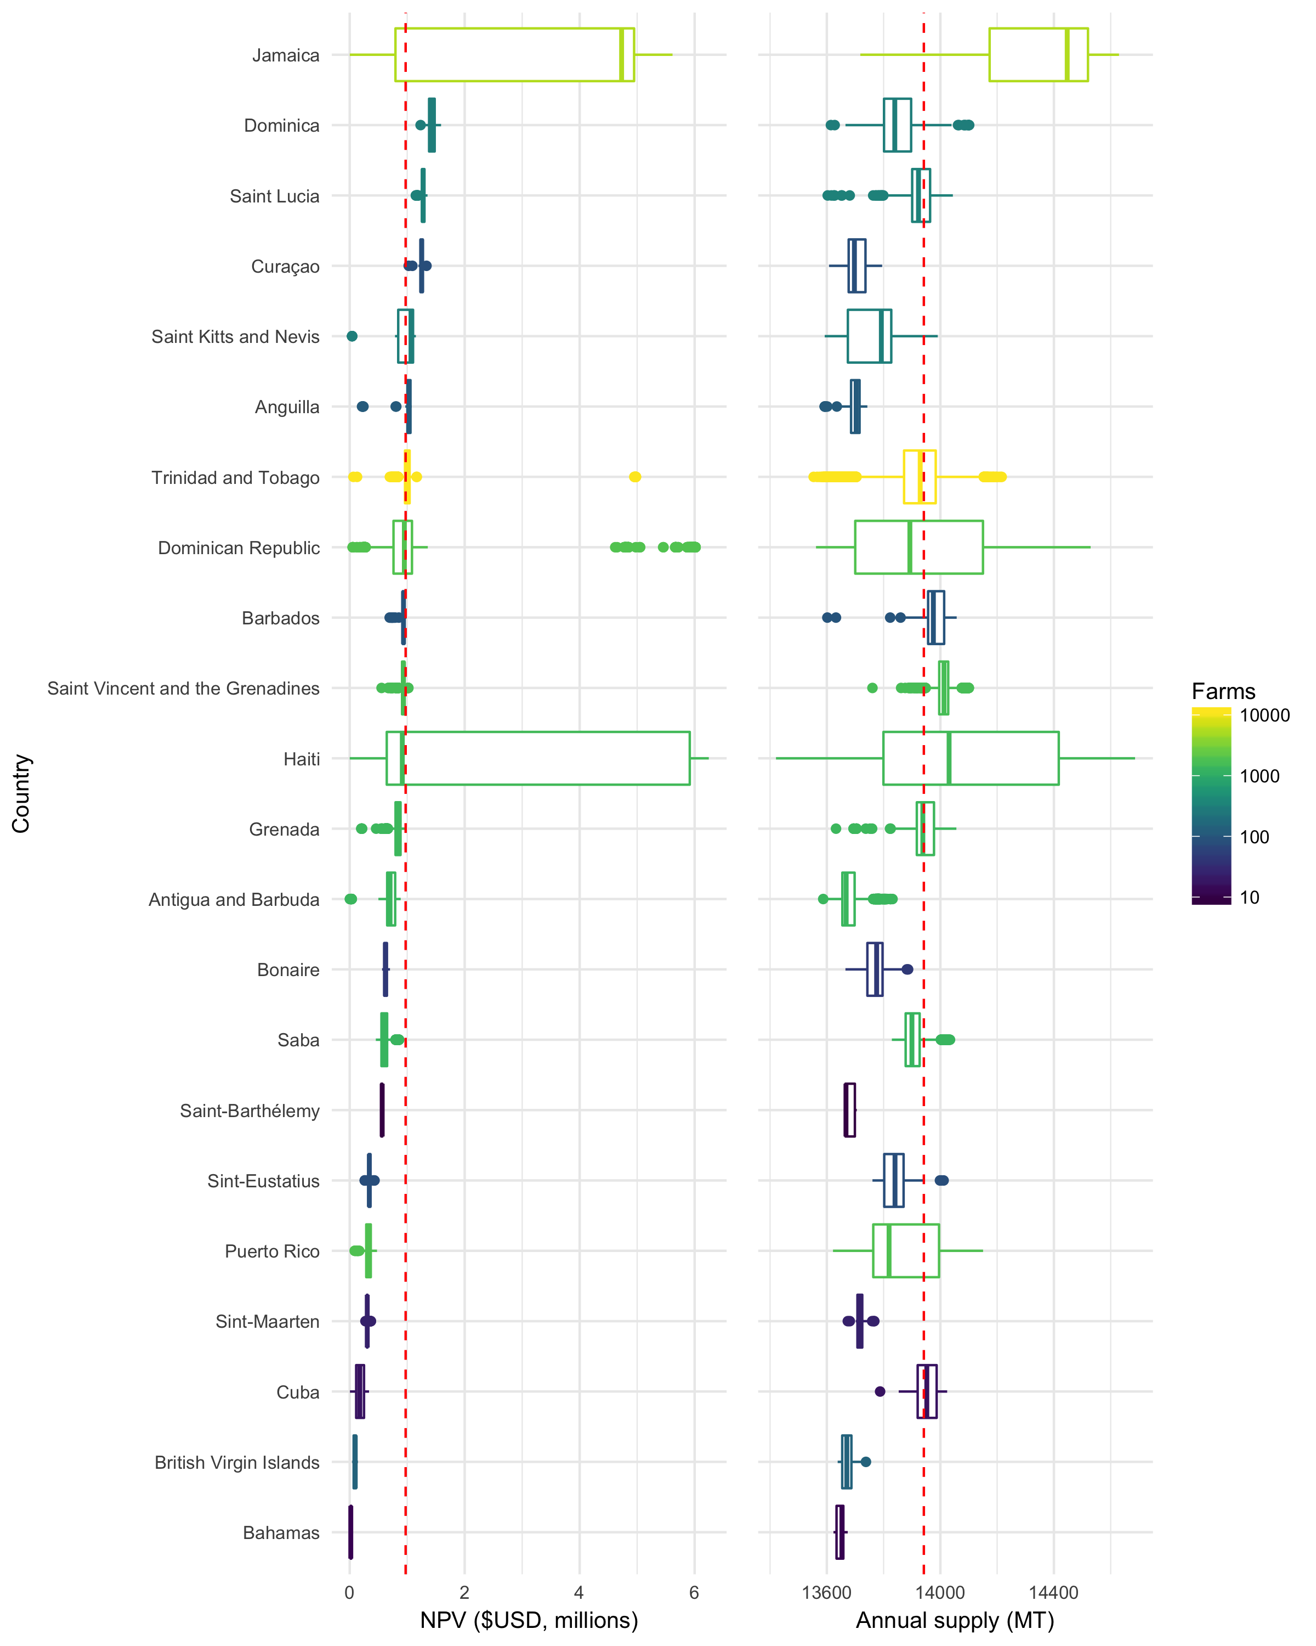

NPV of cobia aquaculture per farm by Caribbean EEZ

Feed is well known to account for the large portion of operating costs in aquaculture (REF), and our findings support this conclusion (90.1% of operating costs). However, given that economic forces are driving promising advances in feed technology, we also explored results if current feed costs ($1.65/kg) are reduced by 10%. A reduction in feed costs by 10% would increase cobia production (supply) by XXX. No farms in the Caribbean would be profitable if price for cobia drops below $8/kg at current feed costs.

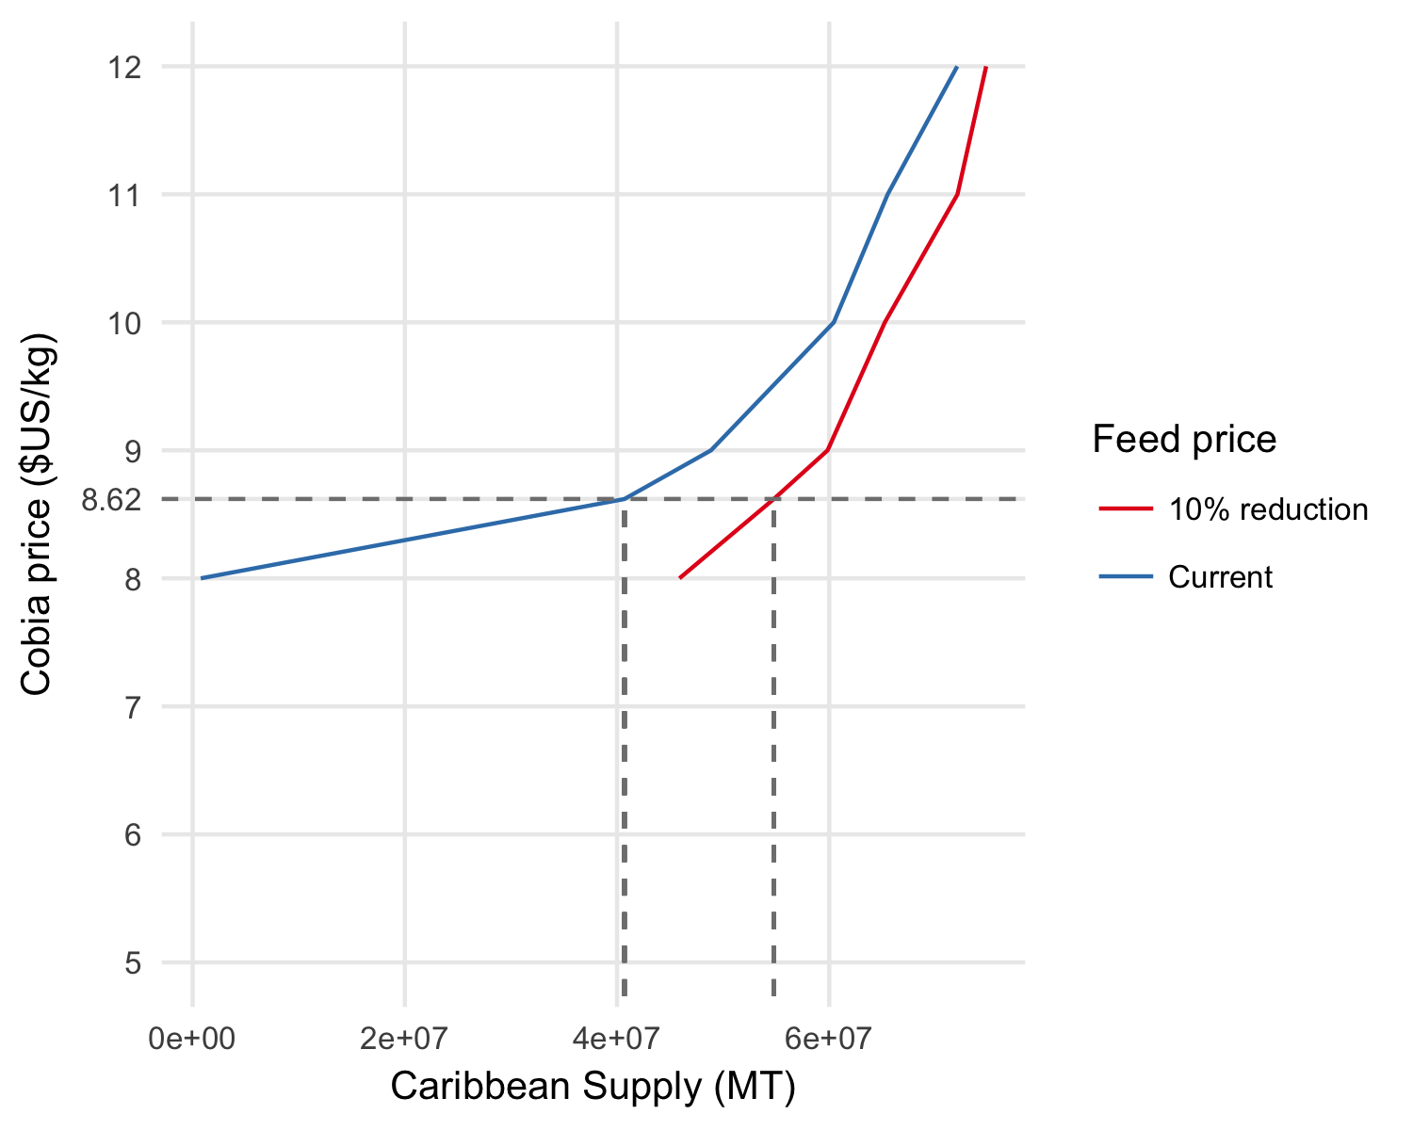

Figure XX. Cobia supply curves under current feed cost (feed price index = 1) and a 10% reduction in feed cost (feed price index = 0.9).

A reduction in feed costs would increase production and NPV…

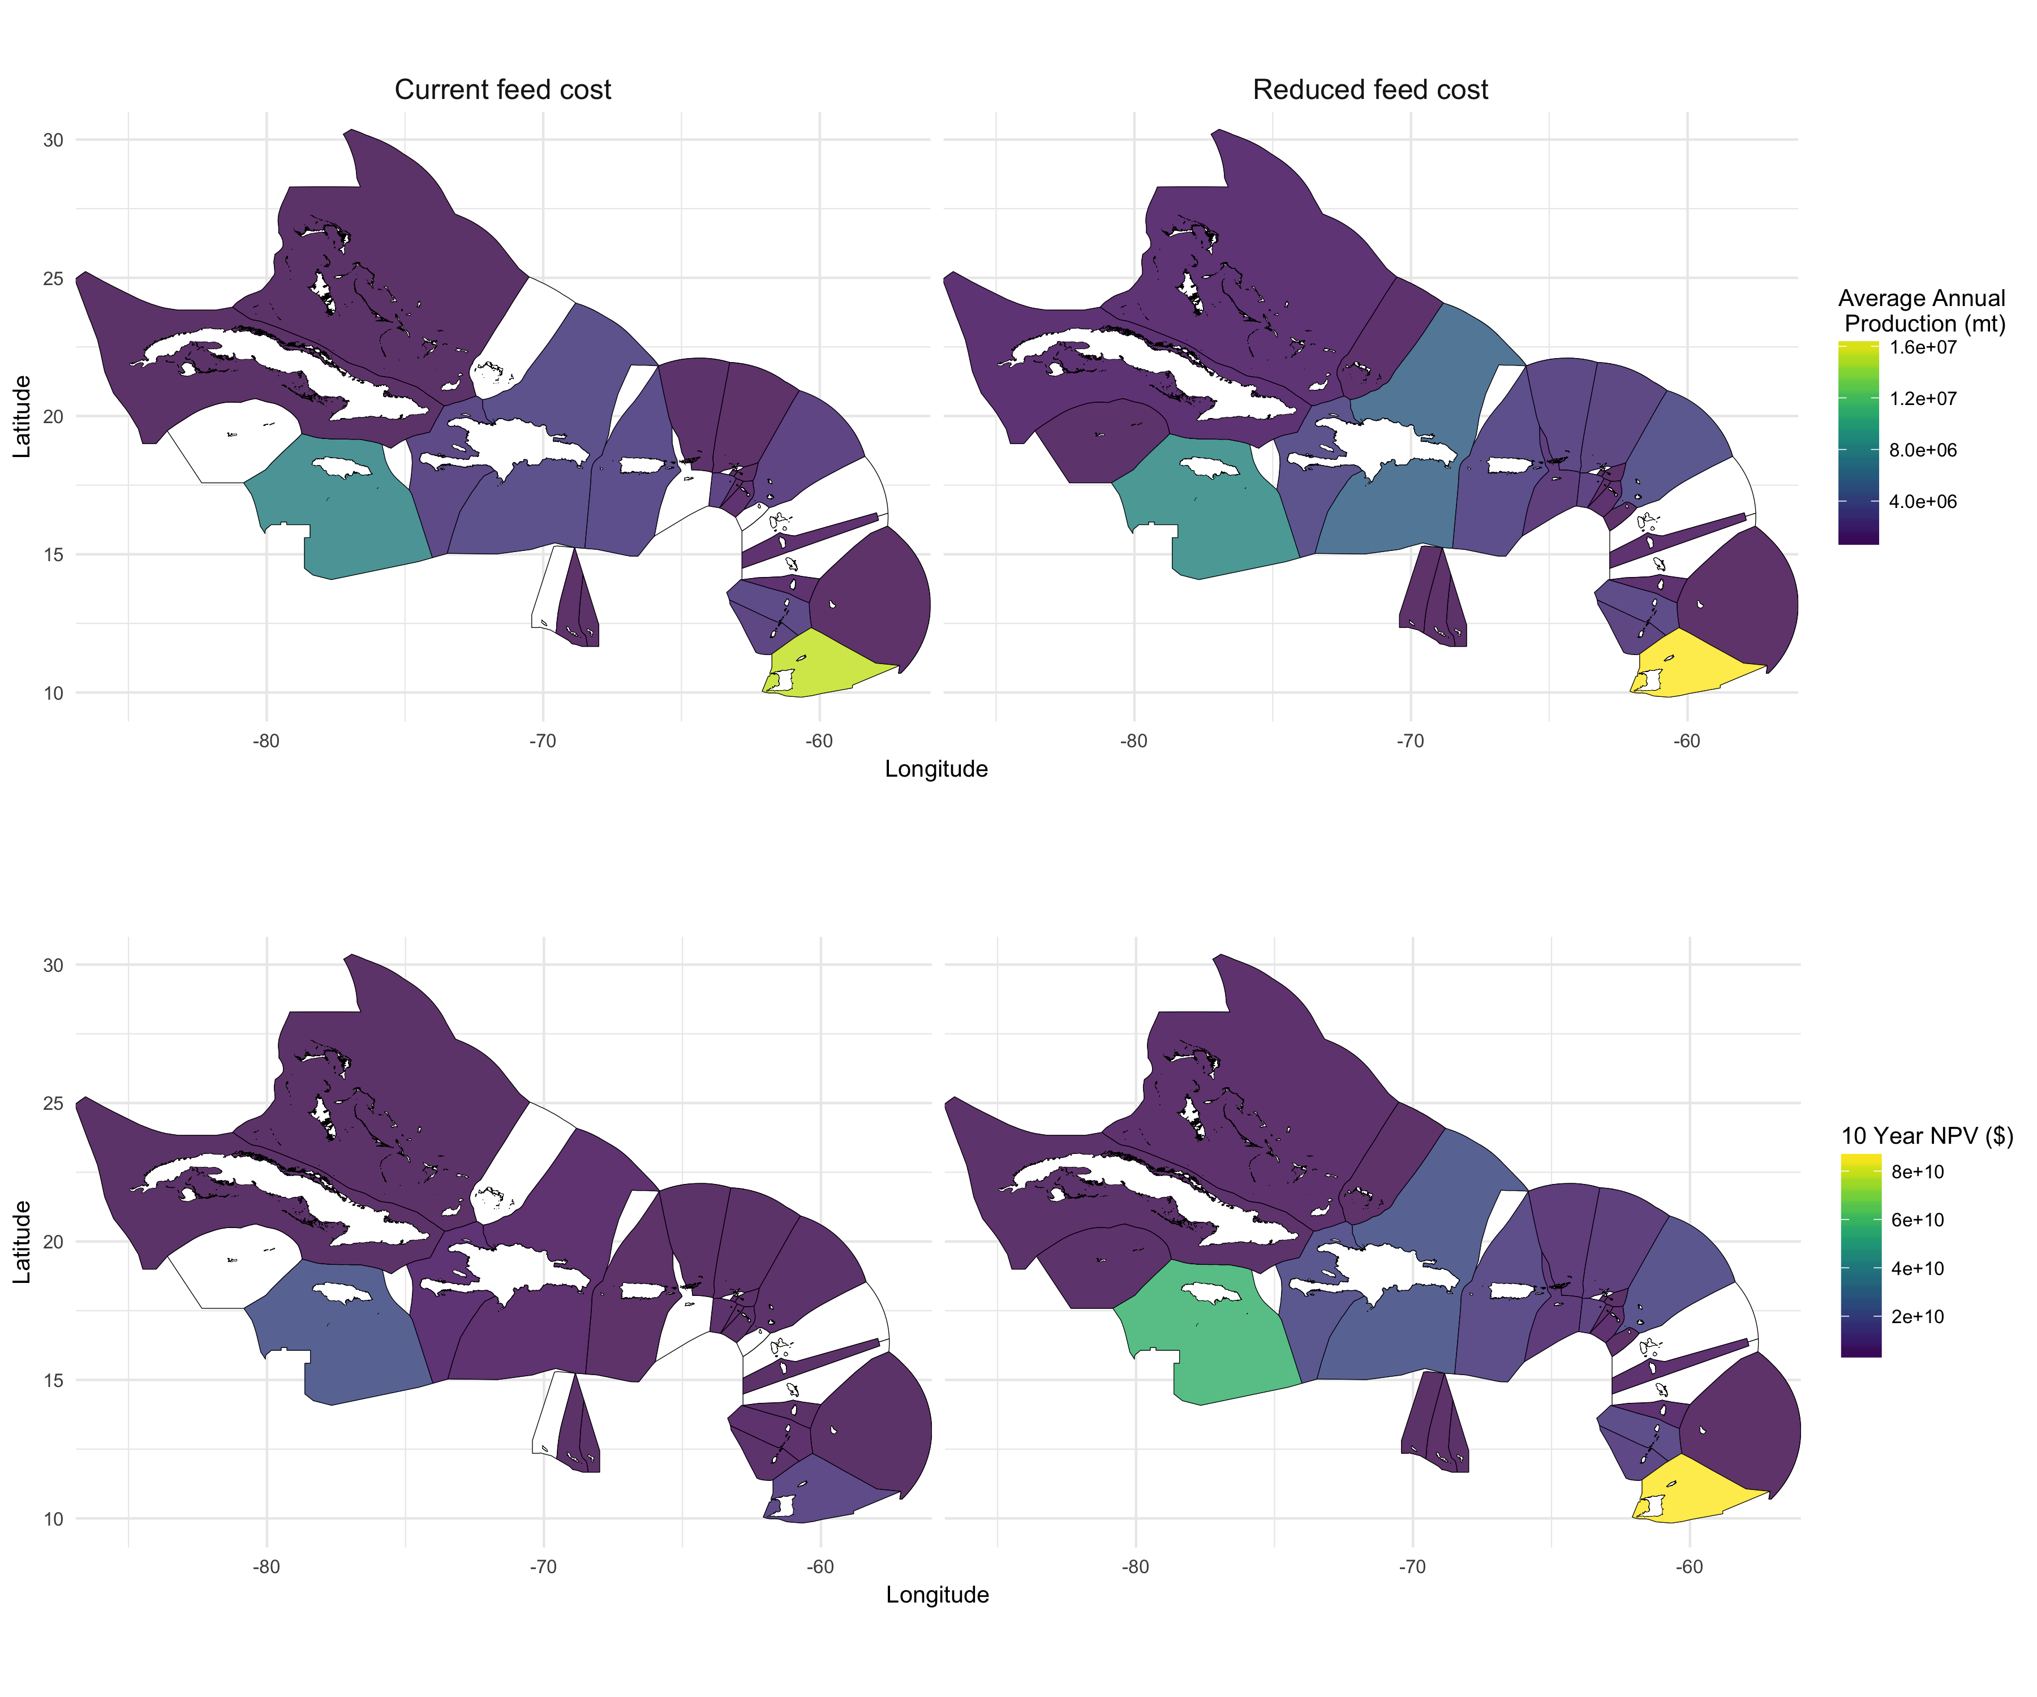

Total production (mt) (top) and 10 year NPV ($) (bottom) of farms that are profitable over a 10 year period at current feed prices and when cost of feed is reduced by 10%

## Other Figures

Cobia growth is a function of temperature and, in addition to the amount of suitable area avaialable, is a major factor for cobia production. Not surprisingly then, average cobia growth (kg/month/farm) shows a clear seasonal trend, which varies across EEZs (Figure XX).

As a result of the variability in growth rates acros the Caribbean, farms vary in the length of time require to raise cobia to a market size of 5 kg, with the median farm requiring X months to complete a harvest cycle (Figure SX).

# Discussion

# References

# Supplementary Information

#### Discount Rate

*(need to update and add methods used to convert to discount rate)*

Individual discount rates are determined for each Caribbean country that incorporate the foreign investment risk associated with that country. We modify previously published methodologies to quantify a country’s relative investment risk in the Caribbean, where limited data on economic and political conditions are available. Bhalla (1983) developed the Foreign Investment Risk Matrix (FIRM) to assist investors in classifying the political and economic risks associated with investing in different countries using discrete risk categories. An expanded version of FIRM was developed by McGowan and Moeller (2009) that utilizes three political and three economic continuous risk variables that are readily available for most countries.

Limited data were available for the risk variables described by McGowan and Moeller (2009) for Caribbean island countries. Only three countries in our study have data available for the “conflict” variable and only nine have data available for all five of the other McGowan and Moeller risk variables. Therefore, to calculate risk scores for the island countries in our region, we identify comparable, substitute risk variables for each of McGowan and Moeller’s risk variables. We then calculate Pearson’s correlation coefficients and significance vales between McGowan and Moeller’s risk variables and our selected substitute variables using countries with data available for both sets to validate our substitute variables (Table XX). Although there are not enough data for the conflict variable in the Caribbean to calculate a correlation coefficient, we assume WRI’s political stability score to be a logical substitute.

Averages of political and economic variables are calculated by removing any variables for which data qre not available for that country. In some cases this means that the only data available to calculate a final relative risk score is GDP per capita. Bhalla (1983) states that GDP per capita is one of the most important variables determining both political and economic risk because income per capita reflects both the underlying economy and the effectiveness of political management. For the 14 countries with data available for all variables, we find GDP to be a significant (r = 0.88, *p*-value = < 0.001) predictor of the final risk score, providing further support for this approach (Figure 1).

For each variable, a country’s rating is determined by transforming the data for that variable to a scale of 1 (low risk) to 5 (high risk) and multiplying by the specified weight to determine the variable’s final score (R x W) (Table 3). Political and economic risk scores are calculated by taking the sum of final scores for all three variables, and the total risk score is calculated by multiplying the political and economic risk scores by the specified weight and summing the values (Table 3). The weights shown in Table 3 were arbitrarily chosen by McGowan and Moeller (2009). In practice, they recommend weighting variables according to relevance and importance to the particular project that is being assessed. For this analysis, all political and economic variables are given equal weight.

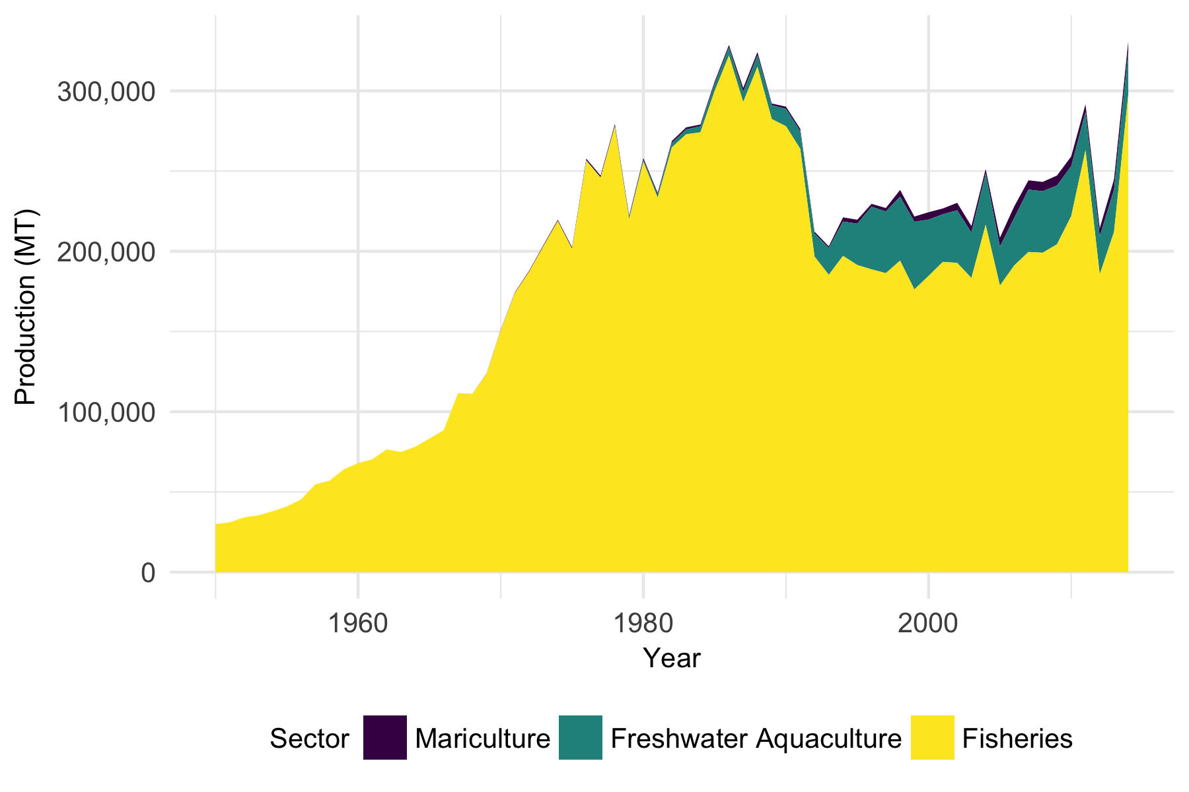

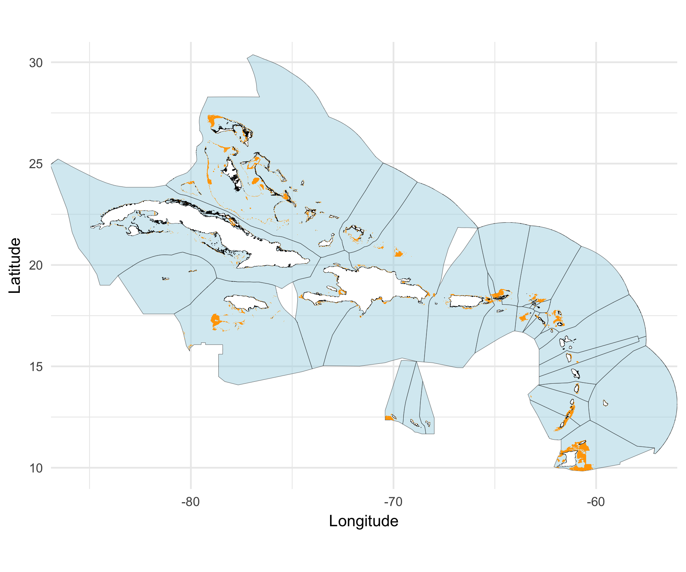

Figure S1. Areas suitable for offshore mariculutre in the Caribbean

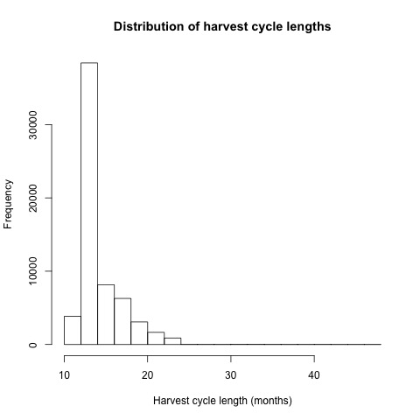

Average harvest cycle length (months) by farm

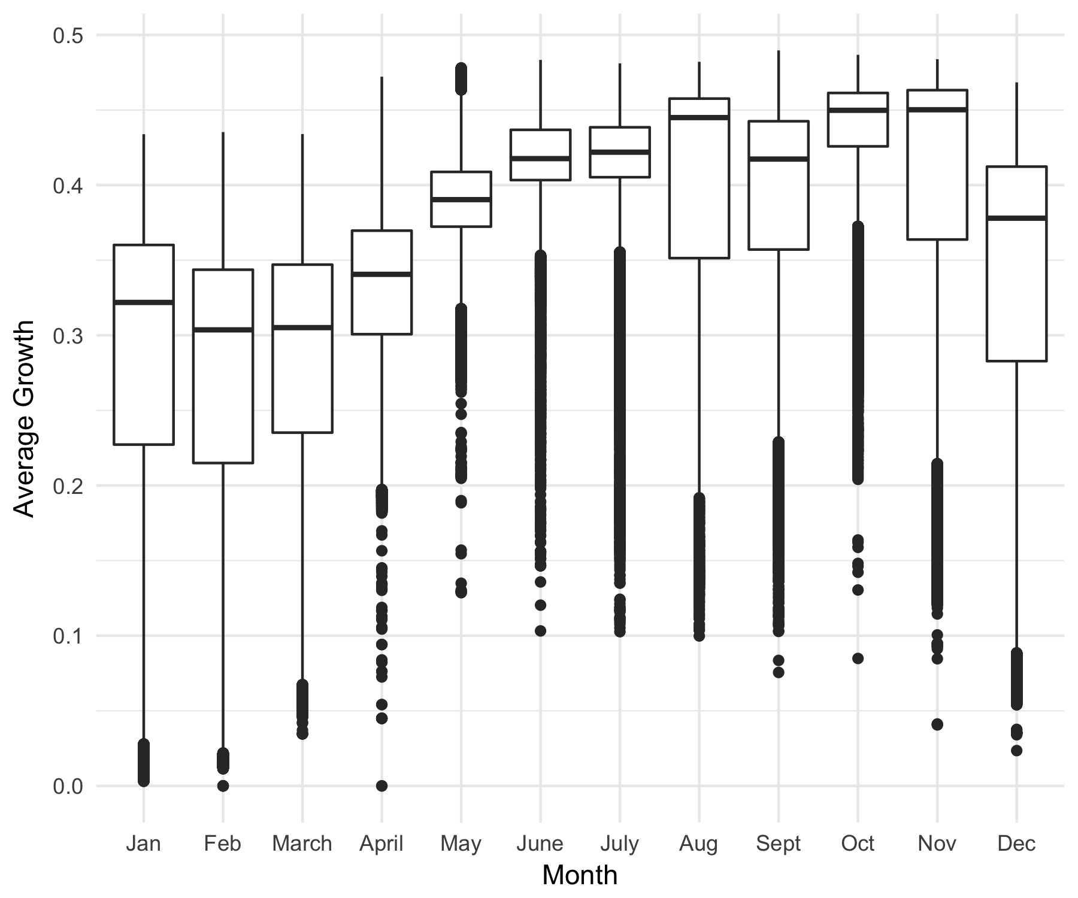

Average growth of cobia by month

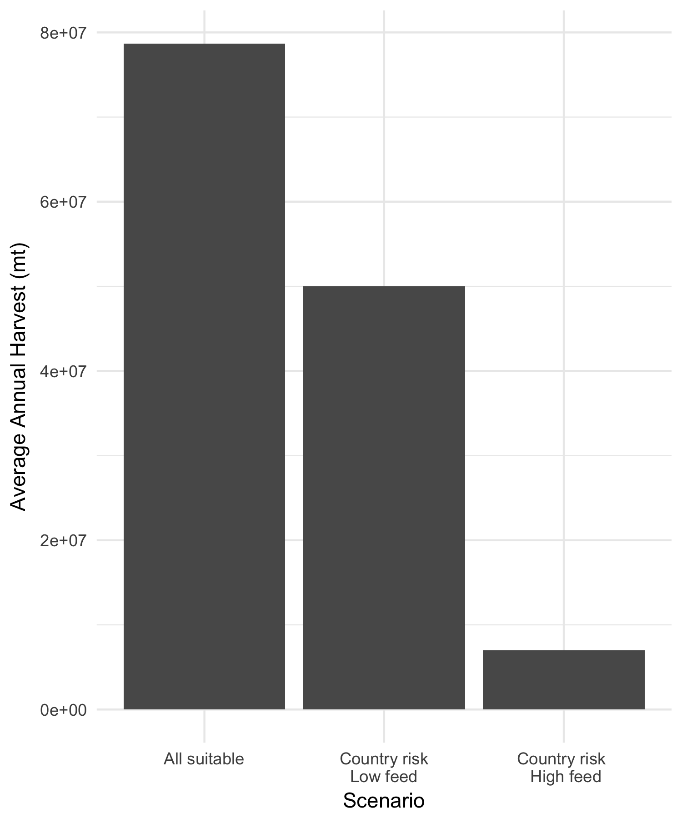

Comparison of production when all suitable farms are developed, only profitable farms, and only profitable farms with lower feed costs

Table S1. Description of spatial data layers and criteria used to identify cells suitable for development of offshore aquaculture in the Caribbean

|  |  |  |  |
| --- | --- | --- | --- |
| Layer | Year | Criteria | Source |
| Marine Protected Areas | 2016 | Not an established, designated or proposed Marine Protected Area | IUCN and UNEP-WCMC 2016 |
| Oil Rigs | 2003 | No existing benthic oil structures | Halpern et al. 2008 |
| Shipping | 2005 | Not included in the top 10% of relative shipping activity in the Caribbean | Halpern et al. 2008 |
| Coral Reefs | 2010 | No coral reefs are present in the 1 km2 area | UNEP-WCMC, WorldFish Centre,¾WRI,¾TNC¾2010 |
| Depth | 2009 | Depths >=25 and < = 100 | Kapetsky et al. 2013 |
| Current Velocity | 2005-2015 | Maximum average monthly zonal or meridional current velocity < 1 | ESR 2009 |
| Deep sea bed mining claims | 2016 | No mining claim or contract present | deepseaminingwatch.ms.ucsb.edu |

Table S2. Temperature-growth parameters and linear function constants for cobia

|  |  |
| --- | --- |
| Parameter | Value |
| Tmin | 22 |
| Topt | 29 |
| Tmax | 32 |
| Growth rate (g/month) | 0.5 |
| a1 | 0.071 |
| a2 | -0.17 |
| b1 | -1.6 |
| b2 | 5.3 |

Farm design specification for hypothetical 1 square kilometer offshore cobia farms

|  |  |
| --- | --- |
| Farm Specification | Value |
| Cage volume (m3) | 6,400 |
| Number of cages | 16 |
| Harvest size (kg) | 5 |
| Harvest density (kg/m3) | 15 |
| Harvest desnity (# of individiuals per cage) | 16,000 |
| Natural mortality rate (M) |  |
| Stocking density (# of individuals per cage) |  |

Table XX: Cost parameters used in the bioeconomic model for cobia offshore aquaculture

|  |  |  |  |
| --- | --- | --- | --- |
| Cost Parameter | Value | Unit | Reference |
| Capital Costs |  |  |  |
| Cage | 269701 | US$/cage | Bezerra et al. 2016 |
| Support vessel | 158331 | US$/vessel | Bezerra et al. 2016 |
| Farm site lease | 3265 | US$/km2 | Bezerra et al. 2016 |
| Labor installation | 52563 | US$/farm | Bezerra et al. 2016 |
| Operating Cost Parameters |  |  |  |
| fingerlings | 2.58 | US$/fingerling | Bezerra et al. 2016 |
| feed price | 1.64 | US$/kg | Bezerra et al. 2016 |
| hourly wage | varies by EEZ see Table AX | US$/hour |  |
| fuel price | varies by EEZ see Table AX |  |  |
| distance from port | varies by EEZ see Table AX | km |  |
| fuel efficiency | 3219 | m/gallon |  |
| farm workers | 17 | no. of employees operating farm/day | Bezerra et al. 2016 |
| farm days | 30 | work days at farm/month |  |
| farm hours | 8 | work hours/day |  |

## removed text (just in case we need later)

Guidelines for aquaculture development in U.S. waters of the Gulf of Mexico listed in a recent Fishery Management Plan stated that all aquaculture farms should be a minimum of 3 km apart and set a production limit of r prettyNum(Totalproduction, big.mark=“,”) mt for a total area of prettyNum(Totalarea,big.mark=“,”) km2 identified for aquaculture development, or r prettyNum(Productionrate,big.mark=“,”) mt/ km2. This production limit was identified as precautionary and based on historical wild fisheries capture for the region, due to lack of better methods or information on the ecological capacity of the region. To determine how this specified limit on production per unit area compared to production levels in other regions, we conducted a global assessment of production per unit of EEZ area in depths of 0 to 90 m for all EEZs. We obtained total marine aquaculture production by country, including finfish, invertebrate, and algae aquaculture production, for 2014 from FAO and calculated the total area in a depth range of 0-90 m for aquaculture by EEZ using global 1 km2 resolution bathymetry data from Becker *et al* (**???**). Total marine aquaculture production included finfish, invertebrates, and algae, thus we did not apply a minimum depth limit, because some these species are farmed in shallower water than is required for finfish cage culture. Although this does not allow for a direct comparison to production as modeled in our study, it provides another regional production level benchmark for comparison.

Alvarez-Lajonchère, Luis, and Leonardo Ibarra-Castro. 2013. “Aquaculture Species Selection Method Applied to Marine Fish in the Caribbean.” *Aquaculture* 408-409 (Supplement C): 20–29. doi:[10.1016/j.aquaculture.2013.05.020](https://doi.org/10.1016/j.aquaculture.2013.05.020).

Benetti, D., L. Brand, J. Collins, R. Orhun, A. Benetti, B. O’Hanlon, A. Danylchuk, D. Alston, J. Rivera, and A. Cabarcas. 2006. “Can Offshore Aquaculture of Carnivorous Fish Be Sustainable? Case Studies from the Caribbean.” *World Aquaculture*.

Benetti, Daniel D., Gabriel I. Benetti, José A. Rivera, Bruno Sardenberg, and Brian O’Hanlon. 2010. “Site Selection Criteria for Open Ocean Aquaculture.” *Marine Technology Society Journal* 44 (3): 22–35. doi:[10.4031/MTSJ.44.3.11](https://doi.org/10.4031/MTSJ.44.3.11).

Benetti, Daniel D., Brian O’Hanlon, José A. Rivera, Aaron W. Welch, Christopher Maxey, and M. Refik Orhun. 2010. “Growth Rates of Cobia (Rachycentron Canadum) Cultured in Open Ocean Submerged Cages in the Caribbean.” *Aquaculture* 302 (34): 195–201. doi:[10.1016/j.aquaculture.2010.02.021](https://doi.org/10.1016/j.aquaculture.2010.02.021).

Bhalla, Bharat. 1983. “How Corporations Should Weigh up Country Risk.” *Euromoney, June* 6672.

Brett, J. R. 1979. “10 - Environmental Factors and Growth.” In *Fish Physiology*, edited by D. J. Randall W.S. Hoar and J. R. Brett, 8:599–675. Bioenergetics and Growth. Academic Press. doi:[10.1016/S1546-5098(08)60033-3](https://doi.org/10.1016/S1546-5098(08)60033-3).

Burke, L., K. Reytar, M. Spalding, and A. Perry. 2011. *Reefs at Risk Revisited*.

Costello, Christopher, Daniel Ovando, Tyler Clavelle, C. Kent Strauss, Ray Hilborn, Michael C. Melnychuk, Trevor A. Branch, et al. 2016. “Global Fishery Prospects Under Contrasting Management Regimes.” *Proceedings of the National Academy of Sciences* 113 (18): 5125–9. doi:[10.1073/pnas.1520420113](https://doi.org/10.1073/pnas.1520420113).

Creswell, Leroy. 5AD–2007. “The History of Aquaculture in the Caribbean Through Presentations from 1948 2007.” In *Proceedings of the 60th Gulf and Caribbean Fisheries Institute*, 62–64. Punta Canta, Dominican Republic.

CRFM. 2014. “STUDY ON THE POTENTIAL OF FISH FARMING IN THE CARIBBEAN.”

Estrada, Uriel Rodriguez, Fanny Ayumi Yasumaru, Albert G. J. Tacon, and Daniel Lemos. 2016. “Cobia (Rachycentron Canadum): A Selected Annotated Bibliography on Aquaculture, General Biology and Fisheries 19672015.” *Reviews in Fisheries Science & Aquaculture* 24 (1): 1–97. doi:[10.1080/23308249.2015.1088821](https://doi.org/10.1080/23308249.2015.1088821).

FAO, ed. 2016. *Contributing to Food Security and Nutrition for All*. The State of World Fisheries and Aquaculture 2016. Rome: Food and Agriculture Organization of the United Nations.

Froehlich, Halley E., Alexandra Smith, Rebecca R. Gentry, and Benjamin S. Halpern. 2017. “Offshore Aquaculture: I Know It When I See It.” *Frontiers in Marine Science* 4. doi:[10.3389/fmars.2017.00154](https://doi.org/10.3389/fmars.2017.00154).

Gentry, Rebecca R., Halley E. Froehlich, Dietmar Grimm, Peter Kareiva, Michael Parke, Michael Rust, Steven D. Gaines, and Benjamin S. Halpern. 2017. “Mapping the Global Potential for Marine Aquaculture.” *Nature Ecology & Evolution*, August, 1. doi:[10.1038/s41559-017-0257-9](https://doi.org/10.1038/s41559-017-0257-9).

Gentry, Rebecca R., Sarah E. Lester, Carrie V. Kappel, Crow White, Tom W. Bell, Joel Stevens, and Steven D. Gaines. 2017. “Offshore Aquaculture: Spatial Planning Principles for Sustainable Development.” *Ecology and Evolution* 7 (2): 733–43. doi:[10.1002/ece3.2637](https://doi.org/10.1002/ece3.2637).

GMFMC (Gulf of Mexico Fishery Management Council), and NOAA (National Oceanic and Atmospheric Administration). 2009. “Fishery Management Plan for Regulating Offshore Marine Aquaculture in the Gulf of Mexico.” Tampa, FL.

Holmer, Marianne. 2009. “Environmental Issues of Fish Farming in Offshore Waters:: Perspectives, Concerns and Research Needs.” *Aquaculture Environment Interactions* 1 (1): 57–70.

Huang, Cheng-Ting, Sha Miao, Fan-Hua Nan, and Shi-Mu Jung. 2011. “Study on Regional Production and Economy of Cobia Rachycentron Canadum Commercial Cage Culture.” *Aquaculture International* 19 (4): 649–64. doi:[10.1007/s10499-010-9391-y](https://doi.org/10.1007/s10499-010-9391-y).

Kapetsky, J. M., J. Aguilar-Manjarrez, and J. Jenness. 2013. “A Global Assessment of Potential for Offshore Mariculture Development from a Spatial Perspective.” *FAO Fisheries and Aquaculture Technical Paper (FAO)*.

Kobayashi, Mimako, Siwa Msangi, Miroslav Batka, Stefania Vannuccini, Madan M. Dey, and James L. Anderson. 2015. “Fish to 2030: The Role and Opportunity for Aquaculture.” *Aquaculture Economics & Management* 19 (3): 282–300. doi:[10.1080/13657305.2015.994240](https://doi.org/10.1080/13657305.2015.994240).

Lovatelli, Alessandro, José Aguilar-Manjarerez, Doris Soto, and Technical Workshop Entitled “Expanding Mariculture Farther Offshore: Technical, Environmental, Spatial and Governance Challenges”, eds. 2013. *Expanding Mariculture Farther Offshore: Technical, Environmental, Spatial and Governance Challenges ; FAO Technical Workshop, 22 - 25 March 2010 Orbetello, Italy*. FAO Fisheries and Aquaculture Proceedings 24. Rome: Food and Agriculture Organization of the United Nations.

Loverich, Gary F. 2010. “A Case Study of an Offshore SeaStation.” *Marine Technology Society Journal* 44 (3): 36–46.

McGowan Jr, Carl B., and Susan E. Moeller. 2009. “A Model for Making Foreign Direct Investment Decisions Using Real Variables for Political and Economic Risk Analysis.” *Managing Global Transitions* 7 (1): 27.

Merino, Gorka, Manuel Barange, Julia L. Blanchard, James Harle, Robert Holmes, Icarus Allen, Edward H. Allison, et al. 2012. “Can Marine Fisheries and Aquaculture Meet Fish Demand from a Growing Human Population in a Changing Climate?” *Global Environmental Change* 22 (4): 795–806. doi:[10.1016/j.gloenvcha.2012.03.003](https://doi.org/10.1016/j.gloenvcha.2012.03.003).

OceanSpar. 2013. “Product Description: Ocean Spar.”

Pérez-Ramírez, Mónica. 2017. “Climate Change and Fisheries in the Caribbean.” In *Climate Change Impacts on Fisheries and Aquaculture*, edited by Bruce F. Phillips and Mónica Pérez-Ramírez, 639–62. John Wiley & Sons, Ltd. doi:[10.1002/9781119154051.ch19](https://doi.org/10.1002/9781119154051.ch19).

Sims, Neil Anthony. n.d. “Kona Blue Water Farms Case Study: Permiting, Operations, Marketing, Environmental Impacts, and Impediments to Expansion of Global Open Ocean Mariculture.”

Tidwell, James. 2012. *Aquaculture Production Systems*. John Wiley & Sons.

Van Wyk, Petrer, and Megan Davis. 2006. “Integrating Aquaculture into Caribbean Development: Selection of Marine Species.”

Xu, W. B., K. Q. Zhu, and Y. C. Miao. 2015. “Research of the Hydrodynamic Characteristics of Ocean Spar Sea Station.”