**Audio References**

<https://www.aigei.com/>





*GameFail.wav(option 1 Fail Condition)*

*Gun_Shot_Fail(Fail Condition 2)*

*Open_Store.wav(Check Balance/Open shop)*

*Open_Inventory.wav(Inventory check)*

*Crop_Plant(Plant the crop)*

*Crop_Harvest(Harvest the crop)*

<https://wav-sounds.com/wp-content/uploads/2017/09/Vehicle-01.wav>

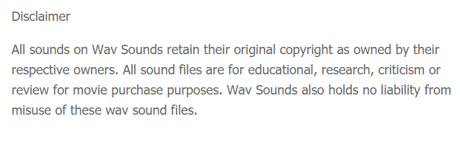

*Steam_boat .wav(Player bought fake passport and escaped)*

<https://sc.chinaz.com/yinxiao/>

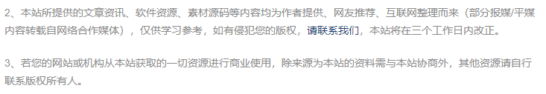

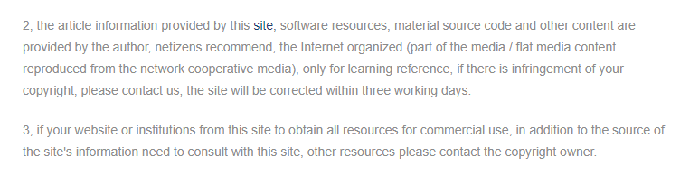

*Heavy_Rain_Bad_Weather.wav (Bad weather condition 1)*

*GameFail2.wav(backup option for fail)*

*Unlock_New_Land_Option_1.wav(Unlock new land option 1)*

*Bad_Mood.wav(Bad Mood)*

<https://www.ear0.com/>



*BGM_option2.wav*

*Item_Upgrade.wav*

<https://www.liangchan.net/liangchan/11435.html>

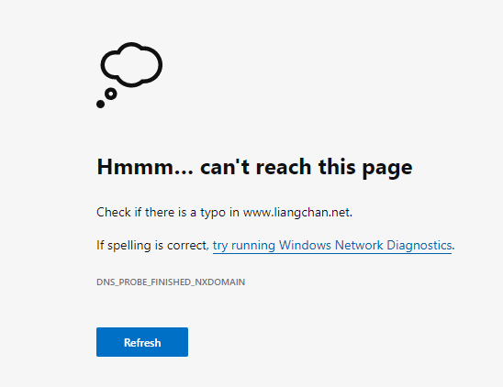

（WEB NO LONGER EXISTS）

*Alarm.wav*

<https://www.aigei.com/item/shou_ren_nan_si.html>





*Die.wav*

**Font References**

All these fonts are 100% free to use as said on the links and have no mention of a license.

Chernobyl.otf - <https://www.dafont.com/search.php?q=Chernobyl>

Pixelated.ttf - <https://www.dafont.com/pixelated.font>

Russian.ttf - <https://www.dafont.com/russian.font>