# Name of Company: VMware, Inc.

VMware, Inc. is a publicly traded software company listed on the NYSE under stock ticker VMW. Dell Technologies is a majority shareholder. VMware provides cloud computing and virtualization software and services. It was one of the first commercially successful companies to virtualize the x86 architecture. (Wikipedia)

According to Industry Today “Global Cloud Analytics Market,Top key players are Vmware, Inc., Tibco Software, Teradata, Tableau Software, Sas Institute Inc., SAP, Rackspace, Qlik Tchnologies Inc., Pivotlink, Panorama Software, Oracle Corp., Newvem, Microstrategy, Microsoft Corp” (Industy Today: Published 02/11/2019)

# Contributors & Alliances:

`

* Dell Technologies
* Pivotal Software
* Carbon Black
* Air Watch

# Company Profile:

VMware provides cloud computing and platform virtualization software and services. Its virtualization infrastructure solutions are designed to deliver a software-defined data center, run on industry-standard desktop computers and servers and support a wide range of operating systems and application environments, as well as networking and storage infrastructures. The company develops and markets its products and service offerings within three main product groups: software-defined data center, end-user computing, and hybrid cloud computing. (craft.co)

[Technology](https://craft.co/technology-companies)

* + [cloud](https://craft.co/cloud-companies)
  + [cloud infrastructure(IaaS)](https://craft.co/infrastructure-as-a-service-companies)
  + [cloud platforms(PaaS)](https://craft.co/cloud-platforms-companies)
  + [cloud services(SaaS)](https://craft.co/cloud-services-companies)
  + [data storage](https://craft.co/data-storage-companies)
  + [enterprise software](https://craft.co/enterprise-software-companies)
  + [it services](https://craft.co/it-services-companies)
  + [virtualization](https://craft.co/virtualization-companies)

# Financials:

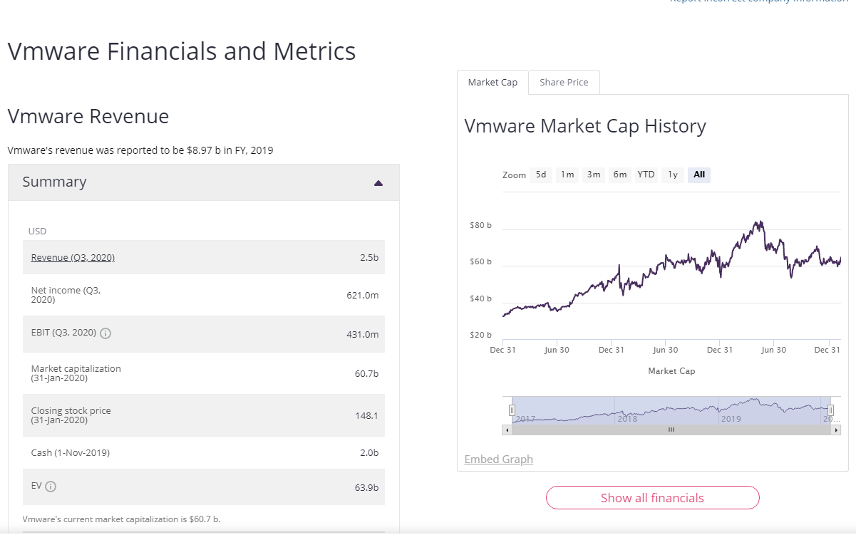

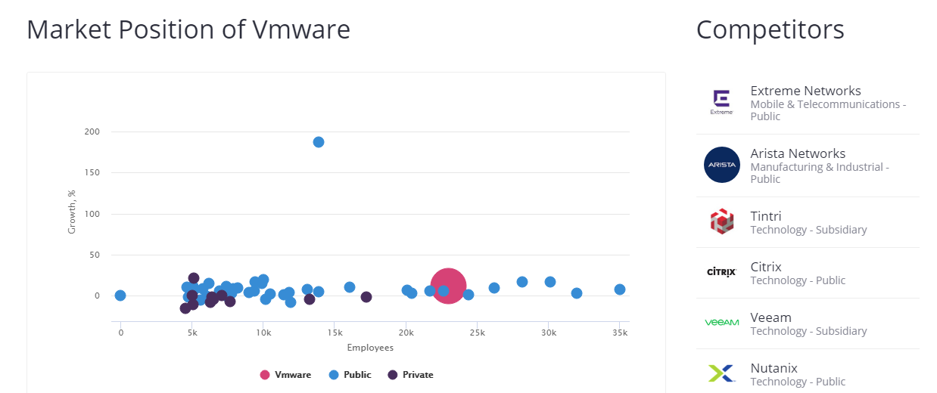

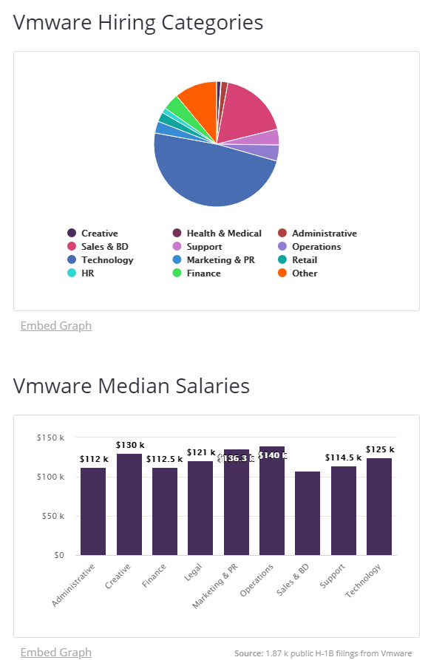

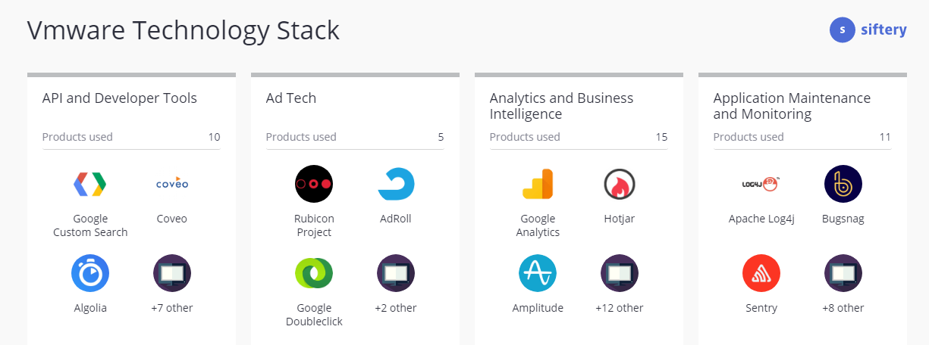

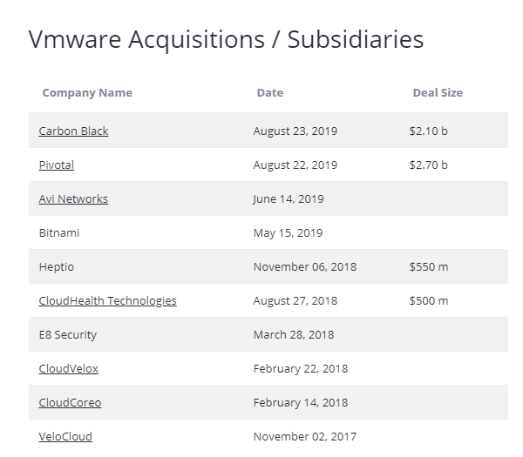

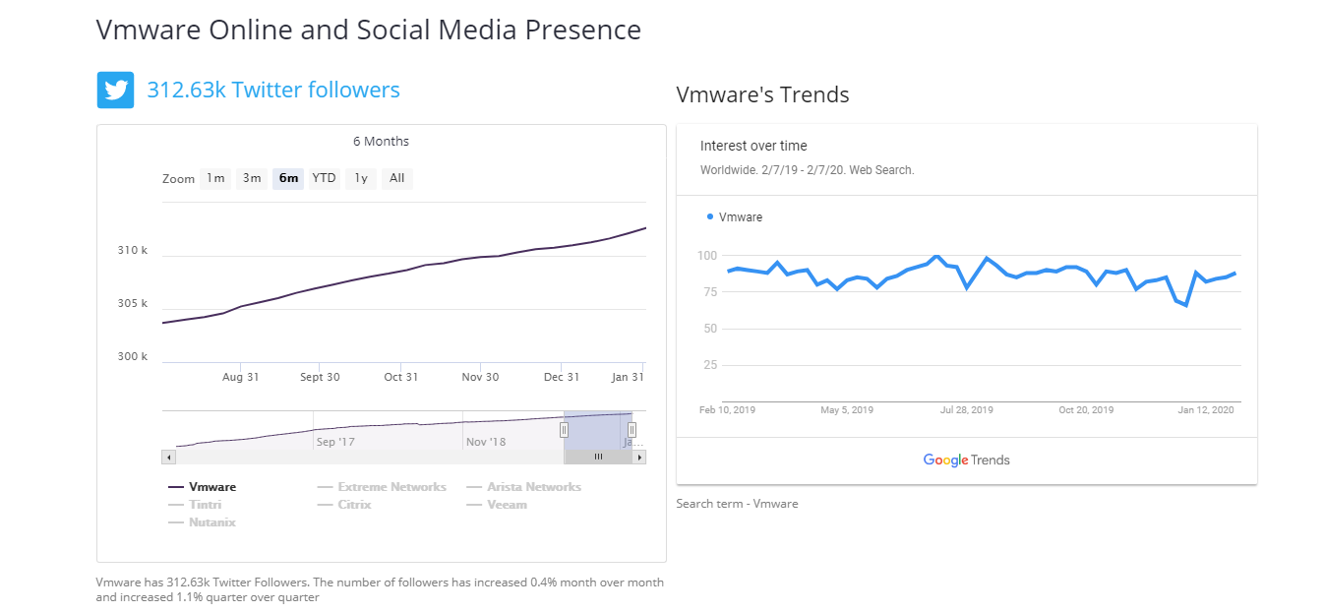

# Glassdor Company Profile:

VMware Careers

Website[www.vmware.com](http://www.vmware.com/)

HeadquartersPalo Alto, CA

Size10000+ employees

Part of[Dell Technologies](https://www.glassdoor.com/Overview/Working-at-Dell-Technologies-EI_IE1327.11,28.htm)

Founded1998

TypeCompany - Public (VMW)

IndustryComputer Hardware & Software

Revenue$5 to $10 billion (USD) per year

At VMware, we believe that software has the power to unlock new opportunities for people and our planet. We look beyond the barriers of compromise to engineer new ways to make technologies work together seamlessly. Our compute, cloud, mobility, networking and security offerings form a digital foundation that powers the apps, services and experiences that are transforming the world.  
  
Since our founding over two decades ago, our 24,000+ employee community and ecosystem of 75,000 partners have been behind the technology innovations transforming entire industries – from banking, healthcare, and government to retail, telecommunications, manufacturing, and transportation.  
  
Every day, we work to solve our customers’ toughest challenges through disruptive technologies like edge computing, artificial intelligence, blockchain, machine learning, Kubernetes and more – to define the digital foundation that will accelerate the next wave of innovation.

**Mission:**VMware, a global leader in cloud infrastructure and business mobility, accelerates our customers’ digital transformation journey. VMware enables enterprises to master a software-defined approach to business and IT with its Cross-Cloud Architecture™ and digital workspace solutions. Based in Palo Alto, California, VMware is a member of the Dell Technologies family of brands. (Glassdoor)

# Benefits:

**Employer Summary**

VMware provides a meaningful exchange of value for the talents, expertise and contributions that our employees bring to the company every day. VMware Rewards supports personal wellbeing, builds financial security, and enables employees to share in the success of VMware. Rewards include:  
  
-Competitive compensation (salary, equity and bonuses) and comprehensive benefits designed to foster work-life balance, care for your health, protect your finances, and help you save and invest for the future.  
  
-Generous paid time away from work including vacation, holidays, sick time, and 5 days of paid time off each year to serve and learn through volunteering.  
  
-Great perks, which vary by location and can include: employee discounts, transportation reimbursements, subsidized cafes and fitness facilities, conveniences such as dry cleaning and car washes, and composting & recycling programs. (Glassdoor)

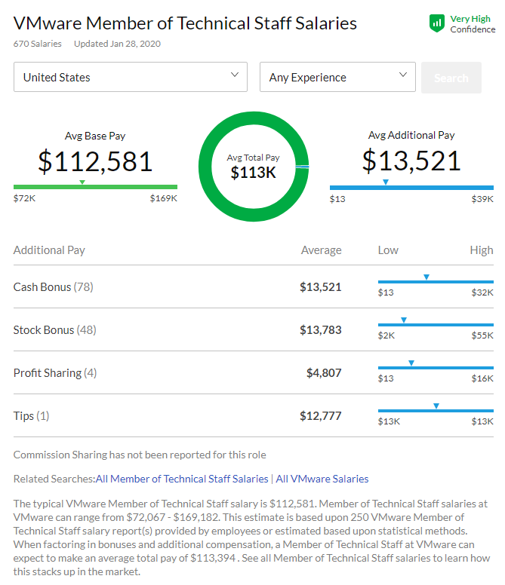

# Bibliography:

* <https://craft.co/vmware>
* <https://industrytoday.co.uk/it/global-cloud-analytics-market-top-key-players-are-vmware--inc---tibco-software--teradata--tableau-software--sas-institute-inc---sap--rackspace--qlik-tchnologies-inc---pivotlink--panorama-software--oracle-corp---newvem--microstrategy--microsoft-corp/189656/189656?utm_source=feedburner&utm_medium=feed&utm_campaign=Feed%3A+IndustryToday+%28Industry+Today+All+Feeds%29>
* <https://www.glassdoor.com/Overview/Working-at-VMware-EI_IE12830.11,17.htm>
* <https://en.wikipedia.org/wiki/VMware>