INDIAN ART FORM (21LEM301)
INDIAN TRADITIONAL PAINTING
GROUP DISCUSSION & REPORT

KERALA MURAL PAINTING
From Temple Walls to a Living Visual Language

Submitted by
Ananya Jaiswal
Arindam Jaiman

CSE-AIML-A | III Year
Subject: Indian Art Form
Faculty: Dr. Nalini
Academic Year: 2026–27

1. Introduction: When a Wall Becomes a Sacred Story
Kerala mural painting, known in Malayalam as chuvarchitram (“wall picture”), is one of India’s most distinctive classical wall-painting traditions. Associated with the temples, palaces and churches of Kerala and the adjoining areas of the former Travancore state, it developed within sacred and royal architecture before becoming visible on canvas, paper, cloth, exhibitions and contemporary design. Its importance therefore cannot be reduced to glowing colours or ornate figures. It is a visual system through which communities have represented devotion, epic narrative, royal identity, ritual order and the relationship between the human and the divine.
Kerala Tourism notes that most of the celebrated murals date from the fifteenth to the nineteenth centuries, although some traces go back much earlier, and the Archaeological Survey of India (ASI) likewise describes the surviving paintings as mostly belonging to the fifteenth to nineteenth centuries. The tradition is closely connected with temple ritual, Sanskrit iconographic texts, the aesthetics of Kathakali and Koodiyattam, and the ritual floor drawing known as kalamezhuthu, from which its style is often said to have grown.
This history makes Kerala murals especially valuable for the study of Indian art because it shows how a highly rule-bound, classical art could flourish inside the sanctum walls and palace chambers of a coastal South Indian kingdom. Here, the wall of a shrine became a site of worship. A painting could be consecrated with an eye-opening ritual and receive daily prayers rather than being an object made only for display.
“The first gallery of Kerala mural painting was not a museum; it was the sanctum wall of the temple.”
The tradition is also an example of cultural continuity through change. After declining sharply in the nineteenth and early twentieth centuries, it was revived after the Guruvayur temple fire of 1970, which led to the founding of the Institute of Mural Painting at Guruvayur in 1989. Murals then moved from temple walls onto canvas, plywood, paper and fabric, carrying the visual language of Kerala to audiences far beyond its original setting. The result was both an artistic revival and an economic transformation.
Our report therefore asks a central question: how can a tradition change profoundly and still remain a tradition? To answer it, we examine its geography, history, patrons, symbols, techniques, social significance, transformation and present-day challenges.

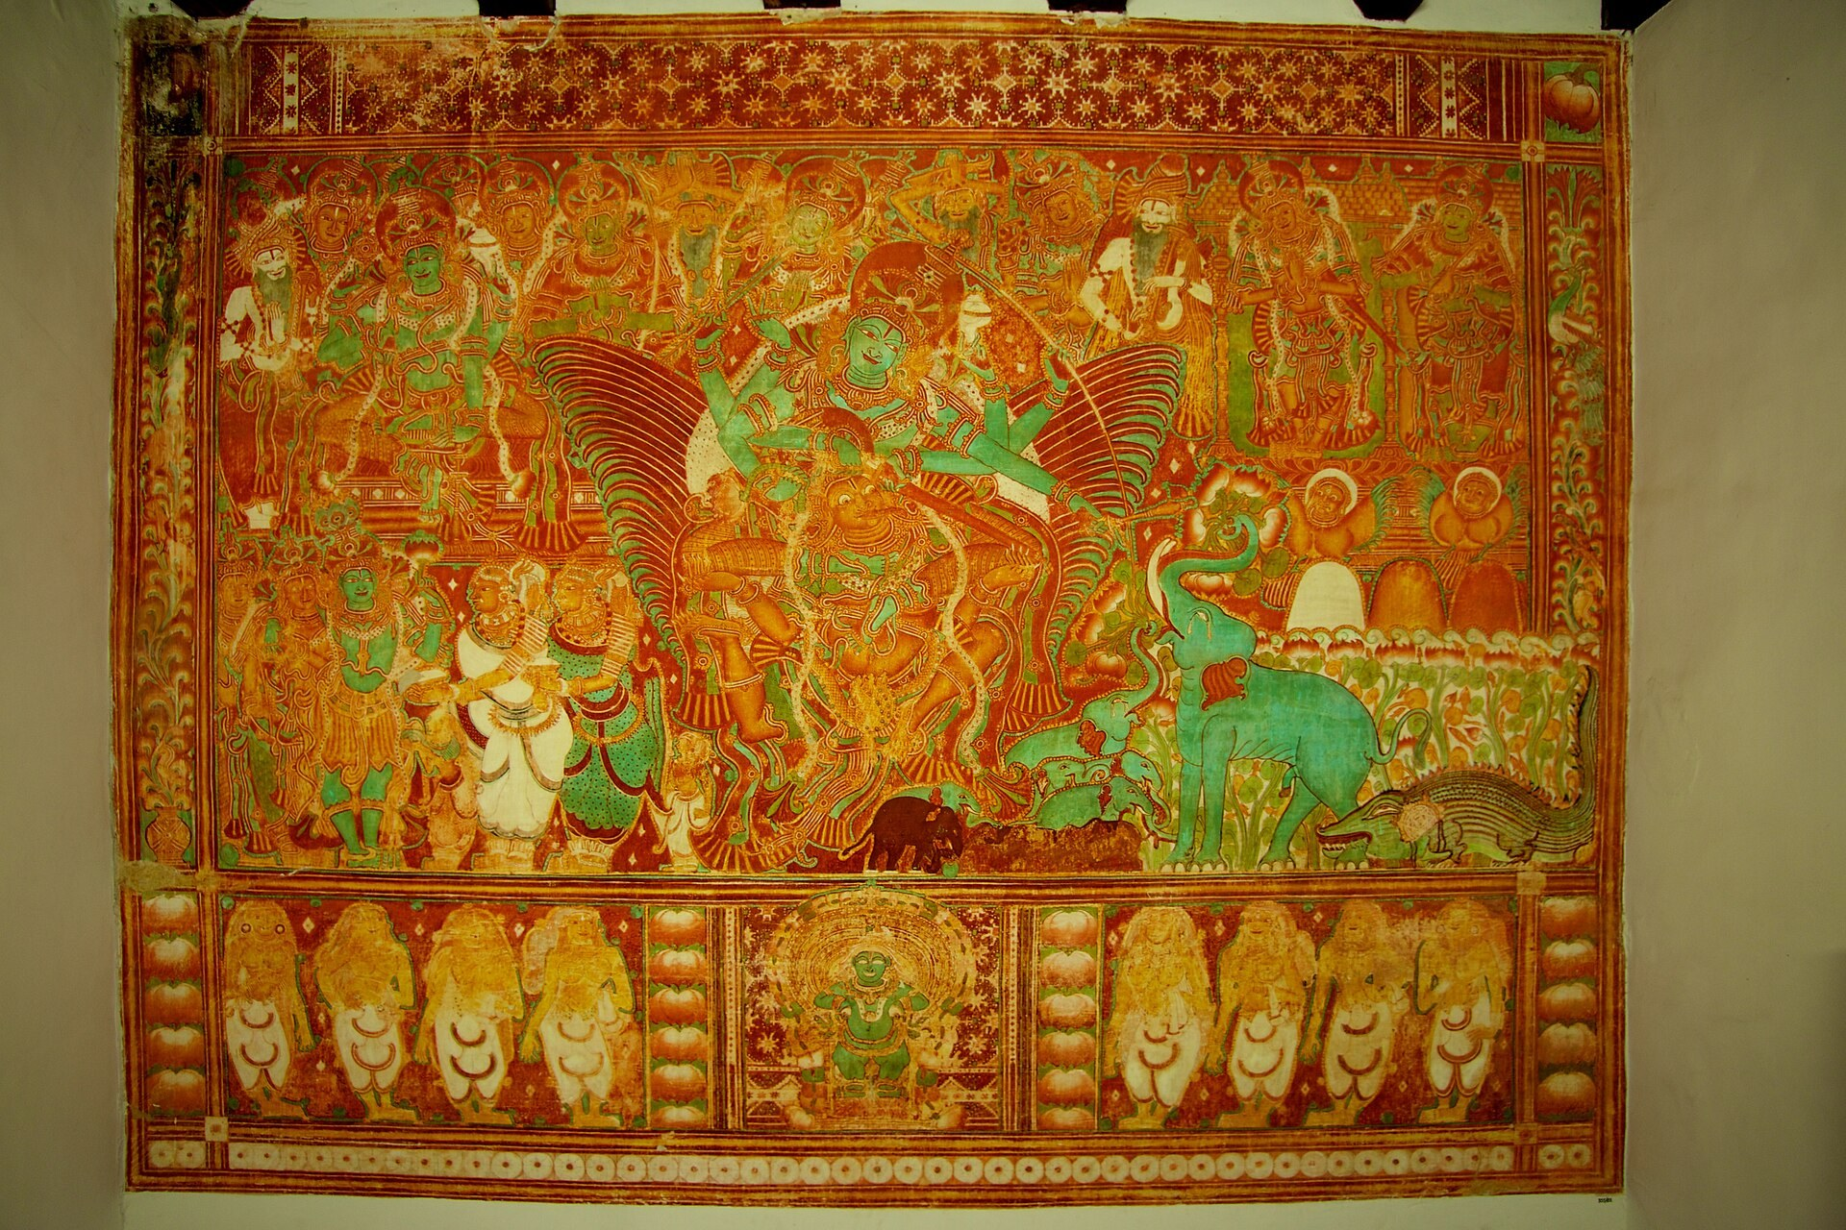

2. Origin, Region and Historical Background

2.1 Kerala and Travancore: Geography as Cultural Memory
The Kerala mural tradition belongs to the narrow coastal land between the Western Ghats and the Arabian Sea, and to the cultural world of the old kingdoms of Venad/Travancore, Kochi and the Zamorin of Kozhikode. Its boundaries follow these historical regions rather than modern state borders: two of its most important sites, the Thirunandikkara cave temple and Padmanabhapuram Palace, now lie in Kanyakumari district of Tamil Nadu but were part of Travancore. Padmanabhapuram Palace is still owned and maintained by the Government of Kerala’s Department of Archaeology.
“Kerala mural painting” therefore names more than a style: it connects the artwork to a landscape, a temple culture, Malayalam and Sanskrit learning, and the performing arts of the region. Important murals survive at Mattancherry Palace in Kochi, Krishnapuram Palace in Kayamkulam, Padmanabhapuram Palace, the Vadakkunnathan temple in Thrissur, and temples at Ettumanoor, Vaikom, Guruvayur, Trikkodithanam, Thodeekalam (near Kannur), Pundareekapuram, Panayannarkavu and Lokanarkavu, as well as in churches at Angamaly, Kanjoor, Akaparambu, Cheppad and Paliakkara.

2.2 Temple and Palace Practice
Historically, mural painting was closely associated with sacred and royal architecture. Murals covered the outer walls of the sreekovil (sanctum), the gopurams (gateways), mandapams and palace chambers, and their placement followed the rules of vastu. Patrons were temples and royal houses such as those of Kochi and Travancore. Some paintings are still worshipped daily: at the Vadakkunnathan temple in Thrissur, the Vasukisayana (reclining Shiva) and the twenty-armed Nritta Nataraja, about 350 years old, receive regular worship.
This is an important distinction. Modern viewers often evaluate an artwork through permanence, rarity and market value. Traditional Kerala murals developed under a different logic. Their value lay in auspiciousness, worship, the correct representation of each deity’s form, and the instruction of devotees who could “read” the epics on the walls. A finished mural traditionally received nethronmeelanam, the ritual opening of the eyes, which marked it as sacred — a ritual still performed in restorations today.
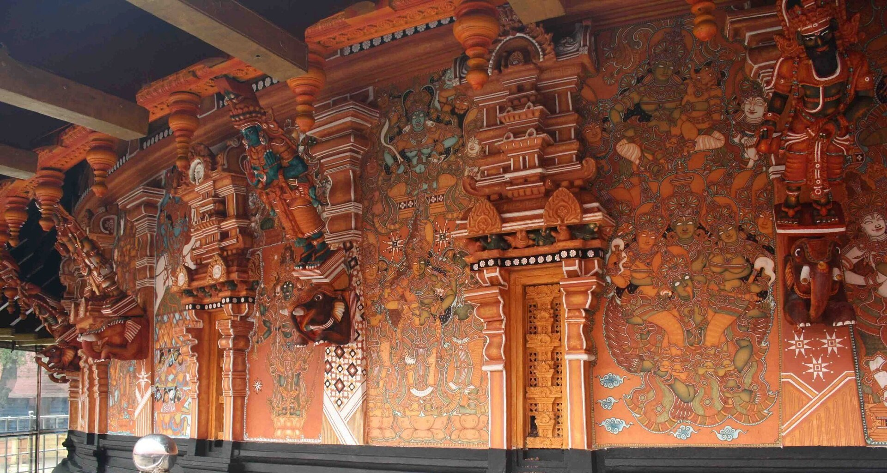

2.3 Early Examples, Major Sites and Documentation
The earliest surviving traces are the faint fragments in the ninth-century rock-cut Thirunandikkara cave temple, where a Ganesha drawn in red outline can still be seen; historians differ on whether the cave was made under the Ay or the Pandya rulers. A. Ramachandran’s study places the mature tradition in phases: fifteenth-century work such as Trikkodithanam, sixteenth-century work such as the Ramayana panels of Mattancherry Palace, and later, flatter work such as Panayannarkavu, before decline set in. Mattancherry Palace was built by the Portuguese around 1555 for the Raja of Kochi and renovated by the Dutch in 1663. Krishnapuram Palace was rebuilt under Marthanda Varma of Travancore in the eighteenth century; its Gajendra Moksham panel, about three metres high, is widely described as the largest single mural found in Kerala.
Documentation came later and in stages. T.A. Gopinatha Rao’s Travancore Archaeological Series (from 1908), Stella Kramrisch’s contribution to The Arts and Crafts of Travancore (1948), A. Ramachandran’s Painted Abode of Gods (2005), M.G. Sasibhooshan’s studies, and the ASI’s Kerala Murals (2015), based on fieldwork in seven protected monuments in 2008–10, all brought wider attention to the tradition. Documentation, however, should not be confused with origin. The paintings were not created because scholars recorded them; they belonged to an established temple practice whose knowledge existed independently of outside recognition.

2.4 Painters, Texts and Transmission
Most historic Kerala muralists are anonymous, and some groups of painters appear to have travelled between temples and churches. Knowledge moved through the guru–shishya relationship rather than formal art schools: students learned by assisting masters, memorising Sanskrit dhyana slokas (verses describing each deity’s form) and following canonical texts such as the Silparatna of Srikumara (sixteenth century), the Tantrasamuchaya of Chennas Narayanan (fifteenth century) and the Chitrasutra of the Vishnudharmottara Purana. Temple mural painting was traditionally a male occupation. This makes the tradition significant not only artistically but socially: it demonstrates how cultural knowledge can be preserved through practice, texts and lineage — one documented line of teachers runs from Karuvaparambath Achuthan Nair to Krishna Variar, Mammiyur Krishnankutty Nair and the teachers of the Guruvayur institute.
[ FIGURE 2 — MAP OF KERALA’S HISTORIC HERITAGE SITES ]
Caption: Major historic sites of Kerala (c. 400–1800 CE), the temple and palace landscape within which the mural tradition developed.
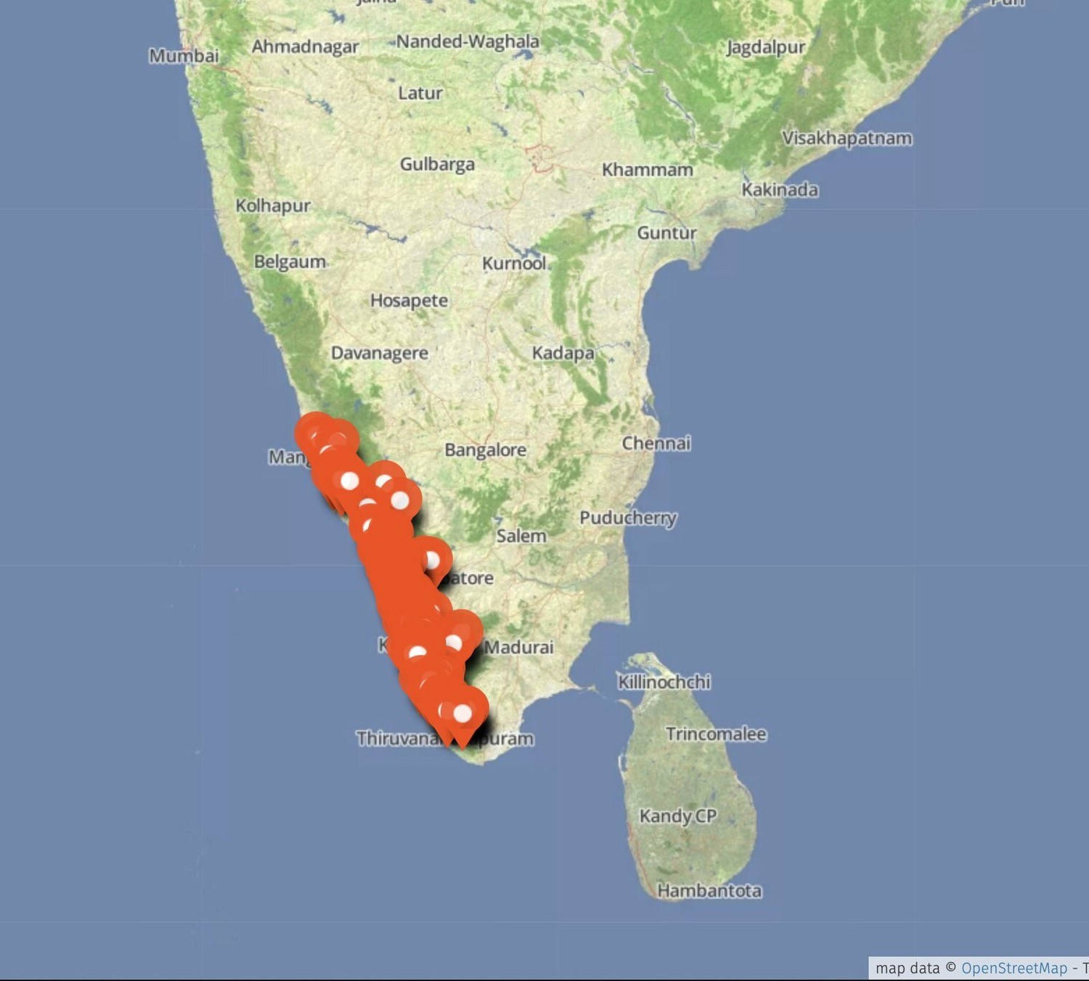

3. From Temple Wall to Portable Artwork
One of the decisive turning points in the modern history of Kerala murals came after a long decline. With the fading of royal patronage, the disruption of the Mysore invasions in the late eighteenth century and the British-era takeover of temple administration in Travancore in 1811, commissions dried up and very few practitioners remained. Many murals were lost to whitewash, lamp soot and careless renovation. Then, on 30 November 1970, a fire at the Guruvayur Sri Krishna temple damaged the sanctum murals. Only a handful of veteran painters — among them Mammiyur Krishnankutty Nair, M.K. Sreenivasan and K.K. Warrier — could be found to repaint them, work completed in 1986–89. The difficulty of finding painters led the Guruvayur Devaswom to found the Institute of Mural Painting in 1989, with a five-year gurukula-style course.
A wall is fixed to a shrine. A canvas can travel. As the institute’s graduates entered the field from the 1990s, murals began to be painted on canvas, plywood, paper and cloth for clients and exhibitions. Once the painting became portable, it could be sold, exhibited, collected, transported and reproduced. Kerala mural painting therefore entered a new economic and artistic environment.
The transformation also changed the relationship between artist and audience. A temple mural was made for a deity, a shrine and a worshipping community, under strict iconographic rules. A painting made for the market could be created for an unknown buyer, hotel lobby, gallery visitor or collector; today Kerala murals hang in hotels and airports and appear on sarees and the Kerala set mundu. This shift created new opportunities while introducing questions about commercial taste, authenticity and authorship.

3.1 The Emergence of Recognised Artists
Artists such as Mammiyur Krishnankutty Nair, the founding principal of the Guruvayur institute who led the restoration of the temple’s murals, and K.K. Warrier (1934–2018), who founded the Indian School of Arts in Kochi and transferred around a hundred decaying murals onto canvas, became important figures in the wider recognition of the art. Their students and successors — M.K. Sreenivasan and K.U. Krishnakumar at Guruvayur, P.K. Sadanandan, Suresh Muthukulam, Sasi Edavarad and others — carried the style into new institutions such as the Vasthuvidya Gurukulam at Aranmula (1993) and the mural programmes of Sree Sankaracharya University of Sanskrit, Kalady, as well as public commissions and exhibitions. Women artists such as Kalamandalam Bindhulekha and Syamala Kumari have entered a field that was historically male, and in 2023 an all-woman team painted the murals of a temple in Kozhikode.
This creates an important tension. Traditional knowledge was collective, anonymous and rule-bound, while the modern art market tends to emphasise the named individual creator. The modern history of Kerala murals therefore contains a movement from anonymous temple practice toward individual artistic identity without completely abandoning its collective and devotional roots.

3.2 The Double Effect of Commercialisation
- Greater visibility for artists and the Kerala mural tradition.
- New possibilities for income through sale, commissions and exhibition.
- Portable paintings on canvas, wood and fabric that can be preserved outside the temple.
- Access to wider national and international audiences, including the Malayali diaspora.
- New pressures created by market demand, digital prints and consumer expectations.
- Potential separation of sacred images from the ritual contexts in which they originated.
Commercialisation should therefore not be treated as a simple story of decline. For many artists it created recognition and livelihood; hand-painted mural sarees, for example, have found buyers in the UAE, the United States and Singapore. At the same time, markets can reward speed, acrylic shortcuts and repeated images, and murals printed on coasters and vases risk losing their exclusivity. The preservation question becomes more complex: who decides what the tradition becomes when the audience is no longer only the worshipper?
“Preservation is not only the survival of an object; it is the survival of the knowledge that makes the object meaningful.”
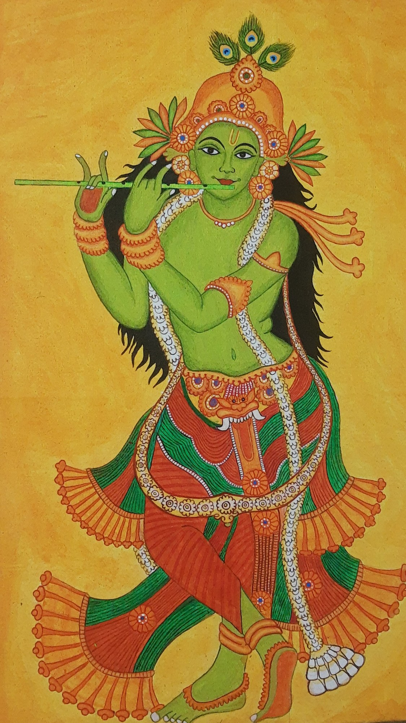

4. Main Characteristics: Themes, Symbols and Visual Grammar

4.1 Mythology and Devotion
Kerala murals mainly represent Hindu deities and epic and Puranic narratives. Shiva, Vishnu and his avatars, Krishna, Devi, Ganesha and Sastha recur frequently, along with famous compositions such as Ananthasayanam (Vishnu reclining on the serpent Ananta), Gajendra Moksham, Pradosha Nritham (Shiva’s dance, trampling the demon of ignorance), Krishna Leela, Venugopala and the Ashta Dikpalas (guardians of the eight directions). Episodes from the Ramayana and Bhagavata appear in palace cycles, such as the Ramayana panels of the royal bedchamber at Mattancherry Palace. Church murals use a related visual language for biblical scenes such as the Last Judgement, the Nativity, Noah’s ark and the arrival of St Thomas.
These figures are stylised rather than naturalistically modelled, yet they are not flat: shading through fine stippling gives them volume. Recognition is created through attributes, crowns, posture, mudras (hand gestures), colour and composition, all governed by the dhyana slokas, so that a given deity is drawn with the same proportions in every temple. The objective is not photographic realism but correct, recognisable sacred form.

4.2 Colour as Character and Nature as Setting
Colour in Kerala murals carries meaning. Following the theory of the three gunas, figures are coloured according to their nature, a system closely related to Kathakali make-up. Sources differ in some details, but the commonly taught scheme is given below. Nature also fills the composition, with trees, creepers, lotus ponds, birds, elephants and serpents surrounding the figures.
- Green (satvika) — divine and virtuous figures such as Vishnu, Rama and Krishna, like Kathakali’s pacha (green) heroes.
- Red and golden yellow (rajasika) — kings, warriors and figures of power, wealth and action.
- Black and white (tamasika) — demons and figures of darkness or evil, like Kathakali’s kari (black) roles.
- Lotus, creepers and trees frame figures and are commonly read as signs of purity, fertility and the sacred grove.
- Elephants, peacocks, serpents and birds link deities to their vehicles, myths and the living landscape of Kerala.

4.3 Gajendra Moksham and the Great Narrative Panels
The Gajendra Moksham at Krishnapuram Palace is especially associated with the grandeur of the tradition. It shows Vishnu arriving on Garuda to rescue the elephant king Gajendra from a crocodile, surrounded by gods, sages and a dense forest of plants and animals. The image is not simply a decorative scene; it expresses ideas of surrender, divine grace and liberation (moksha). Its size is reported differently — Wikipedia gives about 154 square feet, while other sources give other figures — but it is consistently described as one of the largest murals in Kerala, alongside panels such as the Ananthasayanam at Ettumanoor (about 142 square feet).

4.4 Borders, Proportion and Filled Space
A striking feature of Kerala murals is the tendency to minimise empty space. Artists fill the composition with foliage, flowers, ornaments, animals and architectural frames, and even work the doors, windows and corners of the building into the painting. Decorative borders frame each panel and produce rhythm. Figures follow strict talamana (proportional measurement), with wide-open eyes, long eyebrows, elaborate crowns and jewellery, and expressive gestures that recall Kerala’s classical theatre.
This creates a visual grammar: outlines establish figures; colour reveals character; mudras and attributes identify deities; borders structure the surface; stippled shading creates volume; and dense filling integrates the entire composition. Even line weight carries meaning, with thicker lines reading as near and thinner lines as far. The wall becomes almost architectural, with every area participating in the visual argument.
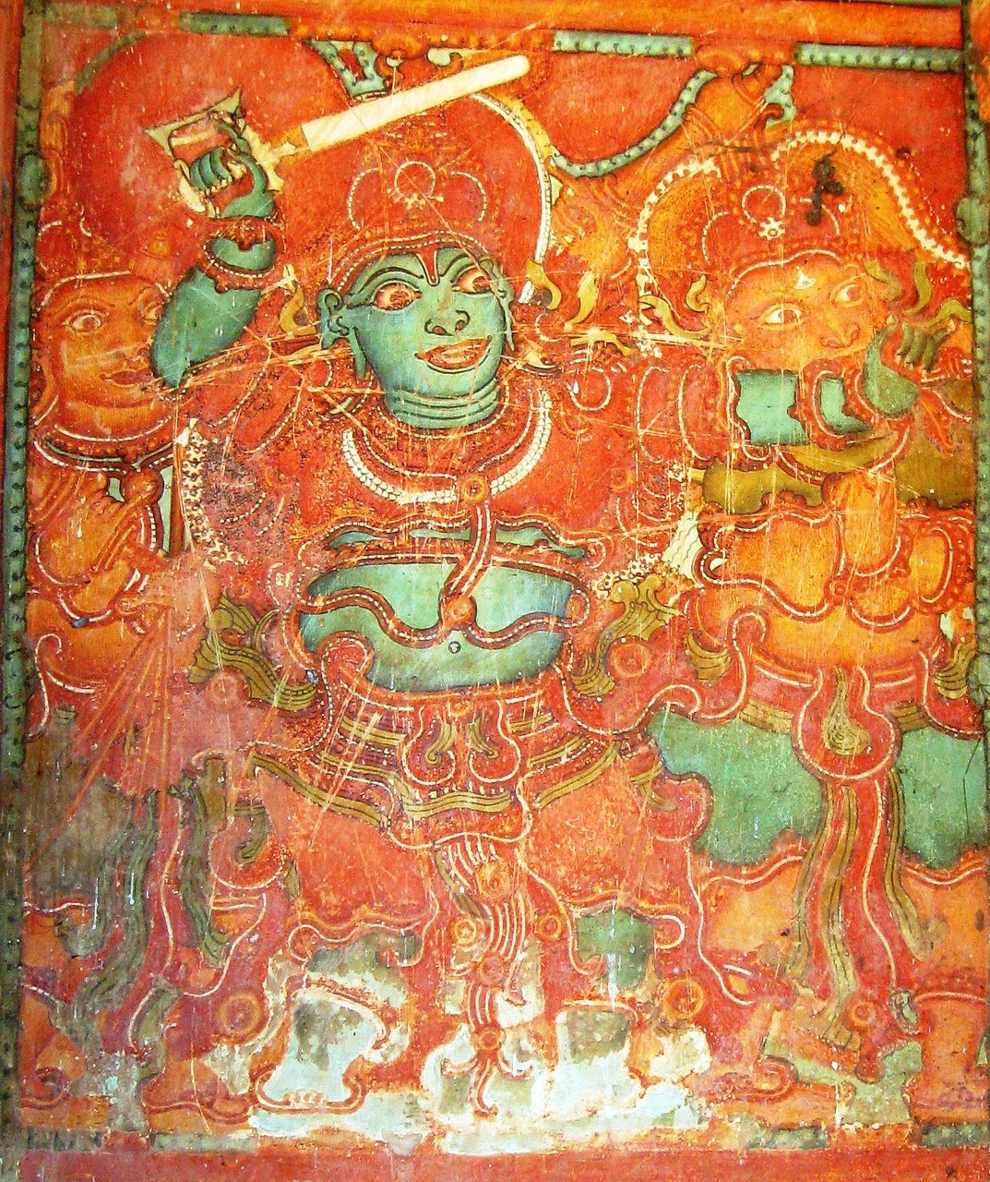

5. Materials, Colours and Techniques
Traditional Kerala mural painting demonstrates an intimate relationship between art and the local environment. Artists historically prepared walls, colours, brushes and binders from materials available in their surroundings — laterite, lime, plant extracts, coconut and neem. Natural pigments remain central in temple restoration today, while contemporary artists working on canvas often use acrylics.

5.1 Colour: The Panchavarna
The traditional palette is the panchavarna, or five colours: red, yellow, green, black and white. Red and yellow ochres come from laterite; white from lime (often the white of the wall itself); black from the soot of oil lamps; and green from the leaf extract of neelamari (indigo) mixed with the yellow resin of eravikkara (Garcinia morella). Pigments were ground on stone and mixed in wooden vessels, with tender-coconut water and neem extract as binders. Exact recipes varied, and a 2026 restoration at a temple in Thrissur still used coloured stones, indigo leaves, lime and lamp soot. The important point is that colour was not simply purchased as a finished product; material knowledge itself formed part of the artistic process.
Colour in Kerala murals is rarely neutral. Warm reds and yellows dominate, set against deep greens and crisp black outlines. Blue is rare in temple murals but prominent in church murals, where lapis lazuli was used. Scientific study has also found copper-based and earth greens in some older murals, showing that historical recipes differed. Contemporary artists have expanded the palette through synthetic pigments and acrylics.

5.2 Wall, Line and Drawing
The wall is prepared in stages: a coat of lime and clean sand in a 1:2 ratio, a second coat of lime and sand mixed with cotton for a smooth white finish, and then many washes of lime and tender-coconut water. The painting is executed on the dry plaster with an organic binder, a method usually described as fresco-secco or tempera, although the word “fresco” is often used loosely. Brushes were traditionally made from eyyampullu grass, screw-pine roots and squirrel or calf-ear hair. Line is fundamental: confident outlines define figures, while fine stippling and graded colour create volume.

5.3 Stages of Work and Stylistic Traditions
- Lekhya karma — the first light sketch in yellow ochre.
- Rekha karma — the outline redrawn in red ochre.
- Varna karma — filling in colours, from light to dark.
- Vartana karma — shading and modelling through fine stippling.
- Lekha karma — the final black outline that defines each form.
- Dvika karma and nethronmeelanam — finishing details, ending with the ritual opening of the eyes.
Historians also divide the tradition into phases — early line-based work, a mature classical phase from about the fifteenth century, and later, flatter and more ornamental work — and note regional variants: round-faced, heavily built figures at Mattancherry, long-faced women at Padmanabhapuram, and church murals with robed figures and a blue-rich palette. These categories are useful for study but should not be treated as rigid compartments. Contemporary artists often combine inherited conventions, experiment with materials and introduce subjects belonging to present-day life.

5.4 Why Technique Matters
Technique is not simply a method of producing an attractive surface. It carries memory. When a student learns to grind laterite into colour, to draw a deity according to its dhyana sloka or to model a face with stippling, they receive more than a skill: they inherit a way of organising sacred and visual information.
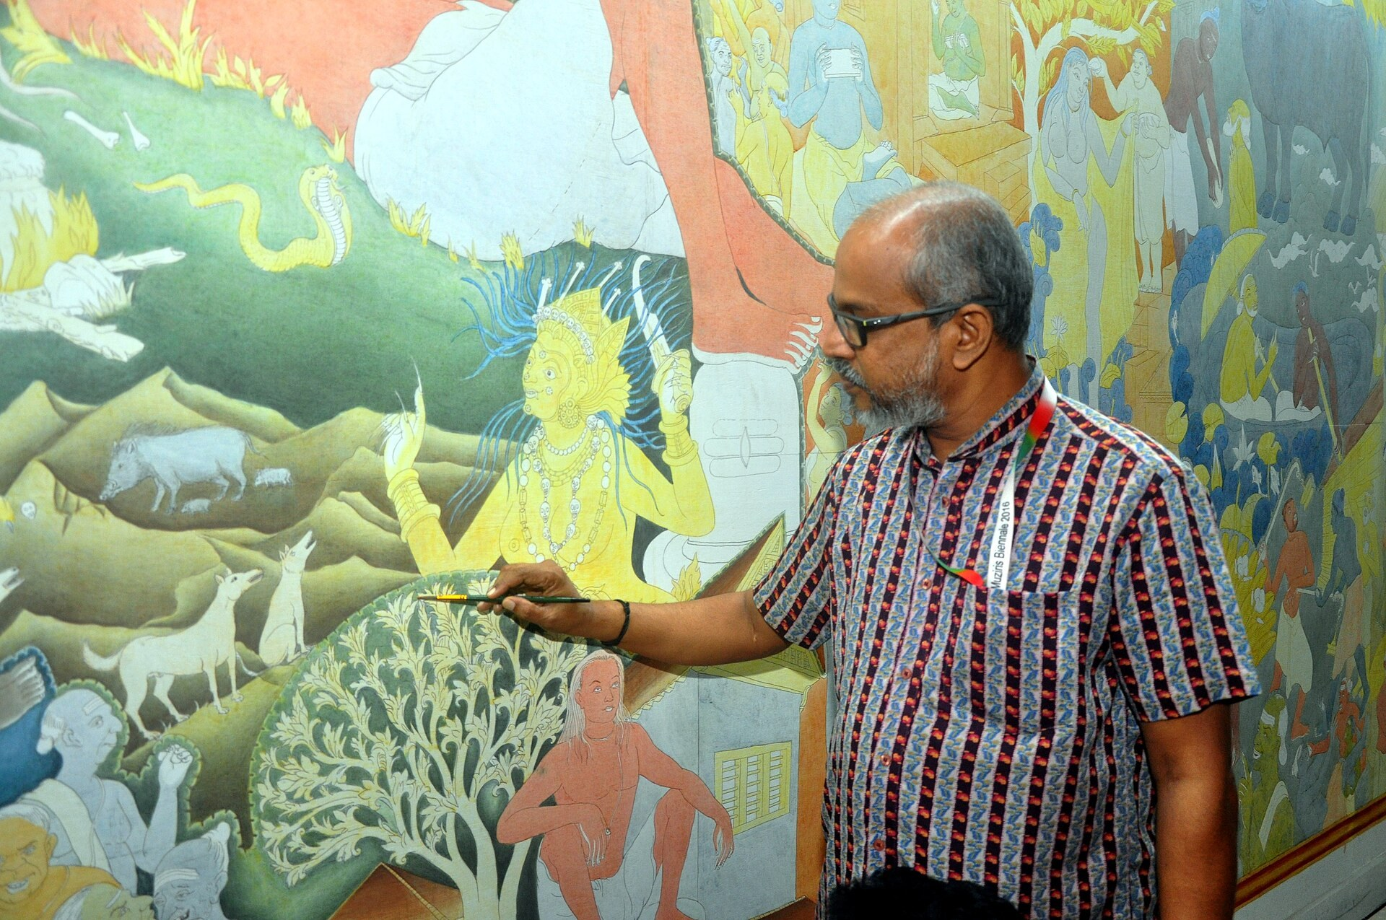

6. Discussion and Analysis: Ananya and Arindam
Our discussion focused on whether Kerala mural painting should be understood mainly as a traditional painting style or as a broader cultural system. We found that the second description captures more of its history.
Ananya: When we started researching Kerala murals, I thought the main task would be to identify the deities — Vishnu, Shiva, Krishna, Ganesha — and famous panels like Gajendra Moksham. But the history made it much more interesting. Even the colours are part of a cultural vocabulary.
Arindam: What surprised me was that many of these paintings were made for worship, not for viewing. A mural on a sanctum wall could be consecrated with an eye-opening ritual, and some are still worshipped every day.
Ananya: That changes the way we define art. If we only think of art as something displayed in museums, we miss the fact that temples and palaces were the first galleries, and the walls told the epics to people who could not read the texts.
Arindam: And the knowledge was carried by lineages of masters. It was learned by assisting a guru, memorising dhyana slokas and following texts like the Silparatna rather than through a modern art school.
Ananya: The Guruvayur fire of 1970 seems equally important. Without it, the revival might never have happened.
Arindam: Exactly. They could barely find painters to restore the sanctum. That led to the Institute of Mural Painting in 1989, and its graduates took murals from walls onto canvas.
Ananya: Which created livelihood opportunities for artists, but also changed the relationship between the artist and the audience.
Arindam: Yes. A temple mural responds to a deity and a ritual. A canvas or a saree may also respond to what buyers want. That can create pressure to repeat popular images like Krishna with the flute or Ganesha.
Ananya: So does commercialisation weaken authenticity?
Arindam: Not necessarily. It can also sustain the practice economically. The important questions are whether artists keep the grammar — proportion, colour and line — and whether they receive recognition and fair value.
Ananya: Contemporary adaptation is especially interesting. Kottayam’s “Mural City” project in 2013 put murals on the railway station, schools and a library, and Kerala murals now hang in airports.
Arindam: That is why I would call Kerala mural painting a living tradition. If it were frozen in one historical form, it might be preserved as an object but not necessarily sustained as a practice.
Ananya: So preservation should not mean telling artists what they are allowed to paint.
Arindam: Right. It should mean protecting the knowledge, symbolism, skills, historic walls and communities that make the tradition possible.
Ananya: There is also an important gender dimension. Temple mural painting was traditionally done by men, but today women such as Kalamandalam Bindhulekha have painted temple murals, and an all-woman team painted a temple in Kozhikode in 2023.
Arindam: But we should not romanticise that either. Access to temple commissions, pricing, digital imitation and middlemen can still affect artists. Cultural recognition does not automatically guarantee economic security.
Ananya: Then perhaps the real challenge is to preserve agency along with heritage.
Arindam: I think that is the key point. A tradition survives most meaningfully when the people who inherit it can decide how it develops.
Ananya: So our resolution should not be ‘preserve Kerala murals exactly as they were.’
Arindam: Yes. It should be about preserving the foundations, and the old walls themselves, while allowing responsible evolution.
“A living tradition remembers its grammar, but it is not forbidden from writing new sentences.”

7. Contemporary Relevance and Social Significance
Kerala mural painting has moved into a contemporary ecosystem of exhibitions, museums, hotels, airports, handicrafts, textiles, public murals, home décor, design and digital marketplaces. Its strong lines and rich palette make it adaptable to new surfaces and audiences. In 2013 Kottayam was declared a “mural city” after a Kerala Lalithakala Akademi camp in which hundreds of artists painted public walls, including the railway station, schools, temples, churches and a library. A mural by P.K. Sadanandan from the Kochi-Muziris Biennale now hangs at Cochin International Airport, and Suresh Muthukulam led a large Kerala-style mural at Mumbai airport’s Terminal 2.
The tradition also matters because it carries regional identity. In a rapidly changing economy, cultural forms can provide communities with a visible connection to place. Kerala murals have become one of the recognisable visual symbols of the state — in tourism, on the set mundu and sarees worn at festivals, and in Malayali homes across the world — while remaining rooted in a specific temple and palace geography.

7.1 Kerala Murals as a Living Archive
A painting can preserve more than an image. It can preserve relationships between humans and the divine, ritual practices, epic stories, royal history, costume, ornament and aesthetic preferences. In this sense, Kerala murals operate like a visual archive; a church mural at Kanjoor even records a war scene from the Mysore wars of 1790.
Its motifs can be read as fragments of a larger cultural memory. The shared vocabulary with Kathakali, Koodiyattam and kalamezhuthu, the dense flora and fauna, and the presence of Hindu and Christian murals in a related visual language reflect a worldview in which the natural, social, theatrical and sacred are closely connected.

7.2 Challenges in Preservation
- Damage to historic murals from lamp soot and oil, climate, leaks, touching by devotees, graffiti, and careless renovation with enamel paint, varnish or whitewash.
- Loss of traditional knowledge when younger generations have limited time or economic incentive to undergo long gurukula training.
- Digital prints and mass-produced imitations that reproduce appearance without transmitting iconographic knowledge.
- Unequal access to markets, exhibitions, temple commissions and fair compensation.
- Replacement of natural pigments and grass brushes by acrylics and synthetic brushes, and loss of material knowledge.
- Difficulty balancing restoration, documentation, intellectual property, ritual use and contemporary creativity.
Conservation work is under way. The ASI and the Kerala State Department of Archaeology protect key sites such as Mattancherry, Padmanabhapuram, Krishnapuram and Thodeekalam; the Vadakkunnathan temple received a UNESCO Asia-Pacific Award of Excellence for conservation in 2015; and the sixteenth-century murals of the Ettumanoor Mahadeva temple were restored in 2025–26 by the Travancore Devaswom Board with the Vasthuvidya Gurukulam.

7.3 Geographical Indication
Kerala Mural Painting is not registered as a Geographical Indication in India. Our search of the Intellectual Property India GI registry in November 2026 found no entry for “Kerala mural” or “chuvarchitram” under any status. Kerala does hold many GIs for handicrafts — such as Aranmula Kannadi (one of India’s earliest GIs, certified in 2005), Payyannur Pavithra Ring, Screw Pine Crafts, Maddalam of Palakkad, and Chendamangalam and Kuthampully Dhoties & Set Mundu — and the only mural tradition on the registry is Banaras Mural Painting from Uttar Pradesh.
Interestingly, the set mundu on which mural designs are often painted is GI-protected, while the mural art itself is not. GI recognition would connect the name of the art to its geographical origin and provide a legal framework for protecting its identity. However, legal recognition alone cannot preserve a living tradition. Skills still have to be taught, historic walls still have to be conserved, artists still need sustainable livelihoods, and communities must remain active participants.

8. Group Findings
Our group found that Kerala mural painting is best understood as a meeting point of art, ritual, architecture, theatre, ecology, patronage and cultural memory. Its visual identity is immediately recognisable, but its deeper significance lies in the knowledge system behind that identity — texts, proportions, colour symbolism and natural materials.
We also found that the movement from temple wall to canvas should not be described simply as a loss of tradition. It was a historical adaptation, prompted by decline and by the Guruvayur fire, that created new possibilities while producing new tensions. The continuing evolution of Kerala murals demonstrates that preservation and innovation can coexist when the cultural foundations remain visible.

9. Our GD Resolution
“Kerala mural painting should be preserved as a living cultural tradition by protecting its historic murals, traditional knowledge, symbolism and artist communities while allowing responsible contemporary adaptation. Preservation should focus not only on conserving old paintings, but on sustaining the people, skills and cultural meanings that enable new generations to create.”
[ FIGURE 5 — CONTEMPORARY KERALA MURAL ARTWORK ]
Caption: Contemporary Kerala mural work in Kottayam’s “Mural City”, demonstrating how inherited visual language can address modern public spaces.
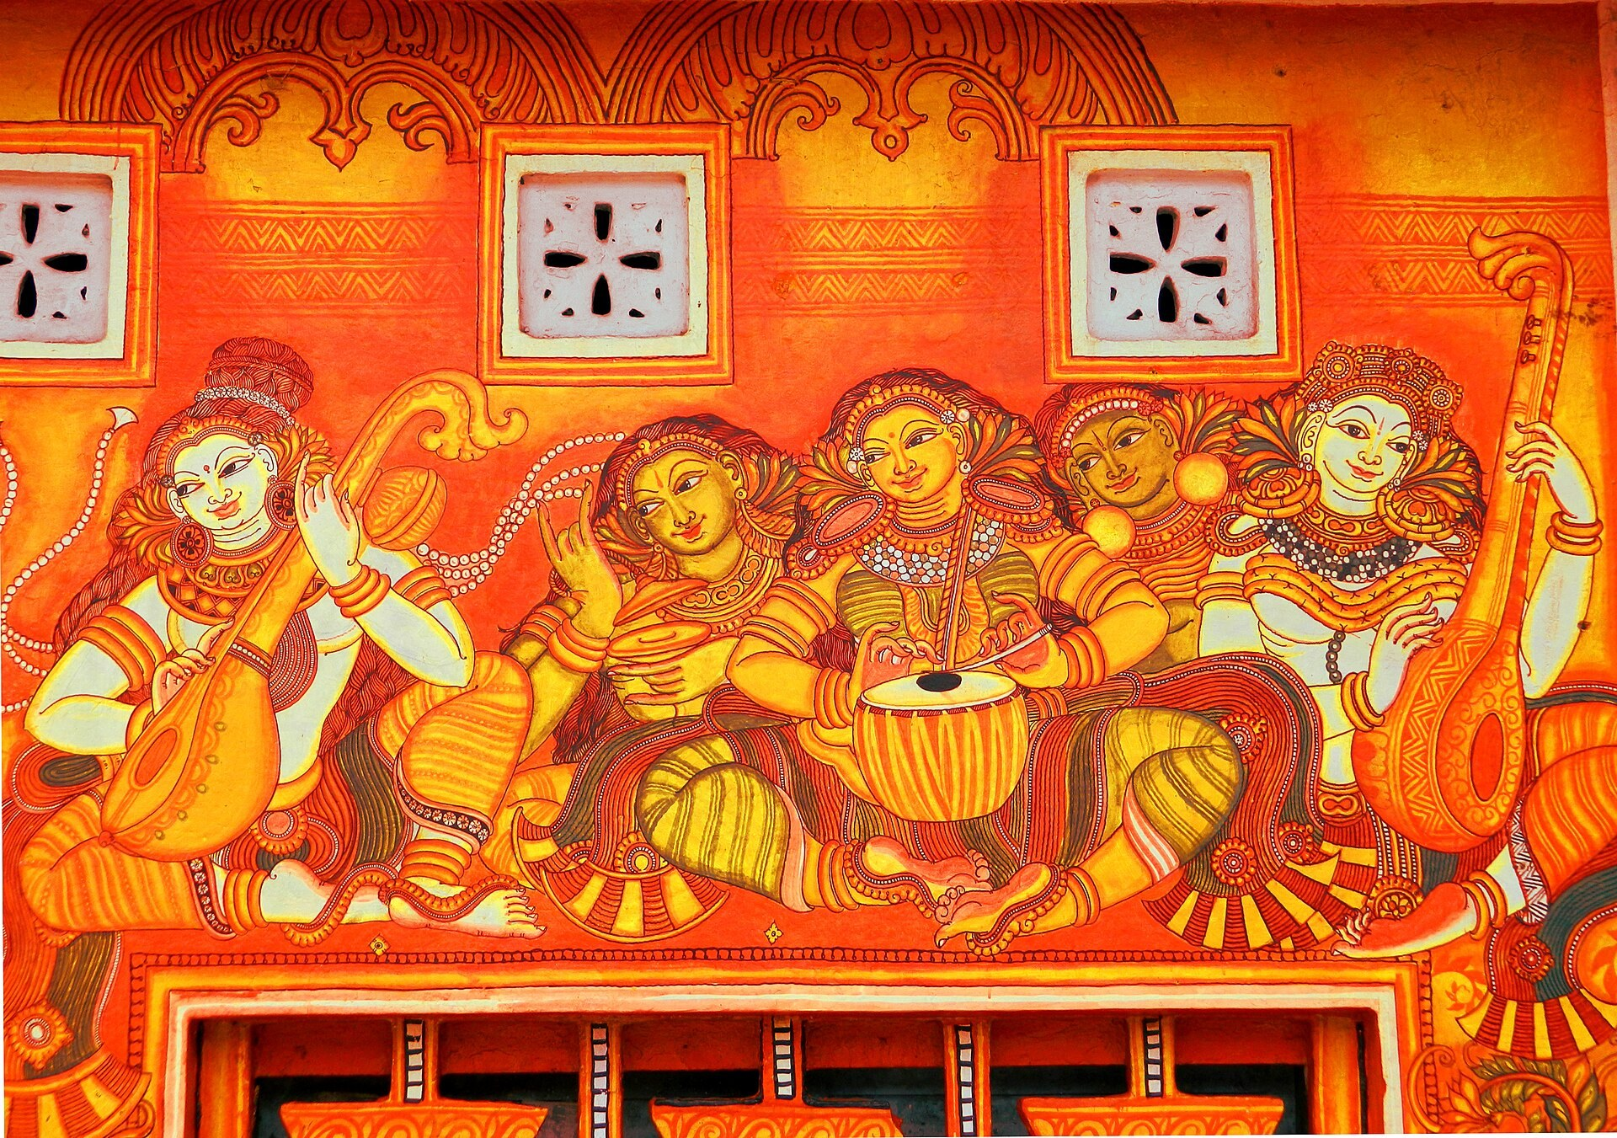

10. Conclusion
Kerala mural painting is often introduced through its glowing colours, ornate crowns and familiar deities. Yet those visible features are only the surface of a much deeper tradition. Its history reveals a relationship between artistic practice and sacred life in which sanctum walls, gateways and palace chambers became sites of worship, storytelling and royal identity.
The tradition also reveals the importance of masters and lineages as cultural transmitters. Knowledge was not preserved through books alone; it travelled through dhyana slokas, canonical texts, apprenticeship, practice and memory. This makes Kerala murals an important example of both tangible and intangible cultural heritage.
Its twentieth-century transformation demonstrates the complexity of cultural survival. The near-disappearance of the art, the Guruvayur fire and the founding of the mural institute led to a revival that expanded the audience, created markets and helped individual artists gain recognition. At the same time, commercialisation introduced new questions about authenticity, ownership, imitation, natural materials and economic fairness.
The contemporary relevance of Kerala murals lies precisely in their ability to negotiate these tensions. They can remain connected to inherited iconography while addressing new spaces. They can exist on a sanctum wall and on a modern canvas, an airport wall or a saree. They can be both a cultural inheritance and a field for individual creativity.
“The future of Kerala mural painting is not secured by keeping the painting unchanged; it is secured by keeping the knowledge alive.”
For our group, the most important lesson is that heritage is not merely something inherited from the past. It is something communities continually reinterpret. Kerala mural painting survives not because its images remain frozen, but because artists continue to find reasons to paint them.

11. Key Takeaways
- Kerala mural painting (chuvarchitram) is rooted in the temples, palaces and churches of Kerala and the former Travancore region.
- Most surviving murals date from the fifteenth to the nineteenth centuries, with ninth-century traces at Thirunandikkara.
- Traditional practice was tied to temple ritual and royal patronage, and passed on through guru–shishya lineages and texts such as the Silparatna.
- The art uses mythology, epic narrative, guna-based colour symbolism and dense natural imagery as a visual vocabulary.
- The panchavarna palette of natural pigments, lime-plastered walls and a staged drawing process form the core of its technique.
- The Guruvayur fire of 1970 and the Institute of Mural Painting (1989) sparked a revival and a move from walls to portable surfaces.
- Modern artists have expanded its media, audiences and public presence while retaining recognisable visual conventions.
- Kerala Mural Painting is not a registered GI; long-term preservation depends on conservation, artists, knowledge transmission, fair economic opportunities and cultural respect.

12. References
- Kerala Tourism, Government of Kerala: articles on the mural paintings of Kerala, the mural heritage of Kerala, Krishnapuram Palace and church mural paintings.
- Archaeological Survey of India: M. Nambirajan and S. Suresh, Kerala Murals (ASI, 2015).
- A. Ramachandran, Painted Abode of Gods: Mural Traditions of Kerala (2005).
- M.G. Sasibhooshan, Keralathile Chuvarchitrangal (Kerala Bhasha Institute, 1994) and Murals of Kerala.
- Stella Kramrisch, J.H. Cousins and R. Vasudeva Poduval, The Arts and Crafts of Travancore (1948).
- Intellectual Property India, Geographical Indications Registry, public search (accessed November 2026).
- Institute of Mural Painting, Guruvayur Devaswom; Kerala State Department of Archaeology.
- P.V. Mini, study of the traditional pigments of Kerala murals, Indian Journal of Traditional Knowledge, Vol. 9(4), 2010.
- Sahapedia, “Mural Paintings in the Churches of Kerala”; Hinduism Today features on Kerala’s mural treasures and muralists; Onmanorama reports on Kerala murals and their restoration (2018–2026).
- Image credits (Wikimedia Commons): Gajendra Moksham mural, Krishnapuram Palace — Essarpee1, CC BY-SA 3.0; Map of historic heritage sites of Kerala — Ms Sarah Welch, CC BY-SA 4.0 (map data © OpenStreetMap contributors); Vaikom temple sreekovil murals — Sivavkm, CC BY-SA 3.0.
- Image credits (Wikimedia Commons): Sree Krishna mural painting — Sujith Nair Pattoor, CC BY-SA 4.0; Thodeekalam Siva temple mural — Vijayakumarblathur, CC BY-SA 4.0; P.K. Sadanandan painting at the Kochi-Muziris Biennale 2016 — Fotokannan, CC BY-SA 4.0; Kottayam Mural City — Akhilan, CC BY-SA 2.5 India.

