16.90: Project 1 Report

15 March 2017

Lenny Martinez

**Part 1**

Using MATLAB’s ode45 function, figures 1 and 2 were generated.

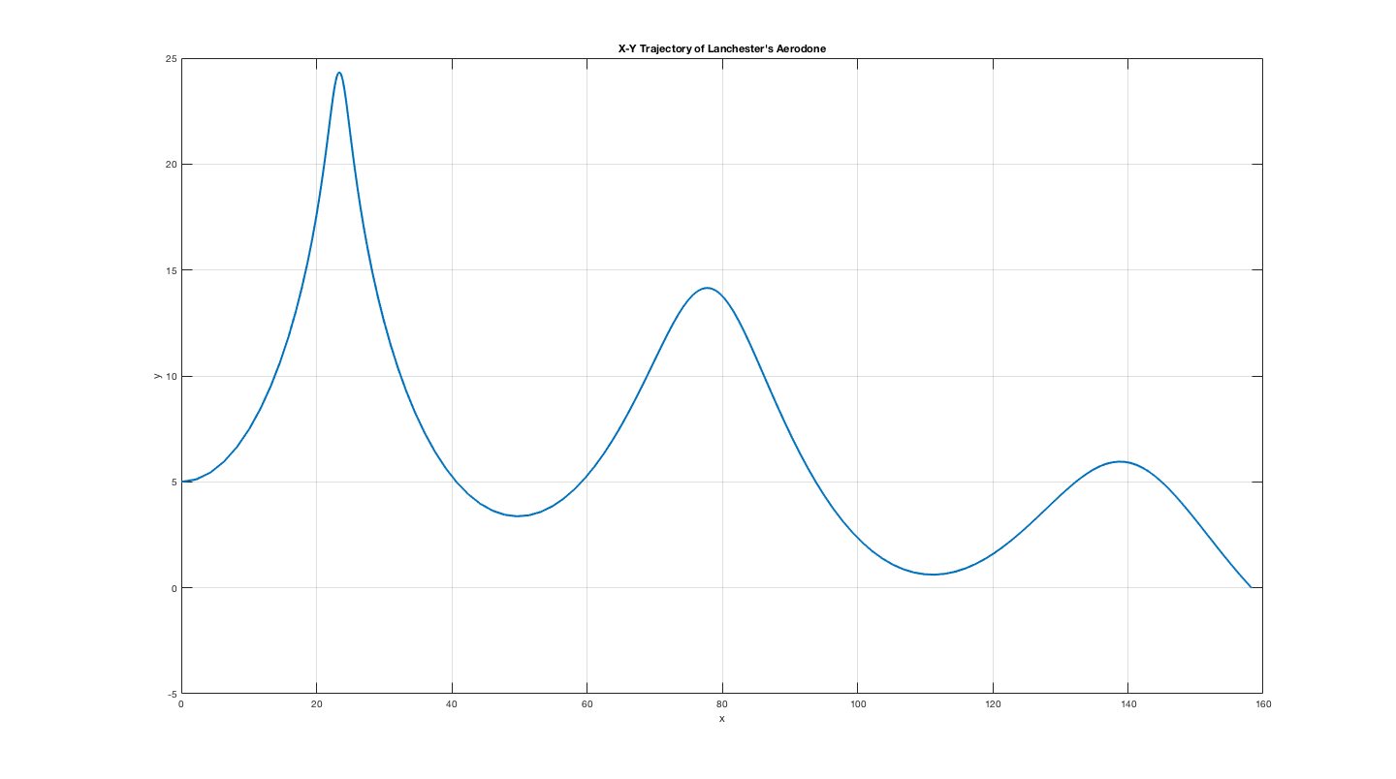

**Figure 1**. x-y trajectory of glider using Lanchester’s initial conditions and ode45 function.

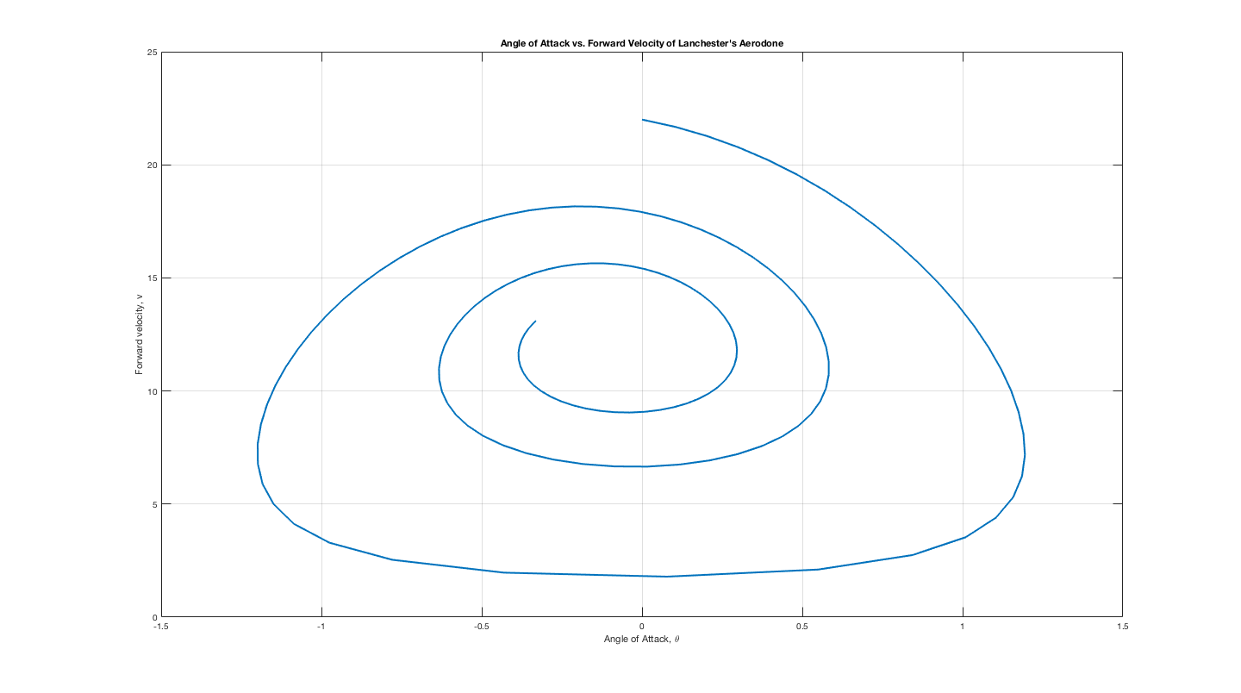

**Figure 2.** Angle of Attack vs. velocity plot for glider using Lanchester’s initial conditions and ode45 function.

**Part 2**

When creating the Forward Euler approximation of the system, I initially used a time step of Δt = 0.1 which I had used for the reference solution, but this was not stable and created a trajectory that resembled part of the reference solution, and an Angle of attack vs. velocity plot that was too erratic (Figures 3, 4).

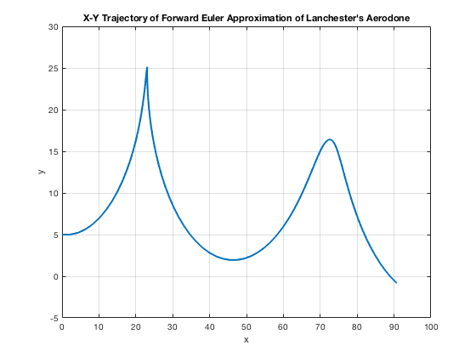

**Figure 3.** x-y trajectory of glider using Lanchester’s initial conditions, and a Forward Euler approximation with Δt = 0.1.

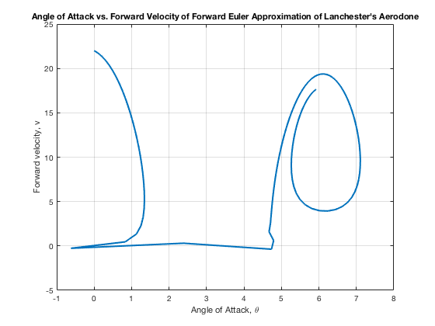

**Figure 4.** Angle of Attack vs. velocity plot for glider using Lanchester’s initial conditions, and a Forward Euler approximation with Δt = 0.1. The time discretization is too coarse which lead to a seemingly chaotic evolution of angle of attack and velocity.

After this, I used Δt = 0.01 to test and found things to be working well. The trajectory compared to the reference solution’s trajectory is very similar as is the angle of attack vs. velocity plot for the Forward Euler approximation.

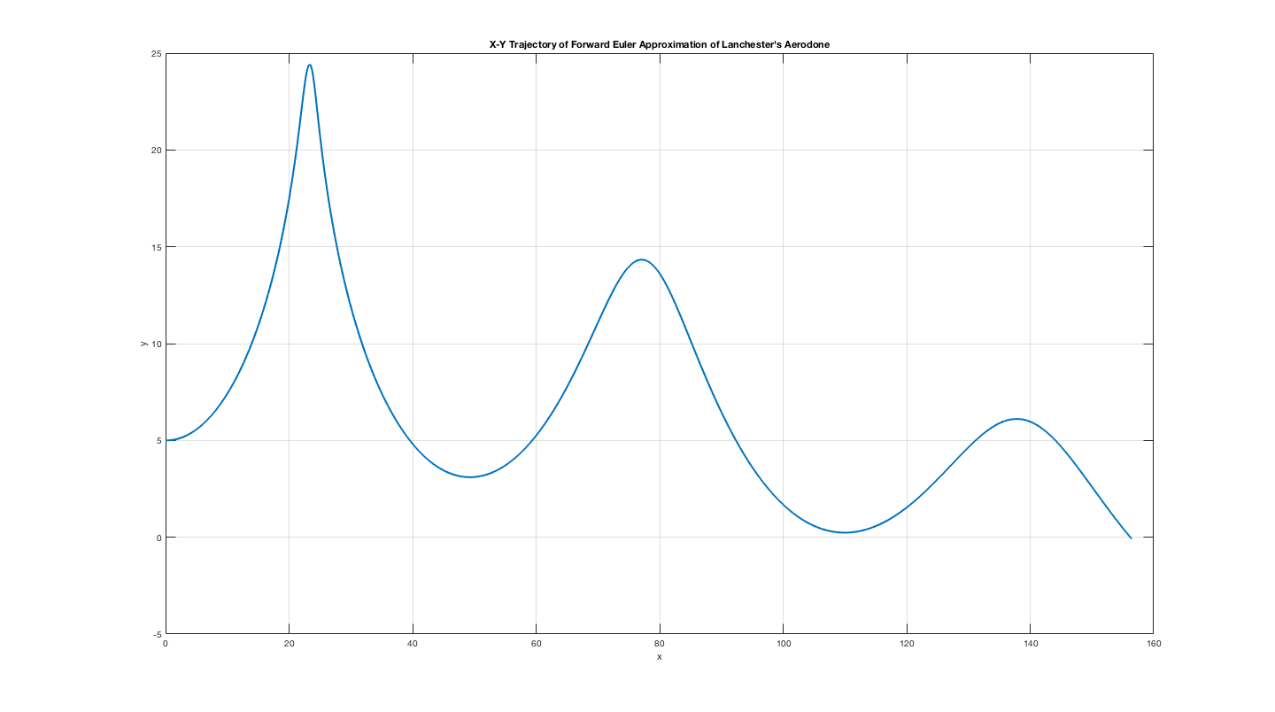

**Figure 5.** x-y trajectory of glider using Lanchester’s initial conditions, and a Forward Euler approximation with Δt = 0.01.

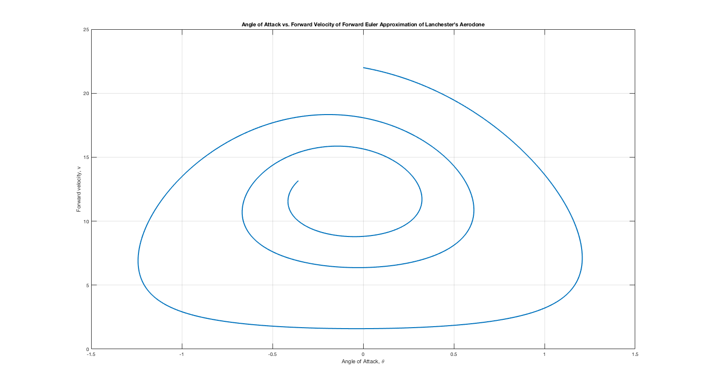

**Figure 6.** Angle of Attack vs. velocity plot for glider using Lanchester’s initial conditions, and a Forward Euler approximation with Δt = 0.01.

For implementing the 4-Stage Runge-Kutta method, I used the scheme given in the lecture notes:

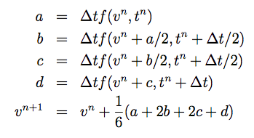

I began with Δt = 0.01 because it worked well with Forward Euler and in the end it was also good enough for the 4-Stage Runge-Kutta method.

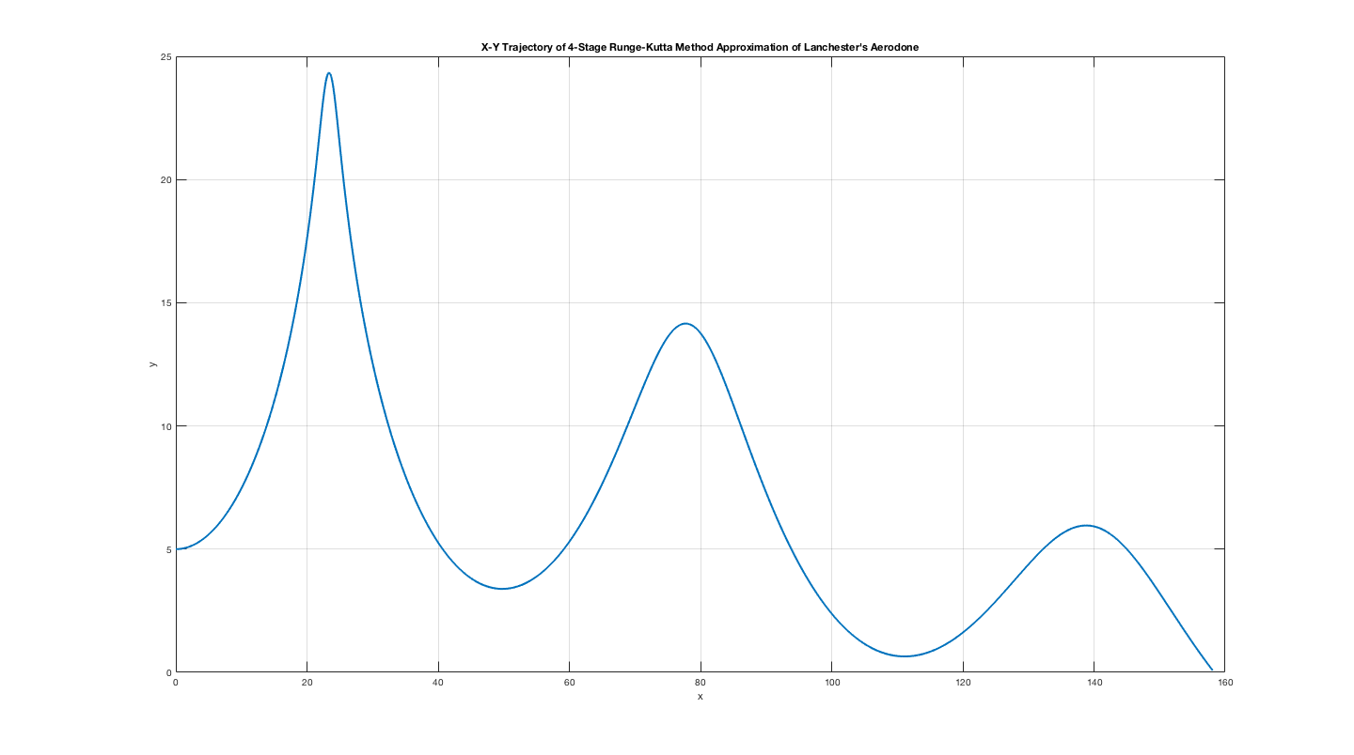

**Figure 7.** x-y trajectory of glider using Lanchester’s initial conditions, and a 4-Stage Runge-Kutta approximation with Δt = 0.01.

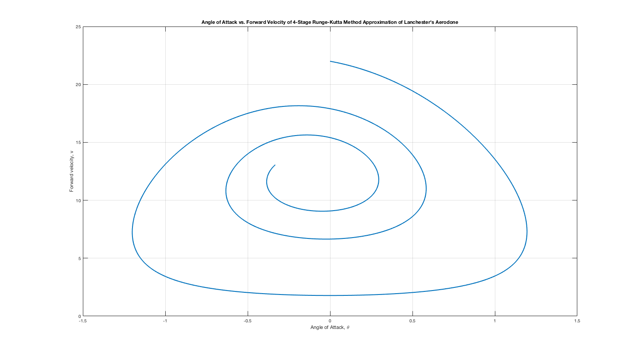

**Figure 8.** Angle of Attack vs. velocity plot for glider using Lanchester’s initial conditions, and a 4-Stage Runge-Kutta approximation with Δt = 0.01.

The implementation of the 4-Stage Runge-Kutta with a Δt = 0.01 was also pretty similar to the reference solution. After plotting each approximation individually, I compiled the plots into one, to better compare the reference solution against both the Forward Euler and 4-Stage Runge-Kutta approximations. As we can see in Figures 9 and 10, the approximations are almost exactly the same as the 2 approximation methods used.

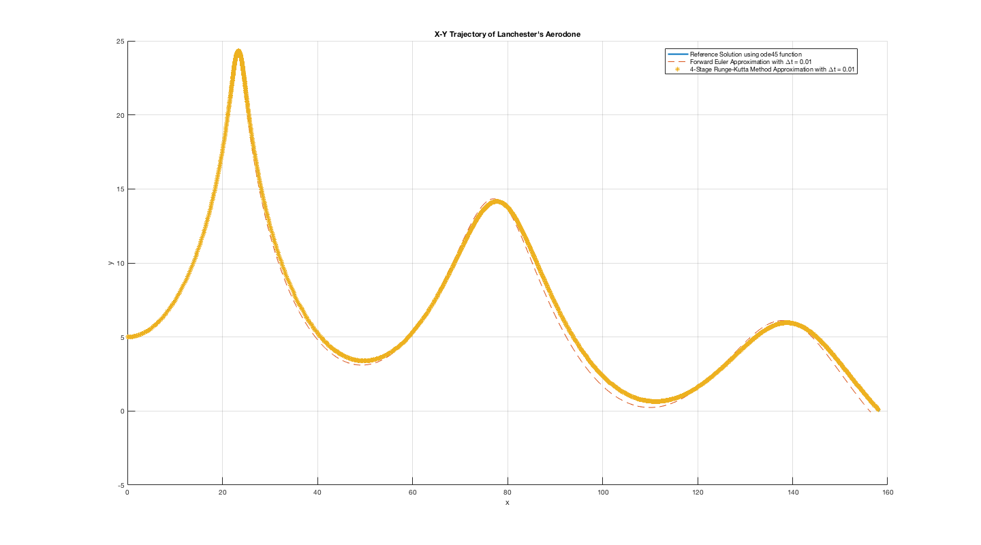

**Figure 9.** x-y trajectories for glider using Lanchester’s initial conditions, and showing both the reference solutions and the two numerical approximations. The 4-Stage Runge-Kutta approximation matches the reference solution perfectly as noted by the fact that we can’t see the blue line of the reference solution. The Forward Euler approximation is a bit off, but still very close.

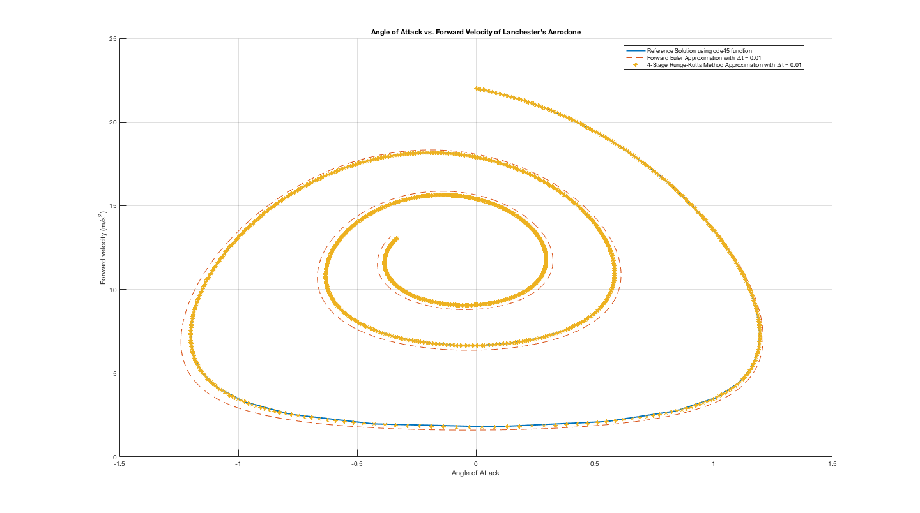

**Figure 10.** Angle of Attack vs. velocity plot for glider using Lanchester’s initial conditions, and showing both the reference solutions and the two numerical approximations. Both numerical approximations match the reference solution closely for late and early values of angle of attack and velocity.

**Part 3**

After plotting Global error vs. Time step size for Forward Euler and 4-Stage Runge-Kutta approximations, I found the slopes using the first and last points. For Forward Euler approximation, the slope was 1.0402 which is on point with the order of accuracy of the method, p =1. For 4-Stage Runge-Kutta approximation, the slope was 3.9358 which is on point with the order of accuracy of the method, p = 4. Slight over and under calculations for both cases are due to computational limitations.

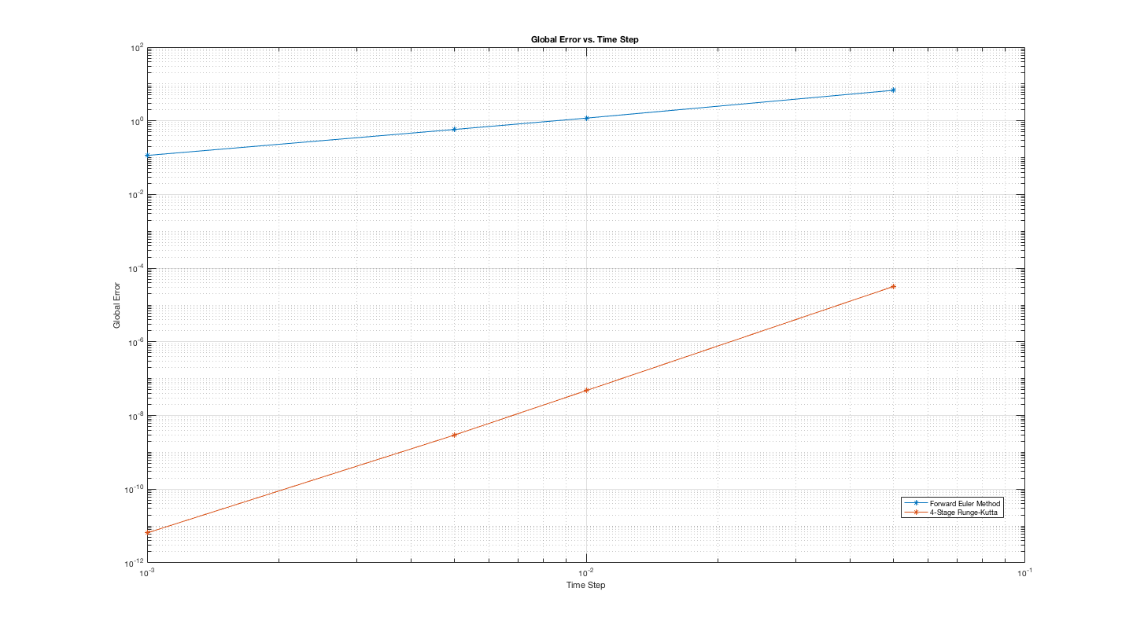

**Figure 11.** Plot of global error vs. time step at t=10 for both Forward Euler and 4-Stage Runge-Kutta approximations. The order of accuracy for the systems are p=1, and p=4 respectively.

**Part 4**

**Part a.**

Using the initial condition: $v\left(0\right)= 29\frac{m}{s}, θ\left(0\right)= 0, x\left(0\right)= 0m, y\left(0\right)=10m$, we obtained the trajectory in Figure 12. The trajectory is similar to Lanchester’s trajectory but a larger initial velocity, and starting at twice the height, allow the glider to go further in the x-direction, but also create a large increase in maximum height.

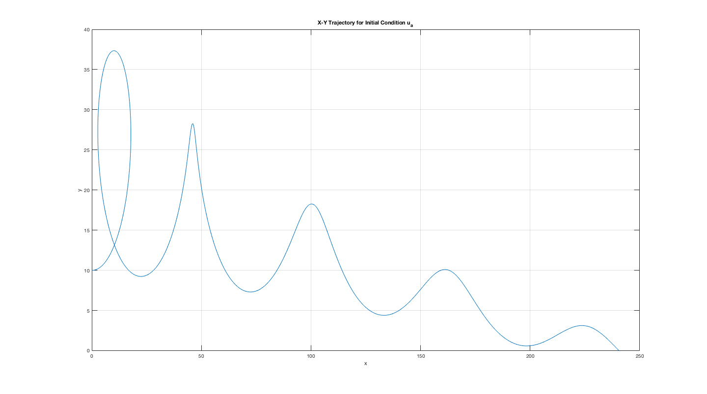

**Figure 12.** x-y trajectory of glider using initial conditions: $v\left(0\right)= 29\frac{m}{s}, θ\left(0\right)= 0, x\left(0\right)= 0m, y\left(0\right)=10m$, and a Forward Euler approximation with Δt = 0.01.

**Part b.**

Using the initial condition: $v\left(0\right)= 23.1\frac{m}{s}, θ\left(0\right)= 0, x\left(0\right)= 0m, y\left(0\right)=10m$, we obtained the trajectory in Figure 13. Even though Initial velocity is very close to that of Lanchester’s experiment, the glider starts at a higher location, and the trajectory reflects this change with a larger x-displacement and an earlier max height than Lanchester’s experiments.

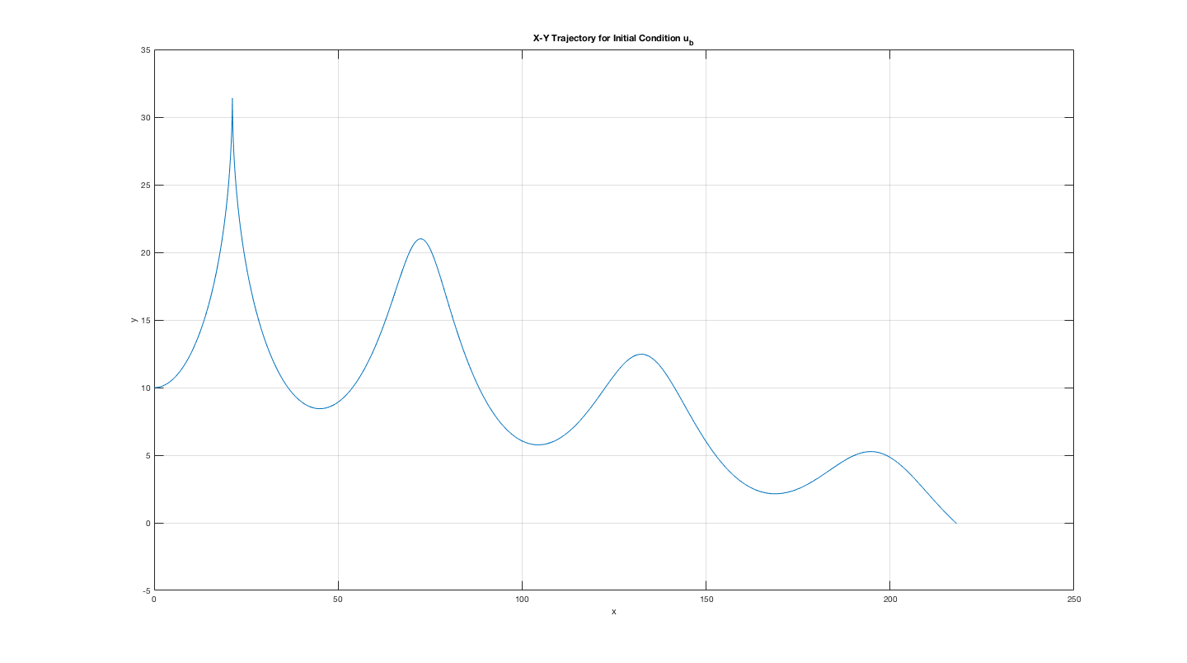

**Figure 13.** x-y trajectory of glider using initial conditions: $v\left(0\right)= 23.1\frac{m}{s}, θ\left(0\right)= 0, x\left(0\right)= 0m, y\left(0\right)=10m$, and a Forward Euler approximation with Δt = 0.01.

**Part c.**

Using the initial condition: $v\left(0\right)= 12.0223\frac{m}{s}, θ\left(0\right)= -0.0831, x\left(0\right)= 0m, y\left(0\right)=10m$, we obtained the trajectory in Figure 14. Trajectory resembles a projectile shot at the ground.

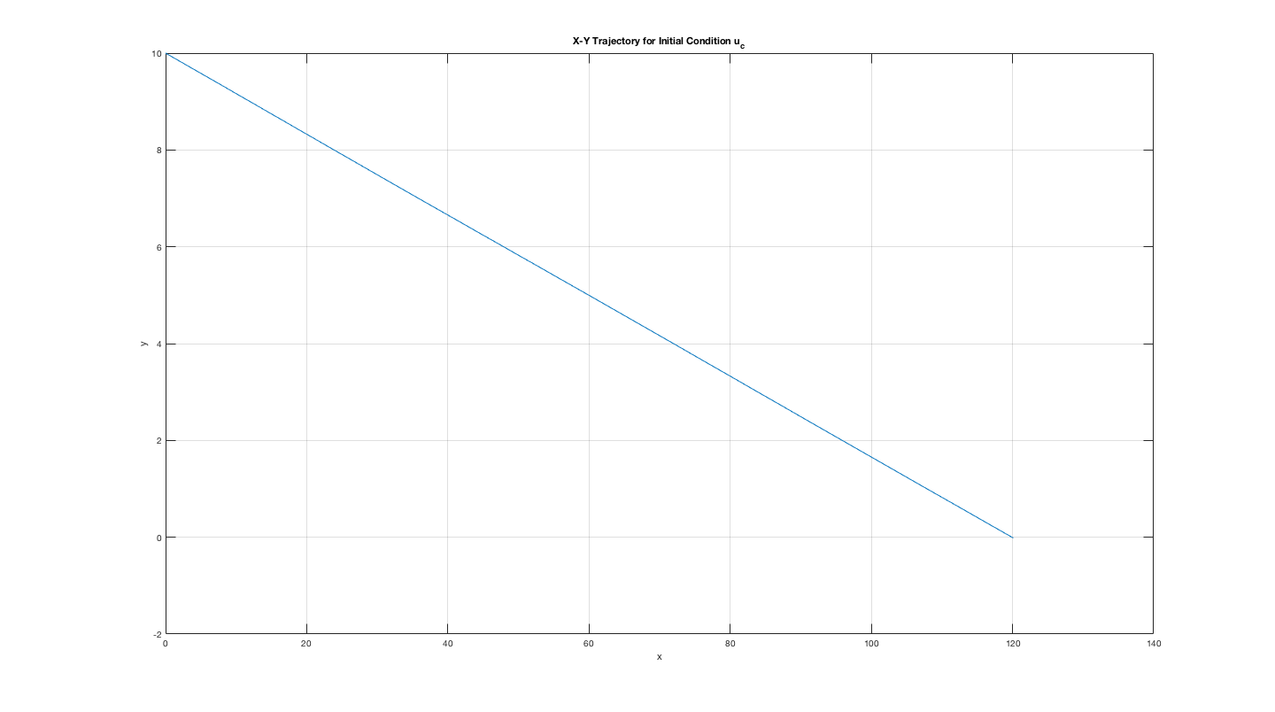

**Figure 14.**  x-y trajectory of glider using initial conditions: $v\left(0\right)= 12.0223\frac{m}{s}, θ\left(0\right)= -0.0831, x\left(0\right)= 0m, y\left(0\right)=10m$, and a Forward Euler approximation with Δt = 0.01.

**Part d.**

Using the initial condition: $v\left(0\right)= 6\frac{m}{s}, θ\left(0\right)= 0, x\left(0\right)= 0m, y\left(0\right)=10m$, we obtained the trajectory in Figure 15. Trajectory resembles a simple projectile similar to a classical mechanics problem. Since initial velocity is smaller and the initial angle of attack than in part c, the glider “gently” goes towards the ground.

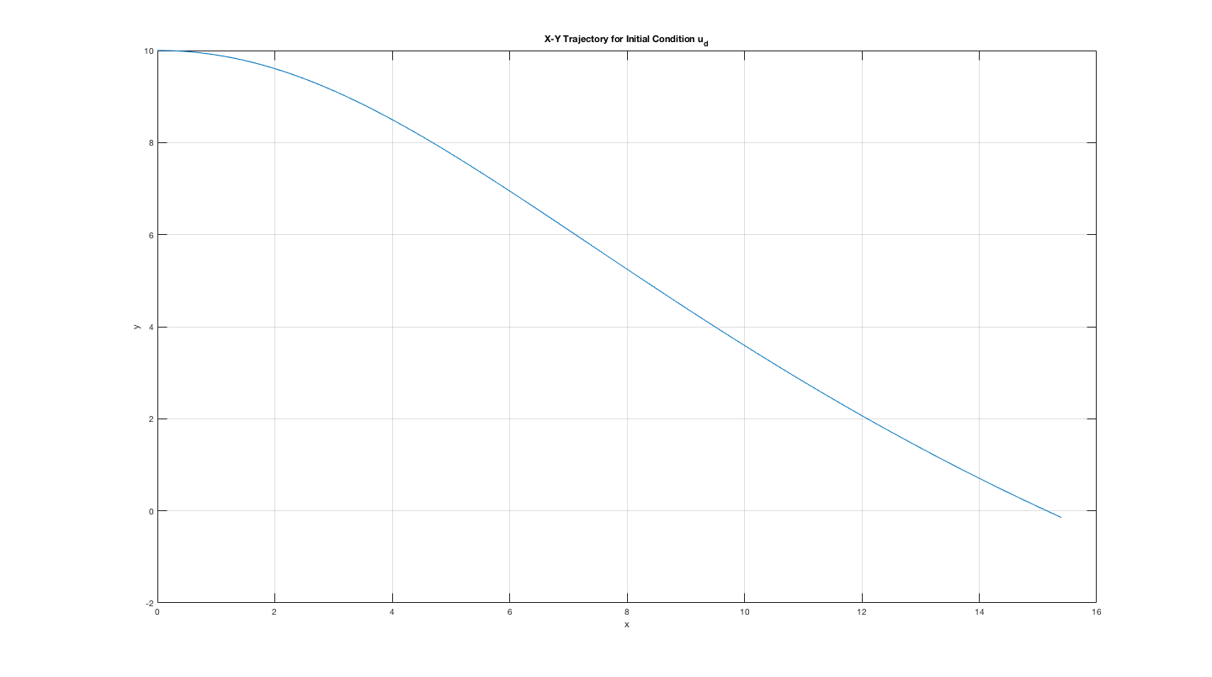

**Figure 15.** x-y trajectory of glider using initial conditions: $v\left(0\right)= 6\frac{m}{s}, θ\left(0\right)= 0, x\left(0\right)= 0m, y\left(0\right)=10m$, and a Forward Euler approximation with Δt = 0.01.

**Part 5**

The quiver plot is given in Figure 16. Also on plot is initial condition: Starting at the conditions $θ\left(0\right)= 0, v\left(0\right)= 0$, solution should stay where it is because there is no motion.

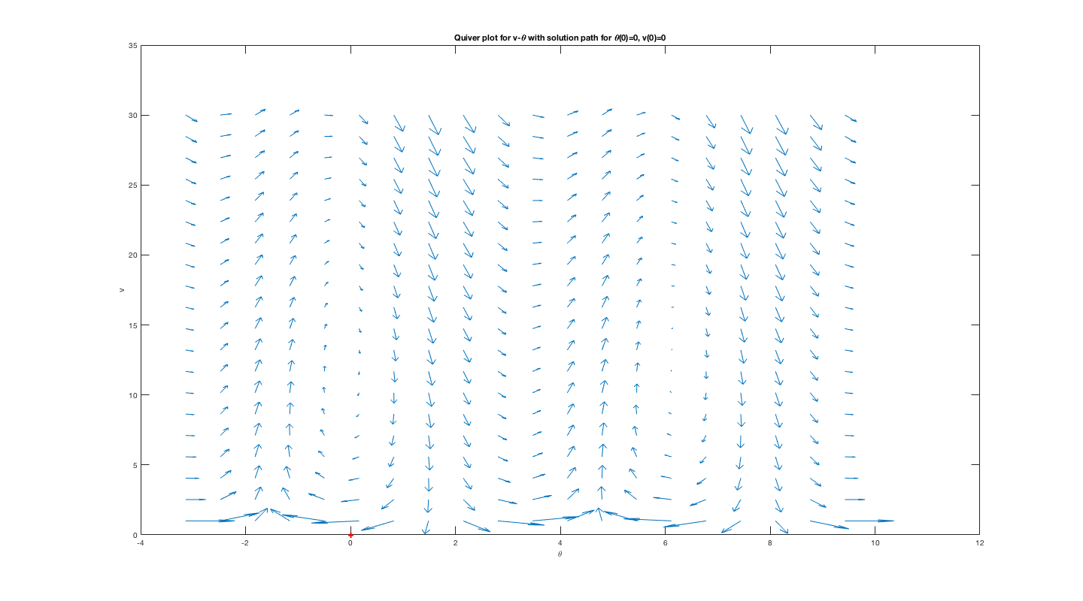

**Figure 16.** Quiver plot of angle of attack and velocity for system. The red dot represents initial condition: $θ\left(0\right)= 0, v\left(0\right)= 0$.

If we look at conditions from part a of part 4, the point should follow the vector arrows to drop and then continue to increase before entering a cyclical pattern, as shown in Figure 17.

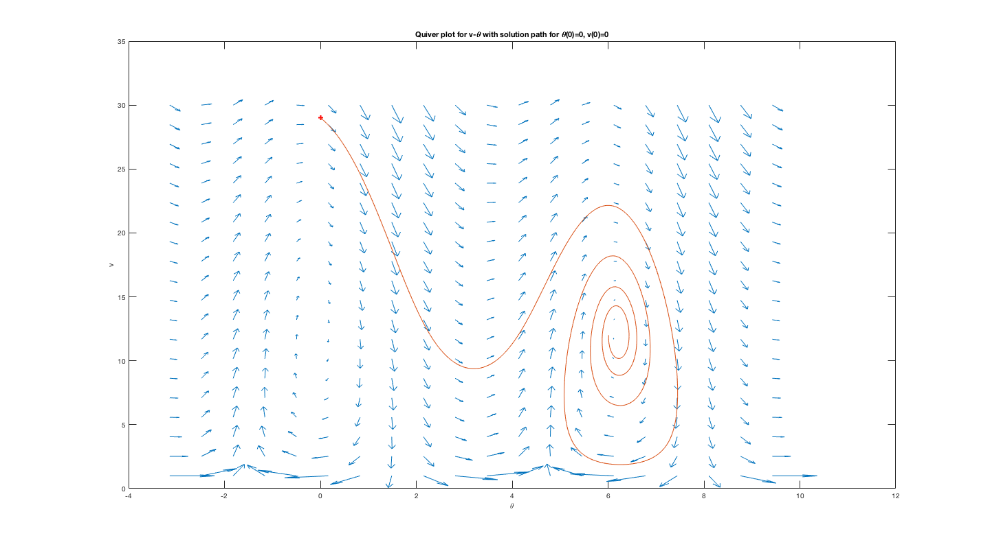

**Figure 17.** Quiver plot of angle of attack and velocity for system. The red dot represents initial condition: $θ\left(0\right)= 0, v\left(0\right)= 29$.

**Part 6**

To find $θ^{*}$ and $v^{*}$, I solved the system:

$$-g⋅\sin\left(θ^{*}\right)-R_{D}⋅{v^{*}}^{2}=0 \\ R_{L}⋅v^{*}-\frac{g⋅\cos\left(θ^{*}\right)}{v^{*}}=0$$

In the end, $θ^{*}=-0.0831$, and $v^{*}=3.8404$. I then linearized the $v-θ$ system around these values:

$$u_{t}=f=\left[\begin{aligned} -g⋅\sin\left(θ\right)-R_{D}⋅v^{2} \\ R_{L}⋅v-\frac{g⋅\cos\left(θ\right)}{v}\end{aligned}\right]$$

$$u_{t,lin}=f\left(θ^{*}, v^{*}\right)+{\left[\begin{aligned} -g⋅cos⁡(θ) \\ \frac{g⋅\sin\left(θ\right)}{v}\end{aligned}\right]}_{θ^{*}, v^{*}}⋅θ+ {\left[\begin{aligned} -2⋅R_{D}⋅v \\ R_{L}-\frac{g⋅\cos\left(θ\right)}{v^{2}}\end{aligned}\right]}_{θ^{*}, v^{*}}⋅v$$

The point ${(θ}^{*}, v^{*})$ is a source as shown on the quiver plot in Figure 18.

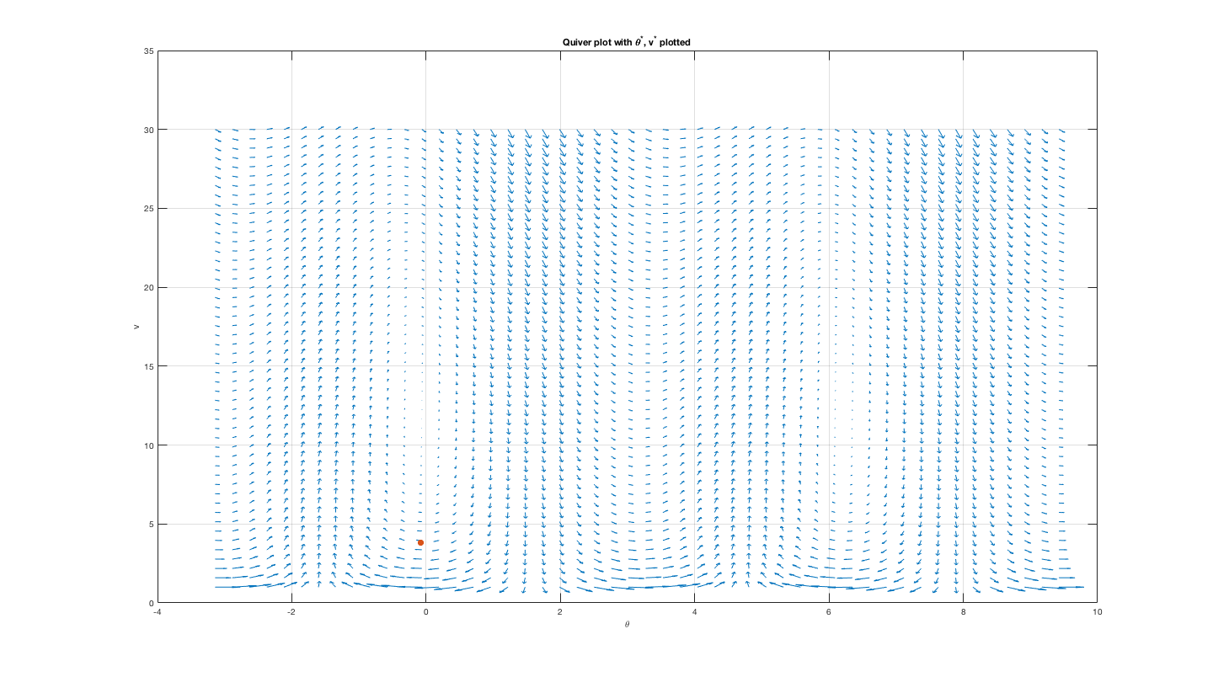

**Figure 18.** Quiver plot of angle of attack and velocity for system. The red dot represents initial condition: $θ\left(0\right)= -0.0831, v\left(0\right)= 3.8404$.