# **Part I**

For the analytical solution, the following figure was used:

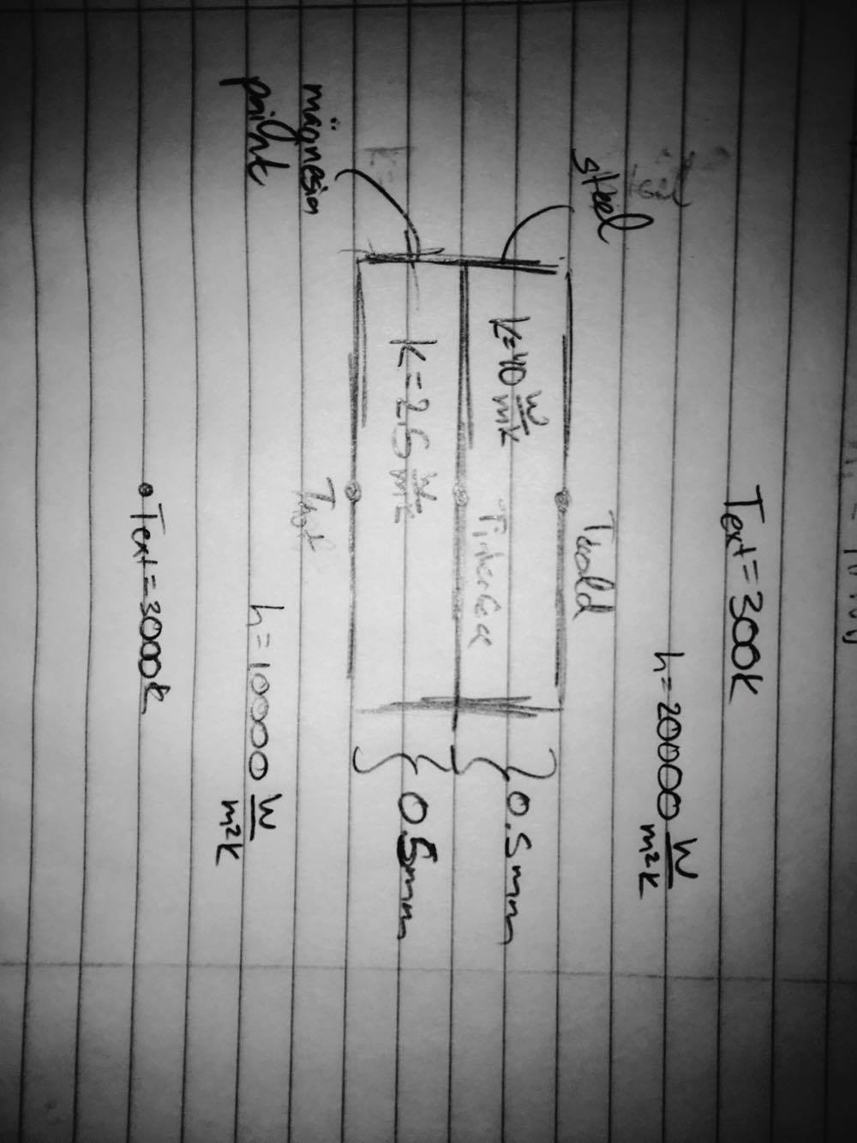

Figure 1. Model used for analytical Solution.

Using convection and conduction relations we got the following system of equations to solve:

$$q=\frac{k_{steel}⋅\left(T_{interface}-T_{cold}\right)}{L} \\ q=\frac{k_{magnesia paint}⋅\left(T_{hot}-T_{interface}\right)}{L} \\ q=h_{cold}⋅\left(T_{cold}-300\right) \\ q=h_{hot}⋅\left(3000-T_{hot}\right)$$

Solving this system of equations, I got:

$$T_{hot}=2255.2 K; T_{interface}=765.5 K; T_{cold}=672.4 K$$

Using the code, the temperatures are:

$$T_{hot}=2255.2 K \\ T_{interface}=765.5 K \\ T_{cold}=672.4 K$$

Which are identical to the analytical solution.

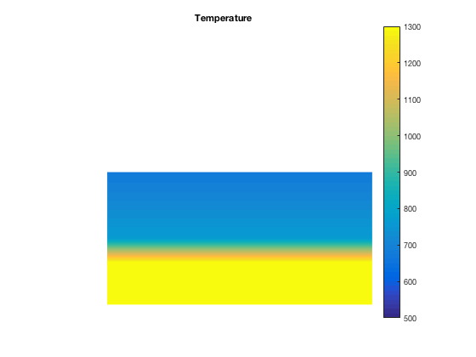

Figure 2. Temperature gradient for TestMesh.

**Part II**

The following figures show stiffness matrices for each NozzleMesh.

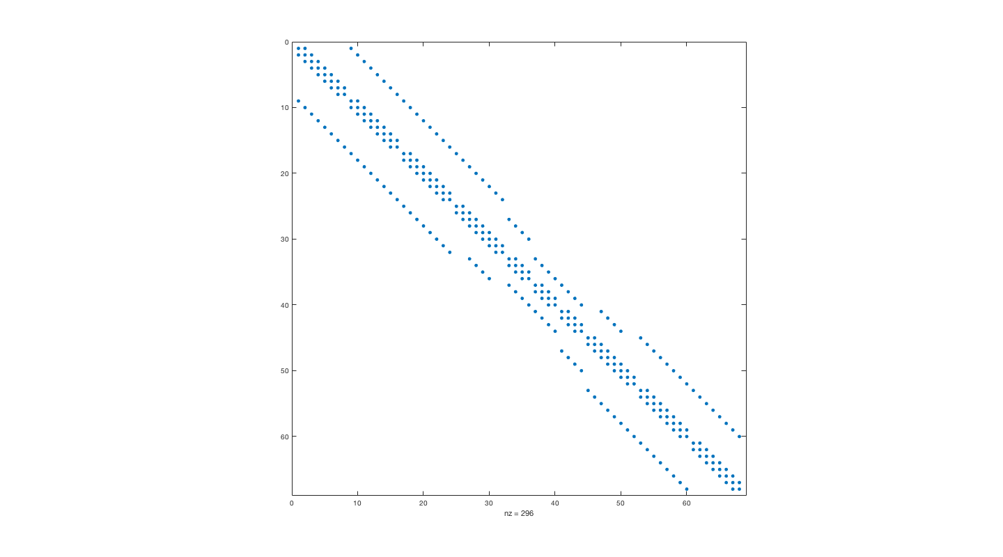

Figure 3. Non-zero entries for stiffness matrix for NozzleMesh1.

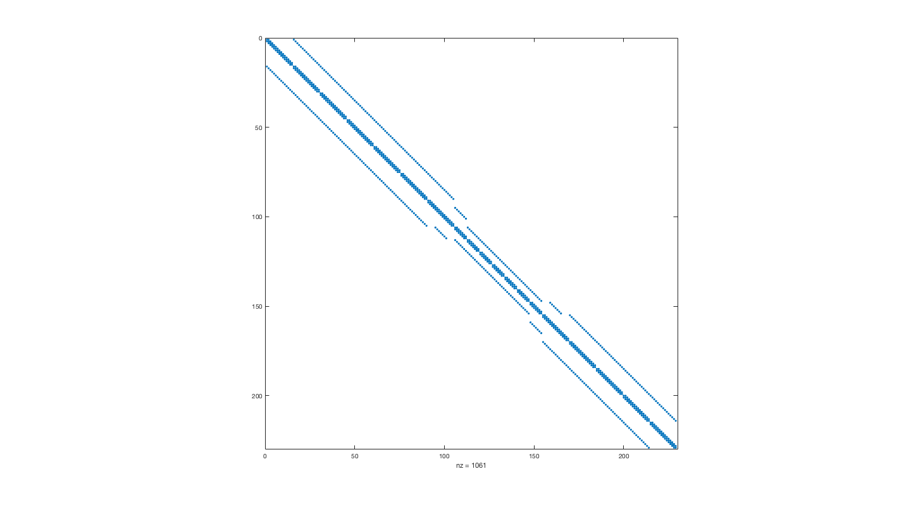

Figure 4. Non-zero entries for stiffness matrix for NozzleMesh2.

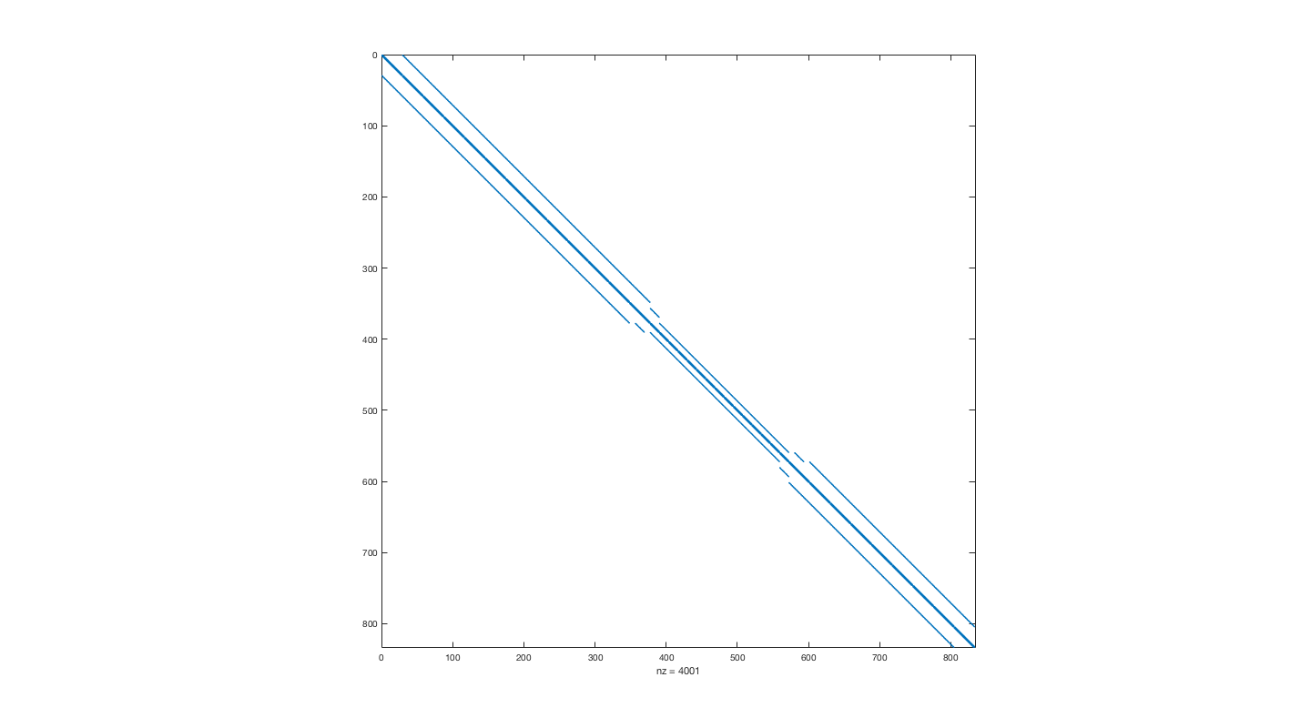

Figure 5. Non-zero entries for stiffness matrix for NozzleMesh3.

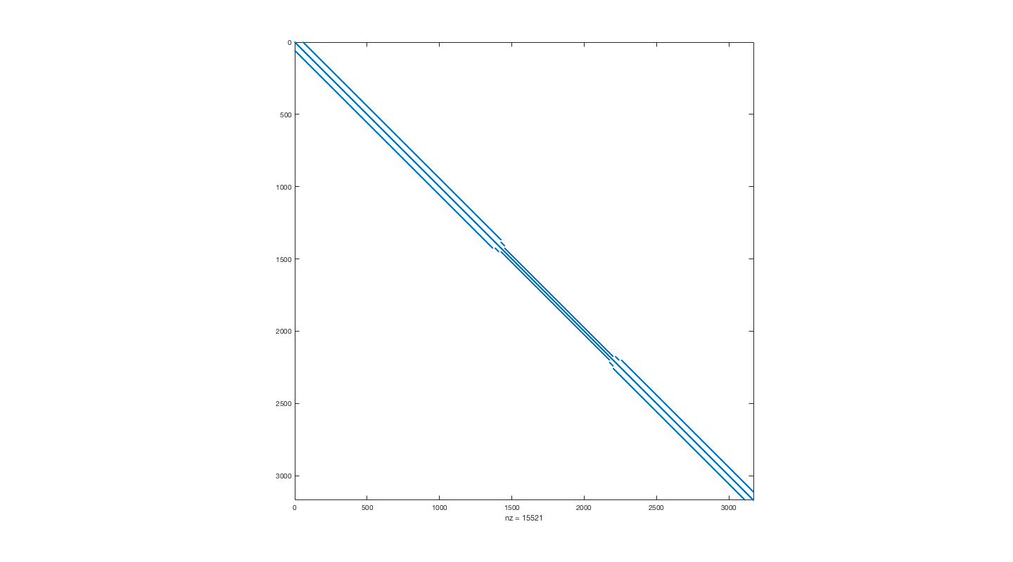

Figure 6. Non-zero entries for stiffness matrix for NozzleMesh4.

The number of nonzero elements per row is controlled by the location of each node. Nodes on the edges contribute to less rows.

Along the hot wall of NozzleMesh4, we have the lowest temperature in the center because there is more material surrounding the node to transfer the heat through so the temperature will be lower. Figure 7, shows the plot of

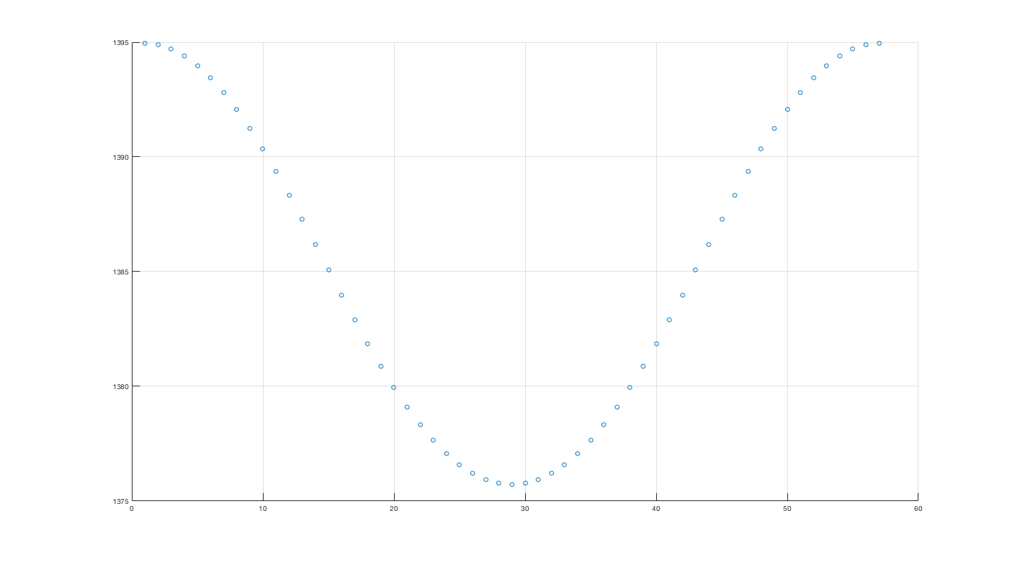

Figure 7. Node vs. Temperature plot for NozzleMesh4 along hot wall.

In Figure 8 we can see the log-log plot of Number of Elements vs. Temperature error for each of the nozzle meshes. The errors for each mesh is listed in the table below.

|  |  |
| --- | --- |
| Nozzle Mesh | Temperature Error |
| 1 | 4.9613 |
| 2 | 2.0029 |
| 3 | 0.6082 |

The convergence rate of this error is ~1.

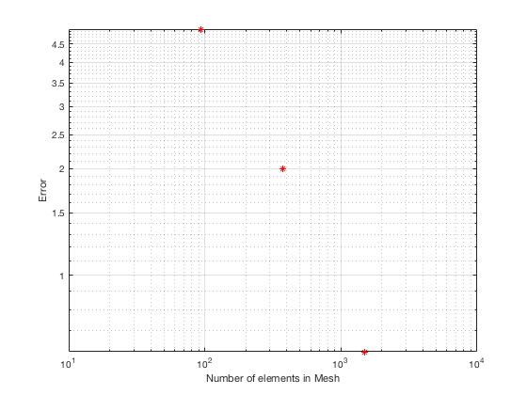

Figure 8. Number of Elements vs. Temperature error for meshes at first node.

Heat flux on cold side and heat flux on hot side are equal because energy is conserved and there is no heat source or sink within the nozzle. For NozzleMesh4,

$$q_{hot}=q_{cold}= 28258.9\frac{W}{m}$$

The convergence rate of heat flux error is also ~1.

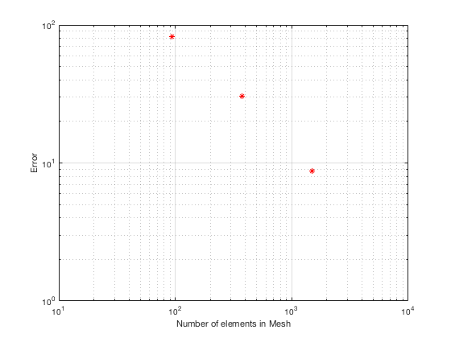

Figure 9. Number of Elements vs. heat flux error for meshes.

# **Part III**

The following three graphs show how max temperature in steel as we vary kmagnesia , hhot , and hcold respectively:

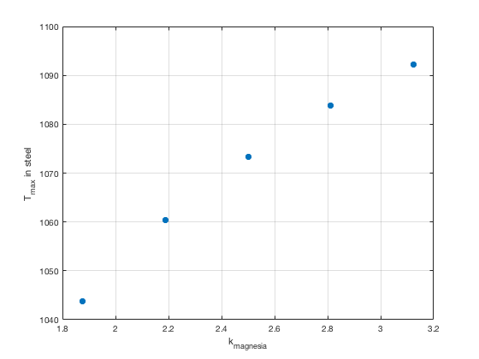

Figure 10. Maximum temperature in steel as kmagnesia varied.

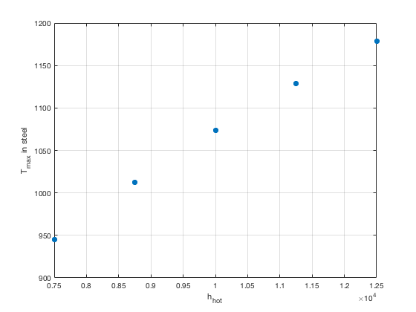

Figure 11. Maximum temperature in steel as hhot varied.

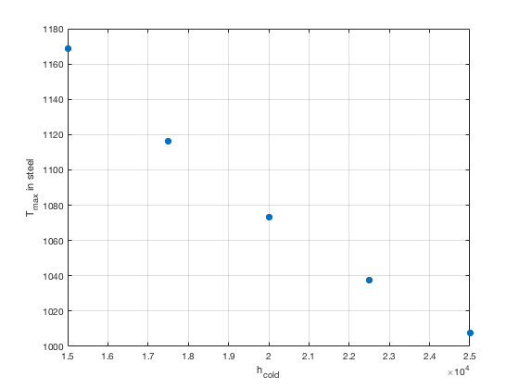

Figure 12. Maximum temperature in steel as hcold varied.

To see which is more sensitive to change I looked at the magnitude of the slopes of each graph and found that hhot was the most sensitive since it had a slope that was about three times bigger than the slope of either of the other two graphs.

The following temperature field plots are at the extrema of the parameter ranges. They are pared by parameter changed and on the left we have the lower extrema, and on the right, the higher extrema.

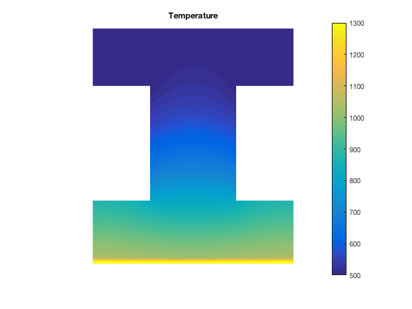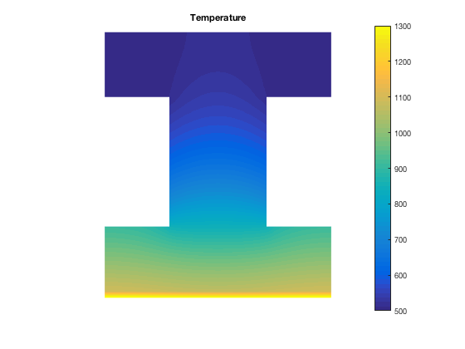

Figure 13. Temperature field plots for minimum (left), and maximum (right) extrema of kmagnesia .

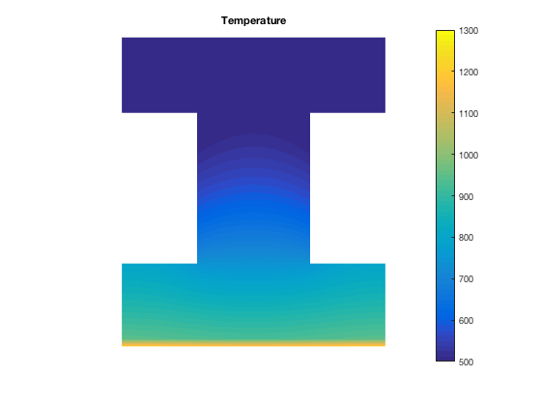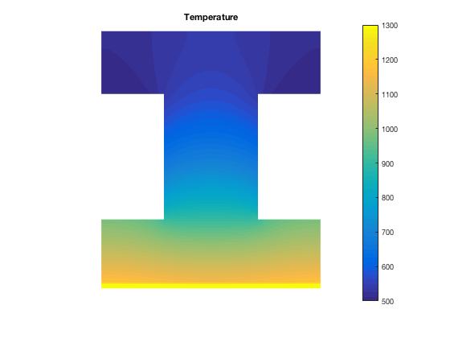

Figure 14. Temperature field plots for minimum (left), and maximum (right) extrema of hhot .

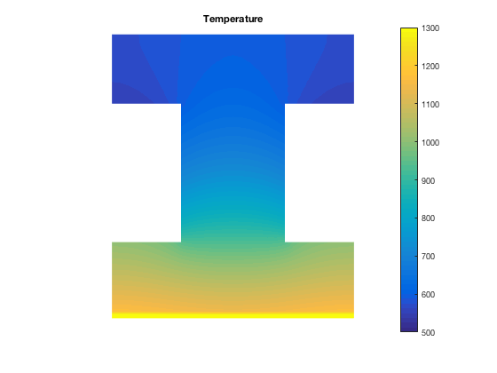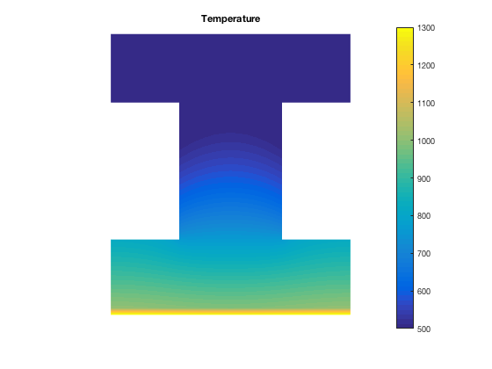

Figure 15. Temperature field plots for minimum (left), and maximum (right) extrema of hcold .

Maximum steel temperature did not change location. It was in node 117 for all cases.