Monday 2-5

Go Forth and Measure

**Comparison of Vibrational Sweet Spots of Tennis Rackets**

**Lenny Martinez**

5/10/16

2.671 Measurement and Instrumentation

Monday PM

Prof. Ming Guo

# Abstract

# Performance tennis rackets cost somewhere in the range of 170 and 230 dollars, making buying one a matter of careful consideration and comparison. A measure for comparing rackets based solely on the percentage of the vibrational sweet spot in the longitudinal direction was calculated using an accelerometer and an impact hammer to measure the vibrations of the string bed for a Babolat™, a Head® and a Prince® racket. The Prince® racket had the largest longitudinal percentage of 31 ± 11 %. This is 7% and 5% larger than both the Babolat™ and the Head® rackets, respectively.

# 1. Introduction

The first tennis racket was made in London in 1874 out of solid wood. [1] Since then, rackets have evolved in both size and material composition. Solid wood gave way to steel and in 1975, the first oversized aluminum racket was created. In 1987, Wilson introduced the first “widebody” racket that had a larger beam width. In 1990, Wilson also introduced a racket with a heavier head. In more recent years, rackets have been getting increasingly lighter and have been made using composite materials. Rackets are both compared quantitatively using head size, weight, length, and string tension and also qualitatively using swing speed, stroke style and power level.

But throughout this time, there haven’t been good measures for objectively comparing different rackets. Because of their different compositions and geometry, rackets are hard to compare and a lot of it relies on testing them out yourself and finding the one that feels best. Another pain point when comparing rackets is the price. Due to the materials used and the engineering that goes into manufacturing them, performance rackets can range from 170 to 230 dollars. As a result, anyone considering purchasing a racket for regular to extensive use will take a long time to pick a racket to make sure they invest their money wisely. This experiment attempts to derive a new measure for comparing tennis rackets based on the size of the sweet of a tennis racket as a ratio to the overall dimension of the racket string bed.

# 2. Background

The sweet spot of a tennis racket is defined as an area on the racket where the force transmitted to the player’s hand is relatively small. On any given racket there are usually three different sweet spots along the axis of the handle. One corresponds to minimal initial shock, another to minimal vibration, and the third corresponds to the maximum coefficient of restitution and results in the most power [2]. For this experiment, the focus was solely on the sweet spot corresponding to minimal vibration.

The vibrational sweet spot is defined as the nodal point of the first elastic mode of vibration. For a system, a mode is a sinusoidal motion. Each mode has a fixed frequency associated with it, also known as its natural or resonant frequency. In the case of the tennis racket, the first elastic mode, which occurs at a lowest frequency, typically produces vibrations of highest amplitude [2]. This makes it a top priority because strong vibrations can lead to player injury.

One common tennis injury is called tennis elbow. Tennis elbow (also known as lateral epicondylitits) is caused by injury, abrupt or subtle, of the area where the muscles and tendons of the forearm attach on the outside of the elbow. Although the main cause in tennis player is stress from overusing the forearm, low-frequency vibrations (such as those of the first elastic mode) aid the injury formation process. Li et al. [3] have in the past used finite element simulations to observe the effects of vibration on a tennis racket during a racket collision with a tennis ball. Specifically they focused on investigating how string tension and impact location affected the racket deformation and resultant force on a player’s hand as a way to look at ergonomics and injury prevention.

Another past study by Buechler [4] was very similar to the experiment I performed. Buechler analyzed vibration characteristics of a tennis racket through the use of a physical setup aided by modal software analysis to identify mode shapes of the racket with and without commercial dampeners [4]. The study also used finite element simulation to match the experimental data to mode shapes. Although this study gives a more precise location of the sweet spot associated with minimal vibration, it focuses more on quantifying the effects of string tension on sweet spot and mode shapes as well as the effect of vibrational dampeners on the sweet spot. While this focus does help to better quantify the sweet spot as a racket performance measure and give information as to which rackets may be better, it does not look at the area of the sweet in comparison to the overall area of the racket head. Thus, this inquiry into the ratio of sweet spot area to racket head area of various rackets aims to measure the ratio area of the sweet spot which maybe offer insight into a more objective measure of racket performance since racket and string materials vary.

These studies have done a solid job at creating models for measuring the vibrational sweet spot and observing how different parameters like string tension and accessories like vibrational dampeners affect the sweet spot, providing a great base for what the vibrational sweet spot is, where it is located and how it changes. [2 - 4] Unfortunately they fail to look at the difference in racket manufacturing (in terms of racket and string material properties) and size of the racket head and how that affects not only the size and location of the spot. This experiment aims to use dimensions of the racket head to compute a normalized value for the size of the sweet spot that can be used to compare different racket types (or brands) and even among the same racket at different tension levels.

# 3. Experimental Design

In order to quantify the vibrational sweet spot of different tennis rackets, an experiment was conducted using an accelerometer, an impact hammer, and three different rackets.

## 3.1 Testing Set-up

For all three rackets the setup was the same. The rackets were clamped down at the handle using a large industrial C-Clamp close to the lower end of the racket and a large plastic clamp nearer to the throat of the racket. On the lower end of the tennis racket head, above the throat, a Vernier 3-axis accelerometer was attached with cable ties in between the two middle longitudinal strings of the racket. The accelerometer was used to measure the vibration of the racket head. Only the Z-axis channel was used for this sensor that can recognize a maximum acceleration of ±5 g. Input force was measured using an Impact Hammer PCB model 086D05. The impact hammer has a max force of 22.2 kN with a 0.23 mV/N sensitivy. Voltage measured with the impact hammer first went through a Vernier Instrumentation Amplifier with a gain setting of 0-1 V. All data was collected by the Vernier LabQuest Mini and the Logger Pro 3.10.1 software, at 5000 samples/second for 1 second per sample.

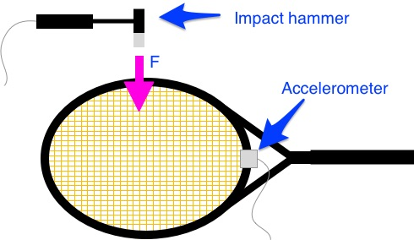

**Figure 1:** Diagram of testing setup. An accelerometer was attached with plastic cable zip ties to the lower end of the tennis racket head to measure the movement of the tennis racket when struck with an impact hammer.

## 3.2 Data Collection

For this experiment, data was taken from three different commercially sold rackets: Babolat™ AeroPro Drive, Head® Graphene Prestige Midplus, and Prince® Tour 98. After the accelerometer was attached to the racket throat and the impact hammer set-up, data samples were collected by striking the racket string bed at 6 locations along the longitudinal axis and away from the center of the racket. The locations are shown in Figure 2. Every round of data collection was triggered by the voltage transmitted from the force of the impact hammer increasing across 10 mV. All data analysis was done in MATLAB R2015b and Microsoft Excel 2016.

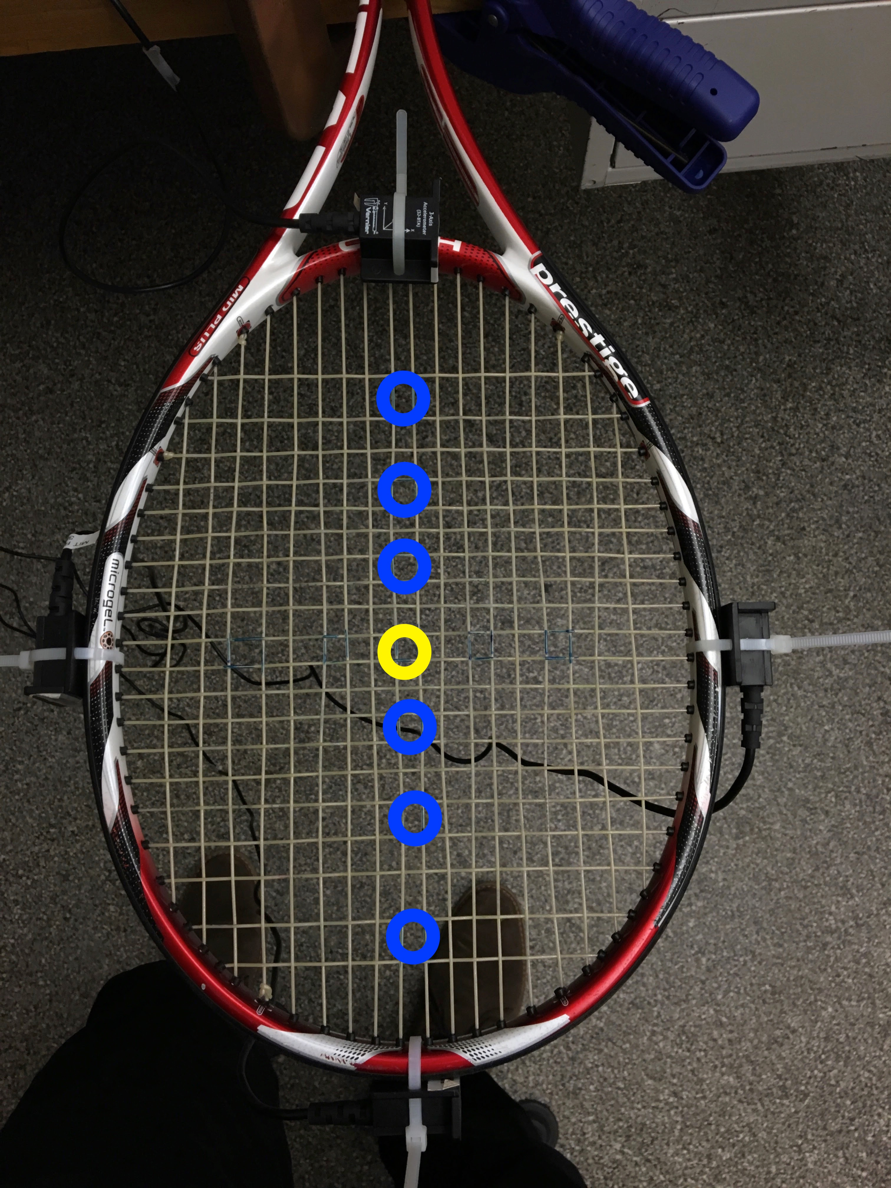

**Figure 2:** Location rackets were struck at. Starting from the center of the racket given by the midpoint of the strings in both the longitudinal and perpendicular directions and marked by the yellow circle, locations were chosen by counting 2 square spaces between locations. This led to a consistent number of locations for each racket regardless of stringing pattern.

# 4. Results and Discussion

To compare the rackets, the distances from center had to first be normalized against the longitudinal dimensions of each racket string bed. Distances from the center were measured for the three points up from the center (away from the accelerometer). Because the rackets deviate from a perfect ellipse in the perpendicular direction and not so in the longitudinal direction the distances from center to the throat are the same as the distances from the center to the top of the racket (top referring to away from the accelerometer). Table 1 shows the distances from the center of each racket to each testing location.

**Table 1:** Distances from center to tested locations for each racket bed. Distances to each location lack units because they’ve been normalized against the length from the center of the racket to the edge of the frame farthest from the accelerometer in the longitudinal direction of each racket, allowing for inter racket comparison. For the Babolat™racket, the length used to normalize was 6.5 inches, while for the Head® and Prince® rackets it was 6.375 inches.

|  |  |  |  |
| --- | --- | --- | --- |
| **Location** | **Babolat™ Racket** | **Head® Racket** | **Prince® Racket** |
| Up 3 | 0.72115 | 0.74490 | 0.70588 |
| Up 2 | 0.45192 | 0.43878 | 0.43137 |
| Up 1 | 0.22115 | 0.20408 | 0.21569 |
| Down 1 | -0.22115 | -0.20408 | -0.21569 |
| Down 2 | -0.45192 | -0.43878 | -0.43137 |
| Down 3 | -0.72115 | -0.74490 | -0.70588 |

At each of these locations samples of acceleration and input force using the accelerometer and the impact hammer were collected. The input (force in the form of voltage) and output (acceleration response to striking the racket bed) were used to non-parametrically compute a transfer function for the sample. From the Bode plot of the transfer function, the maximum gain was extracted from the sample.

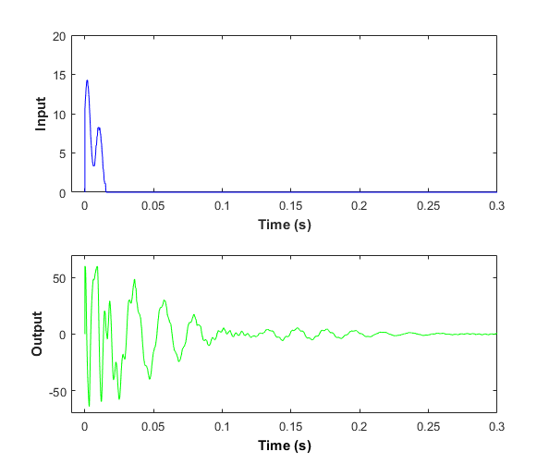 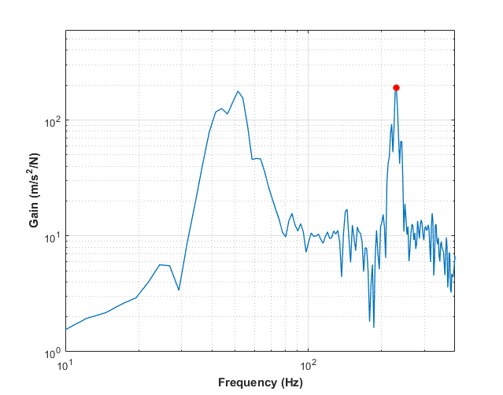

(a)

(b)

**Figure 3:** (a) At each location, an input force was provided by striking the racket bed with an impact hammer. This force was measured as a voltage. When the racket bed was struck, and accelerometer measured the movement of the racket. (b) The measured input and output were used to compute a non-parametric transfer function from which the maximum gain value was extracted. In this figure, the maximum gain is indicated a red point.

This process was repeated several times at each location and each racket and the gain values extracted were used to determine the size of the vibrational sweet spot. Drawing from both experience with tennis rackets and from the elliptical shape of the racket, if a racket is struck the deformation would be a deformed cone composed of a parabola in both the longitudinal and perpendicular directions. With this in mind, second order fits were created for each data set as can be seen in Figure 4a, 4b, 4c.

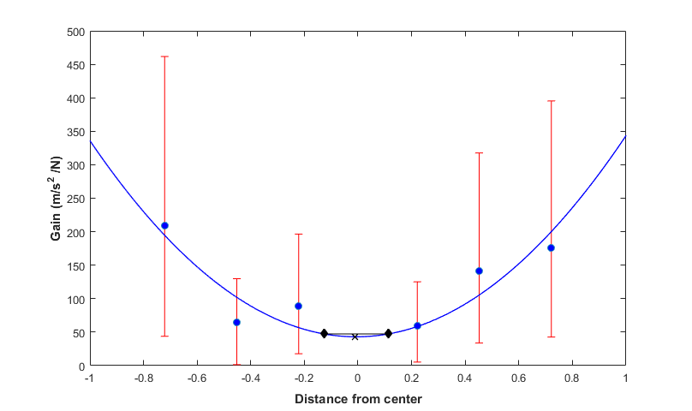

(a)

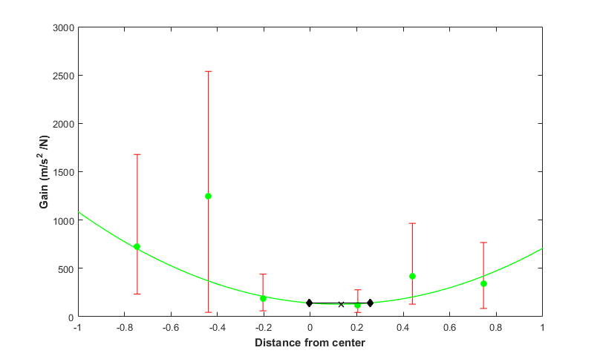

(b)

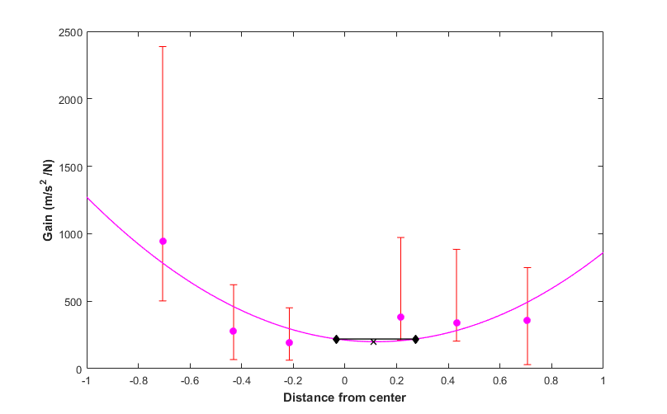

(c)

**Figure 4:** All three figures show the average Gain at each location as well as the second order fit for the gain as a function of distance from center. Error bars for each location at each racket are in red. (a) For the Babolat™ racket, the second order fit equation is given by:. (b) For the Head® racket, the second order fit equation is given by:. When calculating the fit for the Head® racket, the points at -0.45192 (location “Down 2”) were not used as they were outliers. (c) For the Prince® racket, the second order fit equation is given by:.

From the second-order fit equations the vibrational sweet spot was found by locating the minimum gain. To compare different rackets a cutoff gain was established to be at 10% above the minimum gain. The width was calculated by finding the intersection points between the fit equation and the 10% cutoff and then calculating the distance between the two points. All the values used before calculating the width are contained in Table 2.

**Table 2:** This table shows the minimum gain, the 10% cutoff and boundaries for the boundaries for the vibrational sweet spot sections across the three rackets.

|  |  |  |  |  |
| --- | --- | --- | --- | --- |
| **Racket** | **Minimum Gain** | **10% Cutoff Gain** | **Left Boundary** | **Right Boundary** |
| Babolat™ | 42.9941 | 47.2935 | -0.1263 | 0.1135 |
| Head® | 129.3178 | 142.2496 | -0.0065 | 0.2552 |
| Prince® | 198.7146 | 218.5861 | -0.0326 | 0.2726 |

With these boundaries where the fit equation is at 10% above the minimum we can calculate the width of the vibrational sweet spot in the racket’s longitudinal directions. This calculation was done by subtracting the left boundary from the right boundary. Table 3 lists the widths of the vibrational sweet spots by rackets.

**Table 3:** Table of widths of vibrational sweet spots for rackets in the longitudinal direction.

|  |  |
| --- | --- |
| **Racket** | **Width of Vibrational Sweet Spot** |
| Babolat™ | 24 ± 10% |
| Head® | 26 ± 20% |
| Prince® | 31 ± 24% |

From the analysis, we can conclude that the Prince® Tour 98 racket has the largest vibrational sweet spot in the longitudinal direction when compared to the Babolat™ AeroPro Drive and the Head® Graphene Prestige Midplus rackets. The Prince® Tour 98 racket has a vibrational sweet spot that is 31 ± 24 % of the length of the racket that is 5% and 7% larger than the areas of the Head® Graphene Prestige Midplus and the Babolat™ AeroPro Drive rackets respectively.

The main limitations to this approach are the inability to accurately model the racket head and the inability to eliminate string tension as a factor. Tennis racket heads are elliptically shaped and thus the size of the vibrational sweet spot in the perpendicular direction would be needed to create a more accurate model for comparing different rackets. Also, all three rackets had different amounts of tension in the string bed, and the experiment currently doesn’t account for this. During initial data collection, there were samples of data that resulted in very large maximum gain values and this was most likely a result of the string tension being different in each racket. String tension is how tense or stiff the strings. If the tension is high, the strings are less likely to move significantly when the racket bed is struck.

# 5. Conclusions

Through looking at the transfer function at various locations on a tennis racket string bed and creating a parabolic fit to the maximum gains along the longitudinal axis of a racket, this experiment was able to create a measure for comparing rackets based on the size of the vibrational sweet spot in the longitudinal direction. When comparing the Babolat™ AeroPro Drive, the Head® Graphine Midplus and the Prince® Tour 98 rackets, the latter had the largest vibrational sweet spot size of 30 ± 24% of the longitudinal direction. The Babolat™ AeroPro Drive had a vibrational sweet spot that was 24 ± 10% of the longitudinal direction, and the Head® Graphine Midplus had a vibrational sweet spot that was 26 ± 20% of the longitudinal direction

These results have interesting implications for tennis players who are looking to buy a tennis racket. When purchasing a racket, the rule of thumb is that a larger racket head means a larger sweet spot. This experiment gives us a new way to compare rackets and find the one with the biggest vibrational sweet spot size. The benefit of this is that we can compare rackets across the same price range, and thus pick a racket that is less likely to lead to injury if used extensively.

# Acknowledgments

The author would like to thank Professor Guo and Dr. Hughey for their guidance in analyzing data from this experiment, and his friends for lending him their rackets.

# References

[1] “The Evolution of the Tennis Racket,” Complex [Online]. Available: http://www.complex.com/sneakers/2012/08/the-evolution-of-the-tennis-racket. [Accessed: 04-Apr-2016].

[2] Mohanty, P., and Rixen, D. J., 2002, “Measuring sweet spots of tennis rackets,” Proceedings of IMAC-XX: A Conference on Structural Dynamics, February 4, 2002 - February 7, 2002, SPIE, pp. 1539–1545.

[3] Li, L., Yang, S. H., Hwang, C.-S., and Kim, Y. S., 2010, “Effects of string tension and impact location on tennis playing,” J. Mech. Sci. Technol., **23**(11), pp. 2990–2997.

[4] Miles A Buechler, L. A. E., “Vibration modeling and supression in tennis racquets.”