USER MANUAL
Sprintbox Warehouse Dashboard
Version 1.0 | 2026
Operator and user guide

1. Introduction

Sprintbox Warehouse Dashboard is a web-based pallet management application for the Schaeflein warehouse. It runs in a browser — no installation required, just double-click run.bat.

What the application provides:
- Comparison of orders against actually removed or received pallets
- Viewing current stock levels by article and date
- Generating PID (pallet identifier) lists for physical removal
- Automated data download from the ihka.schaeflein.de portal
- Monthly reports, historical charts, stagnant stock analysis

2. Starting the Application

2.1 Standard Launch (Windows)

- Locate run.bat in the application folder
- Double-click run.bat
- A black command prompt window opens — this is the application server. Do not close it while working
- Your browser automatically opens http://localhost:8501

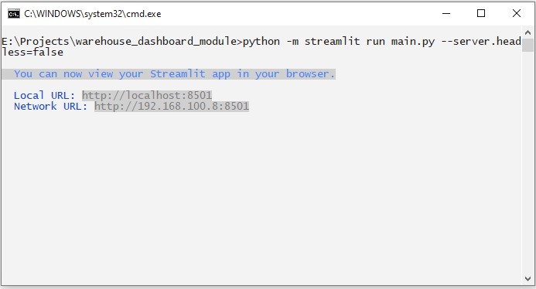
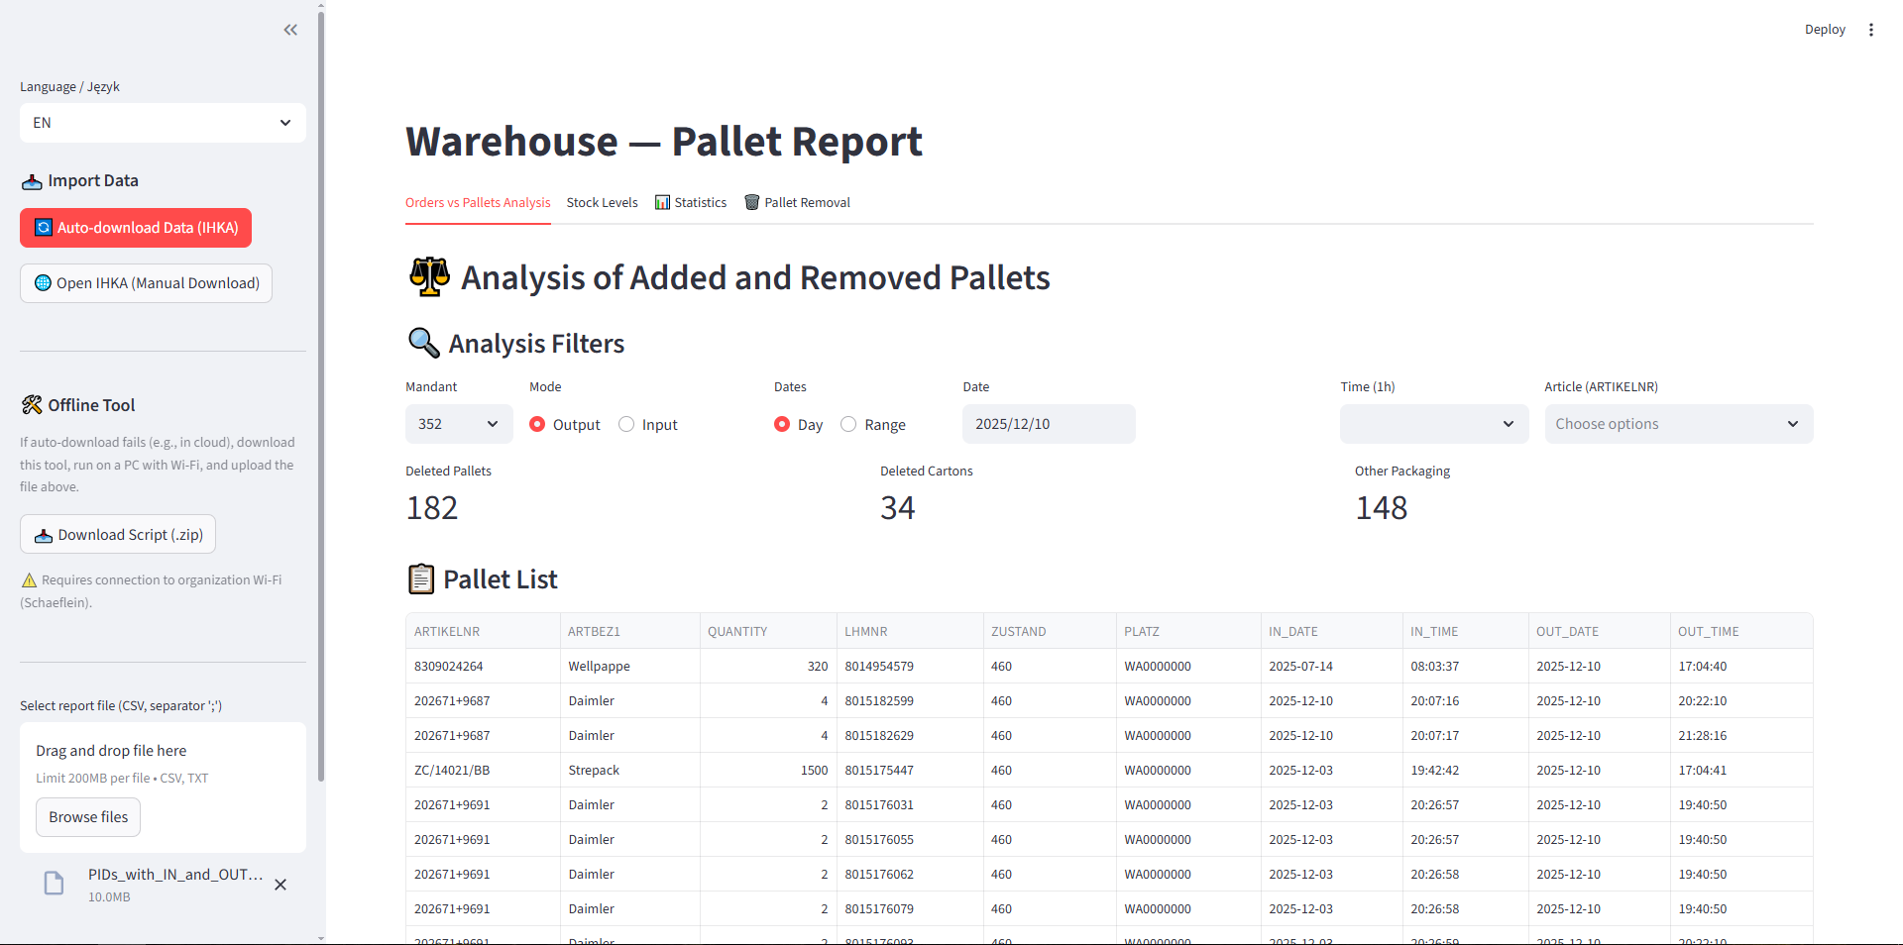

IMPORTANT: The black command prompt window is the application server. The app runs as long as this window stays open.
Closing it stops the application.

2.2 Portable Mode (no Python installation)

If Python is not installed on the computer, use run_portable.bat. It uses the embedded Python from the py311_emb\ folder. Launch: double-click run_portable.bat.

2.3 Interface Language

In the left sidebar at the top, select the language from the Language / Język dropdown: PL (Polish) or EN (English). Changing the language refreshes the page.

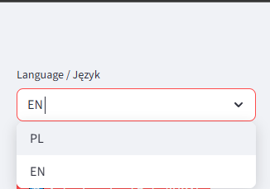

3. Loading Warehouse Data

Before working with the application, data must be loaded. There are two methods:

3.1 Automatic Download from IHKA

- In the left sidebar, find the 'Import Data' section
- Click the red 'Auto-download from IHKA' button
- The app opens Firefox, logs into ihka.schaeflein.de and downloads the report automatically
- Parameters are set automatically: Mandant 352, date from 20.12.2016, date to: today
- When complete, 'Done!' appears — data loads automatically

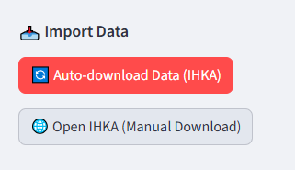

Requirements for auto-download:
• Firefox must be installed on the computer
• Computer must have access to ihka.schaeflein.de
• IHKA login and password configured by administrator in .streamlit/secrets.toml

3.2 Manual Report Download and File Upload

If auto-download is unavailable, the CSV report can be downloaded manually from the IHKA portal:

- Go to http://ihka.schaeflein.de and log in
- Navigate to: Öffentliche Abfragen → LZB → LZB Abfragen Breslau → PIDs with IN and OUT date
- Set the report parameters:
- Mandant: 351 or 352 (as needed)
- Date IN: inbound date of the oldest pallet still in stock
- Date OUT: today's date
- Generate the report (click the table icon) and download the CSV file
- Return to the app. In the sidebar section 'Select report file', click 'Browse files' and select the downloaded CSV

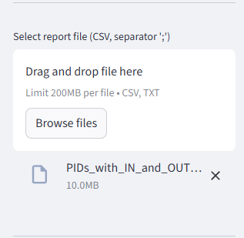

For accurate stock levels, the CSV should be generated with a date range from 01.01.2016 to today.
Too short a date range will result in incomplete stock data.

4. Tabs Overview

After data loads, tabs appear at the top of the page:

Tab | Purpose
Analysis | Compare orders against actual pallets (removals/receipts)
Stock | Current stock levels for a selected date
Statistics | Historical charts, monthly reports, Top-5, stagnant stock
Pallet Removal | PID list generator for physical pallet removal
Settings | System configuration (admin only)

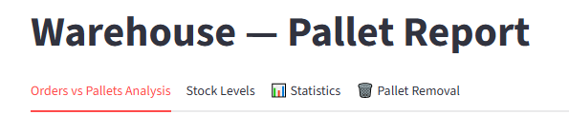

5. Analysis Tab

The main working tab. Use it to compare order data against actual pallet movements.

5.1 Analysis Filters

Filter | Description | Values
Mandant | Select warehouse/client | 351 / 352
Mode | Direction of pallet movement | Removed (OUT_DATE) or Received (IN_DATE)
Date | Date range for analysis | Single date or range (calendar)
Time | Hour slot within the day | 6:00–22:00, 1h
Article | Filter by article number | Multiple selection from list

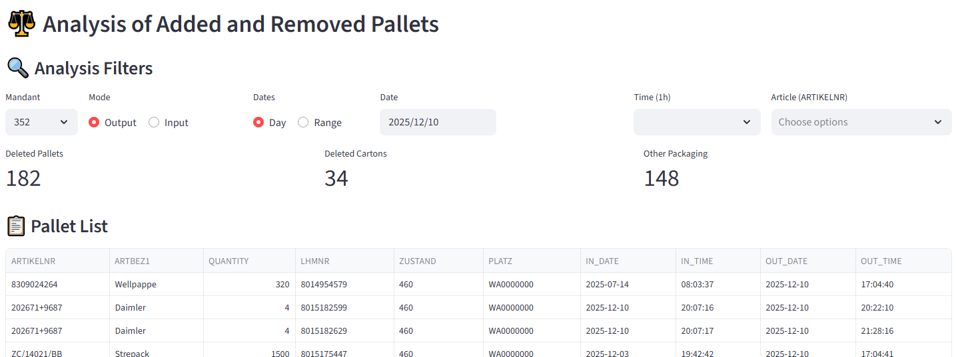

5.2 Loading Order Files

- In the lower section of the tab, find the 'Orders' area
- Click 'Upload order files' and select one or more files (CSV or XLSX)
- The app reads the columns, aggregates by article and displays a summary table

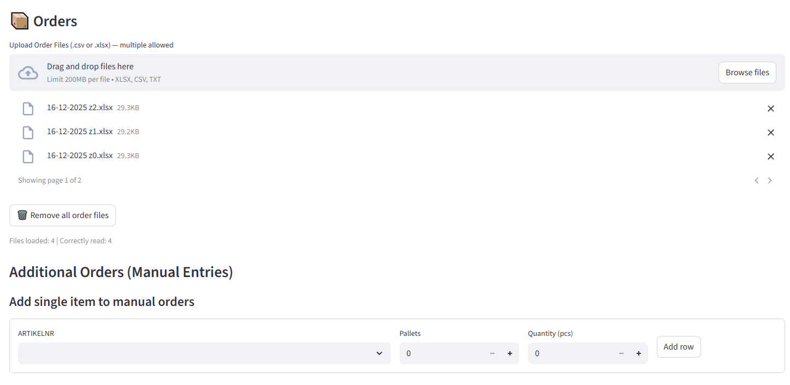

5.3 Orders vs Pallets Comparison Table

After loading orders and setting filters, a comparison table appears. For each article it shows ordered quantity and actually registered warehouse figure.

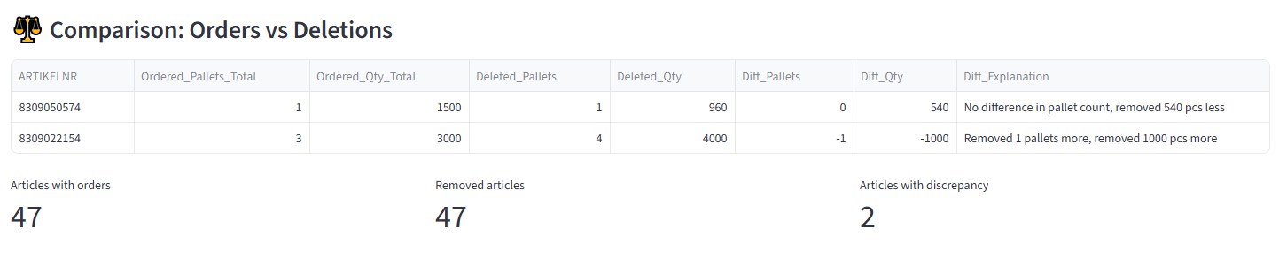

5.4 Data Export

Use 'Download CSV' and 'Download Excel' buttons to export the current filtered results.

6. Stock Tab

Shows current stock levels for a selected date and article.

6.1 Stock Filters

Filter | Description
Mandant | Select warehouse — 351 or 352
Date | Date for which stock is displayed (start of day)
Article | Optional article filter (multiselect)

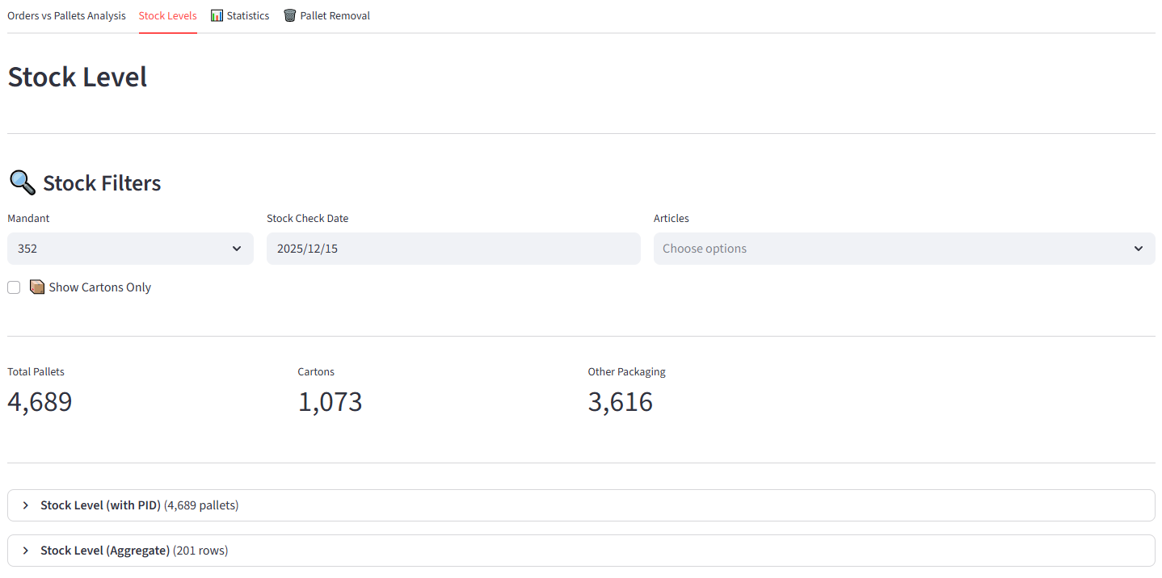

IMPORTANT: Stock levels are accurate only if the CSV was generated with a date range from 01.01.2016 to today.
A shorter date range may result in incomplete or incorrect stock data.

6.2 Stock Tables

Two tables are shown: (1) Detailed — each pallet as a separate row (by PID/LHMNR). (2) Aggregated — quantity totals per article. For Mandant 352, cartons and other packaging are counted separately.

7. Statistics Tab

Four analytical sections — each in a collapsible block (expander):

Section | Content
Stock History | Plotly chart of day-by-day stock changes over selected range
Monthly Report | Table and bar chart of pallet inbound/outbound per month
Top-5 Articles | Article ranking by activity (movement count) in selected period
Stagnant Stock | Pallets in stock longer than configured threshold — list with location

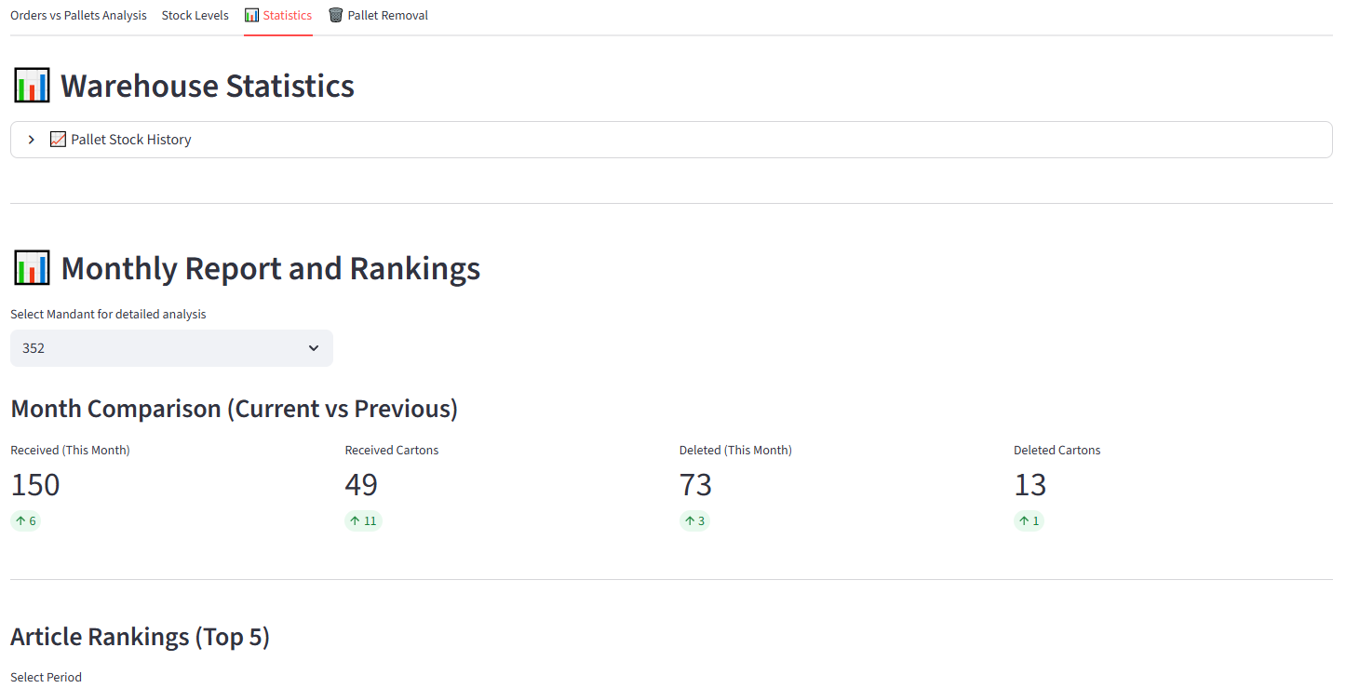

8. Pallet Removal Tab

A tool for warehouse operators. Helps select specific pallets (PID + storage location) to fulfil an order and generates a removal list.

8.1 Selecting an Order or Article

From the dropdown at the top of the tab, select:
- An order file — previously uploaded in the Analysis tab (Orders section)
- A manually added article — if you have no order file, enter the article and quantity directly
- "Manual selection (no order)" — manual mode without an order file

8.2 PID Selection Logic — Standard Articles vs Cartons

STANDARD articles (non-cartons):
→ PIDs selected AUTOMATICALLY by the application based on location priority.

CARTON articles (Mandant 352):
→ Operator selects PIDs MANUALLY from the dropdown list.
→ Protection: cartons have warehouse-specific handling — manual selection prevents accidental removal of wrong pallets.

8.3 Storage Location Priority

The application automatically suggests pallets in the following order (for standard articles):
- Priority 1 — WE and BL zones (reception): should be cleared first
- Priority 2 — standard racks (PLATZ starting with 02)
- Priority 3 — all other storage locations

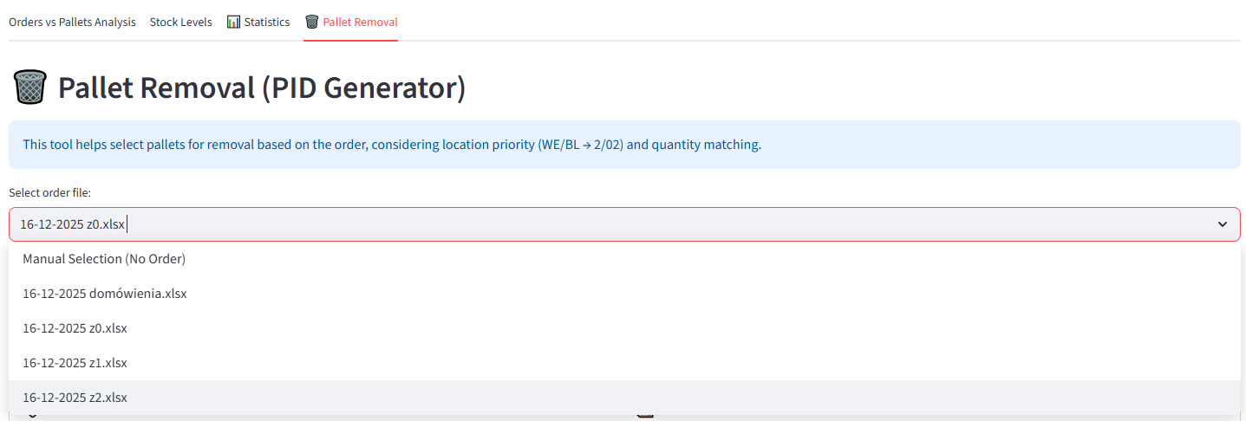

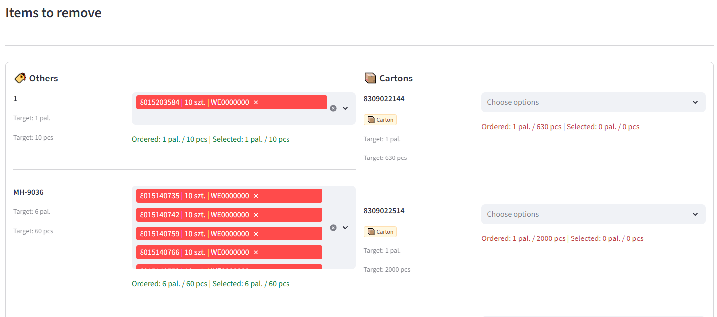

8.4 Confirming Selection and the Result Block

- Review suggested PIDs for standard articles — change selection in the multiselect if needed
- For cartons: manually select PIDs from the dropdown
- Click 'Recalculate / Confirm Selection' — the app updates the block and incorporates manually chosen carton PIDs
- The Result block displays the complete list of selected PIDs ready to copy
- Copy the PID list and remove from the stock

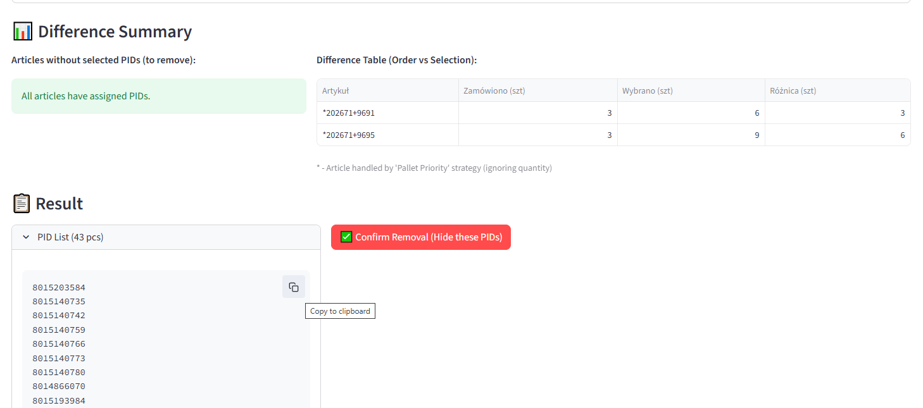

8.5 Processing Multiple Orders Sequentially — Confirm Removal

When processing several orders one after another in the same session:
- After copying the PID list from the Result block, click 'Confirm Removal (hide these PIDs)'
- The app marks those PIDs as removed and hides them from the session working base
- Move to the next order — the app will not suggest already-removed PIDs

Without clicking 'Confirm Removal', subsequent orders may suggest the same PIDs that have already been removed.

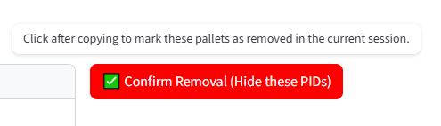

9. Settings Tab (Administrator)

Available only after admin login. In the sidebar, expand 'Admin Login' and enter the password.

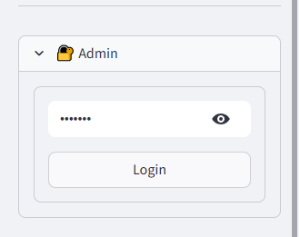

9.1 Article Exclusions

Articles skipped in Analysis tab comparisons. Two types: Exact — full article number; Prefix — start of number (excludes all articles with that prefix). Click Save after changes.

9.2 Packaging Configuration (Mandant 352)

Article prefixes that the app treats as cartons or other packaging. Used for metrics breakdown in Analysis tab and manual PID selection logic in Removal tab.

9.3 Pallet Strategies

For articles with prefixes defined in pallet_priority: the order shows 1 unit = 1 pallet, but physical stock may contain a different quantity. The app ignores unit count and selects the correct number of pallets.

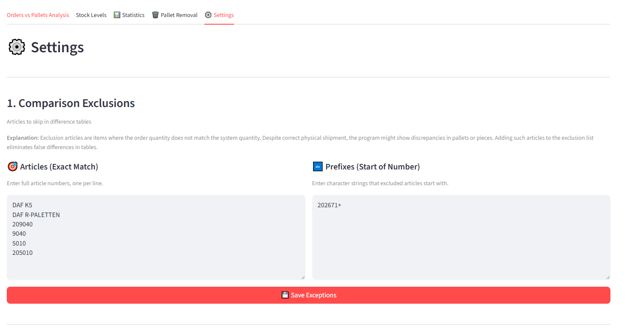

10. Frequently Asked Questions

Problem | Solution
App won't start | Check that Python 3.11 is installed. Alternatively use run_portable.bat
Browser doesn't open automatically | Manually open http://localhost:8501 in your browser
Auto-download fails | Check: Firefox installed; access to ihka.schaeflein.de; .streamlit/secrets.toml configured by administrator
Data disappeared after page refresh | Data is automatically restored (warning in sidebar). Click 'Clear' only if you want to remove old data
Stock levels look incorrect | Generate CSV with date range 01.01.2016 to today and reload
Settings tab not visible | Log in as administrator in the sidebar
Already-removed PIDs appear in next order | After copying the PID list, click 'Confirm Removal (hide these PIDs)' before moving to the next order
Cartons have no automatic PID | For cartons, PIDs are selected MANUALLY from the list — this is the app's intentional behaviour

