AN EXPERT SYSTEM FOR DIAGNOSING DIEASES USING PYTHON

|  |
| --- |
| 1LENON KOH HERDYI, 1TO JUN HUI, 1LEE KOK-KING LEE |
| 1Faculty of Information Science and Technology |
| Multimedia University |
| Jalan Ayer Keroh Lama, Bukit Beruang, Melaka, 75450, Malaysia |
| 1151104418@student.mmu.edu.my; 1151204274@student.mmu.edu.my; 1151204422@student.mmu.edu.my |
| 1151104418; 1151204274; 1151204422 |

ABSTRACT

This project presents the design of an expert system that aims to provide an alternative common diseases diagnosis method in a hospital. Hospital is the main source for general medical care. Patient with sickness or diseases may diagnose and cure by the hospital doctor. There are huge number patients visit hospital daily for medical diagnosis. Python language is used as tool for designing our expert system. The expert system is able to diagnosed common diseases correctly and quickly.

**Keywords**: Artificial Intelligence, Expert Systems – Python, Disease.

# INTRODUCTION

Diseases are some of the most chronic killer in the world. Everyone human will at least suffer any disease once in their life. Thus, diagnosing and curing of disease is important on maintain a healthy life and away from suffer. Hospital is the main source for general medical care. Patient with sickness or diseases may diagnose and cure by the hospital doctor. Somehow, there are huge number of patients visit hospital daily to consult a doctor of their sickness. With greater amount of patient, the time of consulting doctor is limited for each patient. Artificial Intelligence (AI) is widely use among the world. An expert system is one of the solutions to speed up the diagnosing diseases process.

The development of expert system is implemented using Python programming environment. With the experta library in python, it allowed the ability of building expert systems that strongly inspired by CLIPS (C Language Integrated Production System). This library is designed to facilitate the development of software that model human knowledge and expertise for medical treatment.

In this project, a disease diagnosing expert system is develop to assist the doctor and speed up the diagnosing process. This can allow the doctor to obtained patients symptoms immediately. Before consulting the doctor, patient may use our expert system to diagnose their diseases by selecting the symptoms they have. The expert system will automatically diagnose the patient disease with the symptoms input. A definition and details of disease will show to the patient for their further understanding. This can further reduce the task of doctor and speed up the time of diagnose and treatment to the patient.

# LITERATURE REVIEW

A literature review on five existing medical diagnosis expert systems are carried. The expert systems use for studies as following:

* Disease Diagnosis System.
* Expert system for Diagnosing Eye Diseases Using CLIPS.
* Agent-based Intelligent Medical Diagnosis System.
* Web-Based Online Medical Diagnosis System (WOMEDS).
* Fuzzy Expert System Design for Diagnosis of Liver Disorder.

Each method will discuss in details on section A. Section B discuss about the problem statement and motivation of project. Section C discuss about the diseases symptoms.

1. **EXISTING SYSTEM**
2. Disease Diagnosis System.

This is an intelligent medical system to diagnose diseases that use techniques, such as database management system (DBMSs), and artificial intelligence (AI) techniques, such as knowledge-based systems (KBSs) or expert system (ESs) [1]. In this system, DBMSs are used to store, retrieve and manipulate the patient data, whereas ESs are mainly used to perform diagnoses based on the patient data, since they can represent the way experts’ reason. The architecture of this expert system is shown in Figure 2.1.

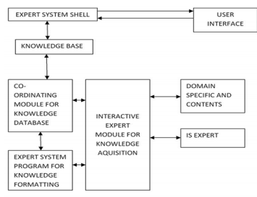

Figure 2.1: *Expert System Architecture.*

**Advantages:**

* It will retrieve data from the previous records to improve the accuracy of current diagnosis, indicates and analyses the laboratory exams and list all the possible diseases that the patient may have.
* Information from previous consultations and examinations are automatically linked and analysed under temporal logic reasoning.

**Challenges:**

* Database are proprietary and difficult to obtain due to most hospitals are still using traditional paper-based to record

1. Expert System for Diagnosing Eye Diseases Using CLIPS.

This proposed system is for dealing with the problem of eye disease diagnosis expert system. Diagnosis of eye disorders is initially based on the symptoms that the person is experiencing, and the results of an examination. Many cases of eye disease can lead to blindness. However, if detected early enough, eyesight can often be saved [2].

This expert system uses the following categories, Rule-based system, Knowledge-based systems, Intelligent agent (IA), Database Methodology, Inference engine and System-user interaction. The structure of this expert system is shown in Figure 2.2.

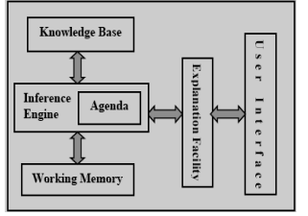

Figure 2.2: *Structure of Eye Diseases Expert System.*

**Advantages:**

* Help doctors and patients in providing decision support system, interactive training tool and expert advice.

**Challenges:**

* The complete the eye diseases database.
* The medical knowledge of specialized doctor is required for the development of this expert system.

1. Agent-Based Intelligent Medical Diagnosis System for Patients.

Due to the limited medical personnel, resources and technology cannot meet the requirements of the current disease’s diagnosis. So, patients may not get enough time and effective treatment from the doctors, and the patient’s satisfaction of diagnostic services is low. Other than that, patients are increasing in the aging society, it will result in the medical staff will work whole day under high-intensity load, and it will increase the chance of misdiagnosis as the medical staff will be tired [3]. So, this expert system is created to solve those problems. The overall architecture of AIMDS is shown in Figure 2.3.

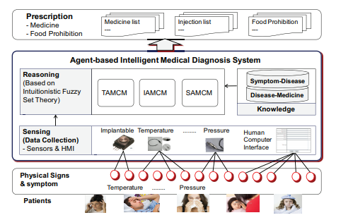

Figure 2.3: *Architecture of AIMDS.*

AIMDS uses theory of intuitionistic fuzzy sets to diagnose. Three diagnosis methods are designed in the reasoning of AIMDS. The three diagnosis methods are Knowledge Database, Patients information input with the human-computer interface and Correlation measure modelling of intuitionistic fuzzy set.

Knowledge database that has been used in this expert system are Symptom-disease matched knowledge database that composed of universal symptom information, disease information and membership correlation set of symptoms and diseases. Other than that, Disease-medicine matched knowledge database that include all the medicine knowledge and disease knowledge.

Patient information input with the human-computer interface are related technologies that are applied in the biomedical field and promote the invention of physical sensors. At present, the physical sensors applied in the biomedical field are divided as shown in Figure 2.4.

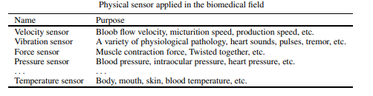

Figure 2.4: *Physical sensor applied in the biomedical field.*

Last but not least, the correlation measure modelling of intuitionistic fuzzy set. They proposed a new-extended formula to apply in the medical diagnosis which respectively describe the membership of patient’s symptoms and that of symptoms and diseases as shown in Figure 2.5.

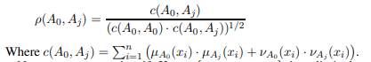

Figure 2.5: *New-extended formula.*

After that, they presented an improve of new correlation measure calculation method so that it can take account of all the data as a while in the view of absolute value of membership and non-membership. The equation of the presented calculation method is shown in Figure 2.6.

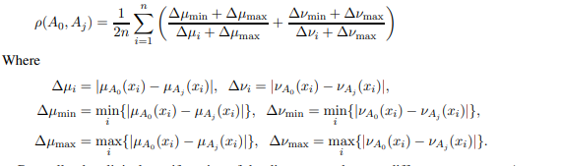

Figure 2.6: *Equation of the presented calculation method.*

Last, they presented a correlation measure calculation method of intuitionistic fuzzy set based on the set theory. The equation represented the correlation coefficient of set A0 and set Aj is shown in Figure 2.7.



Figure 2.7: *Equation of set A0 and set Aj.*

**Advantages:**

* Advanced sensing technology is applied into the biomedical field to pave a feasible approach for detecting the patient’s physical signs.
* Cost less time to acquire more abundant and comprehensive information of patient physical

**Challenges:**

* Do not differentiate the importance of different symptoms in details.
* Difficult to normalize information of patient’s symptoms.

1. Web-Based Online Medical Diagnosis System (WOMEDS).

This system is developed which is known as Web Based Online Medical Diagnosis System. This system has the features for users to do diagnostics for the health problem and the system will provide health monitoring and tips for the user to follow. The doctors also can use this system to do further diagnostics and patient’s database references. This system concentrates on the management of three main part such as registration and administration, diagnosis and treatments, and health monitor and tips [4].

Registration and administration module consist of three sub modules such as new registration, existing user and database, and language option for user to choose. The system has been designed using advance and intelligent techniques that can help the system to produce the best solution.

Secondly, diagnosis and treatment will be used by the doctor and the system will assist them by diagnosing the portal hypertension. Two approach will be considered in doing the expert system; One is rule based and the other one is case based reasoning. The system then will pick whichever reasoning suits best for particular case.

The last part will be health monitor and tips. There will be a consultation scheduler that will act as an alert or reminder to the patient. The duration for the system pop alerts will be based on the intelligent time optimization.

**Advantages:**

* Save times for users.
* The system adopts user-friendly control interface.
* Usage of easy word that allow user to operate without doubts and difficulties.

**Challenges:**

* No protection on the database beside the login page yet.
* To offer the complete personalized service.

1. Fuzzy Expert System Design for Diagnosis of Liver Disorder.

This system is compound of an expert and a fuzzy system and it is known as hybrid system (fuzzy expert). This system consists of expert individual, knowledge engineer and a fuzzy System. Fuzzy system itself consists of four parts (fuzzy rule base, fuzzy inference engine, Fuzzification and defuzzification). The outline model of liver disorders fuzzy expert system is shown in Figure 2.8.

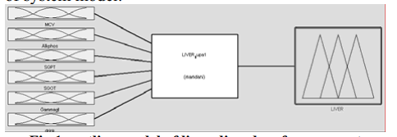

Figure 2.8: *Outline model of liver disorders fuzzy expert system.*

Expert individual knowledge is the basis of designing an expert system, A liver specialist is experienced and skilled in the field. So, an expert individual has special knowledge that is unknown or unavailable for others. The liver specialist experiences are then applied for collecting the fuzzy rules bank and for making the relationship between the disease fields and disease diagnosis [5].

Fuzzifier has defined as an assumption of point . The most important scale in a fuzzifier is that the fact should be considered which entry in X* is certain. Most complicated of calculations of fuzzy inference engine is related to calculate on $\begin{matrix}SUP \\ X∈U\end{matrix}$. Designing and using of triangular or trapezoidal fuzzifier simplifies preparation of inference engine and in according to the nature of data, these fuzzifiers are used preferably.

There are 78 dependant rules in this system, each rule is a collection of variants that have been “AND” together and show an especial situation of disease as shown in Figure 2.9. (L = low, M = medium, B = big)

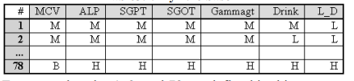

Figure 2.9: *Fuzzy Rule Base.*

The minimum amount of each rule is recognized and then the maximum amount between them is chosen. It will use momdani equation (max/min) to calculate the membership function but the rate of liver disorder will be low. So, they use the centre of gravity defuzzifier formula for calculating the certain resulting amount as shown in Figure 2.10.

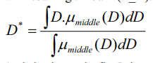

Figure 2.10: *Defuzzifier Formula.*

**Advantages:**

* Cheaper, faster, and also more liable and accurate.

**Challenges:**

* The system report is still disorders.

1. **PROBLEM STATEMENT AND MOTIVATION**

Time is one of the factors that affect the amount of patient which successful diagnosed their disease. The greater the number of patients in each day, the lesser the time for each patient to consult the doctor.

Our diseases diagnosing expert system is designed to assist and speed up the process of diagnosing diseases so that more patients are able to receive their treatment in each day. The expert system consists of user-friendly interface which is simple and easy to use. Patients are asked to select their symptoms which listed in the interface to diagnose the diseases. The system provided clear definitions and details of each diagnosed disease for patients understanding which others medical expert system do no provide. With the details of diseases, patient is able to understand the cause of disease and their symptoms.

1. **MEDICAL SYMPTOMS**

Every disease has its own symptoms. In this project, 8 diseases are selected to diagnose by the expert system. Details and definition of each included diseases is referred from the National Health Service [6]. Figure 2.11 shows the list of supported diseases with its symptoms in the system.

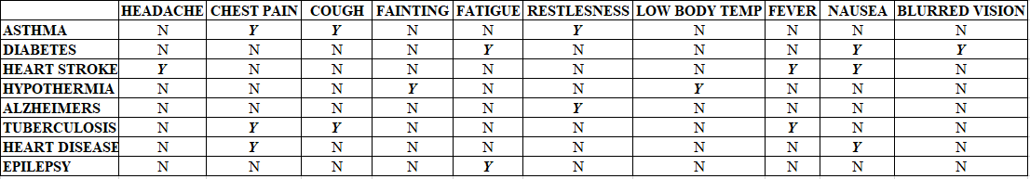

Figure .: List of Supported Diseases with Symptoms.

# THE FUNCTION OF THE SYSTEM

The proposed system performs multiple functions. It will conclude the disease diagnosis based on inputs of the user to specific question that the system asks the user. The questions provide the system for explanation for the symptoms of the patient that helps the expert system for diagnosis the disease by inference engine. It processes the input facts in order to extract rules, which complete the knowledge base.

# EXPERT SYSTEM

The expert system developed in this work consists of the user interface, the knowledge base and the inference engine. The system is created by using experta library with python programming language. The figure 4.1 shows the architecture of designed expert system. First is to prompt all the symptoms of the patient. The symptoms consist of headache, chest pain, cough, fainting, low body temperature, restless, fever, blurred vision and nausea. Once the selected symptoms are submitted, the facts are declared with using “@DefFacts()” for recording the patient’s symptoms as shown in Figure 4.2.

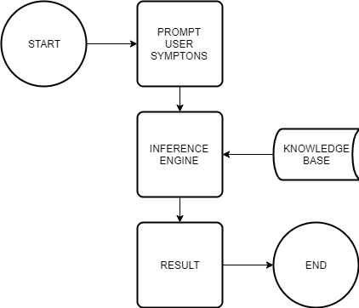

Figure 4.1: *Architecture of Designed Expert System.*

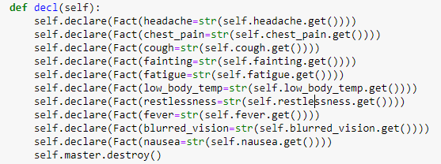

Figure 4.2: *Declare facts.*

Then based on the declared facts, trigger the rules with using inference engine. This expert system consists of 10 rules as shown in figure below, the 8 rules are created based on the knowledge of the disease expert. The rule will be triggered and create the disease fact when the requirement of symptoms is fulfilled. Another 2 rules are used to find diseases and display the information of the disease. The diseases consist of asthma, diabetes, heat stroke, hypothermia, alzheimers, tuberculosis, heart disease and epilepsy.

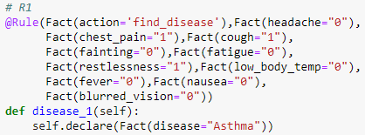

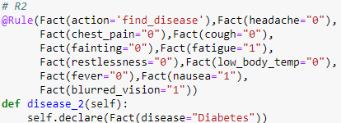

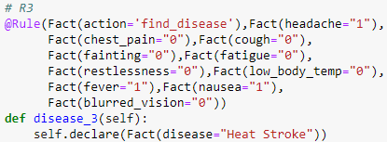

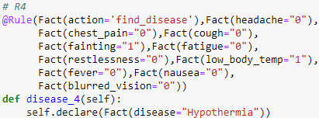

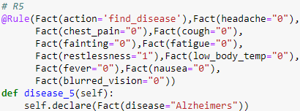

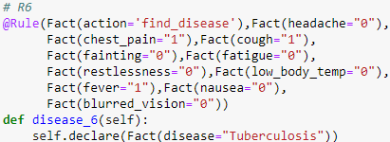

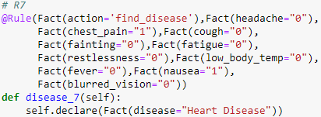

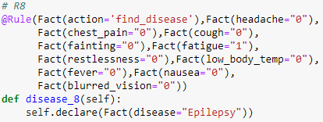

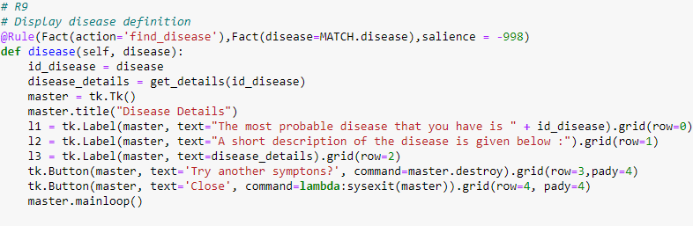

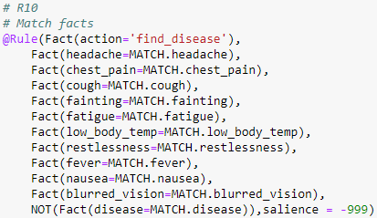

# USER INTERFACE

The GUI is created with using Tkinter library. First, the GUI will prompt the patient’s symptoms as shown in Figure 5.1. While the symptoms fulfill the requirement of a rule, the GUI will display the details and definition of the disease. If there are no symptoms fulfill a disease, the GUI will display no disease is found information. Then the user can proceed to try other symptoms or close the program. The Figure 5.2 show the sample details and definition of diseases. While figure 5.3 shows the example of undefined diseases.

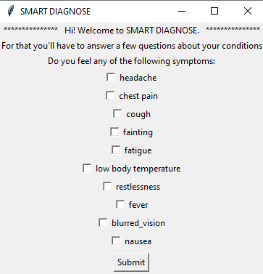

Figure 5.1: *GUI of The Expert System.*

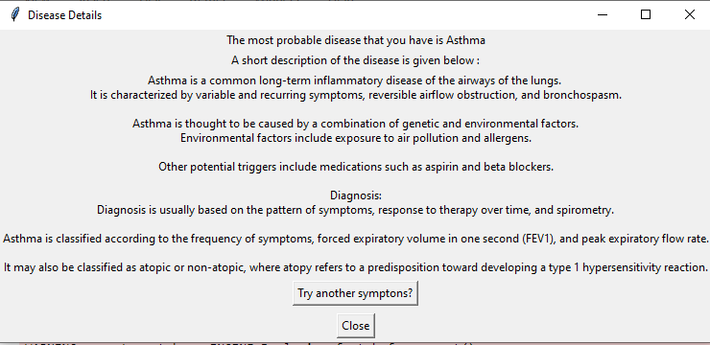

Figure 5.2: *Details and Definitions of Disease.*

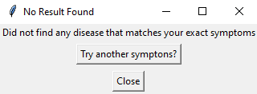

Figure 5.3: *GUI of Undefined Diseases.*

# CONCLUSION

The medical diagnosing expert system is important to the medical industry. The proposed system is designed to help patients and assist doctors not to replace them. There are times that some symptoms that a patient has overlooked and they will not see a need to consult a doctor. This means that instead of a patient waiting for their turn to consult the doctor for mild cases of sickness, the patient can diagnose their disease with the help of expert system before consulting a doctor. The system uses the computer with a simple interface which patients select their symptoms on the screen and click a button to diagnose. This will reduce the task of doctor and speed up the diagnosing process. In future plan, the expert system will design in web-based whereby everyone can access the system anywhere and anytime.

# REFERENCES

1. Biswas, D., Bairagi, S., Panse, N., & Shinde, N. (2011). Disease diagnosis system. International Journal of Computer Science & Informatics, 1(2), 48-51.
2. SS, A. N., & OA, A. Z. (2008). An Expert System For Diagnosing Eye Diseases Using Clips.
3. Zhang, Y., Liu, S., Zhu, Z., & Si, S. (2015). Agent-based intelligent medical diagnosis system for patients. Technology and Health Care, 23(s2), S397-S410.
4. Kolandaisamy, Raenu & Md. Noor, Rafidah. (2013). WEB BASED ONLINE MEDICAL DIAGNOSIS SYSTEM (WOMEDS). International Journal on Computer Sciences and Technologies. 1. 64 - 70.
5. Neshat, M., Yaghobi, M., Naghibi, M. B., & Esmaelzadeh, A. (2008, December). Fuzzy expert system design for diagnosis of liver disorders. In 2008 International Symposium on Knowledge Acquisition and Modeling (pp. 252-256). IEEE.
6. NSH. (n.d.). Illnesses and conditions. Retrieved October 3, 2019, from https://www.nhsinform.scot/illnesses-and-conditions