Name: 黃子蒨

Student ID: 4106056012

* 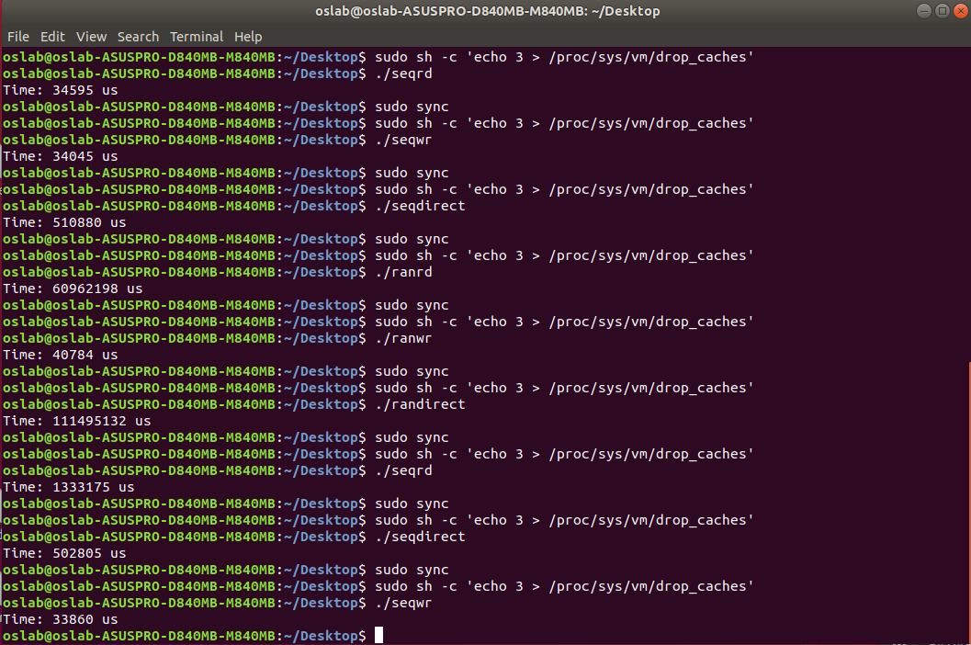Snapshot of Sequential Read
* Snapshot of Sequential Write
* Snapshot of Sequential Write (using O_DIRECT)



* Snapshot of Random Read



* Snapshot of Random Write



* Snapshot of Random Write (using O_DIRECT)

Explain your execution times.

1. Compare and explain your results of Sequential Read, Sequential Write and (O_DIRECT) Sequential Write. (8%)

execution time: Sequential Read > (O_DIRECT) Sequential Write > Sequential Write

執行Sequential Read會花比較多時間是因為若是要read的資料不在cache中，則需要再去disk抓取。而一般Sequential Write只需將data寫入cache即可再由cahe寫入disk，可節省最多時間。(O_DIRECT)Sequential Write則是在data寫入過程中直接做I/O，要等前一批資料寫完才能往下寫，故要花比一般write更多時間。

1. Compare and explain your results of Random Read, Random Write and (O_DIRECT) Random Write. (8%)

execution time: (O_DIRECT) Random Write >Random Read > Random Write

執行Random Read會花比Random Write還要久是因為若是要read的資料不在cache中，則需要再去disk抓取。而一般Random Write只需將data寫入cache即可再由cahe寫入disk，可節省最多時間。(O_DIRECT) Random Write則是在data寫入過程中直接做I/O，但因random要等待更久的seek time+rotational latency才能寫入，故要花比一般random write更多時間。

1. Compare and explain your results of Sequential Read and Random Read. (8%)

execution time: Random Read>Sequential Read

Sequential Read較快是因為他的seek time+rotational latency遠遠少於Random Read的seek time

1. Compare and explain your results of Sequential Write and Random Write. (8%)

execution time: Random Write> Sequential Write

理由同上題:Sequential Write較快是因為他的seek time+rotational latency遠遠少於Random Write的seek time+rotational latency

1. Compare and explain your results of (O_DIRECT) Sequential Write and (O_DIRECT) Random Write. (8%)

execution time: (O_DIRECT) Random Write>(O_DIRECT) Sequential Write

理由同上題，(O_DIRECT) Sequential Write較快是因為他的seek time+rotational latency遠遠少於(O_DIRECT) Random Write的seek time