SMARTLIB
Development of a Functional Automated Library System
Project Report
Prepared for: KNUST — School Project Submission
Repository: github.com/lenoxspider/automated_library
August 11, 2026

Table of Contents

Abstract
SmartLib is a fully automated library management system built to replace manual library operations with a working, tested software solution. It manages the book catalog, member and staff accounts, borrowing and returning of books, reservations, overdue fines, and automated email notifications, while enforcing role-based data security throughout. The system was implemented as a full-stack web application: a TypeScript/Express REST API backed by a normalized Prisma/SQLite database, and a Next.js 14 frontend styled with a custom design system named "Signal." This report documents the problem the system addresses, its design (entity-relationship, use case, and data flow diagrams), its implementation, and the testing performed to verify it — including live, end-to-end verification of the complete checkout-to-return circulation cycle as both a staff member and a registered student.
The system currently manages 52 real books across 12 subject categories, sourced automatically from the OpenLibrary public API rather than entered by hand, and passes an automated test suite of 64 tests across 10 suites covering authentication, circulation, fines, reservations, and notifications.

1. Introduction

1.1 Problem Statement
Manual library operations — paper-based checkout logs, hand-tallied fines, and physical card catalogs — do not scale with a growing student population and are prone to human error: lost records, miscalculated overdue fines, and no way for a member to check their own borrowing status without visiting the library in person. Existing university library systems are often either expensive commercial products with more features than a small library needs, or ad-hoc spreadsheets with no real workflow enforcement (nothing stops a book being "checked out" twice, or a fine going uncalculated). SmartLib addresses this gap directly: a purpose-built, web-based system sized for a university library, automating the operations that are currently manual while remaining simple enough to deploy and maintain.

1.2 Objectives
The system was built against six explicit objectives:
- Automate routine library tasks — check-in/check-out, reservations, and overdue notifications.
- Implement secure user account management for both members and library staff, with role-based authentication.
- Develop an efficient catalog search and filter system for fast retrieval of books and resources.
- Maintain accurate, real-time inventory data for all library items.
- Provide reporting tools for circulation trends, overdue items, and popular resources.
- Ensure modularity and scalability to accommodate future growth or additional features.
Section 6 (Results and Discussion) assesses the system against each of these six objectives individually.

1.3 Scope
In scope: web-based catalog browsing and search; member registration and role-based login (member, librarian, admin); book check-out and return with barcode-style copy tracking; reservations with staff approval; automatic overdue fine calculation; automated email reminders for due-soon and overdue loans; circulation and roster reporting; an admin panel for catalog, settings, and member management; and a book-cover image pipeline that fetches real cover art automatically and never shows a broken image.
Out of scope for this iteration: physical barcode-scanner or Raspberry Pi hardware integration (listed as optional in the original brief); SMS notifications (email only); and production deployment to a public host (the system currently runs in a local development environment, documented in Section 5.2 and Section 6).

2. Review of Existing Approaches
Two broad approaches were considered before implementation began. The first is fully manual record-keeping (ledgers, index cards), which was rejected outright as the exact inefficiency this project exists to remove: no real-time inventory visibility, error-prone fine calculation, and no self-service for members. The second is adopting an existing open-source or commercial ILS (Integrated Library System) such as Koha or Evergreen — powerful, but heavyweight for the scope of a single university department library, and not something students could reasonably build, extend, and demonstrate understanding of within this project’s timeframe. SmartLib instead follows a third path common in modern software engineering education: a purpose-built full-stack application using the same architectural patterns (MVC backend, relational schema, role-based access control, REST API) that production ILS software uses internally, scaled to the actual requirements of the brief rather than a general-purpose product.

3. System Design

3.1 System Architecture
SmartLib follows a three-tier architecture:
- Presentation tier — a Next.js 14 (App Router) single-page application, styled with a custom design system ("Signal") that gives staff-facing screens a dark, terminal-style surface and member-facing screens a light, high-contrast surface — a deliberate accessibility choice rather than a single fixed theme.
- Application tier — an Express.js REST API written in TypeScript, organized by the MVC pattern (routes → controllers → services → repositories), with dependency injection via tsyringe and request validation via Zod schemas at every write endpoint.
- Data tier — a Prisma-managed SQLite database with tracked, versioned migrations, plus Redis (via BullMQ) for the background email queue and JWT session/blacklist storage.
This separation means the frontend never talks to the database directly — every read and write goes through validated, role-checked API endpoints, which is what makes the role-based security in Section 4.4 enforceable in the first place.

3.2 Entity-Relationship Diagram
The diagram below is generated directly from the live Prisma schema (prisma/schema.prisma), not drawn from memory — every entity, field, and relationship shown is what the database actually enforces today.
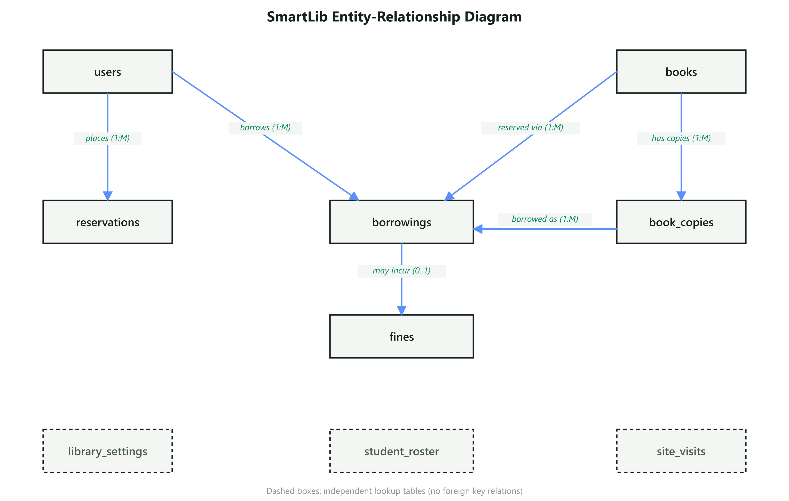
Figure 3.1 — Entity-Relationship Diagram
Three tables — library_settings, student_roster, and site_visits — are intentionally independent lookup/log tables with no foreign-key relationships to the rest of the schema; student_roster in particular is compared against a registering user’s claimed student ID at the application layer, not joined at the database level.

3.3 Use Case Diagram
Five actors interact with the system: an unauthenticated Guest, an authenticated Member, a Librarian, an Admin, and the System itself acting through scheduled cron jobs. Every use case shown below maps to a real, implemented, and tested API endpoint — this is not an aspirational diagram of planned features.
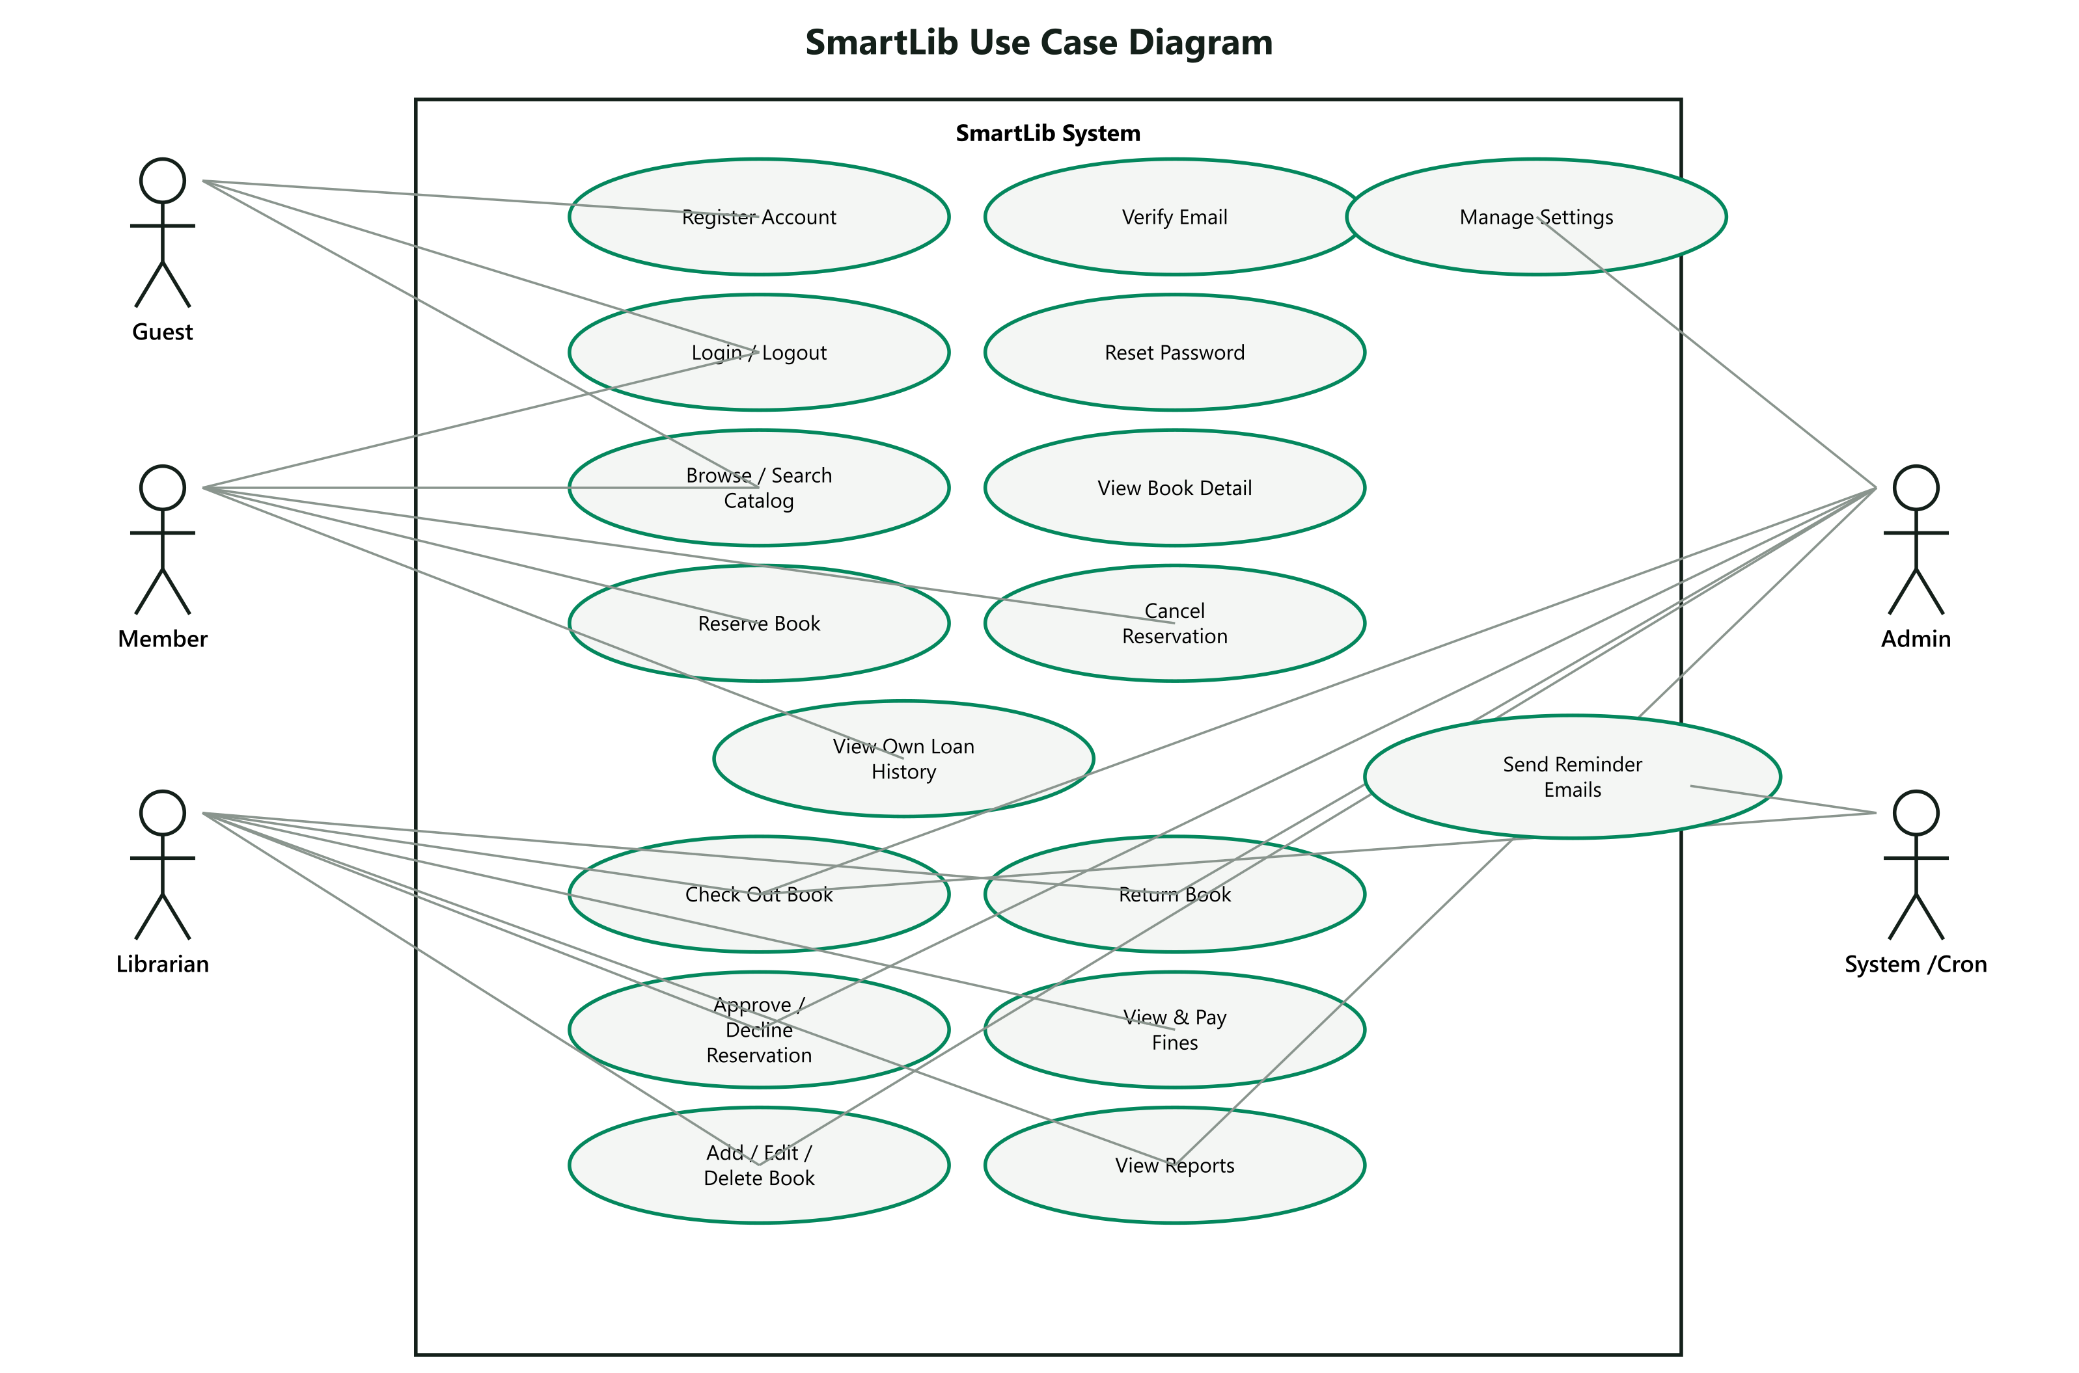
Figure 3.2 — Use Case Diagram

3.4 Data Flow Diagrams
The Level 0 diagram shows SmartLib as a single process exchanging data with its external actors and two third-party services (an SMTP provider for email, and the OpenLibrary API for book cover artwork).
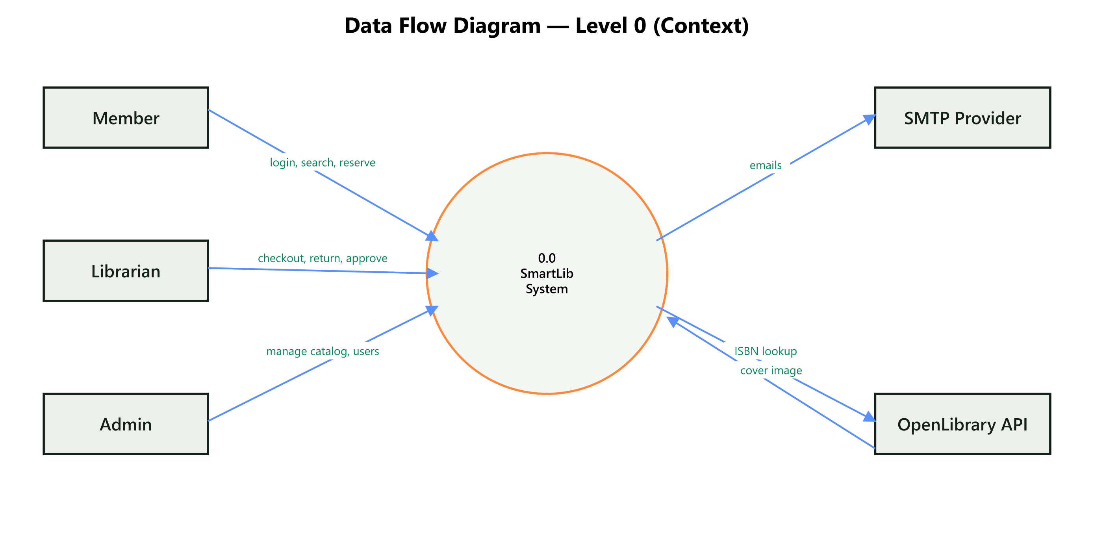
Figure 3.3 — Data Flow Diagram, Level 0 (Context)
The Level 1 diagram decomposes the system into its seven major processes and six data stores.
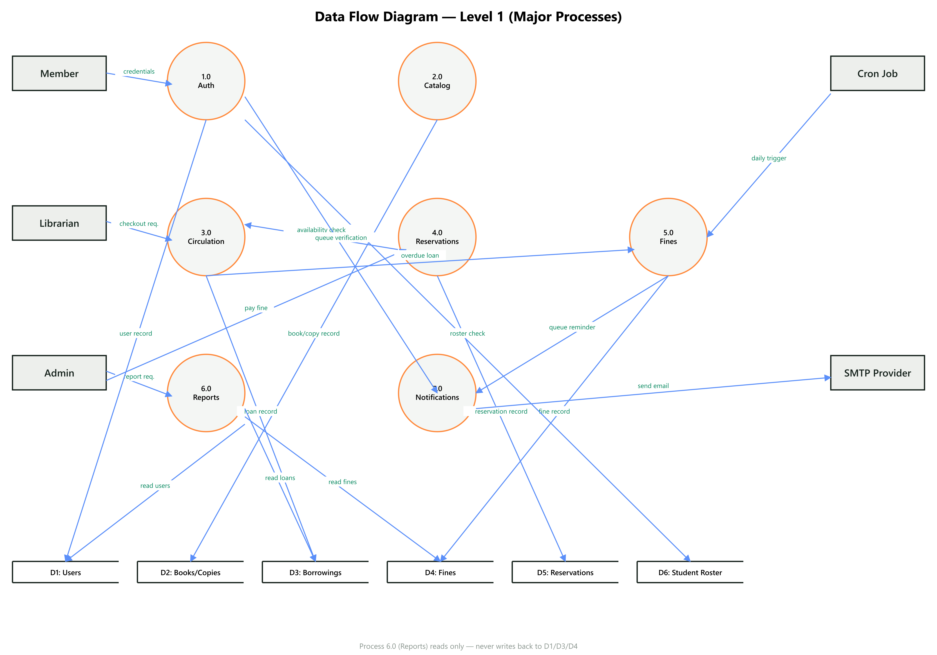
Figure 3.4 — Data Flow Diagram, Level 1 (Major Processes)

3.5 Database Schema and Normalization
All nine tables are normalized to Third Normal Form (3NF): every non-key attribute depends on the whole primary key and nothing but the key. The one deliberate denormalization is books.available_copies, which is maintained as a running counter rather than computed by counting book_copies rows on every request — a standard, intentional read-performance tradeoff, not a normalization defect.
Table | Purpose | Key Relationships
users | Member and staff accounts, roles, credentials | Referenced by borrowings, reservations
books | Catalog metadata (title, author, genre, ISBN, cover) | Has many book_copies, reservations
book_copies | Individual physical/circulating copies with a barcode and status | Belongs to books; referenced by borrowings
borrowings | A checkout transaction: who, which copy, dates, status | References users, book_copies; has one fines
fines | An overdue charge tied to one borrowing | References borrowings (1:0..1)
reservations | A pending or approved hold on a book | References users, books
library_settings | Configurable policy values (fine rate, max loans) | Independent
student_roster | Reference list used to verify registration | Independent (app-level check)
site_visits | Simple visit-count log | Independent

4. Implementation

4.1 Technology Stack
Layer | Technology
Backend runtime & language | Node.js, TypeScript, Express 5
Backend architecture | MVC (routes/controllers/services/repositories), tsyringe dependency injection, Zod validation
Database & ORM | SQLite via Prisma 7 (tracked, versioned migrations)
Authentication | JWT access + refresh tokens, bcrypt password hashing, Redis-backed token blacklist on logout
Background jobs | node-cron (daily fine processing, due-soon reminders) + BullMQ/Redis (email queue)
Frontend framework | Next.js 16 (App Router), React 19
Frontend styling | Tailwind CSS v4, custom "Signal" design token system
State & data fetching | Zustand (auth state), TanStack React Query (server state)
Testing | Jest + Supertest (backend), 64 tests across 10 suites
External integrations | OpenLibrary Books/Search API — cover art fetch and ISBN metadata lookup, no API key required

4.2 Key Features Implemented

4.2.1 Authentication & Account Management
Registration, login, logout, email verification, and password reset are all implemented against real endpoints. Passwords are hashed with bcrypt before storage; sessions use short-lived JWT access tokens plus longer-lived refresh tokens; logging out blacklists the active access token in Redis so it cannot be reused even before it naturally expires.

4.2.2 Catalog Search & Filtering
The member-facing catalog supports live, real-time search by title or author (filtering on every keystroke, no submit button), plus a genre filter and an availability filter, both derived from the real book data rather than a hardcoded list.

4.2.3 Circulation (Check-out / Check-in)
A dedicated Circulation Desk screen lets staff check out a book copy to a member (POST /borrowings) or process a return (POST /borrowings/return/:id). Checking out decrements the book’s available_copies count and marks the specific copy — not just the book — as checked out; returning reverses both effects and, if the loan was overdue, calculates and records a fine in the same transaction.

4.2.4 Reservations
Members can place a hold on a book that has no available copies; staff see a live reservations queue and can approve or decline each request. A member is prevented from placing a duplicate pending reservation on the same book.

4.2.5 Fines
Overdue fines are calculated in two places that were both verified against real data: synchronously, the moment an overdue book is returned; and in batch, via a daily cron job that upserts (rather than duplicates) a fine for every loan still overdue, at a per-day rate read from library_settings so it can be changed without a code deployment.

4.2.6 Automated Notifications
Two scheduled jobs send real emails via a BullMQ-backed queue: one runs daily at 09:00 and emails members whose loan is due within the next two days; the other runs daily at midnight alongside fine processing and emails members whose loan is now overdue, including the days overdue and the fine amount. A failed or slow email send is caught and logged without blocking fine calculation for the rest of the batch.

4.2.7 Reporting
The Reports screen surfaces active-loan count, an overdue-rate percentage, a most-borrowed-titles chart built from real circulation data (no charting library — deliberately simple bar visualizations, per the brief), and a flagged-accounts table combining blocked-status users with users who have unpaid fines.

4.2.8 Inventory Management & ISBN Lookup
Staff can add, edit, and delete books. Adding a book with a valid ISBN automatically (a) fetches and caches a real cover image from OpenLibrary, and (b) can auto-fill the title, author, and subject from the same ISBN via a "Lookup" action, so a librarian only has to type the ISBN for a well-known title. Creating a book also generates the correct number of individual book_copies records, which is what actually makes checkout possible (see Section 5.2 for how this was discovered and fixed).

4.2.9 Catalog Population
A repeatable seed script (npm run seed:books) queries OpenLibrary’s public search API by subject — Engineering, Computer Science, Physics, Business, Mathematics, Chemistry, Biology, Electrical Engineering, Economics, Agriculture, and Fiction — and imports real, deduplicated books with real ISBNs and cover art directly into the catalog. This was used to populate the system with 52 real books rather than placeholder test data.

4.3 Visual Design System ("Signal")
The frontend uses a purpose-built design system rather than a generic UI kit. Its core rule is a deliberate accessibility choice: every screen a student/member sees defaults to a light, high-contrast surface (#F4F6F4 background, #14201A text), while every staff/admin screen defaults to a dark, terminal-inspired surface (#111412 background, #E9EDEA text) — the application does not force one theme on everyone. Status is always communicated with both a color and a distinct icon shape (never color alone), so the interface remains usable for colorblind users. Data-heavy text — ISBNs, dates, IDs, barcodes — is set in a monospace typeface (Space Mono) for scannability, while body copy uses a standard sans-serif for readability.

4.4 Security Measures
- Passwords are never stored in plaintext — bcrypt hashing with a salt round of 10.
- JWT access tokens are short-lived (15 minutes); refresh tokens are stored server-side in Redis so a logout can actually invalidate a session, not just delete a client-side cookie.
- Every state-changing endpoint validates its request body against a Zod schema before touching the database.
- Role-based access control (authorize middleware) is enforced at the route level for every staff/admin endpoint, and re-checked in this project’s test suite (Section 5.1).
- CORS is restricted to an explicit allow-list of origins read from configuration, not left open to any origin.
- Rate limiting is applied globally to reduce brute-force risk on the API.

5. Testing and Validation

5.1 Automated Test Suite
The backend is covered by 64 automated tests across 10 Jest test suites, run with npx jest and gated in CI on every push. Tests use mocked Prisma/Redis clients so they run deterministically without a live database or Redis instance.
Test Suite | What It Verifies
auth.test.ts | Login success/failure, JWT issuance, logout token blacklisting, authenticate/authorize middleware (expired tokens, wrong secret, missing header, role checks)
fines.service.test.ts | Fine calculation: no fine before due date, no fine at the exact due-date boundary, correct amount at custom rates, day-rounding on partial-day overdues
reservations.test.ts | Create, list, approve, and cancel reservations; duplicate-reservation rejection; book-not-found handling
borrowings.controller.test.ts | Role-based data scoping — staff see every loan/fine, a member sees only their own
books.controller.test.ts | Book creation generates the correct number of book_copies records
bookCover.service.test.ts | Cover cache hit/miss, OpenLibrary placeholder-image filtering, network failure and disk-write failure fallbacks
bookLookup.service.test.ts | ISBN metadata lookup success, not-found, and network-failure fallback
cron.service.test.ts | Daily fine processing, due-soon reminder queuing, resilience to a failed email send
circulation.service.test.ts | Checkout validation (unavailable copy, loan limit, unpaid-fine block)
settings.integration.test.ts | Settings read/update via the real Express router

5.2 Manual End-to-End Verification
Automated tests verify logic in isolation; the system was additionally exercised live, in a running browser, against the real backend and a real (if local) Redis instance, as both a staff account and a registered student account. This surfaced and fixed real defects that unit tests alone did not catch:
- Checkout was completely non-functional for every book in the system. Creating a book set a total_copies counter but never generated the individual book_copies records that checkout actually references by ID — so there was nothing to check out. Fixed by generating matching book_copies rows on creation, with a one-time backfill for books that already existed; verified by performing a real checkout and return through the UI and confirming available_copies moved 3 → 2 → 3.
- The Admin role was silently blocked from checkout, return, and fine-payment actions — those three endpoints authorized only the librarian role, inconsistent with every other staff endpoint in the system, which allow both. Fixed and re-verified live.
- Three books imported from OpenLibrary landed under a mismatched genre due to imprecise third-party subject tagging (e.g. a chemistry textbook tagged "physics"). Corrected by hand after review.
- The book-cover fetch timeout (originally 3 seconds, per the design spec) was measured to be too tight for this environment’s real network latency (~3.1s observed) and was failing more often than it should; increased to 5 seconds and re-verified.
After these fixes, the full cycle was confirmed working end-to-end: an admin account checked out a copy to a student account, the book’s available-copy count updated correctly, the loan appeared in the student’s own "My Dashboard" (role-scoped to that student only), the book was returned, the count reverted, and the completed loan appeared correctly in that student’s borrowing history.

5.3 Known Issues and Limitations
The following gaps are documented deliberately rather than hidden — the system’s own UI states them plainly where they are user-visible:
- A member can see their own loans and fines (fixed this iteration), but cannot yet see a personal, filtered list of just their own reservations — GET /reservations exists and is used by staff, but is not yet scoped per member.
- Editing a book’s total_copies through the Edit Book form does not reconcile the underlying book_copies records — only initial creation does. Increasing or decreasing the count after the fact would need a follow-up feature.
- The system has not been deployed to a public host; it currently runs in a local development environment (documented for reproducibility in the repository README).
- There is no automated frontend test suite yet (backend-only); this was identified and consciously deferred rather than overlooked.

6. Results and Discussion
Measured against the six objectives from Section 1.2:
# | Objective | Status
1 | Automate check-in/check-out, reservations, overdue notifications | Met — all three verified live, including a real bug found and fixed in checkout itself
2 | Secure account management for members and staff | Met — JWT + bcrypt + role-based access control, tested
3 | Efficient catalog search and filter | Met — real-time search, genre and availability filters
4 | Accurate real-time inventory data | Met — available_copies verified to update correctly on every checkout/return
5 | Reporting on circulation, overdue items, popular resources | Met — Reports screen built from live circulation data
6 | Modularity and scalability | Met — layered MVC backend, componentized frontend, 64 automated tests as a regression safety net for future changes

The most significant finding of this project was not a feature gap but a process one: automated unit tests, however thorough, did not catch that checkout was entirely non-functional, because the tests mocked the very data layer where the defect lived. It took manually operating the running application — the "Testing & Validation" phase of the brief’s own methodology — to discover it. This is a genuine, transferable lesson about the limits of unit testing in isolation from integration and manual verification.

7. Conclusion and Future Work
SmartLib meets its stated objectives as a working prototype: it automates circulation, reservations, and notifications; enforces secure, role-based account management; provides real-time inventory and reporting; and is built on a modular architecture intended to support future growth. It manages a real catalog of 52 books across 12 subjects, sourced automatically rather than by hand, and its core workflows have been verified both by an automated test suite and by live, manual end-to-end operation as multiple user roles.

Recommended Future Work
- Scope a member-facing "my reservations" endpoint to close the last known self-service gap.
- Add a frontend automated test suite (e.g. Vitest + React Testing Library) to match the backend’s coverage.
- Reconcile book_copies when a book’s copy count is edited, not just on initial creation.
- Deploy to a public host with a production-grade Redis instance and a CI/CD release pipeline.
- Optional hardware integration: a barcode scanner at the circulation desk, as suggested (but not required) by the original project brief.

Appendix A — Repository and Reproducibility
Full source, commit history, and this report’s source diagrams are available in the project repository.
- Repository: github.com/lenoxspider/automated_library
- Branch: main
- Diagrams source (Mermaid + generated SVG/PNG): docs/diagrams/
- To run locally: npm install, npx prisma migrate deploy, npm run seed (admin user), npm run seed:books (catalog), npm run dev (backend) and cd client && npm run dev (frontend).
- To run the automated test suite: npm test.

