LABORATORY WORK NO. 10
LAYER 2 NETWORKS, SPANNING TREE PROTOCOL, LINK AGGREGATION AND ETHERCHANNEL

1. Objectives
At the end of the lab, students will be able to explain the functions of the switches, the Spanning-tree and EtherChannel operation, and to configure Layer 2 networks.

2. Theoretical considerations
The current practical work focuses on the Data Link layer of the ISO/OSI stack (Figure 11.1).
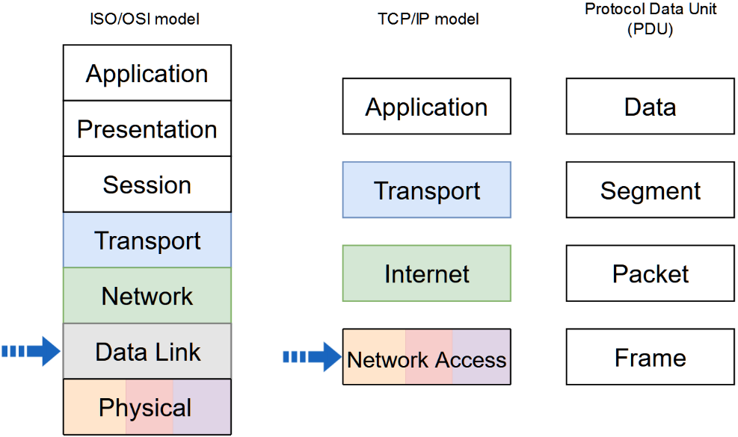
Figure 11.1 Network stack models and PDU naming in each level. The arrows indicate the addressed layers in the current activity
2.1 Switches and bridges
Switches and bridges are layer 2 devices that are used to increase available bandwidth and reduce network congestion. Switches and bridges perform two basic operations: switching data frames and maintaining switching operations. Switches and bridges segment the LAN creating multiple smaller collision domains. Each port creates one segment which is a collision domain because the switch or the bridge learns the MAC addresses of devices connected to each port, enters this information into a switching or bridging table and forwards or blocks traffic based on that table (Figure 11.2). Segmentation allows network congestion to be significantly reduced within each segment. The devices within that segment share the total available bandwidth. If the switch or the bridge does not know where to send the frame, it broadcasts the frame out to all ports. When a reply is returned, the switch or the bridge records the new address in the switching or bridging table. Another advantage of the switched connection is that it permits full-duplex Ethernet which allows the transmission of a packet and the reception of a different packet at the same time. The disadvantage of layer 2 devices is that they forward broadcast frames to all connected devices on the network, so all hosts connected to the switch or bridge are still part of the same broadcast domain.
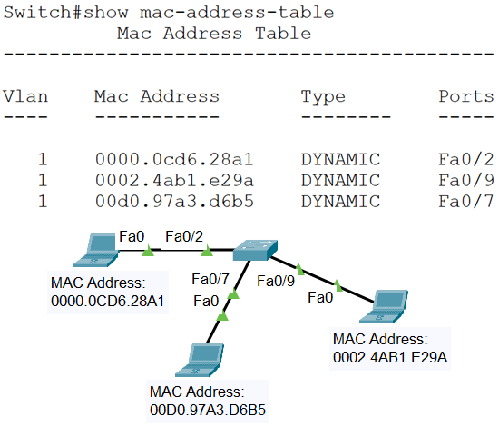
Figure 11.2 Switching table
Switching is classified as symmetric or asymmetric. Symmetric switching provides switched connections between ports with the same bandwidth. Asymmetric switching provides switched connections between ports of unlike bandwidth. Asymmetric switching enables more bandwidth to be dedicated to the server switch port in order to prevent a bottleneck.
Switching modes are classified as store-and-forward or cut-through, each mode representing a compromise between latency and error detection. In store-and-forward switching mode the entire frame is received before any forwarding takes place. This switching mode increases the transmission latency and allows more error detection. In cut-through switching mode the frame is forwarded through the switch before the entire frame is received. At least the frame destination address must be read before the frame can be forwarded. This switching mode decreases the transmission latency and allows less error detection. Cut-through switching mode has two forms: fast-forward and fragment-free. Fast-forward switching forwards the packet after reading the destination address. This switching mode has the lowest level of latency and error detection. Fragment-free switching forwards the packet after reading the first 64 bytes of the frame. Because collision fragments are smaller than 64 bytes, fragment-free switching mode filters out this type of error which also represents the majority of packet errors. This switching mode has a higher level of latency and error detection than the fast-forward mode.
2.2 Spanning-Tree Protocol
Redundant networking topologies increase the reliability of the network by introducing redundant links. These connections introduce physical loops into the network. Because layer 2 has no mechanism to eliminate lost frames, the frames can loop forever in a layer 2 looped topology causing two types of problems to appear: broadcast storm and switching or bridging table instability. The broadcast storm is created by endlessly flooded broadcast frames too all ports of the switches or bridges, wasting the bandwidth or making the network unusable. Switching or bridging table instability appears when multiple copy of a frame arrive at different ports of a switch or a bridge causing MAC entry instability in the switching or bridging table. The IEEE 802.1d Spanning-Tree Protocol uses the spanning-tree algorithm to create loop free shortest path logical topology in a layer 2 looped topology. The IEEE 802.1w Rapid Spanning-Tree Protocol uses a rapid spanning-tree algorithm to perform the same function as spanning-tree algorithm with a shorter convergence time.
Spanning-Tree Protocol uses Bridge Protocol Data Unit (BPDU) multicast layer 2 messages which are sent by the network devices every two seconds by default. The structure of these messages is presented in Figure 11.3.
Root BID | Root Path Cost | Sender BID | Port ID
Figure 11.3 BPDU message structure
The BID is an 8-byte field. The two high order bytes are the bridge or switch priority that defaults to 32768 and the six low order bytes are the MAC address of the bridge or switch. The BID structure is presented in Figure 11.4.
7 | 6 | 5 | 4 | 3 | 2 | 1 | 0
Bridge Priority |  | MAC address
Figure 11.4 BID structure
Spanning-Tree Protocol calculates the shortest path network based on cumulative link costs. Link costs are based on the speed of the link. Some of the link costs defined by the IEEE 802.1D standard are presented in Table 11.1.

Table 11.1 Link costs defined by the IEEE 802.1D standard
Link Speed | Cost
4Mbps | 250
10Mbps | 100
16Mbps | 62
100Mbps | 19
1Gbps | 4
10Gbps | 2
Some of the link costs defined by the IEEE 802.1w standard are presented in Table 11.2.

Table 11.2 Link costs defined by the IEEE 802.1w standard
Link Speed | Cost
10Mbps | 2000000
100Mbps | 200000
1Gbps | 20000
10Gbps | 2000
1Tbps | 20
10Tbps | 2
The Port ID is a 2-byte field. The high order byte is the port priority that defaults to 128 and the low order byte is the port number. The Port ID structure is presented in Figure 11.5.
1 | 0
Port Priority | Port Number
Figure 11.5 Port ID structure
The Spanning-Tree Protocol establishes a single root node, called root bridge and constructs a topology that has one path for reaching every network node. The resulting tree originates from the root bridge. The bridges and switches calculate the shortest path from itself to the root bridge. The first decision that all bridges or switches in the network make is the root bridge identification, which is done through BPDU messages that are received by all bridges and switches. All other decisions in the network are made regarding this root bridge. When a bridge or switch first starts up, it assumes it is the root and sends BPDU-s containing the bridge or switch MAC address in both the root and sender BID. If a bridge or switch receives a BPDU with a lower root BID it sets this root BID in the BPDU-s that are sent out. The bridge or switch with the smallest BID value will be the root bridge. Setting the bridge or switch priority to a smaller value than the default will make the BID smaller and will influence the root bridge identification. For each LAN segment, Spanning-Tree Protocol establishes a designated switch as the closest one to the root bridge which handles all communication from that LAN towards the root bridge. For each non-root bridge a root port is elected, which gives the best path to the root bridge. So, the port with the lowest path cost to the root bridge is elected as the root port. If multiple ports have the same path cost to the root bridge, the port with lowest Port ID is selected as the root port. The Spanning-Tree Protocol also selects the designated ports which are part of the shortest path tree. So, the port with the lowest path cost to the root bridge is selected as the designated port. If more than one port in the segment has the same path cost, the port on which the bridge or the switch has the lowest bridge or switch ID is selected as designated port. On the root bridge, all its ports are designated ports. Redundant links that are not part of the shortest path tree are blocked and data frames received on blocked links are dropped.
Each port on a bridge or switch that is using the Spanning-Tree Protocol has one of the following five states: blocking, listening, learning, forwarding and disabled. In the blocking state ports can only receive BPDU-s, data frames are discarded and no addresses can be learned. It may take up to 20 seconds to change from this state. Ports go from the blocking state to the listening state. In this state, the switches or bridges determine if there are any other paths to the root bridge. The path that is not the least cost path to the root bridge goes back to the blocked state. In the listening state BPDU-s are processed, user data is not being forwarded and MAC addresses are not being learned. The listening period is called the forward delay and lasts for 15 seconds. Ports go from the listening to the learning state. In this state BPDU-s are processed, user data is not being forwarded, but MAC addresses are learned from any traffic that is seen. The learning state is also called the forward delay and lasts for 15 seconds. A port goes from the learning state to the forwarding state. In this state BPDU-s are processed, user data is forwarded and MAC addresses continue to be learned. The port can be in disabled state when it is administratively down or fails. The time values given for each state are the default values. These values have been calculated on an assumption that there will be a maximum of seven switches in any branch of the spanning tree from the root bridge. When the network topology changes, switches and bridges recompute the Spanning Tree. Convergence on a new spanning-tree topology using the IEEE 802.1D standard can take up to 50 seconds.
2.3 EtherChannel
Link aggregation is the ability to create one logical link using multiple physical links between two devices. EtherChannel is a form of link aggregation used in switched networks (Figure 11.6). This allows for redundancy and higher bandwidth through load sharing among the physical links. EtherChannel creates a one-to-one relationship; that is, one EtherChannel link connects only two devices. An EtherChannel link can be created between two switches or an EtherChannel link can be created between an EtherChannel-enabled server and a switch.
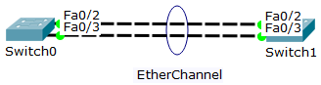
Figure 11.6 EtherChannel
EtherChannel technology was originally developed by Cisco as a LAN switch-to-switch technique of grouping several physical ports into one logical channel. When an EtherChannel is configured, the resulting virtual interface is called a port channel. The physical interfaces are bundled together into a port channel interface (Figure 11.7). Most configuration tasks can be done on the EtherChannel interface instead of on each individual port, ensuring configuration consistency throughout the links.
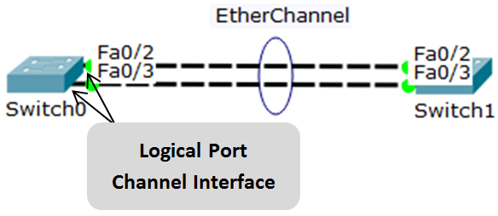
Figure 11.7 Port channel interface
EtherChannel relies on existing switch ports. There is no need to upgrade the link to a faster and more expensive connection to have more bandwidth.
Load balancing takes place between links that are part of the same EtherChannel. Depending on the hardware platform, one or more load-balancing methods can be implemented. These methods include source MAC to destination MAC load balancing, or source IP to destination IP load balancing, across the physical links.
EtherChannel creates an aggregation that is seen as one logical link. Where there is only one EtherChannel link, all physical links in the EtherChannel are active because STP sees only one logical link.
EtherChannel provides redundancy because the overall link is seen as one logical connection. Additionally, the loss of one physical link within the channel does not create a change in the topology; therefore a spanning-tree recalculation is not required. Assuming at least one physical link is present, the EtherChannel remains functional, even if its overall throughput decreases because of a lost link within the EtherChannel. The spanning-tree cost is calculated based on the number of ports assigned to the port-channel and it does not dynamically change when links go down or are brought back up within the port-channel. Spanning-Tree Protocol calculates the shortest path network based on cumulative link costs. Link costs are based on the speed of the link. Some of the link costs for links defined by the IEEE 802.1D standard are presented in Table 11.3.

Table 11.3 Link costs defined by the IEEE 802.1D standard
Link Speed | Cost (Short mode – 16bit)
10Mbps | 100
100Mbps | 19
Two-port * 100Mbps EtherChannel | 9
Three-port * 100Mbps EtherChannel | 8
Four-port * 100Mbps EtherChannel | 7
Five-port * 100Mbps EtherChannel | 6
Six-port * 100Mbps EtherChannel | 5
Seven-port * 100Mbps EtherChannel | 5
Eight-port * 100Mbps EtherChannel | 5
1Gbps | 4
Two-port * 1Gbps EtherChannel | 3
Three-port * 1Gbps EtherChannel | 2
Four-port * 1Gbps EtherChannel | 2
Five-port * 1Gbps EtherChannel | 2
Six-port * 1Gbps EtherChannel | 2
Seven-port * 1Gbps EtherChannel | 2
Eight-port * 1Gbps EtherChannel | 1
10Gbps | 2
Two-port * 10Gbps EtherChannel | 1
Interface types cannot be mixed; they must be compatible-configured Ethernet ports. The individual EtherChannel group member port configuration must be consistent on both devices. If the physical ports of one side are configured as trunks, the physical ports of the other side must also be configured as trunks within the same native VLAN. Additionally, all ports in each EtherChannel link must be configured as Layer 2 ports. Each EtherChannel has a logical port channel interface. A configuration applied to the port channel interface affects all physical interfaces that are assigned to that interface. Layer 3 EtherChannels can be configured on Cisco Catalyst multilayer switches. A Layer 3 EtherChannel has a single IP address associated with the logical aggregation of switch ports in the EtherChannel.
The maximum number of physical ports in an EtherChannel link depends on the switch hardware platform and IOS version. Usually each EtherChannel can consist of up to 8 compatible-configured Ethernet ports.
The maximum number of EtherChannels supported by a switch depends on the hardware platform and IOS version. The Cisco IOS switch can usually support 6 EtherChannels.
EtherChannel can be configured static, unconditional or it can be formed through negotiation using one of two protocols: Port Aggregation Protocol (PAgP) or Link Aggregation Control Protocol (LACP). These protocols allow ports with similar characteristics to form a channel through dynamic negotiation with adjoining switches.
PAgP is a Cisco-proprietary protocol that aids in the automatic creation and management of EtherChannel links. There are three modes for PAgP: on, desirable and auto. The on mode forces the interface to channel without PAgP. The desirable mode places an interface in an active negotiating state in which the interface initiates negotiations with other interfaces by sending PAgP packets. The auto mode places an interface in a passive negotiating state in which the interface responds to the PAgP packets that it receives, but does not initiate PAgP negotiation. Figure 11.8 presents the channel establishment when ports of switches S1 and S2 are in the different modes for PAgP.
S1 | S2 | Channel Establishment
On | On | Yes
Auto/Desirable | Desirable | Yes
On/Auto/Desirable | Not Configured | No
On | Desirable | No
Auto/On | Auto | No
Figure 11.8 Channel establishment with PAgP
LACP is part of an IEEE specification (802.3ad) that allows several physical ports to be bundled to form a single logical channel. LACP is also defined in IEEE 802.1AX standard for local and metropolitan area networks. LACP allows a switch to negotiate an automatic bundle by sending LACP packets to the peer. It performs a function similar to PAgP. Because LACP is an IEEE standard, it can be used to facilitate EtherChannels in multi vendor environments. There are three modes for LACP: on, active and passive. The on mode forces the interface to channel without LACP. The active mode places a port in an active negotiating state in which the port initiates negotiations with other ports by sending LACP packets. The passive mode places a port in a passive negotiating state in which the port responds to the LACP packets that it receives, but does not initiate LACP packet negotiation.

Figure 11.9 presents the channel establishment when ports of switches S1 and S2 are in the different modes for LACP.
S1 | S2 | Channel Establishment
On | On | Yes
Active/Pasive | Active | Yes
On/Active/Passive | Not Configured | No
On | Active | No
Passive/On | Passive | No
Figure 11.9 Channel establishment with LACP
3. Lab activity
3.1 Discuss the theoretical aspects presented in this chapter.
3.2 Switch configuration
Cisco switches and routers use a very similar command-line interface (CLI) which is used for configuration and verification purposes.
The help command is question mark (?) which displays the list of commands available for the current command mode, the list of commands that begin with a particular character sequence or the list of keywords or arguments that are associated with a particular command.
Switches have several command modes. The User EXEC mode has a limited command set that can change terminal settings, perform basic tests, or display system information. The enable command is used to change from User EXEC mode to Privileged EXEC mode. The Privileged EXEC mode has a larger command set that includes the User EXEC mode command set and the configure command used to change from Privileged EXEC mode to global configuration mode. Global configuration mode allows other command modes to be accessed, which are used to configure the switch. The command exit is used to exit back from a command mode.
Issue show running-config command to view the current configuration file of the switch.
Enter the Privileged EXEC mode with the enable command.
Issue copy running-config startup-config command to copy the current configuration file to back up configuration file.
In order to completely erase the switch configuration, the following steps have to be followed:

Delete the VLAN database file vlan.dat from the flash directory with the delete flash:vlan.dat command.

Erase the backup configuration file startup-config with the erase startup-config command.

Reload the switch with the reload command.
Switch# enable
Switch# copy running-config startup-config
Switch# delete flash:vlan.dat
Switch# erase startup-config
Switch# reload
Change from Privileged EXEC mode to global configuration mode with the configure terminal command.
Set the switch name with the hostname host_name command.
Switch# enable
Switch# configure terminal
Switch(config)# hostname SWITCH_EXAMPLE

Configure the primary terminal line with the following commands:
Switch(config)# line console 0
Switch(config-line)# password password
Switch(config-line)# login
Switch(config-line)# exit

Configure virtual terminal with the following commands:
Switch(config)# line vty 0 4
Switch(config-line)# password secret_password
Switch(config-line)# login
Switch(config-line)# exit

In order to allow the switch to be accessible by TCP/IP applications, IP addresses and a default gateway should be set. This allows switch configuration using a telnet or ssh connection. Unlike routers, in the case of switches, IP addresses are configured on VLAN interfaces. Configure IP address and default gateway with the following commands:
Switch(config)# interface VLAN1
Switch(config-if)# ip address ip_address netmask
Switch(config-if)# no shutdown
Switch(config-if)# exit
Switch(config)# ip default-gateway default_gateway_address
3.3 Spanning Tree
Step 1: Configure the network presented in Figure 11.10. If the amber port LED in your topology is not in the same position as in the picture, move the switches so that the amber port LED to be as it is in the figure.
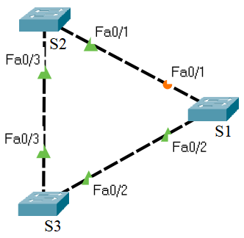
Figure 11.10 Test network topology
- Specify the host names for the switches
- Examine the Spanning Tree configuration
- The port LED color is green if the port is in forwarding state, while the port LED color is amber if the port is in blocking state.
- View the Spanning Tree information on each switch, with the corresponding show command. Examine and explain the output of the command.
General syntax:
Switch# show spanning-tree
Description: Displays Spanning Tree information
- Answer the following questions:
- Why is this topology useful and implemented in computer networks?
- Which switch is the root bridge and why?
Step 2: To the previous topology connect the users to S2 and S3 switches and add the router that connects the network to other networks like in the Figure 11.11. In this way, an extended star topology with a backup path is obtained.
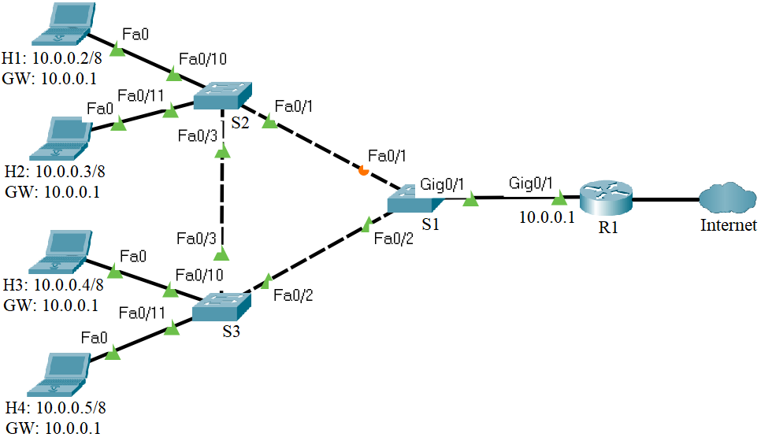
Figure 11.11 Test network topology
Before configuring the network devices, discuss the IPv4 address assignment in the Table 11.4:

Table 11.4 IPv4 addresses for the test network
Device | Interface | IP Address | Netmask | Gateway
Laptop H1 | Fa0 | 10.0.0.2 | 255.0.0.0 | 10.0.0.1
Laptop H2 | Fa0 | 10.0.0.3 | 255.0.0.0 | 10.0.0.1
Laptop H3 | Fa0 | 10.0.0.4 | 255.0.0.0 | 10.0.0.1
Laptop H4 | Fa0 | 10.0.0.5 | 255.0.0.0 | 10.0.0.1
R1 | Gig0/1 | 10.0.0.1 | 255.0.0.0 | -

- Specify the host name for the router
- Assign the IP information to the hosts and the router
- Test the connectivity between the hosts and the router using the ping command
- Analyze the network and answer the following questions:
- Which path should be the backup path (redundant link) and why?
- Which switch should be the root bridge to obtain the optimal paths in the Layer 2 network?
- What configuration should be done so that a particular switch becomes the root bridge regardless of the MAC addresses of the switches on the network?
- Change the root switch by changing its priority to a lower value than the default value

General syntax:
Switch(config)# spanning-tree vlan vlan_number priority priority_number
Description: Changes the Spanning-tree priority of the switch
Consider: switch S1, vlan 1 and priority 0
- Issue show spanning-tree command (Figure 11.12) several times to view the Spanning Tree information on switch S1
- Pay attention to the following:
  - Switch S1 becomes the root bridge
  - The port in the blocking state goes to the forwarding state passing through listening and learning states

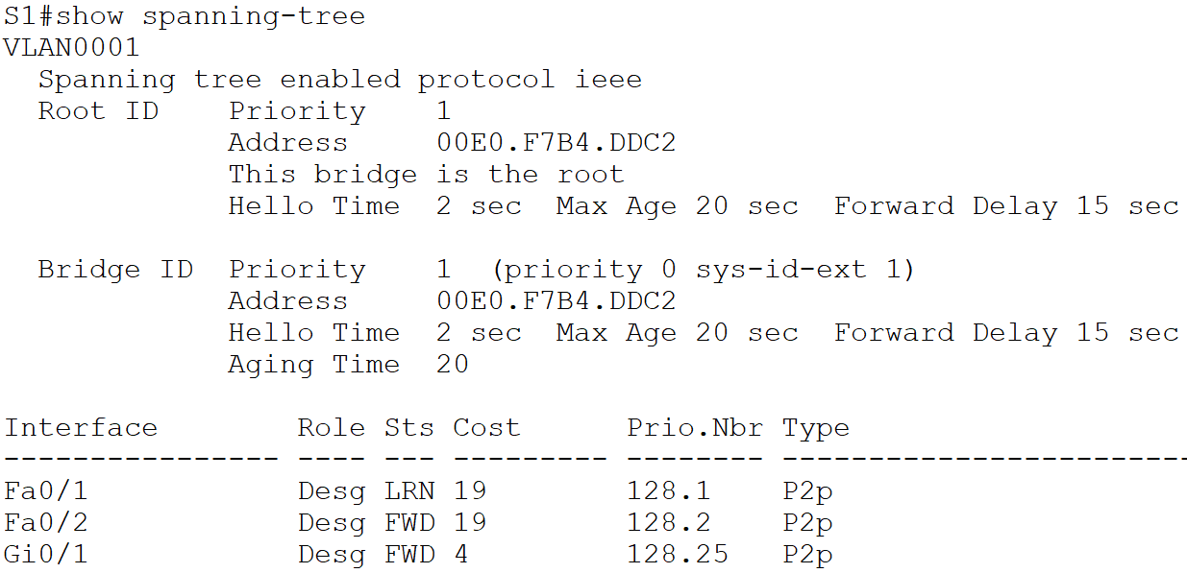
Figure 11.12 Show spanning-tree command output for S1
- In the network topology, the amber port LED becomes green while a port LED between S2 and S3 switches becomes amber (Figure 11.13). The link between S1 and S2 forwards the traffic while the link between S2 and S3 becomes the backup path, the redundant link. Issue show spanning-tree command (Figure 11.14) to view the Spanning Tree information on the switch having the amber port LED.
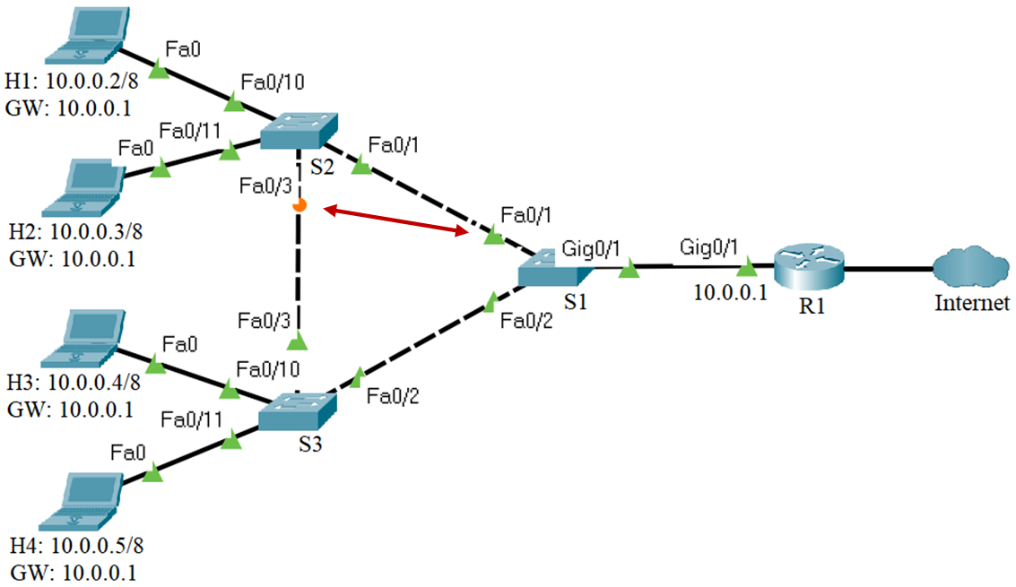
Figure 11.13 STP changes the state of the ports
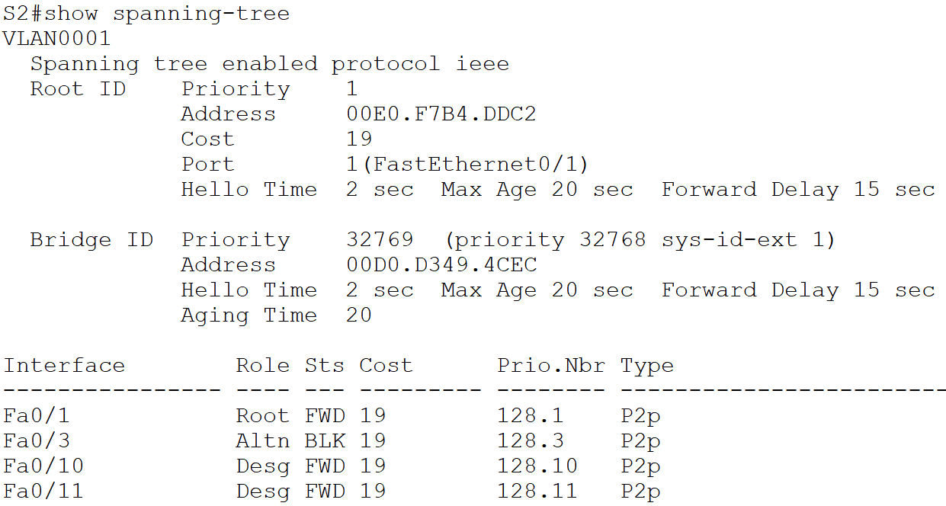
Figure 11.14 Show spanning-tree command output for the switch having the amber port LED

- Continuously test the connectivity between the host H1 and the router using the ping command with -t option (Figure 11.15)

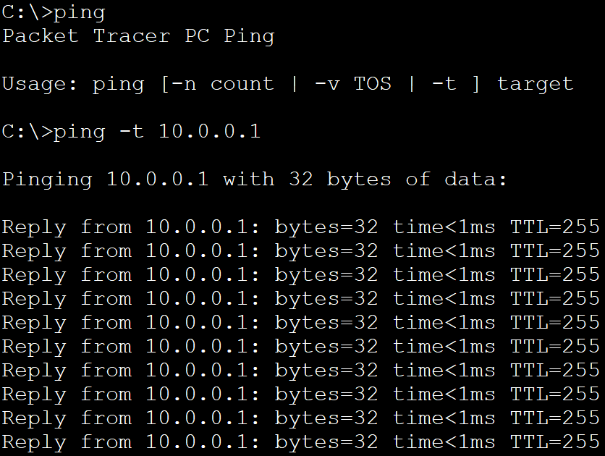
Figure 11.15 Connectivity test between the host H1 and the router
- While the ping command is testing the connectivity between the host H1 and the router, remove the link between the S1 and the S2 switches (Figure 11.16).
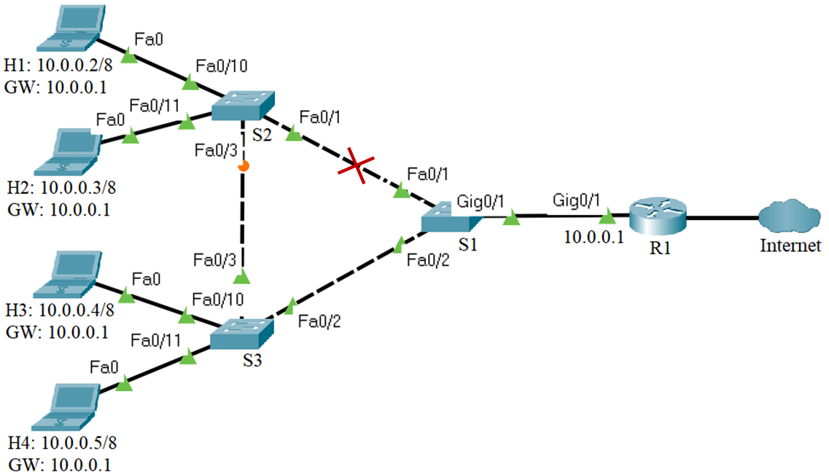
Figure 11.16 Removing the link between S1 and S2 switches
- Issue show spanning-tree command (Figure 11.17) several times to view the Spanning Tree information on switch S2; pay attention to the port in the blocking state, it goes to the forwarding state passing through listening and learning states

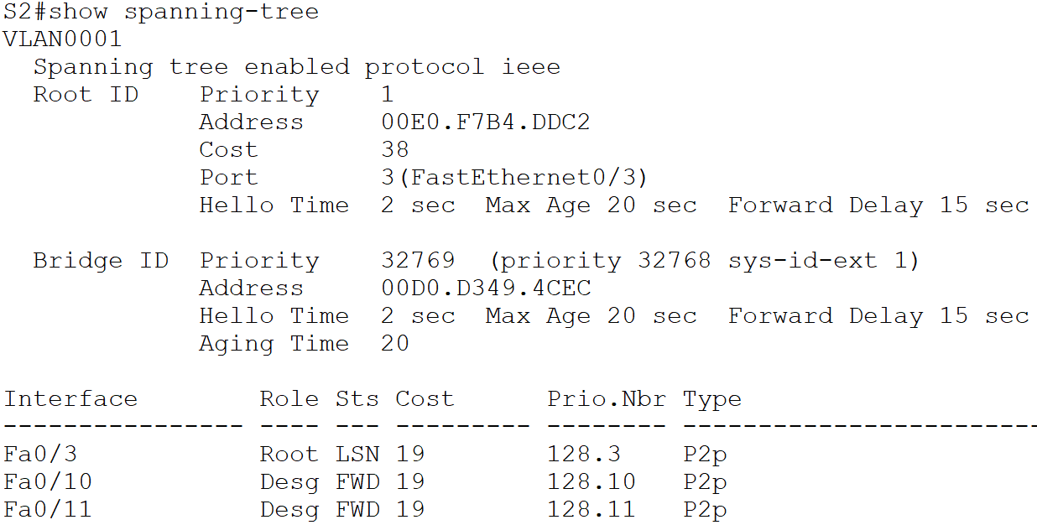
Figure 11.17 Show spanning-tree command output for S2
- In the network topology, the amber port LED becomes green (Figure 11.18), the link between S2 and S3 forwards the traffic.

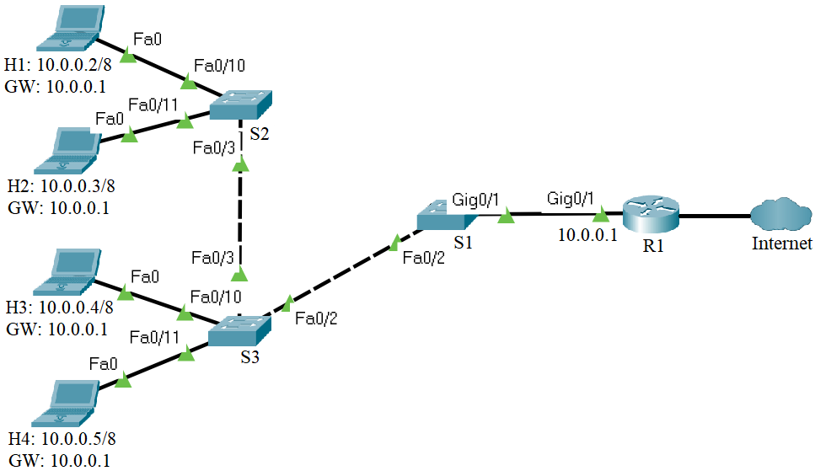
Figure 11.18 STP changes the state of the ports
- The Spanning-tree protocol restores connectivity between the H1 host and the router through the redundant link (Figure 11.19)

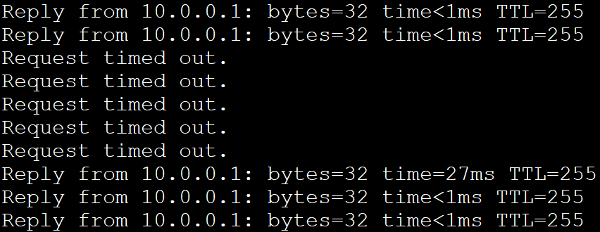
Figure 11.19 Connectivity test between the host H1 and the router
- Restore the link between the S1 and the S2 switches and observe how Spanning-tree protocol chooses the shortest paths to the root bridge and blocks the redundant links (Figure 11.20).
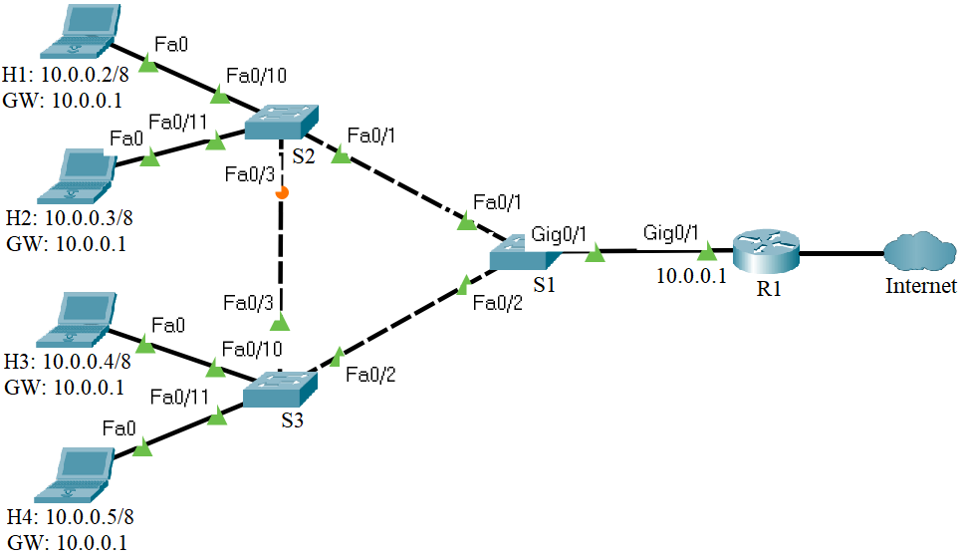
Figure 11.20 Restoring the link between S1 and S2 switches

3.4 EtherChannel
Cable the network presented in the Figure 11.21.
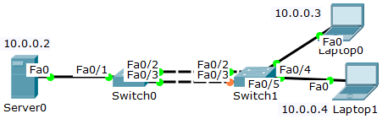
Figure 11.21 Test network topology
Before configuring the network devices, discuss the IPv4 address assignment in the Table 11.5:

Table 11.5 IPv4 addresses for the test network
Device | Interface | IP Address | Netmask
Server0 | Fa0 | 10.0.0.2 | 255.0.0.0
Laptop 0 | Fa0 | 10.0.0.3 | 255.0.0.0
Laptop 1 | Fa0 | 10.0.0.4 | 255.0.0.0
- Configure the IP addresses on the hosts.
- Verify the connectivity between the laptops and Server0 with the ping command.
- Connect to the Switch0 and enter the Privileged EXEC mode. View the Spanning Tree information with the show spanning-tree command. Examine and explain the output of this command.
Switch0#show spanning-tree
- Repeat the previous step for Switch1.
- Connect to Switch0 and specify the interfaces that compose the EtherChannel group using the interface range interface global configuration mode command. Create the port channel interface with the channel-group identifier mode on command in interface range configuration mode. The identifier specifies a channel group number.
Switch0(config)#interface range fastEthernet 0/2-3
Switch0(config-if-range)#channel-group 1 mode on
- Repeat the previous step for Switch1.
- Connect to the Switch0 and enter the Privileged EXEC mode. View the running-config file with the show running-config command. Examine and explain the output of this command. View the Etherchannel information with the show etherchannel summary command. Examine and explain the output of this command. View the Spanning Tree information with the show spanning-tree command. Examine and explain the output of this command.
Switch0#show running-config
Switch0#show etherchannel summary
Switch0#show spanning-tree
- Repeat the previous step for Switch1.
- Connect to Switch0 and enter port channel interface configuration mode using the interface port-channel command, followed by the interface identifier. Configure the EtherChannel as a trunk interface using the switchport mode trunk command.
Switch0(config)#interface port-channel 1
Switch0(config-if)#switchport mode trunk
- Repeat the previous step for Switch1.
- Connect to the Switch0 and enter the Privileged EXEC mode. View the running-config file with the show running-config command. Examine and explain the output of this command. View the trunking information with the show interfaces trunk command. Examine and explain the output of this command.
Switch0#show running-config
Switch0#show interfaces trunk
- Repeat the previous step for Switch1.
- Connect to Switch0 and configure EtherChannel load balancing method using the port-channel load-balance global configuration mode command. Select the load-distribution method based on the destination-host MAC address of the incoming packet (dst-mac). Enter the Privileged EXEC mode and view the EtherChannel load balancing method information with the show etherchannel load-balance command. Examine and explain the output of this command.
Switch0(config)#port-channel load-balance dst-mac
Switch0(config)#end
Switch0#show etherchannel load-balance

