CO2 Emissions Impact of a Local Microgrid: a case study in Southern California

As renewable energy penetration in electric grids increases with time, it becomes more important for electric utilities to update their electric rates such that they minimize CO2 emissions. In this paper, we evaluate a case study at the University of California, Riverside (UCR) to simulate different Time of Use (TOU) rate optimizations that minimize CO2. Using the openmodelica model, we based off of different electric utility rates in Southern California. The different amounts of power and energy consumed by each rate is compared with CAISO CO2 emissions data in order to see the different emission levels from the different utility electric rates on a 15 minute basis. Pricing is also compared in order to see the different savings the consumer will have with the different rates. It was found that Southern California Edison (SCE) TOU rate had the most savings for the consumer and that Riverside (RPU) TOU flat rate had the lowest CO2 emissions.

micorgrids, demand response, TOU

# Introduction

## Background

California is going through a major transition in energy production, which involves a higher share of renewable energy in the electricity mix. This is to meet California's climate goals of a 48% reduction in greenhouse gas by 2030 . However, achieving that goal will involve utility companies, government agencies, and consumers to all play a role. Many industrial and commercial sites are adopting not only by installing solar, but introducing battery energy storage systems as well. Since January 2023, California law requires new commercial buildings to have solar and battery storage systems installed . This has major potential in addressing current issues associated with solar power as a large percentage of the energy mix. The infamous duck curve has only been getting steeper in recent years, leading to a huge stress onto the grid and concerns about reliability . Equally as important, while California has a relatively clean grid during solar peak production hours, the electrical demand does not align with these low CO2 emissions times and relies on the grid during when CO2 emissions are higher. Battery energy storage systems (BESS) have been proposed as one of the solutions to mitigate the duck curve problems. This paper reviews rates(flat, TOU) of various utility companies coupled with a typical microgrid at UC Riverside to compare how customers using a BESS for both economic benefit, and as a means of reducing CO2 emissions.

## Literature Review

Previous literature has explored various topics concerning TOU impacts on CO2 emissions. In , a lightning search algorithm (LSA) is used to optimize a microgrid controller based on CO2 emissions, energy use, and demand costs. Their model predicts a reduction of 78 to 220 tons of CO2 from the atmosphere, does not optimize using TOU rates, and calculates emissions using a flat demand. In , the authors investigate the deployment cost of multiple scenarios in a multi-carrier microgrid (MCMG) model that considers demand shifting, monthly peak, and CO2 emissions. They advocate for better environmental policies in the utility sector since the MCMG scenario optimized solely for CO2 emissions was 39% less cost-effective than the scenario optimized for cost. In , simulations are run on a system consisting of three microgrids while considering and neglecting emission charges. CO2 Emissions were halved when considering CO2 emissions charges. However, the lower emission operation has a higher upfront cost and is less economically attractive for customers. In five scenarios with cost and emission reduction in mind are done in an isolated microgrid. The authors conclude that running the pareto control strategy is the best compromise between cost and CO2 emissions output. In , the authors assess different demand side management strategies utilizing the Artificial Bee Colony algorithm under different tariff structures. TOU, critical peak pricing (CPP), real-time electricity pricing (RTEP), and day-ahead pricing (DAP) seasonal pricing structures were assessed for CO2 emissions output. compares microgrids considering demand response and/or electricity sharing and compares those scenarios by the amount of costs and carbon CO2 emissions.

Contributions of Various Papers in the CO2 Emissions of Electric Grids

|  |  |  |  |  |  |
| --- | --- | --- | --- | --- | --- |
| Paper | Flat Rate | Emissions Output | TOU | BESS | Utility Pricing Structure |
|  | X |  |  |  | X |
|  |  |  |  |  | X |
|  |  |  |  |  | X |
|  |  |  |  | X | X |
|  |  |  |  | X |  |
|  |  |  |  | X | X |
|  |  |  |  | X |  |
|  |  | X |  |  |  |
|  |  | X |  |  |  |
| This Paper |  |  |  |  |  |

This paper's main contribution is to analyze the impacts different pricing structures have on the behavior of microgrids and the associated CO2 emissions. One goal every TOU pricing schedule should have is for the economic incentives to align with CO2 emission reductions. This paper evaluates flat rate and TOU pricing from different electric utilities in California. This paper also uses a higher time resolution than most to date and explains in further detail of a realistic simulation of a microgrid using system dynamics software.

## Pricing (Flat vs TOU)

One of the main contributions of this paper is to see how a flat rate versus TOU pricing affects the CO2 emissions associated with adapting different rate schedules. A flat rate demand charge means the customer is charged for the maximum power consumed within a 15-minute rolling average, regardless of when this maximum occurs. A TOU rate means the customer has a charge for the maximum amount of power used if any 15-minute rolling average within each of the predefined blocks, usually off-peak, mid-peak, on-peak, and any depending on the season super off-peak. In our case study, the official rate schedule is RPU flat demand charge; however, we simulate other pricing scenarios, including the RPU TOU rate, and investor-owned utilities (IOU) TOU rates. TOU rates can be seasonal, meaning the rate peak times change depending on the season. All rates in this case study utilize the summer seasonal rate since it is usually when the grid is the most strained and electric utilities are the least flexible to changing the times. The customer is usually charged for both demand and energy charges in commercial rates. Energy charges are similar to demand charges since they both use the same TOU time period but differ in that energy charges are the sum of energy for that time period compared to the maximum demand during the TOU period for demand charges. The SCE and Los Angeles Department of Water of Power (LADWP) rate schedules are analyzed in this paper as they are the other two major electric utilities in Southern California. The different rates used in this study are shown in Table x.

TOU Schedule Rates in Southern California

|  |  |  |  |
| --- | --- | --- | --- |
|  | RPU | LADWP | SCE |
| Off-Peak Demand Charges ($) | 1.85 | 0 | 0 |
| Mid-Peak Demand Charges ($) | 3.69 | 3.75 | 0 |
| On-Peak Demand Charges ($) | 7.38 | 10 | 18.11 |
| Off-Peak Energy Charges ($) | 0.0808 | 0.03522 | 0.03712 |
| Mid-Peak Energy Charges ($) | 0.0946 | 0.05595 | 0.06412 |
| On-Peak Energy Charges ($) | 0.1154 | 0.06322 | 0.07275 |
| Off-Peak Hours | 0 - 8, 23 - 0 | 0 - 10, 20 - 0 | 0 - 16, 21 - 0 |
| Mid-Peak Hours | 8 - 12, 18 - 23 | 10 - 13, 17 - 20 | N/A |
| On-Peak Hours | 12 - 18 | 13 - 17 | 16 - 21 |

## Peak Shaving Strategy

Peak shaving is a standard method for reducing high-demand charges. Since demand charges are based on only the maximum value over the entire month, in this simple algorithm, we assume the consumer wants to minimize the demand charges as much as possible. The algorithm is based solely on cost savings for a typical microgrid. During flat-rate peak shaving, the algorithm looks at the amount of power being imported, if there is enough energy, and if the batteries can mitigate a fraction of that or the total amount. With TOU, peak shaving is prioritized more during on-peak times, and shifts demand to mid-peak and off-peak hours.

## CO2 Emissions

Our microgrid's solar production greatly overlaps with the local solar energy production within the larger grid. This leads to the problem within our microgrid that while it is zero CO2 emissions during solar peak hours we still rely on the 30 main electrical grid during off peak hours, which is when there are higher CO2 emissions. However, with a BESS, we can utilize renewable energy during peak times and at night. In this scenario, the control algorithm is economic-based since we want to see how the TOU rates align with actual CO2 emissions output. The simulation uses emission output calculations from CAISO for each time interval, and the amount of power pulled from the grid is multiplied by this average. This method is similar to the one used in . This gives us an estimate of the amount of CO2 emissions from the microgrid when it consumes power from the grid. When the grid does not pull power from the grid or is sending power, the CO2 emissions are assumed to be zero, since we are using our solar energy.

# Simulation in OpenModelica

Openmodelica is an open-source implementation of the Modelica programming language \cite[]. Modelica is a programming language that is designed for dynamic systems simulation. OMEdit is the GUI interface for open Modelica, allowing the user to draw a system for simulation. The microgrid scenarios are simulated in open Modelica using the Modelica buildings library. Lawerence Berkley National Laboratory created the Modelica buildings library for building and district energy and control systems. However, its capability for energy storage systems, bi-directional inverter, solar, and HVAC modeling make it ideal for a microgrid simulation setup. The power circuits are three-phase balanced circuits. The simulation of our case study microgrid is the grid-connected to the building netload. The model's net load is broken down into solar power, HVAC loads, regular building loads, electric vehicle chargers, and the BESS as shown in Figure 1 .

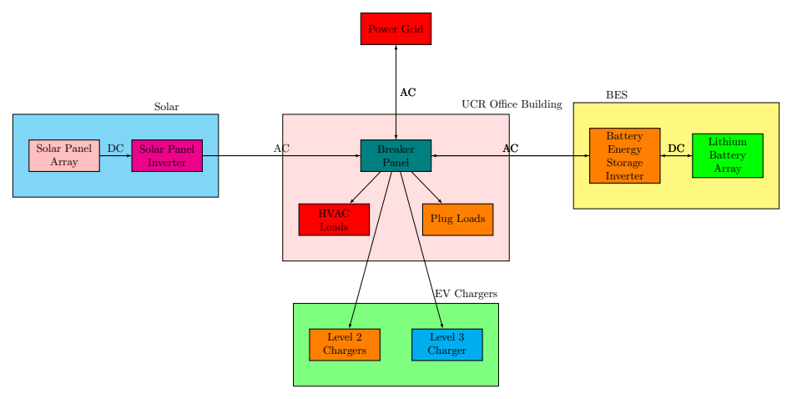

## Validation

To ensure that our model accurately portrays our real world system, a year of real world data was used to validate the $P_{G}$ output . $P_{G}$ is defined as the power the microgrid sends or consume from the grid. The actual data was compared to the simulated with a correlation coefficient of $≈$ 0.965087 as shown in Figure 2.

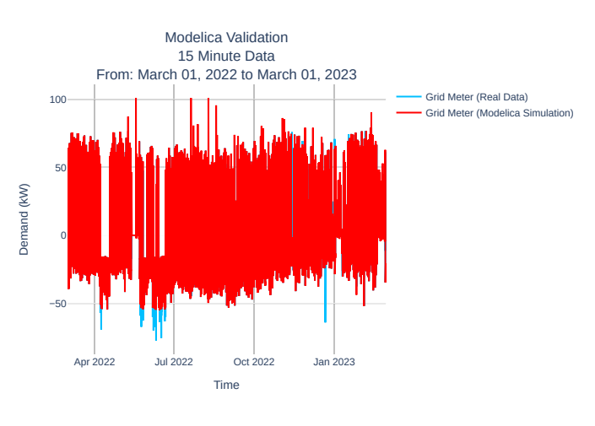

## Solar Generation and Building Loads

The solar power in our model is based on the historical solar data from our PV array. The HVAC loads and the regular building loads are represented separately in this model but utilize the same method; they both use historical real world power data to represent a their load in the system.

## EV Charger Loads

Our model also considers transportation loads in the form of EV chargers. The EV chargers are represented as two models: Level 2 EV chargers, and Level 3 EV chargers. While other loads follow a typical daily and yearly pattern, EV loads are different since they switch on and off. Our case study microgrid has four Level 2 chargers, so it can have four "steps" of 7.2 kW each, while there is only one "step" of 50 kW with the Level 3 chargers. To generate EV loads, we use a Poisson random generator to generate the number of charge sessions in a day, the arrival times, and charging durations based on real world data.

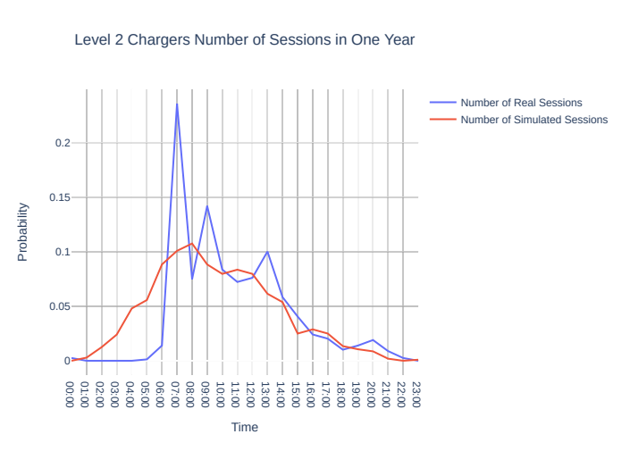

Historical data was collected from the Level-2 charger to determine the parameters for the Poisson random generator, following a typical daily charge pdf shown in Figure 3, and the power output of the Level 2 chargers in Figure 4.

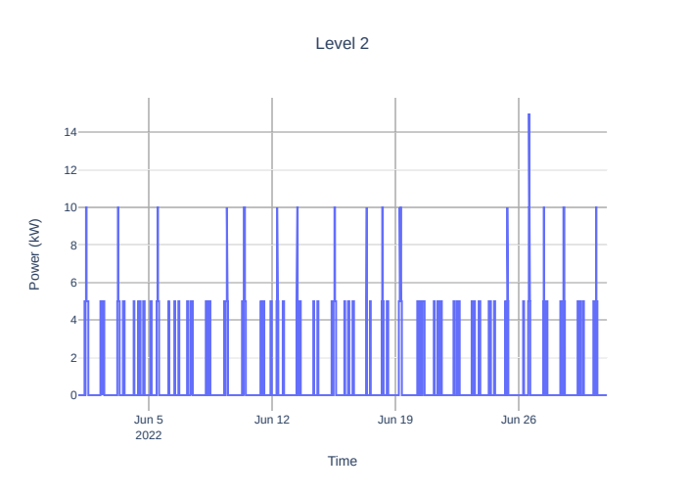

## BESS and Peak Shaving

The BESS is modeled as a battery connected to a bidirectional inverter. The BESS output is controlled by generated data from the control algorithm. The BESS output is computed in real-time by using a peak shaving algorithm utilizing BESS SOC and the grid meter output. The algorithm charges the battery when excess solar power is exported to the grid, and the battery needs to be charged. A Python module reads the net load from the grid and determines the amount of CO2 being produced during that interval. Figure 5 shows the peak shaving algorithm sufficient for flat rate demand response. However, for a TOU pricing structure, both energy and demand charges are assumed to be TOU rates with no additional flat rate demands. The TOU peak shaving algorithm is presented in Equation 1 with a simple objective to minimize the amount of power the microgrid pulls from the grid while accounting for energy and demand charges. The minimization objective is accomplished by optimizing for the summation of TOU energy (alpha * PG) and the maximums TOU demands (beta PG). This algorithm is further described and validated in , .

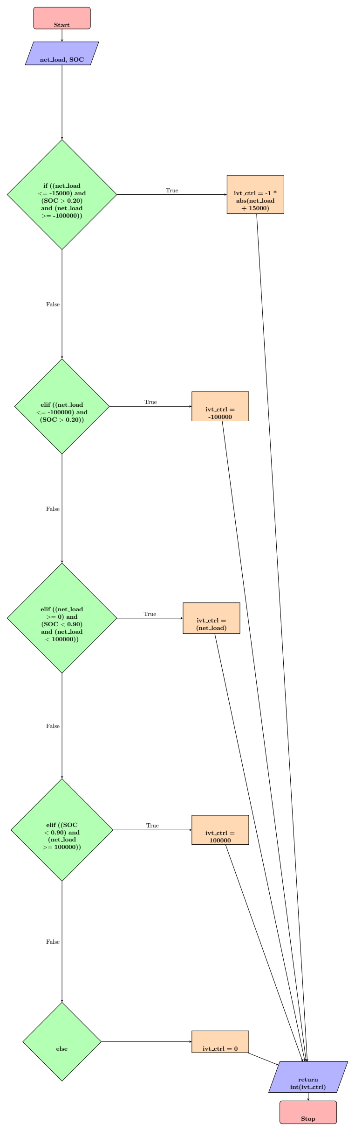

Flat Rate Peak Shaving Algorithm Flowchart

$$\text{min}f\left(P^{G}\right)=Δtα^{T}P^{G}+\text{max}\left(β^{\text{on }}P^{G}\right)+\text{max}\left(β^{\text{Mid }}P^{G}\right)+\text{max}\left(β^{\text{off }}P^{G}\right)$$

subject to

$$\begin{matrix}E_{t+1}^{B}=E_{t}^{B}+P_{t}^{B}⋅Δt,∀t∈T^{tot} \\ E^{Bmin}≤E_{t}^{B}≤E^{Bmax},∀t∈T^{tot} \\ P_{t}^{B}=P_{t}^{B+−P_{t}^{B−,∀t∈T^{\text{tot }}}0≤P_{t}^{B+≤δ_{t}P^{B+\text{max}},∀t∈T^{tot}}0≤P_{t}^{B−≤\left(1−δ_{t}\right)P^{B−\text{max}},∀t∈T^{tot}}0≤δ_{t}≤1,∀t∈T^{tot}}P_{t}^{B+=η^{+P_{t}^{SB},∀t∈T^{tot}}P_{t}^{S}=P_{t}^{SB}+P_{t}^{SL},∀t∈T^{tot}}P_{t}^{L}=P_{t}^{SL}+P_{t}^{BL}+P_{t}^{G},∀t∈T^{\text{tot }} \\ \end{matrix}$$

# Experiment

## Scenarios

Simulated Scenarios of the UCR Microgrid using Different Layouts and Electric Pricing Structures

|  |  |
| --- | --- |
| Scenario |  |
| 1 | Building with no solar power nor BESS |
| 2 | Building with solar power but no BESS |
| 3 | Building with solar power and a BESS that utilizes flat rate peak-shaving |
| 4 | Building with solar power and a BESS that utilizes RPU TOU rate peak-shaving |
| 5 | Building with solar power and a BESS that utilizes LADWP TOU rate peak-shaving |
| 6 | Building with solar power and a BESS that utilizes SCE TOU rate peak-shaving |

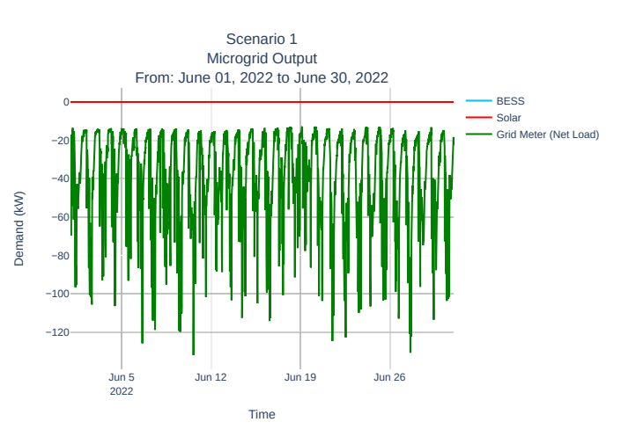

Scenario 1

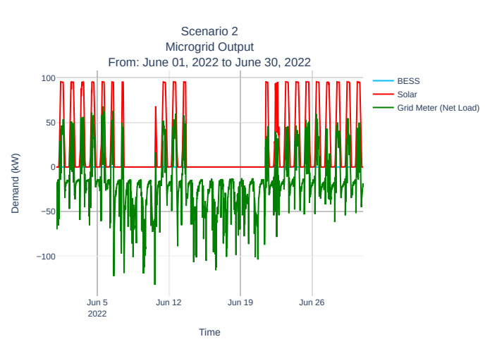

Scenario 2

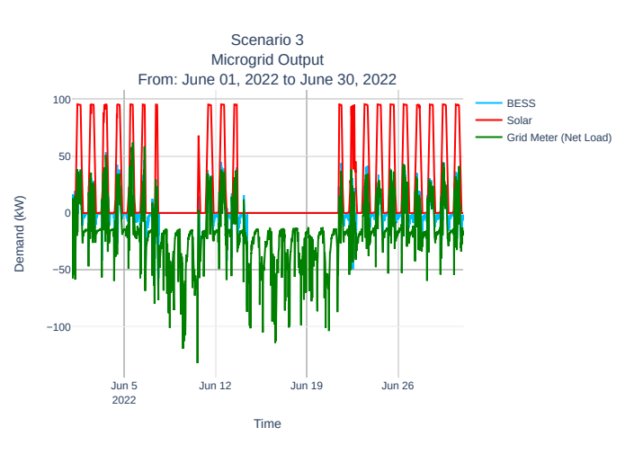

Scenario 3

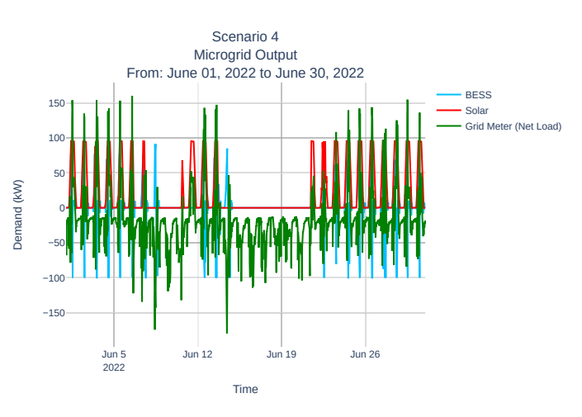

Scenario 4

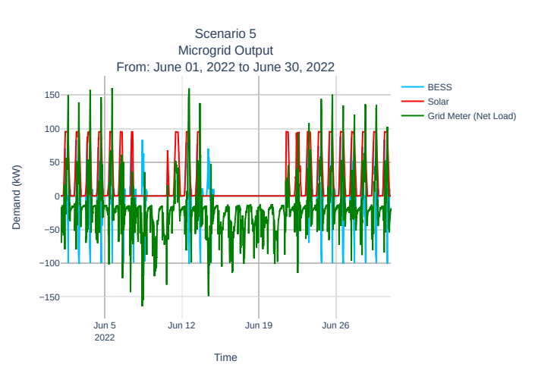

Scenario 5

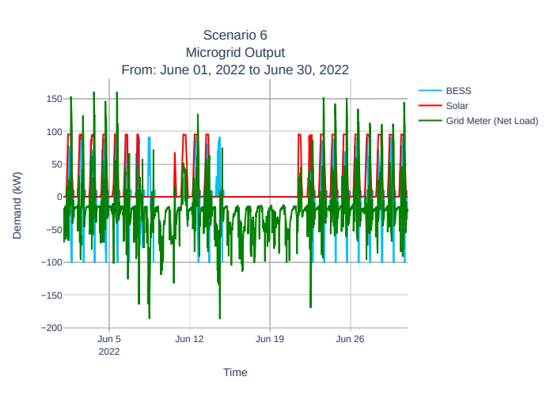

Scenario 6

# Results

The microgrid is modified in open Modelica for layout and scenarios. The scenariosare described in Table . Scenarios 1 and 2 are modified in open Modelica directly by shutting down both the solar system and the BESS in scenario 1 and shutting off the BESS in scenario 2. Scenarios 3 -6 by modifying the Python control algorithm open Modelica calls for the BESS. Scenario 3 represents the microgrid's current flat rate pricing structure, while scenarios 4-6 represent different optimizations if our microgrid were under different TOU rates. Each scenario is run independently of one another, and the power outputs of the different components in the simulation are shown in Figures x . Each scenario's power pulled from the grid is juxtaposed in Figure y , and the daily emissions average from each scenario is shown in Figure z.

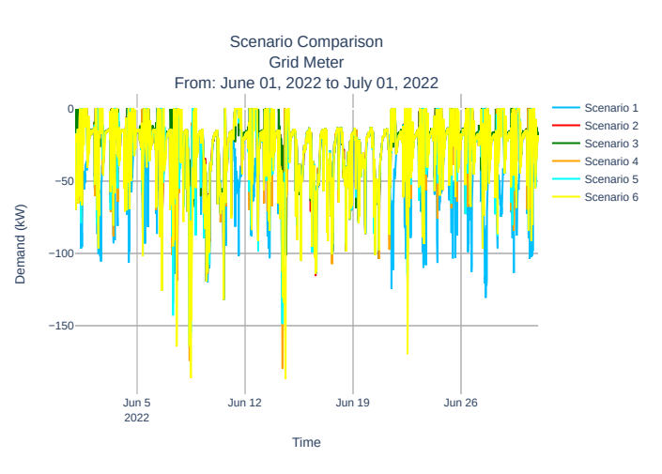

Summer Net Load Scenario Comparison

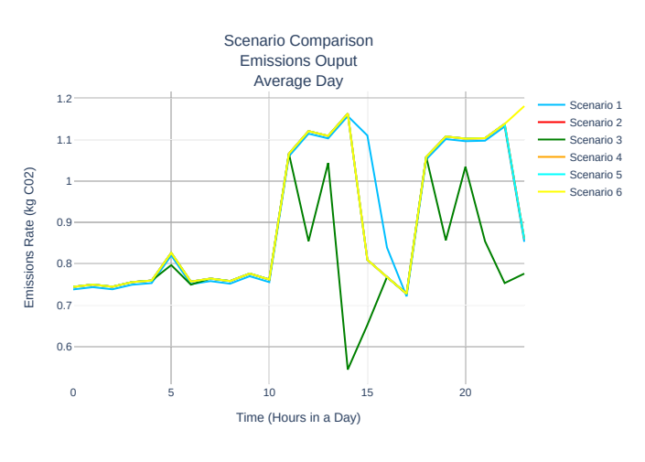

Microgrid CO2 Emissions Outputs Averages During Times of Day

# Conclusion

The lowest pricing structure for the microgrid customer is SCE's TOU pricing structure, while the lowest emitting setup is standard TOU peak shaving with RPU's flat rate demand cost pricing structure. Surprisingly, while adding reliability to any microgrid, a BESS does not always guarantee reduced CO2 emissions. The opposite is even possible, depending on the pricing structure of the utility. As seen in this paper, all the utility companies have Off-Peak hours during the nighttime, and any price-optimized control algorithm would prioritize charging during that period, so higher net-load peaks occur with a TOU-controlled BESS microgrid. A higher peak during off-peak hours is economically favorable and lower overall demand cost. While current TOU pricing is a great method to mitigate the stress on the grid during on-peak hours, there is major CO2 production to pricing structure when it comes to microgrids. Cheap nighttime off-peak hours incentivize nighttime charging for BESS when the grid in California is most reliant on natural gas for power . A stronger emphasis is also needed on clean nighttime energy, such as wind, geothermal, hydroelectric, and nuclear power, to be further integrated into California's electric grid.

# Future Works

Future papers will investigate different microgrid setups and optimizations for a more in-depth analysis. The effects NEM 3.0 will have on pricing and CO2 emissions compared to NEM 2.0 is of great interest. Also control algorithms and electric utility TOU rates that can optimize pricing and CO2 emissions will also be assessed.