**BET dispatching model description**

The dispatching model follows the assumptions that including:

1. The BET fleet dispatching follows the backhaul strategy [1]. The customers are divided into two groups, including linehaul customers who require delivery and backhaul customers who require pickups. For each trip, the linehaul customers should be visited first, followed by backhaul customers. A trip only containing backhaul customers is not allowed.
2. Similar to [2], a microscopic energy consumption model [3] is applied to estimate the energy consumption and the potential equvilant greenhouse gas emissions.
3. The truck fleet is allowed to visit home-based recharging facilities at distribution center (DC) once during operation. The DC has smart grid energy allocation strategy (see Section XX), to control the load distribution in terms of power grid, 100 W solar system, and energy storage systems (ESS).
4. The total operation time is limited. The truck fleet should start operation at and end serive before . The service times, travel times and recharging time are considered.
5. We assume the initial SOC is limited as less clean energy is generated at night. Therefore, that assumption can encourage the BET fleet to visit recharging facilities daily at DC.

**Dispatching Model formulation**

The purposes of the dispatching algorithm are twofold. On the one hand, the dispatching algorithm aims to find a set of routes miniming the total transportation energy cost. On the other hand, a favorable home-based recharging visit is determined. To estimate the energy cost of the BET fleet, we apply a real-world energy consumption model that has been used in Peng et al. [4]. First, the required tractive power can be calculated by **Equation 1**, where total vehicle weight (vehicle weight plus cargo weight on an arc ), denotes the acceleration, , and represent the air density, the aerodynamic and rolling friction coefficients, respectively. denotes the air density and the front area of the BET. The average speed for an arc can be calculated by the corresponding travel distances and travel times. denotes gravity.

   

Adopted from [5] and [2], the electric energy consumption is calculated by **Equation 2**. The discharging efficiency and the motor efficiency are considered. We use to represent an arc-specific constant coefficient and to denote the vehicle specific constant. Additionally, a constant accessory power is considered.

   2

Extending the integer programming model presented in [1], the dispatching model can be defined in a directed graph . A set of vertices is denoted by , where and represent the depot nodes, i.e., start node and end node. The customer set contains two subsets, i.e., linehaul customers and backhaul customers , which can be represented by . Similar to [1] and [3], the arc set is defined by , where a set connects all forward flows, a set represents the backward flows, and the interface arcs are represented by . Let denotes the forward flows, and denotes the backward flow arcs. Futhermore, the decision binary variable determines whether a vehicle travels on arc . Battery capacity binary variable decides whether a vehicle can be arrival at node .

The integer linear programming model formulation for the proposed dispatching problem is as follows (**Equation 3**). The first term denotes the total travel cost, where denotes the electricity factor during off-peak hours. The second term is also a convex optimization problem, representing the recharging cost at the charging station (see **Section X**). It should be noted that a time-variant energy allocation algorithm is incorporated into the dispatching model, which can be estimated by function . The recharging cost is related to the SOC when the BET arrivals at the home-based recharging station, the leaving SOC and the available recharging time window [].

(3)

Subject to:

(4)

(5)

(6)

(7)

(8)

(9)

(10)  
 (11)(12)

(13)

The proposed dispatching model extends [3]. **Equation 3** shows the objective function of the developed co-optimization framework, aiming to minimize the total energy cost. Considering the backhaul strategy, constraints (4) and (5) denote the forward and backward flows, respectively. Constraint (6) defines flow conservation. The initial SOC for a BET is limited to as shown in constraint (7). Constraint (8) shows that a home-based recharging visit is limited to at most once. Constraint (9) ensures that the battery capacity is always positive and can not exceed the maximum capacity. The operation time is limited as indicated in constraint (10), where the BET fleet should go back to the depot at the predetermined time windows. Constraint (12) defines the recharging policy. A binary variable represents if an arc has been visited.

**Co-optimization framework**

The co-optimzition framework is depicted in **Figure X**.

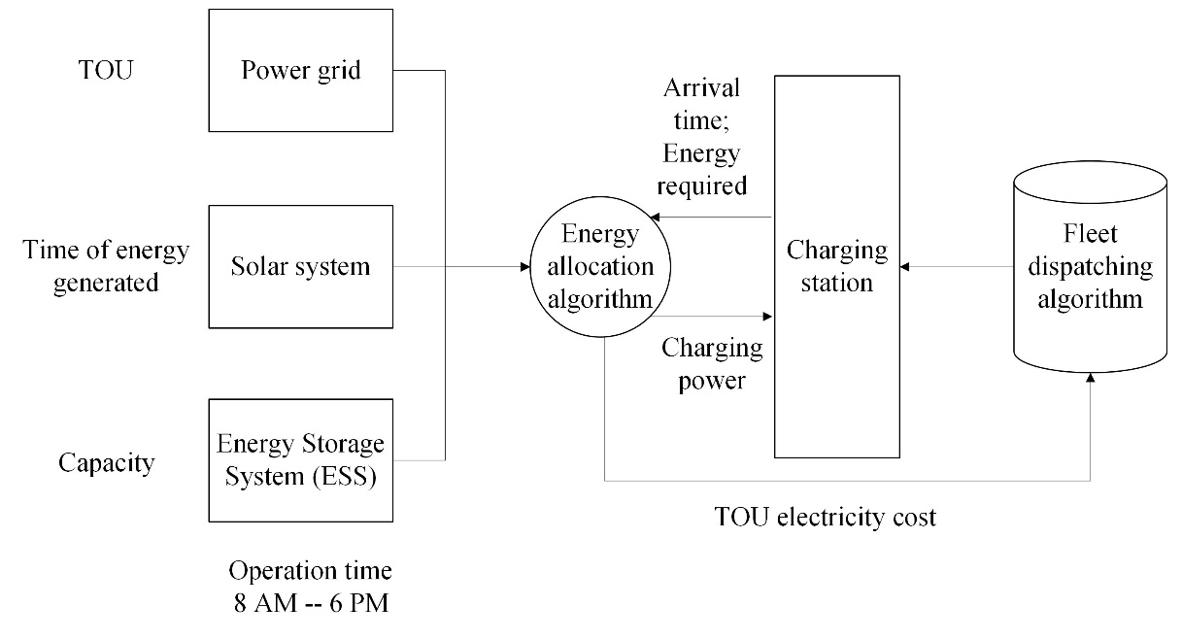

**Figure X Co-optimization framework integrating microgrid and BET fleet dispatching. Considering a time-dependent and time-dependent power load distribution, the energy allocation algorithm can estimate the recharging cost (see Section X) when scheduling the recharging visit. The developed co-optimization framework aims to minimize the total energy use and the total recharging cost.**

**BET dispatching algorithm**

An ALNS-based metaheuristics algorithm ([6], [7]) is applied to solve the proposed dispatching problem. The ALNS metaheuristics algorithm has been widely used to solve the vehicle routing problem and its variations (see examples [3], [4], [8], [9], [10], [11]). In this study, we developed an ALNS-based algorithm as a search engine to determine the energy-efficient route and favorable recharging schedule, which can achieve lower TOU costs.

The ALNS metaheuristic begins by generating an initial feasible solution for the BET routes. We use a modified greedy algorithm [12] to construct a set of initial feasible routes. At the beginning of the construction, a customer is randomly selected and inserted into a BET journey. A greedy algorithm is then employed to find a candidate customer and their optimal insertion location, determined by the lowest incremental cost. This process continues until no more customers can be added to the current BET trips due to battery capacity constraints. At this point, a recharging visit is included in the current BET trip, allowing more customers to be added. The current BET route is completed when no additional candidate customers can be visited. Next, a new BET route starts following the same procedure. The greedy construction algorithm terminates once all customers have been inserted into the BET routes.

After generating an initial feasible solution, the ALNS-based metaheuristics algorithm is iteratively performed to find a better solution. Based on the ALNS framework built in [3], we modify the objective function to **Equation 1**. Next, we combine the ALNS algorithm with the energy allocation algorithm from a micro-grid perspective. The intuition behind this idea is to minimize the total energy cost. We consider the energy cost for the dispatching service and the dynamic recharging cost, which is dependent on the dynamic power load.

In this section, we only briefly introduce the framework of the ALNS-based metaheuristics algorithm for limited space, and we refer interested readers to [3] for more details. Similar to [3], we use the same five removal operators (i.e., worst removal, shaw removal, random removal, path removal and cluster removal operators) to partially destroy the solution. Then, three reconstruction operators (i.e., greedy, regret-2, and greedy with charging station insertion operators) are used to reconstruct a new solution. The weight of each operator can be updated according to the quality of the new solution. Then, a simulated annealing heuristic algorithm is implemented to determine if the new solution should be accepted. The ALNS algorithm terminates when the maximum iteration is reached. For the parameters of the ALNS algorithm, we apply the same parameters presented in [3], but we set the maximum iterations to 500, ensuring the time efficiency when combined with the energy allocation algorithm.

**A real-world case study in San Bernardino County, California.**

This section presents a real-world case study to assess the performance of our co-optimization framework. Real-world dispatching data from a full-service logistics company is used in this study. The dataset can be accessed via Github link. The dataset is sampled from a heavy-duty diesel truck fleet containing customers' historical iternatives. It includes customer IDs, required weight, service types (deliveries or pickups), and locations. It is worth noting that the BET can reach the farthest fully recharged and is allowed to come back to the depot. To this end, we generate a real-world instance with 19 customers, where 14 customers are linehaul customers and the rest are backhaulcustomers. **Table X** summaries the problem parameters.

**TABLE X Summary of Problem parameters (Adopted from** [5]**)**

|  |  |  |
| --- | --- | --- |
| **Notation** | **Description** | **Value** |
| *A* | Frontal surface area of a BET [] | 10 |
| *C* | BET usuable battery capacity [kWh] | 265 |
| *Q* | BET payload capacity [lbs..] | 37,000 |
|  | Motor efficiency | 0.7 |
|  | Discharging efficiency | 0.91 |
|  | Rolling resistance coefficient | 0.008 |
|  | Aerodynamic drag coefficient | 0.7 |
| 𝑤 | Vehicle curb weight [lbs.] | 8,000 |
| 𝑔 | Gravitational constant [] | 9.81 |
|  | Air density (km/m3) | 1.2041 |
|  | Road angle | 0° |
|  | Acceleration | 0 |
|  | Initial battery capacity [kWh] | 100 |
|  | Accessory power [kW] | 5.6 |

We devise three dispatching scenarios to investigate the solutions under different power load conditions, which is shown in the following:

* **Scenario I**: Dispatching without considering micro-grid energy allocation algorithm. A basiness rate schedule TOU-GS-2 Rate fact [13] is considered. The off-peak energy consumption rate (0.0427 USD/kWh) and on-peak hour energy consumption rate (0.2320 USD/kWh) are considered.
* **Scenario II**: Dispathching by co-optimziation framework during one day in April. The (micro-grid) energy allocation algorithm is applied to reduce the recharging cost according to real-world load data in April.
* **Scenario III**: Dispathching by co-optimziation framework during one day in August. The (micro-grid) energy allocation algorithm is applied to reduce the recharging cost according to real-world load data in August.

For all dispatching scenarios, we assume that the BET fleet is partially recharged 100 kWh during the night with off-peak rate since there is no solar energy during the night. Then we compare the total energy cost among those three dispatching scenarios. **Figure X** shows the experiments results of the dispatching solutions. Each colored line represents a BET route.

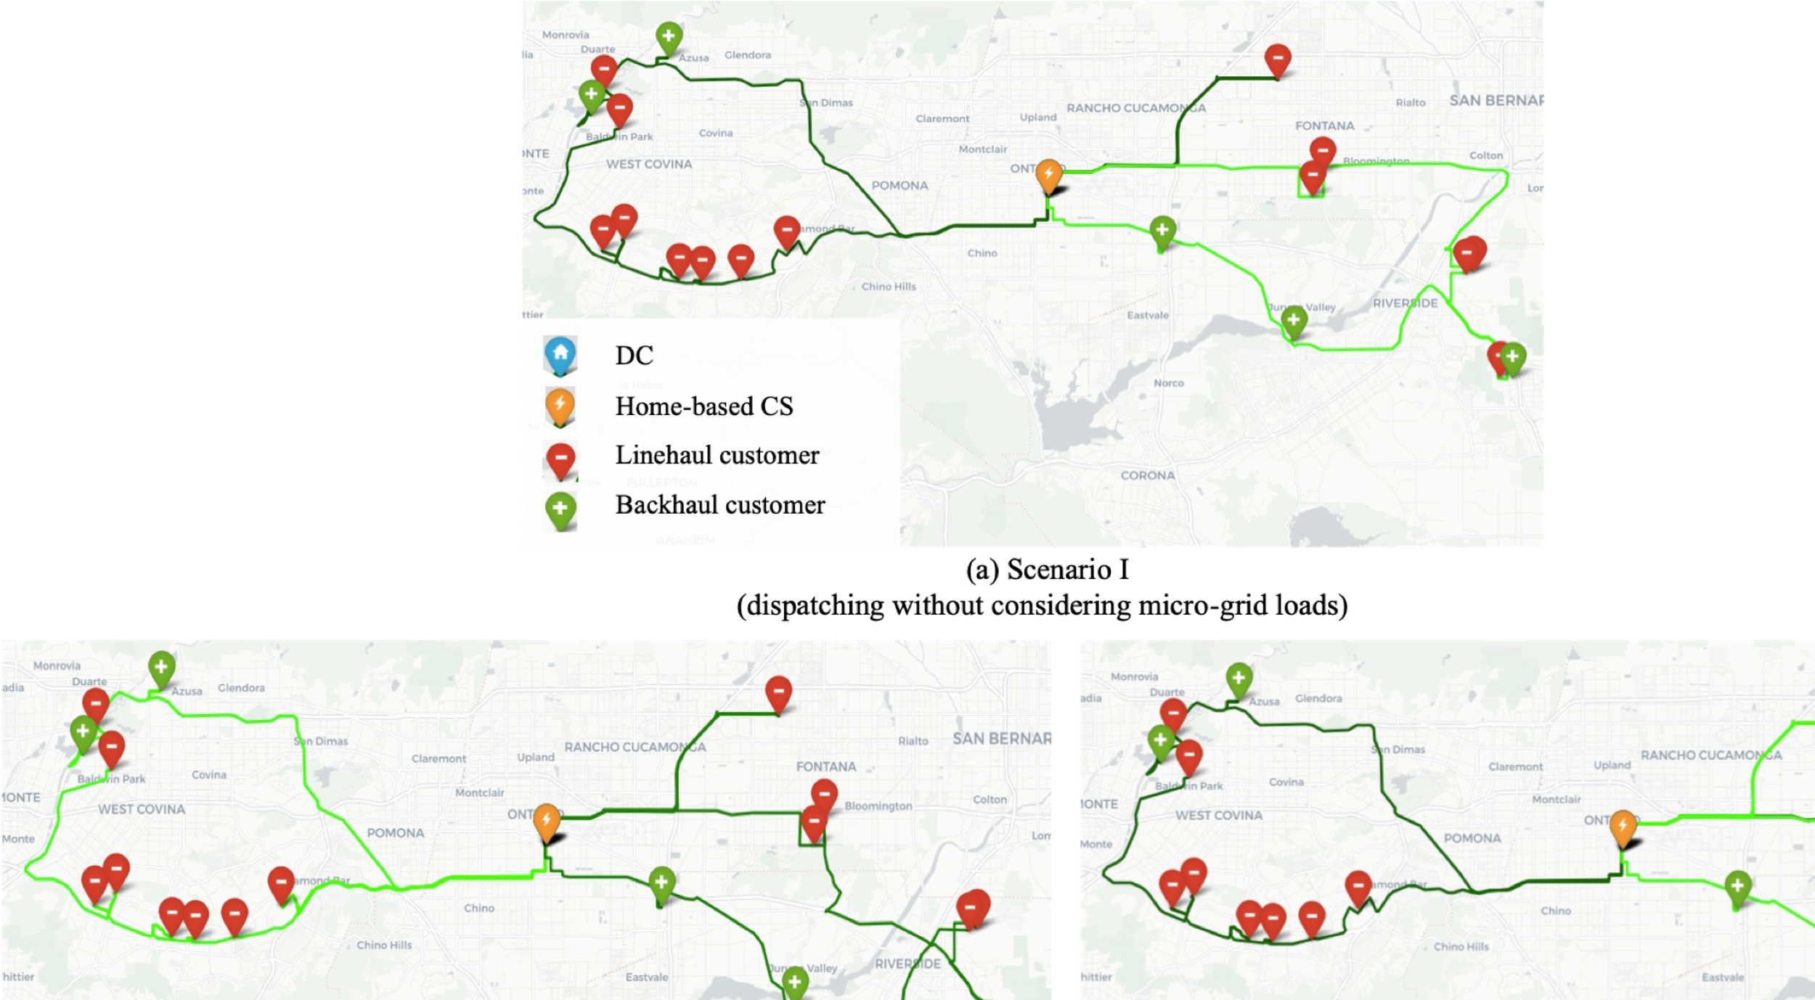

**Figure X Visulization of BET routes in different dispatching scenarios. Each colored line represents a BET route.**

**Table X** summarizes the detailed energy consumption in different dispatching scenarios. We set Scenario I as a baseline result. The route of this scenario is shown in **Figure X (a)**. Two BETs should be dispatched to satisfy the demands of underserved communities. **Table X** shows that the total energy cost in Scenario I is higher than Scenario II and III by 17.05 USD and 7.25 USD, respectively. The reason is scenario I does not consider the energy allocation algorithm. The BET fleet can be recharged under the on-peak hour electricity rate. Therefore, the charge energy is drained directly from the power grid, which cause a higher en route charging cost.

Additionally, the total energy consumption in Scenario I is relatively lower than in other dispatching scenarios because the impacts of micro-grid load and dynamic time-of-use (TOU) rates are not considered. The BET fleet aims to find the most energy-efficient dispatching solutions. However, considering power loads and time-varying TOU rates in Scenarios II and III, the decision-makers should consider a better recharging schedule to optimize the charging costs, such as using clearer energy from solar systems or the energy storage systems (ESS) as much as possible.

**TABLE X Experiment results on different dispatching scenarios.**

|  |  |  |  |  |
| --- | --- | --- | --- | --- |
| **Scenarios** | **Total energy**  **cost [USD]** | **En route Charging**  **cost [USD]** | **Total energy**  **consumption [kWh]** | **Total en route**  **charge [kWh]** |
| Scenario I (Baseline) | 23.41 | 17.05 | 259.96 | 74.49 |
| Scenario II (April) | 5.36 | 0.00 | 310.25 | 110.26 |
| Scenario III (August) | 15.02 | 9.81 | 302.08 | 102.09 |

(Please provide some analysis from the perspective of microgrid: 1) why the charging cost is high in August (scenario III); 2) how to demonstrate that considering cleaner energy resources, the charging cost is lower; etc.)

**REFERENCES**

[1] P. Toth and D. Vigo, “An Exact Algorithm for the Vehicle Routing Problem with Backhauls,” *Transportation Science*, vol. 31, no. 4, pp. 372–385, Nov. 1997, doi: 10.1287/trsc.31.4.372.

[2] S. Zhang, Y. Gajpal, S. S. Appadoo, and M. M. S. Abdulkader, “Electric vehicle routing problem with recharging stations for minimizing energy consumption,” *International Journal of Production Economics*, vol. 203, pp. 404–413, Sep. 2018, doi: 10.1016/j.ijpe.2018.07.016.

[3] D. Peng, G. Wu, and K. Boriboonsomsin, “The Bi-objective Battery Electric Truck Dispatching Problem with Backhauls and Time Windows,” *Transportation Research Record*, doi: 10.1177/03611981241246270.

[4] D. Peng, G. Wu, and K. Boriboonsomsin, “Energy-Efficient Dispatching of Battery Electric Truck Fleets with Backhauls and Time Windows,” *SAE International Journal of Electrified Vehicles*, vol. 13, no. 14-13-01–0009, 2023, Accessed: Jan. 25, 2024. [Online]. Available: https://www.sae.org/publications/technical-papers/content/14-13-01-0009/

[5] C. Wang, P. Hao, K. Boriboonsomsin, and M. Barth, “Developing a Mesoscopic Energy Consumption Model for Battery Electric Trucks Using Real-World Diesel Truck Driving Data,” in *2022 IEEE Vehicle Power and Propulsion Conference (VPPC)*, Nov. 2022, pp. 1–6. doi: 10.1109/VPPC55846.2022.10003335.

[6] S. Ropke and D. Pisinger, “An adaptive large neighborhood search heuristic for the pickup and delivery problem with time windows,” *Transportation science*, vol. 40, no. 4, pp. 455–472, 2006.

[7] S. Ropke and D. Pisinger, “A unified heuristic for a large class of Vehicle Routing Problems with Backhauls,” *European Journal of Operational Research*, vol. 171, no. 3, pp. 750–775, Jun. 2006, doi: 10.1016/j.ejor.2004.09.004.

[8] “Model-Based Vehicle-Miles Traveled and Emission Evaluation of On-Demand Food Delivery Considering the Impact of COVID-19 Pandemic - Haishan Liu, Peng Hao, Yejia Liao, Kanok Boriboonsomsin, Matthew Barth, 2023.” Accessed: Jun. 05, 2023. [Online]. Available: https://journals.sagepub.com/doi/full/10.1177/03611981231169276

[9] “Eco-Friendly Crowdsourced Meal Delivery: A Dynamic On-Demand Meal Delivery System with a Mixed Fleet of Electric and Gasoline Vehicles | IEEE Journals & Magazine | IEEE Xplore.” Accessed: Jul. 19, 2024. [Online]. Available: https://ieeexplore.ieee.org/abstract/document/10457861

[10] F. Y. Vincent, P. Jodiawan, and A. Gunawan, “An Adaptive Large Neighborhood Search for the green mixed fleet vehicle routing problem with realistic energy consumption and partial recharges,” *Applied Soft Computing*, vol. 105, p. 107251, 2021.

[11] D. Goeke and M. Schneider, “Routing a mixed fleet of electric and conventional vehicles,” *European Journal of Operational Research*, vol. 245, no. 1, pp. 81–99, 2015.

[12] D. Peng, M. Barth, and K. Boriboonsomsin, “Addressing the Robust Battery Electric Truck Dispatching Problem with Backhauls and Time Windows under Travel Time Uncertainty,” *In 2024 IEEE 27th International Conference on Intelligent Transportation Systems (ITSC). IEEE.*.

[13] “Business Time-Of-Use Rate Plans | Rates | Your Business | Home - SCE.” Accessed: Jul. 19, 2024. [Online]. Available: https://www.sce.com/business/rates/time-of-use