CO2 Impact Electric Vehicle Charging on a Local Microgrid: a case study in Southern California

As renewable energy penetration in electric grids increases with time, it becomes more important for electric utilities to update their electric rates such that they minimize CO2 emissions. In this paper, we evaluate a case study at the University of California, Riverside (UCR) to simulate different Time of Use (TOU) rate optimizations that minimizes electric costs while analyzing CO2 output, by using the openmodelica model, we based on different electric utility rates in Southern California. The different amounts of power and energy consumed by each rate is compared with CAISO CO2 emissions data in order to review the different emission levels from the different utility electric rates on a 15 minute basis. Electric costs are also compared in order to see the different savings the consumer will have with the different rates. It was found that Southern California Edison (SCE) TOU rate had the most savings for the consumer and that Riverside (RPU) TOU flat rate had the lowest CO2 emissions.

micorgrids, demand response, TOU, CO2 emissions, modelica

# Introduction

## Background

California is committed to reducing greenhouse gas emissions through various approaches. However, the two largest contributors to greenhouse yes emissions in California are transportation and electricity generation. California currently has X percent of electric vehicle sales and plans on banning internal combustion engine vehicles by 2035. At the same time, California is increasing the number of charging stations in the state, having over X currently and Y amount in 20xx. Electric vehicle technology has improved, and new vehicles can charge in X minutes. This is due to Level 3 charging, which can be as high as 350 kilowatts (kW) opposed to Level 2 charging, which is capped at 19 kW. While this innovation has led to a higher practicality for electric vehicles, it also leads to more difficulty for the owners of these chargers since they can create a tremendous amount of loads very quickly. Most Level 2 chargers consumers use are similar in load to an air conditioner. While California tries to increase clean energy penetration, it also needs to reduce the amount of GHG emissions produced by transportation through electrification. This leads to two conundrums: how will California add enough capacity for electrified transport, and how clean is the grid to minimize the amount of emissions associated with battery electric vehicles? One proposal to mitigate the strain on the grid is to keep electricity production and EV charging local by using microgrids. A microgrid is defined as: “‘a group of interconnected loads and distributed energy resources within clearly defined electrical boundaries that acts as a single controllable entity with respect to the grid. A microgrid can connect and disconnect from the grid to enable it to operate in both grid-connected or island-mode” As microgrids and EV chargers become ubiquitous, it is crucial to study the economic and environmental impacts EV charging in particular fast charging, will have on microgrids.

## Literature Review

This paper’s main contribution is to analyze the impacts different pricing structures have on the behavior of microgrids and the associated CO2 emissions. One goal every Time of Use (TOU) pricing schedule should have is for the economic incentives to align with CO2 emission reductions. This paper evaluates flat rate and TOU pricing from different electric utilities in California. This paper also uses a higher time resolution than most to date and explains in further detail a realistic simulation of a microgrid using system dynamics software.

## Peak Shaving Strategy

Peak shaving is a standard method for reducing high-demand charges. Since demand charges are based on only the maximum value over the entire month, in this simple algorithm, we assume the consumer wants to minimize the demand charges as much as possible. The algorithm is based solely on cost savings for a typical microgrid. During flat-rate peak shaving, the algorithm looks at the amount of power being imported, if there is enough energy, and if the batteries can mitigate a fraction of that or the total amount. With TOU, peak shaving is prioritized more during on-peak times, and shifts demand to mid-peak and off-peak hours.

## CO2 Emissions

Our microgrid’s solar production greatly overlaps with the local solar energy production within the larger grid. This leads to the problem within our microgrid that while it is zero CO2 emissions during solar peak hours, we still rely on the 30 main electrical grid during off-peak hours, which is when there are higher CO2 emissions. However, with a BESS, we can utilize renewable energy during peak times and at night. In this scenario, the control algorithm is economic-based since we want to see how the TOU rates align with actual CO2 emissions output. The simulation uses emission output calculations from CAISO for each time interval, as a sum of all the powerplant CO2 emissions (imports, natural gas, biogas, biomass, geothermal, coal) mTONCO2 / hour. The CO2 emissions output is divided by the amount of power produced (solar, wind, geothermal, biomass, biogas, small hydro, grid batteries, large hydro, imports, nuclear, coal ) in MW, which gives us an emissions rate of (TONCO2 / hour) / W. This is multiplied with our 15-minute data kW and a multiplier of to convert kW into W and to address for the four 15 minute periods in an hour. This gives us an estimate of the amount of CO2 emissions in mTONCO2 for every 15 minutes that is summed together to give us the total for the entire period. This method is similar to the one used in . When the grid does not pull power from the grid or is sending power, the CO2 emissions are assumed to be zero since we are using our solar energy.

# Simulation in OpenModelica

OpenModelica is an open-source implementation of the Modelica programming language. Modelica is a programming language that is designed for dynamic systems simulation . OMEdit is the GUI interface for open Modelica, allowing the user to draw a system for simulation . The microgrid scenarios are simulated in OpenModelica using the Modelica buildings library. Lawrence Berkeley National Laboratory created the Modelica buildings library for building and district energy and control systems . However, its capability for energy storage systems, bi-directional inverter, solar, and HVAC modeling make it ideal for a microgrid simulation setup. This allows us to create scenarios that do not currently exist in our microgrid, like running a month with solar with the same load, or running the BESS control algorithm for different electric rates. The power circuits are three-phase balanced circuits. The simulation of our case study microgrid is the grid-connected to the building netload. The model’s net load is broken down into solar power, HVAC loads, regular building loads, electric vehicle chargers, and the BESS as shown in Figure 1 .

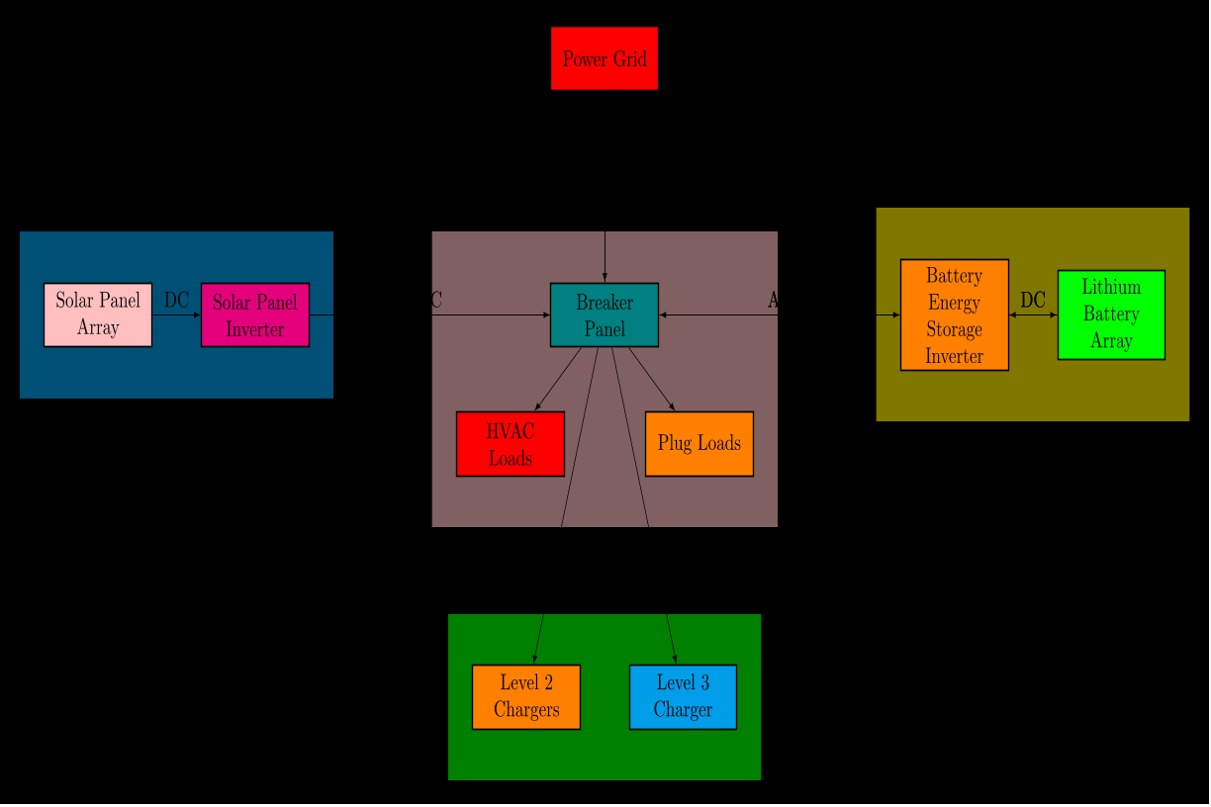

*Microgrid Layout*

## Validation

To ensure that our model accurately portrays our real-world system, a year of real-world data was used to validate the output . is defined as the power the microgrid sends or consumes from the grid. The actual data was compared to the simulated with a correlation coefficient of 0.965087 as shown in Figure 2.

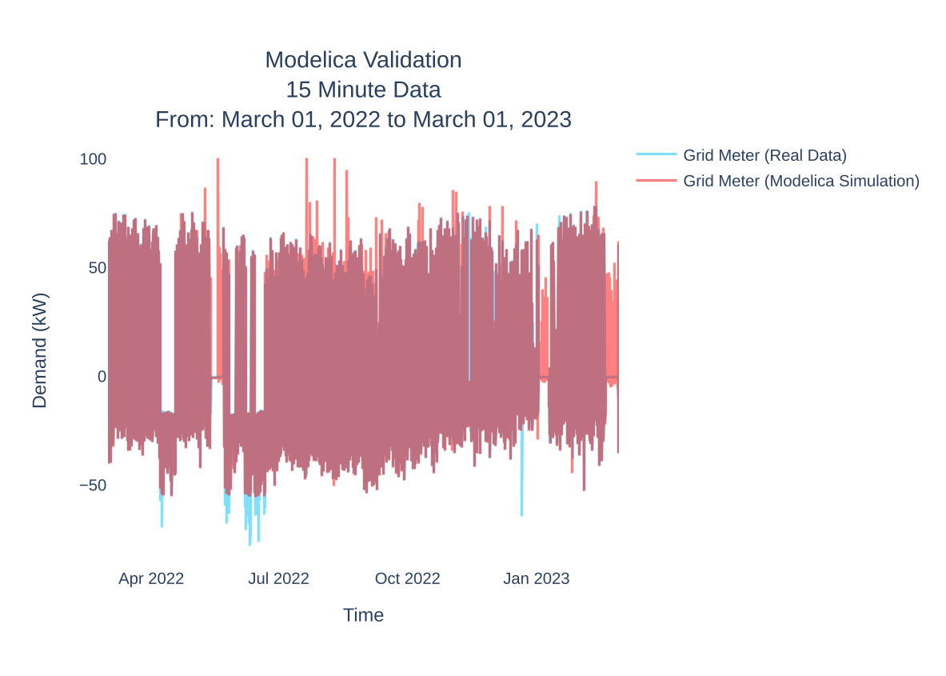

*Whole Year Validation*

## Solar Generation and Building Loads

The solar power in our model is based on the historical solar data from our PV array. The HVAC loads and the regular building loads are represented separately in this model but utilize the same method; they both use historical real world power data to represent their load in the system.

## EV Charger Loads

Our model also considers transportation loads in the form of EV chargers. The EV chargers are represented as two models: Level 2 EV chargers, and Level 3 EV chargers. While other loads follow a typical daily and yearly pattern, EV loads are different since they switch on and off. Our case study microgrid has four Level 2 chargers, so it can have four “steps” of 7.2 kW each, while there is only one “step” of 50 kW with the Level 3 chargers. To generate EV loads, we use a Poisson random generator to generate the number of charge sessions in a day, the arrival times, and charging durations based on real world data.

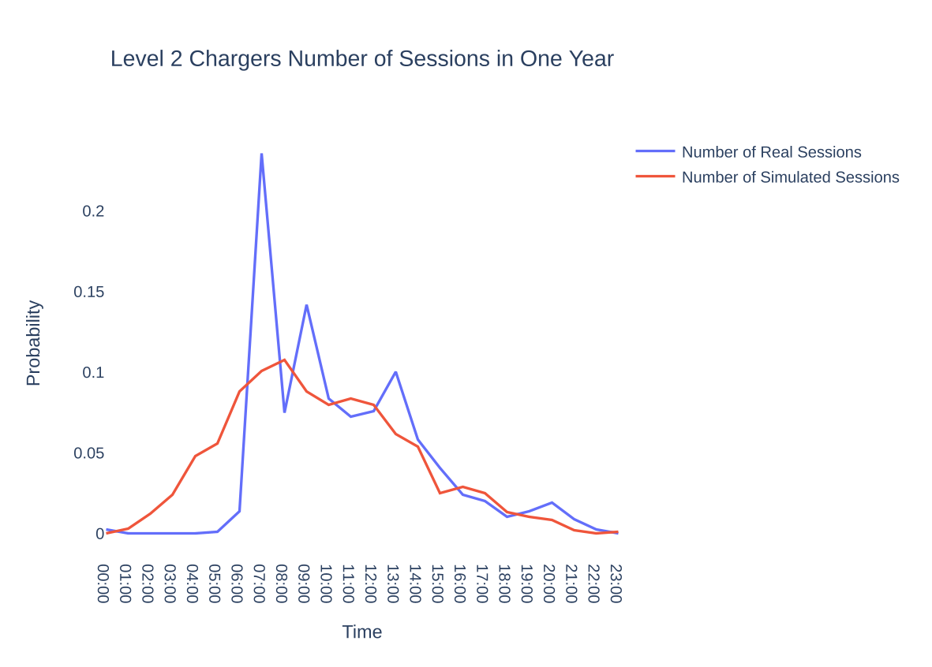

*Probability Density Function of the Level 2 EV Charger Validation*

Historical data was collected from the Level-2 charger to determine the parameters for the Poisson random generator, following a typical daily charge pdf shown in Figure 3, and the power output of the Level 2 chargers in Figure 4.

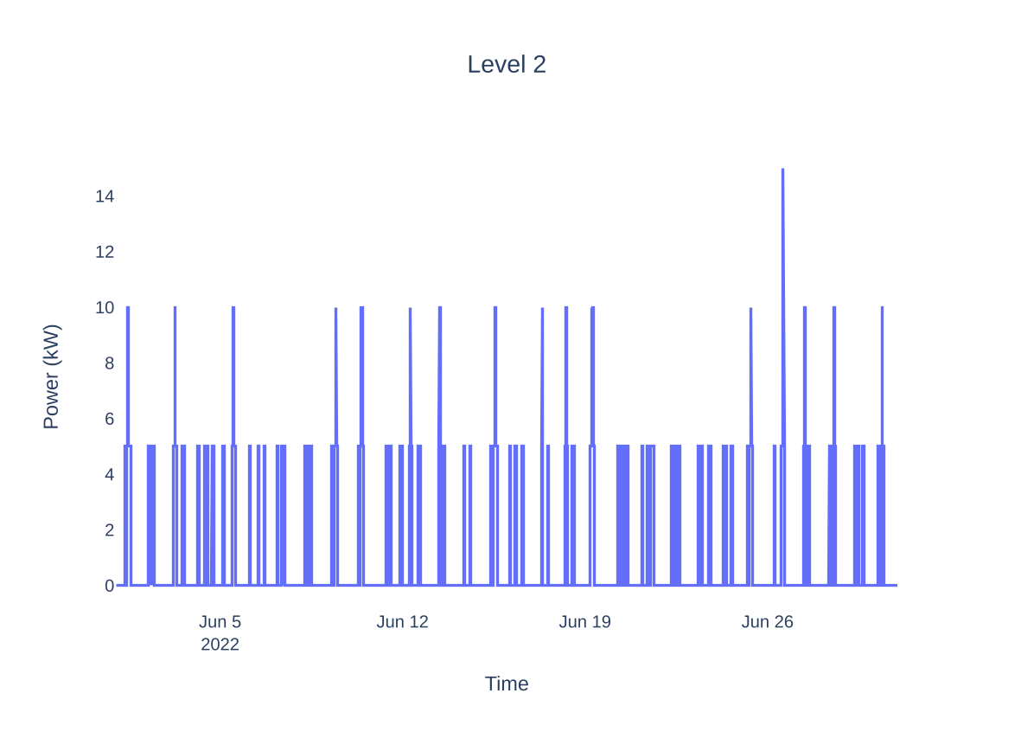

*Level 2 Chargers Simulated Power Output*

## BESS and Peak Shaving

The BESS is modeled as a battery connected to a bidirectional inverter. The BESS output is controlled by generated data from the control algorithm. The BESS output is computed in real-time by using a peak shaving algorithm utilizing BESS SOC and the grid meter output. The algorithm charges the battery when excess solar power is exported to the grid, and the battery needs to be charged. Python code reads the net load from the grid model and determines the amount of CO2 being produced during that interval. Algorithm [alg:peakshavingflatrate] shows the peak shaving algorithm sufficient for flat rate demand response.

net_load, SOC Modelica Data Output

# Results

# Results

The charging setup is modified in OpenModelica for different layouts and scenarios. The scenarios are described in Table 1. Scenarios 1 through 4 best represent a more typical setup at most EV charging stations without a BESS. Scenarios 5 through 8 utilize the peak shaving abilities of a large BESS to mitigate the impacts on demand and emissions of EV charging, especially Level 3 charging. Scenarios 1 and 5 show a base case where only solar or solar and ABS are installed at a building. This is to control the experience and compare it with the other scenarios to show the impact of EV charging. scenarios 2 and 6 would be considered the more typical EV charging setup. Most commercial centers mostly use level 2 charging, which is relatively cheap and simple to install and does not have too much of a major impact. Scenarios 3,4,7,8 add one 50 kW charger to the setup. This represents the rapid adoption of fast charging and its impacts on commercial buildings. Each scenario is run independently of one other, and the power outputs of the different components in the simulation are shown in Figure 5. Each scenario’s power pulled from the grid is juxtaposed in Figure 5 and the daily CO2 emissions average from each scenario is shown in Figure 6. The emissions and electric price amounts of each scenario are shown in Table [tab:emissions].

*Simulated Scenarios of the UCR Microgrid using Different Layouts and Electric Pricing Structures*

| Scenario |  |
| --- | --- |
| 1 | Level 2 Charging with no BESS |
| 2 | Level 3 Charging with no BESS |
| 3 | Level 2 and Level 3 Charging with no BESS |
| 4 | Level 2 Charging with BESS |
| 5 | Level 3 Charging with BESS |
| 6 | Level 2 and Level 3 Charging with no BESS |

[tab:scenarios]

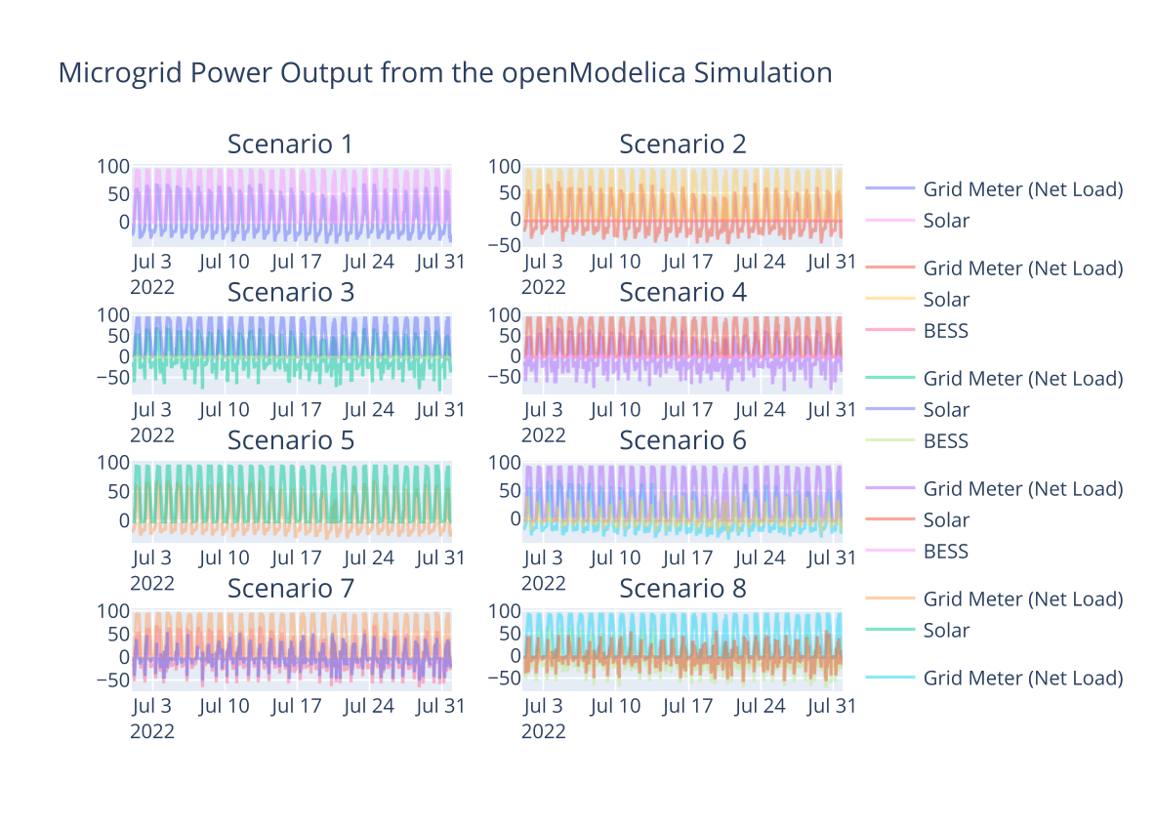

[tab:emissions]

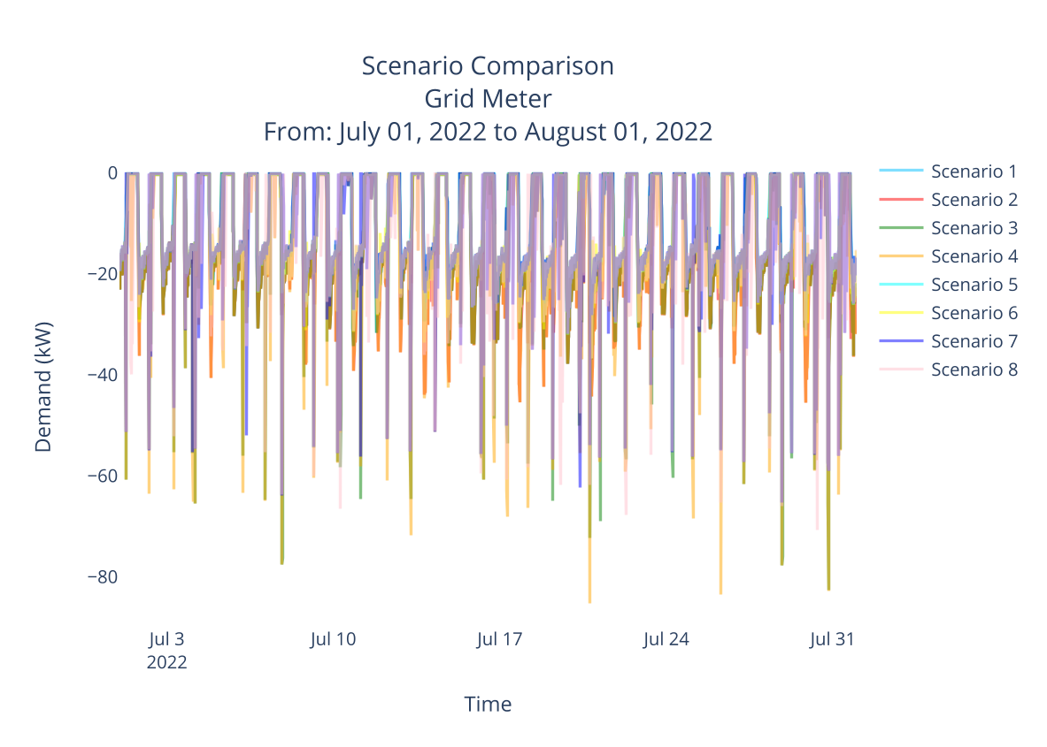

*Summer Net Load Scenario Comparison*

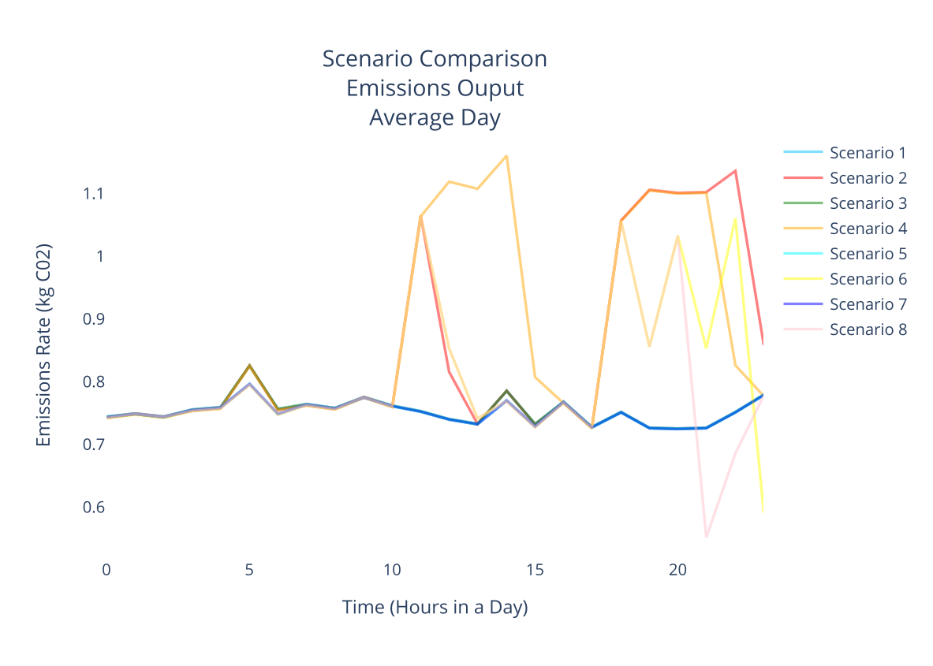

*Microgrid CO2 Emissions Outputs Averages During Times of Day*

# Conclusion

Electric vehicle charging will have a significant impact on the electric costs and emission levels of a microgrid. Level 2 charging had and relatively minimal effect on costs, with a 60 to 90% increase in electricity costs, which is not much considering that four Level 2 chargers were used. However, just one Level 3 EV charger can cause double to quadruple electric costs. Level 2 chargers have a very small impact on demand charges even when all four chargers are running since the 7.2 kilowatts of each EV charger is way less, and each has a max peak relative to the system. However, the 50 kW peaks created by the Level 3 charger nearly eclipse the demand for the HVAC units, and both used in unisoncan double the maximum peak and the demand costs. This happens mostly at noon when HVACs and EVs run simultaneously. Energy charges for both with and without the BESS are similar, albeit slightly higher with BESS. This was expected since BESS does not reduce energy costs, only demand charges with the flat rate used by the university’s utility company. Level 2 charging and significantly easier to recover the charging costs compared to Level 3 charging. The difficulty is that just one charging event that aligns with the other loads can easily double the price of that month’s electrical bill. Implementing a Level 3 charging control system must prohibit users from utilizing fast charging at peak hours when charging one vehicle can cause major costs to the provider. Aside from the major cost differences, locally produced solar combined with EV charging has a huge potential to reduce CO2 emissions from transportation. Even when utilizing both Level 2 and three chargers and no BESS, there’s only a 42% increase and carbon dioxide emissions compared to no EV charging at all, Increasing volume from 21 tons of CO2 to 30 tons of CO2. The X amount of vehicle trips mitigates this slight increase in CO2 if combustion engine vehicles were used instead.

# Future Works