Supporting Information
Uptake and translocation of polycyclic aromatic hydrocarbons (PAHs) and heavy metals in maize from soil irrigated with wastewater

Shichao Zhang^{a,c}, Hong Yao^{a,*}, Yintao Luª, Xiaohua Yu^{a,c}, Jing Wangª, Shaobin Sunª, Mingli Liuª, Desheng Liª ,Yi-Fan Li^{d}, Dayi Zhang^{b,c,*}

ª Beijing Key Laboratory of Aqueous Typical Pollutants Control and Water Quality Safeguard, School of Civil Engineering and Architecture, Beijing Jiaotong University, Beijing 100044, PR China.
^{b} School of Environment, Tsinghua University, Beijing, 100086, PR China.
^{c} Lancaster Environment Centre, Lancaster university, Lancaster, LA1 4YQ, UK.
^{d} IJRC-PTS, School of Municipal and Environmental Engineering, Harbin Institute of Technology, Harbin 150090, China.

*Corresponding author
Dr Hong Yao, Beijing Key Laboratory of Aqueous Typical Pollutants Control and Water Quality Safeguard, School of Civil Engineering and Architecture, Beijing Jiaotong University, Beijing 100044, PR China; Tel.: +86(0) 1051682157; Fax: +86(0)1051682157; Email: yaohongts@163.com
Dr Dayi Zhang, School of Environment, Tsinghua University, Beijing, 100086, PR China; Lancaster Environment Centre, Lancaster University, Lancaster, LA1 4YQ, UK; Tel.: +44(0)1524510288; Fax: +44(0)1524510082; Email: d.zhang@lancaster.ac.uk

Pages: 9
Figures: 2
Tables: 6

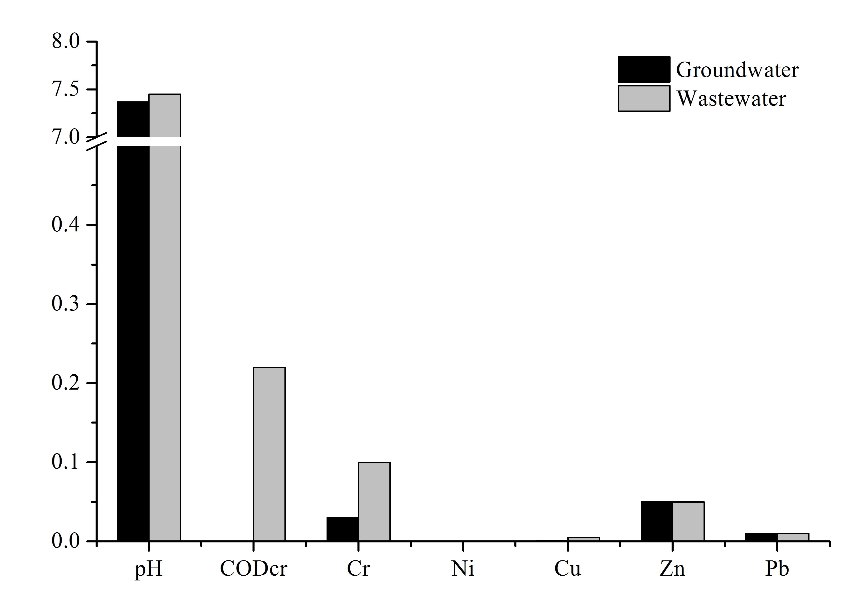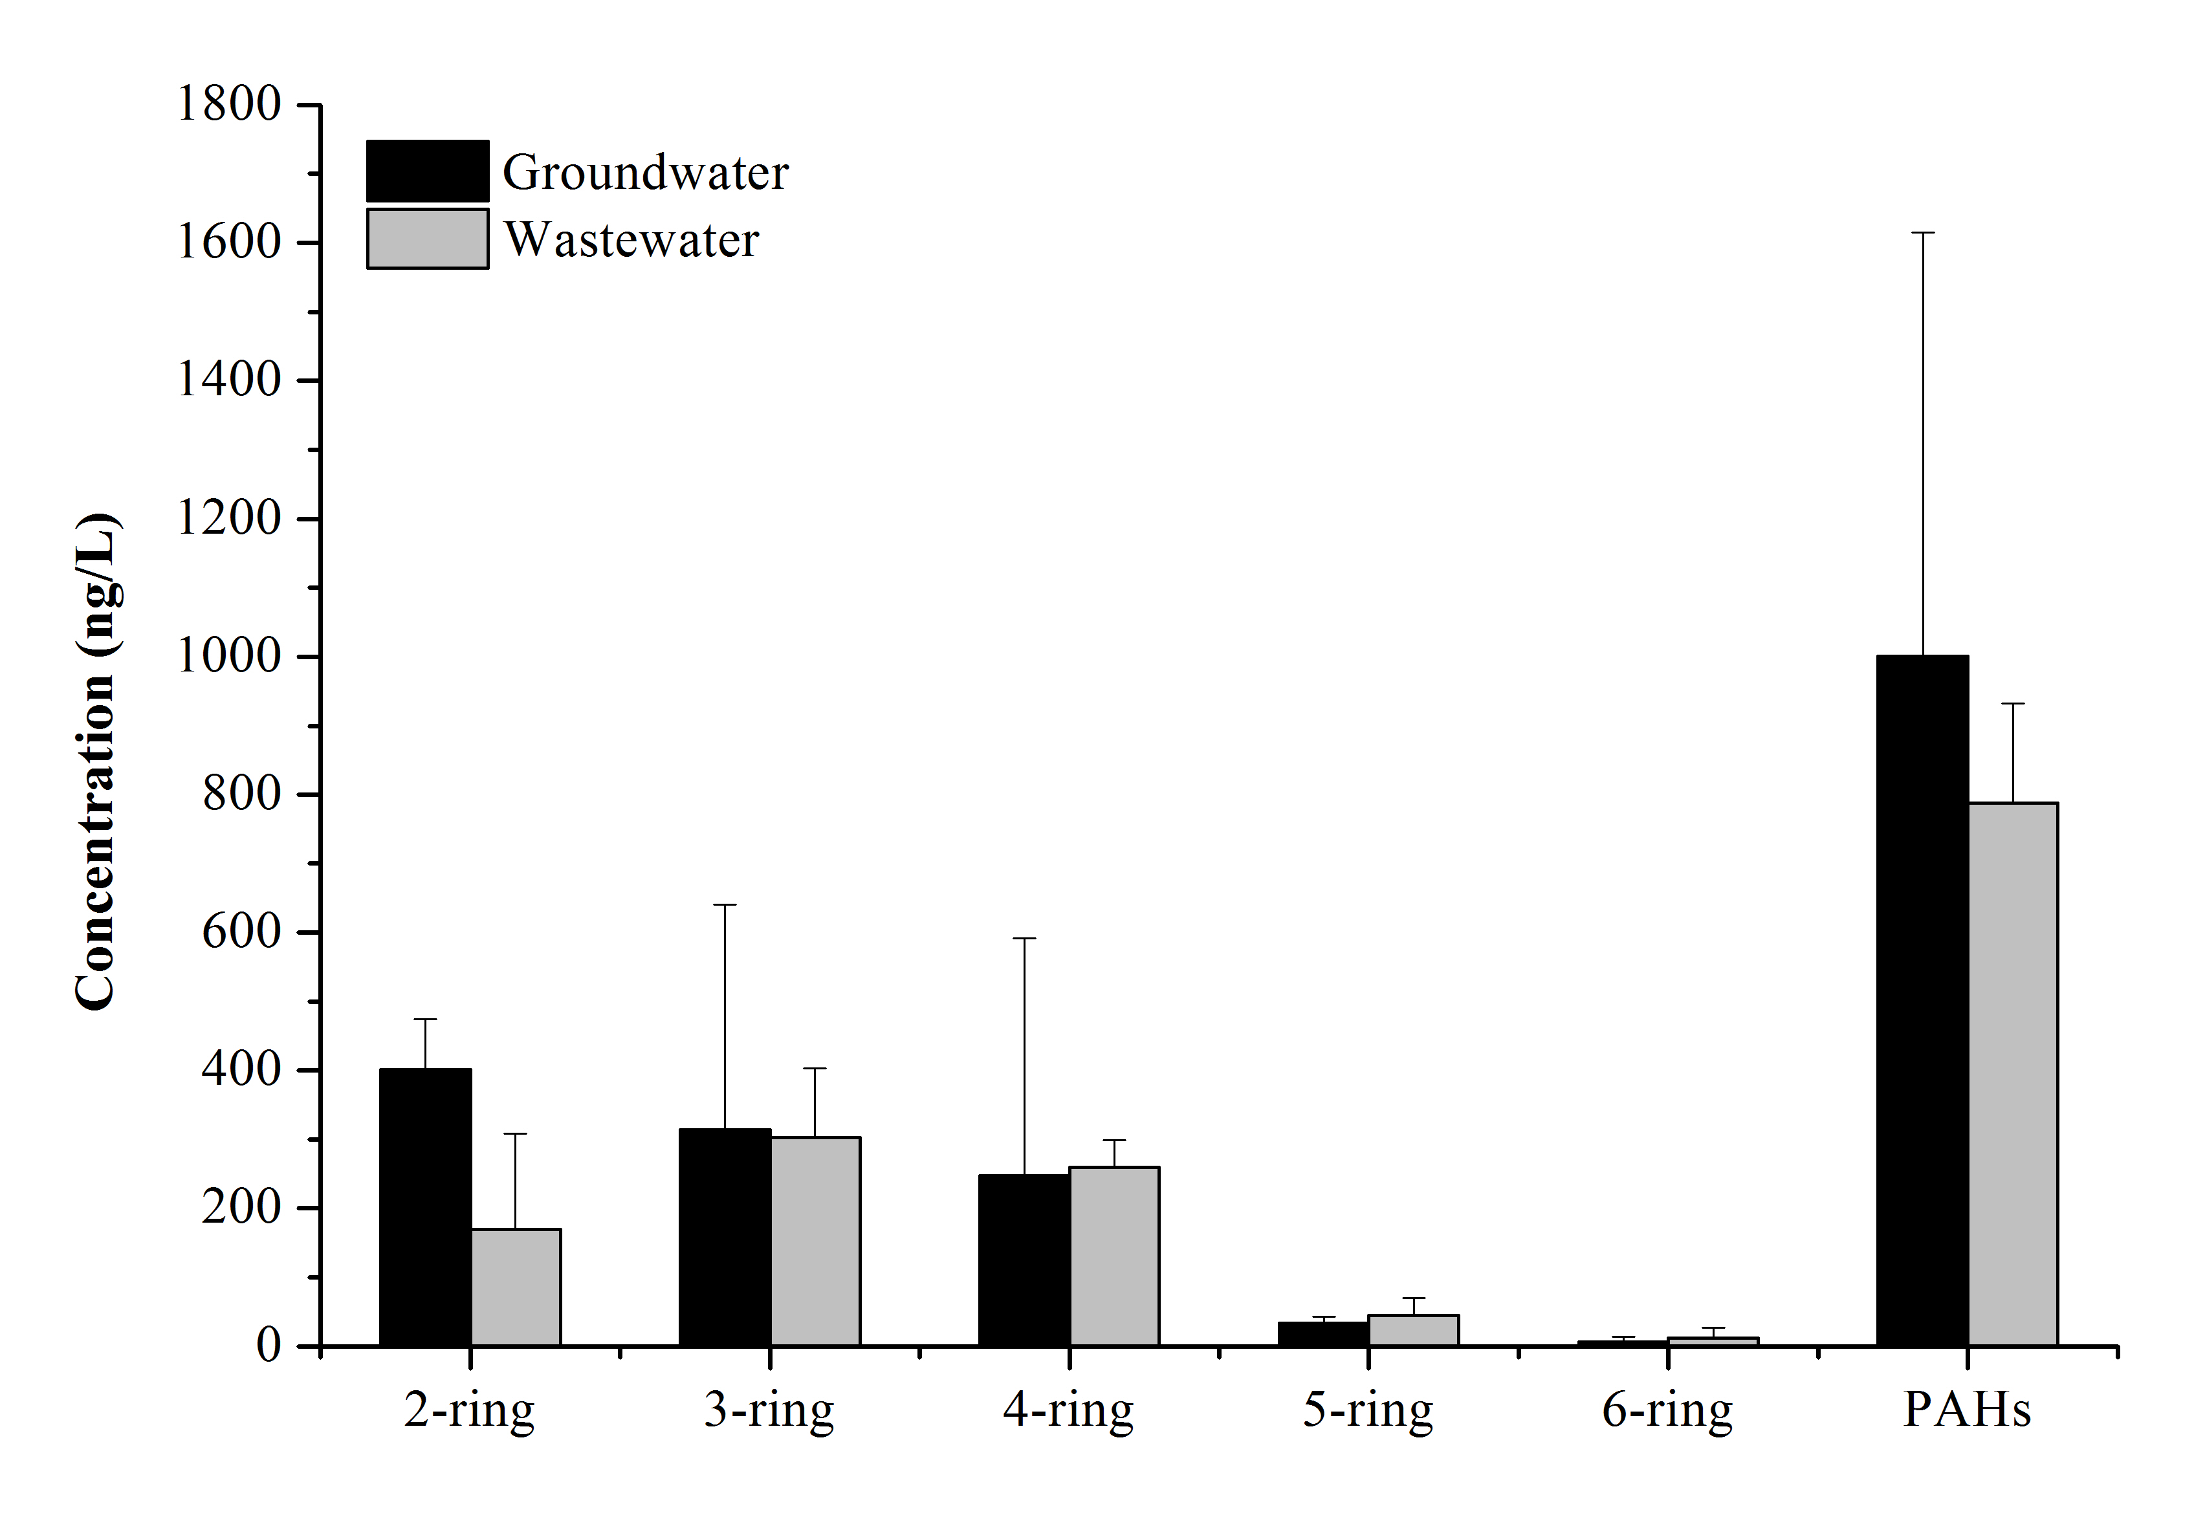
(A) (B)
Figure S1. (A) The concentrations of heavy metals (Cr, Ni, Cu, Zn and Pb) in irrigated wastewater and groundwater. (B) The concentrations of PAHs with different ring numbers in irrigated wastewater and groundwater.

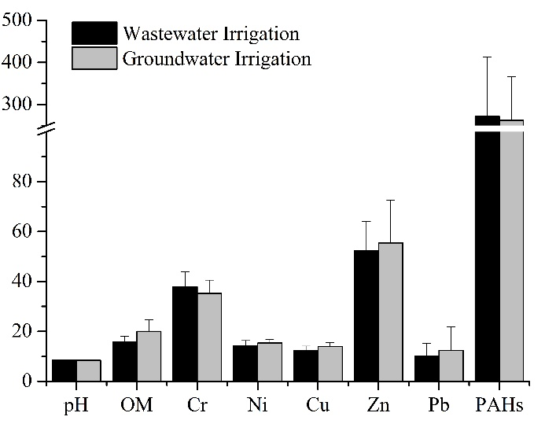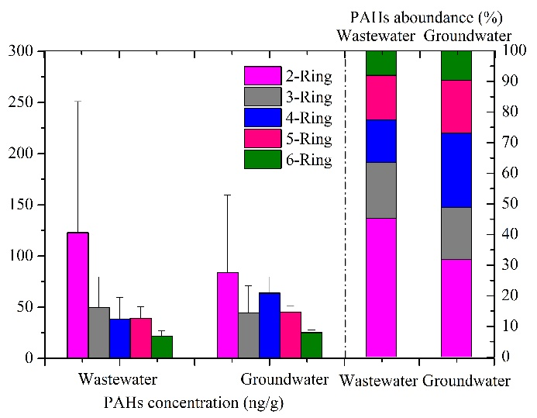
(A) (B)
Figure S2. (A) The concentrations of heavy metals (Cr, Ni, Cu, Zn and Pb) in surface soils with wastewater and groundwater irrigation. (B) The concentration and abundance of PAHs with different ring number in wastewater- and groundwater-irrigated soils.

Table S1. Sampling sites.
Site | Longitude | Latitude | Irrigation type | Samples
 |  |  |  | Top | Vertical
W01 | 43°40.688′ | 122°24.337′ | Wastewater | Yes | Yes
W02 | 43°40.709′ | 122°24.517′ | Wastewater | Yes | -
W03 | 43°40.715′ | 122°24.672′ | Wastewater | Yes | -
W04 | 43°41.067′ | 122°16.511′ | Wastewater | Yes | Yes
W05 | 43°40.919′ | 122°16.496′ | Wastewater | Yes | -
W06 | 43°40.934′ | 122°16.648′ | Wastewater | Yes | -
W07 | 43°30.526′ | 122°23.503′ | Wastewater | Yes | Yes
G01 | 43°40.036′ | 122°24.361′ | Groundwater | Yes | -
G02 | 43°40.032′ | 122°24.391′ | Groundwater | Yes | -
G03 | 43°40.061′ | 122°24.367′ | Groundwater | Yes | -
G04 | 43°41.082′ | 122°16.183′ | Groundwater | Yes | Yes
G05 | 43°40.017′ | 122°16.063′ | Groundwater | Yes | -
G06 | 43°41.053′ | 122°59.912′ | Groundwater | Yes | -
G07 | 43°30.464′ | 122°23.348′ | Groundwater | Yes | -
G08 | 43°30.506′ | 122°23.072′ | Groundwater | Yes | Yes

Table S2. The concentrations of total PAHs and heavy metals in top soils.
Site | Wastewater irrigation¹ | Groundwater irrigation¹ | p-value
pH | 8.09-8.90 (8.43±0.25) | 8.18-8.56 (8.44±0.12) | 0.100
SOM (mg/g) | 11.54-18.99 (15.58±2.39) | 14.61-29.61 (20.03±4.63) | 0.420
Cr (mg/kg) | 27.70-46.66 (37.14±6.24) | 27.46-43.39 (35.23±5.29) | 0.045*
Ni (mg/kg) | 11.88-17.41 (14.67±1.93) | 13.64-17.76 (15.32±1.55) | 0.653
Cu (mg/kg) | 10.36-15.19 (12.55±1.81) | 11.08-15.57 (13.96±1.64) | 0.141
Zn (mg/kg) | 41.20-74.04 (52.18±12.64) | 39.24-90.56 (55.47±17.03) | 0.089
Pb (mg/kg) | 5.88-21.32 (10.50±5.35) | 5.34-30.97 (12.38±9.38) | 0.160
Total PAHs (ng/g) | 103.28-479.32 (294.03±51.41) | 140.46-418.32 (262.52±36.74) | 0.800
¹ Data are presented in range (mean ± standard deviation).
* Correlation is significant at the 0.05 level (2-tailed).

Table S3. The correlation of PAHs and heavy metals concentrations with depth in vertical soils.
 |  | PAHs |  |  |  |  | Heavy metals
 |  | 2-ring | 3-ring | 4-ring | 5-ring | 6-ring | Cr | Ni | Cu | Zn | Pb
Wastewater irrigation | PCC | 0.511 | 0.282 | -0.826** | 0.661 | -0.698* | -0.469 | -0.333 | 0.754* | -0.389 | -0.377
Wastewater irrigation | p-value | 0.159 | 0.462 | 0.006 | 0.053 | 0.036 | 0.202 | 0.381 | 0.019 | 0.300 | 0.317
Groundwater irrigation | PCC | 0.059 | 0.650 | -0.344 | -0.605 | -0.732* | -0.186 | -0.945** | -0.862** | -0.745* | -0.215
Groundwater irrigation | p-value | 0.879 | 0.058 | 0.365 | 0.084 | 0.025 | 0.631 | 0.000 | 0.003 | 0.021 | 0.579
PCC: Pearson correlation coefficient.
* Correlation is significant at the 0.05 level (2-tailed).
** Correlation is significant at the 0.01 level (2-tailed).
Table S4. The maximum permitted levels of heavy metal concentrations (mg/kg) in maize grain in China and the European Union.
Heavy metals | Safe limits of cereals
Heavy metals | China (GB2762-2012) | European Union (EC: No 1881/2006)
Cr | 1 | -
Ni | - | -
Cu | - | -
Zn | - | -
Pb | 0.2 | 0.20

Table S5. The correlation among log RCFs, log LCFs, log SCFs and log GCFs of PAHs.
 | log RCFs | log LCFs | log SCFs | log GCFs
log RCFs | 1.000 | - | - | -
p-value | - | - | - | -
log LCFs | 0.912** | 1.000 | - | -
p-value | <0.001 | - | - | -
log SCFs | 0.811** | 0.926** | 1.000 | -
p-value | <0.001 | <0.001 | - | -
log GCFs | 0.936** | 0.971** | 0.917** | 1.000
p-value | <0.001 | <0.001 | <0.001 | -
** Correlation is significant at the 0.01 level (2-tailed).

Table S6. Summary of the forward selection procedure in the redundancy analysis (RDA).
Environmental variable | E (%)¹ | P² | F³
PAHs | 61 | 0.002** | 20.53
RCFs-Pb | 20 | 0.004** | 12.20
pH | 4 | 0.104 | 2.74
OM | 1 | 0.280 | 1.39
RCFs-Cu | 2 | 0.288 | 1.25
RCFs-Ni | 1 | 0.658 | 0.32
RCFs-Zn | 0 | 0.468 | 0.60
RCFs-Cr | 1 | 0.814 | 0.14
¹ E represents the variation explained by the selected variables.
² P refers to the significance of explained variation.
³ F is the probability distribution of F test. The values of p and F were tested using Monte Carlo permutation test with 499 permutations.
** Correlation is significant at the 0.01 level (2-tailed).

