Supporting Information
Soil Microbiomes Divergently Respond to Heavy Metals and Polycyclic Aromatic Hydrocarbons in Contaminated Industrial Sites
Zhen-Ni Yang^{a,1}, Ze-Shen Liu^{a,1}, Ke-Huan Wang^{a,b}, Zong-Lin Liang^{a,b}, Rashidin Abdugheni^{a,b}, Ye Huang^{a,b}, Run-Hua Wang^{a,b}, Hong-Lin Ma^{a,b}, Xiao-Kang Wang^{a,b}, Mei-Ling Yang^{c}, Bing-Ge Zhang^{d}, De-Feng Liª, Cheng-Ying Jiang^{a,*}, Philippe F.-X. Corvini^{e} and Shuang-Jiang Liu^{a,f,}*
ª State Key Laboratory of Microbial Resources, Institute of Microbiology, Chinese Academy of Sciences, Beijing 100101, China
^{b} University of Chinese Academy of Sciences, Beijing 100049, China
^{c} School of Life Sciences, Hebei University, Baoding 071002, Hebei Province, China
^{d} School of Public Health, Xuzhou Medical University, Xuzhou 221004, Jiangsu Province, China
^{e} School of Life Sciences, University of Applied Sciences and Arts Northwestern Switzerland, Muttenz 4132, Switzerland
^{f} State Key Laboratory of Microbial Technology, Microbial Technology Institute, Shandong University, Qingdao 226237, Shandong Province, China
¹ The two authors contributed equally to this work.
* Correspondence: jiangcy@im.ac.cn (C. Y. Jiang); liusj@im.ac.cn or liusj@sdu.edu.cn (S. J. Liu)
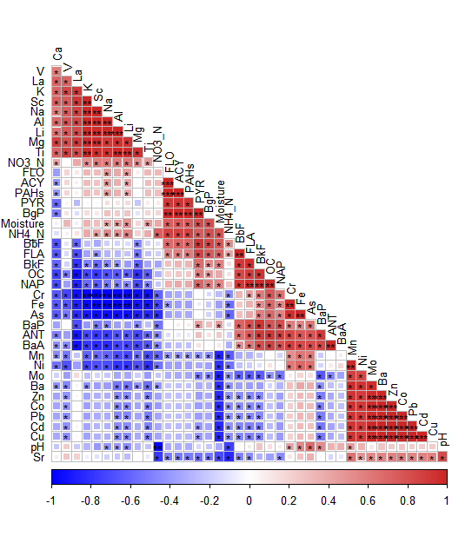
Figure S1. Correlation between environmental factors of the five soil samples

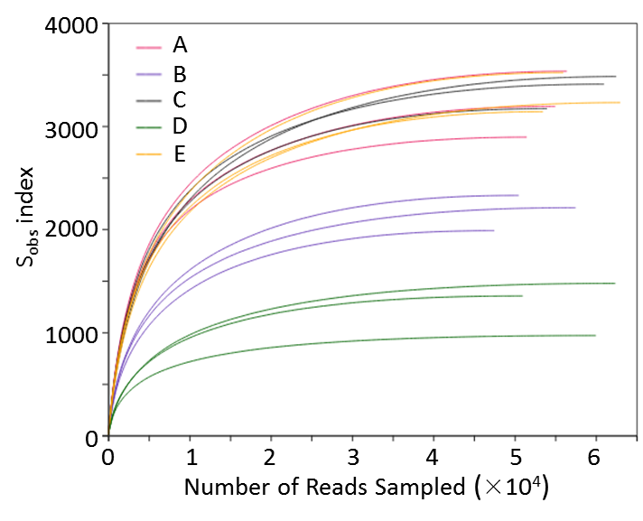
Figure S2. Rarefaction curves of the soil samples. S_{obs} index refers to the observed number of ASVs.

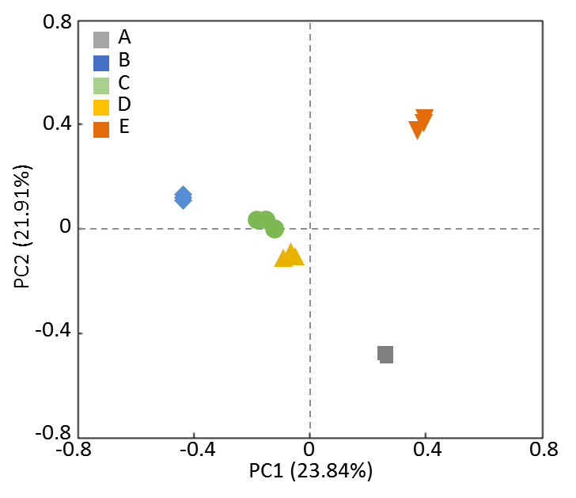
Figure S3. The β-diversities of soil microbiomes.

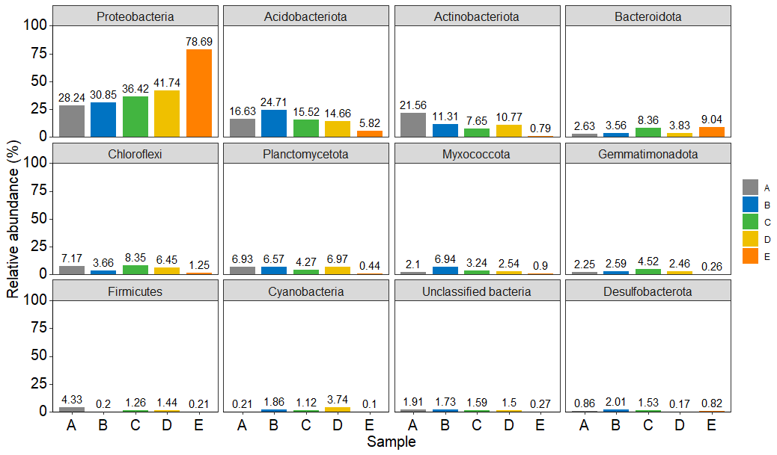
Figure S4. Relative abundances of bacterial phyla

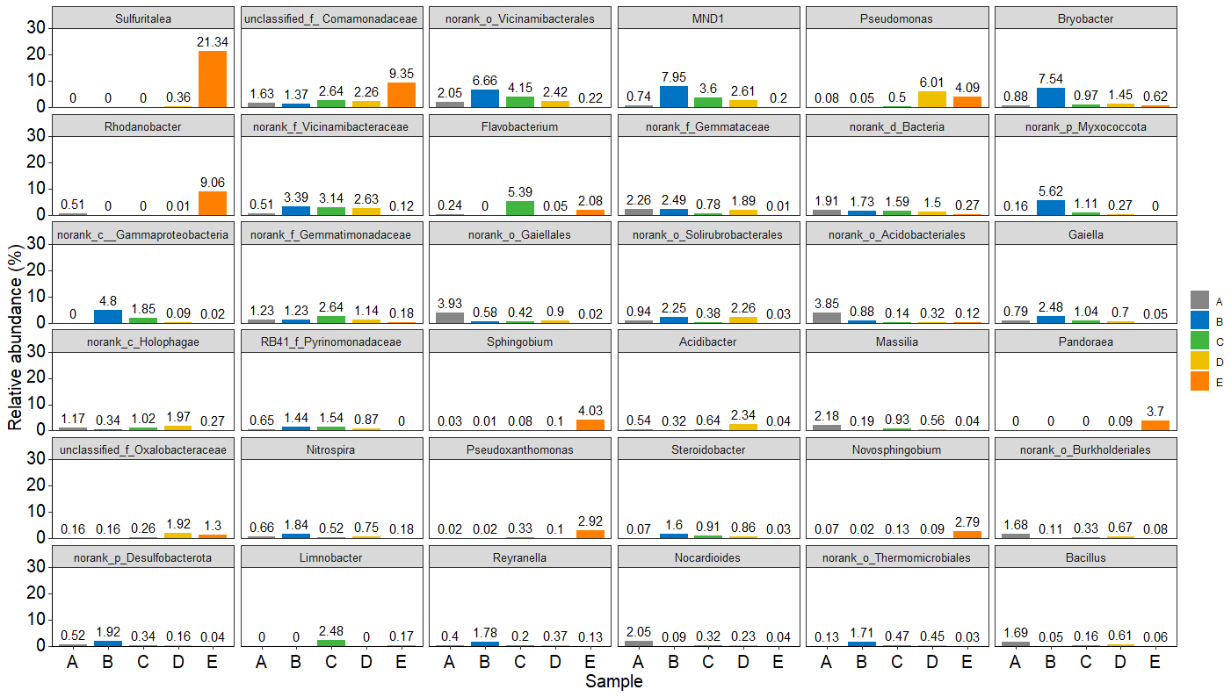
Figure S5. Relative abundances of bacterial genera

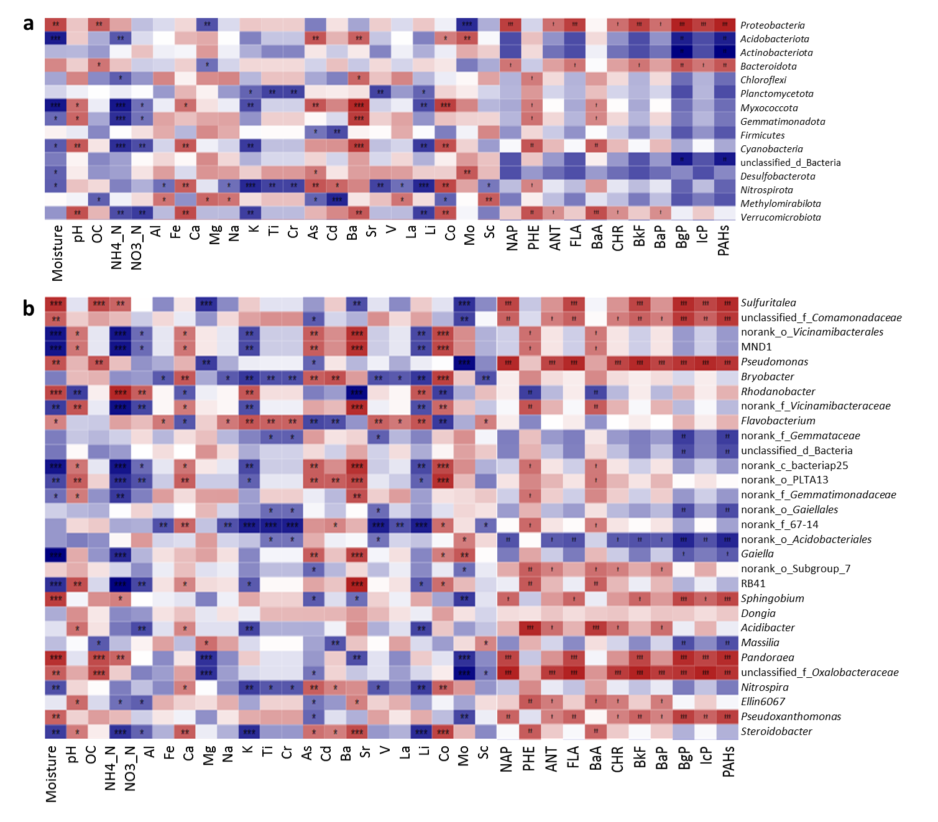
Figure S6. Correlation between the environmental factors and bacterial phyla (a) and genera (b)

