Statistics
Assignment #1
___________________________
Allen Lapitan, C24383676
___________________________
TU 850/2: BSc (Hons.) Data Science and Artificial Intelligence
___________________________

Introduction:
For the first statistics assignment, we were tasked with analysing our given datasets in Python or R and make relevant graphs using the data. In my case I used Python and my dataset was about Phoenix Park from 2003-present. My dataset covered precipitation, temperature, soil, and CBL pressure mainly but it had 11 columns: Date, Indicator, Maximum Air Temperature, Minimum Air Temperature, Rain, Mean CBL Pressure, Soil Temperature and 8160 rows of information.
Step 1: Initial Setup
Firstly, I downloaded the CSV that was given to me. I then skimmed through the file and noted that the first 14 lines were empty and that there were empty cells. After this, I setup VSCode and made a python file. I chose pandas for my data analysis and seaborn and matplotlib for my graphing.
Step 2: Setting up the data
I imported my libraries and made a data frame using the CSV. The extra arguments were to skip the first 14 lines and turn the empty values into NaN which doesn’t get used in analysis or calculations. I then used the .head() command to get a small view of the dataset and .dtype to get the datatypes.
Step 3: Changing datatypes
Realising that most of the datatypes were object, I thought that had to be changed because it might get mixed up during the analysis. I changed the relevant ones like date, maxtp, mintp, etc. Aswell as this, I created year, month name, day_of_year and mean columns. The month column was tricky mainly due to it defaulting to alphabetical order rather than actual month order. It was fixed using categories [‘’] and ordered = True.
Step 4: Rain (Wettest month)
The first graph I tackled was a bar chart of wettest months and due to the phrasing of the question I thought it would be more appropriate to calculate total rain(mm) per month rather than total rainy days. I graphed rain(mm) on y and the months on x.
The answer for wettest months in Phoenix Park is: October, November, December
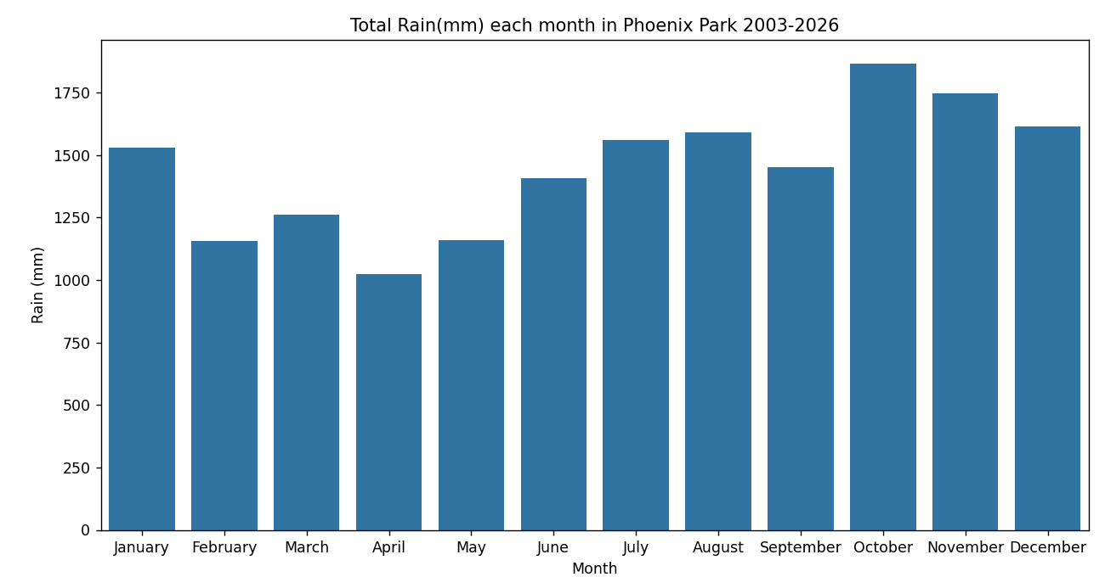
Step 5: Rain (Chances of rain any day)
While a graph wasn’t necessary, I made a pie chart to show how much days were wet and dry. With this I was able to calculate the probability of it being rainy using P(rain) = Rainy Days/ Rainy Days + Dry Days.
The answer would be: 61.78% chance of raining on a given day based on past 30 years.
.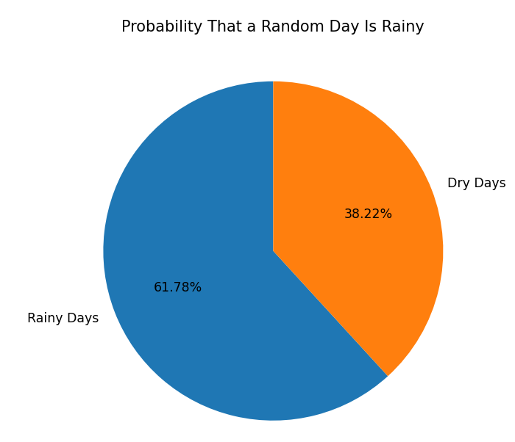
Step 6: Temperature (Mean temp vs LTA temps)
For this graph I made a sub data frame for 2019 my chosen year. I plotted the 2019 averages against the long-term averages.
I chose the first and third quartile as well as the 10th and 90th percentile. The relevance of each is that if something lies between the 25-75 range (orange) it is normal. If something is above the 75th its unusually hot. If something is below the 25th then it is unusually cold. If something is above the 90th percentile then it is notably hotter. If something is below 10th percentile it is notably colder. 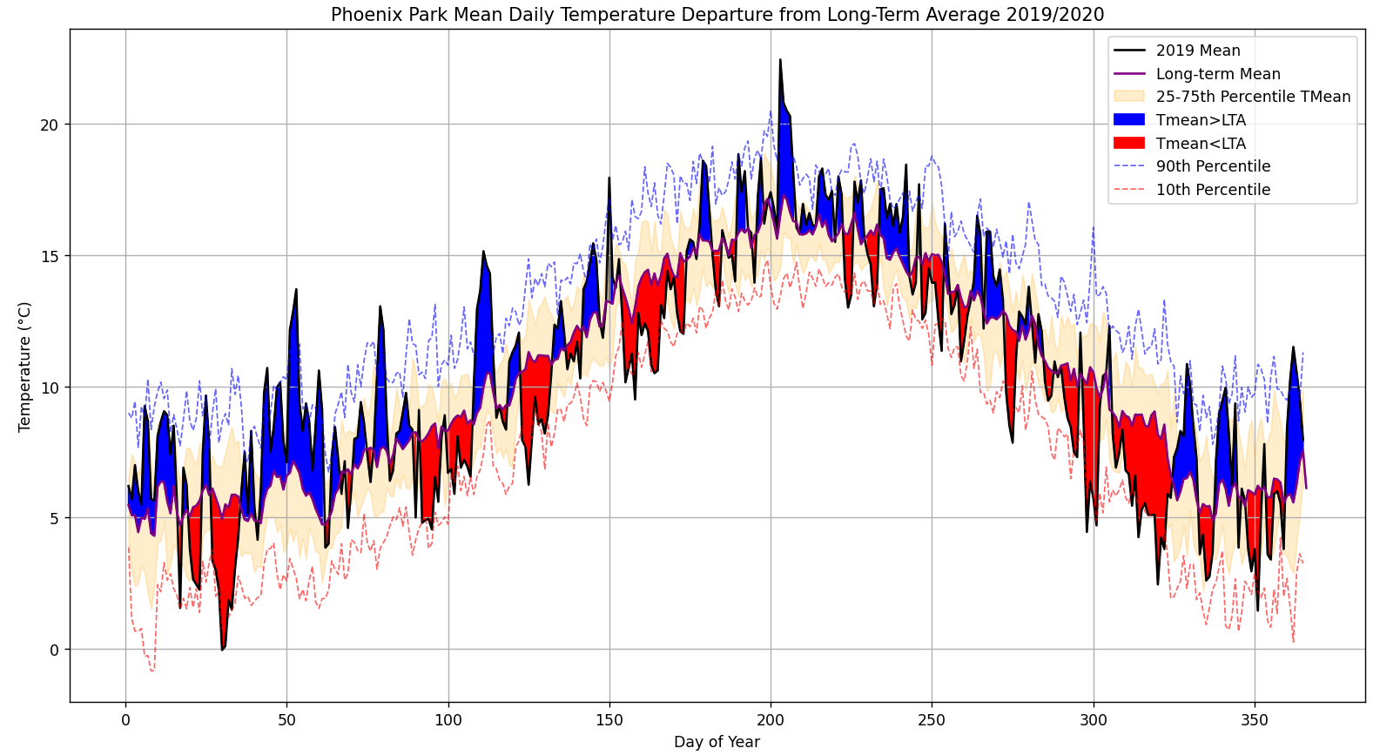
Step 7: Temperature (Min and Max temp vs their long term counterparts)
For this graph I still stuck the same year 2019 and calculated. The minimum and maximum temperatures versus their long-term counterparts. I chose to do this similarly to step 6 but replace mean with maximum and minimum.
I picked the same percentiles to plot as before but this time I didn’t add the 90th percentile for the long-term minimum temperature or the 10th percentile for the long-term maximum because it would just be lying within the normal range which isn’t very notable and because it was visually unappealing.
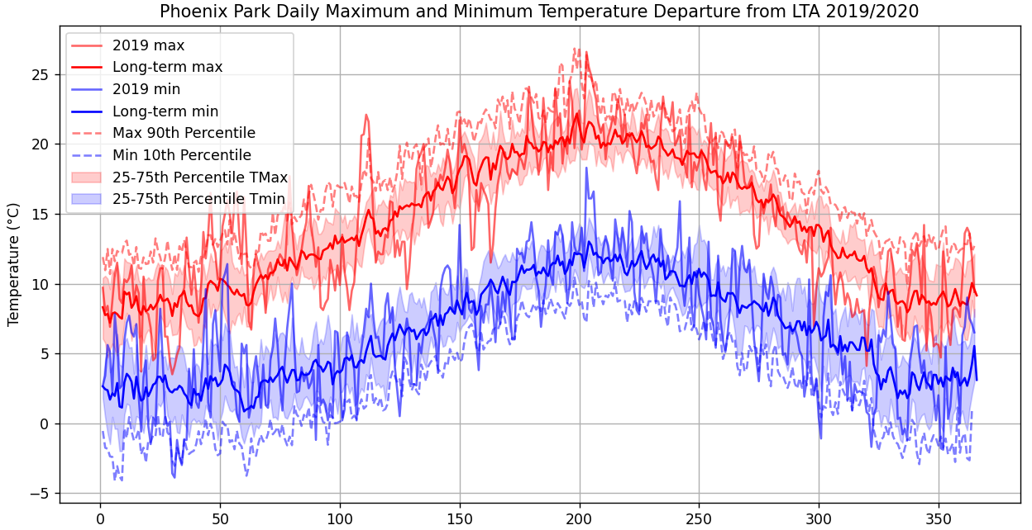

Step 8: Rain (monthly rainfall over time)
This graph is monthly rainfall over time. I plotted rain against time using a sub data frame called rainovertime_df. The reason I turned my date into a timestamp format rather than datetime is because it would automatically get plotted alphabetically e.g 1st of January would come after 1st of April because April is first in alphabet.
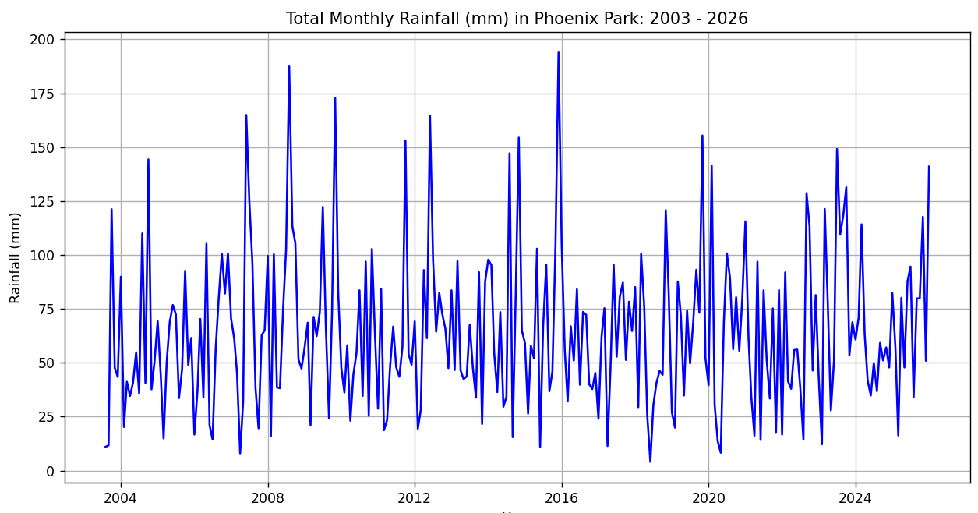

References
Matplotlib documentation
Matplotlib Development Team. (2024). Matplotlib coding guidelines (Version 3.10.7). https://matplotlib.org/3.7.10/devel/coding_guide.html
Pandas documentation
Pandas Development Team. (2024). Pandas user guide (Version 3.0.1). https://pandas.pydata.org/docs/
Seaborn Documentation
Waskom, M., et al. (2024). Seaborn: Statistical data visualization (Version 0.13.2). https://seaborn.pydata.org/

