Systems Engineers as Architects of Societies
James S. Wheaton <james.wheaton@colostate.edu>
Wade O. Troxell <wade.troxell@colostate.edu>

Abstract: Human societies now face a myriad of critical threats such as the climate crisis, environmental devastation, international war and the refugee crisis, economic destabilization and inequality, structural racism and social inequity, access to healthcare and viral pandemics to name a few. Yet despite the symptomatic problem-solving of actors in this Earth system, these (super) wicked problems have only gotten worse because they are in fact problems of the prevailing civilizational model. As systems engineering advances towards its 2025 Vision that expands its role into new domains including social and natural systems, how can systems engineers contribute to the United Nations Sustainable Development Goals that aim to stop these threats to our survival and prosperity? By applying transdisciplinary systems engineering to model the system structures of our existing societies, synthesizing theories of social and political ecology and ecological economics to develop new system requirements, and employing ontological design to model, simulate and analyze civilizational transitions, perhaps we can begin to understand how to eliminate the structural violence from our social and economic systems. Attempts to solve these wicked problems within the current paradigm of thinking will inevitably fail, so we must begin to engineer the context and design system interventions that transcend paradigms for positive lasting change and that catalyze the transition to the Age of Sustainment.
Keywords: ontological design; social ecology; political ecology; transdisciplinary systems engineering; sustainability; systems thinking; global capitalism; ecological economics

Introduction
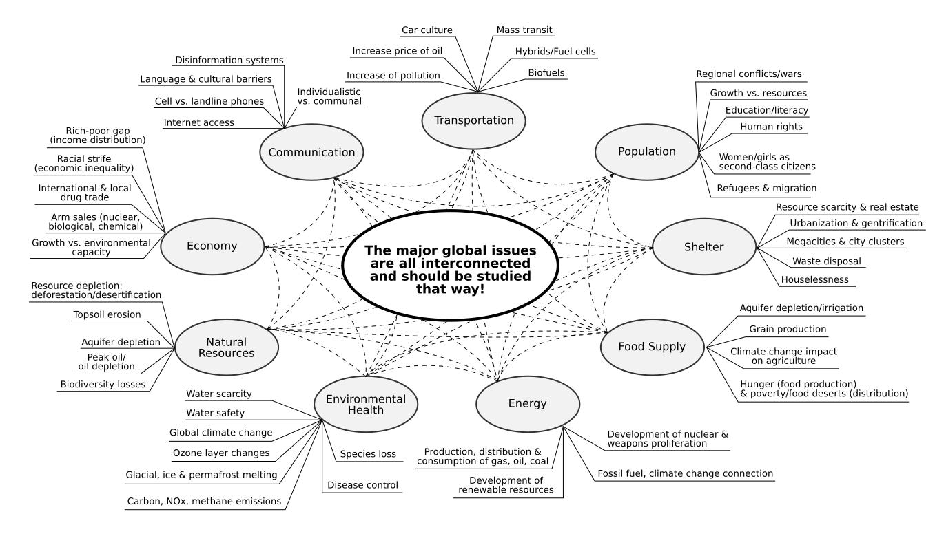Figure 1: Interconnected societal issues, adapted from the Global Energy Network Institute’s Global Issues Index[CITATION "GENI2009"]
How do we make the world work for 100% of humanity in the shortest possible time through spontaneous cooperation without ecological damage or the disadvantage of anyone? [CITATION "Fuller1982"]
The dire global issues we face are all interconnected and should be studied that way (Figure 1). As practiced systems thinkers, we should also recognize the relationship between the emergence of these threats and our collective human actions both as initiators and intervenors. For example, if it were not for the encroachment on wilderness areas by human activities such as mining and logging, the likelihood of the deadly pathogens spreading to humans would be greatly decreased. The Global Safety Net project has identified 50.4% of the Earth’s land to be reserved for biodiversity and climate resilience [CITATION "GlobalSafetyNet2020"]. But how can we begin to make coordinated use of this information to protect our future?
The late Buckminster Fuller called for a “Design Science Revolution” to orient engineering and design efforts from weaponry to livingry [CITATION "Fuller1982"]. Livingry is that technology that is designed to support and sustain life. Designing livingry means giving up designing weaponry. It is a conscious choice of where our human labor is applied, and a choice to be reckoned with by the systems engineering community given the discipline’s origins and continued participation in projects for the military.
While INCOSE’s Systems Engineering 2025 Vision [CITATION "INCOSE2014"] sees systems engineering being applied to new domains, can market forces really be overcome such that those projects that are not profitable and not well-subsidized by the public are tackled by a coordinated systems praxis effort [CITATION "Praxis2012"]? A new economic system with a different accounting method in a different social system may be needed to remove the sources of the global issues outlined above and to remediate them without a profit motive. With relative few systems engineers, and with the global crises we now face, a radical shift will be needed to deploy that talent to livingry efforts and to systems training and organizational learning leadership [CITATION "Senge2006"] for localized, context-sensitive production around the world.
There is increasing acknowledgment that systems engineering can be brought to bear on policy issues, social and natural systems. How do we make the opportunities for that vital contribution of systems thinking and systems engineering? How do we make our contribution compelling enough to be adopted by policy-makers so we may positively affect human lives? Indeed, a new way of approaching the problems of life on this planet is needed, starting with changing how we ask those questions, i.e. bounding the problem space. For example, consider the differences among these related questions and the assumptions they hold:
- How do we make healthcare affordable for everyone?
- How do we make healthcare accessible to everyone?
- How do we guarantee equal access to comprehensive healthcare for everyone?

As systems engineers we ought to be familiar of just how important asking the right questions is, even if we may be unfamiliar with asking such questions as an engineering exercise. This effort represents a shift to engineering the context where the problem-solution-space becomes more nebulous [CITATION "White2008"] [CITATION "White2016"]. Attempts to solve world hunger, for example, at the same level of thinking as that which created it will inevitably fail. As systems engineers, we should be keenly aware of this tendency to ill-define problem spaces and the danger that causes to the solution space.
Recent studies of UN Sustainable Development Goal 2 of Zero Hunger show that we need to rethink and reframe our policy interventions to sustainably end world hunger [CITATION "Lipper2020"]. The common system dynamics archetype of addiction, or Shifting the Burden to the Intervenor, may be familiar [CITATION "Senge2006"] [CITATION "Meadows2008"]. Simply speaking, food aid for the impoverished belies the fundamental solution that is local agriculture and food production (Figure 2). These structural problems require structural solutions.

To properly address such super wicked problems [CITATION "Rittel1973"] [CITATION "Jeffrey2006"] [CITATION "Levin2012"] as the climate crisis and world hunger and the 15 other UN Sustainable Development Goals [CITATION "UNSDG"], radical thinking is required with particular sensitivity to systems context (in-development and in-operation) and eco-social system requirements. Systems engineering is uniquely suited for untangling the knots and managing the system intervention development process, so bravery is needed to think big, to cross-examine mental models, to have tough conversations, and to dare to make a difference with bold designs that have the potential to disrupt the prevailing social order for lasting good. The implication is that systems engineers will become architects of societies and civilizational transitions.
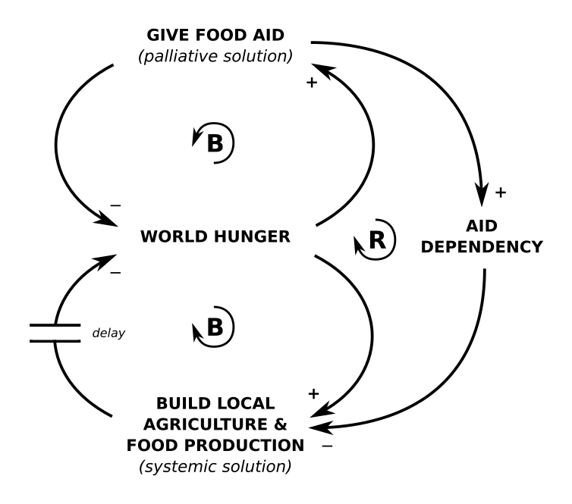Figure 2: Shifting the Burden to the Intervenor: System Archetype of World Hunger
“Comprehensive Anticipatory Design Science” is about creating futures with a future: futurality [CITATION "Binyamini2016"]. Designing futures for life on this planet means imagining a different social order than the prevailing one that is hurdling us toward extinction, and designing it in such a way that makes space for other ways of being, knowing and doing: a pluriverse, or worlds coexisting within a world [CITATION "Escobar2018"].
In this paper we discuss how to meet the general human and societal needs outlined in the 2025 Vision using a transdisciplinary systems engineering approach:
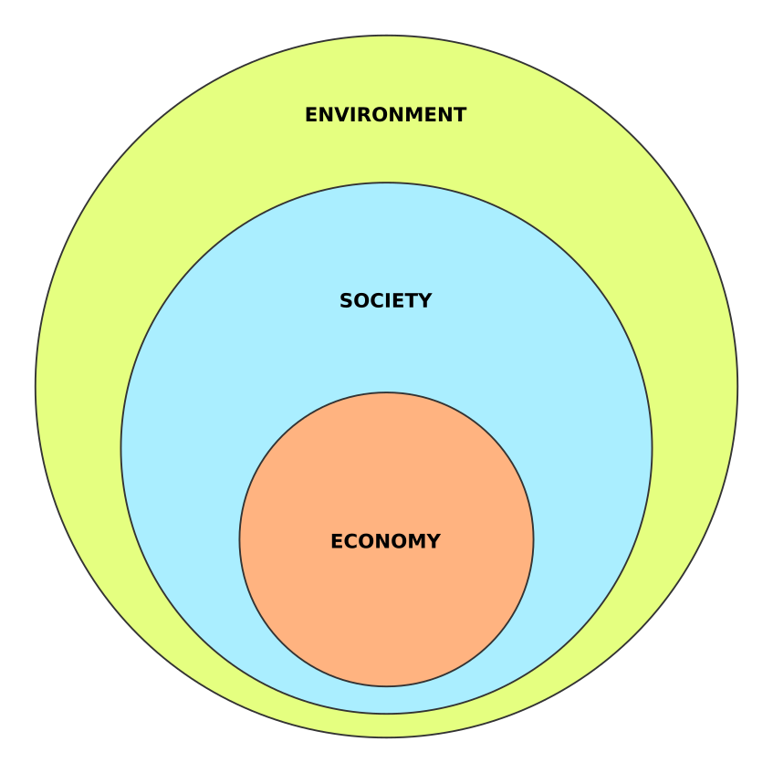Figure 3: Basic conceptual model of the systems-of-interest
- food and shelter,
- clean water,
- healthy (physical) environment,
- access to healthcare,
- access to information, communication, education,
- transportation and mobility,
- economic security and equity,
- security and safety.
Our argument is that these needs cannot be met with engineered systems alone – or else we would not see such disparities across socioeconomic boundaries – but they can be met with a renewed focus on engineering the context of those systems, bringing systems engineering firmly into the realm of economic, social, political and ecological systems (Figure 3).

Background
Paradoxically, the engineering professions have been a central agent in the creation of the structural unsustainability of the contemporary world. [CITATION "Escobar2018"]
It is important for us to acknowledge engineers’ complicity in the desolation of the natural environment and in the acceleration of climate change, and to recognize that merely designing for the product life cycle is insufficient to address eco-societal problems at scale. Like many technologies, engineering and analytical processes, systems engineering as a bonified discipline arose from military organizations and problems faced by the military, but was later applied to other domains owing to their generality and abstraction utility. INCOSE recognizes systems engineering being used as far back as the construction of the Giza Pyramids; however, it is the industrial revolution and transition to modernity that have scaled the societal and ecological side-effects of engineered systems.
Climate change is not only affecting people on the coastlines but also people living in hot biomes that are themselves expanding [CITATION "ClimateRefugees2011"], contributing to already 1% of the world’s population that have been forcibly displaced according to the UN High Commissioner for Refugees [CITATION "UNHCR2020"]. Failure to deal with rapid climate change and other wicked problems of this era has mostly been due to a lack of political will, as evidenced by nation-states signing the Kyoto Protocol and Paris Accord but not stopping subsidies to the oil industry or implementing policies that significantly curtail energy usage and unsustainable economic growth. Greenwashing is not a solution. For example, the EU buys wood pellets manufactured from cutting down forests in the lower Eastern Seaboard of the US [CITATION "Koester2018"], transports them across the Atlantic, and then burns them to generate electricity, claiming carbon neutrality [CITATION "Davis2020"]. And of course, carbon oxides are not the only greenhouse gas — carbon accounting is a partial solution that fails to challenge why carbon is being expelled into the atmosphere in the first place. Actually, humanity has long been engaged in terraforming projects and land stewardship that recognized the symbiosis of human life, animal life, plant life, and the other natural systems such as watersheds [CITATION "Kimmerer2013"].
INCOSE’s Systems Engineering Vision 2025 proposes a number of efforts that may help us move forward in addressing super wicked problems. An important one that may have been overlooked is “Earth understanding on demand: the state of the Earth systems will be made widely available in near real time,” a vision shared by Buckminster Fuller and his World Game project [CITATION "Fuller1982"]. The 2025 Vision stated eight key system characteristics desired by stakeholders: 1) sustainable, 2) scalable, 3) safe, 4) smart, 5) stable, 6) simple, 7) secure, 8) socially-acceptable. It should be emphasized that the system be socially-acceptable, especially by the marginalized. Indigenous peoples who demand international treaties be honored have blockaded recent North American oil pipeline projects [CITATION "Whyte2019"] [CITATION "Estes2019"] and the Thirty Meter Telescope on Hawai’i Island [CITATION "Kahanamoku2020"]: project leaders must be willing to accept a no-deal if prior informed consent cannot be obtained without coercion.
The 2025 Vision also includes the NAE Grand Engineering Challenges for the 21st Century [CITATION "NAE2017"] but avoids the UN’s Sustainable Development Goals adopted by 193 countries of the UN General Assembly. The document provides the following caveat,
However, these systems must be embedded in the prevailing social, physical, cultural, and economic environment, and the technologies applied to system solutions must be tailored to the relevant local or regional capabilities and resources.
In other words, the NAE Engineering Grand Challenges are a techno-centric view of how to address problems of our social and natural systems. The verbiage avoids the possibility to engineer social and economic systems as a way to enter these challenges, thereby reaffirming the prevailing social and economic order.

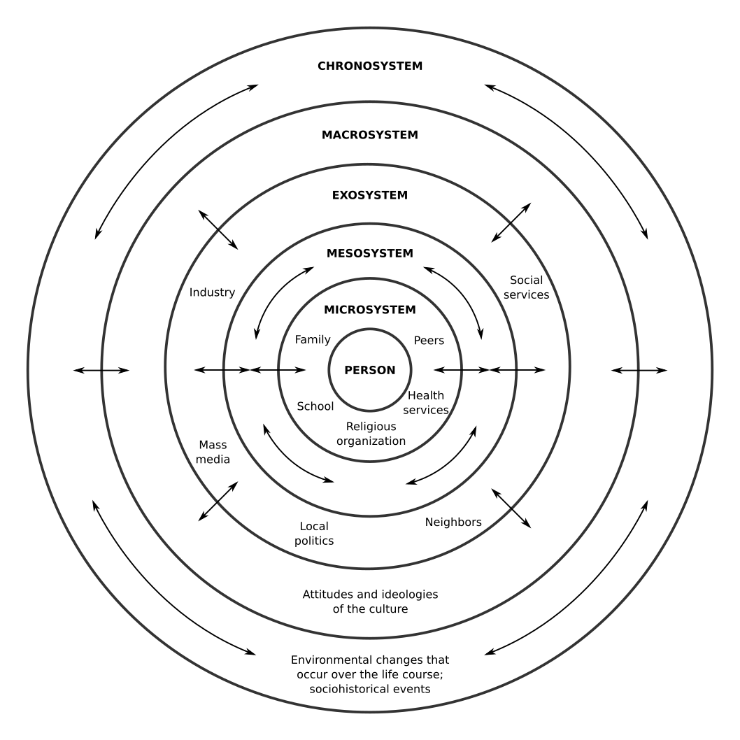Figure 4: Bronfenbrenner's Ecological Theory of Development
The 2025 Vision includes global trends, much of which we have already covered above, and mentions “increasing globalization,” another ominous statement given recent trends of de-globalization in the West and rich conversations of the dangers of globalization especially from degrowth theorists and the Latin American academic and activist communities [CITATION "Escobar2018"] [CITATION "Jackson2017"] [CITATION "Degrowth2015"]. The inevitability of increasing globalization of trade is not certain, given the severe strain it causes on natural systems like the ocean and atmosphere. To an engineer, regular transportation of goods across thousands of miles should be red flag for cost and sustainability concerns.
Other relevant topics of the 2025 Vision are the work environment, collaborative engineering, education and training, and tools. We invite readers to revisit these sections with a fresh perspective about what may be possible without the undue constraints of the current economic and social order. Primarily, the profit motive and relentless competitive mindset, i.e. knowledge hoarding, are holding us back from open collaboration.
We will draw from systems thinkers and other radical thinkers in this paper to assist in re-framing global issues relevant to the future of systems engineering. High-level systems models are provided to help orient the reader (Figure 4). This analysis should be considered as a starting point, a different and (hopefully) productive way of framing future conversations to avoid the rut of “solving problems with the same level of thinking that created them” (Albert Einstein).

Discussion

Global capitalism as a systemic threat
Though the Western subject’s core is eschatologically-progressive, always moving towards a future, it now seems that this futurality no longer permits any being in the subject beyond a structural servility to the future. [CITATION "Binyamini2016"]
As systems thinkers, we trace events down to patterns, to system structures, and finally to mental models. Mental models create the system structures that effect behaviors in the real world. By analyzing in this way the climate crisis and various humanitarian crises of the world, it is impossible to avoid questions about the kind of thinking that created these problems, how it framed these problems, and how it proposes to intervene.
Neoliberal capitalist globalization has created transnational corporations that pay little to zero taxes, and which are only beginning to become accountable to their customers who are starting to demand supply chain transparency and ethical sourcing. The relentless search for cheap labor has moved production to the Global South: to poorer countries with fewer environmental and labor regulations. The exploitation of workers – who commit suicide, die due to overwork or are injured on the job due to poor safety practices and are subsequently fired without severance – and the desolation of their nearby natural environment can never be said to be a net benefit even if it means consumers in the Global North get the latest iPhone. That is the dialectical relationship between an iPhone’s use and its production, just to use a familiar example.
Nowadays, garbage and recycling is being shipped across oceans to the Global South for cheap processing, bringing up uncomfortable questions about the efficacy of recycling. Countries such as Malaysia have refused this waste, some of it illegal medical waste, at port customs and then redirected the container ships back to their point of origin [CITATION "Reuters2019"], and in the process more bunker fuel is burned that releases not just carbon dioxide and carbon monoxide, but also nitrogen oxides that act as greenhouse gases, and PM2.5 that is extremely harmful to respiratory systems.
All the responsible parties want to wash their hands of the uncomfortable truths of neoliberal capitalist globalization – whitewashing. The structural inefficiencies and structural violence have been normalized as necessary for low-cost, high-quality products, which not surprisingly, much of the Global South cannot afford to buy. While raw materials may only be found in certain parts of the globe, production can happen anywhere. What is missing is the know-how and manufacturing equipment that have been systemically deprived in the name of intellectual property and private profit. Furthermore, neo-colonial campaigns such as the fascist coup of the Bolivian government [CITATION "Beeton2020"] in pursuit of raw lithium for Tesla batteries [CITATION "Telesur2020"], or the economic warfare (sanctions) of governments that do not want to yield to capitalist globalization exacerbate existing problems of access to knowledge and equipment that creates real harm such as food, medicine, fuel and electricity shortages.
In this way, the Global South is a plantation for the Global North, supplying it with consumables and luxury goods just like it did at the height of the British and other European empires. This is an uncomfortable truth we should all be at least vaguely familiar with if we have ever checked the manufacturing origin of the products we buy. Even products “Made in the USA” of course contain components made elsewhere, or are in fact manufactured in US Territories with lax labor laws. It may be apparent that even the knowledge of how to manufacture products that were once made in the US is being drained.
The coronavirus pandemic shocked global supply chains (the bullwhip effect [CITATION "Forrester1961"]) and created shortages of medical supplies such as personal protective equipment, causing the US Government to pirate goods en route to other countries [CITATION "Willsher2020"]. Relentless cost-saving measures have created Just-In-Time inventories, shrinking stored supplies of daily necessities such as toilet paper to minimal levels that cannot tolerate even moderate disruptions in demand. Corporations were put on life-support using central bank debt monetization schemes, effectively becoming “zombie corporations” because their revenues were unable to pay interest on their debt. While these incidents may have appeared like harmless accidents, they were actually years in the making, waiting for the perfect storm to reveal the system fragilities [CITATION "Taleb2014"].

Decolonizing the system and the project
This [modern] age, however, is a complex constellation of coevolving processes, including a particular episteme, an ensemble of social forms among which patriarchal capitalism and coloniality occupy pride of place, and an ontological architecture structured around the founding dualisms of nature/cultures and West/non-West. It is this onto-epistemic and social formation that is at the foundation of design. [CITATION "Escobar2018"]
Projects require consent. They can be made equitable or inequitable to the stakeholders involved and locally affected. The result of a socially inequitable project to the local inhabitants can be found in environmental racism wherein Black, Indigenous, and people of color (BIPOC) often reside in areas where toxic waste is dumped or effused by nearby industrial activity [CITATION "Seamster2020"] [CITATION "Bullard1999"]. A high-profile example is Flint, Michigan where oil fracking (an unprofitable activity without oil subsidies) has contaminated the water supply of a predominantly Black American community – part of the African diaspora and an internally-colonized people – causing many ailments such as lead poisoning and Legionnaires disease [CITATION "Pulido2016"] [CITATION "Ranganathan2016"].
Another important case study of the coloniality of power is the Thirty Meter Telescope (TMT) project at Mauna Kea, Hawai’i. Already the site of a number of astronomical observatories, Mauna Kea is regarded as a sacred mountain by the Hawaiian people. Past manufactured consent is not a substitute for consent of a new project. TMT is a multi-billion dollar project involving astronomical societies from multiple countries, and is in a kind of race to construct a thirty-meter telescope in response to a US National Academy of Sciences request. The site is preferred for scientific reasons and the project has already passed through a number of legal hurdles, yet no amount of Environmental Impact Statements can make up for the fact that Hawai’i is a colonially-occupied sovereign nation, in violation of international law recognized by the UN Human Rights Committee [CITATION "Kahanamoku2020"] [CITATION "Sai2018"] [CITATION "deZayas2018"].
The appeal here is for systems engineers to recognize their possible role in neo-colonial projects, and to consider doing something else if the project charter cannot be ratified by the colonized people(s). Continued participation in these projects impinges on the national sovereignty of Indigenous peoples and perpetuates structural violence that reduces the human lifespan among other psycho-, physio-, and socio-logical ills. That in order for systems engineering to graduate from the imperial tradition, it must respect the rights of people(s). To do otherwise would violate our Code of Ethics and would stymie the free development of life on this planet.

On pedagogy, epistemology, and ontology
Ontological design stems from a seemingly simple observation: that in designing tools (objects, structures, policies, expert systems, discourses, even narratives) we are creating ways of being. [CITATION "Escobar2018"]
Pedagogy will be important too, to bring systems engineering into the pluriverse and to integrate futurality as a fundamental design principle. Where military systems are currently used as case studies and examples, livingry systems will supplant them in the classroom of the future. Likewise, where details of systems-of-study are currently national and corporate secrets, radically open-source specifications and models in support of open science [CITATION "Chan2019"] will be used in the classroom to give students the opportunity to study the intricacies of real-world livingry systems. Whence the political will exists, significant effort will be needed to document existing systems such as Singapore’s water management system [CITATION "Chia2008"] in an open-source MBSE architecture model and translated into various languages. Further, an open-source document or model is of no use if it can only be read and modified by proprietary closed-source software; therefore, continued development of open-source Macro-CAD engineering tools [CITATION "Fabrycky2011"] is needed to satisfy the openness characteristic of system architecture models and to satisfy community stakeholders.
Modernity is beginning to understand the value of other epistemic frameworks and is beginning to adapt those knowledge systems into its own to better serve people and the Earth [CITATION "McCarthy2014"] [CITATION "Vinyeta2013"] [CITATION "Houde2007"]. Some examples of which are called Traditional Chinese Medicine and Traditional Ecological Knowledge [CITATION "Kimmerer2013"] [CITATION "Degrowth2015"]. These epistemic frameworks tend to be holistic as opposed to modernity’s scientistic reductionism. Therefore, some systems-related concepts may be easier to express in other languages and epistemic frameworks, although not necessarily incompatible with modern definitions. For the systems engineer, it is important to recognize alternate ways of being, knowing and doing as valid and worthy of respect although they may be difficult to understand as an outsider. The risk of cultural appropriation should be noted here and it is always best to seek the consent and advice of Indigenous practitioners. Future collaborations with Indigenous scholars and makers will create opportunities to solve eco-social problems in radically different ways that may not be easily expressible in existing English and modern science/engineering terminology.
One of the central themes of Arturo Escobar’s Designs for the Pluriverse: Radical Interdependence, Autonomy, and the Making of Worlds is the exploration of relational-ontological approaches to design of social systems in an attempt to answer the questions:
- Will there still be “modern solutions to modern problems”?
- Or has modernity’s ability to even imagine the questions that need to be asked to effectively face the contemporary ecological and social crisis been so fatally compromised, given its investment in maintaining the worlds that created it, as to make it historically necessary to look elsewhere, in other-than-modern world-making possibilities?
The book should be read along three axes which serve to orient our design thinking:
- ontology, concerned with world making from the perspective of radical interdependence and a pluriversal imagination
- design, as an ethical praxis of world making
- and politics, centered on a reconceptualization of autonomy precisely as an expression of radical interdependence, not its negation.
The author states that “the notion of relationality involves more than nondualism; that reimagining the human needs … in order to contemplate effective possibilities for the human as a crucial political project for the present; and that to the awareness of how we live in a world (or worlds) of our own making (again, a prevalent theme in Western philosophy) we now need to add a sharper consciousness of how those worlds make us — sometimes with deeply troubling results” (emphasis added). Following from Escobar’s admonition that engineers have been “central agents of structural unsustainability,” it is important for us to reflect on the truth of this statement and how our own biases and exposure to disinformation systems have contributed to engineering’s continued techno-centrism in service of the global plantation. Only by reckoning with this cognitive dissonance will we work to resolve it and transform systems engineering from being part of the problem to being instrumental to new pluriversal solutions.

Architecting Economic Systems with a Future
The main finding is that all economic theory is inherently flawed. Any system of ideas whose purpose is to describe capitalism in mathematical or engineering terms leads to inevitable logical inconsistency; an inherent error that stands between us and a decent grasp of capitalist reality. The only scientific truth about capitalism is its radical indeterminacy, a condition which makes it impossible to use science’s tools (e.g. calculus and statistics) to second-guess it. [CITATION "Varoufakis2011"]
Capitalism as an economic system is premised upon unlimited growth but now we are reaching the limits of what the Earth system can tolerate while still supporting life as we know it [CITATION "Meadows2004"]. Non-Government Organizations (NGOs) and nonprofits frequently appear to intervene in issues of social and environmental justice but with only marginal success. But what if the system of oppression did not exist to perpetrate those crimes against humanity in the first place? Much has been written about how capitalism as an economic system in tandem with the police state both function to enforce the global socioeconomic order with its “haves and have-nots” [CITATION "Robinson2020"]. It is not simply a truth of human existence to starve and be deprived access to healthcare and clean water: there is a system functioning to create these systemic inequities. Neither is it beyond the capability of modern technology to provide these basic human needs for all 7+ billion people: there are system structures in (physical and metaphysical) place and system policies that are enforced to prevent this advancement from occurring.
Leading economists Professor Richard Wolff and Yanis Varoufakis, Ph.D. have written extensively about the structural flaws of global capitalism and what could possibly replace it [CITATION "Wolff2020"] [CITATION "Varoufakis2020"]. The novel coronavirus pandemic of 2020 hit an already fracturing global economic system – one that had not resolved its contradictions after the global financial crash of 2008 – and exposed its most pernicious flaws: its inability to support public health and its systemic fragility that was exposed by a sudden disruption of supply and demand. It even forced authorities to specify exactly what economic and social services are essential [CITATION "Krebs2020"], implicitly admitting to the prevalence of non-essential jobs as described by [CITATION "Graeber2018"]. Wolff often mentions the cyclical system failures of capitalism that occur every 4-7 years; they happen so often that we have many names for them: depression, recession, crash, bubble, bust, etc.
As a possible solution he proposes democracy in the workplace by restructuring the enterprise to remove the employer-employee dialectical relationship and replace it with worker-owners who cooperate to decide what to produce, how to produce it, where/when/why and what to do with the profits. With practice, such a worker-owned cooperative enterprise will be more sustainable to prevent job loss, erroneous investments, and disruption of products/services to customers compared to traditional corporations that see sometimes frequent turnover of board members and executives [CITATION "Wolff2012"]. Policy-makers may implement an incentive system to create this new social sector of the economy such as what was proposed in Barcelona [CITATION "ImpetusSSE"]. Italy has made use of laws since the 1970s that offer a government loan if a newly unemployed person can assemble 9 others to start their own worker-owned cooperative, as an alternative to receiving unemployment insurance income [CITATION "Antonazzo2019"] [CITATION "Antonazzo2018"] [CITATION "Vieta2015"] [CITATION "Parker2014"]. Worker buyouts of factories using the Marcora Law have improved the resiliency of Italy’s economic system and the individual.
In order for engineered systems to avoid negative environmental and social impacts, the Quadruple Bottom Line should be adopted as a standard for enterprise and engineered systems [CITATION "Waite2013"]. Just as we would not optimize an engineered system for a single characteristic such as speed, it is unwise to optimize an economic system solely on profit. In this pervasive method of accounting, social and environmental concerns are erased from the quantitative assessment. A composite Quality Attribute [CITATION "Borky2019"] for the system-of-interest and enterprise consisting of People, Planet, Profit, and Future Generations (intergenerational equity) will win the approval of subalterns and future generations and will work to support sustainability programs that uphold the United Nations Global Compact [CITATION "UNGC"] and pursue the UN Sustainable Development Goals.
Finally, alternative economic decision-making models have been proposed that avoid the tyranny of the free market. These are based on democratic processes that share information among locally-affected parties in order to optimize resource allocation. One such decentralized economic model was proposed by [CITATION "Devine2002"] called participatory planning through negotiated exchange. One way for systems engineers to contribute to this economic innovation is to model this economic system structure and behaviors using SysML or OPM, thereby creating an initial executable architecture that can be improved upon with further modeling, simulation and analysis, released as open science, of course [CITATION "Chan2019"].

Design-for Conviviality
Conviviality refers to a society in which modern tools are used by everyone in an integrated and shared manner, without reliance on a body of specialists who control said instruments. . . . [A] tool is convivial if it can be used and adapted with ease and for a purpose chosen by the individual, and if it has the result of expanding freedom, autonomy, and human creativity. [CITATION "Degrowth2015"] [CITATION "Illich1973"]
Just as systems engineers design for maintainability, usability, reliability, we can expand our methods to include design-for-conviviality. Convivial tools are not as likely to be produced under capitalism because the corporation needs the customer to keep coming back and to buy more or subscribe to more services. Convivial systems respect the user’s autonomy and inherent creative ability to (re-)make their world. These tools and systems may be more easily repaired on-site and adapted to new uses and environments beyond the designer’s original vision [CITATION "Jakubowski2012"]. It also puts a limit on industrial production since constant updates to products aggravate personal and collective autonomy.
The concentration of power, energy, and technical knowledge in bureaucracies (the State) resulted in the institutionalization of these tools and enabled a tight system of control over production and destruction. Illich referred to this process as instrumentation and showed how it systematically destroys convivial modes of living. The result was a mega-tooled society embedded in multiple complex systems that curtail people’s ability to live dignified lives. The corollary is that society has to be reinstrumentalized to satisfy the twin goals of conviviality and efficiency within a postindustrial framework. [CITATION "Degrowth2015"]
System design in this way precludes hoarding of knowledge. The system is simply more trustworthy if its specifications are published freely, thus able to be independently audited, deconstructed and reconstructed to learn its architecture, just as machines once were. Since in a post-capitalist economy, survival of an enterprise no longer depends on limitless revenue growth, other firms may locally manufacture the same system by means of access to its specifications and architecture model, just as there are now many manufacturers of flip-flop sandals — further product differentiation becomes harmful to the customer, e.g. there is a lower limit on cost of the materials, and alterations of the design can make it less useful, i.e. there exists some optimum design for which we can call the architecture finished. Modern counter-examples exist prominently in the Right to Repair debate, where farmers especially are stripped of their power to repair their tractors without violating the law — not that they have access to the specifications to understand how the computer subsystems work — and some farmers go so far as getting rid of their modern tractor in favor of a simpler less powerful one so they can get on with their work of farming instead of being stuck hacking firmware [CITATION "Shah2018"].

From sustainability to Sustainment
It is thus important to recover our future-imagining capacity, for which [Illich] proposes a transition from the Enlightenment to a new horizon of "Sustainment,: a new age capable of nourishing those relational ways of being-in-the-world capable of countering the ontology of defuturing [by which he means design’s contribution to the systemic conditions of structured unsustainability that eliminate possible futures]. [CITATION "Escobar2018"]
The individualistic modes of living we are accustomed to in the West create physical architectural barriers to community-making and sharing of food and tools, amplifying costs of living and consumption of resources. The single-family home of the nuclear era must give way to opportunities to share spaces and to communally support the young and elderly to provide for long prosperous lives unthreatened by constantly-rising housing costs.
One alternative living architecture that would be of interest to readers is Low2No, used as a case study in [CITATION "Hill2015"] a book about strategic design and systems thinking. It is a building architecture design that fits on a city block but contains living space, community space, businesses and schools. It is constructed of sustainable materials and can be replicated across city blocks, thus providing walk-able access to most daily needs.
In places where space is scarce such as in San Francisco, California, communal living arrangements are becoming more popular to support the population. This way of living contrasts with contemporary housing projects that are rather designed to maximize the number of tenants and individually bill them for utilities and facilities usage, dampening the need for neighbors to interact and adding to building architecture complexity and cost. City blocks could have urban gardens and be dual-zoned for residential and agriculture: localizing food production by integrating food systems in the physical architectures of cities will alleviate hunger and food deserts.
The unsustainability of the US lifestyle in particular has been widely studied but little has changed. The average US American consumes 100 times more energy than people in many other parts of the world [CITATION "kWhPerCapita2020"], and wastes roughly a third of food available at the retail and consumer levels [CITATION "Kibler2018"]. The statistics are startling and sickening.
Although animal production makes up 25% of the world’s food supply by weight, 18% of dietary calories, and 39% of protein, it accounts for approximately 75% of agricultural land area, 29–43% of the total agricultural water footprint, 46–74% of agricultural GHG emissions, and 34–58% of total nitrogen use. [CITATION "GlobalFEWNexus2018"]
We need not go far to improve living standards of people: the US is one of only three countries that has dropped in rank in the latest report of the Social Progress Index [CITATION "SocialProgressIndex2020"]. Native Americans in particular are vulnerable due to reduced access to electricity, clean water, nutritious food, and Internet [CITATION "Sandoval2018"] [CITATION "Doyle2018"] [CITATION "Pindus2018"] [CITATION "Simonds2019"] [CITATION "Lewis2017"] [CITATION "Langridge2006"] [CITATION "Arthur2020"]. That said, significant opportunities exist in the US to set an example for transitioning to ecological-minded and pluriversal living starting with the most marginalized of society, but concrete proposals need to be made. MBSE architectures can fill the gap left by static statistical and conceptual models. Given their skillset, systems engineers have an ethical imperative to contribute to civilizational models that transition the planet to an Age of Sustainment, but courage is needed to shake up the status quo and provide a convincing case for systems architectural-level elimination of social and ecological ills.

Conclusion
We have made a case for a future of systems engineering that respects the plurality of cultures and synthesizes theories in social ecology, political ecology, and ecological economics to effect change at the societal level. Model-based systems engineering will be critical to make open-source civilizational transition models convincing enough to implement. Those architecture models will facilitate advanced modeling, simulation and analysis to finally avail socioeconomic models of reliable predictive and prescriptive analytics. Open data and knowledge are paramount in this transition and radical cooperation is the way forward to safely raising the standard of living of everyone without ecological damage. Further, exploration and respect of alternative ways of being, knowing and doing will help us avoid the future reproduction of existing global issues. Systems engineers can feel inspired to apply their unique skillsets to co-design convivial systems that sustain human lives into the future.
The way forward may seem daunting and risky but we are faced with intersecting global threats most notably accelerating climate change that will force us to adapt quickly. The risk of continued business-as-usual is greater, as climate scientists have warned us for decades, so to fail to act now is a dereliction of duty to ourselves and to future generations. Only after reckoning with the self-destructive mode of living that is modernity can we enter the Age of Sustainment.
Bibliography
GENI2009: , Global Issues Index, 2009
Fuller1982: R. Buckminster Fuller; Kiyoshi Kuromiya, Critical Path, 1982
GlobalSafetyNet2020: E. Dinerstein; A. R. Joshi; Vynne; A. T. L. Lee; F. Pharand-Deschênes; M. França; S. Fernando; T. Birch, K. Burkart; G. P. Asner and D. Olson, A “Global Safety Net” to reverse biodiversity loss and stabilize Earth’s climate, 2020
INCOSE2014: INCOSE Systems Engineering Vision 2025 Project Team, A World in Motion – Systems Engineering Vision 2025, 2014
Praxis2012: J. Martin; J. Bends; G. Chroust; D. Hybertson; H. Lawson; R. Martin; H. Sillitto; J. Singer; M. Singer; T. Takaku, Towards a Common Language for Systems Praxis, 2012
Senge2006: Peter M. Senge, The Fifth Discipline: The Art & Practice of The Learning Organization, 2006
White2008: B. E. White, Complex Adaptive Systems Engineering, 2008
White2016: B. E. White, A Complex Adaptive Systems Engineering (CASE) Methodology: The Ten-Year Update, 2016
Lipper2020: Lipper, Leslie and DeFries, Ruth and Bizikova, Livia, Shedding light on the evidence blind spots confounding the multiple objectives of SDG 2, 2020
Meadows2008: Donella H. Meadows, Thinking in Systems: A Primer, 2008
Rittel1973: Horst W. J. Rittel; Melvin M. Webber, Dilemmas in a General Theory of Planning, 1973
Jeffrey2006: Conklin, E. Jeffrey, Dialogue Mapping: Building Shared Understanding of Wicked Problems, 2006
Levin2012: Kelly Levin; Benjamin Cashore; Steven Bernstein; Graeme Auld, Overcoming the tragedy of super wicked problems: constraining our future selves to ameliorate global climate change, 2012
UNSDG: , Sustainable Development Goals, , https://sdgs.un.org/
Binyamini2016: Itzhak Binyamini, Futurality, an Eschatological Methodology, 2016
Escobar2018: Arturo Escobar, Designs for the Pluriverse: Radical Interdependence, Autonomy, and the Making of Worlds, 2018
ClimateRefugees2011: Susana B. Adamo; Alexander de Sherbinin, The Impact of Climate Change on the Spatial Distribution of Populations and Migration, 2011
UNHCR2020: United Nations High Commissioner for Refugees, Global Trends Report, 2020
Koester2018: Stefan Koester; Sam Davis, Siting of Wood Pellet Production Facilities in Environmental Justice Communities in the Southeastern United States, 2018
Davis2020: Sam L. Davis; Nataly Perez; Stefan Koester, Forests Are Not Fuel, 2020
Kimmerer2013: Robin Wall Kimmerer, Braiding Sweetgrass: Indigenous Wisdom, Scientific Knowledge, and the Teachings of Plants, 2013
Whyte2019: Kyle Powys Whyte, The Dakota Access Pipeline, environmental injustice, and US settler colonialism, 2019
Estes2019: Nick Estes, Our History Is the Future: Standing Rock Versus the Dakota Access Pipeline, and the Long Tradition of Indigenous Resistance, 2019
Kahanamoku2020: Kahanamoku, S., Alegado, R.A., Kagawa-Viviani, A., Kamelamela, K.L., Kamai, B., Walkowicz, L.M., Prescod-Weinstein, C., Reyes, M.A.D.L. and Neilson, H., A Native Hawaiian-led summary of the current impact of constructing the Thirty Meter Telescope on Maunakea, 2020
NAE2017: , NAE Grand Challenges for Engineering, 2017, http://www.engineeringchallenges.org/
Jackson2017: Tim Jackson, Prosperity Without Growth: Foundations for the Economy of Tomorrow, 2017
Degrowth2015: , Degrowth: A Vocabulary for a New Era, 2015
Reuters2019: Reuters, Malaysia to send 3,000 tonnes of plastic waste back to countries of origin, 2019, https://www.reuters.com/article/us-malaysia-waste-idUSKCN1SY0M7
Beeton2020: Dan Beeton, Major Coding Error Reveals Another Fatal Flaw in OAS Analysis of Bolivia's 2019 Elections, 2020, https://cepr.net/press-release/major-coding-error-reveals-another-fatal-flaw-in-oas-analysis-of-bolivias-2019-elections/
Telesur2020: Telesur, Elon Musk Confesses to Lithium Coup in Bolivia, 2020, https://www.globalresearch.ca/elon-musk-confesses-lithium-coup-bolivia/5719776
Forrester1961: Jay Wright Forrester, Industrial Dynamics, 1961
Willsher2020: Willsher et al., US accused of 'modern piracy' after diversion of masks meant for Europe, 2020, https://www.theguardian.com/world/2020/apr/03/mask-wars-coronavirus-outbidding-demand
Taleb2014: Taleb, N.N., Antifragile: Things that Gain from Disorder, 2014
Seamster2020: Louise Seamster; Danielle Purifoy, What is environmental racism for? Place-basedharm and relational development, 2020
Bullard1999: Robert D. Bullard, Dismantling Environmental Racism in the USA, 1999
Pulido2016: Laura Pulido, Flint, Environmental Racism, and Racial Capitalism, 2016
Ranganathan2016: Malini Ranganathan, Thinking with Flint: Racial Liberalism and theRoots of an American Water Tragedy, 2016
Sai2018: Keanu Sai, The U.S. Occupation of the Hawaiian Kingdom , 2018, https://www.nea.org/advocating-for-change/new-from-nea/us-occupation-hawaiian-kingdom
deZayas2018: Dr. Alfred M. deZayas, Re: The case of Mme Routh Bolomet, 2018
Chan2019: Chan et al, Contextualizing Openness: Situating Open Science, 2019
Chia2008: E. S. Chia; F. K. P. Gilbert, A large-scale systems engineering perspective of water management in Singapore, 2008
Fabrycky2011: Wolter J. Fabrycky; Benjamin S. Blanchard, Systems Engineering and Analysis, 2011
McCarthy2014: Gina McCarthy, Memorandum: U.S. Environmental Protection Agency's "Policy on Environmental Justice for Working with Federally Recognized Tribes and Indigenous Peoples", 2014
Vinyeta2013: Kirsten Vinyeta; Kathy Lynn, Exploring the Role of Traditional Ecological Knowledge in Climate Change Initiatives, 2013
Houde2007: Nicholas Houde, The Six Faces of Traditional Ecological Knowledge: Challenges and Opportunities for Canadian Co-Management Arrangements, 2007
Varoufakis2011: Yanis Varoufakis; Joseph Halevi; Nicholas J. Theocarakis, Modern Political Economics: Making Sense of the Post-2008 World, 2011
Meadows2004: Donella H. Meadows; Jorgen Randers; Dennis L. Meadows, Limits to Growth: The 30-Year Update, 2004
Robinson2020: William I. Robinson, The Global Police State: A critical look at the terrifying rise in the control of 'surplus' populations, 2020
Wolff2020: Richard D. Wolff, The Sickness is the System: When Capitalism Fails to Save Us from Pandemics or Itself , 2020
Varoufakis2020: Yanis Varoufakis, Another Now: Dispatches from an Alternative Present , 2020
Krebs2020: Christopher C. Krebs, Advisory Memorandum on Identification of Essential Critical Infrastructure Workers During COVID-19 Response, 2020
Graeber2018: David Graeber, Bullshit Jobs: A Theory, 2018
Wolff2012: Richard D. Wolff, Democracy at Work: A Cure for Capitalism, 2012
ImpetusSSE: Ajuntament de Barcelona, The Impetus Plan for the Social and Solidarity Economy in Barcelona, 2015
Antonazzo2019: Luca Antonazzo, Narratives of cooperation, resilience and resistance: workers’ self-recovery in times of crisis, 2019
Antonazzo2018: Luca Antonazzo, Cooperation against capitalism’s biases. Workers-recuperated enterprises in Italy during the Great Recession, 2018
Vieta2015: Marcelo Vieta, The Italian Road to Creating Worker Cooperatives from Worker Buyouts: Italy’s Worker-Recuperated Enterprises and the Legge Marcora Framework , 2015
Parker2014: Parker et al, The Routledge Companion to Alternative Organization, 2014
Waite2013: Marilyn Waite, SURF Framework for a Sustainable Economy, 2013
Borky2019: John M. Borky; Thomas H. Bradley, Effective Model-Based Systems Engineering, 2019
UNGC: , Global Compact, , https://www.unglobalcompact.org/
Devine2002: Pat Devine, Participatory Planning Through Negotiated Exchange, 2002
Illich1973: Ivan Illich, Tools for Conviviality, 1973
Jakubowski2012: Cameron Colby Thomson; Marcin Jakubowski, Toward an Open Source Civilization, 2012
Shah2018: Agam Shah, Can You Repair What You Own?, 2018
Hill2015: Dan Hill, Dark Matter and Trojan Horses: A Strategic Design Vocabulary, 2015
kWhPerCapita2020: OurWorldInData.org, Per capita: where do people consume the most electricity?, 2020, https://ourworldindata.org/energy-production-consumption
Kibler2018: Kelly M. Kibler; Debra Reinhart; Christopher Hawkins; Amir Mohaghegh Motlagh; James Wright, Food waste and the food-energy-water nexus: A review of food wastemanagement alternatives, 2018
GlobalFEWNexus2018: Paolo D’Odorico; Kyle Frankel Davis; Lorenzo Rosa; Joel A. Carr; Davide Chiarelli; Jampel Dell’Angelo; Jessica Gephart; Graham K. MacDonald; David A. Seekell; Samir Suweis; Maria Cristina Rulli, The Global Food-Energy-Water Nexus, 2018
SocialProgressIndex2020: Social Progress Imperative, 2020 Social Progress Index, 2020, https://www.socialprogress.org/
Sandoval2018: Catherine J.K. Sandoval, Energy Access is Energy Justice: The Yurok Tribe's Trailblazing Work to Close the Native American Reservation Electricity Gap, 2018
Doyle2018: John T. Doyle; Larry Kindness; James Realbird; Margaret J. Eggers; Anne K. Camper, Challenges and Opportunities for Tribal Waters: Addressing Disparities in Safe Public Drinking Water on the Crow Reservation in Montana, USA, 2018
Pindus2018: Nancy Pindus; Carol Hafford, Food security and access to healthy foods in Indian country: Learning from the Food Distribution Program on Indian Reservations, 2018
Simonds2019: Vanessa W. Simonds; Miranda Margetts; Rima E. Rudd, Expanding Environmental Health Literacy—A Focus on Water Quality and Tribal Lands., 2019
Lewis2017: Johnnye Lewis; Joseph Hoover; Debra MacKenzie , Mining and Environmental Health Disparities in Native American Communities, 2017
Langridge2006: Ruth Langridge; Juliet Christian-Smith; Kathleen A. Lohse, Access and Resilience: Analyzing the Construction of SocialResilience to the Threat of Water Scarcity, 2006
Arthur2020: Gary Arthur, Native American Health Disparities: What Can Be Done?, 202

Author Biographies
James S. Wheaton is a doctoral student in the Department of Systems Engineering at Colorado State University, Fort Collins. He holds a Bachelor of Science, Mechanical Engineering from Purdue University, West Lafayette, Indiana. He has spent the last 10 years in the software industry, co-founding a web development startup, working on ecommerce systems, and consulting for a “Big Four” accounting firm where he specialized in big data systems architecture and blockchain technologies. His current research is about minimizing the Trusted Computing Platform of general-purpose computers using a seamless model-based systems engineering architecture methodology.

Dr. Wade O. Troxell is Associate Professor of Mechanical Engineering at Colorado State University, Director of NetEnergy (Center for Networked Distributed Energy), Director of RamLab (Robotic and Autonomous Machines Laboratory) and Mayor of Fort Collins. His research investigates organizing principles underlying biological and robotic systems, synthesis of intelligent systems, and applications of intelligent control of distributed systems.

Acknowledgments
We are grateful for the knowledge shared by Indigenous peoples who have struggled to preserve their cultural identities and who continue to protect the land and water under life-threatening circumstances. This paper is dedicated to social justice for BIPOC.
Colorado State University acknowledges, with respect, that the land we are on today is the traditional and ancestral homelands of the Arapaho, Cheyenne, and Ute Nations and peoples. This was also a site of trade, gathering, and healing for numerous other Native tribes. We recognize the Indigenous peoples as original stewards of this land and all the relatives within it. As these words of acknowledgment are spoken and heard, the ties Nations have to their traditional homelands are renewed and reaffirmed.
CSU is founded as a land-grant institution, and we accept that our mission must encompass access to education and inclusion. And, significantly, that our founding came at a dire cost to Native Nations and peoples whose land this University was built upon. This acknowledgment is the education and inclusion we must practice in recognizing our institutional history, responsibility, and commitment. — CSU Land Acknowledgment

A topic for a future paper, of how to architect such a system.

