INTRODUCTION

1.INTRODUCTION

This project develops a Robot which can behave as a social creature like man.It can communicate with people by speech and gestures.It can responds to our speech intelligently.The core section of this project is an Artificial Intelligent Program that runs on a Computer.The sensors like mic and camera gives input to the AI program.The AI program will produce an intelligent output and send to the output device like speakers and express emotions and gestures through servo motors in the robot body.The Robot has two types of sensors,one is for sound reception and other is for vision.The robot will analyse the sound and convert to text and respond to the corresponding text,also it analyse the surroundings by using a camera.Using camera ,it detect faces ,motion and some coloured objects around it.It can express emotions according with the surroundings.
The robot has three main sections .They are mechanical section,electronic section and Processing section.The mechanical section consist of 10 servo motors used for the entire movement of the robot,and the electronic section consist of a microcontroller and serial data reception circuitry.The processing section consist two computer nodes.
The microcontroller used in this robot is Atmel Atmega8,it controlls the entire
servo motor by PWM drive.It can be program using a special software.The PWM signal can be controll by serial data coming from computers.The motion is controlled by serial data coming from the computer.In the processing nodes,the programming is mainly done using Python Language.Programs consist of AI section,Image Processing Section and audio reception section.Image Processing is done using a library called Intel's Open computer vision,and speech processing using microsoft speech sdk.
This project has many future scope and application.It can be used for reasearch works.

ROBOTICS

2.ROBOTICS

2.1 WORLD OF ROBOTICS

A robot is a virtual or mechanical artificial agent. In practice, it is usually an electro-mechanical machine which is guided by computer or electronic programming, and is thus able to do tasks on its own. Another common characteristic is that by its appearance or movements, a robot often conveys a sense that it has intent or agency of its own.

2.2 HISTORY OF ROBOTICS

The word robot was introduced to the public by the Czech interwar writer Karel Capek in his play R.U.R. (Rossum's Universal Robots), published in 1920. The play begins in a factory that makes artificial people called robots, though they are closer to the modern ideas of androids, creatures who can be mistaken for humans. They can plainly think for themselves, though they seem happy to serve. At issue is whether the robots are being exploited and the consequences of their treatment. Karel Capek himself did not coin the word. He wrote a short letter in reference to an etymology in the Oxford English Dictionary in which he named his brother, the painter and writer Joseph Capek, as its actual originator.
The word robotics, used to describe this field of study, was coined by the science fiction writer Isaac Asimov. Asimov and John W. Campbell created the
"Three Laws of Robotics" which are a recurring theme in his books
hese have since been used by many others to define laws used in fact and fiction. Introduced in his 1942 short story "Runaround" the Laws state the following

2.3 LAWS OF ROBOTICS

- A robot may not injure a human being or, through inaction, allow a human being to come to harm.
- A robot must obey any orders given to it by human beings, except where such orders would conflict with the First Law.
- A robot must protect its own existence as long as such protection does not conflict with the First or Second Law.

2.4 SOCIAL ROBOTICS

Social robotics is a research field dedicated to robots that are placed in social spaces. Social spaces are defined as spaces that involve the general public; examples include hospitals, galleries, nursing homes, museums, airports and domestic environments (not factory robots). We are active in the creation and use of robotics technology in all types of intelligent machines, devices and products that assist, improve and enhance our experience in using these technologies in everyday life activities. We are therefore interested not only in large-scale robots but also in smaller-scale interactive, intelligent objects and products. These areas bring together multi-disciplinary expertise in intelligent machines, electronics, software and human-machine interaction.
Our approach to designing and developing such technologies is influenced not only by strictly scientific criteria but takes into consideration social concerns. As rapid scientific and technological progress is made in robotics, and as robots begin to move out of factories and laboratories into everyday life, we recognise that social dimensions of robotics are becoming critical not only to wide adoption of these emerging technologies, but also to their appropriate deployment in society.

2.5 SOCIAL ROBOTS

A social robot is an autonomous robot that interacts and communicates with humans or other autonomous physical agents by following social behaviors and rules attached to its role. This definition suggests that a social robot must have a physical embodiment (screen characters would be excluded). Recently some robots have been developed that use a screen to display the robot's head. Such a machine is on the borderline of being a robot. If the body only functions as a holder for the screen then such a system cannot be considered a robot but if the robot has some physical motor and sensor abilities then such a system could be considered a robot.

2.6 BACKGROUND

The field of social robotics was started in the 1940s-50s by William Grey Walter,and developed since the early 1990s by artificial intelligence, most notably, Kerstin Dautenhahn, as well as Maja Mataric, Cynthia Breazeal, Aude Billard, Yiannis Demiris, and Brian Duffy. Also related is Kansai engineering movement in Japanese science and technology for social robotics, see especially works by Yoshihiro Miyake, Tomio Watanabe, Hideki Kozima, Takayuki Kanda,Hiroshi Ishiguro.
Autonomy is a requirement for a social robot. A completely remote controlled robot cannot be considered to be social since it does not make decisions by itself. It is merely an extension of another human. This does not mean that the robot must be completely autonomous. A semi-autonomy still appears to be acceptable.

2.7 DEFINITION

The definition states that a social robot should communicate and interact with humans and embodied agents. These are likely to be cooperative, but the definition is not limited to this situation. Moreover, uncooperative behavior can be considered social in certain situations. The robot could, for example, exhibit competitive behavior within the framework of a game. The robot could also interact with a minimum or no communication. It could, for example, hand tools to an astronaut working on a space station. However, it is likely that some communication will be necessary at some point.
Two suggested ultimate requirements for social robots are the Turing Test to determine the robot's communication skills and Isaac Asimov's Three Laws of Robotics for its behavior (The usefulness to apply these requirements in a real-world application, especially in the case of Asimov's laws, still is disputed and maybe not possible at all). However, a consequence of this viewpoint is that a robot that only interacts and communicates with other robots would not be considered to be a social robot: Being social is bound to humans and their society which defines necessary social values, norms and standards. This results in a cultural dependency of social robots since social values, norms and standards differ between cultures.
This brings us directly to the last part of the definition. A social robot must interact within the social rules attached to its role. The role and its rules are defined through society. For example a robotic butler for humans would have to comply with established rules of good service. It should be anticipating, reliable and most of all discreet. A social robot must be aware of this and comply with it. However, social robots that interact only with other autonomous robots would behave and interact according to non-human conventions.

HARWARE SECTION

3.HARDWARE SECTION

3.1ROBOT MORPHOLOGY
EYES
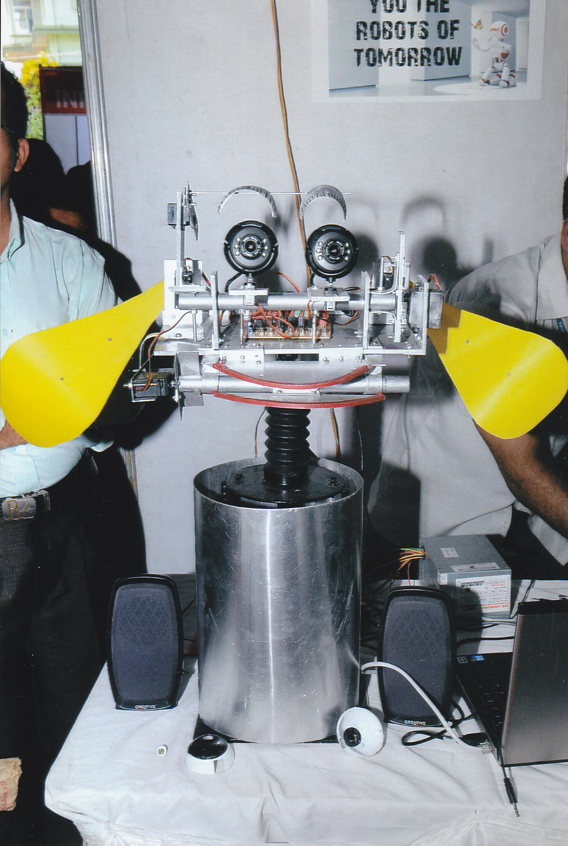
EARS

MOUTH
NECK

Fig 3.1

3.2 BLOCK DIAGRAM

SERVO MOTORS-ROBOT BODY

ATMEGA8 MICROCONTROLLER

RS232 INTERFACING CIRCUIT

CAMERA1

CAMERA2

MIC

COMPUTER FOR IMAGE

PROCESSING

COMPUTER FOR SPEECH

PROCESSING

SPEAKER

Fig 3.2

3.3 COMPONENT DESCRIPTION

- MICROCONTROLLER:The entire mechnanical section is controlled by ATMEGA8 –which actuates the respective motors
- MOTORS:Servo motors are used to move the neck and head section
- CAMERA:Robot consist of two cameras for vision.It detect faces,motion and objects.
- MIC:Microphone recieves sound from the user
- POWERSUPPLY:Power supply circuitry provides the necessary supply voltages to the blocks
6.SPEAKERS:Robot sound is outputed through speakers connceted to computer

3.3.1. AVR ATMEGA8 MICROCONTROLLER

3.3.1.1 Introduction
The embedded information processing revolution is truly hidden inside the product we use everyday,Micro controllers drive the revolution in embedded intelligence.
The micro controller is the most important part of weather station.The microcontroller contains CPU,I/O Ports,RAM,ROM,timers;COM ports all in single a chip.This reduces the power consumption and space.The AVR, which means Advanced Virtual RISC,is an 8-bit micro controller from Atmel.Here AVR Atmega8 is used which meet the task efficiently.
It is popularly used for embedded control solutions .

3.3.1.2. Microcontroller Features

- High-performance, Low-power AVR 8-bit Microcontroller
- Advanced RISC Architecture
- 130 Powerful Instructions – Most Single-clock Cycle Execution
- 32 x 8 General Purpose Working Registers
- Fully Static Operation
- Up to 16 MIPS Throughput at 16 MHz
- On-chip 2-cycle Multiplier
- High Endurance Non-volatile Memory segments
- 8K Bytes of In-System Self-programmable Flash program memory
- 512 Bytes EEPROM
- 1K Byte Internal SRAM
- Write/Erase Cycles: 10,000 Flash/100,000 EEPROM
- Data retention: 20 years at 85°C/100 years at 25°C
- Optional Boot Code Section with Independent Lock Bits
- In-System Programming by On-chip Boot Program
- True Read-While-Write Operation
- Programming Lock for Software Security
- Peripheral Features
- Two 8-bit Timer/Counters with Separate Prescaler, one Compare Mode
- One 16-bit Timer/Counter with Separate Prescaler, Compare Mode, and Capture Mode
- Real Time Counter with Separate Oscillator
- Three PWM Channels
- 8-channel ADC in TQFP and QFN/MLF package
- Eight Channels 10-bit Accuracy
- 6-channel ADC in PDIP package
- Six Channels 10-bit Accuracy
- Byte-oriented Two-wire Serial Interface
- Programmable Serial USART
- Master/Slave SPI Serial Interface
- Programmable Watchdog Timer with Separate On-chip Oscillator
- On-chip Analog Comparator
- Special Microcontroller Features
- Power-on Reset and Programmable Brown-out Detection
- Internal Calibrated RC Oscillator
- External and Internal Interrupt Sources
- Five Sleep Modes: Idle, ADC Noise Reduction, Power-save, Power-down, and Standby
- I/O and Packages
- 23 Programmable I/O Lines
- 28-lead PDIP, 32-lead TQFP, and 32-pad QFN/MLF
- Operating Voltages
- 2.7 - 5.5V (ATmega8L)
- 4.5 - 5.5V (ATmega8)
- Speed Grades
- 0 - 8 MHz (ATmega8L)
- 0 - 16 MHz (ATmega8)
- Power Consumption at 4 Mhz, 3V, 25C
- Active: 3.6 mA
- Idle Mode: 1.0 mA
- Power-down Mode: 0.5 μA

3.3.2 SERVO MOTORS

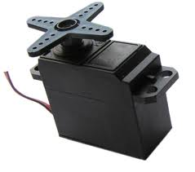

Fig 3.3

Ten servomotors used for the walking mechanism.One servomotor is used for rotating head.Servomotors are the angle motors,they can attain different angles depending upon the coded pulses,and coded pulses are given to the control pin of the servomotor.The servomotor has three pins VCC,GND,PWM
Servomotors are basically geared down dc motors with positional feedback control allowing for accurate poistioning of the rotor,with a range of 90 degress.They can also be modified to allow for continuous rotation
Servomotors have three wires;usually red ,black and white.The red wire is for +VDC,the black for ground,and the white is for position control.This control signal is a variable-width pulse,which can be varied from 1 to 2ms.The pulse width controls the rotor position
A 1.0 ms pulse rotates the shaft all the way counter-clockwise.A 1.5 ms pulse puts the rotor at neutral(0 degrees) and a 2.0 ms pulse will position the shaft all the way clockwise.The pulse is sent to the servo at the servo at a frequency of approximately 50Hz .The relationship between the pulse width and the rotot position can be seen in figure 1

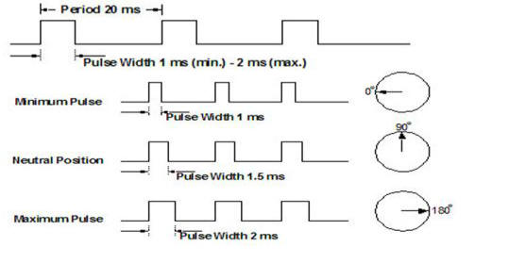

Fig 3.4

3.3.3 VGA CAMERA

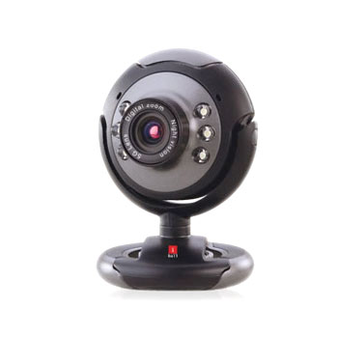
Fig 3.5

A camera is a device that records/stores images. These images may be still photographs or moving images such as videos or movies. The term camera comes from the camera , an early mechanism for projecting images.
Cameras may work with the light of the visible spectrum or with other portions of the electromagnetic spectrum. A camera generally consists of an enclosed hollow with an opening (aperture) at one end for light to enter, and a recording or viewing surface for capturing the light at the other end. A majority of cameras have a lens positioned in front of the camera's opening to gather the incoming light and focus all or part of the image on the recording surface. Most 20th century cameras used photographic film as a recording surface, while modern ones use an electronic camera sensor. The diameter of the aperture is often controlled by a diaphragm mechanism, but some cameras have a fixed-size aperture.
The still camera takes one photo each time the user presses the shutter button. A typical movie camera continuously takes 24 film frames per second as long as the user holds down the shutter button, or until the shutter button is pressed a second time.
From its inception, the camera has been instrumental in the recording of still images from then-present surroundings, and further modifications led to the development of motion picture sequences in the late 19th century. Cameras and the exhibition of camera-captured images are widely used in both professional and consumer settings in the 21st century for both mass and interpersonal communication purposes.

3.3.4 MICROPHONE

Microphone is an acoustic-to-electric transducer or sensor that converts sound into an electrical signal. In 1876,Emile Berliner invented the first microphone used as a telephone voice transmitter. Microphones are used in many applications such as telephones, tape recorders, karaokesystems, hearing aids, motion picture production, live and recorded audio engineering, FRS radios, megaphones, in radio and television broadcasting and in computers for recording voice, speech recognition, VoIP, and for non-acoustic purposes such as ultrasonic checking or knock sensors.
Most microphones today use electromagnetic induction (dynamic microphone), capacitance change (condenser microphone), piezoelectric generation, or light modulation to produce an electrical voltage signal from mechanical vibration.

3.4 CIRCUIT DIAGRAM

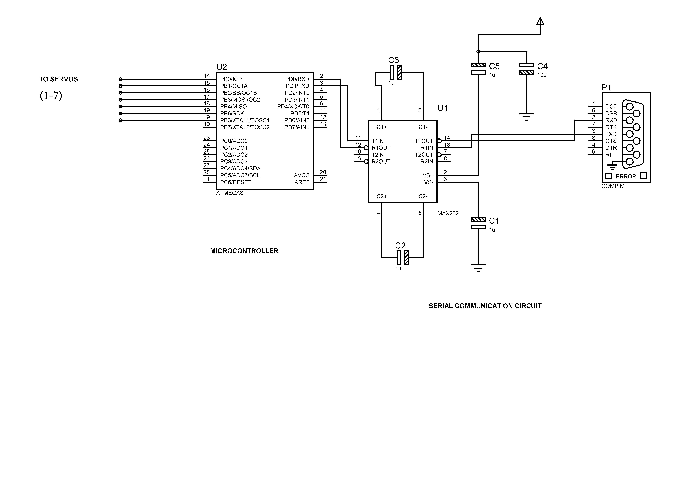

Fig 3.6

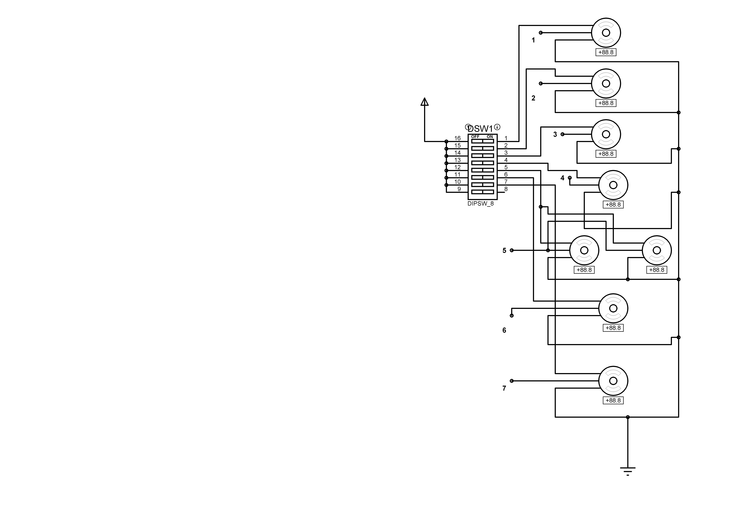

Fig 3.7

3.4.1.CIRCUIT EXPLANATION

The circuit consist of a regulated powersupply,ten servo motor,a Atmega 8,10 servo motors a MAX232 circuit.The regulated powersupply provides the necessary powersupply for the entire circuit.The Atmega8 control the entire servo motors.The atmega8 microcontroller circuit is controlled by rs232 serial communication.MAX232 is the driver IC used for converting RS232 level into TTL.Servomotors are angle motors,they can attain different angles depending upon the coded pulses,and coded pulses are given to the control pin of servomotor.Here 10 servomotors are used for entire movement,one for controlling the head movement.

SOFTWARE SECTION

4.SOFTWARE SECTION
4.1 PROGRAM FLOW CHART
4.1.1 Main Program

Start

Speech
to
Text

Intelligent Replay
Replay To Speech
Stop

Import A I library

Fig 4.1
4.1.2Microcontroller Program

Start

Recieve servo no,angle by serial port by serial port

Move the servos to corresponding angle

Stop

Fig 4.2

4.1.3 Image Processing Program
4.1.3.1 Face detection Program

Start
Grab frame from camcamera
Process frame and find face
If face found
Stop
Send Cordinates

Yes

No

fig 4.3

4.1.3.2Motion Sensing Program
Start
Grab frame from cam
Detect Motion by image processing
If motion
Stop

Y Y
Motion in left

Send left

N
Fig 4.4. N
Send right
4.1.3.3Object Tracking Program
Start
Grab frames from cam
Getting colored information
If blue colour
Send blue colour cordinates

Send red colour cordinates
to robot
Stop

Y

N
Fig 4.5
4.2 PROGRAMMING LANGUAGES

The programming languages used are PYTHON 2.6,C++.Python is an object oriented programming language and C++ also a powerful object oriented programming language.Other libraries used with python are PyAIML,PySpeech,C++ libraries are OpenCV,CVBlob

4.2.1.PYTHON

Python is an interpreted, general-purpose high-level programming language. whose design philosophy emphasizes code readability. Python aims to combine remarkable power with very clear syntax , and its standard library is large and comprehensive. Its use of indentation for block delimiters is unique among popular programming languages.
Python supports multiple programming paradigms, primarily but not limited to object oriented, imperative and, to a lesser extent, functional programming styles. It features a fully dynamic type system and automatic memory management, similar to that of Scheme, Ruby, Perl, and Tcl. Like other dynamic languages, Python is often used as a scripting language, but is also used in a wide range of non-scripting contexts.
The reference implementation of Python (CPython) is free and open source software and has a community-based development model, as do all or nearly all of its alternative implementations. CPython is managed by the non-profit Python Software Foundation.
Python interpreters are available for many operating systems, and Python programs can be packaged into stand-alone executable code for many systems using various tools

4.2.2.Open CV

Computer vision is a rapidly growing field, partly as a result of both cheaper and more
Capable cameras, partly because of affordable processing power, and partly because visionalgorithms are starting to mature. OpenCV itself has played a role in the growth ofcomputer vision by enabling thousands of people to do more productive work in vision.

With its focus on real-time vision, OpenCV helps students and professionals efficiently
implement projects and jump-start research by providing them with a computer vision
and machine learning infrastructure that was previously available only in a few mature
research labs.

One of OpenCV’s goals is to provide a simple-to-use computer vision infrastructure
that helps people build fairly sophisticated vision applications quickly. The e OpenCV
library contains over 500 functions that span many areas in vision, including factory
product inspection, medical imaging, security, user interface, camera calibration, stereo
vision and robotics. Because computer vision and machine learning often go hand-in hand,
OpenCV also contains a full, general-purpose Machine Learning Library (MLL).
Since its alpha release in January 1999, OpenCV has been used in many applications,
products and research efforts. These applications include stitching images together in
satellite and web maps, image scan alignment, medical image noise reduction, object
analysis, security and intrusion detection systems, automatic monitoring and safety systems,manufacturing inspection systems, camera calibration, military applications, and unmanned aerial, ground, and underwater vehicles. It has even been used in sound and music recognition, where vision recognition techniques are applied to sound spectrogram images. OpenCV was a key part of the vision system in the robot from Stanford, “Stanley”, which won the $2M DARPA Grand Challenge desert robot race

4.2.3.AIML

AIML, or Artificial Intelligence Markup Language, is an XML dialect for creating natural language software agents.

4.2.3.1.Background
The XML dialect called AIML was developed by Richard Wallace and a worldwide free software community between the years of 1995 and 2002. It formed the basis for what was initially a highly extended Elizacalled "A.L.I.C.E." ("Artificial Linguistic Internet Computer Entity"), which won the annual Loebner Prize Contest for Most Human Computer three times, and was also the Chatterbox Challenge Champion in 2004.
Because the A.L.I.C.E. AIML set was released under the GNU GPL, and because most AIML interpreters are offered under a free or open source license, many "Alicebot clones" have been created based upon the original implementation of the program and its AIML knowledge base. Free AIML sets in several languages have been developed and made available by the user community. There are AIML interpreters available in Java, Ruby, Python, C++, C#, Pascal, and other languages. A semi-formal specification and a W3C XML Schema for AIML are available.

4.2.3.2 .Elements of AIML
AIML contains several elements. The most important of these are described in further detail below.

Categories
Categories in AIML are the fundamental unit of knowledge. A category consists of at least two further elements: the pattern and template elements. Here is a simple category:
<category>
<pattern>WHAT IS YOUR NAME</pattern>
<template>My name is John.</template>
</category>

When this category is loaded, an AIML bot will respond to the input "What is your name" with the response "My name is John."

Patterns
A pattern is a string of characters intended to match one or more user inputs. A literal pattern like
WHAT IS YOUR NAME
will match only one input, ignoring case: "what is your name". But patterns may also contain wildcards, which match one or more words. A pattern like
WHAT IS YOUR *
will match an infinite number of inputs, including "what is your name", "what is your shoe size", "what is your purpose in life", etc.
The AIML pattern syntax is a very simple pattern language, substantially less complex than regular expressions and as such not even of level 3 in the Chomsky hierarchy. To compensate for the simple pattern matching capabilities, AIML interpreters can provide preprocessing functions to expand abbreviations, remove misspellings, etc.

Template
A template specifies the response to a matched pattern. A template may be as simple as some literal text, like
My name is John.
A template may use variables, such as the example
My name is <bot name="name"/>.
which will substitute the bot's name into the sentence, or
You told me you are <get name="user-age"/> years old.
which will substitute the user's age (if known) into the sentence.
Template elements include basic text formatting, conditional response (if-then/else), and random responses.
Templates may also redirect to other patterns, using an element called srai. This can be used to implement synonymy, as in this example (where CDATA is used to avoid the need for XML escaping):
<category>
<pattern>WHAT IS YOUR NAME</pattern>
<template><![CDATA[My name is <bot name="name"/>.]]></template>
</category>
<category>
<pattern>WHAT ARE YOU CALLED</pattern>
<template>
<srai>what is your name</srai>
</template>
</category>
The first category simply answers an input "what is your name" with a statement of the bot's name. The second category, however, says that the input "what are you called" should be redirected to the category that matches the input "what is your name"--in other words, it is saying that the two phrases are equivalent.
Templates can contain other types of content, which may be processed by whatever user interface the bot is talking through. So, for example, a template may use HTML tags for formatting, which can be ignored by clients that don't support HTML.

4.2.4.PyAIML

PyAIML implements an interpreter for AIML, the Artificial Intelligence
Markup Language developed by Dr. Richard Wallace of the A.L.I.C.E. Foundation.
It can be used to implement a conversational AI program.

4.2.4.1.Examples
Here's some basic sample code that demonstrates how to use the PyAIML package.

4.2.4.2.Basic Use
First of all, import the package:
import aiml

Next, you need to instantiate a Kernel object. The Kernel is the only class you should ever have to use in your dealings with PyAIML.
k = aiml.Kernel()

The Kernel is now ready to respond to user input -- but it doesn't have anything to say. So, the next step is to load some AIML files. This is done through the Kernel's learn() method:
k.learn("std-startup.xml")

In this example, we've loaded the startup file from the Standard AIML set. It defines a single AIML pattern, "LOAD AIML B", which in turn causes the rest of the set to load. To trigger this process, we pass "load aiml b" as input to the Kernel:
k.respond("load aiml b")

The respond() method returns a string containing the Kernel's response to the input, but in this case we ignore the response. We're now ready to start responding intelligently to user input. The following line sets up the input/output loop:
while True: print k.respond(raw_input("> "))

That's all you need to know to get started!

4.2.4.3.Loading and Saving Brains
If your bot's AIML files aren't changing much, you can significantly reduce the startup time by using the Kernel's loadBrain() and saveBrain() methods. These functions let you dump the contents of your bot's "brain" to a file on disk. The next time your bot runs, rather than re-parsing all the AIML files, it can just load its brain from the last session and pick up right where it left off!
First, you need to create the brain dump. First, create a Kernel object and load up the standard AIML set. Remember that just loading "std-startup.xml" isn't enough -- the bulk of the AIML files aren't loaded until you pass "load aiml b" to the Kernel's respond() method!
import aiml
k = aiml.Kernel()
k.learn("std-startup.xml")
k.respond("load aiml b")

Now that the brain is populated with knowledge, use the saveBrain() method to dump the brain to disk:
k.saveBrain("standard.brn")

To reload the brain, just use the loadBrain() method. We'll create a new, empty Kernel object so we can be sure we're starting from a clean slate.
k2 = aiml.Kernel()
k2.loadBrain("standard.brn")

That's all there is to it! You should favoring loading brains vs. loading AIML files whenever possible, since loading a brain is roughly three times as fast as re-parsing the AIML files!
NOTE: if you load a bot's brain from disk, all the existing contents of the brain will be overwritten! However, after the brain is loaded, you can continue to learn() new AIML files just as before, and their contents will be added to the brain.

4.2.4.4.Advanced Kernel Initialization using bootstrap()
The Kernel provides a bootstrap() method that you can use to simplify your bot's initialization process. The bootstrap() method takes the following optional arguments: brainFile, learnFiles and commands. The actual process that bootstrap() uses to initialize the Kernel object is as follows:
- If the brainFile argument is present, the Kernel loads the specified brain using k.loadBrain(brainFile).
- If the learnFiles argument is present, the Kernel loads each of the files specified in the learnFiles list using k.learn(file).
- If the commands argument is present, the Kernel passes each of the commands in the commands list into the respond() method, and prints the result.
Using the bootstrap() method, the initialization process can be reduced to the following idiom:
import aiml
import os.path

k = aiml.Kernel()
if os.path.isfile("standard.brn"):
k.bootstrap(brainFile = "standard.brn")
else:
k.bootstrap(learnFiles = "std-startup.xml", commands = "load aiml b")
k.saveBrain("standard.brn")

4.2.4.5.More Initialization Tips
There are two more common initialization tasks to take care of: setting the verbosity level, and setting your bot's name. The verbosity setting determines whether warnings and non-critical error messages are printed to the text console at runtime. These messages can be useful when tracking down problems, but other times you don't want to deal with them. To set the verbosity mode, use the Kernel's verbose() method. Kernel.verbose(True) enables verbose mode, and Kernel.verbose(False) disables it. Verbose mode is enabled by default.
Your bot has a name associated with it. To set your bot's name, use the Kernel's setBotPredicate("name","newName") method. The name you provide must be a single word! The bot's name is "Nameless" by default. You can query the bot's current name with Kernel.getBotPredicate("name").

4.2.4.6.Session Management
Sometimes, you want your bot to carry on multiple conversations at once. While you could just pass the input of two or more users to Kernel.respond(), your bot (and your users) might get confused as a result. The bot could call people by the wrong names, refer to earlier conversation topics that never happened, and so on.
You could solve this problem by creating a separate Kernel object for each conversation, but that results in a lot of wasted memory. Each individual Kernel would have to load and store the exact same AIML sets, and those things aren't small.
To prevent these problems, PyAIML supports the concept of multiple sessions. Each session represents a single conversation with one or more users, and each one is stored independently from all the others (thus avoiding conversational cross-pollination). And you only need to load the AIML set once!
To make use of multiple sessions, you use the optional sessionID parameter (supported by the respond(), getPredicate() and setPredicate() Kernel methods). The session ID can be anything: a string containing the user's name, an IRC channel name, an IP address...so long as it uniquely idenitifies the conversation. So, if you're having a conversation with two users, Alice and Bob, and you receive some new input from Bob, you'd make the following call:
response = Kernel.respond(input, "Bob")

4.2.5.CvBlob

Binary image labeling library for OpenCV.Blob orientation, centroid, contours, Blobs parameters render. Basic blob tracking. Interface similar to OpenCV.
.

4.2.5.1.Blob Tracking Modules

4.2.5.2.General Description

The blob tracking system includes 5 modules as depicted on diagram.

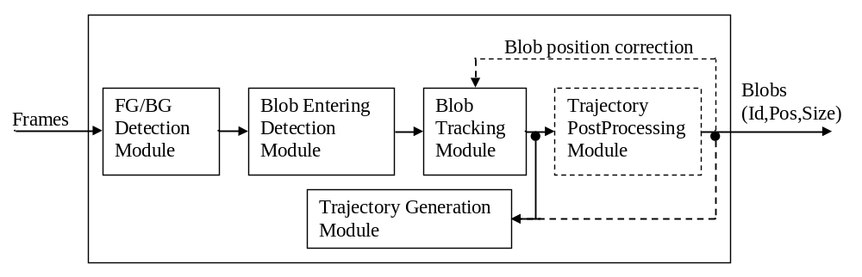This pipeline is called “Blob Tracking Auto” module and implemented as individual module in BlobTrackingAuto.cpp and BlobTrackingAuto.h files.
“FG/BG Detection” module performs foreground/background segmentation for each pixel.
“Blob Entering Detection” module uses the result (FG/BG mask) of “FG/BG Detection” module to detect new blob object entered to a scene on each frame.
“Blob Tracking” module initialized by “Blob Entering Detection” results and tracks each new entered blob.
“Trajectory Generation” module performs a saving function. It collects all blobs positions and save each whole blob trajectory to hard disk when it finished (for example tracking is lost).
“Trajectory PostProcessing” module performs a blob trajectory smoothing function. This module is optional and can not be included in specific pipeline.
The blob tracking system includes 4 modules as depicted on diagram.

4.2.5.3.Data structures description

CvBlob

It is a simple structure describing a blob position, size and ID.

typedef struct CvBlob
{
float x,y; /* blob position */
float w,h; /* blob sizes */
int ID; /* blbo ID */
}CvBlob;

CvBlobList

This is a class to collect set of blobs. This set can be trajectories or (for example) list of blob on current frame. So this list is the indexed array and each element of this array can be addressed by key.

class CvBlobSeq
{
public:
CvBlobSeq(int BlobSize = sizeof(CvBlob));
virtual ~CvBlobSeq();
virtual CvBlob* GetBlob(int BlobIndex);
virtual CvBlob* GetBlobByID(int BlobID);
virtual void DelBlob(int BlobIndex);
virtual void DelBlobByID(int BlobID);
virtual void Clear();
virtual void AddBlob(CvBlob* pB);
virtual int GetBlobNum();
};

Now this class is implemented using CvSeq from OpenCV. Initially this class was implemented to simplify blob list creation and manipulation.

4.2.5.4.Modules descriptions

CvFGDetector
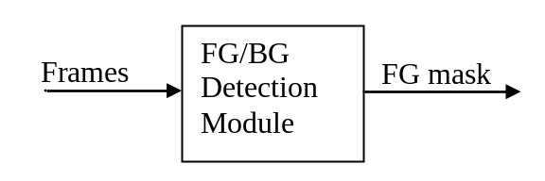

This is virtual class, describing interface of “FG/BG Detection” module.
The interface is defined in videomining\Surveillance\src\BG-FG-Estimation\PM\BG_FG_Estimation.h file. If someone wants to create own module, he must create a class inherited from CvFGDetector and implement all virtual methods declared in CvFGDetector.

Input Data:
Image of current frame.
Output Data:
FG/BG mask of current frame.

class CvFGDetector
{
public:
virtual IplImage* GetMask() = 0;
/* process current image */
virtual void Process(IplImage* pImg) = 0;
/* release foreground detector */
virtual void Release() = 0;
};

This module classify pixels on current frame to FG or BG pixels. As result the FG mask is returned by GetMask method. All methods must be redefined in child class. Also some creation function must be written.

CvBlobDetector
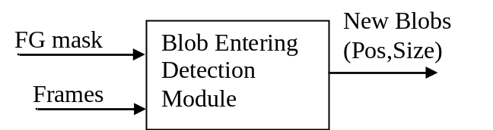

This is virtual class, describing interface of “Blob Entering Detection” module.
The interface is defined in EnteringBlobDetection.h file. If someone wants to create own module, he must create a class inherited from CvBlobDetector and implement all virtual methods declared in CvBlobDetector.

Input Data:
FG/BG mask of current frame;
List of existed Blobs.
Output Data:
List of newly detected blobs.

class CvBlobDetector
{
public:
/* try to detect new blob entrance based on foreground mask */
/* pFGMask - image of foreground mask */
/* pNewBlobList - pointer to sequence to save new detected blobs */
/* pOldBlobList - pointer to blob list which already exist on image */
virtual int DetectNewBlob(IplImage* pFGMask, CvBlobSeq* pNewBlobList, CvBlobSeq* pOldBlobList) = 0;
/* return number of detected blobs */
/* release blob detector */
virtual void Release()=0;
};

This module detects new blob using FG mask. As result the newly detected blobs saved to sequence of blob pNewBlobList. Also this module may use list of existing blobs pOldBlobList to recognize actually new blob. All methods must be redefined in child class. Also some creation function must be written.

CvBlobTracker
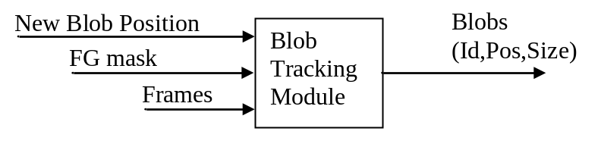

This is virtual class, describing interface of “Blob Tracking” module.
The interface is defined in BlobTracking.h file.
If someone wants to create own module, he must create are class inherited from CvBlobTracker and implement all virtual methods declared in CvBlobTracker.

Input Data:
BGR Image of current frame;
FG/BG mask of current frame;
Output Data:
Blobs (Id, pos, size) on current frame.

class CvBlobTracker
{
public:
/* Add new blob to track it and assign to this blob personal ID */
/* pBlob - pinter to structure with blob parameters (ID is ignored)*/
/* pImg - current image */
/* pImgFG - current foreground mask */
/* return pointer to new added blob */
virtual CvBlob* AddBlob(CvBlob* pBlob, IplImage* pImg, IplImage* pImgFG = NULL ) = 0;
/* return number of currently tracked blobs */
virtual int GetBlobNum() = 0;
/* return pointer to specified by index blob */
virtual CvBlob* GetBlob(int BlobIndex) = 0;
/* delete blob by its index */
virtual void DelBlob(int BlobIndex) = 0;
/* process current image and track all existed blobs */
virtual void Process(IplImage* pImg, IplImage* pImgFG = NULL) = 0;
/* release blob tracker */
virtual void Release() = 0;

/* return pinter to blob by its unique ID */
virtual int GetBlobIndexByID(int BlobID);
/* return pinter to blob by its unique ID */
virtual CvBlob* GetBlobByID(int BlobID);
/* delete blob by its ID */
virtual void DelBlobByID(int BlobID);
/* Set new parameters for specified (by index) blob */
virtual void SetBlob(int BlobIndex, CvBlob* pBlob);
/* Set new parameters for specified (by ID) blob */
virtual void SetBlobByID(int BlobID, CvBlob* pBlob);
};
This module must contain list of blobs. This list of blob updated after Process() is called. User can update blob parameters manually by SetBlob and SetBlobByID methods.Methods AddBlob, GetBlobNum, DelBlob, Process, Release must be redefined in child class. Other methods may be redefined but it is not necessary. Also some creation function must be written.

CvBlobTrackerList
One implementation of “Blob Tracking” module is CvBlobTrackerList class. It is some “shell” module. The purpose of this module is simplifying creation of “Blob Tracking” module. The creation function cvCreateBlobTrackerList of this module has one parameter – pointer to a more simple blob tracker for one blob - CvBlobTrackerOne.

CvBlobTracker* cvCreateBlobTrackerList(CvBlobTrackerOne* (*create)());
So, the CvBlobTrackerList and CvBlobTrackerOne modules can be depicted as

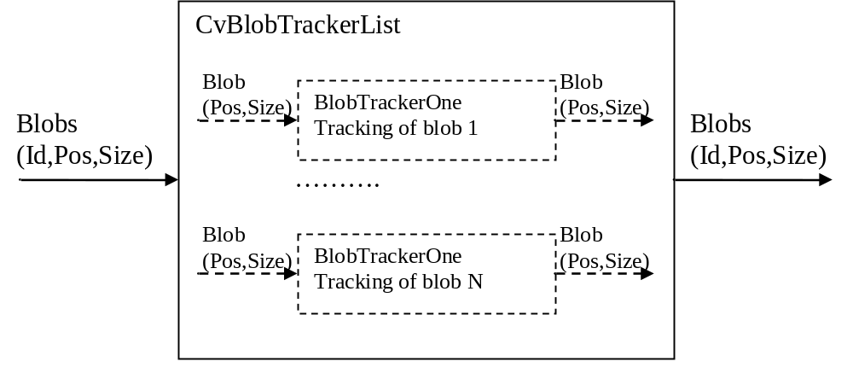

CvBlobTrackerOne

This is virtual interface for “Blob Tracking One” module for one trajectory. This interface is used for example by CvBlobTrackerList module

class CvBlobTrackerOne
{
public:
virtual void Init(CvBlob* pBlobInit, IplImage* pImg, IplImage* pImgFG = NULL) = 0;
virtual CvBlob* Process(CvBlob* pBlobPrev, IplImage* pImg, IplImage* pImgFG = NULL) = 0;
virtual void Release() = 0;
};
This class produces the tracking for one trajectory. One each frame the Process method is called to estimate new position and size of blob. As result the tracked position and size are returned by this method.

CvBlob

TrackGen
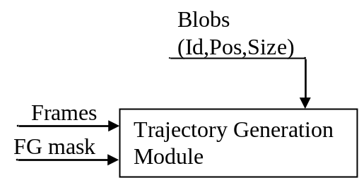
This is virtual class describing interface for “Trajectory Generator” module. The purpose of this module is to save whole trajectory to specified file. Also this module can calculate some features (using original image and FG mask) for each blob and saves it too.
The interface is defined in BlobTrackGen.h file.
If someone wants to create own module, he must create are class inherited from CvBlobTrackGen and implement all virtual methods declared in CvBlobTrackGen.

Input Data:
Blobs on current frame
Output Data:
Saved trajectory list

class CvBlobTrackGen
{
public:
virtual void SetFileName(char* pFileName) = 0;
virtual void AddBlob(CvBlob* pBlob) = 0;
virtual void Process(IplImage* pImg = NULL, IplImage* pFG = NULL) = 0;
virtual void Release() = 0;
};

All methods must be redefined in child class. Also some creation function must be written.

CvBlobTrackPostProc
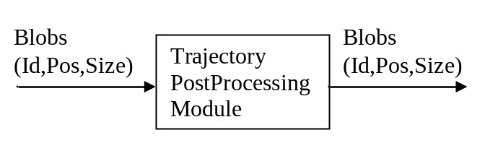
This is virtual class describing interface for “Trajectory Post Processing” module. The purpose of this module is to produce some filtering operation on blob trajectory. For example this module can be Klaman filter or another smoothing filter.
The interface is defined in BlobTrackPostProc.h file.
If someone wants to create own module, he must create are class inherited from CvBlobTrackPostProc and implement all virtual methods declared in CvBlobTrackPostProc.

Input Data:
Blobs on current frame
Output Data:
Blobs on current frame

class CvBlobTrackPostProc
{
public:
virtual void AddBlob(CvBlob* pBlob) = 0;
virtual void Process() = 0;
virtual int GetBlobNum() = 0;
virtual CvBlob* GetBlob(int index) = 0;
virtual void Release() = 0;

/* additional functionality */
virtual CvBlob* GetBlobByID(int BlobID);
};

Methods Process, GetBlobNum, GetBlob and Release must be redefined in child class. Also some creation function must be written.

CvBlobTrackPostProcList
One implementation of “Trajectory Post Processing” module is CvBlobTrackPostProcList class. It is some “shell” module. The purpose of this module is simplifying creation of “Trajectory Post Processing” module. The creation function cvCreateBlobTrackPostProcList of this module has one parameter – pointer to a more simple one post processing module CvBlobTrackPostProcOne.

CvBlobTrackPostProc* cvCreateBlobTrackPostProcList(CvBlobTrackPostProcOne* (*create)());

So, the CvBlobTrackPostProcList and CvBlobTrackPostProcOne modules can be depicted as

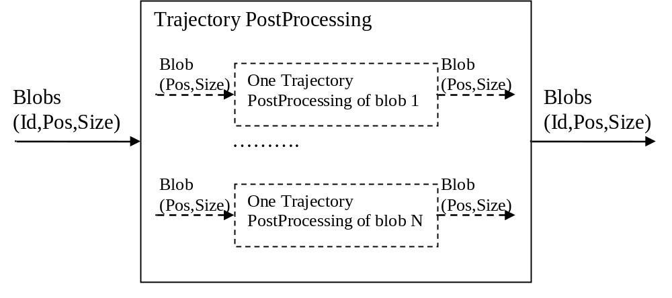

CvBlobTrackPostProcOne
This is cvirtual interface for “Trajectory Post Processing” module for one trajectory. This interface is used for example CvBlobTrackPostProcList module

class CvBlobTrackPostProcOne
{
public:
virtual CvBlob* Process(CvBlob* pBlob) = 0;
virtual void Release() = 0;
};

This class produces the post processing for one trajectory. One each frame the Process method is called to process new position and size of blob. As result the filtered position and size are returned by this method.

4.2.6.Microsoft Speech API

The Speech Application Programming Interface or SAPI is an API developed by Microsoft to allow the use of speech recognition and speech synthesis within Windows applications. To date, a number of versions of the API have been released, which have shipped either as part of a Speech SDK, or as part of the Windows OS itself. Applications that use SAPI include Microsoft Office, Microsoft Agent and Microsoft Speech Server.
In general all versions of the API have been designed such that a software developer can write an application to perform speech recognition and synthesis by using a standard set of interfaces, accessible from a variety of programming languages. In addition, it is possible for a 3rd-party company to produce their own Speech Recognition and Text-To-Speech engines or adapt existing engines to work with SAPI. In principle, as long as these engines conform to the defined interfaces they can be used instead of the Microsoft-supplied engines.
In general the Speech API is a freely-redistributable component which can be shipped with any Windows application that wishes to use speech technology. Many versions (although not all) of the speech recognition and synthesis engines are also freely redistributable.
There have been two main 'families' of the Microsoft Speech API. SAPI versions 1 through 4 are all similar to each other, with extra features in each newer version. SAPI 5 however was a completely new interface, released in 2000. Since then several sub-versions of this API have been released.

4.2.7.PySpeech

Pyspeech seems to be merely a python interface to the regular Windows speech APIs. speech.pyspeech.py is a Python module that provides a clean interface to Windows's voice recognition and text-to-speech capabilities. It's very easy to use within a program that needs to listen for specific phrases or general speech, or that needs to speak.Example codeHere's a very simple program that repeats whatever it hears you say, until you say "turn off".
import speech
while True:
phrase = speech.input()
speech.say("You said %s" % phrase)
if phrase == "turn off":
breakspeech.input()

PCB FABRICATION

5.1 DESIGN
The main thing in the design of PCB is drawing layout. Using software’s like PCB or EAGLE we can do this. Initially the schematic of the circuit was drawn using Proteus. The necessary PCB footprints were given, thereby specifying the component size and spacing. After giving the footprints a net list was created. Rooting procedure was done using the PCB software.

5.2 FABRICATION
PCB fabrication involves the following steps:

5.3.Film preparations
In this process, the negative of the film is made on photographic film. For this, the printed image of the layout in the butter paper is placed over the film and is exposed to the UV rays from the top so that the film will be exposed to the UV rays in the regions other than the layout. Then the developer solution is made and the film is taken out of the exposure unit and it is put in the developer solution, then the reaction will take place, then the regions not exposed by UV rays become transparent and the other regions are dark in color. Thus the negative is produced. Then the film is washed in fixing solution. After that the film is kept for drying.

5.4.Transfering of the layout to copper clad.
First the copper clad sheet of required size is cut by using a cutting machine. Then the sheet is clean by using steel scrubber. After perfect cleaning of the board, it is dipped in the photo resist solution so that film of the resist is formed on the board. Then the copper clad sheet is placed in an oven for some time so that the photo resist will fix to the surface of the board. The next step is to form an image of the lay out on the copper clad sheet. For that, the negative of the layout is placed over the sheet. Then it is placed on the UV exposure unit so that the UV rays will fall on the photo resist over the board in the regions of the layout were the negative is transparent. Then the board is taken out and put in a developer solution for about 1.15 minutes. After that, the board is washed gently in water for about one minute so that the chemical reaction takes place in the regions exposed by the UV rays. Then the board is washed in a dye so that the dye will be fixed to the layout region. Thus we get a visible image of the layout on the board. Then check the layout on the board with the actual circuit. If any mistakes the above processes are repeated. If the layout is correct, the board is now ready for etching.

5.5.Etching of the board
When the board is ready for the etching it is placed in ferric chloride solution. It is check in regular intervals to prevent over etching and successive damage to the board. After the etching is compete, the board is taken out of etch and washed in water to remove the excess ferric chloride. Now the copper lines are exposed and hen the board is checked with the magnifying glass to see whether all the lines in the layout are clearly formed. Now the board is ready for tinning.

5.6. Tinning
For tinning, the PCB is cleaned well and the flux is supplied to the surface. Then it is passed through the tinning machine. In tinning the copper lines are plated with an alloy of tin and lead.

5.7.Drilling
After tinning, the next process is the drilling. In this, the holes of required sizes are drilled in the PCB wherever needed, using an electric drilling machines.

5.8.COMPONENT PLACEMENT
The components were placed on other side of PCB using layout as reference. Solder was applied on the trackside in order to fix the components. The printed circuit board was thus completed.
5.9.SOLDERING
Soldering is a method of joining metal parts using a filler material (solder),which has melting temperature below 450⁰C(842⁰F).In a soldering process, heat is applied to the parts to be joined, causing the solder to melt and be drawn into the joint by capillary action and bond to the materials to be joined by wetting action. After the material cools, the resulting joints are not as strong the base metal, but have adequate strength, electrical conductivity, and water-tightness for many uses. Soldering is an ancient technique that has been used practically as long as humans have been taking items out of metal.
The most frequent application of soldering is assembling electronic components to printed circuit boards (PCBs.) Soldering filler materials are available in many different alloys for differing applications. Especially alloys are available with properties such as higher strength, better electrical conductivity and higher corrosion resistance.
In high-temperature metal joining processes (welding, brazing and soldering) the primary purpose of flux is to prevent oxidation of the base and filler materials. Flux is a substance, which is nearly inert at room temperature, but which becomes strongly reducing at elevated temperatures, preventing the formation of metal oxides. Secondarily, flux acts as a wetting agent in the soldering process.
All solder pads and device terminals must be clean for good wetting and heat transfer. The soldering iron or gun must be clean and pre-tinned with solder, otherwise, components may heat up excessively due to poor heat transfer. The devices must then be mounted on the circuit board properly. One technique is to elevate the components from the board surface ( a few millimeters) to prevent heating of the circuit board during circuit operation. After inserting a device the excess leads can be cut leaving only a length equal to the radius of the pad. We can use plastic mounting clips or holders for large devices to reduce mounting stresses.
Heat sinks the leads of sensitive devices to prevent heat damage. Apply soldering iron or gun to both terminal lead and copper pad equally heat both. Apply solder to both lead and pad but never directly to the tip of soldering iron or gun. Direct contact will cause the molten solder to flow over the gun and not over the joint. The moment the solder melts and begins to flow, remove the solder supply immediately. Do not remove the iron yet. The remaining solder will then flow over the junction of the lead and pad, assuming both are of dirt. Let the iron heat the junction until the solder flows and then remove the iron tip. This will ensure a good solid junction.

5.10.LAYOUT

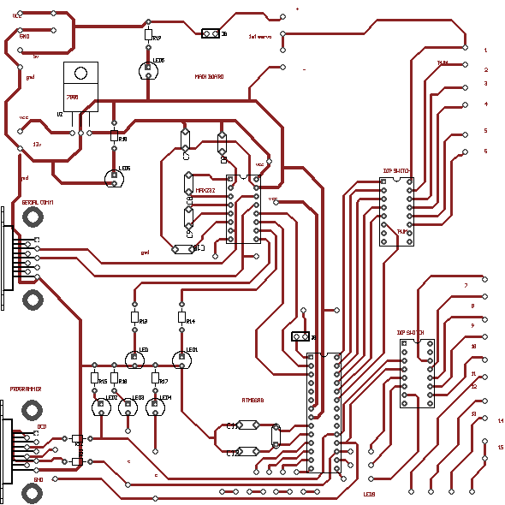

Main Board
Fig 5.1
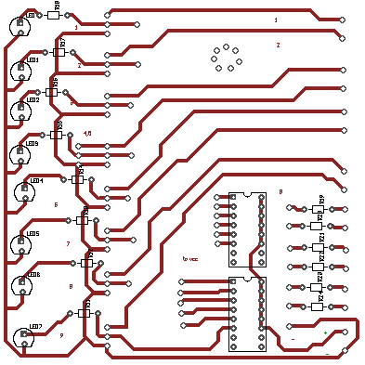

Board on Robot
Fig 5.2

CONCLUSION

6.CONCLUSION SECTION

6.1.ADVANTAGES

Simple Hardware

The entire robotic structure is controlled by very simple hardware.All
components are available in stores.No componenets are imported

Low cost
The entire robot is made of simple components and also it is of low cost
The real implementation will take lakh of rupees

Simple design
The robot design is very simple.The circuit implemented is not complex.
Robotic projects are too complex in nature,and also expensive.Due to simple design and low cost component in this projects

6.2.DISADVANTAGES

Limited degree of motion

The robot has limited degree of freedom.It uses low cost RC servo motors,So the motion will not be smooth.For higher degree of freedom and accuracy ,servos of higher accuracy have to be used,but it is too expensive.

Slow Response

Robot has slow response compared to standard robots.It is because of the type of operating system used.The robotic operating system are mainly realtime os.In real time system,the response will higher than normal operating.
7.0.APPLICATION

Research Application
Robotics are developing for acquring intelligence like human being .This robot is just a model that showing intelligence like human being. Further development of this robot can be done and can improve the intelligence capacity.

Home Robotics
Robots are not only for heavy duty work in industries but it can also employ for home for entertainment purpuses.

7.1.FUTURE EXPANSION

- The knowledge databse can be expand.Now it consist of 300 files.It can expand and increse the intelligence of robot
- Two Robotic arms can be implanted to robot.It can make robot more attractive.

7.2.CONCLUSION

The project “social robot” is a different view of robots in the robotic society.The project aimed to make a social robot which can communicate and interact with people.This project has many future scope and applications.The intelligence of human cannot achived in robots but a small amount of it can be achived.This intelligence is implemented in this robot.The main feature of this robot is ,the intelligence can be expand.So future development is mainly concentrated to expand the intelligence.

8. REFERENCE

1.http://www.ai.mit.edu/projects/kismet/

2.http://en.wikipedia.org/wiki/Kismet_(robot)

