# PAYMENT TRACKER – UPDATED VERSION

The payment tracker is a useful tool for accounting as it allows the user to follow the pattern of purchase orders, keep track of what orders are still in open, manage tables for managers’ meetings and adds a look to the general stock in the warehouse.

## BEFORE USING THE FILE:

The application is based on two files, kept in the “reports” folder:

STOCK.CSV – PURCHASE.CSV – EST_COST.CSV

The est_cost file needs to be updated by the user. The file is updated by Sara (research department) regularly and can be requested.

STOCK AND PURCHASE FILES:  
These files are automatically downloaded when the file is opened, but it would be wise for the user to check that everything went fine.

Go to Filezilla -> public_html -> reports -> reports_for_apps.

Check that the STOCK AND PURCHASE files have the most updated date, which corresponds to Yesterday’s midnight (there could be 10 minutes difference in the timing).

SOLUTION 1: IF THE DATE ISN’T UPDATED  
 Go to Linnworks -> Export Data

Select “Stock_Levels_1” and click on “Run Now”.

Select “Purchase Order Report” and click on “Run Now”.

Once the query ran, go back to filezilla and check if the files were updated. If not, try to run the process another 2 times (sometimes, it’s a matter of loading times).   
*If there are errors, please contact the developer.*

Automatic Update is on: Once you open the Purchase Tracker file, go to the “reports folder” and check that the STOCK AND PURCHASE reports have been updated correctly (they should show the current day and time).

SOLUTION 2: IF THE DATE ISN’T UPDATED

Go to Linnworks -> Dashboard -> Query Data

Download “Total Stock Level Warehouse”.

Put it in the folder “reports”, rename it as “stock”.

Download “Purchase Order Report”

Put it in the folder “reports”, rename it as “purchase”

# STRUCTURE

The file is composed of three sheets:

### **MAIN**

### ADD DATA

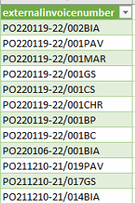Double-click on the green column, on the matching purchase order.

A window with a form to fill will open up.

TIP: if the user doesn’t see the purchase order she’s searching for, any order can be used and be updated in the user form.

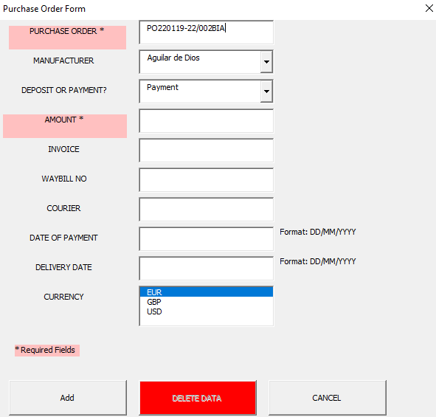Fill the fields as instructed. Click on “Add” to add the data to the table, or “Cancel” if you want to abort the user form.

### EDIT DATA

Double-click on any cell of the item you want to edit.

The user form will open. Change any data you want to update, and press “Edit”. “Cancel” will abort the operation.

### DELETE DATA

Double-click on any cell of the item you want to edit.

The user form will open. Click the button “Delete Data” and confirm your choice on the prompt. “Cancel” will abort the operation.

### **DASHBOARD**

The data are displayed here. Use the filters to show your preferred selections.

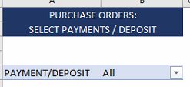Switch between payments and deposits.

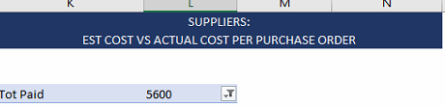Hide the 0 in the filter to display only the orders that have been paid so far.

### **VALUE OF STOCK**

Displays the latest value of the stock in the warehouse, both in hold and in default.

### Graphical user interface, application, Word Description automatically generatedTROUBLESHOOTING

For extra security, please do the follow operations:

1. Click on Data -> queries and connection. A window will open on the right side. Make sure there are no warning signs.

If you see a warning yellow sign, try this operation:

Data -> refresh All.

If the query still shows a warning, please contact the developer. Refrain from using the file as it might be not updated correctly.

1. Data -> Refresh All.

Even if the query shows no warnings, refreshing the file at opening could prevent hidden mistakes.