# HOW TO USE

## MAIN SCOPE:

The Purchase Report file creates a dashboard with an overview of the main parts of the pending or partial purchase orders, and a general reminder of which purchase orders were downloaded last.

## WORKFLOW:

Download the main reports needed from

Linnworks -> Dashboards -> Query Data.

* “purchaseOrderReport” -🡪
  + Graphical user interface, application

    Description automatically generatedSave in “Reports” as “po”
* “purchaseOrdersDelivered” 🡪
  + Save in “Reports” as “delivered”
  + Note: you can edit the preferred timeframe.

Click on “Edit”

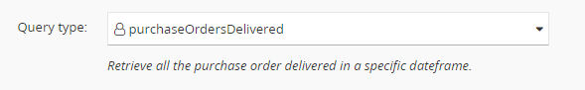

Change the number of “Days Ago” you want to check. The current selection checks which orders were delivered since today up to 30 days ago.

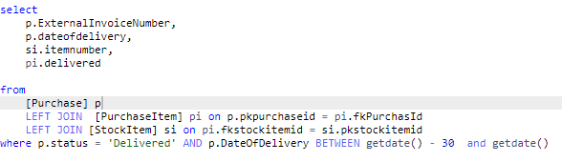

## PLEASE NOTE! SAVE THE FILES WITH THE APPROPRIATE NAMES, OTHERWISE THEY WON’T BE RECOGNISED BY THE SYSTEM!

## DASHBOARD:

The summary of the page.

Click   
to import the new reports.

You can check the latest deliveries

On the left side.

You can switch between one supplier to a multiple selection by clicking the 🡪

This shows all the expected SKUs in the undelivered purchase orders.

A summary of all orders overdue. The Expected time is considered on a 2 months basis from the order date.

A quick recap of which suppliers have orders still in open.

For a look to the bigger data, use the “mainData” sheet, although these tables are not organised as they are used for reference.