Toro® LH621i is a 21 tonne loader made for rapid mine development and large scale underground production. With superior hydraulic power for fast bucket filling and drivetrain power for high ramp speed, the loader is designed to quickly clear tunnel headings.
Toro® LH621i is equipped with a fuel efficient 352kW Tier 2 / Stage II engine as standard. Tier 4f and Stage V state-of-the-art low emission engine options are also available with the use of Ultra Low Sulphur Diesel fuel. These optional engines come with an engine brake.
The equipment cabin offers superior operator ergonomics and comfort through a slim line dash board, 7” color touch screen display, greater headroom, increased leg space and improved pedal positions. To improve maintainability and serviceability, the loader has been designed with smarter placement of key service areas and safer service access.
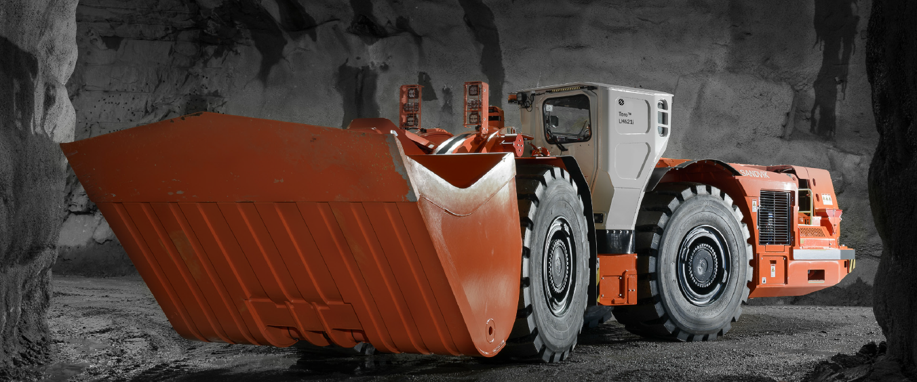
In the area of digitalization and intelligence, Toro® LH621i loader features multiple smart solutions such as Sandvik Intelligent Control System, My Sandvik Digital Services, The Knowledge Box™ on-board hardware and AutoMine® readiness as standard. The Integrated Weighing System (IWS) is optionally available for measuring payload in the bucket as well as the number of buckets filled during a shift.
SHARK™ Ground Engaging Tools (G.E.T.) are available on a wide range of bucket sizes, optimized for loader productivity and extended bucket service life.

