

**Bachelor’s Thesis**

Large Eddy Simulation of Heat Transfer on Wing Surfaces in 3D

Submitted by: Stefan LENGAUER

Registration Number: 1210587029

Academic Assessor: Dr.rer.nat Wolfgang Hassler

Date of Submission: DD Month YYYY [date of submission of the final version, which must be identical with the electronic version]

**Declaration of Academic Honesty**

I hereby affirm in lieu of an oath that the present master’s thesis entitled

**"Large Eddy Simulation of Heat Transfer on Wing Surfaces in 3D"**

has been written by myself without the use of any other resources than those indicated, quoted and referenced.

Graz, [date of submission:] DD Month YYYY

Stefan LENGAUER,

**Preface**

This thesis was written as part of the Bachelors Degree Program at FH Joanneum, University of Science, Graz Austria.

**Table of Contents**

Abstract v

Kurzfassung vi

List of Figures vii

List of Symbols viii

List of Tables ix

List of Abbreviations x

1. Introduction 1

1.1. Basics of Turbulent Flows 1

1.2. CFD Attempts to deal with Turbulence 2

1.3. Basic Idea of Large Eddy Simulation 3

1.4. Fine Structure Model 3

1.5. Turbulence Models 3

1.5.1. k-ε Turbulence Model 4

1.5.2. The Smagorinksy SGS Model 4

1.6. Wall Models 5

1.6.1. Wall function in Ansys CFX 5

1.7. Heat Transfer 5

2. Methods 6

2.1. Technology used 6

2.1.1. Hardware 6

2.1.2. Software 6

2.2. Mesh generation with Ansys ICEM 14 7

2.2.1. Y+ Value 8

2.3. Simulation Setup in Ansys CFX-Pre 15 8

2.3.1. Domain 9

2.3.2. Analysis Type 9

2.3.3. Boundary Conditions 9

2.3.4. Initial Conditions 10

2.3.5. Solver Control Settings 10

2.3.6. Output Control 11

2.3.7. Solution Coupling 11

2.4. Solution with Ansys CFX-Solver-Manager 15.0 11

2.5. Post-Processing with Ansys CFX-Post 15.0 12

3. Results 13

3.1. Results – 1st Subheading (Structural Level) 13

3.1.1. Results – 2nd Subheading (Structural Level) 13

3.1.2. Results – 2nd Subheading (Structural Level) 13

3.2. Results – 1st Subheading (Structural Level) 14

4. Discussion 15

4.1. Discussion of Methods 15

4.2. Comparison Large Eddy Simulation and RANS Equations 15

5. Conclusions 16

References 17

Appendix A: Source Code or Similar Appendices 19

Appendix B: Style Sheet for Creating the References List 20

# Abstract

Turbulence is a phenomenon that occurs more or less in almost every natural flow.

This leads to great ambitions in terms of calculating turbulent flows in order to predict their behavior.

The objective of this work is the investigation of the heat transfer on a NACA 0012 airfoil by means of the Large Eddy Simulation.

The LES Simulation has not yet become standard for industrial application, due to its high demand on resources.

Large Eddy Simulation, a subdomain of Computational Fluid Dynamics, is recently experiencing an increased attention, due to increasing capabilities of the necessary hardware, in detail CPU and memory. In most sectors it is not yet industrial standard, because of its high demand in terms of resources, but it will become an important tool for investigation of complex flow prob- lems in near future.

Therefore the aim of the Bachelor project is the execution of a high-resolution simula- tion of the heat transfer on a wing surface in three dimensions. The given geometry for this task is a NACA 0012 airfoil and the software used will be Ansys ICEM and Ansys CFX. Subsequent the achieved results shall be compared to results obtained from RANS- simulations, which are nowadays standard for industrial application.

Due to the complexity of the Large Eddy Simulation a majority of the work will be studying the theoretical basics as well as performing LES in practice in order to achieve the necessary skills.

# Kurzfassung

Der Inhalt dieser Arbeit umfasst die Simulation des Wärmeübergangs an einer Flügeloberfläche mithilfe des sogenannten Large Eddy Turbulenzmodells. Im Gegensatz zu den standartmäßig verwendeten RANS (Reynoldsgemittelten Navier Stokes) Modellen erfordert dieses Verfahren einen erhöhten Resourcenaufwand was die Berechnung betrifft. Mit zunehmender Leistungsfähigkeit von Computern, was CPU Leistung und verfügbarer Speicher betrifft gewinnt dieses Verfahren jedoch, immer mehr an Bedeutung für die Untersuchung industriell bedeutsamer Strömungsprobleme.

Im Zuge der Arbeit wird die Anwendbarkeit und Akkuratät dieses Verfahrens anhand einer einfachen Modellkonfiguration, dem NACA 0012 Profil durchgeführt. Anschließend wurden die Ergebnisse der Simulation mit den Ergebnissen der RANS Simulation an selbigem Modell verglichen. Ein Großteil der Projektarbeit bestand jedoch aus Aneignung der theoretischen Grundlagen, sowie Einarbeitung in die praktische Anwendung der Large Eddy Simulation.

# List of Figures

Insert the List of Figures HERE, using the following format:

|  |  |
| --- | --- |
| Figure 1: Caption (description) (with corresponding reference if necessary, e.g. (Thomson, 1999, p.8) or [6, p.8]) | 2 |
| Figure 2: Caption (description) (with corresponding reference if necessary, e.g. (Thomson, 1999, p.8) or [6, p.8]) | 7 |
| Figure 2.1: Provided domain with mesh refinement in viscinity of the wing surface. | 9 |
| Figure 2.2: | 10 |
| Figure 2.3: Closeup of the meshed geometry in isotropic view. |  |
| Figure 2.4: |  |
| Figure 3.1: Y+ value plotted on the wing surface in Ansys CFX-Post 15.0 |  |
| Figure 3.2: Distribution of the Wall Heat Flux on the wing surface per unit depth. |  |

# List of Symbols

If necessary, insert a List of Symbols or further lists (for example, List of Tables, List of Abbreviations) HERE.

# List of Tables

# List of Abbreviations

|  |  |
| --- | --- |
| CFD | Computational Fluid Dynamics |
| LES | Large Eddy Simulation |
| VLES | Very Large Eddy Simulation |
| RANS | Reynolds Averaged Navier-Stokes |
| DNS | Direct Numerical Simulation |
| GS | Grid Scale |
| SGS | Sub-Grid Scale |
| FS | Fine Structure |
| HPC | High Performance Computing |
| GUI | Graphical User Interface |

# Introduction

Paragraph about Large Eddy Simulation

With RANS equations a single turbulence model is used to describe the behaviour of all scales of eddies.

## Basics of Turbulent Flows

Independent of their complexety, all flows become unstable above a certain Reynolds number. While flows are usually laminar at low Reynolds numbers they become more and more turbulent, when it increases. This specific value when the flow turns over from laminar to chaotic is called critical Reynolds number.

Turbulences have always three-dimensional spacial character, even if the velocities and pressure vary just in one or two dimensions. The typical sighns of turbulence are the so-called turbulent eddies which are basically rotational flow structures as they can be seen in fig ... . There eddies come with a wide range of various length- and time scales. Due to this rotational flow fields, particles which are initially seperated by long distances can be brought together quickly, which leads to a high efficiency in terms of heat, mass and momentum exchange.

Altough turbulent flows are highly caotic and almost impossible to predict over longer periods of time, the characterisic lenghs of the large eddies is proportional to the considered flow problem. An important term which has to be considered in this term is the energy cascade. In a typical turbulent flow kinetic energy is handed down from the large scale eddies, which are by far the most energetic ones, to the smaller ones. Figure xx shows the spectral energy of eddies dependant on their size. Obviously the smalles eddies hold by far the least energie. The large eddies get their energy from the mean flow and break up in the smaller scales. The Reynolds number of the smales scales equals one, which means that the intertia and the viscous effects are of equal strength. All the work they perform is against the viscous stresses and therfore all the energy they hold dissipates into internal thermal energy.

## CFD Attempts to deal with Turbulence

In Computational Fluid Dynamics there are different ways in order to deal with turbulent flows. All natural flows are more or less turbulent, but in the calculation of flows the turbulences are usually only resolved to a certain degree or omitted at all. Methods for calculation of flows can be organized according to their turbulence resolving capability.

The so called RANS (Reynolds Averaged Navier-Stokes) equations ...

This method yields time averaged properties of the flow like mean velocities, mean pressures, mean stresses, etc. For many technical flow investigation this is enough and therfore this simulation type has been the method of choice for CFD calculations for the past decades. Other advantages are the modest demand on ressources and that two dimmensional calculations are sufficient.

The RANS equations for incompressible flow lead to six additional stresses, known as the Reynolds stresses. This stresses are unknown and for computing turbulent flows they need to be predicted by dedicated turblence models like the k-e model.

The LES (Large Eddy Simulation) represents a sort of compromise between RANS equations and DNS (Direct Numerical Simulation). It has high demands on storage and CPU performance sine unsteady flows need to be computed. Nevertheless, due to the fast improvement of hardware, this method becomes more and more applicable, even for more complex flow problems. As the title suggest this project concentrates mostly on this kind of simulation and therfore it will be discussed in more detail in the following chapters.

With DNS (Direct Numerical Simulation) all scales of turblence are simulated numerical. Therfore a three dimensional is needed which is at least as fine as the the smalest scale eddy. Additionally the timestep needs to be small enough to resolve even the fastest flunctuation. This leads to a tremendous demand of ressources and mesh quality and therefore it is nowadays only performed for academic researches on rather small and simple geometries.

There exist also a lot of sub-forms and mixtures of various approaches, like DES (Detached Eddy Simulation), VLES (Very Large Eddy Simulation), etc., but to mention them would go beyond the scope of this report.

For the project the RANS and the LES simulation have been applied. This chapter is dedicated to introduce the reader to some crucial basics of LES. Therefore it will cover the terms fine structure model, turbulence model and wall function. Due to the numberous different models, equations and the like, each subchapter will deal only with the stuff used for this particual project.

The last subchapter will cover the term heat transfer which is used frequently during this thesis and is also part of the title.

## Basic Idea of Large Eddy Simulation

Turbulences appear in a great range of shapes and sizes. ...

Zu turbulenter Strömung ...

Große Scalen sind von der individuellen Konfiguration bestimmt und daher nur schwer mit einem allgemeingültigen Modell zu erfassen.

Large scale eddies dependend of the geometry, well ordered and carry a lot of energy. The smaller scale ones are breakdown products of the large eddies and have therfore much less energy. They show a very transient and chaotic behavior. The basic idea behind the Large Eddy Simulation ist o resolve the large eddies numerically while smaller ones are modeled with dedicated functions. There are special filters applied with divide the turbulences according to their scales into GS (grid scale) and SGS (sub-grid scale).

In comparison to the RANS the LES need much less modelling since the small eddies present just a small amount of the overall energy.

## Fine Structure Model

A majority of the scientific research concerning LES is dedicated to the developement of the so called fine structure modells. They are used to represent the impact SGS symbolically by dissipating as much energy as it would be the case with a DNS modell of the same problem. Most of the fine structure modells used today are deterministic. Therefore the FS (Fine Structure) model is dependend of the velocity field and yields exactly on solution [1].

The finer the applied filter is, the more eddies are modelled numericaly and therfore the FS model can be simpler while leading to a similar accurate solution. If the filter becomes, theoretically, indefinitely small the LES passes into a DES. The other margin case would be a very [rau] filter which allows only the most energized eddies. This kind of simulation is known as VLES (Very Large Eddy Simulation) [1].

This circumstances offer two possible options in order to improve the simulation. There can be improved either the FS model or the used grid. In most cases an improvement of the FS model is the option of choice, since a refinement of the grid leads to a much higher demand in terms of resources and comes with no warranty to provide a more accurate solution [1]. However a LES is also highly dependend on the prceding inlet circumstances as well as the wall functions.

## Turbulence Models

There are various different modells for simulating turbulence for RANS as well as Large Eddy. This report deals with the k-ε model and the Smagorinsky model, because these are the ones used for this project.

### k-ε Turbulence Model

The k-ε models are the most frequently used best prooved model for RANS turbulence. The reason for their popularity is their convincing performance in confinded flow, which is usually the case in industrial application [CFD Buch p.79]. For these simulations the k-ε model offers a good compromise between accuracy and robustness [ansys 4.1.3].

This models presume an isotropic turbulent viscosity [wiki] and add two extra transport equations which need to be solved alongside the RANS flow equations.

„They are based on the presumption that there exists an analogy between the action of visous stresses and Reynolds stresses on the mean flow. Both stresses appear on the right hand side of the momentum equation, and in Newton’s law of viscosity the viscous stresses are taken to be proportional to the rate of deformation of fluid elements.“

Formel p. 67 (2.31)

„The standard k-ε model (Launder and Spalding, 1974) has two model equations, one for k and one for ε, based on our best understanding of the relevant processes causing changes to these variables.

We use k and ε to define velocity scale (ypsilon?) and length scale l representative of the large-scale turbulence as follows:

Formel

Based on this assumptions the eddy viscosity is defined as

Formel p.75 (3.44).

### The Smagorinksy SGS Model

The basic idea behind the Smagorinsky SGS Model is that the turbulent stresses are proportional to the mean rate of strain.

„Thus, in Smagorinsky’s SGS model the local SGS stresses Rij are taken to be proportional to the local rate of strain of the resolved flow Sij ... [p.102]“

## Wall Models

### Wall function in Ansys CFX

In Ansys CFX the wall model is implemented as wall function, whi

http://www.arc.vt.edu/ansys_help/cfx_thry/cfxTurbModeMath.html

## Heat Transfer

# Methods

The majority of the work for this thesis was acquiring the necessery theoretical knowledge and subsequent the execution of the practical simulation by means of the Ansys Software Ansys ICEM xx and Ansys CFX 15.0.

This chapter starts with some basics concerning the problem to solve, then it deals with setting up the mesh in Ansys ICEM as well as the simulation setup in the CFX program.

## Technology used

CFD is an area with a high demand in terms of resoucres. Therefore industrial CFD calculations are often performed by supercomputers and … . Everything needed for the conduction of this project was provided by FH Joanneum and will be discussed in the following.

### Hardware

The department of Aviation at the University of Applied Sciences Graz is equipped with a HPC (High-performance computing) laboratory, compromising sixteen high performance computers, capable of providing the huge amount of CPU power needed for CFD calculations.

For executing the calculation a cluster of six machines, described in table xx were used.

### Software

The computers in the HPC laboratory feature the operating system xxx. Each has the programs ANSYS ICEM XX and ANSYS CFX 15.0, which were used for conducting the simulation, installed. Additionally minor calculation, as well as the analysis and visualisation of the results was done with MATLAB®.

ANSYS ICEM is an effective software tool for generating, improving and repairing CAD (Computer Aided Design) meshes. Its primary function however is the generation and enhancement of meshes, which are necessary for the flow simulation. Therfore it allows the import from various different CAD softwares and is able to export the mesh for several different CFD solvers such as ANSYS CFX.

ANSYS CFX is the solving software used for this project. It is a high-performance CFD program for many different fluid flow problems and comes with a highly potent and intuitive GUI. There are three different subprograms for individual simulation tasks. ANSYS CFX-PRE is responsible for setting up initial conditions, solver settings and the like, while ANSYS CFX Solver-Manager deals with the actual solving of the equations for the indiviual meshes and timesteps. The third one, ANSYS CFX Post, is used for the post-processing and analysis of finished calculations and is capable of 3D visualization of the results, as well as performing various calculations and drawing charts.

The following subchapters are divided according the the software tool, used for this step.

## Mesh generation with Ansys ICEM 14

The meshed NACA 0012 airfoil was provided as two dimensional C-grid mesh by Dr. Wolfgang Hassler with a total of 219.000 elements and can be seen in fig. xx. It is meshed with hexahedral elements and features a total of 219.000 elements. The domain shows physical meassurements of 7m by 5m while the wing profile inside the domain shows a chord length of 1m due to the nature of the profile a maximum thickness of 12%, which would therefore be 0,12m in total values. On the left side is located the inlet, on the right the outlet and the upper and lower border are defined as walls, as you can see in figure xxx.

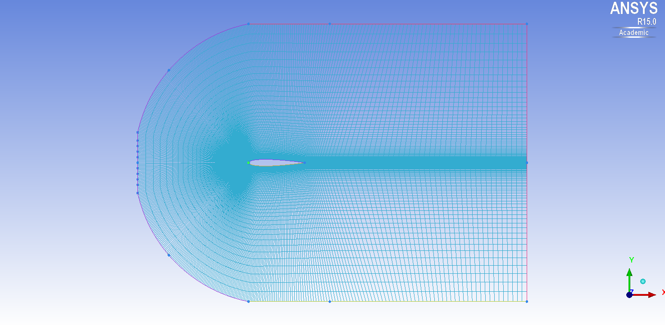

**Figure 2.1:** Provided domain with mesh refinement in viscinity of the wing surface.

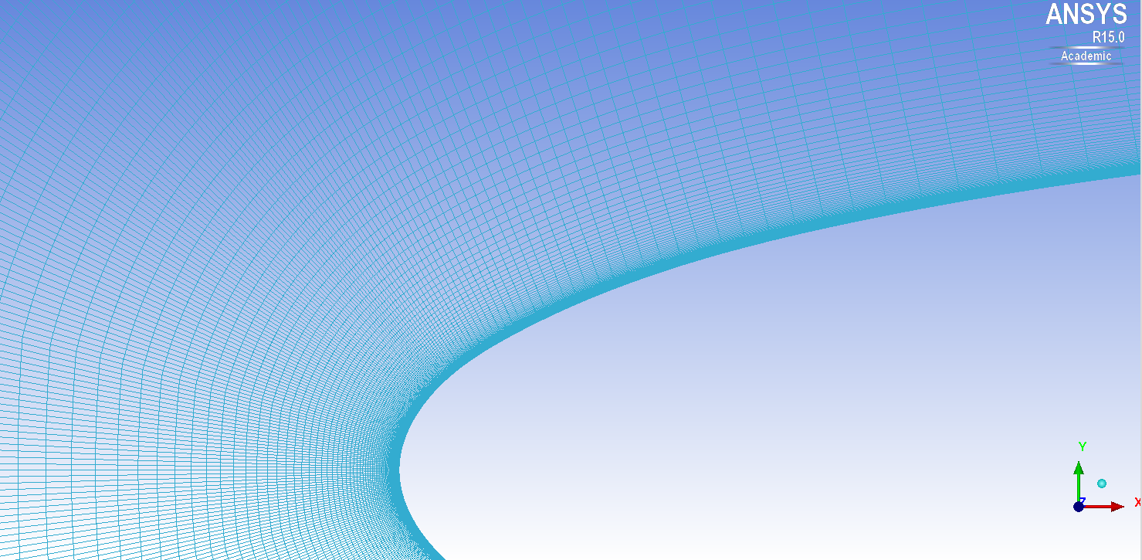

**Figure 2.2:** blabla

Due to the three dimensional characteristics of the Large Eddies this two dimensional mesh was not sufficient, but had to be extended in the third dimenstion, in order to be capable of providing convincing results. This was achieved by simply extending the given mesh in the third direction by 30 elements. This leads to a total of 6.570.000 elements. The properties of the final mesh, as it was exported from Ansys ICEM can be seen in table xxx.

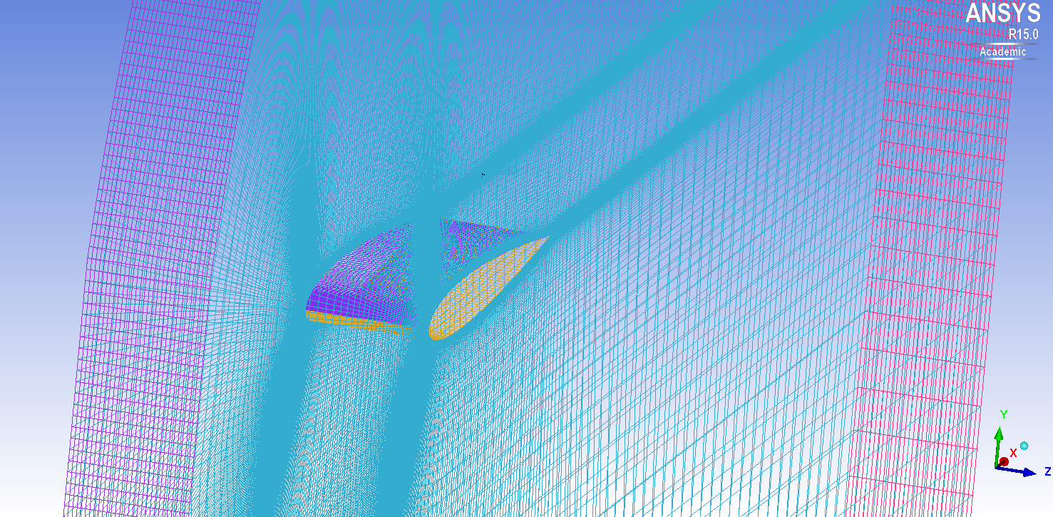

**Figure 2.3:** Closeup of the meshed geometry in isotropic view.

|  |  |
| --- | --- |
| Domain length | 7m |
| domain height | 5m |
| domain width |  |
| profile chord length | 1m |
| profile maximum thickness | 0,12m |

### Y+ Value

For the Large Eddy Simulation it is crucial to score a Y+ value at around 1. There exist formulas for estimating the first cell height in order to achieve a desired Y+ value.

The definition of the Y+ value is:

$y+ = \frac{ρ*UT*∆y1}{μ} → ∆y1=\frac{y+ *μ}{ρ*UT}$ $y+ = \frac{ρ*UT*∆y1}{μ} → ∆y1=\frac{y+ *μ}{ρ*UT}$

where the friction velocity UT is:

The wall shear stress, Tw can be obtained by the following formula:

The value for Cf needs to be taken from empirical estimations. For this calculation the value provided on … has been used, which numbers the Cf with

$$C_{f}=0.0079*{Re}^{-0.25}$$

for internal flows.

Although the Y+ value is dependend from time and location for simple geometries and flows, such as the one used for this simulation, this correlation is highly accurate.

For the calculation of the deltay1 value a short MATLAB script has been applied, which yielded a result of xx. An investigation of the given geometry in Ansys ICEM showed that the height of the cell closest to the wing surfaces features a cell height of xx, which is already beneath the desired value and therefore an alteration of the 2D mesh was unnecessary.

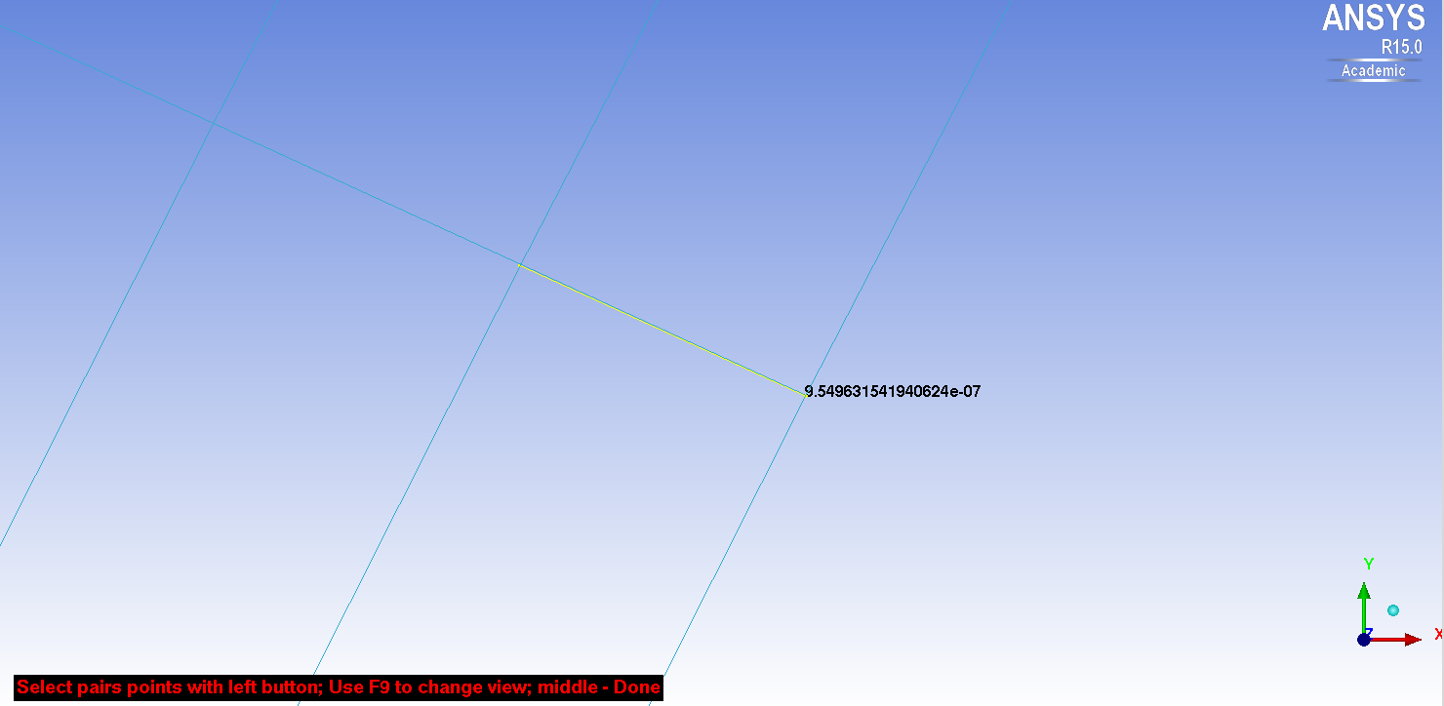

**Figure 2.4: blabla**

## Simulation Setup in Ansys CFX-Pre 15

There have been two simulations set up in Ansys CFX-Pre, linked together with [Simulation Control?]. The first one is a stationary RANS simulation with the goal to provide a fully developed flow field as initial condition for the subsequent LES.

In the following paragraphs/chapters? the content is divided by subheading if there have been differences between this two simulations.

### Domain

Stationary Simulation:

The fluid model for the transient simulation remains the same, apart from the turbulence model. For the transient simulation the LES Smagorinsky model has been appliend, which is capable of dealing with Large Eddy Turbulences.

To model the subgrid-scale viscosity the Smagorinsky model has been applied. This method deals with the assumption that energy production and dissipation of small scales is in equilibrium.

Large Eddy Simulation

### Analysis Type

For the transient analysis a number of time steps and a value for the time steps themselves have to be considered. The so-called Courant number is a good measurement for the accuracy. In order to provide reliable and stable results an average Courant number in the range of 0.5-1 is demanded [1]. There are also stable results possible with higher Courant number, but the turbulences may be damped.

According to the Documentation [2] “1,000 – 10,000 timesteps are typically required for getting converged statistics.” Since the simulation is based on the results of a static simulation with a developed flow field and time, as well as resources were limited, a total of 2.000 timesteps was chosen for this simulation.

The value for the timestep was set as 1ms, which leads to a Courant number of … .

### Boundary Conditions

The boundary conditions have been identical for stationary-, as well as Large Eddy simulation.

In total there have been ...? boundary conditions defined. The first one is for the inlet conditions and provides a constant inlet velocity of 66.8m/s at the western front of the domain. Instead of an outlet, a opening was specified on the eastern border. This is the option of choice for turbulent flows, allowing backflows of the fluid reentering the domain, instead of just leaving. The northern and southern walls were defined as free-slip walls and the wing surface as no-slip wall, leading to a velocity of zero on surface of the wing. Two symmetry conditions at the front- and the backside completed the closure, allowing the domain to stretch out in z?-direction hypothetical infinite.

### Initial Conditions

Stationary Simulation:

For the stationary simulation an inital inlet velocity of 66.8m/s was specified at initial inlet. Furthermore a relative pressure of zero, meaning that the initial prssure in the domain equals the pressure precedig at the outlet.

Large Eddy Simulation:

This part deals with the same initial conditions, but additionally it uses the resultig flow field of the Stationary solution as initial flow in the domain.

### Solver Control Settings

For the Advection Scheme was chosen Central Difference and for the Transient Scheme the Second Order Backward Euler. This was done due to recommendations at the CFX Documentation [1], where it was stated that the Central Difference Scheme is less dissipative and has provided superior results than the High Resolution Scheme and therefore it is the better choice for turbulent flows.

However, when running the solver it became obvious, that the usage of this advection scheme leads to a numerical error already in the first timestep. The solution to this problem was to conduct the solving with the Specified Blend Factor instead. This scheme allows using a mixture of the High Order Advection Scheme and the CDS. The relation of these two techniques is controlled with the Blend Factor. For the start a Blend Factor of 0.5 was choosen, meaning that the schemes were used in equal shares. In advance of the solving this factor was altered according to table …, in order to become more and more equal to the CDS.

“The implicit coupled solver used in CFX requires the equations to be converged within each timestep to guarantee conservation. The number of coefficient loops required to achieve this is a function of the timestep size. With CFL numbers of order 0.5-1, convergence within each timestep should be achieved quickly. It is advisable to test the sensitivity of the solution to the number of coefficient loops, to avoid using more coefficient loops (and hence longer run times) than necessary.” – [3]

As an initial … try the number of maximum coefficient loops has been set to 10. However if the size of the timestep requires more than tree to five coefficient loops the result can be considered as inaccurate [3]. After starting with this initial value and reviewing the solver output the value was adjusted to … .

As convergence criteria a root mean square of below 1e-6 of the residual target has been demanded.

<https://www.sharcnet.ca/Software/Fluent14/help/cfx_mod/i1303019.html>

### Output Control

Due to numberous timesteps and the resulting large amount of data, only the results of every thenth timestep have been permanently saved to a file. Furthermore the output of the Transient Results has been limited to the variables Pressure, Wall Heat Flux, ... and the output of the Transients Stats to the variables ... to further reduce the necessary storage.

For easy restorage after a shutdown or the like a full backup has been automatically produced on every hundred timestep.

### Solution Coupling

The sequence of the simulations and their relationship has been specified in the … . The stationary simulation was executed first with given initial conditions. The transient simulation followed subsequent and was able to benefit from the fully developed flow field of the preceding simulation.

## Solution with Ansys CFX-Solver-Manager 15.0

The solver setup has been specified as full run with double precission checked, which leads to more exact results. The [Verfahren?] of choice was Intel MPI Distributed, which allows the usage of multiple machines on the local network. In total six computers of type ... have been applied for executing the solving. Each computer provided six cores, which makes a total of thirysix cores at the calculations disposal.

Due to the adjustments in the [simulation control?] the solver started with the stationary simulation, which finished normally after ... . Thereafter the transient one was conducted. It took the computers ... to calculate all tenthousand timesteps. It finished normally after a duration of ... CPU seconds, after writing 2,000 transient result files and 200 backup files.

## Post-Processing with Ansys CFX-Post 15.0

One of the thins conducted in post-processing was checking whether the y+ value on the wing surface was within the correct scope. As you can see in fig. ... the value on the surface in nowhere beyond ..., which is a necessary requirement in order to receive reliable values for the heat transfer.

Before investigating the actual heat transfer it was checked whether the fluid has reached a kind of steady state flow. This was conducted by mirroring the drag coefficient over the last ... timesteps.

# Results

In total 20,000 timesteps have been computed, with transient results every 10 timesteps and full backups every 100 timesteps. With a timestep duration of 1e-5s this makes a physical duration of 0.2s. Altough this seems to be a rather short time, it is sufficient, because with a velocity of 66.8m/s the flow passes the wing surface with a length of 1m five times during this simulation time.

The post-processing was conducted with Ansys CFX-Post 15.0. The first thig was checking whether the y+ value on the wing surface was within the correct scope. This was achieved by plotting the y+ value on the wing surface as you can see in fig. ... . The value on the surface in nowhere beyond ..., which is a necessary requirement in order to receive reliable values for the heat transfer.

Nevertheless the drag coefficient of the wing was mirrored additionally. When it does not change any more over several timesteps it can be assumed that the simulation has reached a kind of steady state. The values for the drag coefficient for the last 200 steps are listed in table xx. It can be seen that they stay the same, apart from some minor deviations.

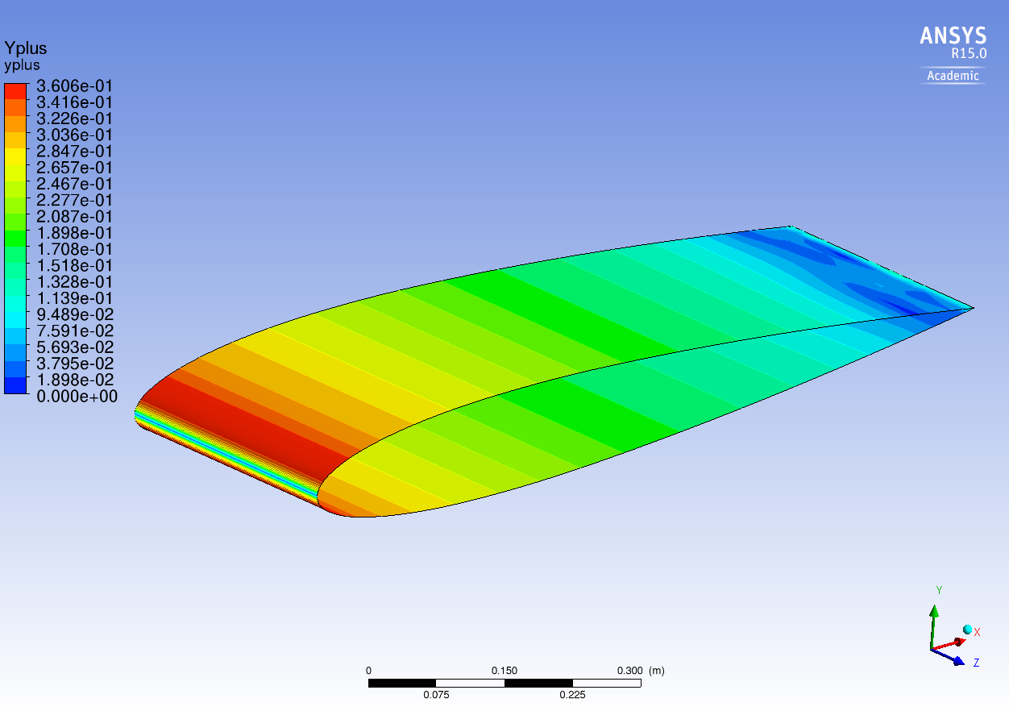

**Figure 3.1:** Y+ value plotted on the wing surface in Ansys CFX-Post 15.0

## Results – 1st Subheading (Structural Level)

The Wall Heat Flux was plotted on a polyline which was inserted exactly at the middle of the wing, in terms of depth in z-direction (0.15m). The polyline was obtained by intersecting the wing surface with a xy-plane, which was inserted at 0.15m in z-direction.

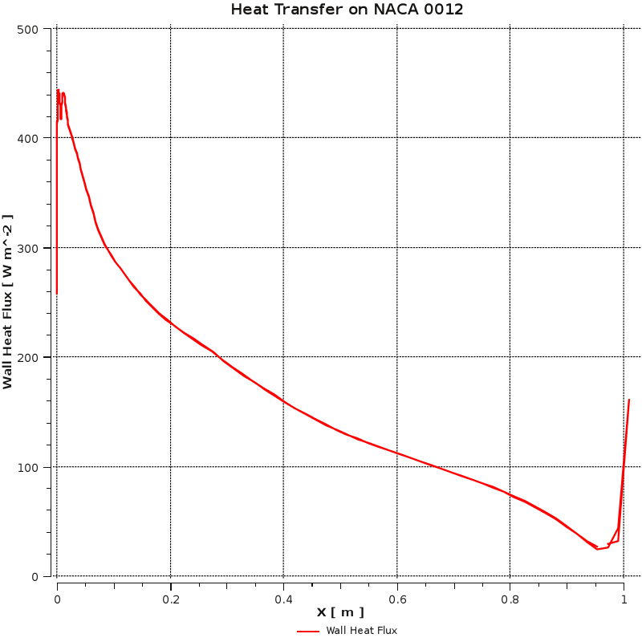

**Figure 3.2:** Distribution of the Wall Heat Flux on the wing surface per unit depth.

### Results – 2nd Subheading (Structural Level)

Text

### Results – 2nd Subheading (Structural Level)

Text

## Results – 1st Subheading (Structural Level)

Text

# Discussion

As mentioned in the abstract the aim of this project is the conduction of a heat transfer by means of a large eddy simulation and afterwards comparing the obtained results with the results of a stationary simulation of the same flow problem and analyzing deviations and similarities.

The results of a stationary simulation have been provided by Mr. Hassler.

## Discussion of Methods

In this section, the applied methods are critically examined if this seems appropriate. Comparisons with other working groups and researchers (quotations and references) should help the author to evaluate his or her own thesis. This section may also suggest possible improvements in the course of further studies.

## Comparison Large Eddy Simulation and RANS Equations

This part critically examines and interprets the results obtained. It further analyses and evaluates their significance in connection with the overall aims of the thesis and in the context of the respective scientific and technological fields. It also compares the current results with those presented in other scientific publications (quotations and references). The author should draw conclusions from the results about their plausibility, meaningfulness and universal validity. The most natural tense for the discussion of methods and results is the present tense.

# Conclusions

The Conclusions section follows the organisation of the main part (Introduction – Methods – Results – Discussion) and repeats the most important findings and their implications in new words. Special emphasis lies on the results obtained and the conclusions drawn from the discussion (evaluation of results). The most common tense for the Conclusions section is the present tense, followed by the past tense.

An outlook for future research is part of the Conclusions section and completes the current thesis, for example by suggesting ways to improve the weak points identified in the Discussion section or by giving the prospects for further theses founded on the results presented. For the outlook, authors should choose the most natural tenses as required (future forms).

# References

Students need to choose either the alphabetical author-date format or the numbered format below and align it with their in-text references. This list needs to include the full bibliographical information on all sources used, also those quoted in the Appendices.

**[References list for literature quoted in this template in the author-date system]**

American Institute of Aeronautics and Astronautics (AIAA), “Author Kit and Meeting Papers Templates” [web site], URL: [http://www.aiaa.org/documents/home/ Papers_Template_0907r.dot](http://www.aiaa.org/documents/home/Papers_Template_0907r.dot) [cited 21 January 2010].

Versteeg, H.K., and Malalasekera, W., *An Introduction to COMPUTATIONAL FLUID DYNAMICS: The Finite Volume Method*, 2nd ed., Pearson Education Limited, Harlow, England, 2007.

Fröhlich, J., *Large Eddy Simulation turbulenter Strömungen*, 1st ed., Teubner Verlag, Wiesbaden, 2006.

Ochoa, J.S., and Fueyo, N., “Large Eddy Simulation of the flow past a square cylinder”, Zaragoza, Spain.

Flühr, H., *Avionik und Flugsicherungstechnik*, 1st ed., Springer-Verlag, Heidelberg, Germany, 2010.

Kirkman, J., *Good Style: Writing for Science and Technology*, 2nd ed., Routledge, Taylor and Francis, Abingdon, UK, 2005.

McMillan, K., and Weyers, J., *How to Write Dissertations and Project Reports*, new ed., Smarter Student Series, Prentice Hall, Pearson, Harlow, UK, 2010.

Sporer-Fellner, S., Flühr, H., Haider, M., Kappertz, P., and Hering, H., “Evaluation of a Mobile Horizontal Radar Display Filter for Air Traffic Controllers,” *International Journal of Applied Aviation Studies*, Vol. 9, No. 1, 2009, pp. 43–55.

Thomson, S., “A Fantastic Paper on Everything,” *International Expert Studies*, Vol. 24, No. 3, 1999, pp. 7–21.

Van Aken, D. C., and Hosford, W. F., *Reporting Results: A Practical Guide for Engineers and Scientists*, Cambridge UP, Cambridge, England, UK, 2008.

**[References list for literature quoted in this template in the number system]**

|  |  |
| --- | --- |
| [1] | American Institute of Aeronautics and Astronautics (AIAA), “Author Kit and Meeting Papers Templates” [web site], URL: [http://www.aiaa.org/documents/home/ Papers_Template_0907r.dot](http://www.aiaa.org/documents/home/Papers_Template_0907r.dot) [cited 21 January 2010]. |
| [2] | Flühr, H., *Avionik und Flugsicherungstechnik*, 1st ed., Springer-Verlag, Heidelberg, Germany, 2010. |
| [3] | Kirkman, J., *Good Style: Writing for Science and Technology*, 2nd ed., Routledge, Taylor and Francis, Abingdon, UK, 2005. |
| [4] | McMillan, K., and Weyers, J., *How to Write Dissertations and Project Reports*, new ed., Smarter Student Series, Prentice Hall, Pearson, Harlow, UK, 2010. |
| [5] | Sporer-Fellner, S., Flühr, H., Haider, M., Kappertz, P., and Hering, H., “Evaluation of a Mobile Horizontal Radar Display Filter for Air Traffic Controllers,” *International Journal of Applied Aviation Studies*, Vol. 9, No. 1, 2009, pp. 43–55. |
| [6] | Thomson, S., “A Fantastic Paper on Everything,” *International Expert Studies*, Vol. 24, No. 3, 1999, pp. 7–21. |
| [7] | Van Aken, D. C., and Hosford, W. F., *Reporting Results: A Practical Guide for Engineers and Scientists*, Cambridge UP, Cambridge, England, UK, 2008. |

# Appendix A: Source Code or Similar Appendices

Appendices could include source code generated during work on the thesis or accompanying documents, such as legal texts.

# Appendix B: Style Sheet for Creating the References List

Depending on academic disciplines and publishers’ policies, the formatting of entries in References sections varies considerably, and up to this date no international standards exist for regulating this area. The Institute of Luftfahrt/Aviation has adopted and slightly adapted the style sheet from a renowned international aeronautical organisation, the American Institute of Aeronautics and Astronautics (AIAA) [1]. Reports and theses submitted to the Institute of Luftfahrt/Aviation have to follow AIAA style. Exceptions to this rule can be granted in written form by the academic assessor if certain disciplines or research topics require it, but such changes have to be communicated to students before they start writing their reports or theses. Reports, theses and papers have no style sheet in the Appendix.

**Books, Contributions to Books**

Main rule:

Author(s), *Title: Subtitle*, edition number {if given}, Series Name {if given: series number}, Publisher, Place, State/Country, date of publication {if required: chapter(s), pages}.

Explanation:

Publisher, place, and date of publication are required for all books. No state or country is required for major cities: New York, London, Moscow, etc. A differentiation must always be made between Cambridge, MA, and Cambridge, England, UK. Contributions to books require page numbers indicating the length of the contribution. If given, editors must be included. If a book has an editor or editors and no author(s) on the title page and if the reference is to the whole book and not to a specific contribution, the entry is listed under the editor’s name. An abbreviation is added to the name(s): “(ed.)” for a single editor, “(eds.)” for multiple editors.

Examples:

Burghardt, M., *Einführung in Projektmanagement,* Publicis-MCD-Verlag, Erlangen, Germany, 1995.

Flühr, H., *Avionik und Flugsicherungstechnik*, 1st ed., Springer-Verlag, Heidelberg, Germany, 2010.

Oates, G. C., (ed.), *Aerothermodynamics of Gas Turbine and Rocket Propulsion*, AIAA Education Series, AIAA, New York, 1984.

Peyret, R., and Taylor, T. D., *Computational Methods in Fluid Flow*, 2nd ed., Springer-Verlag, New York, 1983, Chaps. 7, 14.

Tatzl, D., “English for Aviation and the ICAO Language Proficiency Requirements,” *Contexts of English in Use: Past and Present: A Festschrift for Peter Bierbaumer on the Occasion of the 40th Anniversary of His Career at the University of Graz*, edited by M. Reitbauer, N. Campbell, S. Mercer and R. Vaupetitsch, Braumüller, Wien, 2007, pp. 77–88.

**Periodicals**

Main rule:

Author(s), “Title,” *Periodical Name*, Vol. {volume}, No. {number}, date of publication, pp. {pages}.

Explanation:

All of the preceding information is required. The journal issue number (“No. 11”) is preferred, but the month (Nov.) can be substituted if the issue number is not available. Use the complete date for daily and weekly publications. Transactions follow the same style as other journals; if punctuation is necessary, use a colon to separate the transactions title from the journal title. Page numbers indicate the length of an article. Pages quoted can be added, but since they are included in the text reference, this is not necessary. Articles completely interrupted by intervening sections list all the pages that contain passages of that article.

Examples:

Dornheim, M. A., “Planetary Flight Surge Faces Budget Realities,” *Aviation Week and Space Technology*, Vol. 145, No. 24, 9 Dec. 1996, pp. 44–46.

Sporer-Fellner, S., Flühr, H., Haider, M., Kappertz, P., and Hering, H., “Evaluation of a Mobile Horizontal Radar Display Filter for Air Traffic Controllers,” *International Journal of Applied Aviation Studies*, Vol. 9, No. 1, 2009, pp. 43–55.

Terster, W., “NASA Considers Switch to Delta 2,” *Space News*, Vol. 8, No. 2, 13–19 Jan. 1997, pp. 1, 18.

Vatistas, G. H., Lin, S., and Kwok, C. K., “Reverse Flow Radius in Vortex Chambers,” *AIAA Journal*, Vol. 24, No. 11, 1986, pp. 1871–1877, here pp. 1872, 1873.

**Proceedings**

Main rule:

Author(s), “Title,” *Proceedings/Conference Name*, edited by {Name}, Vol. {volume}, Publisher, Place, State/Country, date of publication, pp. {pages}.

Explanation:

At a minimum, proceedings must have the same information as other book references: paper (chapter) and volume title, editor (if applicable), name and location of publisher, and page numbers. Do not include paper numbers in proceedings references, and delete the conference location so that it is not confused with the publisher’s location (which is mandatory, except for government agencies). Frequently, CP or SP numbers (Conference Proceedings or Symposium Proceedings numbers) are also given. These elements are not necessary, but when provided, their places should be as shown in the examples below.

Examples:

Chi, Y., (ed.), *Fluid Mechanics Proceedings*, SP-255, NASA, 1993.

Morris, J. D., “Convective Heat Transfer in Radially Rotating Ducts,” *Proceedings of the Annual Heat Transfer Conference*, edited by B. Corbell, Vol. 1, Inst. of Mechanical Engineering, New York, 1992, pp. 227–234.

Thompson, C. M., “Spacecraft Thermal Control, Design, and Operation,” *AIAA Guidance, Navigation, and Control Conference*, CP849, Vol. 1, AIAA, Washington, DC, 1989, pp. 103–115.

**Reports, Theses and Individual Papers**

Main rule:

Author(s), “Title,” report number/reference {if required: type of source such as Master’s Thesis}, Place, State/Country, date of publication/submission {if required: chapter(s), pages}.

Explanation:

Government agency reports do not require locations. For reports such as NASA TM-85940, neither insert nor delete dashes; leave them as provided by the author. Place of publication should be given, although it is not mandatory, for military and company reports. Always include a city and state for universities. Papers need only the name of the sponsor; neither the sponsor’s location nor the conference name and location are required. Do not confuse proceedings references with conference papers.

Examples:

Chapman, G. T., and Tobak, M., “Nonlinear Problems in Flight Dynamics,” NASA TM-85940, 1984.

Steger, J. L., Jr., Nietubicz, C. J., and Heavey, J. E., “A General Curvilinear Grid Generation Program for Projectile Configurations,” U.S. Army Ballistic Research Lab., Rept. ARBRL-MR03142, Aberdeen Proving Ground, MD, Oct. 1981.

Tseng, K., “Nonlinear Green’s Function Method for Transonic Potential Flow,” Ph.D. Dissertation, Aeronautics and Astronautics Dept., Boston Univ., Cambridge, MA, 1983.

**Electronic Publications**

Main rule:

Electronic journals:

Author(s), “Title,” *Periodical/Proceedings/Conference Name* [type of source], Vol. {volume}, No. {number}, Publisher {if required}, Place {if required}, State/Country {if required}, date of publication, pp. {if given: pages}, URL: <http://www.xxx.yyy> [cited dd month yyyy].

Web sites:

Web site owner, “(Sub)Title,” [web site], URL: <http://www.xxx.yyy> [cited dd month yyyy].

Explanation:

CD-ROM publications and regularly issued, dated electronic journals are permitted as references. Archived data sets also may be referenced as long as the material is openly accessible and the repository is committed to archiving the data indefinitely. References to electronic data available only from personal web sites or commercial, academic, or government ones where there is no commitment to archiving the data are not permitted (see Private Communications and Web Sites). Always include the citation date using [cited dd month yyyy] for online references. Break web site addresses after punctuation, and do not hyphenate at line breaks. CD-ROMs require the publisher, place of publication, and state/country of publication.

Examples:

Atkins, C. P., and Scantelbury, J. D., “The Activity Coefficient of Sodium Chloride in a Simulated Pore Solution Environment,” *Journal of Corrosion Science and Engineering* [online journal], Vol. 1, No. 1, 1997, Paper 2, URL: <http://www.cp/umist.ac.uk/JCSE/vol1/> vol1.html [cited 13 April 1998].

Richard, J. C., and Fralick, G. C., “Use of Drag Probe in Supersonic Flow,” *AIAA Meeting Papers on Disc* [CD-ROM], Vol. 1, No. 2, AIAA, Reston, VA, 1996.

Vickers, A., “10-110 mm/hr Hypodermic Gravity Design A,” *Rainfall Simulation Database* [online database], URL: http://www.geog.le.ac.uk/bgrg/lab.htm [cited 15 March 1998].

Electronic books are permitted as references only if they were originally published as electronic books. In such a case, the same rules apply as for printed books (see “Books, Contributions to Books”). In addition, identify the type of source after the title (“[e-book]”) and include the network address and citation date at the end of the entry.

**Computer Software**

Explanation:

Include a version number and the company name and location of software packages.

Examples:

TAPP, Thermochemical and Physical Properties, Software Package, Ver. 1.0, E. S. Microware, Hamilton, OH, 1992.

**Patents**

Explanation:

Patents appear infrequently. Be sure to include the patent number and date.

Examples:

Scherrer, R., Overholster, D., and Watson, K., Lockheed Corp., Burbank, CA, U.S. Patent Application for a “Vehicle,” Docket No. P-01-1532, filed 11 Feb. 1979.

**Unpublished Papers and Books**

Explanation:

Unpublished works can be used as references as long as they are being considered for publication or can be located by the reader (such as papers that are part of an archival collection). If a journal paper or a book is being considered for publication, choose the format that reflects the status of the work (depending upon whether it has been accepted for publication). Unpublished works in an archive must include the name of the archive and the name and location of the university or other organisation where the archive is held. Also include any cataloguing information that may be provided. Always query for an update if a work is about to be published.

Examples:

Doe, J., “Title of Paper,” *Name of Journal* (to be published).

Doe, J., “Title of Chapter,” *Name of Book*, edited by…, Publisher, Place, State/Country (to be published).

Doe, J., “Title of Work,” Name of Archive, Univ. (or Organisation) Name, Place, State/Country, Year (unpublished).

**Private Communications and Web Sites**

References to private communications and personal web site addresses are generally not permitted. Private communications can be defined as privately held unpublished letters or notes or conversations between an author and one or more individuals. They may be cited as references in some case studies, but only with permission of the academic assessor. Depending on the circumstances, private communications and web site addresses may be incorporated into the main text of a manuscript or may appear in footnotes.

The AIAA entries in the References section may be listed alphabetically with or without numbers (as explained in this template). In agreement with academic assessors, entries may also be ordered serially, according to the quotations’ occurrence in the text. A subdivision of the References section into “Books”, “Periodicals”, “Internet” and the like is not permitted because all these single categories are of equal value. The subdivisions in this style sheet merely serve instructional purposes.