

**Bachelor’s Thesis**

Large Eddy Simulation of Heat Transfer on Wing Surfaces in 3D

Submitted by: Stefan LENGAUER

Registration Number: 1210587029

Academic Assessor: Dr.rer.nat Wolfgang Hassler

Date of Submission: DD Month YYYY [date of submission of the final version, which must be identical with the electronic version]

**Declaration of Academic Honesty**

I hereby affirm in lieu of an oath that the present master’s thesis entitled

**"Large Eddy Simulation of Heat Transfer on Wing Surfaces in 3D"**

has been written by myself without the use of any other resources than those indicated, quoted and referenced.

Graz, [date of submission:] DD Month YYYY

Stefan LENGAUER,

**Preface**

This thesis was written as part of the Bachelors Degree Program at FH Joanneum, University of Science, Graz Austria.

This work should give the reader a broad overview on the basics of Large Eddy Simulation as well as its advantages and disadvantages.

**Table of Contents**

Abstract v

Kurzfassung vi

List of Figures vii

List of Symbols viii

List of Tables ix

List of Abbreviations x

1. Introduction 1

1.1. Basics of Turbulent Flows 1

1.2. CFD Attempts to deal with Turbulence 2

1.3. Basic Idea of Large Eddy Simulation 3

1.4. Fine Structure Model 3

1.5. Turbulence Models 3

1.5.1. k-ε Turbulence Model 4

1.5.2. The Smagorinksy SGS Model 4

1.6. Wall Models 5

1.6.1. Wall function in Ansys CFX 5

1.7. Heat Transfer 5

1.7.1. Mecanisms of Heat Transfer 5

1.7.2. Wall Heat Flux in Ansys CFX 6

1.8. Similitude of Heat Transfer 6

2. Methods 9

2.1. Technology used 9

2.1.1. Hardware 9

2.1.2. Software 9

2.2. Mesh generation with Ansys ICEM 14 10

2.2.1. Y+ Value 12

2.3. Simulation Setup in Ansys CFX-Pre 15 13

2.3.1. Domain 14

2.3.2. Analysis Type 14

2.3.3. Boundary Conditions 14

2.3.4. Initial Conditions 15

2.3.5. Solver Control Settings 15

2.3.6. Output Control 16

2.3.7. Simulation Control 16

2.4. Solution with Ansys CFX-Solver-Manager 15.0 16

3. Results 18

3.1. Checking Border Conditions 18

3.2. Exporting data from Ansys CFX-Post 20

3.3. Processing data in Matlab 20

4. Discussion 23

4.1. Investigation of the Wall Heat Flux 23

4.2. Interpretation of the dimensionless numbers 23

4.3. Comparison Large Eddy Simulation and RANS Equations 24

5. Conclusions 25

References 26

Appendix A: Source Code or Similar Appendices 27

# Abstract

Turbulence is a phenomenon that occurs more or less in almost every natural flow.

This leads to great ambitions in terms of calculating turbulent flows in order to predict their behavior.

The objective of this work is the investigation of the heat transfer on a NACA 0012 airfoil by means of the Large Eddy Simulation.

The LES Simulation has not yet become standard for industrial application, due to its high demand on resources.

Large Eddy Simulation, a subdomain of Computational Fluid Dynamics, is recently experiencing an increased attention, due to increasing capabilities of the necessary hardware, in detail CPU and memory. In most sectors it is not yet industrial standard, because of its high demand in terms of resources, but it will become an important tool for investigation of complex flow prob- lems in near future.

Therefore the aim of the Bachelor project is the execution of a high-resolution simula- tion of the heat transfer on a wing surface in three dimensions. The given geometry for this task is a NACA 0012 airfoil and the software used will be Ansys ICEM and Ansys CFX. Subsequent the achieved results shall be compared to results obtained from RANS- simulations, which are nowadays standard for industrial application.

Due to the complexity of the Large Eddy Simulation a majority of the work will be studying the theoretical basics as well as performing LES in practice in order to achieve the necessary skills.

# Kurzfassung

Der Inhalt dieser Arbeit umfasst die Simulation des Wärmeübergangs an einer Flügeloberfläche mithilfe des sogenannten Large Eddy Turbulenzmodells. Im Gegensatz zu den standartmäßig verwendeten RANS (Reynoldsgemittelten Navier Stokes) Modellen erfordert dieses Verfahren einen erhöhten Resourcenaufwand was die Berechnung betrifft. Mit zunehmender Leistungsfähigkeit von Computern, was CPU Leistung und verfügbarer Speicher betrifft gewinnt dieses Verfahren jedoch, immer mehr an Bedeutung für die Untersuchung industriell bedeutsamer Strömungsprobleme.

Im Zuge der Arbeit wird die Anwendbarkeit und Akkuratät dieses Verfahrens anhand einer einfachen Modellkonfiguration, dem NACA 0012 Profil durchgeführt. Anschließend wurden die Ergebnisse der Simulation mit den Ergebnissen der RANS Simulation an selbigem Modell verglichen. Ein Großteil der Projektarbeit bestand jedoch aus Aneignung der theoretischen Grundlagen, sowie Einarbeitung in die praktische Anwendung der Large Eddy Simulation.

# List of Figures

|  |  |
| --- | --- |
| Figure 1.1: Heat Transfer Model in Ansys CFX (http://www.arc.vt.edu/ansys_help/cfx_mod/i1301427.html) | 2 |
|  | 7 |
| Figure 2.1: Provided domain with mesh refinement in viscinity of the wing surface. | 9 |
| Figure 2.2: | 10 |
| Figure 2.3: Closeup of the meshed geometry in isotropic view. |  |
| Figure 2.4: |  |
| Figure 3.1: Y+ value plotted on the wing surface in Ansys CFX-Post 15.0 |  |
| Figure 3.2: Distribution of the Wall Heat Flux on the wing surface per unit depth. |  |

# List of Symbols

If necessary, insert a List of Symbols or further lists (for example, List of Tables, List of Abbreviations) HERE.

# List of Tables

# List of Abbreviations

|  |  |
| --- | --- |
| CFD | Computational Fluid Dynamics |
| LES | Large Eddy Simulation |
| VLES | Very Large Eddy Simulation |
| RANS | Reynolds Averaged Navier-Stokes |
| DNS | Direct Numerical Simulation |
| GS | Grid Scale |
| SGS | Sub-Grid Scale |
| FS | Fine Structure |
| HPC | High Performance Computing |
| GUI | Graphical User Interface |

# Introduction

The majority of the work for this thesis was acquiring the necessery theoretical knowledge and subsequent the execution of the practical simulation by means of the Ansys Software Ansys ICEM 14.0 and Ansys CFX 15.0.

...

## Basics of Turbulent Flows

Independent of their complexety, all flows become unstable above a certain Reynolds number. While flows are usually laminar at low Reynolds numbers they become more and more turbulent, when it increases. This specific value when the flow turns over from laminar to chaotic is called critical Reynolds number.

Turbulences have always three-dimensional spacial character, even if the velocities and pressure vary just in one or two dimensions. The typical sighns of turbulence are the so-called turbulent eddies which are basically rotational flow structures as they can be seen in fig ... . There eddies come with a wide range of various length- and time scales. Due to this rotational flow fields, particles which are initially seperated by long distances can be brought together quickly, which leads to a high efficiency in terms of heat, mass and momentum exchange.

Altough turbulent flows are highly caotic and almost impossible to predict over longer periods of time, the characterisic lenghs of the large eddies is proportional to the considered flow problem. An important term which has to be considered in this term is the energy cascade. In a typical turbulent flow kinetic energy is handed down from the large scale eddies, which are by far the most energetic ones, to the smaller ones. Figure xx shows the spectral energy of eddies dependant on their size. Obviously the smalles eddies hold by far the least energie. The large eddies get their energy from the mean flow and break up in the smaller scales. The Reynolds number of the smales scales equals one, which means that the intertia and the viscous effects are of equal strength. All the work they perform is against the viscous stresses and therfore all the energy they hold dissipates into internal thermal energy.

## CFD Attempts to deal with Turbulence

In Computational Fluid Dynamics there are different ways in order to deal with turbulent flows. All natural flows are more or less turbulent, but in the calculation of flows the turbulences are usually only resolved to a certain degree or omitted at all. Methods for calculation of flows can be organized according to their turbulence resolving capability.

The so called RANS (Reynolds Averaged Navier-Stokes) equations ...

This method yields time averaged properties of the flow like mean velocities, mean pressures, mean stresses, etc. For many technical flow investigation this is enough and therfore this simulation type has been the method of choice for CFD calculations for the past decades. Other advantages are the modest demand on ressources and that two dimmensional calculations are sufficient.

The RANS equations for incompressible flow lead to six additional stresses, known as the Reynolds stresses. This stresses are unknown and for computing turbulent flows they need to be predicted by dedicated turblence models like the k-e model.

The LES (Large Eddy Simulation) represents a sort of compromise between RANS equations and DNS (Direct Numerical Simulation). It has high demands on storage and CPU performance sine unsteady flows need to be computed. Nevertheless, due to the fast improvement of hardware, this method becomes more and more applicable, even for more complex flow problems. As the title suggest this project concentrates mostly on this kind of simulation and therfore it will be discussed in more detail in the following chapters.

With DNS (Direct Numerical Simulation) all scales of turblence are simulated numerical. Therfore a three dimensional is needed which is at least as fine as the the smalest scale eddy. Additionally the timestep needs to be small enough to resolve even the fastest flunctuation. This leads to a tremendous demand of ressources and mesh quality and therefore it is nowadays only performed for academic researches on rather small and simple geometries.

There exist also a lot of sub-forms and mixtures of various approaches, like DES (Detached Eddy Simulation), VLES (Very Large Eddy Simulation), etc., but to mention them would go beyond the scope of this report.

For the project the RANS and the LES simulation have been applied. This chapter is dedicated to introduce the reader to some crucial basics of LES. Therefore it will cover the terms fine structure model, turbulence model and wall function. Due to the numberous different models, equations and the like, each subchapter will deal only with the stuff used for this particual project.

The last subchapter will cover the term heat transfer which is used frequently during this thesis and is also part of the title.

## Basic Idea of Large Eddy Simulation

Turbulences appear in a great range of shapes and sizes. ...

Large scale eddies dependend of the geometry, well ordered and carry a lot of energy. The smaller scale ones are breakdown products of the large eddies and have therfore much less energy. They show a very transient and chaotic behavior. The basic idea behind the Large Eddy Simulation ist o resolve the large eddies numerically while smaller ones are modeled with dedicated functions. There are special filters applied with divide the turbulences according to their scales into GS (grid scale) and SGS (sub-grid scale).

In comparison to the RANS the LES need much less modelling since the small eddies present just a small amount of the overall energy.

## Fine Structure Model

A majority of the scientific research concerning LES is dedicated to the developement of the so called fine structure modells. They are used to represent the impact SGS symbolically by dissipating as much energy as it would be the case with a DNS modell of the same problem. Most of the fine structure modells used today are deterministic. Therefore the FS (Fine Structure) model is dependend of the velocity field and yields exactly on solution.

The finer the applied filter is, the more eddies are modelled numericaly and therfore the FS model can be simpler while leading to a similar accurate solution. If the filter becomes, theoretically, indefinitely small the LES passes into a DES. The other margin case would be a very [rau] filter which allows only the most energized eddies. This kind of simulation is known as VLES (Very Large Eddy Simulation).

This circumstances offer two possible options in order to improve the simulation. There can be improved either the FS model or the used grid. In most cases an improvement of the FS model is the option of choice, since a refinement of the grid leads to a much higher demand in terms of resources and comes with no warranty to provide a more accurate solution [1]. However a LES is also highly dependend on the prceding inlet circumstances as well as the wall functions.

## Turbulence Models

There are various different modells for simulating turbulence for RANS as well as for Large Eddy. This report deals with the k-ε model and the Smagorinsky model, because these are the ones used for this project.

### k-ε Turbulence Model

The k-ε models are the most frequently used best prooved model for RANS turbulence. The reason for their popularity is their convincing performance in confinded flow, which is usually the case in industrial application [CFD Buch p.79]. For these simulations the k-ε model offers a good compromise between accuracy and robustness [ansys 4.1.3].

This models presume an isotropic turbulent viscosity [wiki] and add two extra transport equations which need to be solved alongside the RANS flow equations.

„They are based on the presumption that there exists an analogy between the action of visous stresses and Reynolds stresses on the mean flow. Both stresses appear on the right hand side of the momentum equation, and in Newton’s law of viscosity the viscous stresses are taken to be proportional to the rate of deformation of fluid elements.“

Formel p. 67 (2.31)

„The standard k-ε model (Launder and Spalding, 1974) has two model equations, one for k and one for ε, based on our best understanding of the relevant processes causing changes to these variables.

We use k and ε to define velocity scale (ypsilon?) and length scale l representative of the large-scale turbulence as follows:

Formel

Based on this assumptions the eddy viscosity is defined as

Formel p.75 (3.44).

### The Smagorinksy SGS Model

The basic idea behind the Smagorinsky SGS Model is that the turbulent stresses are proportional to the mean rate of strain.

„Thus, in Smagorinsky’s SGS model the local SGS stresses Rij are taken to be proportional to the local rate of strain of the resolved flow Sij ... [p.102]“

...

## Wall Models

### Wall function in Ansys CFX

In Ansys CFX the wall model is implemented as wall function, ...

http://www.arc.vt.edu/ansys_help/cfx_thry/cfxTurbModeMath.html

## Heat Transfer

Heat is a special form of energy and is stored in the chaotic movement of atomes and molecules. In a non adiabat system it is the amount of energy which resigns over the border if a temperature gradient is prevailing. The transition of the heat over the system borders is therefore called heat flux and runs always in the direction of the lower temperature.

Basically there are three different ways how heat can be transfered from one system to another, which will be discussed in the following.

### Mecanisms of Heat Transfer

With conduction, heat gets transfered between particles in „unmittelbarer Nähe“. It occurs with adjacent molecules of solids or steady fluids.

Between moving fluids proceedes the so-called convection. This form of heat transfer is the dominant one in liquids and gases.

The last form of heat transfer is by radiation. Radiation is the transmission of energy by means of waves. It can prodeed through different material, altough no material is required for it is also capable of spreading through space. Physically, the internal energy of the radiating system is converted into multiple tiny energies, which are then emited. The movement and location of the single photones cannot be determined, but only the behavior of many photones can be described by means of an electromagnetic wave. Usually the radiation if named after its way of creation, like γ-, or X-radiation.

The specific radiance M of a body is given by

$M=εσT^{4}$,

where ε is the emission coefficient and can be taken from dedicated tables.

### Wall Heat Flux in Ansys CFX

The most important property which will be investigated within this project is the wall heat flux. In Ansys CFX this variable represents the total heat flux into the domain, which consists of convective and radiative participations.

The heat flux at a wall boundary is specified by a heat transfer coefficient hc, which is obtained from the equation

$q_{w}=h_{c}\left(T_{0}-T_{w}\right)=q_{rad}+q_{cond}$,

where T0 is the external boundary temperature and Tw is the temperature at the wall, which is provided explicitly in this project. Figure ?? pictures how the heat transfer is modelled in Ansys CFX.

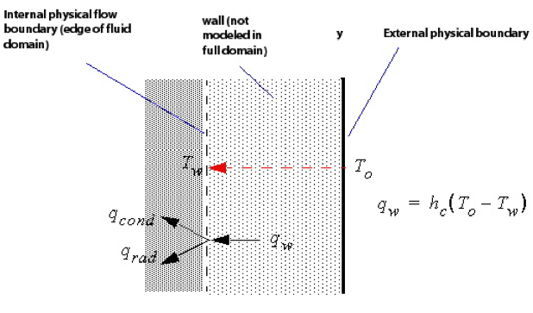

**Figure 1.2:** Heat Transfer model in Ansys CFX

## Similitude of Heat Transfer

It is impossible to determine the heat transfer for every technical problem experimentally. Furtuanatelly it is possible to transfer existing results to physically simiar objects from which the heat transfer coefficient can then be obtained.

The originator of this similitude theorem is Wilhelm Nußelt. The Nußelt number, which is a form of the differential equation of the heat transfer, but with dimensionless parameters, is named after him. It is the dimensionless form of the heat transfer coefficient.

Nu = alpha

Once the Nußelt number of a specific problem is known the heat transfer coefficient alpha can be easyly calculated. The Nußelt number itself is dependent from other dimensionless number which describe flow- and heat transfer processes.

The most important ones are the Reynolds number and the Prandtl number. The Reynolds number is capable of predicting similar flow patterns in different fluid flow situations and is defined as

RE,

where omega is the caracteristic velocity of the fluid, l a caracteristic length of the problem (for example the inner radius of a pipe, which is flowed through by a fluid), and ypsilon, the kinematic viscosity of the fluid.

The Prandtl number is named after the German physicist Ludwig Prandtl and defined as

Pr,

with eta for the dynamic viscosity of the fluid, cp as the specific heat and lambda as the thermal conductivity. As a heavily on temperature dependent material property, it can be often found tables of heat transfer properties. For air and many other gases a Prandtl number of 0.7 to 0.8 is common, under normal circumstances. Unlike the Reynolds number, the Prandl number contains no length scale variable, but is dependent only on the fluid and the fluid state.

For forces convection the Nußelt number is a function or the Reynolds- and the Prandtl number.

Nu = Nu( Re, Pr )

For many technical applications and problems the functional relation of these paramters is known. The value of the Nußelt number at the stagnation line of a cylinder with laminar flow is given by

Nu = 1.14Pr^0.4 * Re^0.5 .

quer angeströmte Zylinder können als Platten angesehen werden, wenn für die characteristische Länge die Länge der Oberfläche verwendet wird. The Nu number and thus the heat transfer coefficient alpha increase with the Reynolds number. This leads to an improved heat transfer at higher velocities.

Table ?? shows, reachable, as well as for practical application common values for the heat transfer coefficient.

|  |  |  |
| --- | --- | --- |
|  | Heat Transfer coefficient alpha | |
|  | acquirable values | common values |
| Gases |  |  |
| - free convection | 5 ... 25 | 8 ... 15 |
| - forces convection | 12 ... 120 | 20 ... 60 |
| Fluids |  |  |
| - free convection | 70 ... 700 | 200 ... 400 |
| - forces convection | 600 ... 12,000 | 2,000 ... 4,000 |

# Methods

This chapter starts with some basics concerning the problem to solve, then it deals with setting up the mesh in Ansys ICEM as well as the simulation setup in the CFX program.

## Technology used

CFD is an area with a high demand in terms of resoucres. Therefore industrial CFD calculations are often performed by supercomputers and … . Everything needed for the conduction of this project was provided by FH Joanneum and will be discussed in the following.

### Hardware

The department of Aviation at the University of Applied Sciences Graz is equipped with a HPC (High-performance computing) laboratory, compromising sixteen high performance computers, capable of providing the huge amount of CPU power needed for CFD calculations.

For executing the calculation a cluster of six machines, described in table 2.1 were used.

**Table 2.1:** Specification of computing hardware

|  |  |
| --- | --- |
| Central Processing Unit (CPU) | Intel® Xeon(R) CPU X5690 |
| Architecture | x86_64 |
| Core speed | 1596 MHz |
| Cores | 12 |
| Random Access Memory (RAM) | 23.6 GB |

### Software

The computers in the HPC laboratory feature the operating system Debian 7.8 (wheezy). Each has the programs ANSYS ICEM 14.0 and ANSYS CFX 15.0 installed, which were used for conducting the simulation, installed. Additionally minor calculation, as well as the analysis and visualisation of the results was done with MATLAB®.

ANSYS ICEM is an effective software tool for generating, improving and repairing CAD (Computer Aided Design) meshes. Its primary function however is the generation and enhancement of meshes, which are necessary for the flow simulation. Therfore it allows the import from various different CAD softwares and is able to export the mesh for several different CFD solvers such as ANSYS CFX.

ANSYS CFX is the solving software used for this project. It is a high-performance CFD program for many different fluid flow problems and comes with a highly potent and intuitive GUI. There are three different subprograms for individual simulation tasks. ANSYS CFX-PRE is responsible for setting up initial conditions, solver settings and the like, while ANSYS CFX Solver-Manager deals with the actual solving of the equations for the indiviual meshes and timesteps. The third one, ANSYS CFX Post, is used for the post-processing and analysis of finished calculations and is capable of 3D visualization of the results, as well as performing various calculations and drawing charts.

The following subchapters are divided according the the software tool, used for this step.

## Mesh generation with Ansys ICEM 14

The meshed NACA 0012 airfoil was provided as two-dimensional C-grid mesh by Dr. Wolfgang Hassler with a total of 219,000 elements and can be seen in fig. xx. It is meshed with hexahedral elements and features a total of 219,000 elements. The domain shows physical meassurements of 7m by 5m while the wing profile inside the domain shows a chord length of 1m due to the nature of the profile a maximum thickness of 12%, which would therefore be 0.12m in total values. On the left side is located the inlet, on the right the outlet and the upper and lower border are defined as walls, as you can see in figure xxx.

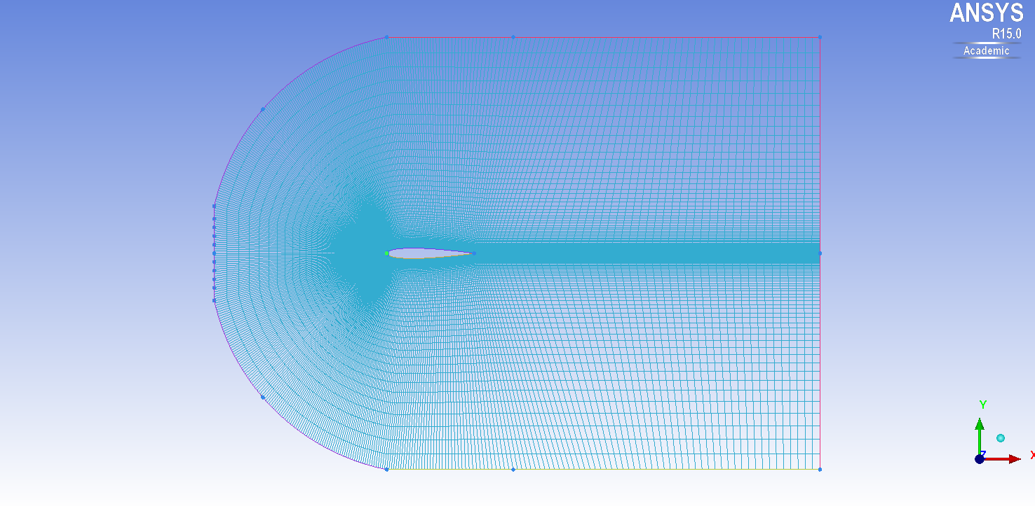

**Figure 2.1:** Provided domain with mesh refinement in viscinity of the wing surface.

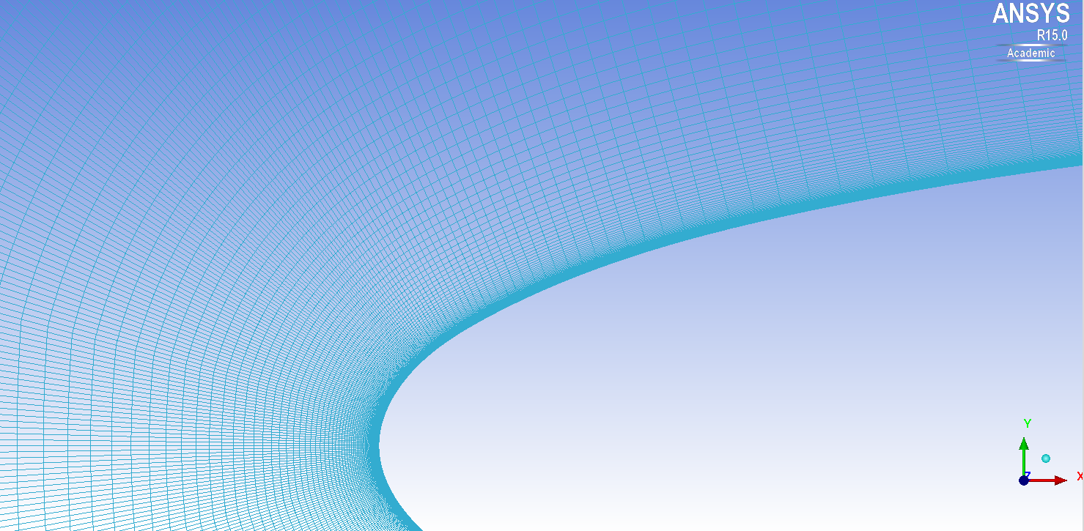

**Figure 2.2:** ??

Due to the three dimensional characteristics of the Large Eddies this two dimensional mesh was not sufficient, but had to be extended in the third dimenstion, in order to be capable of providing convincing results. This was achieved by simply extending the given mesh in the third direction by thirty elements. This leads to a total of 2,263,000 elements and 2,172,810 nodes. The properties of the final mesh, as it was exported from Ansys ICEM and can be seen in table 2.2.

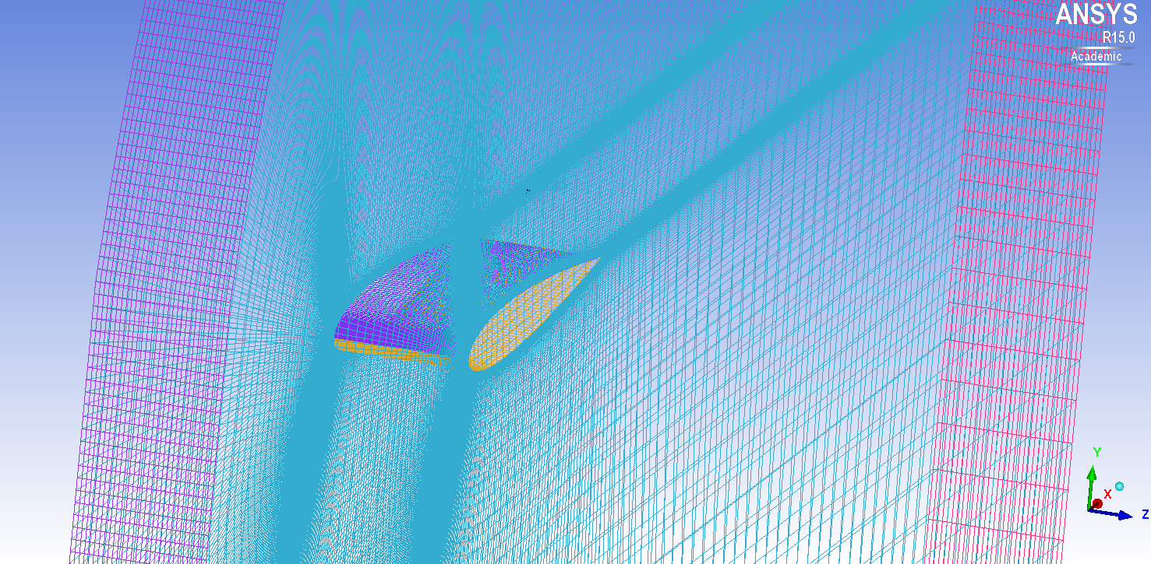

**Figure 2.3:** Closeup of the meshed geometry in isotropic view.

**Table 2.2:** Properties of the mesh

|  |  |
| --- | --- |
| domain length | 7m |
| domain height | 5m |
| domain width | 0.3m |
| profile chord length | 1m |
| maximum profile thickness | 0.12m |

### Y+ Value

For the Large Eddy Simulation it is crucial to score a Y+ value at around 1. There exist formulas for estimating the first cell height in order to achieve a desired Y+ value.

The definition of the Y+ value is:

$y+ = \frac{ρ*UT*∆y1}{μ} → ∆y1=\frac{y+ *μ}{ρ*UT}$ $y+ = \frac{ρ*UT*∆y1}{μ} → ∆y1=\frac{y+ *μ}{ρ*UT}$

where the friction velocity UT is:

The wall shear stress, Tw can be obtained by the following formula:

The value for Cf needs to be taken from empirical estimations. For this calculation the value provided on … has been used, which numbers the Cf with

$$C_{f}=0.0079*{Re}^{-0.25}$$

for internal flows.

Although the Y+ value is dependend from time and location for simple geometries and flows, such as the one used for this simulation, this correlation is highly accurate.

For the calculation of the Δy value a short MATLAB script has been applied, with the formulas from above implemented. It yielded a result of ?? for the cell closest to the wing surface. An investigation of the given geometry in Ansys ICEM showed that the height of this cell features a cell height of 9.55e-7, which is already beneath the desired value and therefore a refinement of the 2D mesh was not necessary.

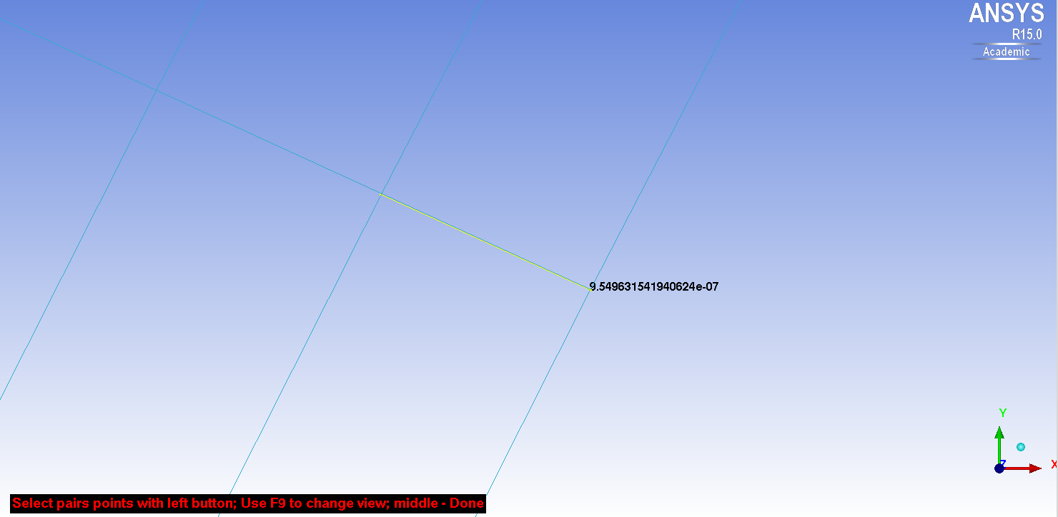

**Figure 2.4:** Meassurement of the height of the cell next to the wing surface

## Simulation Setup in Ansys CFX-Pre 15

There have been two simulations set up in Ansys CFX-Pre, linked together with [Simulation Control?]. The first one is a stationary RANS simulation with the task to provide a fully developed flow field as initial condition for the subsequent LES. In Ansys CFX they were entitled according to their simulation type “Stationary” and “Transient”.

Each simulation has the properties described in the the following chapters for themselves. However since they are mostly the same there will be no strict distinction between the two of them, but it will be refered to explicitly, if there have been differences in the adjustment with the different types of simulation.

### Domain

The CFD software requires a specific area where the equations for each method can be evaluated. Usually the object of interest is located inside the domain and at the borders of a domain are applied so called boundary conditions. ... (überarbeiten)

In Ansys CFX one or more fluid models are defined for a domain. These are used to describe and adjust the fluid dominating in this area. For this project only one fluid model was necessary, featuring air at twenty-five degrees.

The turbulence model of the fluid however, was different for stationary- and transient simulation. While the stationary one was based on the k-ε model, the transient applied the LES Smagorinsky model. It deals with the assumption that energy production and dissipation of small scales is in equilibrium.

### Analysis Type

For the transient analysis a number of time steps and a value for the time steps themselves had to be considered. For the amount 20,000 was chosen. For adjusting the necessary timestep value the so-called Courant number was investigated, which proves to be a good meassurement for accuracy. In order to provide reliable and stable results an average Courant number in the range of 0.5-1 is demanded. There are also stable results possible with higher Courant number, but the turbulences may be damped.

After starting the solving with various different timstep values it settled on a value of 1e-5 seconds, which lead to an equivalent Courant number of 0.87.

### Boundary Conditions

In total there have been seven boundary conditions defined. The first one is for the inlet conditions and provides a constant inlet velocity of 66.8m/s at the western front of the domain. Instead of an outlet, a opening was specified on the eastern border. This is the option of choice for turbulent flows, allowing backflows of the fluid reentering the domain, instead of just leaving. The northern and southern walls were defined as free-slip walls and the wing surface as no-slip wall, leading to a velocity of zero on surface of the wing. Two symmetry conditions at the front- and the backside completed the closure, allowing the domain to stretch out in z-direction hypothetical infinite. All boundary conditions and their location are listed in table ??.

### Initial Conditions

As inital inlet velocity, 66.8m/s was specifie. Furthermore the relative pressure was set to zero, meaning that the initial prssure in the domain equals the pressure precedig at the outlet.

In simulation control? it was declared that the LES simulation uses the flow field of the preceeding simulation as well.

### Solver Control Settings

For the Advection Scheme was chosen Central Difference and for the Transient Scheme the Second Order Backward Euler. This was done due to recommendations at the CFX Documentation [1], where it was stated that the Central Difference Scheme is less dissipative and has provided superior results than the High Resolution Scheme and therefore it is the better choice for turbulent flows.

However, when running the solver it became obvious, that the usage of this advection scheme leads to a numerical error already in the first timestep. The solution to this problem was to conduct the solving with the Specified Blend Factor instead. This scheme allows using a mixture of the High Order Advection Scheme and the CDS. The relation of these two techniques is controlled with the Blend Factor. For the start a Blend Factor of 0.5 was choosen, meaning that the schemes were used in equal shares. In advance of the solving this factor was altered according to table …, in order to become more and more equal to the CDS.

“The implicit coupled solver used in CFX requires the equations to be converged within each timestep to guarantee conservation. The number of coefficient loops required to achieve this is a function of the timestep size. With CFL numbers of order 0.5-1, convergence within each timestep should be achieved quickly. It is advisable to test the sensitivity of the solution to the number of coefficient loops, to avoid using more coefficient loops (and hence longer run times) than necessary.” – [3]

As an initial … try the number of maximum coefficient loops has been set to 10. However if the size of the timestep requires more than tree to five coefficient loops the result can be considered as inaccurate [3]. After starting with this initial value and reviewing the solver output the value was adjusted to … .

As convergence criteria a root mean square of below 1e-6 of the residual target has been demanded.

**Table 2.3:** Adjustment of the Blend factor with respect to the timestep interval

|  |  |
| --- | --- |
| Timestep interval | Blend factor |
| 1 - 10,000 | 0.5 |
| 10,001 – 15,000 | 0.3 |
| 15,001 – 18,555 | 0.1 |

<https://www.sharcnet.ca/Software/Fluent14/help/cfx_mod/i1303019.html>

### Output Control

Due to numberous timesteps and the resulting large amount of data, only the results of every thenth timestep have been permanently saved to the disk. Furthermore the output of the Transient Results has been limited to the variables Pressure, Wall Heat Flux, ... and the output of the Transients Stats to the variables ... to further decrease the necessary storage.

For easy restorage after a shutdown or the like, a full backup has been automatically produced on every hundred timestep.

### Simulation Control

The sequence of the simulations and their relationship has been specified in the … . The stationary simulation was executed first with given initial conditions. The transient simulation followed subsequent and was able to benefit from the fully developed flow field of the preceding simulation.

## Solution with Ansys CFX-Solver-Manager 15.0

The solver setup has been specified as full run with double precission checked, which leads to more exact results. The technique of choice was Intel MPI Distributed, which allows the usage of multiple machines on the local network. In total six computers of type described earlier have been applied for executing the solving.

Due to the adjustments in the simulation control the solver started with the stationary simulation, which finished normally after ... . Thereafter the transient one was conducted. In total it took 1.307e6 seconds (15 days, 3 hours, 3 minutes, 58 seconds) to calculate all 18,555 timesteps, after writing 1,855 transient result files and 200 backup files.

# Results

In total 18,555 timesteps have been computed, with transient results every 10 timesteps and full backups every 100 timesteps. With a timestep duration of 1e-5 seconds this makes a physical simulation duration of 0.2s. Altough this seems to be a rather short time, it is sufficient, because with a velocity of 66.8m/s the flow passes the wing surface with a length of 1m five times during this simulation time.

## Checking Border Conditions

The post-processing was conducted with Ansys CFX-Post 15.0. The first thing was checking whether the y+ value on the wing surface was within the correct scope. This was achieved by plotting the y+ value on the wing surface as you can see in figure ?? . The value on the surface in nowhere beyond one, which is a necessary requirement in order to receive reliable values for the heat transfer.

Additionally the drag coefficient of the wing was mirrored over the last timesteps. When it does not change any more over several timesteps, it can be assumed that the simulation has reached a kind of steady state. The value for the drag coefficient was calculated in Ansys CFX-Post by the equation

$C_{D}=\frac{F_{horizontal}}{\frac{1}{2}ρU^{2}A_{eff}}$,

where Aeff is the projection of the wing geometry in flow direction and Fhorizontal the force operating in x-direction.

The values for the drag coefficient for the last 200 steps are listed in table ??. It can be seen that they stay the same, apart from some minor deviations.

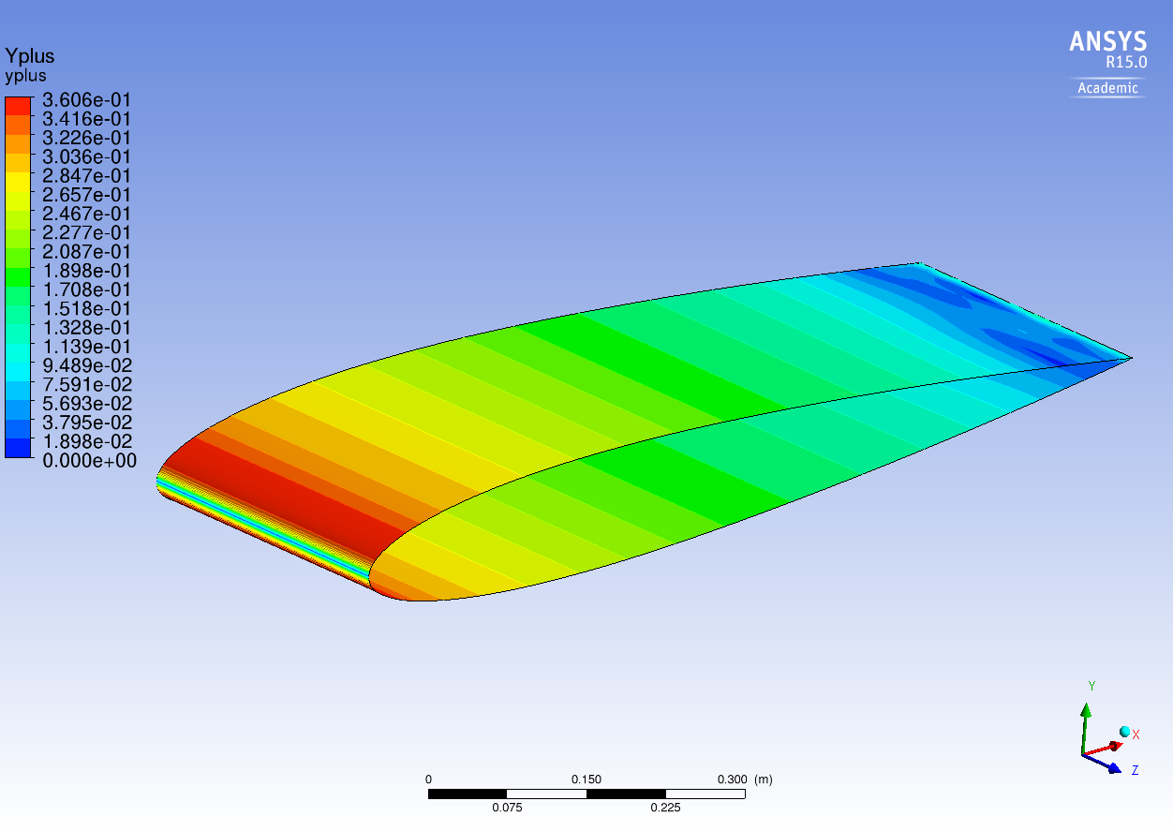

**Figure 3.1:** Y+ value plotted on the wing surface in Ansys CFX-Post 15.0

**Table 3.1:** Variation of the drag coefficient over the last 200 timesteps

|  |  |
| --- | --- |
| 18450 | 0.104639763906978 |
| 18460 | 0.104639857472925 |
| 18470 | 0.104640025982683 |
| 18480 | 0.104640124290383 |
| 18490 | 0.104640333687198 |
| 18500 | 0.104640527598881 |
| 18510 | 0.104640735058614 |
| 18520 | 0.104640635962194 |
| 18530 | 0.104640528407586 |
| 18540 | 0.104640719551398 |
| 18550 | 0.104640922019082 |

## Exporting data from Ansys CFX-Post

For investigating the heat transfer a polyline was inserted exactly at the middle of the wing, in terms of depth in z-direction. The polyline was obtained by intersecting the wing surface with a xy-plane, which was inserted at 0.15m in z-direction.

Subsequent the properties X-coordinate and Wall Heat Flux on this polyline were exported as csv file. This csv file was later as input for Matlab, which was used for plotting the data.

For comparison and evaluation purpose the same flow problem was simulated by Mr. Hassler as stationary simulation. The resolution file of this simulation was proceeded the same way, so that there could be exported a csv-file with the stationary data as well.

## Processing data in Matlab

As next step the csv-files were imported into Matlab, where the data was extracted and used for plotting the wall heat flux over the wing length. For comparison reason both results, the stationary as well as the transient one, were displayed in the same plot, which can be seen in Figure 3.2.

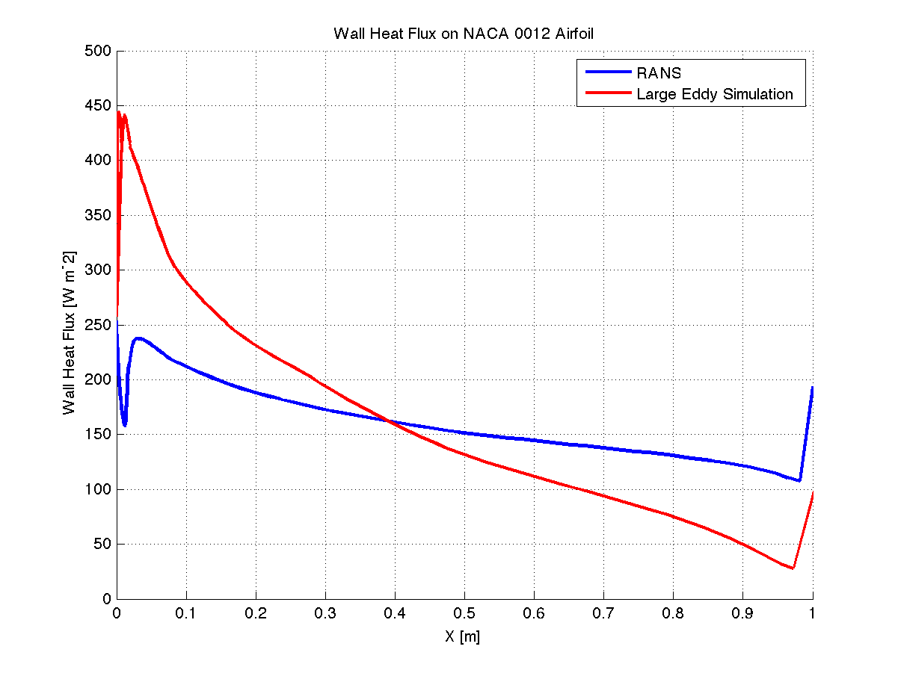

**Figure 3.2:** Distribution of the Wall Heat Flux on the wing surface per unit depth.

This data for the heat transfer was the basis for the calculation of diverse dimensionless numbers, which were of major importance for the evaluation of the simulation.

In detail, the Nußelt and the Froude number were used for comparison. For a cylinder the Froude number is more or less equal to one. This was utilized for the evaluation, since the nose of the airfoil can be compared to a cylinder.

The Nußelt and Froude number have been computed with three different approaches. For the first, the Nußelt number for a cylinder, equal to the airfoil nose diameter, was generated by means of the Prandtl and the Reynolds number with the relation given in equation ??. This was done for comparison reason and a typical specific heat transfer coefficient of 1,005 Joules per kilgram Kelvin was applied.

For the other two approaches the Nußelt number was computed from the values extracted from the simulation. Specificly the values of the wall heat flux at the stagnation point, where x is equal to zero, was of special interest. The stationary simulaton yielded a value of 253.69 Watt per square meter and the transient one a value of 257.05 Watt per square meter. These were used for computating the heat transfer coefficient alpha, which can be obtained through the correlation

alpha = q / delta t,

where delta t is the difference of the temperatures of the wall and the fluid. In this case it is one degree. With that and the airfoil nose diameter as specific length scale, given by

RE = ...,

the Nußelt number was calculated by means of equation ??.

In table ?? the differences and similarities of the single approaches can be observed.

|  |  |  |  |
| --- | --- | --- | --- |
|  | Values for a cylinder | Stationary resuls | Transient results |
| Reynolds number | 134,000 | | |
| Prandtl number | 0.7141 | - | - |
| Nußelt number | 364.72 | 308.94 | 313.03 |
| Froude number | 0.9963 | 0.8439 | 0.8551 |
| Heat transfer coefficient [W m^-2 K^-1] | 257.05 | 253.69 | 299.50 |

# Discussion

As mentioned in the abstract the aim of this project is the conduction of a heat transfer by means of a large eddy simulation and afterwards comparing the obtained results with the results of a stationary simulation of the same flow problem and analyzing deviations and similarities.

## Investigation of the Wall Heat Flux

The core of this project is the investigation of the wall heat flux on the wing surface. The basis for this examination are the results obtained from the simulations, which are plotted in Figure 3.2 and the calculation results, belonging to them, in table ??. Altough in this plot it seems like there is just one graph for each simulation type, there are actually two for each - one for the upper side and one for the bottom side of the wing. However, due to the symetry of the geometry and the flow conditions their heat transfer along the profile is almost the same, appart from numerical inaccuracies.

In the plot of the stationary result there are heavy flunctuations visible at the front end of the airfoil. This is physically illogically and results most likely from the application of the SST (Shear-Stress Transport) turbulence model for this simulation. The LES results seem much more convincing in this respect and it can be oberved that they feature a much higher wall heat flux at the front section of the wing and a lower one at the rear section, while it is equal to the stationary simulation at about forty percent wing depth. This agrees with the exectations, because in a turbulent flow the heat transfer is much better than in a laminar flow, since the turbulent vortices movement favors the energy exchange.

## Interpretation of the dimensionless numbers

This subchapter is dedicated to analysing of the dimensionless number refered to in table ??. The Reynolds number is of course the same for both solutions, since it is independent from heat transfer.

The parameter of interest is the Foude number, which is almost equal to one for a cylinder. For the transient solution the Froude number shows a deviation of about fourteen percent from this value. What causes this inaccuracy may be the subject of further investigations, but an interesting fact here is, that it is still closer to the desired result than the stationary simulation.

## Comparison Large Eddy Simulation and RANS Equations

As already mentioned the Large Eddy Simulation requires massive ressources and a very sophisticated mesh compared to the RANS equations. However there are significant reasons, why LES becomes more and more attractive than RANS. One major drawback of the RANS equations is, that they are not sufficiently reliable in terms of prediction of heat transfers. As it is the case with this simulation, where the RANS equations come up with a physically rather questionable behaviour of the heat transfer.

Furthermore LES is capable of dealing with plenty of different flow conditions, without relying on a priori assumptions.

# Conclusions

It has to be stated that the documentation and reference material for Large Eddy Simulation is rather meager. It seems that the Ansys Software tool are more dedicated to stationary simulations and it became obvious that LES requires more experience and knowledge in CFD in order to produce reliable results. Due to the long calculation durations it appears rather cumbersome and errors in the simulation setup can cost a vast amounts of time.

Nevertheless there are various reasons to perfer the LES, as stated in chapter 4.3, and therefore it is most likely to become more frequently applied for technical flow investigation in the future.

# References

Versteeg, H.K., and Malalasekera, W., *An Introduction to COMPUTATIONAL FLUID DYNAMICS: The Finite Volume Method*, 2nd ed., Pearson Education Limited, Harlow, England, 2007.

Fröhlich, J., *Large Eddy Simulation turbulenter Strömungen*, 1st ed., Teubner Verlag, Wiesbaden, 2006.

Cerbe, G., and Wilhelms, G., *Technische Thermodynamik: Theoretische Grundlagen und praktische Anwendungen*, 15th ed., Carl Hanser Verlag, München, 2008

Schwarzer, R, *CFD-Modellierung: Grundlagen und Anwendungen bei Strömungsprozessen*, Springer-Verlag, Berlin, Heidelberg, 2013

Ochoa, J.S., and Fueyo, N., “Large Eddy Simulation of the flow past a square cylinder”, Zaragoza, Spain.

Anderson, D., and Tsao, J., “Evaluation and Validation of the Messinger Freezing Fraction”, Ohio Aerospace Institute, Brook Park, Ohio, 2003.

# Appendix A: Source Code or Similar Appendices

%%%%%%%%%%%%%%%%%%%%%%%%%%%%%%%%%%%%%%%%%%%%%%%%%%%%%%%%%%%%%%%%%%%%%%%%%%%

%

% Title: wall_heat_flux_plot.m

% Version: 1.0

% Author: Stefan Lengauer

% Date: 15 Februar 2015

% Required Files: wall_heat_flux_stationary.csv

% wall_heat_flux_transient.csv

% Description: File for creating and saving the plots of the data

% obtained from CFX-Post.

%%%%%%%%%%%%%%%%%%%%%%%%%%%%%%%%%%%%%%%%%%%%%%%%%%%%%%%%%%%%%%%%%%%%%%%%%%%

clear all;

close all;

%% Data Import

STAT = csvread( '../simulation_data/wall_heat_flux_stationary.csv' );

TRANS = csvread( '../simulation_data/wall_heat_flux_transient.csv' );

x_stat = STAT( :, 1 );

y_stat = STAT( :, 4 );

x_trans = TRANS( 3:350, 1 );

y_trans = TRANS( 3:350, 4 );

%% Plot

hold on;

grid;

plot( x_stat, y_stat, 'linewidth', 2, 'color', 'blue' )

plot( x_trans, y_trans, 'linewidth', 2, 'color', 'red' )

axis( [0, 1, 0, 500] );

title( 'Wall Heat Flux on NACA 0012 Airfoil' )

legend( 'RANS', 'Large Eddy Simulation' )

xlabel( 'X [m]' )

ylabel( 'Wall Heat Flux [W m^-2]' )

%% Save Plot

saveas( figure(1), '../images/Wall_Heat_Flux_Plot.png', 'png' )

%%%%%%%%%%%%%%%%%%%%%%%%%%%%%%%%%%%%%%%%%%%%%%%%%%%%%%%%%%%%%%%%%%%%%%%%%%%

%

% Title: drag_coefficient.m

% Version: 1.2

% Author: Stefan Lengauer

% Date: 13 Februar 2015

% Required Files: force_x_18450.csv

% force_x_18460.csv

% force_x_18470.csv

% force_x_18480.csv

% force_x_18490.csv

% force_x_18500.csv

% force_x_18510.csv

% force_x_18520.csv

% force_x_18530.csv

% force_x_18540.csv

% force_x_18550.csv

% Description: File for computing the drag coefficient of the airfoil

% for the last 100 timesteps.

%

%%%%%%%%%%%%%%%%%%%%%%%%%%%%%%%%%%%%%%%%%%%%%%%%%%%%%%%%%%%%%%%%%%%%%%%%%%%

rho = 1.1839; % [kg m?3] density of air at 25 degrees

u = 66.8; % [m s^-1] inlet speed

max_thickness = 0.12; % [m] max thickness of the profile

width = 0.3; % [m] profile width

% initialization of the coefficient vector

CD = zeros( 1, 11 );

for i = 450:10:550

file = strcat( '../simulation_data/force_x_18', int2str( i ), '.csv' );

A = csvread( file );

force_x = A(:,4);

% computation of the drag coefficient

index = ( i - 450 )/10 + 1;

CD(index) = sum( force_x ) / ...

( 1/2 * rho * power( u, 2 ) * width * max_thickness );

end