COP4710 G26 — Book Store Management System

Project Report

1. Project Overview
We made a book store management system that works to manage inventory, customer accounts, and orders for a retail bookstore. This database system makes it so that we can track which books are available on which shelves, manage customer accounts, and process orders. Customers are also able to browse available inventory and place orders tied to their account.
The application is built on a MySQL relational database backend. The system was designed to reflect realistic bookstore operations while demonstrating core relational database concepts.

2. Schema Summary
The database consists of 7 tables:
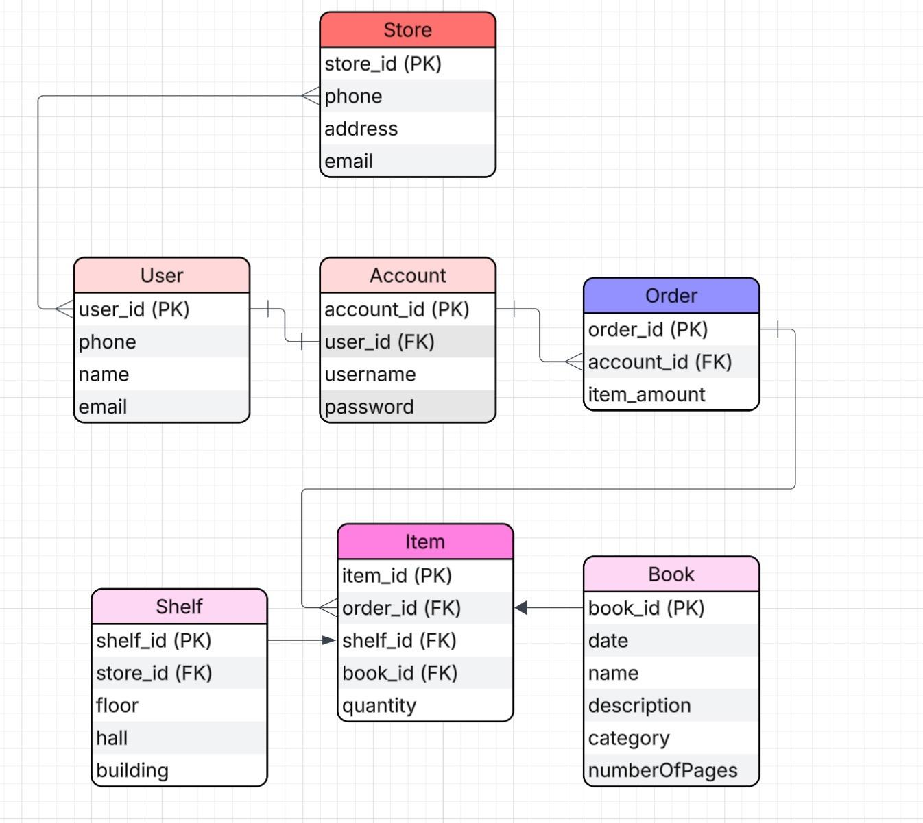

Relationships:
- Users → Account
  - 1 to 1
- Account → Orders
  - 1 to many
- Order → Item
  - 1 to many
- Book → Item
  - 1 to many
- Shelf → Item
  - 1 to many
- Store → Shelf
  - 1 to many

3. Advanced Features
View
v_available_books A customer-facing view that displays all books currently available on shelves that have not been assigned to an order. It joins the Item, Book, and Shelf tables and filters for rows where order_id IS NULL and quantity is greater than zero. In the application, this view powers the customer browse screen, allowing users to see available inventory without exposing order or account data.
Trigger
trg_check_quantity A BEFORE INSERT trigger on the Item table that prevents any item from being inserted with a quantity less than 1. If a quantity of zero or below is attempted, the trigger raises a SQLSTATE 45000 error with the message "Quantity must be at least 1." This enforces a business rule at the database level, independent of the application layer, ensuring data integrity even if the frontend validation is bypassed.

4. Individual Contribution Statement
Anncarolyne Power
- Tables worked on: Store, Account
  - Relationships: Store has user, Account has shelves
- Queries written: Queries involving the Store and Account tables
- Backend features implemented: NA. I worked on the front end.
Alejandro
- Tables worked on: User
  - Relationships: User has account
- Queries written: Queries involving the user table
- Backend features implemented: NA
Andrew
- Tables worked on: Book, Shelf
  - Relationships: Shelf has books, Book
- Queries written: Queries involving book and shelf tables
- Backend features implemented: NA
Lenyn
- Tables worked on: Item
  - Relationships: Junction table
- Queries written: Queries involving the item table and the junction table
- Backend features implemented: v_available_books, trg_check_quantity

5. AI Disclosure
- Tool(s) used
  - Claude
- Front-end file names only

