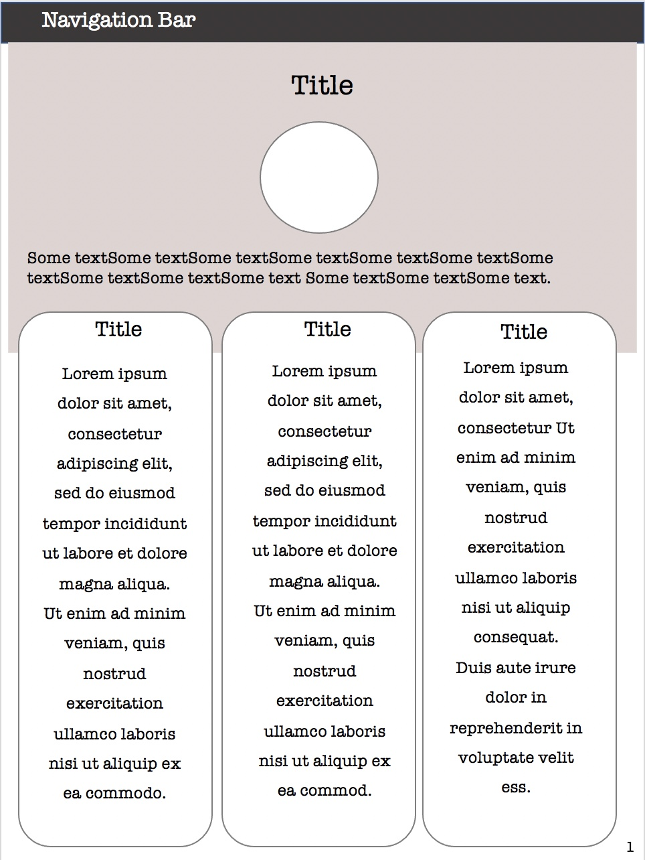

**User Flows**

**Wireframe: Home page**

