CROWS TCG - Rules Concept

What is Crows TCG?
Crows TCG is a champion duel card game inspired by tabletop RPGs, combining classic card game mechanics with TTRPG combat, with its first goal as bringing the feeling of an RPG combat to a TCG table.

How to read a card.
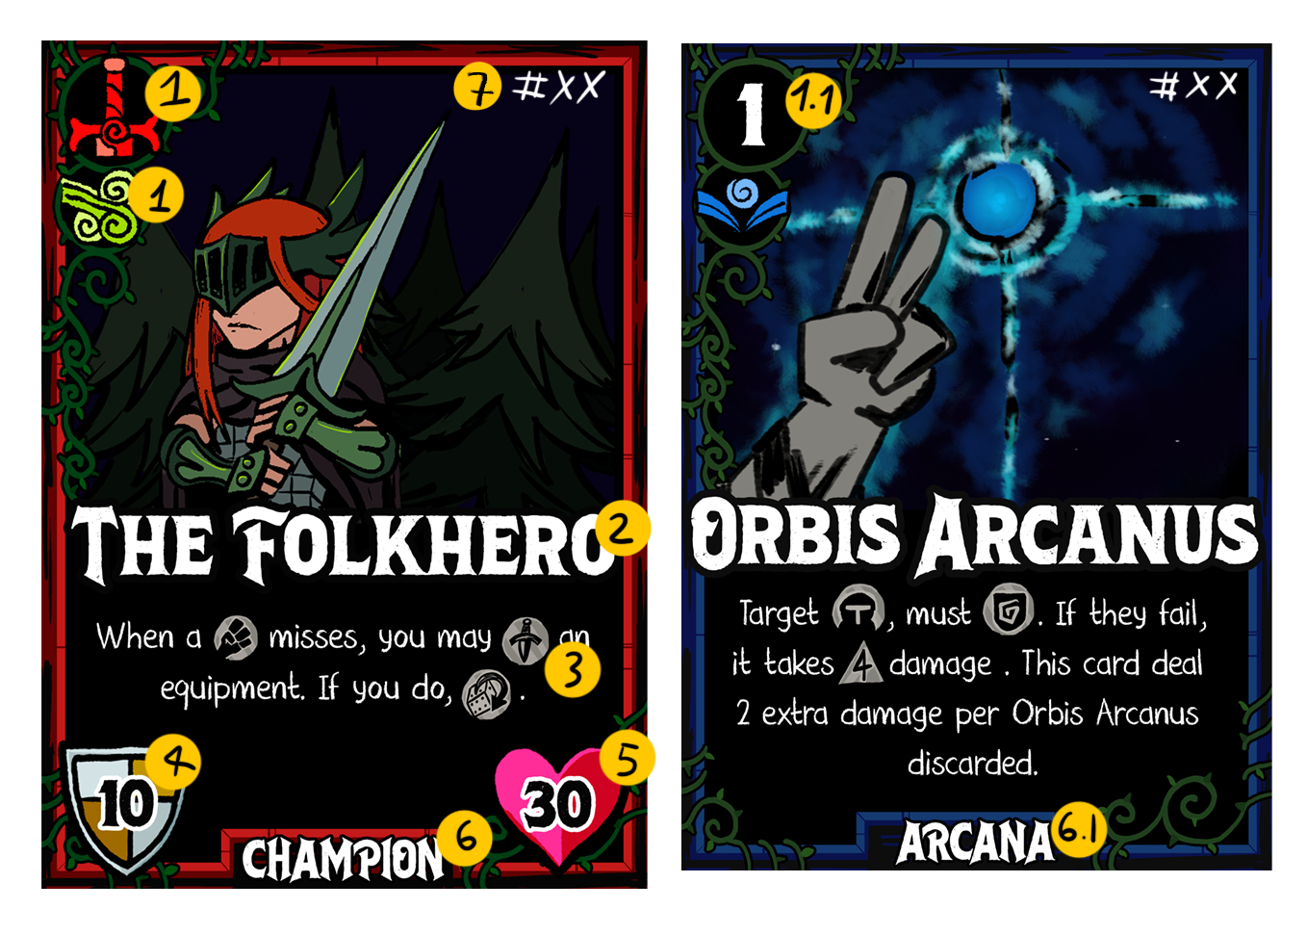
1: Card Archetype, or in this case, the Champion’s Archetype.
1.1: Card Cost to play it. Champions have no cost.
2: Card/Champion’s Name.
3: Card/champion’s effect.
4: Armor Class, it is, How hard is to strike it.
5: Life, the champion's defeat means you lose the game.
6: The Type of the card meaning, the Aspect, A Champion or an Item.
6.1: Aspect, in this case
7: Card ID, to keep track and to make it easier to find it.

How to play the game.
Every player has a deck that includes 20 cards and a Champion, to win the game you must defeat the opponent’s Champion.
0.1: You and your opponent must shuffle both decks.
0.2: Through chance, like a dice roll, decide who plays first.
0.3: The first player must deploy their champion and any other deployment cards on their respective places.
0.4: The second player must do the same. When all deployment cards are on the field the “turn-zero” is done, passing the turn to the first player again.
0.5: At the start of the turn one and any following turn, the currently player must draw 4 cards and has 3 actions; Using cards spend actions, the turn ends when all actions are spent and the player passes giving the turn to the next player. When the turn ends, discard all remaining cards in your hand.
0.6: If you have no cards in your deck to draw, shuffle your discarded cards, they will become your new deck.
0.7: The player plays as the champion, so anything that affects the champion affects the player and vice versa.
0.8: Reduce the enemy champion to zero life to win.

Now let's understand the Battlefield:
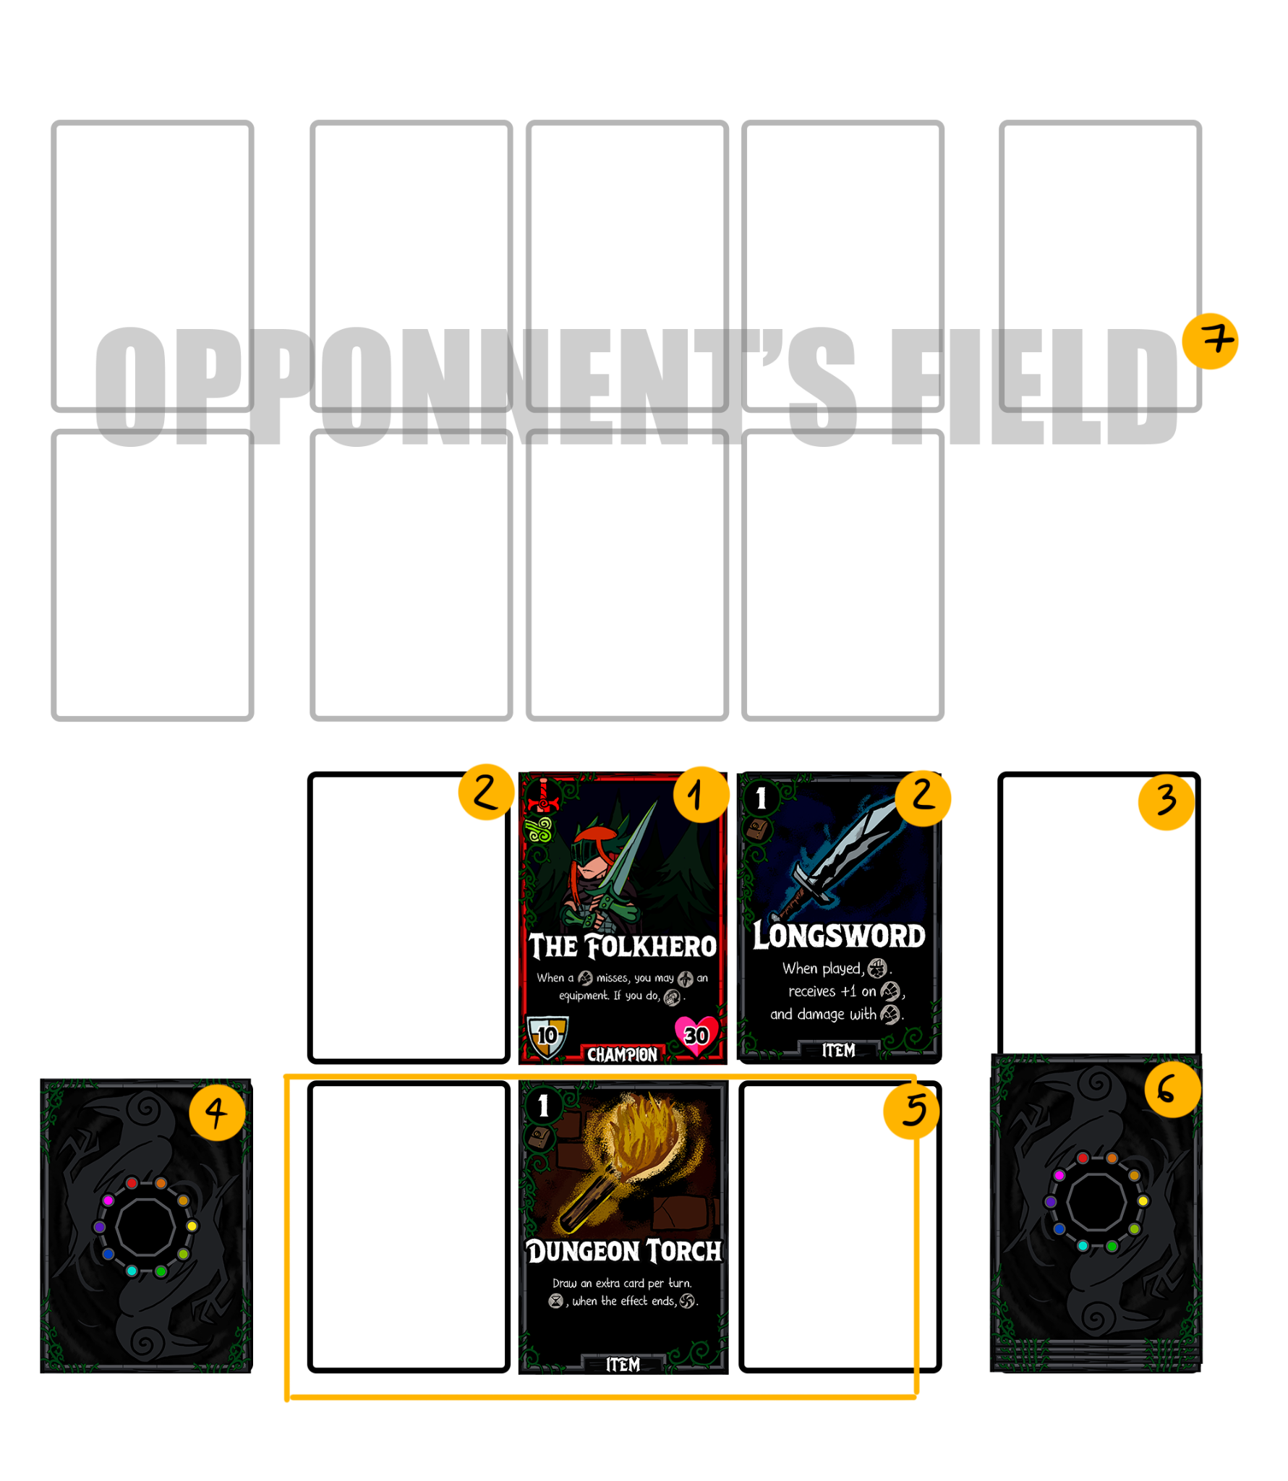
1: The Champion’s slot.
2: Both of the Champion’s hand, being slots which you can play two items that are considered Equipment.
3: The Discard Zone. Where played and discarded cards goes.
4: The Consumed Zone. Where consumed cards are removed for the entire game.
5: The Field Zones: You have three slots to keep cards that stays on the field, continuously or temporarily, normal cards have immediate effect and uses no stop in the field.
6: Your Deck, use it to search and draw cards. If it ends when you need to draw or search, shuffle your discarded cards, they will become your new deck.
7: The Opponent’s Field, the same as yours. You cannot play on the opponent’s field. or use your opponent’s cards and effects without permission.

Understanding all the card Icons, Boons and Ailments.
General and recurrent rules:
 | Unique | A Deck can normally have three copies of the same card, unique cards means a deck can hold a single card of that name.
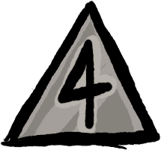 | D4 | When a effect asks for this it means you must roll a dice of four sides, the result will become the variable. Example: “D4 damage” means that if the roll results in a 3, the card will deal 3 damage.
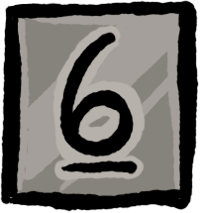 | D6 | When a effect asks for this it means you must roll a dice of six sides, the result will become the variable. Example: “D6 damage” means that if the roll results in a 3, the card will deal 3 damage.
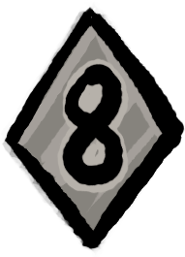 | D8 | When a effect asks for this it means you must roll a dice of eight sides, the result will become the variable. Example: “D8 damage” means that if the roll results in a 3, the card will deal 3 damage.
 | D10 | When a effect asks for this it means you must roll a dice of ten sides, the result will become the variable. Example: “D10 damage” means that if the roll results in a 3, the card will deal 3 damage.
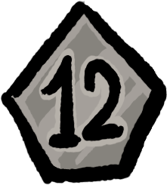 | D12 | When a effect asks for this it means you must roll a dice of twelve sides, the result will become the variable. Example: “D12 damage” means that if the roll results in a 3, the card will deal 3 damage.
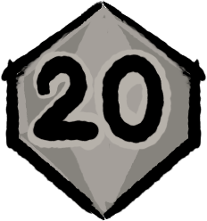 | D20 | When a effect asks for this it means you must roll a dice of twenty sides, the result will become the variable. Example: “D20 damage” means that if the roll results in a 3, the card will deal 3 damage.
 | Life | A variable that will affect or check the champion or minion’s life.
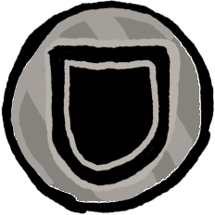 | Armor | A variable that will affect the champion or minion’s armor.  “+”: Any ARMOR icon that accompanies a “+”, it means that you will raise it by the number of ARMOR Symbols.
 | Creature | Means any minion or champion. When targeting a Champion use champion rules, when targeting a minion use Minion rules.
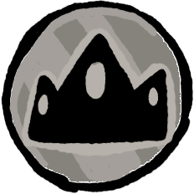 | Champion | The Champion as a target, anything that affects the champion also affects the player.  Cards that says “You” also means the champion.
 | Minion | Similar to a Champion the Minion have Armor, Life and can be destroyed, it stays on a field slot, when destroyed, consume it.
 | Action | A variable that will affect the number of Actions.  “+”: Any ACTION icon that accompanies a “+”, it means that you will receive extra ACTIONS equal to the number of ACTIONS Symbols.
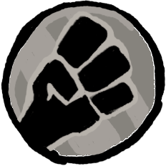 | Strike | You must roll a d20 and add up with any bonuses, comparing the result to the target’s Armor, if the result is equal or above the effect will happen, generally, causing damage. If the roll results in a 20, that strike will be considered a CRITICAL STRIKE, in this case you may roll all the dices of damage twice, but if the roll results in a 1, it will be a CRITICAL FAILURE, in this case, CONSUME the card.  “+”: Any STRIKE icon that accompanies a “+”, it means that you will receive a bonus on STRIKE rolls equal to the number of STRIKE Symbols.
 | Saving | When not specified the difficulty, you must roll your d20 and add up to your bonuses, if its equal or above 10, the noted effect of the card will happen.  “+”: Any SAVING icon that accompanies a “+”, it means that you will receive a bonus on SAVING rolls equal to the number of SAVING Symbols.
 | Discard | A Discarded card is a card that is sent from the hand to the Discard Zone/Pile. It will return to your deck when your deck ends, by shuffling the discard pile and deploying it to the Deck Zone. Discarded Zones are revealed to the opponent.
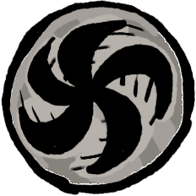 | Consume | A card that is consumed will go to the Consumed Zone. A card that is consumed will not return to the game. Consumed cards will be revealed to the opponent.
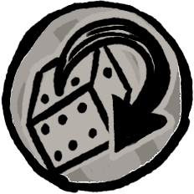 | Re-Roll | Make the same check again, but this time make it twice and pick the best result.
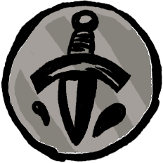 | Sacrifice | Send a card, but not a champion, from your battlefield to the discard zone.
 | Prepare | Pay the Action cost (Always 2). The card will stay on the field face-down until the noted trigger happen. This card will only count as played when it turns face up.
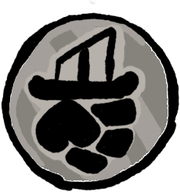 | Equipment | A Equipment is a continuous field card that will stay in the Equip Slot, A Champion can hold up to two equipments. If you deploy a new equipment while currently having both slots occupied you may choose one to send to the Discard pile.
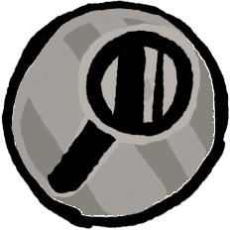 | Search | Look for a card in your deck, reveal, put it in your hand. Shuffle the deck.
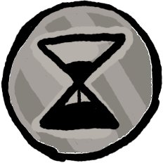 | Temporary | Temporary cards stay in the field for three turns of the player that used it, they will last until the third turn ending including the current. Sacrifice it after.
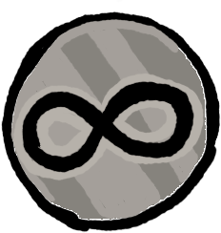 | Continuous | This card will last in the field until destroyed or sacrificed. Like any other card that stays in the field If you deploy a new continuous card while currently having all slots full you may choose one to send to the Discard pile.

Boons:
 | Sharpened | Any time a creature or champion affected by sharpened strikes, it will deal d4 extra damage on a successful strike then remove this condition.
 | Advantage | Rolls made with advantage means that you must make it twice and pick the best result.
 | Blessed | When the creature are blessed receive advantage on the next Saving or Strike and remove the condition.
 | Empowered | While the champion are empowered the target of your next card that asks for a Saving have disadvantage, then remove this condition.
 | Enraged | While Enraged the creature strike with advantage but strikes against you have advantage as well.
 | Focused | Reduce the action cost of all cards by 1.
 | Hidden | Strikes against the creature have disadvantage, If you strike or cause damage, remove hidden from all your creatures.
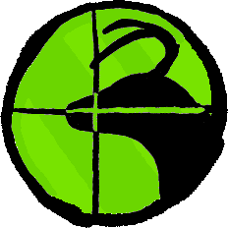 | Hunting | The next strike will have advantage, remove this condition after.
 | Inspired | You have +1 on all Strikes and Savings.
 | Lucky | If you fail in a Saving, Re-roll it with advantage. Remove this condition.
 | Quickened | You receive 1 Extra action.

Ailments:
 | Bleeding | When a creature receives Bleeding, roll a D4; The result will become Bleeding Stacks. When a creature with Bleeding receives damage, they will take extra damage equal to the number of stacks, then reduce its amount by 1.
 | Burning | When a creature receives Burning, roll a D6; The result will become Burning Stacks. At the end of the opponent’s turn, all their creatures with Burning Stacks will receive damage equal to their number of stacks, which is reduced by 1 every round.
 | Chilled | You first card played will cost 1 extra mana, then remove this condition.
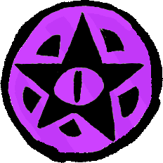 | Cursed | Reduce the amount of cards drawn at the start of your turn by 1.
 | Dazed | Reduce the maximum of actions by 1.
 | Disadvantage | Rolls made with disadvantage means that you must make it twice and pick the worst result.
 | Distress | All cards cost 1 extra action.
 | Entangled | You receive disadvantage on strikes and saves, spend 1 action in your turn to remove this condition.
 | Poisoned | When a creature receive poisoned, roll a D4; The result will become Poison Stacks. At the start of the opponent’s turn, all their creatures with Poison Stacks will receive damage equal to their number of stacks, in which reduce by 1 every round.
 | Sleeping | At the start of your turn, lose an action or discard two cards at random.
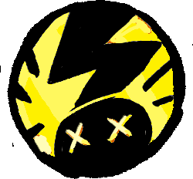 | Smitten | The next strike you receive will deal d4 extra damage, then remove this condition.
 | Stunned | Loose two actions this turn, then remove this condition.
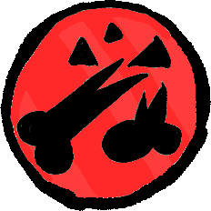 | Trauma | At the start of your turn, the opponent can pick randomly a card in your hand and discard. Then remove this condition.

The 10 Aspects.
Crows TCG brings to the table more options for customization, to bring to life as many unique champions as possible. With this, the most well-known fantasy concepts were brought together and translated as “Aspects”. A Champion has two aspects that define the Champion’s characteristics, being the type of cards that the players can include in their decks. Learn a bit more of each aspect:

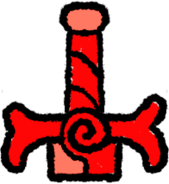 | Might | Warriors and fighters, all about strength
 | Heat | Conflagration of fury and fire.
 | Prospect | The Power of Gold! Buy your way to victory.
 | Divine | The energy of light and the deities above.
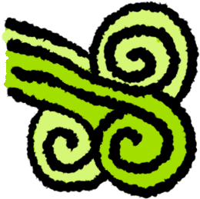 | Gale | Balance between a raging storm and a calm mind.
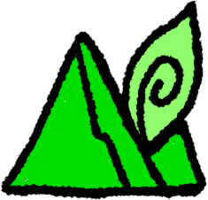 | Land | Hunt, learn about the land, and control the nature. **
 | Boreal | Mold the water to restore or freeze your enemies. **
 | Arcana | The Cosmos and the stars, the pure path to magic. **
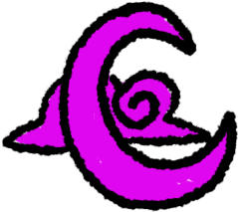 | Dusk | Deceive your way into your goals, do not get caught.
 | Occult | Make pacts and learn the Dark Arts; they offer a lot.

Building a Deck.

The rules to create a deck are the following:
- A deck must contain 21 cards, being 19 cards, plus the Champion.
- The Champion have two Aspects that allows you to choose which kind of cards you can add to your deck plus Item cards that are universal to any champion.
- You can have up to three copies of the same card except by uniques and the champion.
- Since you have three actions you must balance your deck between the action cost in the cards.

