Where am I?
Week 2
For the first submittal, I have created the database tables, and generated the domain objects using the entity framework. Each object has a validation method, which verifies that each has the required fields that are not null.
Created unit test module that includes tests for testing object validation.
Set up folder structure for future enhancements.
Set up project as MVC project to allow for future web interface.
Week 3
Added in Generic Repository for working with database/generated entities. Extended Repository as service layer for both Tasks and Users. A service factory provides the service implementations. There is now an integration test in place, covering everything from retrieving the service from the factory to CRUD operations on the database.
Fixed:
Added unit tests for individual repositories. Fixed configuration file. Fixed relationship structure.
Week 4
Flushed out service layer a bit more. Added authentication for users, and retrieval of tasks for several sorting methods. Added mocking framework to service tests to mock repository for testing purposes.
Week 5
Fixed project structure. Each layer is now own project.
Added business layer using ServiceFactory singleton to create services.
Added testing.
Bugs/Enhancements
- Need to fix directory structure. Double TaskApp directory before project main directory.
- Problem in test for TaskManager. Some issue with protection of items. Potential mocking issue? Will be fixed in next submit.

How to run/verify
Git Repository:
My git repository is named MSSE680. The work for the current week is contained : https://github.com/leo-guinan/MSSE680/tree/Week5

Database/Entity Model setup
Run database creation script: CreateDBScript.sql. This will create the database and all tables.
Use entity framework to generate models from database. Generate to TaskApp.Domain namespace.

Unit Tests
All unit tests are located under TaskApp.Tests. Currently, each domain model, repository, service, and business has its own set of tests:
- TaskApp.Tests.Domain.EstimateTest.cs
- TaskApp.Tests.Domain.TaskTest.cs
- TaskApp.Tests.Domain.UserTest.cs
- TaskApp.Tests.Service.TaskServiceTest.cs
- TaskApp.Tests.Service.UserServiceTest.cs
- TaskApp.Tests.Business.TaskManagerTest.cs
Integration Tests
There is now an integration test suite in place. It tests the entire workflow, from the instantiation of the service factory down to working with the database. It resides under TaskApp.Tests.Integration.

Target DB Diagram (Missing Task collection table, no longer deemed as needed):
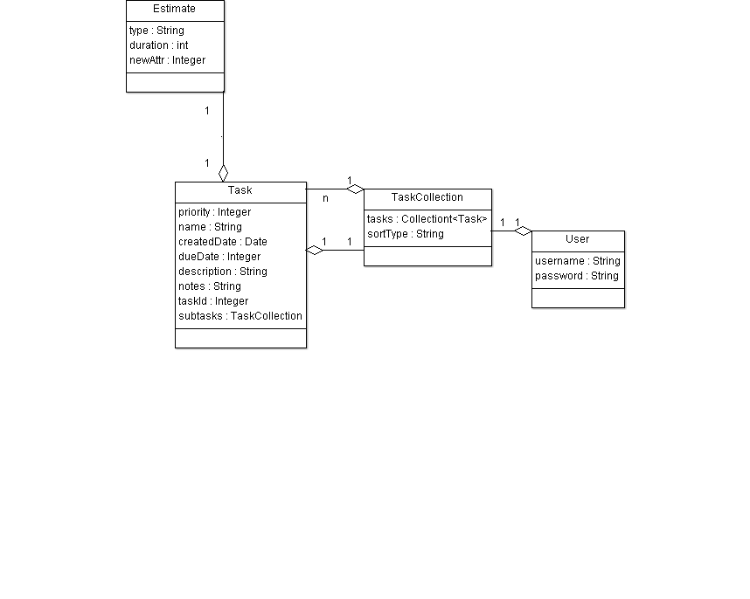

Use case diagram:
