# **Introduction**

The current conflict between Russia and Ukraine has caused people and groups to suffer at different levels and aspects globally. To better understand Twitter users’ discourse and psychological reactions to this conflict, we use deep learning methods to analyze the tweets related to this conflict.

We also want to track how the discussions and attitudes towards the conflict change over time.

The result can have several practical usages, such as improving the donation campaigns and helping local communities to establish emotional support organizations. More generally speaking, we want to see how people outside of Russia and Ukraine are affected by the conflict. Through topic modeling, we can have a view of the most concerned subtopics related to the conflict, which would be a reflection on the effects on people’s daily life and mental states.

The sentiment analysis part is a classification problem, we are trying to predict the posts’ sentiment into 11 different categories of sentiments.

The topic modeling part is an unsupervised learning problem. We will train the model to cluster the posts into groups and then examine the features of each group.

# **Challenges**

What has been the hardest part of the project you’ve encountered so far?

1. Find more suitable training data to train the sentiment analysis model.
2. Tune hyperparameters to improve the accuracy when building the model, and set the appropriate threshold to classify the sentiments.
3. Clean up complex tweet text data and do the word embedding.
4. Decide on creating bigram and trigram models and find the optimal number of topics when using LDA to do the topic modeling

# **Insights**

Using the current training dataset SemEval 2018 (Task EI-oc), we have achieved an f1 score of 0.65. One tweet can be labeled with multiple sentiments that have probabilities above the threshold. We have chosen the threshold to be 0.37 based on the accuracy and f1 score below, the accuracy and f1 score decrease after 0.37.

We have tested the model on one day’s tweets, and the results align with our assumption. Most of the tweets have negative emotions - for 05/02, the leading emotions are disgust (76% of the tweets) and anger (71% of the tweets).

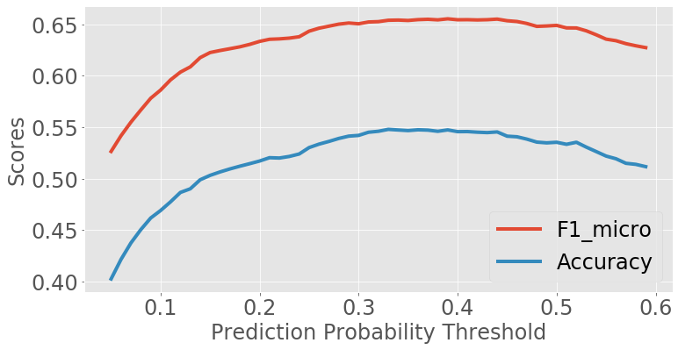

# **Plan**

At the current stage, we have already conducted data engineering and data clearing on the Twitter dataset. We have also trained and validated the bidirectional LSTM model for sentiment analysis. The result we get from our model is also reasonable. Next, we will continue to finish the topic modeling task for the next few days.

* What do you need to dedicate more time to?

1. Improve the LDA model to classify the tweets into an appropriate number of groups, and summarize the group characteristics.
2. Apply the sentiment analysis model to the whole dataset
3. Examine the model performance by showing good and bad examples.
4. Visualize the time trend of sentiments based on the prediction results for the whole dataset

* What are you thinking of changing, if anything?

Moving forward, we will improve the model by using cross-validation to tune the Bidirectional LSTM model’s hyperparameters and structures. Moreover, we may improve the model’s architecture to improve training accuracy.