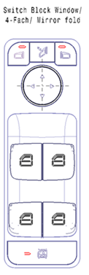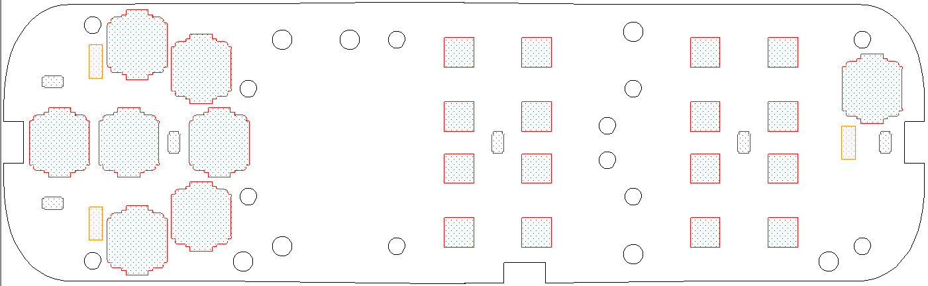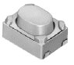

Adjust Up push

Adjust Down push

Adjust Left push

Adjust Right push



Folding push

Select Left push

Select Right push



Child Lock push

Front_Left_Auto_Down push

Front_Left_Auto_Up push

Front_Left_Manu_Down push

Front_Left_Manu_Up push

Front_Right_Auto_Down push

Front_ Right _Auto_Up push

Front_ Right _Manu_Down push

Front_ Right _Manu_Up push

Rear_Left_Auto_Down push

Rear _Left_Auto_Up push

Rear _Left_Manu_Down push

Rear _Left_Manu_Up push

Rear _Right_Auto_Down push

Rear _ Right _Auto_Up push

Rear _ Right _Manu_Down push

Rear _ Right _Manu_Up push

