**Project Synopsis of Phase-1**

**On**

**Words**

Submitted in partial fulfilment of the requirement for the Degree of Bachelor of Technology in Information Technology

at

**DIT University, Dehradun**



**By**

Tanmay Srivastava (1501051072)

Tushar Dua (1501051124)

**Under the guidance of**

Mr. B K Gupta,

Assistant Professor, IT Department

**DIT UNIVERSITY, DEHRADUN**

(State Private University through State Legislature Act No. 10 of 2013 of Uttarakhand and approved by UGC)

**Mussoorie Diversion Road, Dehradun, Uttarakhand - 248009, India.**

**2017-2018**

TABLE OF CONTENTS

1. Abstract
2. Introduction
3. Problem Statement
4. Project Objective and Scope
5. Motivation
6. Methodology
7. Modules Covered
8. Hardware and Software Requirements
9. References
10. Team Details

Abstract

In this project phase, we are developing a text detector Android application called as **WORDS**. This application is used to generate digital text in the device by just scanning the text using the camera. this obtained text can later be saved in the device and can be easily used in different work, such as messaging, translating or creating any kind of the document as a softcopy.

The name Words is given to this project because in the concept of the scanning or detecting of the text, starts with words, then forming sentences and then paragraphs.

The project will be helpful in saving time used in typing, and dealing in the unknown language by an easy translation such as road signs and directions.

Introduction

Text recognition is the process of detecting text in images and video streams and recognizing the text contained therein. Once detected, the recognizer then determines the actual text in each block and segments it into lines and words. The Text API detects text in Latin based languages (French, German, English, etc.), in real-time, on device.

Many of the applications are using the feature of the camera scanning to detect text,scan a barcode ,QR code etc. the most common example used are the translation apps that support the text detection by camera scanning such as in Google and Microsoft translators.

The camera scanning a print document will view it on the runtime the exact same text written there will be either shown in the camera itself or a separate file is created contain the generated text.

Problem Statement

We are residing in a country having a rich culture, each culture having their own language. As a part of being a professional, we can help in the easy cross-culture communication, hence creating a bond between different cultures of our society. This will help us to enrich our life with new experiences and will set our path towards development.

As the demand of understating data efficiently is on a rise, we are in a need to understand and create data to share the information or to store it.

The fast-growing world is full of knowledge and young curious minds full of questions, all we need is to reduce the gap as much as possible. Capturing the information is the innovation to create a new path to understand and develop a whole new pool of facts

The concept of the text detection is the part of the capturing information which will help gaining knowledge by using the scanned data as translating it, learn new words, easy web search.

Project Objective and Scope

Here we are developing a text detector application with an idea to gain knowledge using the technology in hands, about the things around us and understanding every detail possible, getting fast and accurate results keeping the future technology in mind.

Words, the text detection application will be a basic application based on the most preferred mobile OS i.e. Android and will provide a feature to detect a printed data and translate it.

The application can be used in the day-to-day activities and creating a easy-communication environment. This application will prove to be a boon to the development of the society

Motivation

Text is the most preferred way of communicating with each other. Every form of data can be represented as a text, can be easily shared like sending messages. Data is a revolutionary force in the professional landscape today. From education and healthcare to sales and marketing, data has been a disruptive force across sectors. Text is used in almost every field possible. Text is there in form of Print Media and Digital Media. So, we decided to try this project which helps in bridging the gap between the conversion of the form of media from print to digital using the most available device in hand i.e., Mobile phones and all you need is just a camera in phone.

Methodology

The application will be made using Google API and UI based on xml. The code will be in java

The Text Recognizer segments text into blocks, lines, and words. Roughly speaking:

1. a **Block** is a contiguous set of text lines, such as a paragraph or column,
2. a **Line** is a contiguous set of words on the same vertical axis, and
3. a **Word** is a contiguous set of alphanumeric characters on the same vertical axis.

The image below highlights examples of each of these in descending order. The first highlighted block, in cyan, is a Block of text. The second set of highlighted blocks, in blue, are Lines of text. Finally, the third set of highlighted blocks, in dark blue, are Words.

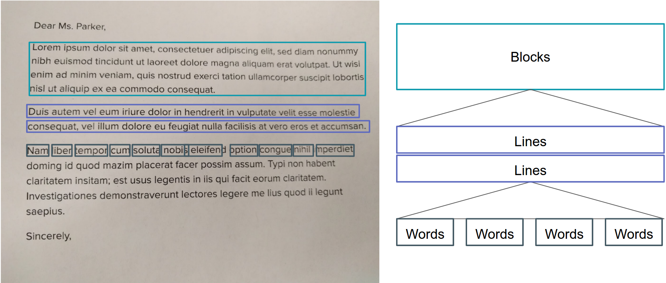

Modules Covered

Hardware and Software Requirements

1. Hardware Requirements:
2. Minimum of 4GB RAM,
3. Processor (2.0GHz or higher)
4. At least 500GB of secondary storage
5. Software Requirements:
6. Any Latest Software, Such as Windows (8 or higher) or Linux or MacOS
7. Android Studio (v 3.0.1)

References

1. <https://developers.google.com/>
2. [www.github.com](http://www.github.com)
3. [www.azure.com](http://www.azure.com)
4. [www.wikipedia.com](http://www.wikipedia.com)
5. [www.mobilevision.com](http://www.mobilevision.com)

**Team Details**

**Project Member:**

**Name and Roll no. Signature of the Candidates**

**Tanmay Srivastava, 1501051072 ___________________**

**Tushar Dua, 1501051124 ___________________**

**Guide Name and Signature:**

**Mr. B K Gupta**

**Assistant Professor, IT Department**

**DIT University**

**Signature: ______________**