**Drone Inspection Assistant of Navigable Aircraft**

**(DIANA)**

ECE4012 Senior Design Project

Team DIANA

Dr. Jennifer Hasler

Honeywell

John Jones, johnnyjones@gatech.edu, Team Leader

Brighton Ancelin, brighton.ancelin@gatech.edu

Yichen Ju, jeffju@gatech.edu

Thomas Kaniff, tkaniff3@gatech.edu

Javi Rodriguez, javi.rod@gatech.edu

Leo Weng, mweng6@gatech.edu, Web Master

Submitted

April 29, 2019

**Table of Contents**

**Executive Summary** iii

1. **Introduction** 1
   1. Objective 1
   2. Motivation 2
   3. Background 3
2. **Project Description and Goals** 4
3. **Technical Specification** 5
4. **Design Approach and Details** 6
   1. Design Approach 6
      1. Motion Planning 6
      2. Wireless Communication 6
      3. User Interface 8
      4. Image Processing and Data Analytics 9
   2. Codes and Standards 9
   3. Constraints, Alternatives, and Tradeoffs 11
      1. Choice of Drone Model 11
      2. Choice of Camera 11
      3. Choice of Wi-Fi Standard 12
      4. Sensing Constraints 12
5. **Schedule, Tasks, and Milestones**  13
6. **Project Demonstration**  14
7. **Marketing and Cost Analysis**  15
   1. Marketing Analysis 15
   2. Cost Analysis 15
      1. Prototype Material 15
      2. Prototype Development 16
      3. Five Year Profitability Plan 18
8. **Conclusion and Discussion** 20
9. **Leadership Roles** 23
10. **References**  24

**Drone Inspection Assistant of Navigable Aircraft**

Drone Inspection Assistant of Navigable Aircraft (DIANA) is a proof of concept system for inspection automation of aircrafts, buildings, and other infrastructures. This phase of the prototype focuses on concrete infrastructure, despite using “Aircraft” in the project name. Using DIANA to perform visual inspections ensures the safety of the inspectors as well as the efficiency of the inspection process. The drone automatically inspects and identifies cracks and defects on the target while autonomously traversing through a pre-determined flight path. The inspection operators can review the findings of the system in real time via a tablet application and verify or flag any outstanding concerns. This reduces the downtime required for an inspection, potentially saving thousands of dollars per inspection, improving the effectiveness, and reducing the risk of a horrific accident costing millions of dollars and human casualties. This system will require a small team of engineers and approximately $997.00 for prototype materials (consisting of a drone platform, cameras, laser sensors, and supporting equipment for operation, calibration, and testing). Team DIANA has improved on previous progress, by demonstrating a minimally viable prototype and fully operating system. This system will include a drone and flight control system to automatically fly the inspection route around the system under test (SUT), an image processing and classification algorithm, and the user interface (UI) on a tablet.

**Drone Inspection Assistant of Navigable Aircraft**

**1. Introduction**

Drone Inspection Assistant for Navigating Aircraft (DIANA) aids in conducting routine maintenance and inspections for concrete structures and infrastructure by reducing the time, cost, and risk from current practices. The drone with accompanying tablet will provide real-time results to the inspection-operator. The team completed a prototype system with approximately $997.00 to fund the hardware and development of the autonomous aircraft inspection system.

* 1. **Objective**

DIANA aids technicians in conducting maintenance and inspections of aircrafts or infrastructure that currently may occur every few years on bridges, roads, or buildings. There are multiple aspects to a physical maintenance inspection, many of which require heavy equipment and cannot be conducted via drone. However, the visual inspection is an area where the drone-based system can excel. A drone equipped with a high-quality camera can quickly and accurately perform the inspection while the inspector can operate the drone safely and remotely. DIANA is programmed with the flight path for the specified target and conducts the inspection using a neural network to categorize the results. This information is then transmitted to the inspection operator’s tablet, where the results are stored to be reviewed and verified. The operator will then determine if the target has passed the visual inspection. The results may also be logged in a database to keep precise records of the inspection results, so they can be referred to as necessary.

* 1. **Motivation**

The motivation behind DIANA is to decrease the duration and cost of the routine maintenance inspections for infrastructure, make inspections faster and easier, and increase the effectiveness of the limited government funding to complete these types of inspections. Safety is the most important aspect of our infrastructure, and these routine inspections are critical to ensuring that building, bridges, airplanes, and roads are meeting safety regulations. Most departments of transportation on federal, state, and municipal level have limited funding for these types of inspections and struggle to meet requirements. Airlines have vast financial incentive to quickly and efficiently turn over their planes being inspected in the hangars. Automating some of these inspection processes provides an opportunity to save tremendous amounts of time and money while increasing accuracy and consistency. Visual inspections are well-qualified to be automated since they can be performed by cameras, which are generally light enough to be carried by a drone for an adequate amount of time. Current inspections are done manually and take significant time, since there is no easy way for inspection operators to visually inspect the aircraft or large infrastructure quickly. Drones do not have this problem, as it is easy for them to precisely maneuver in three-dimensional space. While the drone-based system is faster and more efficient, it also has higher standardization and repeatability. This system is not susceptible to the types of human error and inconsistencies that are possible when a human is conducting an inspection. While the results will always be verified by a trained operator, the autonomous system will likely increase the safety of the aircraft or infrastructure.

* 1. **Background**

Another Georgia Tech senior design group, also working with Honeywell, has attempted this task in the past. To our knowledge, this group spent extensive time working on the flight controls aspect of a drone-based inspection system. While the flight controls are critical to the project, the team developed a broader proof-of-concept prototype showing the whole system including flight controls, vision-based inspection, and results via a tablet app. Donecle, a French start-up company, is pursuing the same task, however, they exclusively work on aircraft inspection applications [1]. They fly their drone along a pre-programmed flight path to do their visual inspections. Donecle’s system has advanced features, such as swarm capabilities, to allow for multiple drones to operate in unison. In addition, their drones have a smart gimbal to provide stable, high-quality images. Honeywell has a team dedicated to developing drone-based solutions for industrial applications [2]. This system, with the ability for both aircraft and concrete infrastructure inspection, fits well within Honeywell’s portfolio of services.

**2. Project Description and Goals**

This system consists of four main aspects: motion planning, wireless communication, data analysis, and end-user application. The official Parrot SDK of the drone is crucial for establishing the flight plan around the aircraft. The drone has the benefit of coming pre-equipped with a gyro-stabilized camera and Wi-Fi Access point. A real-time video feed is sent over the drone’s Wi-Fi to a laptop computer which samples the video and inputs the images into the classifier algorithm. The algorithm utilizes transfer learning with Alex Net and an additional purpose-trained classification layer. These insights are then be presented on the tablet for the inspection operator to draw conclusions from. The system emphasizes the following features:

* Localized positioning system (not-reliant on GPS)
* Reliable, fast, and high-quality communication using modern Wi-Fi standards
* Ability to recognize defects using a neural network
* Require inspection operator to verify results
* Demonstrates a fully integrated prototype

1. **Technical Specifications**

Below are some of the minimum specifications delivered by DIANA.

* 1. **DIANA Specifications**

**Table 1.** DIANA Specifications

|  |  |
| --- | --- |
| **Feature** | **Specification** |
| Number of inspections per drone charge | 1 |
| Time to Charge | 1 hour |
| Reduction in inspection time from current practice | At least 15% |

* 1. **Core Consumer Off-The-Shelf Parts Specifications**

DIANA will rely on several COTS parts in the implementation which are specified below.

**Table 2.** Parrot Bebop 2 Drone Specifications

|  |  |
| --- | --- |
| **Feature** | **Specification** |
| Camera | 14 megapixels with fish-eye lens |
| Battery | 2700 mAh |
| Flight time | Up to 25 minutes |
| GPS | Yes |
| Storage | 8 GB |
| Signal range | Up to 300 m |
| Max horizontal speed | 16 m/s |
| Max upward speed | 6 m/s |
| Video resolution | 1920 x 1080p |
| Weight | 500 g |

**Table 3.** ASUS ZenPad 10 (Z301MF) Tablet Specifications

|  |  |
| --- | --- |
| **Feature** | **Specification** |
| Capacity | 6 GB |
| Display | LED backlit display |
| Battery | Built-in 29.37-watt-hour rechargeable lithium-polymer battery |
| Weight | 468 g |

1. **Design Approach and Details**
   1. **Design Approach**

The Drone Inspection system used a drone and a tablet for all inspection purposes. The drone autonomously gathers visual data which is sent to a human inspector via tablet. The logical components associated with this design are the motion-planning system needed to autonomously fly the drone, the wireless communication system needed to transmit information between the drone and the tablet, the tablet UI needed to interface with the human inspector, and the image processing system needed to enhance the experience for the human inspector.

* + 1. **Motion Planning**

The goal of motion planning aims to direct the drone through a pre-planned path around the system under test. This was achieved using an open-loop time-based method on the laptop which automatically and periodically pushed piloting commands to the drone over the network. Ideally the drone would use multiple forms of feedback and dead reckoning correction in a more complete and robust motion planning scheme. The difficulties preventing this feature from being more developed by the project deadline are further discussed in the Lessons and Future Improvements section.

* + 1. **Wireless Communication**

Wireless communication for the system consisted of two goals: (1) to have the human operator command the drone from the tablet and (2) to have the drone to relay image, video, and other data to the tablet. The operator commands the drone at a high level of abstraction, issuing commands such as “begin inspection,” “pause/resume inspection,” and “stop inspection.” During the inspection, the drone will be relaying images of the system under test back to the tablet for verification by the inspector. Wireless communication is performed using the IEEE 802.11ac Wi-Fi standard between the drone and the tablet.

Ideally, the human operator only needs to issue the “begin inspection” command wirelessly. The rest of the process should occur autonomously. However, it is useful to have commands such as “pause/resume inspection” and “stop inspection” for emergencies and/or other unexpected situations. The descriptions of these basic commands are listed below.

1. “begin inspection” - This command signals the drone to begin the aircraft inspection. The drone assumes that it is already placed in the starting location.
2. “pause/resume inspection” - This command signals the drone to pause or resume the inspection process. In the case of pause, the drone saves its state, stops moving and stops recording video, and hovers. In the case of resume, the drone resumes the process from its previously saved state.
3. “stop inspection” - This command signals the drone to stop its inspection process and immediately head towards the home location.
   * 1. **Tablet User Interface (UI)**

The goal of the tablet UI is to provide the best experience for the human inspector. This UI is installable as an app, however, not available on the App Store for public download. The Android SDK is used to program the app. The current layout of the app is very simple; it presents the inspector with a list of commands that can be performed. This will then send the desired commands to the drone to perform the selected action. If a video recording action is selected, the frames of the test are saved to the file system of the tablet, where the inspector can manually view the inspection results and verify the accuracy of the automated inspection. The inspector can look for false positives or missed cracks, providing a human verification of the test results.

* + 1. **Image Processing and Data Analytics**

The goal of image processing and data analytics is to enhance the experience of the human inspector by drawing their attention to details which may be more important than others. DIANA implements a version of Alex Net cross trained with a large dataset of cracked and solid concrete. Before an adequate dataset was discovered [3,4], the team planned to use a convolution-based feature detection. This dataset allows for a more robust and accurate classification algorithm using computer learning techniques. Using a neural network does require more memory and has a longer runtime per image than a minimal computer vison technique but it provides more accurate results and can be implemented quickly without any expertise in computer vison.

The ideal user experience, as enhanced by image processing, has the human inspector always notice real defects immediately. As they review each image/video, any highlighted segment would definitively be a defect. In general, the highlighting algorithm prioritizes having a low false negative rate over having a low false positive rate, where positive results indicate a highlighting event. It is better to highlight something which is not a defect than to not highlight a true defect.

* 1. **Codes and Standards**

1. IEEE 802.11ac - A Wi-Fi standard used for communication between the drone and the tablet [5]. Main features:
   * 80 MHz channel bandwidths
   * Single-link throughput of at least 500 Mbps (megabits per second)
   * Multi-station WLAN throughput of at least 1 Gbps (gigabits per second)
2. AVC (MPEG-4) / H.264 - A video standard used for compression of video data recorded on the drone [6]. Main features:
   * Support for lossy or lossless compression
   * Spatial prediction through intra-frame coding
   * Support of all major chroma subsampling schemes (4:0:0, 4:2:0, 4:2:2, 4:4:4)
3. GPS - A positioning system used for monitoring the relative location of the drone [7]. Main features:
   * Available nearly anywhere in the world with a clear line of sight to the sky
   * Accuracy to within 5 meters
   1. **Constraints, Alternatives, and Tradeoffs**
      1. **Choice of Drone Model**

For this system, the Parrot Bebop 2 was selected as the drone of choice. Multiple drones were considered in the research and planning phases of the project. Other drones from Parrot, DJI, and Intel were considered, however, the Bebop 2 was decided upon due to its applicable feature set, wide community support, and budget compatibility. The project team valued having two drones available throughout the project. This enabled work to be done simultaneously in parallel by different members, but also provided a backup drone if one of the drones became damaged or broken. This limited our search to drones that would fit into our budget. A drone with reasonable flight time and a high-quality camera were very desirable. A programmable SDK with the ability to control the drone’s flight and the ability to independently control camera angle were essential to the project. When researching the Parrot Bebop 2, it was discovered that it was a highly popular model for hobbyists and has a vibrant community online, which proved valuable during the development of the system. When looking at all our constraints and needs, the Parrot Bebop 2 became the clear choice for drone selection.

* + 1. **Choice of Camera**

Cameras tend to be the heaviest payload on the drone and range wildly in price and capability. The more capable cameras tend to be heavier, and as such tend to require more powerful drones. The Parrot Bebop 2 comes with a camera already attached, which was a contributing factor to selecting it for this project. The camera’s 1080p quality was adequate for the development of our system.

* + 1. **Choice of Wi-Fi Standard**

The IEEE 802.11ac Wi-Fi standard was chosen for this project because it was the most evolved and highest performing Wi-Fi standard supported by both the Bebop 2 drone and modern tablets.

* + 1. **Sensing Constraints**

Every form of sensor/feedback on the drone has some degree of noise, which implicitly places constraints on its ability to perform. GPS is known to have roughly 5 meters of inaccuracy, meaning that it should not be relied on for motion on the order of 5 meters. Visual feedback is sensitive to lighting conditions and changes in perspective, meaning that algorithms need to take this into account. Laser or proximity sensors may be added to provide higher resolution local navigation. Unfortunately, as discussed in Lessons and Future Improvement, Parrot has limited streaming raw sensor values which limited the usefulness in small scale feedback control applications.

1. **Schedule, Tasks, and Milestones**

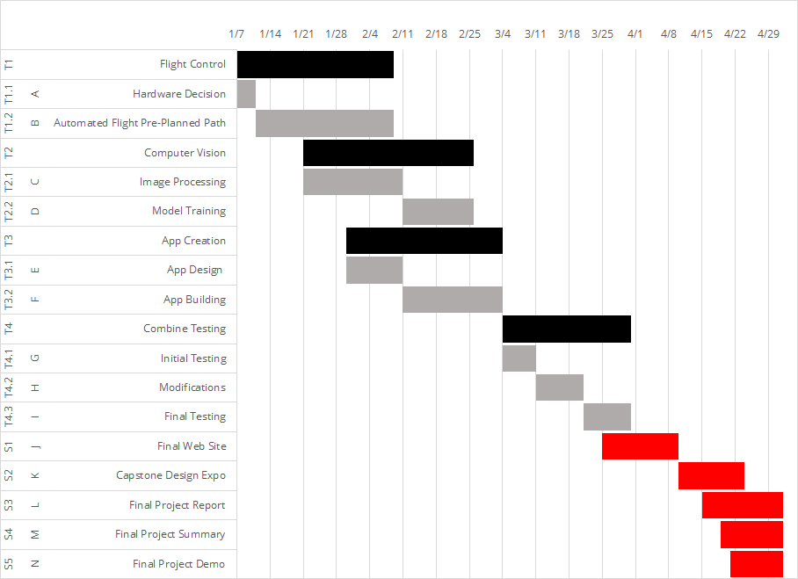

**Figure 1.** AGannt chart for developing DIANA.

The main project was divided into three subsections: Flight Control, Computer Vision, and App Creation. Person 1, Person 2, and Person 3 took charge of Flight Control, Person 4 and Person 5 oversaw Computer Vision, and Person 6 worked on App Creation. After the subsections were completed, testing commenced. Towards the end of the testing stage, Person 6 started designing the website. Once testing and the website were complete, the group presented the project at the capstone design expo. Before the semester ends, the final report, final summary and project demo will all be completed. This schedule is subject to change.

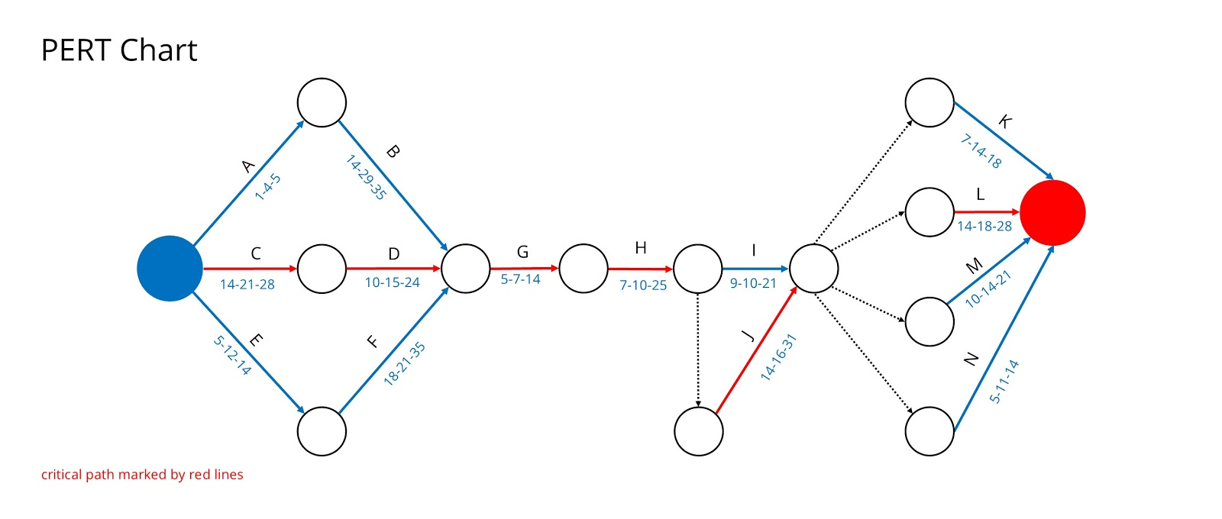

**Figure 3.** Critical path for Team DIANA shown on PERT chart.

The following PERT chart represents the estimated time for each task in the project as well as the critical path. The whole process is expected to be finished within 94 days (including the final reports) with a standard deviation of 6 days. There is an 88.7% chance that the project will be completed one week before the design expo (estimated 100 days). This schedule is subject to change.

1. **Project Demonstration**

The demonstration showcased critical parts of the project, which included the flight path planning, computer vision, and control app. At expo, drone flight was shown in a recorded video and in a live demonstration. The image processing algorithm was also demonstrated in a live small-scale example. The app and website are both fully functional. The app was shown to control the drone in simple directional controls or to run a simulated inspection routine. The website is live and updated to properly represent the product.

1. **Marketing and Cost Analysis**
   1. **Marketing Analysis**

The primary competitive advantages of this design will be price and user-friendliness. Some of the most advanced drones available today can be prohibitively expensive, so selecting the economical Parrot Bebop 2 would keep costs relatively low. This would result in an attractive price point for potential customers. The other major draw to the product would be the user-friendly application offered in conjunction with the fully automated drone. While there are highly advanced drones available on the market today, there are currently no consumer applications capable of guiding a drone through a predefined flightpath with precise captures for further inspection. Adding sensors may require drones with higher payload capacities which may force the design to require a more expensive and capable drone.

* 1. **Cost Analysis**
     1. **Prototype Materials**

Our design prototype consists of several hardware components: a drone with a high-definition camera and a tablet for the user interface and application. In this circumstance, the retail cost of the UI software is not applicable, nor are there any costs related to developing the neural network classification software. Therefore, the total equipment cost will only account for the retail prices of both the drone and the tablet - which yield a total of approximately $997.00 - as detailed below in Table 4. The team bought two drone units to enable parallel development and testing of key design components, as well as reducing the risk of complete design halt in the event one of the drones was damaged.

**Table 5.** Prototype Bill of Materials

|  |  |  |  |
| --- | --- | --- | --- |
| **Description** | **Qty.** | **Price** | **Total** |
| Parrot Bebop 2 Drone | 2 | $399.00 | $798.00 |
| *(accessories and camera included)* |
| ASUS ZenPad 10  Z301MF | 1 | $199.00 | $199.00 |
| *(all accessories included)* |
| **Total materials** | **$997** | | |

* + 1. **Prototype Development**

The development costs of the project are calculated using an engineer’s average hourly wage of $35/hr [7]. As mentioned in Section 5 of this proposal, the team divided the technical aspects of this project to best match each engineer to their area of strength, while still ensuring equal distribution of work.

**Table 6**. Labor Costs by Engineer

|  |  |  |  |  |  |  |
| --- | --- | --- | --- | --- | --- | --- |
|  | **Engineer 1** | **Engineer 2** | **Engineer 3** | **Engineer 4** | **Engineer 5** | **Engineer 6** |
| **Administrative** |  |  |  |  |  |  |
| Weekly Meetings | 32 hr. | 32 hr. | 32 hr. | 32 hr. | 32 hr. | 32 hr. |
| Deliverables | 20 hr. | 20 hr. | 20 hr. | 20 hr. | 20 hr. | 20 hr. |
| Presentation | 1 hr. | 1 hr. | 1 hr. | 1 hr. | 1 hr. | 1 hr. |
| **Technical** |  |  |  |  |  |  |
| Flight Control | 80 hr. | 80 hr. | 80 hr. |  |  |  |
| Computer Vision |  |  |  | 80 hr. | 80 hr. |  |
| App Creation |  |  |  |  |  | 80 hr. |
| Integration | 5 hr. | 5 hr. | 5 hr. | 5 hr. | 5 hr. | 5 hr. |
| Testing | 10 hr. | 10 hr. | 10 hr. | 10 hr. | 10 hr. | 10 hr. |
| **Total Hours** | **148 hr.** | **148 hr.** | **148 hr.** | **148 hr.** | **148 hr.** | **148 hr.** |
| Hourly Rate | $35/hr. | $35/hr | $35/hr | $35/hr | $35/hr | $35/hr |
| **Amount Billable** | **$5,180** | **$5,180** | **$5,180** | **$5,180** | **$5,180** | **$5,180** |

As shown in the table above, each engineer was projected to work approximately 148 hours throughout the course of the project. This generates a total labor cost for the prototype development of $31,080 for all 6 engineers assigned to the project. Assuming fringe benefits make up 30% of labor costs and overhead is approximately 120% of the subtotal (materials, labor, fringe), the total development cost for the prototype is projected to be $91,371, as shown in Table 7 below.

**Table 7.** Prototype Development Costs

|  |  |
| --- | --- |
| **Description** | **Amount** |
| Materials | $997.00 |
| Labor | $31,080.00 |
| Fringe Benefits (30% of labor costs) | $9,324.00 |
| **Subtotal** | **$41,133.00** |
| Overhead (120% subtotal) | $49,359.00 |
| **Total Development Cost** | **$90,492.00** |

* + 1. **Five Year Profitability Plan**

Next, the sales and profit potential for the design under commercial release will be assessed. There are nearly 7,500 commercial aircrafts based in the United States and are operated by over 26 different airlines [8]. Assuming the United States aviation segment would be the primary source of customers, the team has determined that there is potential to sell approximately 3,000 units within the first 5 years of production. This seems to be a fair estimate of demand since it is a relatively young market with no major competitors or long-standing customer relationships. Next, it is assumed that all required hardware (drone and tablet) can be purchased at a 30% discount from their suggested retail prices; this bulk-purchasing strategy is common practice in the industry as a measure to reduce variable costs. It is also assumed that production wages for assembly, testing, and packaging are approximately $20/hr. Lastly, the design is projected to incur an industry-standard selling expense of 6% of the final selling price. The resulting profitability analysis, per unit, is shown below in Table 8. With a target selling price of $1,599.00 per unit, the team projects a 12.50% profit margin percentage.

**Table 8.** Profitability Analysis Per Unit.

|  |  |
| --- | --- |
| **Description** | **Amount** |
| **Production Costs** |  |
| Materials (Negotiated Rate) | $511.00 |
| Packaging | $3.00 |
| Labor (assembly, testing, packaging) | $20.00 |
| Fringe Benefits (30% of labor) | $6.00 |
| Subtotal, no overhead | $540.00 |
| Overhead (120% of subtotal) | $648.00 |
| Subtotal, Production Costs | $1,288.00 |
| **Additional Costs** |  |
| Sales expense (5% of selling price) | $80.00 |
| Amortized development costs | $30.00 |
| **Total, All Costs (per unit)** | **$1,398.00** |
| Selling Price (per unit) | $1,599.00 |
| **Projected Profit (per unit)** | **$201.00** |
| **Projected Profit Margin** | **12.50%** |

1. **Conclusion and Discussion**
   1. **Embedded Implementation**

Most of the efforts of Team DIANA were allocated to training a neural network, automating flight path, and creating a fully integrated demonstratable system. The team attempted to build the classification algorithm on a desktop then migrate to a single board computer running Linux like a Raspberry Pi or ODroid. This is not a simple transition and an alternate less accurate low power algorithm had to be created from nothing. An embedded design must begin from the inception and early development. There are custom ASIC options available, such as Edge TPU from Google, which may be worth investigating.

* 1. **Flight Planning**

Not all sensor values are available to the user though the SDK. Onboard the Bebop 2, a sensor fusion result is calculated and only the interpolated values are available at a sample rate around 10 Hz. Although the Bebop 2 was a good value for a prototype system, an alternative product or custom drone may be more adequate for proper feedback control.

Some difficulties were discovered when navigating the documentation for the SDK. Although Parrot provides more support than most drone manufactures, it is not complete. Some time was lost attempting to implement some of the movement commands and sensor feedback without success. The current flight automatic flight control is simply time-based implementation of the sample code from the stock SDK build, which is not ideal but allowed us to complete a full demonstratable proof-of-concept.

In the future, the motion-planning algorithm might be broken into an initial calibration step, a series of waypoint-to-waypoint steps, and a return-to-base step. The ideal waypoint-to-waypoint distance and change in posture will be determined through research and experimentation. Ideally, multiple forms of feedback will be incorporated with known trajectory data (e.g. known motor speeds) to ensure that a nearly ideal path will be traversed. The viability of such a strategy may be heavily dependent on environmental conditions (e.g. air currents), and as such will need to be examined during initial research and development.

A full path traversal might occur in the following, procedural manner:

1. The drone will be physically placed on the ground at some designated starting location (within some degree of error). From here, the initial calibration step will begin flight and use feedback to arrive at the first waypoint.
2. The drone will use feedback along with known trajectory information to move to the subsequent waypoint. The drone will not continue until it is reasonably certain that it has arrived at the waypoint. This step repeats until the drone arrives at the final waypoint.
3. The drone moves and descends using feedback to arrive (within some degree of error) at a designated home location. This home location may or may not be the same as the starting location.

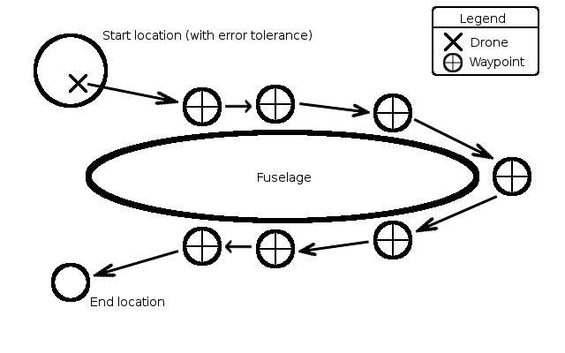

1. **Leadership Roles**

The leadership roles of our team are as follows:

* + John Jones – Team Leader
  + Leo Weng – Web Master
  + Javi Rodriguez – Documentation Coordinator
  + Corbett Kaniff – Expo Coordinator
  + Brighton Ancelin – Tech Lead
  + Yichen Ju – Budget Manager

1. **References**

[1] Donecle[online]. Available at: https://www.donecle.com/ [Accessed 27 Nov. 2018].

[2] Honeywell Aerospace. [Online]. Available: https://aerospace.honeywell.com/uav. [Accessed: 27-Nov-2018].

[3] T. Malekzadeh, M. Abdollahzadeh, H. Nejati, N. Cheung. [Online]. Aircraft Fuselage Defect Detection Using Deep Neural Networks. Available: https://arxiv.org/ftp/arxiv/papers/1712/1712.09213.pdf. [Accessed: 27-Nov-2018].

[4] Lei Zhang , Fan Yang , Yimin Daniel Zhang, and Y. J. Z., Zhang, L., Yang, F., Zhang, Y. D., Zhu, Y. J, & Ç. Özgenel. [Online]. Concrete Crack Images for Classification. 10.17632/5y9wdsg2zt.1

[4] O. Bejarano, E. W. Knightly, M. Park. IEEE 802.11ac: from channelization to multi-user MIMO. Available: <https://ieeexplore.ieee.org/document/6619570/authors#authors>. [Accessed: 27-Nov-2018].

[5] T. Wiegand, G.J. Sullivan , G. Bjontegaard , A. Luthra. Overview of the H.264/AVC video coding standard Avalible: <https://ieeexplore.ieee.org/document/1218189>. [Accessed: 28-Nov-2018].

[6] GPS Accuracy. [Online]. Available: <https://www.gps.gov/systems/gps/performance/accuracy/>. [Accessed: 27-Nov-2018].

[7] Hourly wage for Design Engineer I in the US. [Online]. Available: <https://www1.salary.com/Design-Engineer-I-hourly-wages.html> [Accessed:28-Nov-2018].

[8] US Commercial Aircraft Fleet 2017. [Online]. Available: http://www.fi-aeroweb.com/US-Commercial-Aircraft-Fleet.html. [Accessed:28-Nov-2018]

[9] Parrot Bebop 2. [Online]. Available: <https://www.parrot.com/us/drones/parrot-bebop-2>. [Accessed:28-Nov-2018].

[10] Apple. “iPad”. [Online]. Available:  <https://www.apple.com/shop/buy-ipad/ipad-9-7>. [Accessed:27-Nov-2018].