1. Using stb_image.h  
   <https://github.com/nothings/stb/blob/master/stb_image.h>  
   read attached camera.png  
   stb_image.h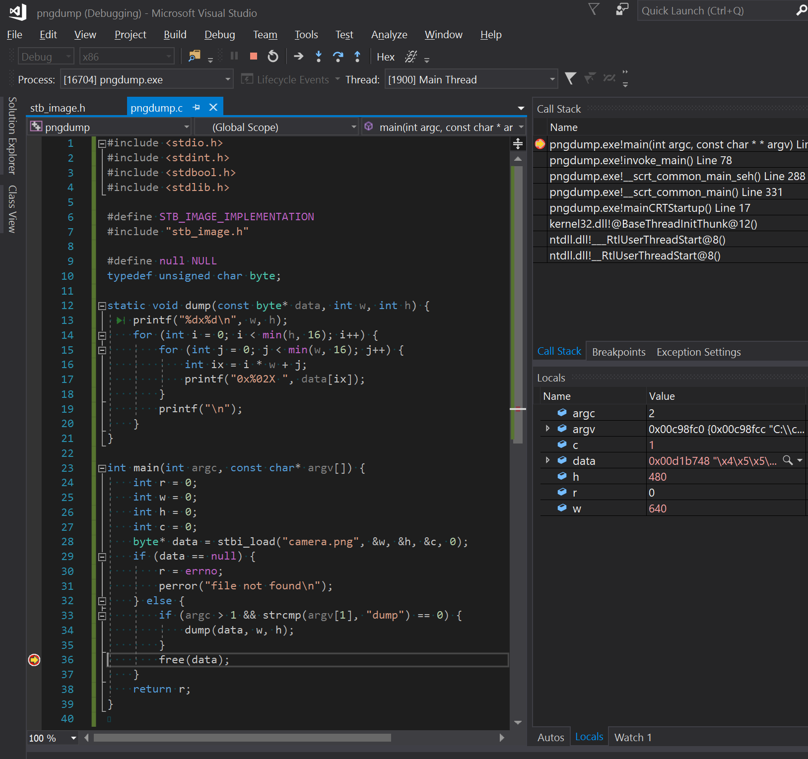
2. Implement command line tool pngdump supporting following command:  
   **pngdump --roi 10,10:20x20 dump**dumps region of interest (--roi x,y:WxH) in hexadecimal form to stdout. **pngdump --roi 10,10:20x20 histogram**dumps histogram of region of interest in csv form to stdout.  
   0, number of bytes in roi that has value 0  
   1, <...>  
   …  
   255, <>  
   The histogram file can be drag-and-dropped to google sheets to create a graph.
3. Bonus:  
   **pngdump --threshold 128 blobs**find all the blobs[1] in the complete image or region of interest and dump x,y mass centers of a blob to stdout.

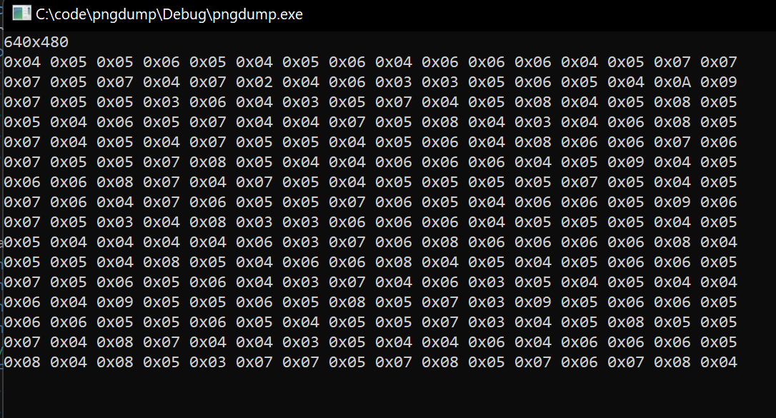

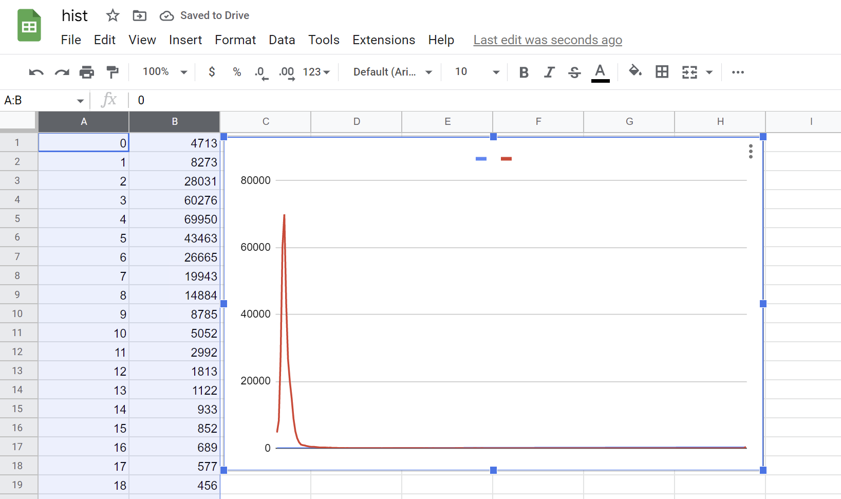

1. “blob” is a connected (vertically/horizontally or diagonally) set of pixels each of which has a value higher or equal to threshold. “Centroid” is center of mass of a blob. See:  
   <https://en.wikipedia.org/wiki/Image_moment>  
   for details.