step1: Get the Image

step2: Convet the image to grayscale

Reduce Noise--Smoothened

Gradient measure of change in brightness over adjacent pixels

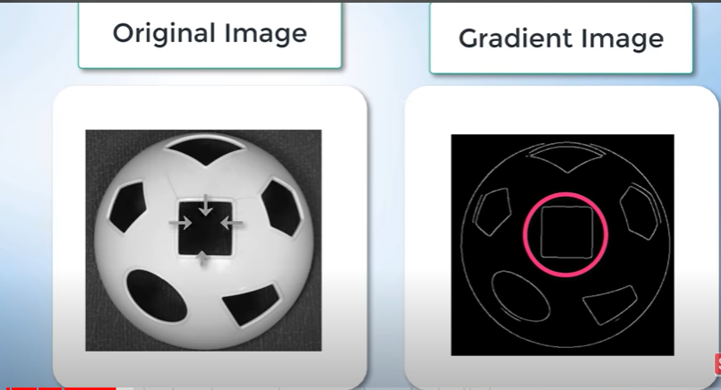

Strong Gradient Small Gradient

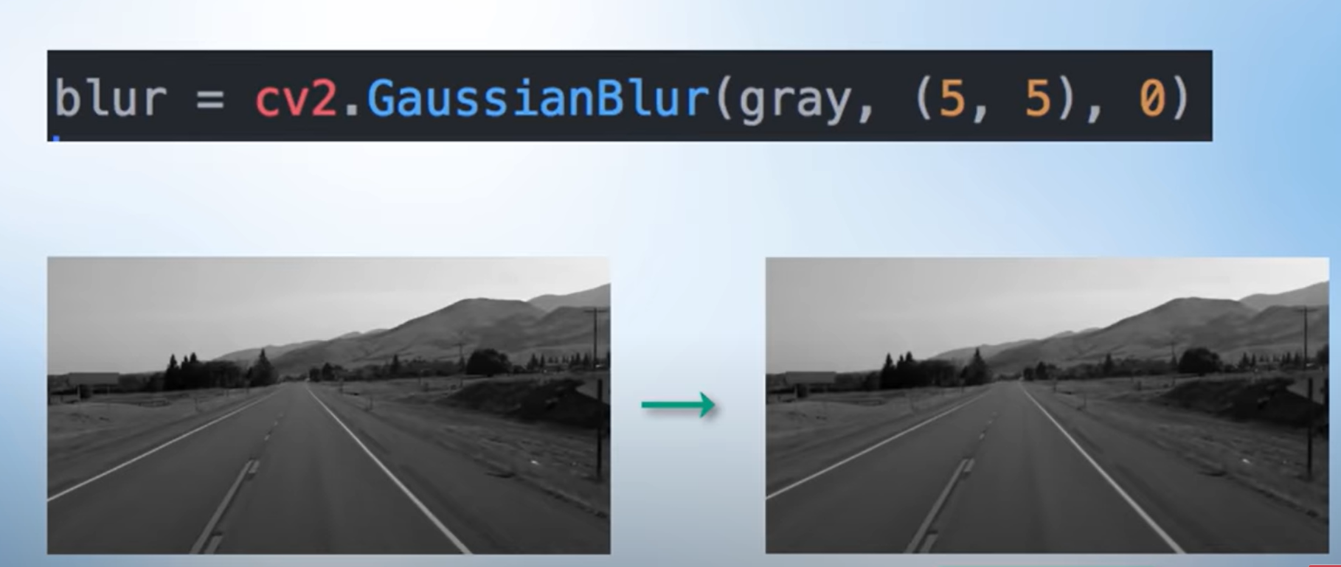

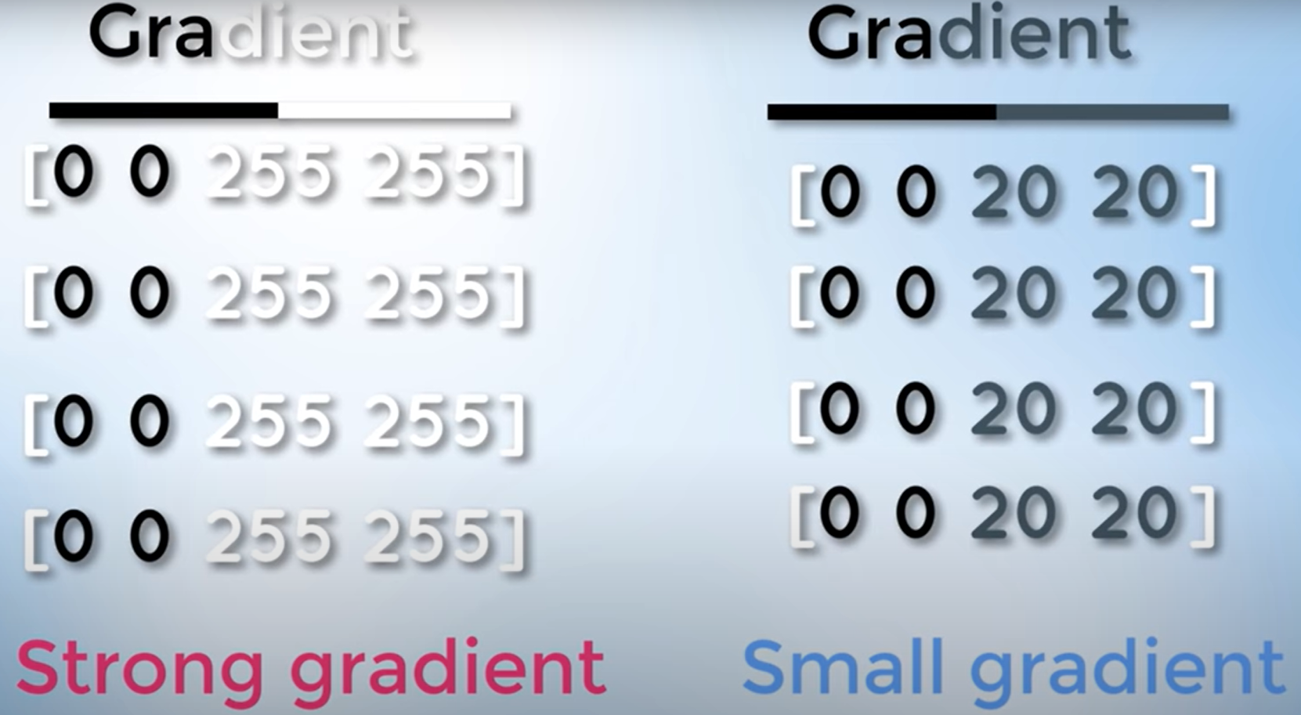

step3: Canny Method--Gradient

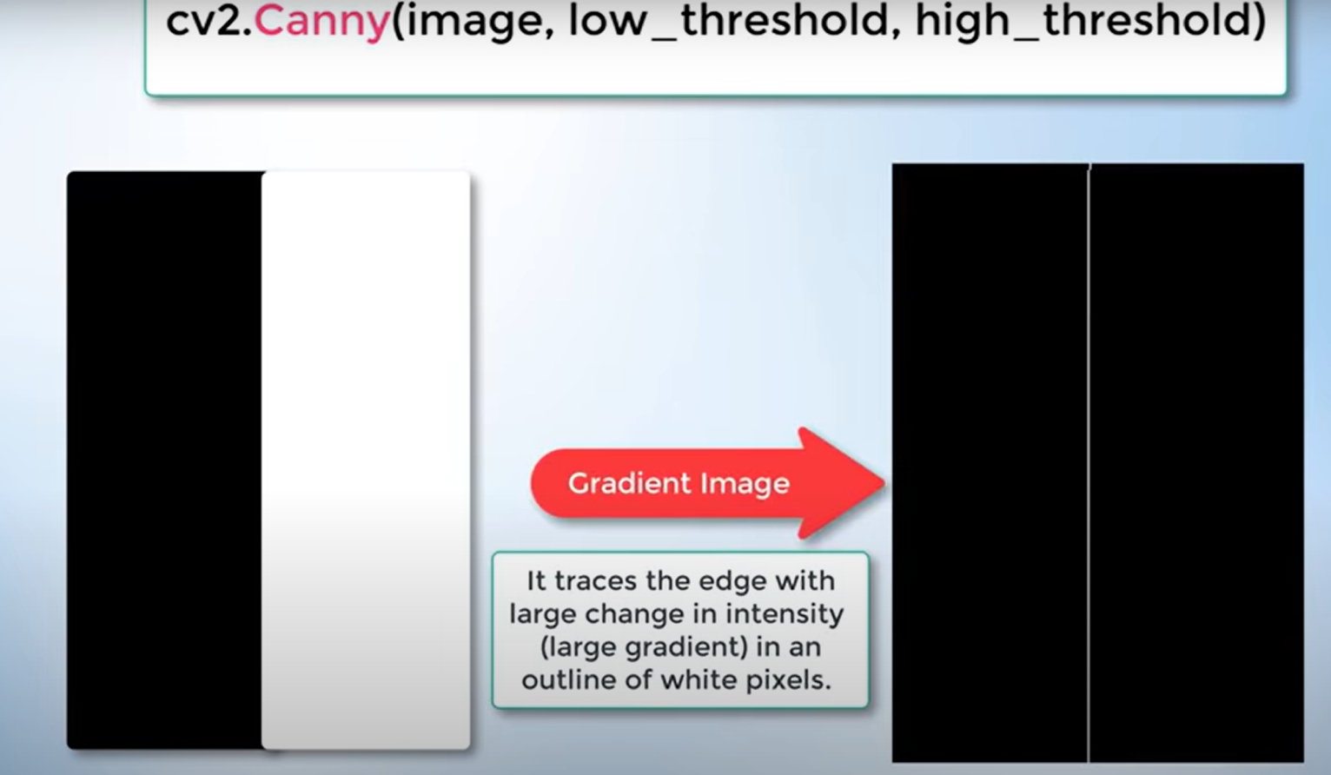

step4: Finding the Region of Interest

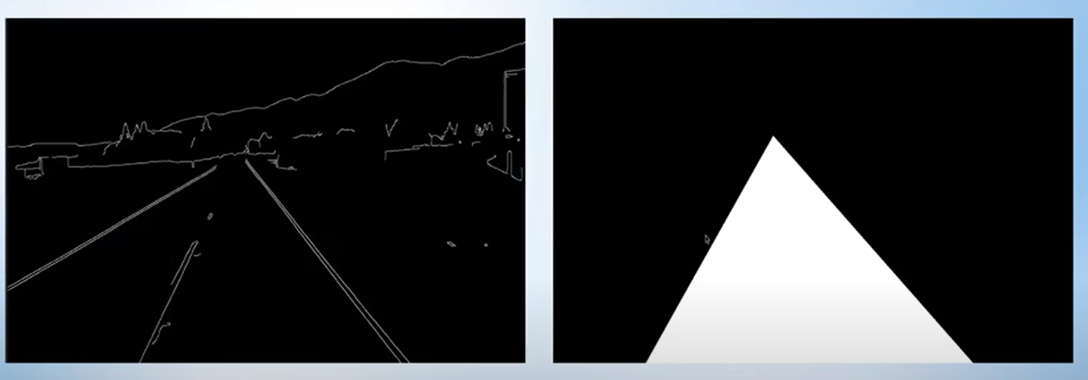

step5: Matplotlib Library to specify the region of interest-triangular Region

step6: Binary Numbers-1111-represnts the white triangular region and 0000 represnts the other region.

Bitwise and Operation between the two images

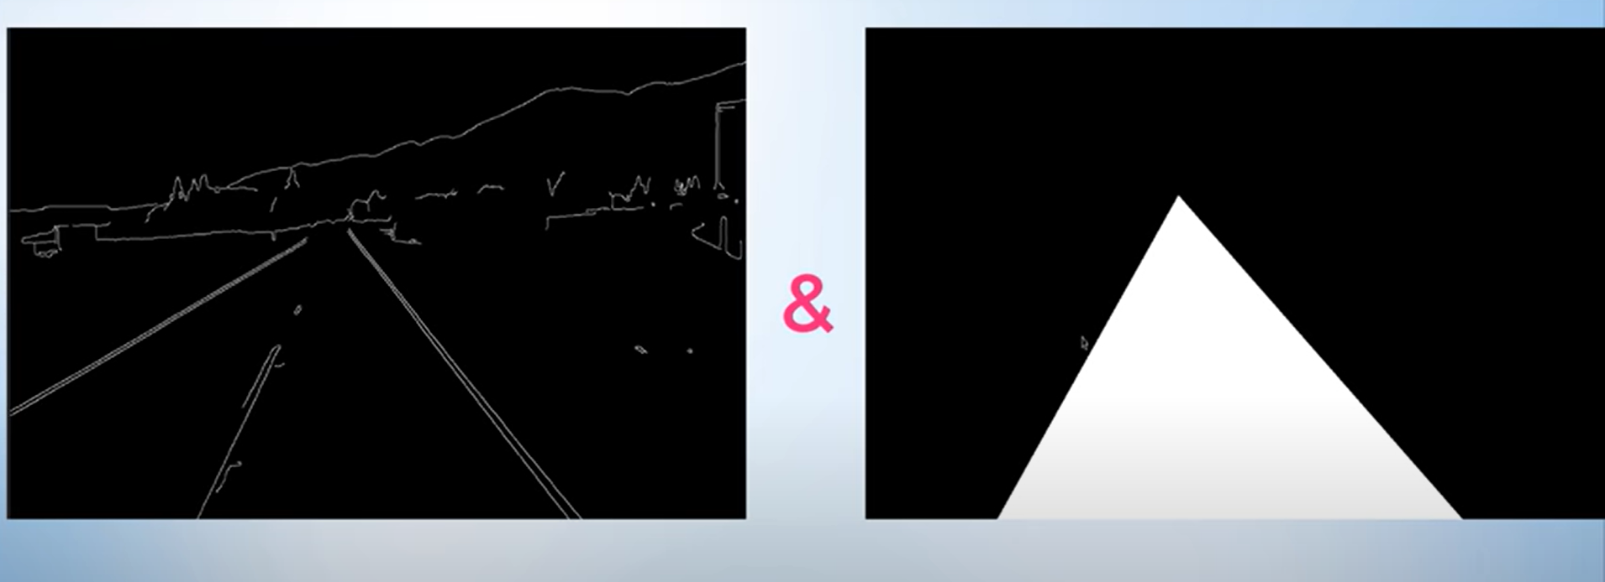

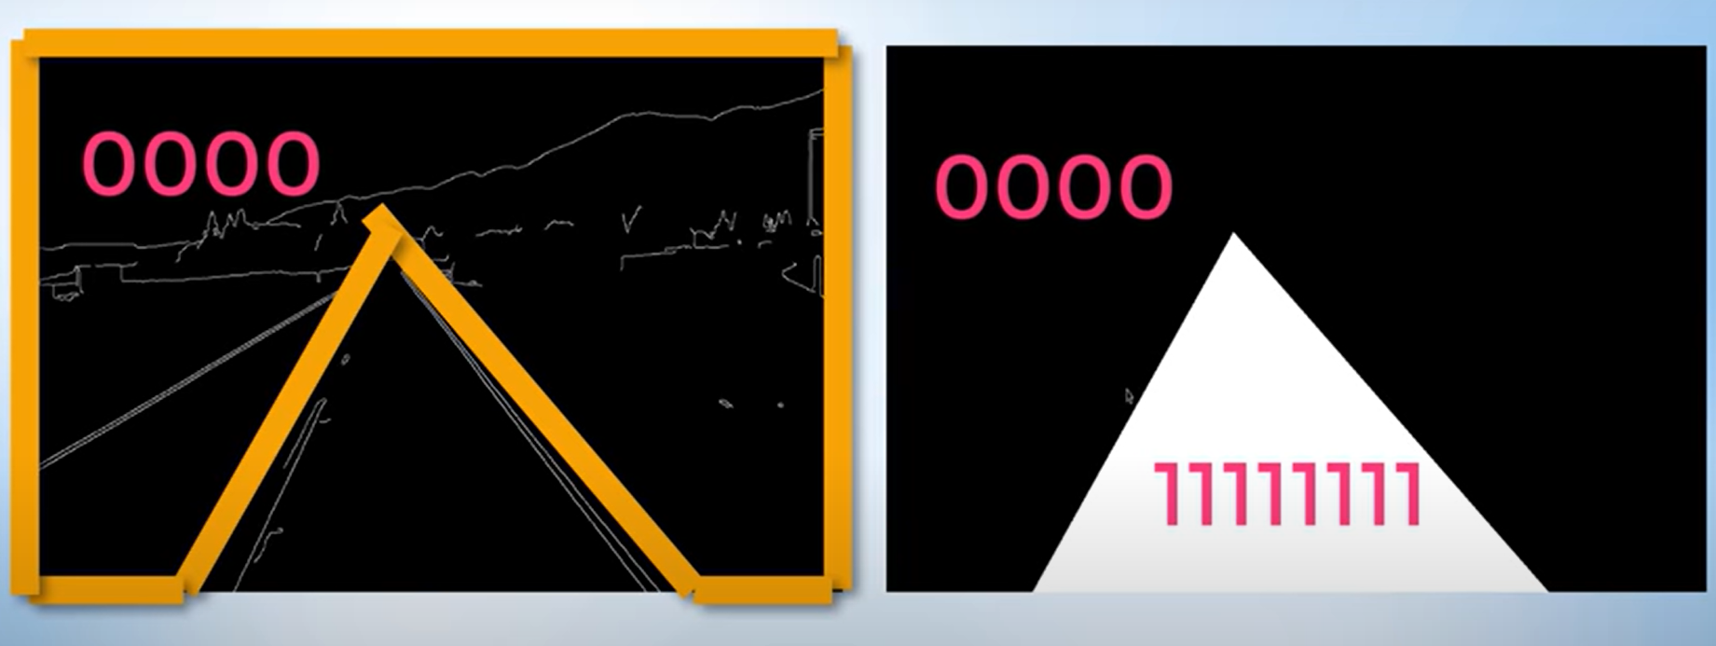

step7: Hough Tranform

Threshold

step8: Finding lanes video