RESEARCH ARTICLE
When Does Hierarchical Video Memory Pay?
Reach–Fidelity Trade-offs under Fixed Context Budgets
Leonid Kulyk
English review edition · 18 July 2026

When Does Hierarchical Video Memory Pay?

Reach–Fidelity Trade-offs under Fixed Context Budgets
Keywords: long-horizon video prediction; context compression; hierarchical latent models; memory; observability; re-entry; diffusion transformer; reproducible evaluation.

Abstract
A bounded-context video predictor must choose not only how much history to retain, but how to represent it. We frame temporal sampling rate, spatial resolution and package depth as a controlled context-packaging design space. A procedural panning-world instrument provides exact geometric observability when content leaves and re-enters the viewport, while a shared diffusion-transformer backbone consumes flat or multistream packages at explicit token budgets.
On a hash-pinned untouched holdout, the hierarchy wins when it alone reaches the relevant past: the registered 14-to-48-frame reach-band effects are +0.0980 and +0.0914 across two training seeds. A simultaneous frontier confirms hierarchy at 896 and 1,152 context tokens, leaves 1,792 unresolved, and confirms flat full-resolution context at 2,432 and 3,072. In the frozen latent interface, 48 fine frames cost 3,072 tokens, whereas 48 coarse frames plus a two- or six-frame fine tail cost 896 or 1,152 tokens. Hierarchical packaging therefore provides the same nominal 48-frame reach with 2.7–3.4 times fewer context tokens, while the upper-budget reversal shows the price of discarded detail.
The main directions persist across a fourfold sampling-work range, three sampler seeds and an independently trained codec, although the 2,432-token inversion is less precise under alternate sampler or codec conditions. A five-seed factorial finds a stable temporal-package advantage under diffusion but sign-changing regression and cross-head effects. A preregistered long-rollout study replicates the early hierarchy benefit but not a seed-0 late inversion, rejecting a stable trust boundary. Finally, a protected persistent-object Moving-MNIST study yields a mixed external boundary: hierarchy better preserves support and trajectory continuity, whereas flat context better preserves digit identity; foreground-only error is unresolved.
The resulting prescription is conditional rather than architectural: buy enough reach to include the memory-relevant past, then preserve the fidelity required by the task. Hierarchy is most useful when a flat full-resolution window cannot afford that reach; flat context becomes preferable when fine detail, rather than temporal access, is limiting.

1. Introduction

1.1 The empirical problem
Hierarchical video models are often motivated by a plausible story: coarse state changes slowly, fine state renders detail, and a hierarchy should therefore retain longer history efficiently. That story is not yet an answer. A model can appear better because it sees more frames, receives a different prediction target, uses more inference work, or is evaluated on a metric that ignores its hallucinations. Conversely, a hierarchy can appear useless on a benchmark where every relevant object remains visible to a short context.
This article begins with two primary explanatory questions and one robustness question rather than a claim that hierarchy must win:
- Reach: when does the supplied context contain the past that determines a re-entering event?
- Fidelity: when reach is available, how much task-relevant information survives the package?
- Self-fed reliability: does an apparent late failure of stored information replicate across
training seeds?
The experimental object is context packaging. “Hierarchy” denotes one family of packages—multiple rates, resolutions or depths—rather than the conclusion. This distinction lets a flat window, a spatially coarse stream, and a temporally subsampled full-resolution stream be compared as design choices under explicitly reported budgets.

1.2 Why aggregate evaluation is insufficient
Aggregate MSE on sparse synthetic video is dominated by background. MSE inside only the ground-truth foreground mask has the opposite blind spot: content hallucinated elsewhere is not penalized. Empty foreground frames also change its meaning if they silently fall back to full-frame MSE. Identity metrics based on left-to-right component order fail when objects cross, and analyses that retain only frames scorable by both arms select easy survivors.
We therefore separate populations and estimands. The core report includes full-frame, non-empty-GT-foreground, background and union-mask errors; foreground precision and recall; component misses, extras and overlap; and scoring coverage. Persistent-object studies use generator-provided identities and one-to-one assignment. No single score is asked to represent fidelity, hallucination, localization and coverage simultaneously.

1.3 Research questions and predictions
RQ1 — Reach. For a fixed context-token budget, is the package advantage concentrated on frames whose relevant evidence lies inside the longer package's reach but outside the shorter package's reach? The effect should be larger in a pair-derived reach-differential band than in generic horizon bins. A result outside this band would weaken the mechanism even if an aggregate comparison remained positive.
RQ2 — Fidelity. Once both packages reach the relevant past, does higher spatial detail recover the advantage? We expect tested inversions as a flat full-resolution window approaches the same temporal span, without assuming monotonicity or a unique crossing between sampled budgets.
RQ3 — Package shape. Are temporal subsampling and spatial coarsening interchangeable ways to buy reach? Not necessarily: static off-screen content may favour sparse full-resolution storage; dynamically evolving or lower-detail content may favour another package. The present testbed locates one operating point rather than proving data-independent ordering.
RQ4 — Self-fed reliability. Does the seed-0 early-benefit/late-inversion pattern replicate under the same long-loop protocol? The preregistered prediction is an early positive and late negative hierarchy effect in at least one new seed; a failed replication demotes the boundary rather than triggering post-hoc localization experiments.

1.4 Contributions
The fourth article contributes:
- a low-cost re-entry instrument with exact geometric observability, complete error metrics and
pair-derived reach bands;
- an untouched, simultaneous fixed-budget frontier showing where hierarchical reach pays and
where flat full-resolution fidelity recovers;
- package-shape, prediction-head, sampler-allocation and codec interventions that separate stable
diffusion directions from training-seed and upper-frontier precision boundaries;
- explicit-access and persistent-object boundary studies that distinguish geometric reach,
support/continuity, identity fidelity and reliable reuse;
- outcome-independent reporting of a failed trust-boundary replication, a confounded B1
configuration result and all protected negative or mixed outcomes.
Energy-based modelling and stochastic reversibility remain dissertation strands and supplementary context; they are not required to make this article's central claim.

1.5 Relation to prior work
Clockwork VAEs introduced hierarchies whose upper latent sequences update at slower rates and demonstrated long video prediction over sequences up to 1,000 frames [Saxena et al., 2021]. Dynamic latent hierarchies, TECO, MilliVid and flexible diffusion conditioning likewise pursue long-horizon generation through hierarchical state, latent temporal consistency, coarse-to-fine rollout or variable history [Zakharov et al., 2023; Yan et al., 2023; Chandratreya et al., 2026; Harvey et al., 2022]. These works motivate temporal abstraction, but they do not provide the matched package-by-budget intervention or exact pair-derived observability bands used here.
Recent work makes it especially important not to claim that memory-focused evaluation or retrieval is absent. WorldPack combines compressed trajectory packing with retrieval and evaluates spatial consistency on LoopNav [Oshima et al., 2025]. CaR/SceneFly, MemLearner and GIM-World study compression or learned retrieval under annotated camera motion and occlusion [Peng et al., 2026; Yu et al., 2026; Wei et al., 2026]. MBench and MemoBench explicitly benchmark long-term entity/environment/causal memory or disappearance and reappearance [Zhang et al., 2026; Chen et al., 2026]. Self Forcing directly targets the mismatch between ground-truth-conditioned training and self-fed autoregressive inference [Huang et al., 2025].
The present contribution is narrower and complementary. It treats temporal rate, spatial resolution and depth as manipulable ways to package a bounded context; computes exact geometric observability from a controlled generator; and tests where longer reach helps and where lost fidelity reverses that benefit. The pose-indexed mosaic reference receives raw pixels and exact pose and is therefore reported separately from token-budget comparisons. Cross-paper numerical ranking is not attempted because datasets, context, decoders, horizons, samplers and endpoints are not protocol-equivalent.
Table 1 — Protocol positioning relative to representative long-memory video work.
Work | Memory mechanism | Matched package budget | Exact observability | Explicitly self-fed evaluation | Role here
CW-VAE | clocked hierarchical latent state | no | no | yes | temporal-hierarchy lineage
FDM | flexible sparse/long-range diffusion conditioning | no | no | yes | conditioning lineage
TECO | compressed latent sequence + temporal transformer | no | no | yes | long-consistency lineage
MilliVid | coarse-to-fine hierarchical latent rollout | no | no | yes | modern hierarchy comparator
WorldPack | trajectory packing + retrieval | no | no | yes | compressed-memory comparator
CaR / MemLearner / GIM-World | learned or geometry-conditioned retrieval | no | annotated or learned geometry | yes | modern retrieval comparators
MBench / MemoBench | benchmark instruments | n/a | task-dependent | model-dependent | memory-evaluation context
Self Forcing | rollout-distribution training | no | no | explicitly targeted | self-fed mismatch intervention
This work | flat, spatial and temporal context packages | yes where stated | analytic LoopMom labels | yes | controlled reach–fidelity study

This table compares experimental roles, not scores. In particular, the later pose-indexed mosaic receives raw pixels and exact pose, so it is visually separated from the matched-budget neural comparisons.

2. Controlled instrument

2.1 Panning-world generator
A 64-pixel viewport moves over a wider toroidal world containing background texture and digit sprites at fixed world coordinates. Recorded actions and viewport positions determine when each world location was last visible. Under the primary loopmom operating point, a directed traversal returns relevant content after approximately 48 frames.
The generator provides exact geometric observability: whether the world region needed for the current re-entry appeared within a candidate context span. This is not called information-theoretic necessity because shared MNIST priors can make unseen glyph content statistically guessable. A stronger necessity experiment would use paired counterfactual worlds that are identical over the short context but differ at re-entry.
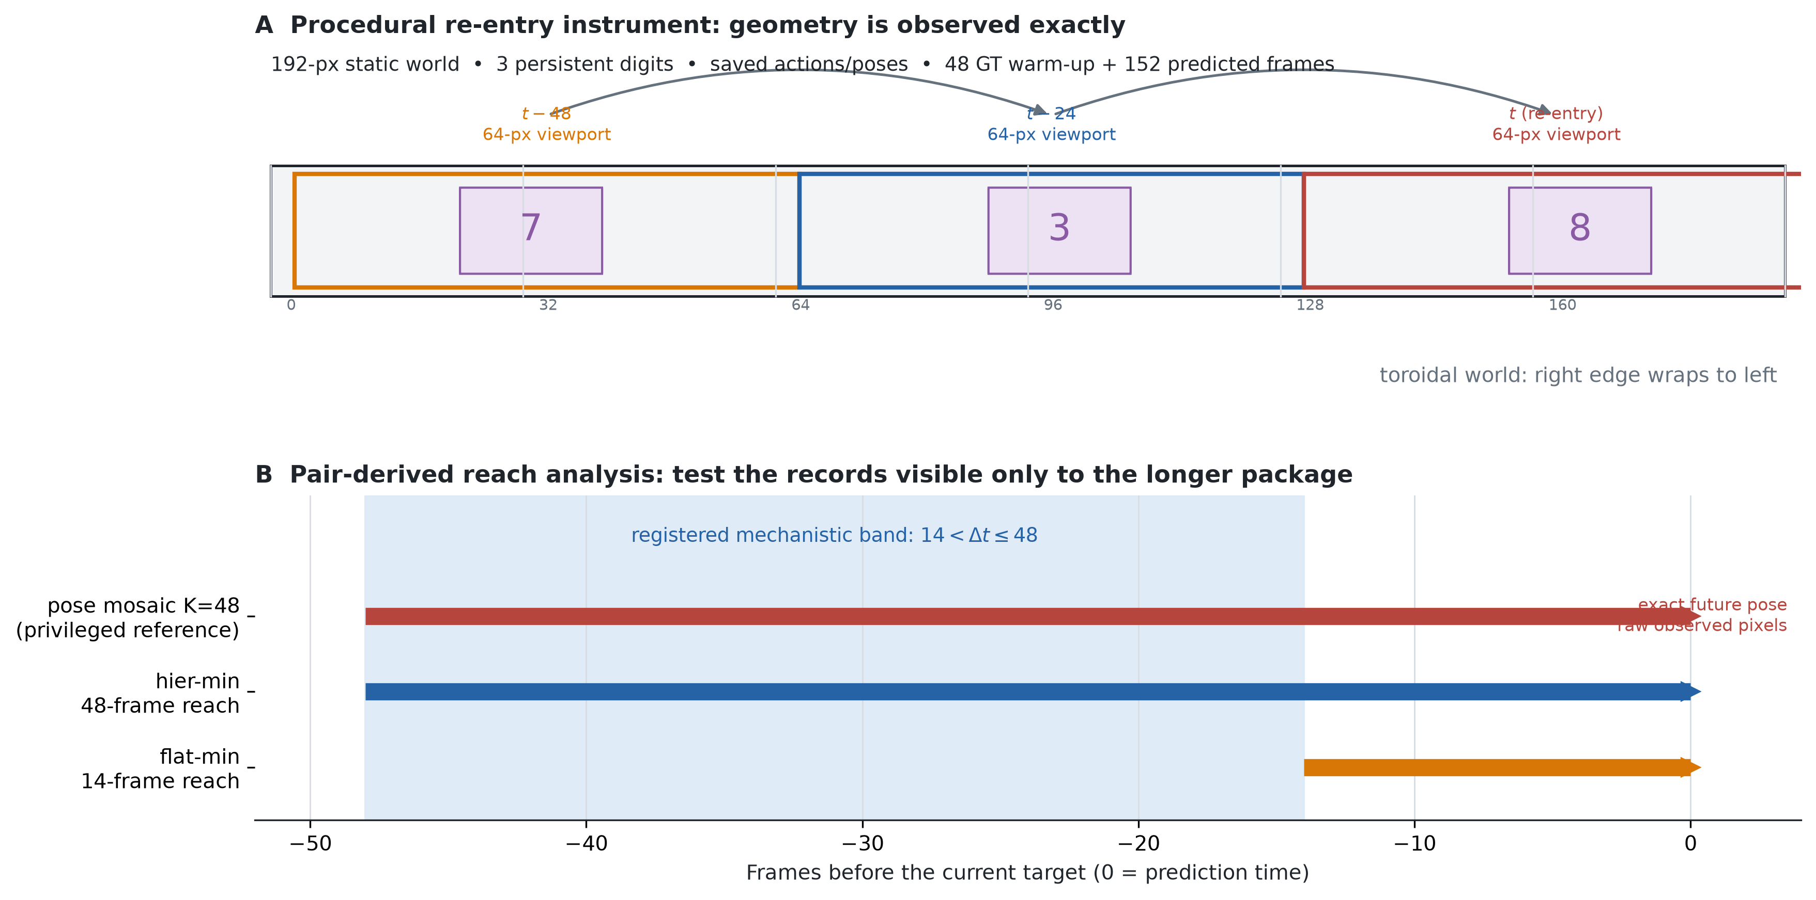
Figure 1. The 64-pixel viewport moves over a 192-pixel toroidal static world. Saved positions make geometric observability exact. The primary reach analysis evaluates records whose relevant content was observed 15–48 frames earlier: available to hier-min, unavailable to flat-min. The pose mosaic is visually separated because it also receives exact future pose and raw stored pixels.

2.2 Context packages and the B1 confound
Every package is described by context temporal stride, context spatial resolution, slots and reach, target stride and slots, auxiliary losses, context/target/total tokens, head and sampler allocation. The legacy B1 stride-2 arm couples context stride to coarse target stride. It therefore compares a complete stride-2 configuration to a short-flat configuration. We permanently retain that configuration-level interpretation in this article; a fixed-target control would be required only to revive a pure causal context-stride claim.
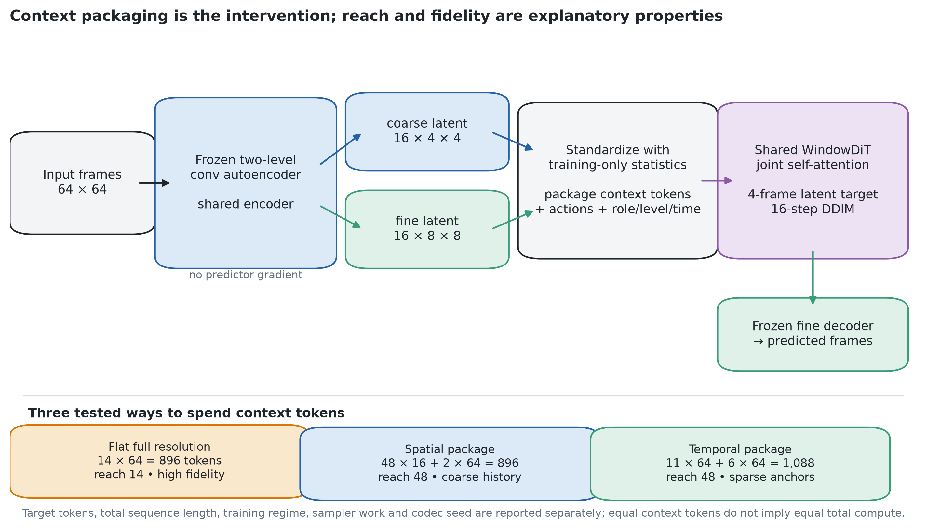
Figure 2. The predictor backbone and frozen two-level codec are shared while the context is packaged as contiguous fine frames, dense coarse history plus a recent fine tail, or sparse full-resolution anchors plus a recent tail. Reach and fidelity describe consequences of the package; they are not separately trained modules.
Table 2 — Exact interface accounting for the central configurations.
Arm | Package | Reach | Context tokens | Target tokens | Total tokens
flat-min | 14 contiguous fine frames | 14 | 896 | 320 | 1,216
hier-min | 48 dense coarse + 2 fine | 48 | 896 | 320 | 1,216
flat-short | 8 contiguous fine frames | 8 | 512 | 320 | 832
hier-s2-min | 24 stride-2 coarse + 2 fine | 48 | 512 | 288 | 800
flat-budget | 18 contiguous fine frames | 18 | 1,152 | 320 | 1,472
hier-long | 48 dense coarse + 6 fine | 48 | 1,152 | 320 | 1,472
strided-flat | 11 stride-4 fine anchors + 6 fine | 48 | 1,088 | 320 | 1,408
flat-c2 / hier-c2 | contiguous fine / dense coarse + fine | 38 / 48 | 2,432 | 320 | 2,752

The strided-flat package is near-matched, not exactly matched, to hier-long: it uses 64 fewer context tokens, a deficit that favors the temporal-package control. B1 changes 32 target tokens as well as the context, so its outcome remains a configuration effect.

2.3 Package, predictor and estimand
Let a context package be
\mathcal P_t=\{(K_\ell,q_\ell)\}_{\ell=1}^{L},
where K_\ell is the set of historical lags retained at representation level \ell and q_\ell is the number of tokens used by one slot at that level. Its context cost and nominal reach are
B_{\mathrm{ctx}}(\mathcal P)=\sum_{\ell=1}^{L}|K_\ell|q_\ell,\qquad R(\mathcal P)=\max_{\ell,k\in K_\ell} k .
This accounting makes reach exact but does not pretend that fidelity is one scalar: spatial resolution, codec distortion and temporal sparsity preserve different information. In the frozen interface q_{\mathrm{fine}}=64 and q_{\mathrm{coarse}}=16. Thus 48 fine slots cost 3,072 tokens, whereas 48 coarse slots plus two or six recent fine slots cost 896 or 1,152.
The common predictor models a target latent block z_{t+1:t+m} conditional on the packaged history and camera actions,
p_\theta\!\left(z_{t+1:t+m}\mid \mathcal P_t,u_{t+1:t+m}\right).
For the diffusion head, training minimizes
\mathcal L_{\mathrm{diff}}= \mathbb E_{z,\epsilon,\tau} \left\|\epsilon-\epsilon_\theta(z_\tau,\tau,\mathcal P_t,u)\right\|_2^2 ,
while the regression control predicts the clean target latents directly. The principal paired effect is always reported as comparator loss minus candidate loss, so positive values favor the registered candidate. For a long package \mathcal P_l and shorter comparator \mathcal P_s, the reach-specific population is
\mathcal D_{\mathrm{reach}}= \{i:R(\mathcal P_s)<\Delta t_i\le R(\mathcal P_l),\ \text{answerable}_i,\ \text{foreground}_i\ne\varnothing\}.
The diffusion and deterministic DDIM sampling conventions follow Ho et al. (2020) and Song et al. (2021); the latent-token transformer follows the DiT design family (Peebles and Xie, 2023).

2.4 Cost accounting
“Matched compute” is avoided unless total work is genuinely matched. Comparison tables list context tokens, target tokens, total sequence length, parameters, examples, optimizer updates, batch size, EMA, per-step and total NFE, runtime and peak memory. The B16x30k and B8x60k regimes process approximately the same examples but differ in updates, gradient noise, grouping and effective EMA horizon; c2 is an optimizer-regime robustness control.

2.5 Development and confirmation populations
The existing test pool informed qualitative monitoring, arm selection and theory development. It provides development evidence, not an untouched final holdout. Confirmation uses a newly generated, hash-pinned set rejected by training and monitoring loaders. The analysis, thresholds, reach bands, table shells and interpretation branches are frozen before access.

3. Endpoints and inference

3.1 Complete frame metrics
For every frame record we save full-frame MSE; GT-foreground MSE only on non-empty frames; GT-background and union-mask MSE; foreground precision, recall and F1; component counts, misses, extras, IoU and centroid error. Empty-GT frames are a named stratum and never inherit a differently defined full-frame value under a foreground label.
The need for this suite is empirical rather than stylistic. On the exact archived 100-clip, 964-target CW-VAE Moving-MNIST population, a deterministic all-black predictor scores 0.7681 SSIM / 13.941 dB, compared with 0.5708 / 12.918 for the trained best-of-5 CW-VAE curve. Because only the model's mean curves survived, this is a hash-pinned same-population metric diagnostic without paired inference—not a budget-matched model ranking. It shows why sparse-background full-frame metrics cannot carry the memory claim.

3.2 Persistent-object metrics
Object claims require stable generator IDs, glyph classes, trajectories, boxes and overlaps. Predicted components are assigned jointly with a frozen Hungarian cost. Misses receive a trajectory penalty, extras remain visible, and identity accuracy is intention-to-score over all labelled GT objects. Matched-only performance is diagnostic; coverage is co-primary.

3.3 Pair-specific reach analysis
For reaches r_s < r_l, the mechanistic band is r_s < \Delta t \le r_l, restricted to non-empty, geometrically answerable records. For hier-min versus flat-min, it is 14 < dt <= 48; for stride-2 B1 versus flat-short, 8 < dt <= 48. These definitions were post-hoc on the development pool and were frozen as primary before the untouched E2 evaluation.

3.4 Statistical protocol
Effects are paired by clip and horizon; confidence intervals resample clips rather than autocorrelated frames. Reports show each seed, record/clip counts and coverage. Opposite seed-specific effects are heterogeneity even when their mean is near zero. Equivalence requires a justified smallest effect of interest and reliable measurement; otherwise a null interval is inconclusive.
Sampling robustness is evaluated separately from training-seed robustness. E7c freezes four already-supported seed-0 diffusion contrasts and five variants before evaluation: NFE 8/16/32 at sampler seed 0 and NFE 16 at sampler seeds 1/2. A 10,000-replicate studentized max-statistic clip-cluster bootstrap covers the resulting 20-effect family. This checkpoint-only design can test sensitivity to inference allocation and randomness; it cannot establish robustness to training seed, representation seed or another dataset family.

4. Results

4.1 Untouched confirmation of reach and the fixed-budget frontier
On the frozen E2 holdout, hier-min versus flat-min yields +0.0980 [0.0788, 0.1179] and +0.0914 [0.0736, 0.1098] in the registered 14 < dt <= 48 band across seeds 0/1. The B1 configuration versus flat-short yields +0.0692 [0.0543, 0.0845] and +0.0743 [0.0588, 0.0899] in 8 < dt <= 48. Whole-population, union/full-frame, recall/F1, missed-component and coverage endpoints corroborate the signs. The concentration of the benefit inside the pair-derived reach band supports reach as the mechanism rather than horizon alone.
The single simultaneous frontier family confirms hierarchy at 896 and 1,152 tokens, leaves 1,792 unresolved, and confirms flat full-resolution context at 2,432 and 3,072. The largest tested family-wise-confirmed hierarchy point is therefore 1,152 tokens and the smallest tested confirmed flat point is 2,432. No value between them is inferred. The memory arithmetic is substantial: the confirmed hierarchical packages provide nominal 48-frame reach with 896 or 1,152 tokens, compared with 3,072 tokens for a 48-frame fine-only window. This is a 2.7–3.4-fold context-token reduction for reach, not a claim of equal information or equal error at every operating point.
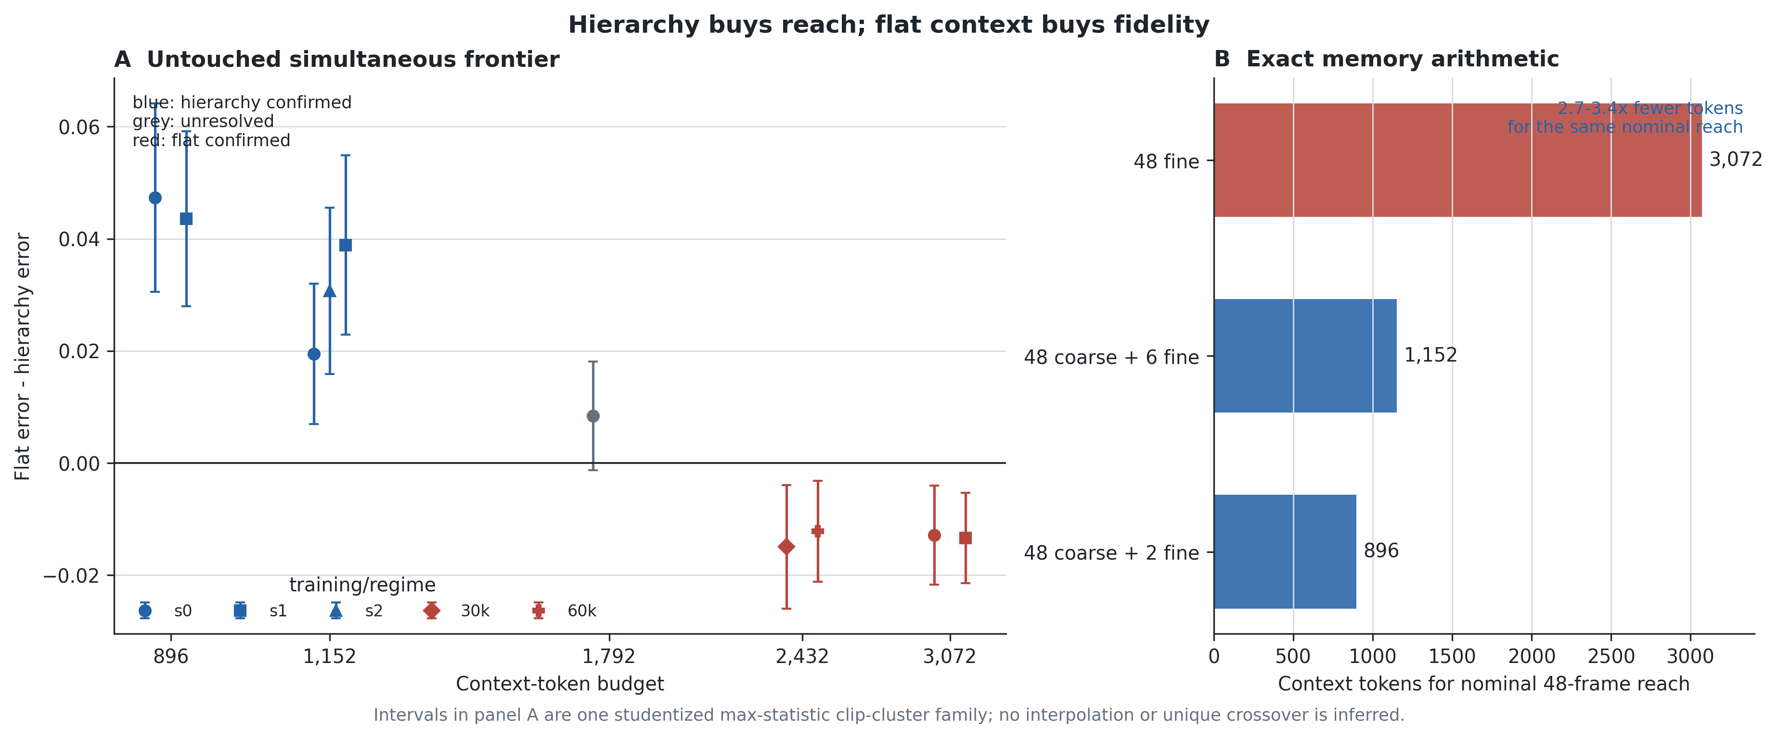
Figure 3. Left: untouched E2 effects under one studentized max-statistic clip-cluster family; positive favors hierarchy. Right: exact cost of 48 fine slots versus coarse history with a recent fine tail. The figure marks tested outcomes only and draws no interpolated crossing.

4.2 Development evidence that motivated the confirmation
On non-empty answerable development records, hier-min versus flat-min yields +0.0880 [0.0668, 0.1083] at seed 0 and +0.0809 [0.0621, 0.0998] at seed 1 in 14 < dt <= 48. Stride-2 B1 versus flat-short yields +0.0675 [0.0526, 0.0828] and +0.0709 [0.0544, 0.0871] in 8 < dt <= 48. These post-hoc observations motivated the frozen E2 analysis; they are not relabelled as confirmatory. Development comparisons also suggested an intermediate hierarchy region and an upper flat recovery. E2 preserved the lower and upper directions but correctly demoted the 1,792-token point to unresolved.

4.3 B1 configuration result
The stride-2 B1 configuration wins under diffusion by +0.0330 and +0.0338 across the completed seeds. Under regression, seed 0 yields +0.0639 [0.0516, 0.0763]. This is strong evidence for the whole configuration. It does not isolate context stride because target slots, target tokens, auxiliary loss, sequence length and optimization difficulty also change. The article retains configuration-level wording permanently within its present scope.

4.4 Temporal versus spatial packages and head interaction
The five-seed factorial gives a clean result under diffusion and a boundary under regression:
Seed | Diffusion temporal advantage | Regression temporal advantage | Head × package interaction
0 | +0.0197 [+0.0143, +0.0252] | +0.0107 [+0.0062, +0.0158] | −0.0089 [−0.0151, −0.0025]
1 | +0.0046 [+0.0007, +0.0084] | −0.0104 [−0.0146, −0.0062] | −0.0150 [−0.0199, −0.0104]
2 | +0.0111 [+0.0070, +0.0151] | −0.0208 [−0.0270, −0.0150] | −0.0319 [−0.0401, −0.0245]
3 | +0.0075 [+0.0037, +0.0114] | +0.0248 [+0.0181, +0.0323] | +0.0173 [+0.0106, +0.0245]
4 | +0.0060 [+0.0027, +0.0092] | −0.0166 [−0.0229, −0.0108] | −0.0226 [−0.0297, −0.0160]

All five diffusion effects favor temporally sparse full-resolution context. Their across-training- seed mean is +0.0098, SD 0.0060, with t95 [+0.0023, +0.0173]. Regression instead has two temporal and three spatial material winners; its mean is −0.0024 with t95 [−0.0266, +0.0217]. The interaction also changes sign, with mean −0.0122 and t95 [−0.0353, +0.0109]. Consequently, the preregistered robust negative head-shift rule fails. The defensible conclusion is that the diffusion package result is stable across the five tested seeds, whereas package utilization under regression and cross-head generalization are training-seed-sensitive. This is not equivalence and not evidence for a directional head law. Clip-cluster intervals condition on each trained model; the t intervals use training seeds as units. Unlike E2, this factorial uses the existing adaptively used evaluation pool and is measured development evidence, not a new untouched confirmation.
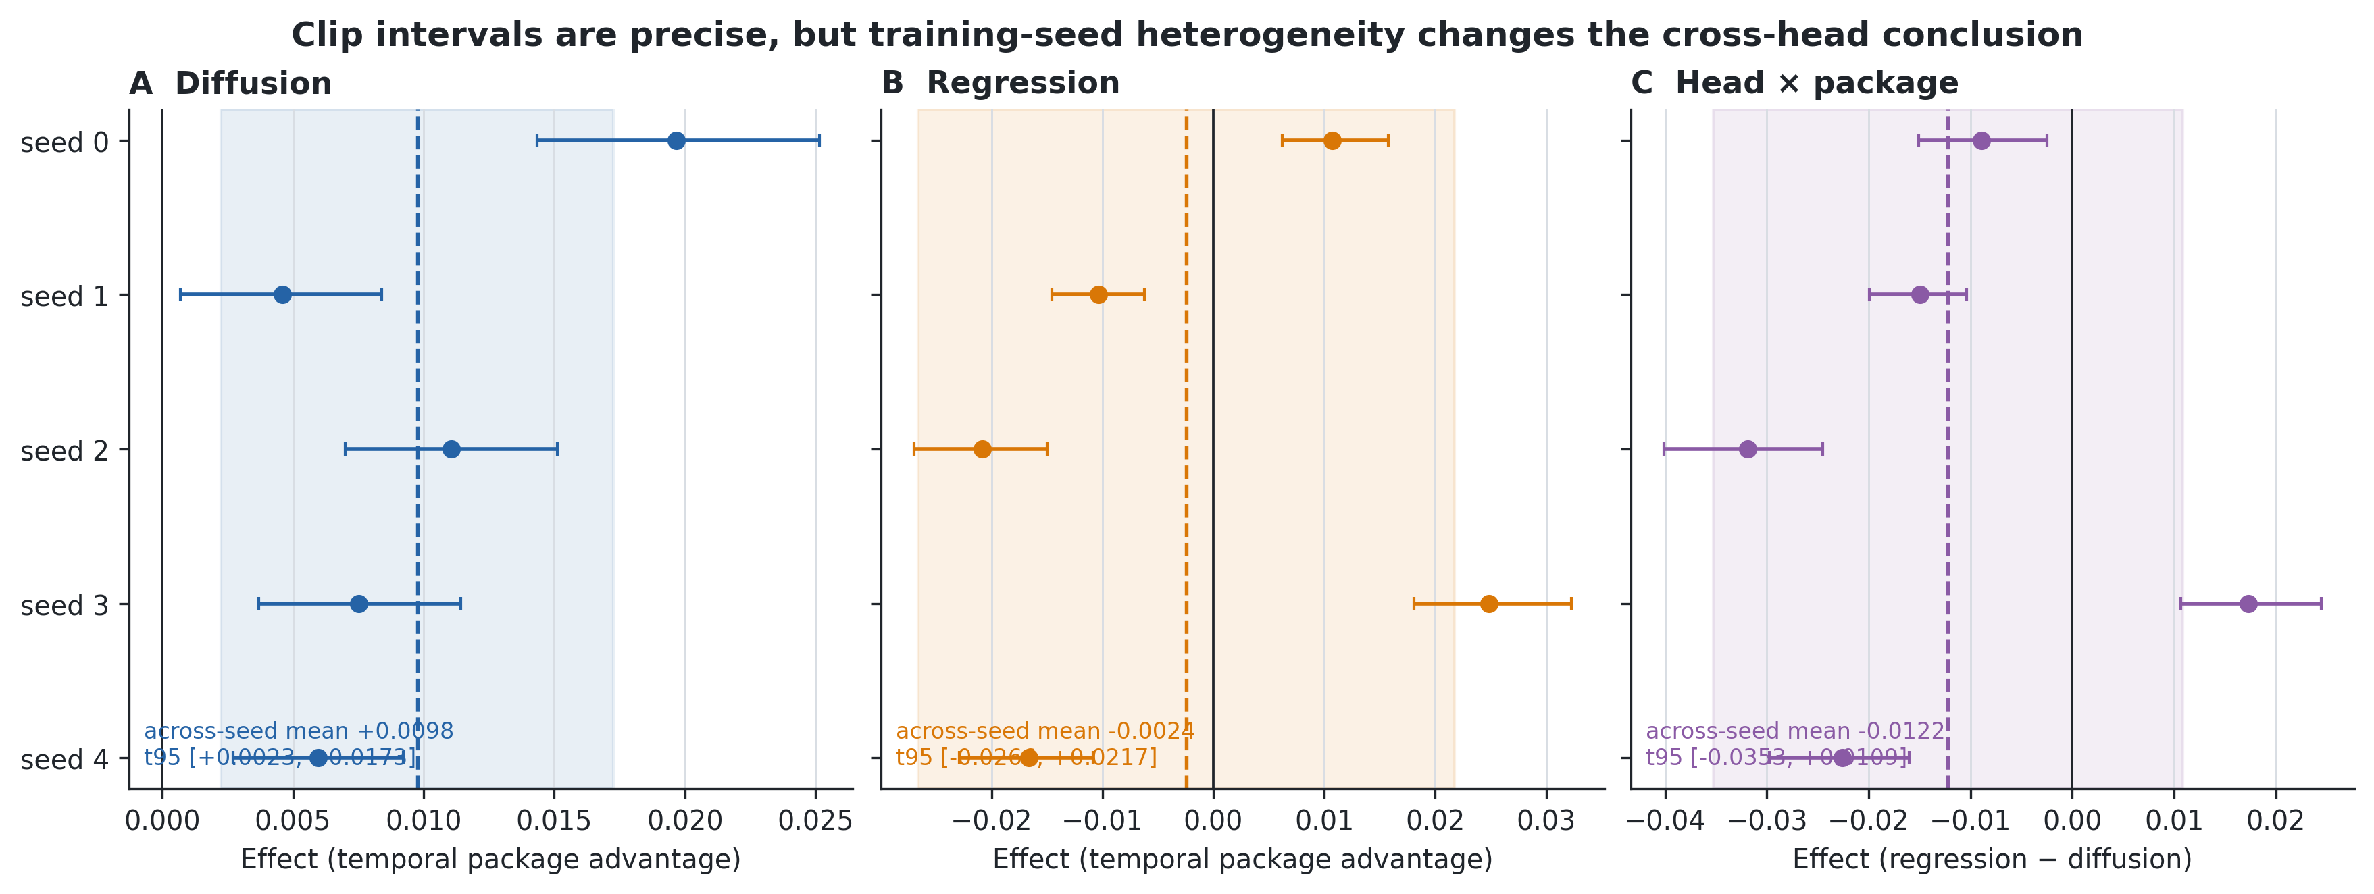
Figure 4. Clip-bootstrap intervals are conditional on a trained model and are shown per seed. The shaded interval and dashed mean instead summarize five training seeds. Diffusion consistently favors temporal anchors; regression and the interaction change sign.

4.5 Addressability and self-fed reliability: a negative replication
At a longer-loop operating point, single-step teacher-forced retrieval succeeds when span covers the loop. Seed 0 then shows an early hierarchy benefit followed by a late inversion during pure self-fed rollout. E5a preregistered that horizon pattern and repeated the same pair at two new training seeds. Positive effects below favor the 224-frame-reach hierarchy:
Training seed | Early h1–24 effect [95% CI] | Late h61–256 effect [95% CI]
0 | +0.0204 [+0.0133, +0.0279] | −0.0064 [−0.0095, −0.0032]
1 | +0.0082 [+0.0035, +0.0133] | +0.0074 [+0.0038, +0.0112]
2 | +0.0230 [+0.0150, +0.0315] | +0.0087 [+0.0035, +0.0139]

The early advantage is positive and CI-clean at all three seeds. Neither new seed reproduces the required late-negative direction; both instead show a positive, CI-clean late hierarchy effect. The registered verdict is NOT_REPLICATED, so the gated horizon/refresh/corruption programme is not authorized. This result preserves the conceptual distinction between addressability and self-fed reliability while rejecting a stable approximately-24-frame trust boundary in the current evidence.
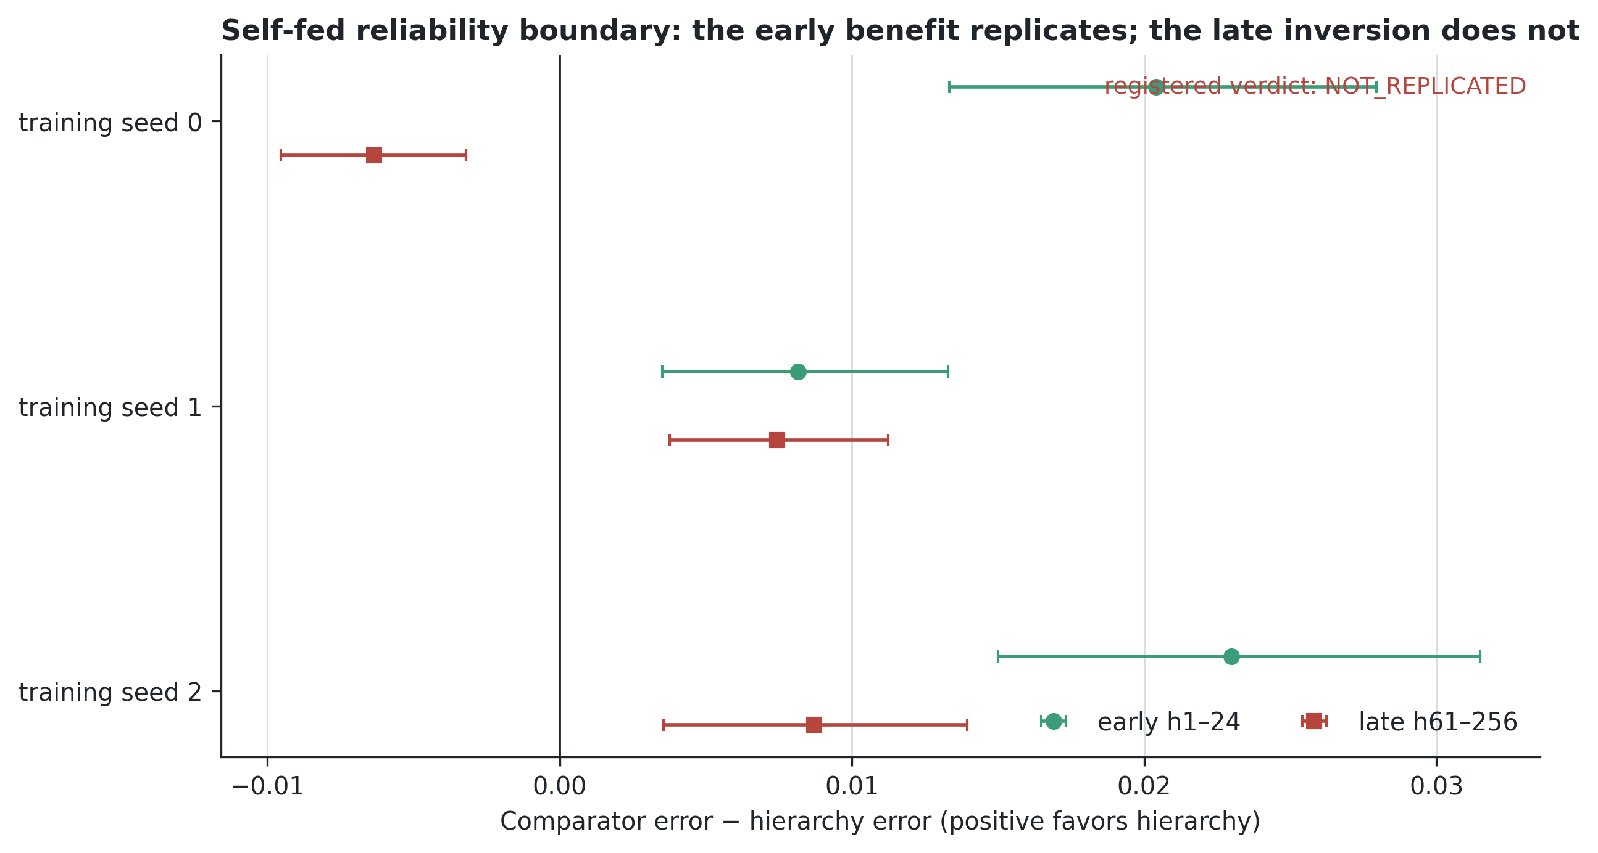
Figure 5. The early hierarchy benefit is positive at all three seeds. The registered late negative direction occurs only at seed 0 and reverses at both new seeds, producing the NOT_REPLICATED verdict.

4.6 Sampler and inference-allocation robustness
E7c evaluates seven frozen seed-0 diffusion checkpoints on a separate purpose-locked LoopMom robustness set. Four contrasts—896-token reach, 1,152-token interior reach–fidelity, the near-matched 1,088-token temporal-versus-1,152-token spatial package shape, and the 2,432-token flat-fidelity inversion—are crossed with five frozen NFE/sampler variants. Positive effects favor the registered candidate. The 64-token deficit favors the temporal control; this package-shape comparison is not described as exactly token matched.
All 20 point estimates retain their expected direction. The 896 reach effects range from +0.0465 to +0.0482; the 1,152 interior effects from +0.0140 to +0.0201; the package-shape effects from +0.0221 to +0.0292; and the 2,432 inversion effects from +0.0077 to +0.0122. The simultaneous family-wise lower bound is positive for every variant of the first three contrasts and for the inversion at NFE 8/16/32 with sampler seed 0. At NFE 16, the inversion remains positive but is family-wise unresolved under sampler seed 1 (+0.0098 [−0.0001,+0.0196]) and sampler seed 2 (+0.0077 [−0.0013,+0.0167]). The registered verdict is therefore DIRECTIONALLY_ROBUST, not ROBUST_CI_CLEAN.
Non-empty foreground, full-frame, background and union-mask errors favor the registered candidate in all 20 variants, as do recall and F1. Component-count diagnostics are not uniformly favorable, so the result is not described as improvement on every endpoint. This study rules out a simple explanation based on the default NFE-16 allocation or one sampling-noise realization for the observed directions. It does not establish universal sampler invariance: it is checkpoint-only, uses seed-0 predictors, one frozen codec and one procedural dataset family.
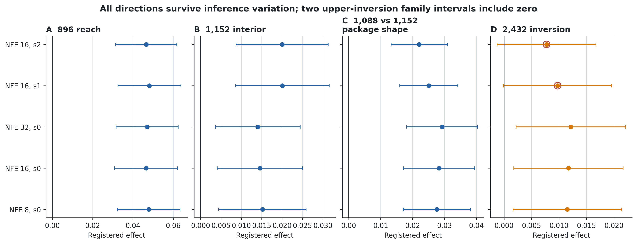
Figure 6. All 20 point estimates preserve their registered direction. Open circles mark the two 2,432-token upper-inversion effects whose simultaneous family intervals include zero under alternate sampler seeds.

4.7 Robustness to an independently trained latent codec
E7a changes the entire latent representation by training a second codec seed, recomputing codec-specific normalization and retraining the same seven seed-0 diffusion predictors. It is therefore a whole-codec intervention—not an isolated test of reconstruction error, latent scale or one normalization component. The new 500×200 LoopMom set is purpose-locked and shared by all four original-codec controls and four alternate-codec contrasts. The eight effects form one studentized max-statistic clip-cluster family.
Codec | 896 reach | 1,152 interior | 1,088 vs 1,152 shape | 2,432 inversion
Original | +0.0494 [0.0339, 0.0649] | +0.0283 [0.0169, 0.0397] | +0.0253 [0.0163, 0.0343] | +0.0150 [0.0065, 0.0235]
Alternate | +0.0521 [0.0374, 0.0669] | +0.0439 [0.0310, 0.0569] | +0.0112 [0.0039, 0.0184] | +0.0079 [−0.0006, 0.0165]

All eight point estimates retain the registered direction. Seven simultaneous lower bounds are positive; only the alternate-codec 2,432-token inversion includes zero. The registered verdict is therefore CODEC_DIRECTIONALLY_ROBUST. The alternate codec strengthens the lower/interior reach effects but descriptively shrinks the package-shape and upper-inversion effects. Because codec seed is not an inferential replicate, those changes locate sensitivity without identifying its latent-space cause.
The upper comparison is metric-sensitive in precision, not reversed: non-empty foreground MSE still favors flat by +0.0097 [0.0019, 0.0177], while full-frame, background, union, precision/F1 and component-count intervals are mixed. No third codec, predictor seed, arm or endpoint was selected after observation.
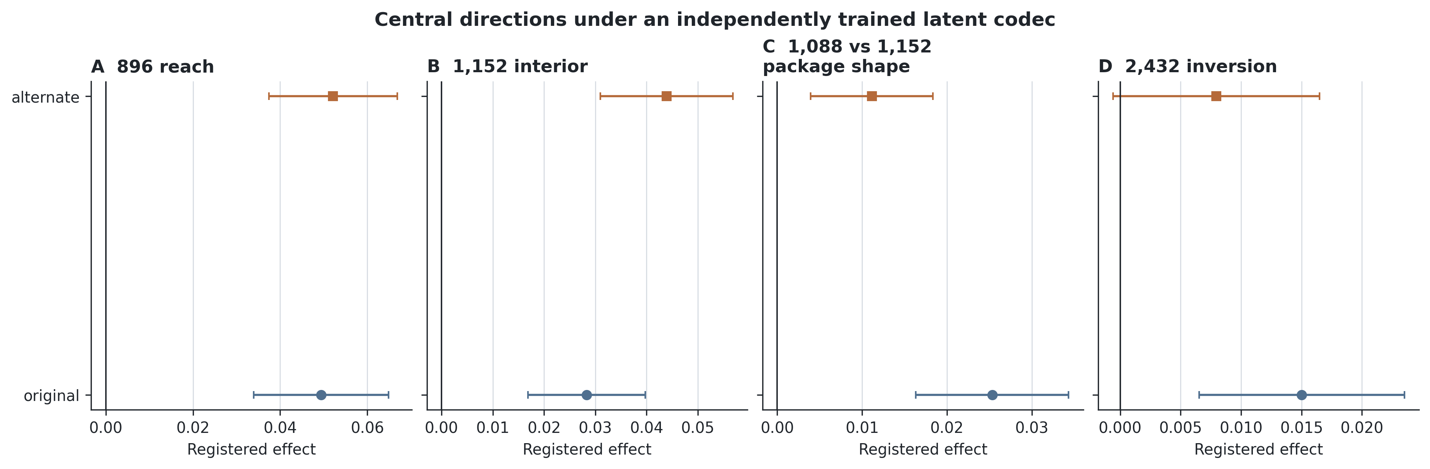
Figure 7. Original- and alternate-codec effects under one simultaneous eight-effect family. All point estimates preserve direction; the alternate-codec upper inversion is the sole interval crossing zero.

4.8 Privileged pose-indexed raw-memory reference
E8a asks how much error remains when access is made explicit. It builds a frozen world-coordinate mosaic from raw warm-up pixels and queries it using exact saved viewport positions. It receives information unavailable to the neural predictors: raw pixel storage and all future query poses. It is therefore an access reference, not a token-matched architecture comparison, learned retrieval baseline or natural-video result.
Registered effect | Estimate | Simultaneous 95% CI
Raw K14 minus raw K48 | +0.0723 | [+0.0548, +0.0898]
Raw K38 minus raw K48 | +0.0210 | [+0.0096, +0.0325]
hier-min minus raw K48 | +0.1219 | [+0.1031, +0.1407]
hier-long minus raw K48 | +0.1368 | [+0.1190, +0.1545]
strided-flat minus raw K48 | +0.1134 | [+0.0944, +0.1324]
flat-c2 minus raw K48 | +0.1310 | [+0.1122, +0.1498]

The K48 mosaic attains foreground MSE 0.0494, full-frame MSE 0.0027 and foreground recall 0.8438, versus foreground MSE 0.1628–0.1862 for the four registered neural references. Every neural-to-K48 point estimate and simultaneous lower bound is positive, giving the preregistered verdict RAW_ACCESS_CEILING_CI_CLEAN. The raw-span diagnostics are also positive: K48 improves over both K14 and K38. The K38 saturation condition is not met. Median stored world coverage increases from 80 columns at K6 to 154 at K48; mean future-crop observed coverage increases from 0.454 to 0.809. Observed pixels are reproduced exactly, while unobserved columns use the frozen training-only row prior.
This closes a useful explanatory gap. Large error remains in the learned self-fed systems even when their context can geometrically reach the relevant past; exact addressing and lossless storage can remove much of it on this static world. The result does not show that hierarchy is unnecessary or that a raw mosaic is deployable: the mosaic has privileged poses, no token budget, no learned dynamics, no decoder loss and no self-fed state. It instead separates the potential value of explicit access from the measured neural package frontier.
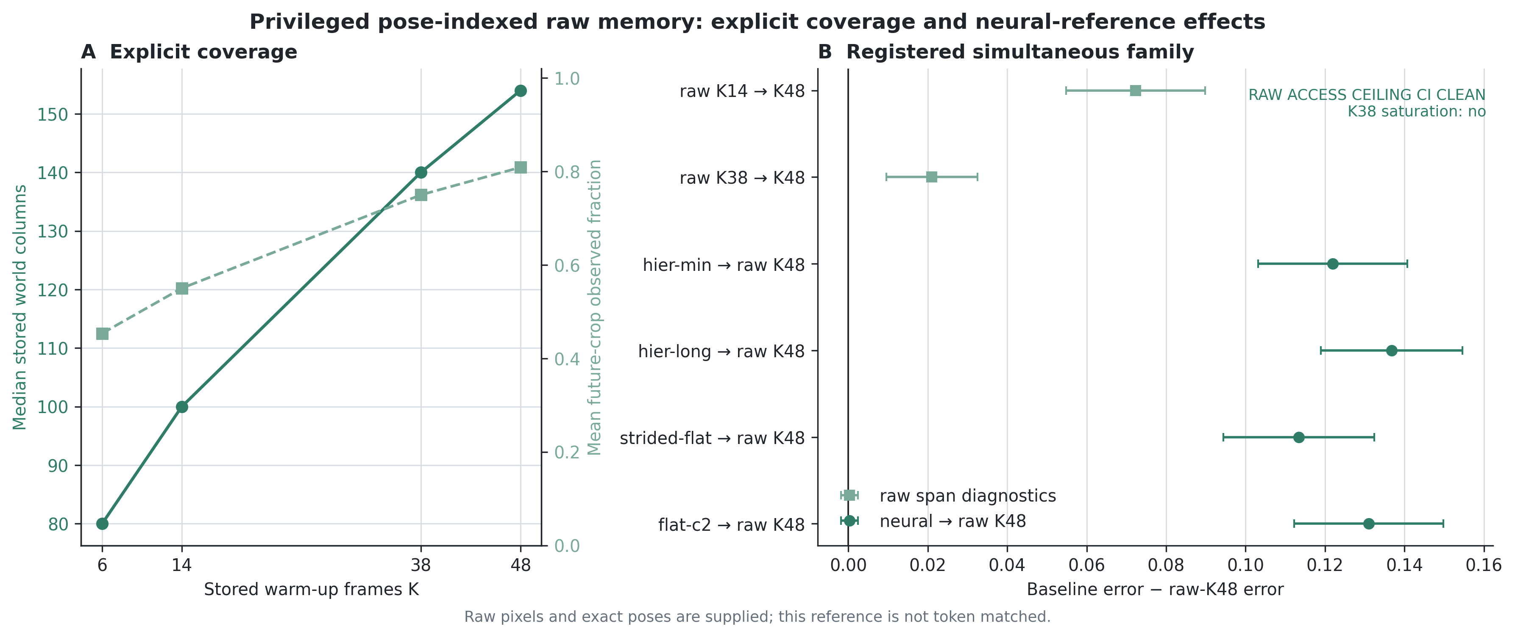
Figure 8. Left: stored-world and future-crop coverage as the raw warm-up span increases. Right: the registered simultaneous family. All six lower bounds are positive; the four circular neural-to-K48 effects determine the clean ceiling verdict.

4.9 External boundary: persistent-object long Moving-MNIST
E6 tests whether the reach–fidelity account survives the recognizable Moving-MNIST setting [Srivastava et al., 2015], with persistent digit identities, collisions and 300-frame self-fed prediction. The comparison uses three training seeds, a 48-frame warm-up, matched 1,152-token flat and hierarchical packages, an official train/test glyph split, generator-saved object identity and trajectory, one-to-one Hungarian assignment, explicit missed/extra-object accounting, and a protected 100-clip holdout. Positive effects below favor hierarchy. All 15 intervals belong to one preregistered studentized max-statistic clip-cluster family.
Seed | Foreground MSE | Union MSE | Trajectory error | Identity accuracy | Coverage
0 | +0.0036 [−0.0074,+0.0146] | +0.0102 [+0.0019,+0.0185] | +2.4786 [+0.2130,+4.7443] | −0.0762 [−0.1106,−0.0418] | +0.0304 [+0.0016,+0.0591]
1 | −0.0031 [−0.0127,+0.0065] | +0.0122 [+0.0052,+0.0192] | +1.4223 [−1.0646,+3.9092] | −0.0561 [−0.0934,−0.0188] | +0.0159 [−0.0163,+0.0482]
2 | −0.0024 [−0.0131,+0.0083] | +0.0169 [+0.0093,+0.0245] | +4.1325 [+1.5271,+6.7380] | −0.0647 [−0.0955,−0.0338] | +0.0498 [+0.0161,+0.0834]

The absolute values are important because both packages remain far from solved:
Seed | Arm | Union MSE ↓ | Trajectory error ↓ | Identity accuracy ↑ | Object coverage ↑
0 | flat / hierarchy | 0.6861 / 0.6759 | 42.19 / 39.71 | 0.214 / 0.138 | 0.619 / 0.650
1 | flat / hierarchy | 0.6901 / 0.6779 | 40.20 / 38.77 | 0.244 / 0.188 | 0.646 / 0.662
2 | flat / hierarchy | 0.6931 / 0.6763 | 43.79 / 39.65 | 0.222 / 0.158 | 0.599 / 0.649

The registered verdict is MIXED_BOUNDARY. Union-mask error favors hierarchy on every seed. Trajectory and coverage favor hierarchy cleanly on seeds 0 and 2 and remain directionally positive but unresolved on seed 1. Missed objects are lower and full-frame/background error is lower for hierarchy at every seed as secondary descriptive evidence. Conversely, identity accuracy favors flat context with simultaneous intervals wholly below zero at every seed. Foreground-only error is unresolved and changes sign.
This is a scientifically useful division of labor. The coarse stream better preserves spatial support—where an object is, whether it remains represented, and how its trajectory continues—but loses fine glyph information needed to preserve what the object is. Because identity uses a fixed ground-truth object denominator, the result is not explained by selecting only detected survivors. It is consistent with the article's reach–fidelity account, but it is not a replication of LoopMom's exact observability mechanism or evidence of natural-video transfer.
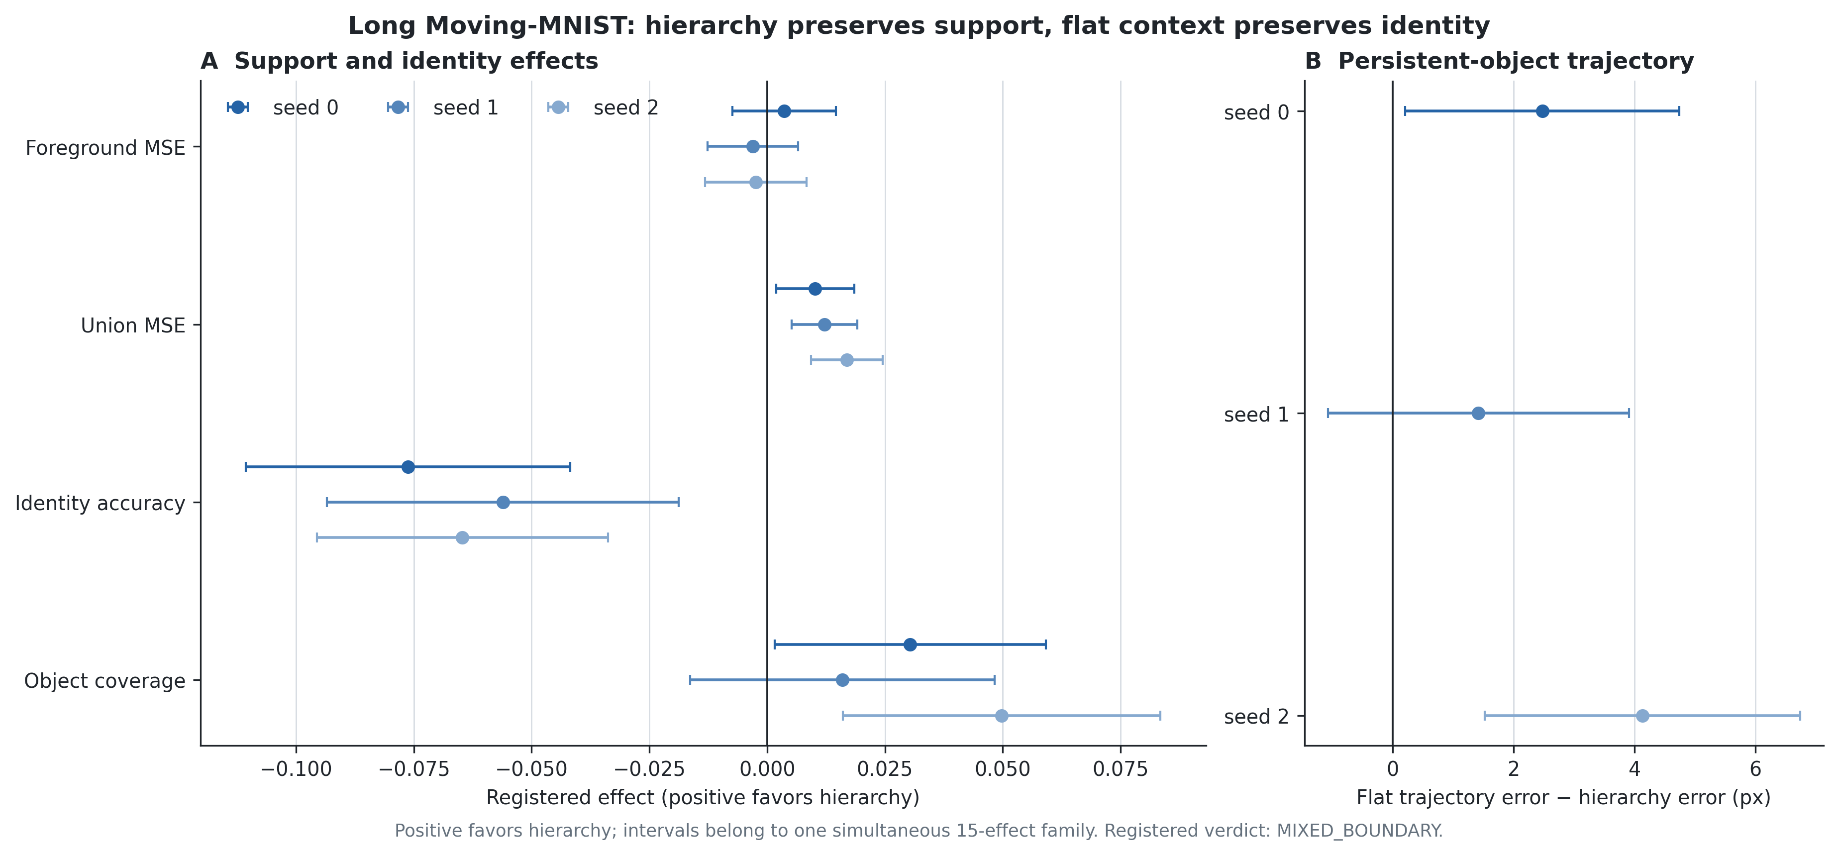
Figure 9. Registered E6 simultaneous effects. Positive favors hierarchy. The support and continuity endpoints separate from identity fidelity, producing the preregistered mixed verdict.

5. Reproducibility and evidence availability
Every confirmatory or robustness dataset has a purpose string, generation seed, split indices and SHA-256 hashes in a committed manifest. Opening a protected dataset requires the matching purpose-specific access log. Each model or evaluation cell has a content-addressed RunSpec, immutable metric artifact, checkpoint provenance, source commit, declared GPU-hour ceiling and cloud run. The evidence index artifacts/rft_claim_artifact_index.json binds the manuscript's central claims to frozen result JSON files; docs/draft/RFT_GENERATED_TABLES.md is regenerated from those artifacts rather than transcribed by hand.
Training checkpoints store model, optimizer and EMA state. New-regime runs additionally record Python, NumPy and Torch RNG state; older resumed runs are described as distributionally reproducible rather than trajectory-identical where those states were absent. CPU gates check dataset hashes, arm interfaces, batch-index and fixed-seed numerical parity where legacy and refactored paths must be combined. W&B is a cloud mirror and health record, not the source of truth: conclusions are recomputed from immutable local NPZ/JSON artifacts. GPU-hour accounting is wall-clock ownership time, including evaluation, pilots, failures and retries.
The repository archive contains the generator, training and evaluation code, frozen protocols, authorization gates, exact command wrappers, access logs, generated tables and figure scripts. Large datasets and checkpoints are identified by cryptographic hashes even when distributed separately. Smoke tests cannot overwrite canonical result names, and a completed study is not accepted unless its independent completion validator passes.

6. Boundaries and positioning
The study does not establish a universal hierarchy advantage, a unique token crossing, a pure B1 context-stride effect, regression equivalence, information-theoretic necessity, natural-video generalization, a trust law, or valid legacy Phase C object conclusions. Moving-MNIST 10-to-10 and TaxiBJ are descriptive boundary/competence anchors rather than equivalence or re-entry evidence. The corrected persistent-object long Moving-MNIST study is valid but remains an external synthetic boundary: it supports neither a universal hierarchy ranking nor LoopMom-mechanism or natural-video generalization. E7a supports whole-codec directional robustness conditional on predictor seed 0; it does not establish component-level codec causality or universal representation invariance. E8a is a privileged static-world access reference. Because it receives exact future poses and raw warm-up pixels without a matched token or inference budget, it cannot support a model-ranking, efficiency or natural-generalization claim.
Prior work already studies slow latent state, compressed trajectory memory, retrieval, memory benchmarks and autoregressive mismatch [CW-VAE; FDM; TECO; recent spatial-memory world models; WorldPack; MBench; CaR/SceneFly; MemLearner; GIM-World; Self Forcing]. The novelty is narrower: an analytic observability instrument, matched-budget rate-versus-resolution tests, measured inversions, pair-specific reach bands, an outcome-independent replication test of self-fed reliability, and a frozen simultaneous inference-robustness family.
A strong follow-up would use paired counterfactual worlds identical over the short visible context but differing in an off-screen texture/barcode that determines re-entry. Crossing static/dynamic hidden content with low/high spatial detail, plus classical pose-indexed and learned retrieval baselines, would test whether the preferred package follows the information structure.

7. Conclusion
The project is a controlled search for boundaries, not proof that one architecture always wins. Current evidence supports two central scoped propositions: effects are largest where only the longer package reaches the relevant past, and full-resolution fidelity can recover after reach is saturated. Context packaging is the intervention; reach and fidelity organize the confirmed explanation. Self-fed reliability remains an important question, not a third empirical law.
The one-time untouched confirmation supports the central reach–fidelity account. The five-seed factorial strengthens the diffusion temporal-package result while rejecting a training-seed- robust directional head shift; regression remains a sign-changing scope boundary rather than an equivalence result. E7c further shows that all four central diffusion directions survive the registered fourfold NFE range and sampler-seed variations as point estimates. Three contrasts are simultaneous-CI clean throughout; the upper flat-fidelity inversion is directionally retained but family-wise unresolved at two alternate sampler seeds. Because the article retains configuration-level B1 wording, the fixed-target control is not required for its present causal scope. E5a failed its preregistered late-inversion replication rule, so trust is removed from the title and the gated E5b diagnostic programme is not run. The three-seed early benefit and seed-0-only late failure are reported together. This outcome-independent narrowing is part of the contribution.
The independently trained codec preserves the same four directions. The lower reach, interior and package-shape contrasts remain family-wise clean, while the upper inversion again becomes a precision boundary rather than a sign reversal. Together, E7c and E7a support a robust reach–fidelity account while making the upper-budget inversion the appropriately qualified edge of the evidence.
The pose-indexed reference then exposes a complementary gap: explicit lossless access to observed content substantially outperforms every registered neural reference, with a clean simultaneous family. This does not replace the learned-model comparison; it shows that reach alone is not enough when addressing, compression and self-fed generation remain imperfect. The final account is sharpened by the persistent-object boundary: hierarchy is better at retaining spatial support and continuity, while flat full-resolution context is better at retaining digit identity. The operational prescription is therefore conditional: buy enough reach to include the relevant past, preserve the fidelity the task needs, and distinguish having information in context from being able to address and reuse it reliably.

References
- Chandratreya, I. P., Charatan, D., Van Hoorick, B., Zakharov, S., Guizilini, V., Isola, P.,
and Sitzmann, V. (2026). MilliVid: Hierarchical Latents for Long-Range Consistency in Video Generation. arXiv:2606.09056.
- Chen, H., Zhou, K., Hua, H., et al. (2026). *MemoBench: Benchmarking World Modeling in
Dynamically Changing Environments*. arXiv:2606.27537.
- Harvey, W., Naderiparizi, S., Masrani, V., Weilbach, C., and Wood, F. (2022). Flexible
Diffusion Modeling of Long Videos. NeurIPS 35.
- Ho, J., Jain, A., and Abbeel, P. (2020). Denoising Diffusion Probabilistic Models.
NeurIPS 33.
- Huang, X., Li, Z., He, G., Zhou, M., and Shechtman, E. (2025). Self Forcing: Bridging the
Train-Test Gap in Autoregressive Video Diffusion. NeurIPS 2025.
- Oshima, Y., Iwasawa, Y., Suzuki, M., Matsuo, Y., and Furuta, H. (2025). *WorldPack:
Compressed Memory Improves Spatial Consistency in Video World Modeling*. arXiv:2512.02473.
- Peebles, W., and Xie, S. (2023). Scalable Diffusion Models with Transformers. ICCV 2023.
- Peng, Z., Ma, J., Sun, H., et al. (2026). *Compression and Retrieval: Implicit Memory
Retrieval for Video World Models*. arXiv:2606.23105.
- Saxena, V., Ba, J., and Hafner, D. (2021). Clockwork Variational Autoencoders. NeurIPS 34.
- Song, J., Meng, C., and Ermon, S. (2021). Denoising Diffusion Implicit Models.
ICLR 2021.
- Srivastava, N., Mansimov, E., and Salakhutdinov, R. (2015). Unsupervised Learning of Video
Representations using LSTMs. ICML 2015.
- Wei, Z., Guo, X., Li, X., et al. (2026). *Geometry-Aware Implicit Memory for Video World
Models*. arXiv:2606.02436.
- Yan, W., Hafner, D., James, S., and Abbeel, P. (2023). Temporally Consistent Transformers for
Video Generation. ICML 2023.
- Yu, J., Gao, J., Bai, J., et al. (2026). *MemLearner: Learning to Query Context Memory for
Video World Models*. ECCV 2026; arXiv:2606.31734.
- Zakharov, A., Guo, Q., and Fountas, Z. (2023). *Long-horizon video prediction using a dynamic
latent hierarchy*. arXiv:2212.14376.
- Zhang, S., Zhang, Z., Huang, S., et al. (2026). *MBench: A Comprehensive Benchmark on Memory
Capability for Video World Models*. arXiv:2606.00793.

