Severe Biodiversity Deterioration and Corporate Pension Debt Allocation
Draft methodology and empirical results | Preferred nine-control staggered DiD and supplementary cohort-specific entropy balancing

3. Research design and methodology

3.0 Data sources, sample construction, and variable selection
We construct the pension and financial panel using data from Wharton Research Data Services (WRDS), drawing defined-benefit pension disclosures from Compustat pension table comp.aco_pnfnda and annual financial statements and identifiers from Compustat North America annual fundamentals (comp.funda). The Python extraction covers data dates from 1980 to 2025; not all years within these limits enter the estimation sample. We use the pension file as the base dataset for a one-to-one merge on GVKEY and the constructed year. The Compustat file supplies total assets, earnings, debt, cash flows, dividends, equity, service cost and market-value inputs, as well as CIK identifiers for matching to SEC EDGAR and headquarters information for the GBIF pipeline. The optional CRSP value-weighted market index is downloaded separately and is not among the reported baseline covariates.
Biodiversity-related corporate reporting is collected directly from the U.S. Securities and Exchange Commission (SEC) EDGAR submission histories and filing archives. The disclosure program covers 10-K annual reports, 10-Q quarterly reports, 8-K current reports (including relevant text-bearing exhibits), and DEF 14A proxy statements. The retrieval period is 2002–2025. The program standardises CIKs, downloads and caches accession-level filings, extracts readable text, identifies document sections and aggregates content to the firm–fiscal-year level. Each SEC filing accession is scored once and then mapped to the sample firms, reducing duplicate processing.
Local biodiversity information comes from Global Biodiversity Information Facility (GBIF) occurrence records. The GBIF pipeline begins with Compustat headquarters addresses and geocodes locations using Nominatim. It retrieves authenticated GBIF bulk occurrence archives for geographic tiles expanded to cover the full search radius and links individual records to headquarters using geographic distance. The program requests occurrences dated 2000–2025, generates annual and rolling ten-year firm-year measures for 2004–2025, and constructs 10-, 25-, and 50-km neighbourhoods. Our baseline uses the 50-km measures. The estimation commands further restrict the analysis period and sample; the preferred dynamic analysis uses 2004–2020.
The sources measure different dimensions of biodiversity exposure: EDGAR text captures firm communication and reporting attention, whereas GBIF occurrences proxy observed ecological conditions near headquarters. Including both in the baseline specification allows us to estimate their separate conditional associations with pension allocation. The seven Rauh-style controls address firm size, pension size, financial distress, funding, pension liabilities, cash-flow capacity, and cash-flow volatility. Firm fixed effects absorb time-invariant firm characteristics, and year fixed effects absorb common time shocks; inference is clustered by firm.

3.0.1 WRDS pension and financial data: retrieval and linkage
We access WRDS using the Python wrds client and request pension fields (including pnate, pnatd, pnatr, pnato, pplao, pbpro, ppsc and ppc) from comp.aco_pnfnda. Pension debt and equity allocation are directly reported Compustat fields; the code aliases pnatd to pension_debt_share and pnate to pension_equity_share, rather than constructing new asset-value ratios. The pension table is filtered by datadate between 1 January 1980 and 31 December 2025, and its year is assigned as calendar year(datadate). Within each GVKEY–year, the latest dated pension observation is retained.
We separately retrieve annual fundamentals from comp.funda, including gvkey, fyear, cik, at, dltt, dlc, mkvalt, prcc_f, csho, dv, dvc, dvp, tlcf, oancf, ni, dp, ebit, sale, re, act, lct, ceq, seq and splticrm. Where these database columns are available, we impose INDL industry format, STD data format, D population source, C consolidation, and U.S. incorporation (fic = USA). We retain the last dated annual-fundamentals record within each GVKEY–fyear and merge it to the pension table on GVKEY and year. The pension-year variable is calculated from the pension data date, whereas comp.funda uses its reported fyear when present. These two year conventions should be checked for alignment before publication, especially for non-December fiscal year ends.
The script retains original raw fields and exports pension_controls_raw.csv. If CRSP access is available, the script also retrieves monthly value-weighted returns (vwretd) from crsp.msi or crsp_a_stock.msi, compounds them by calendar year as ∏(1+vwretd_m)−1, and saves annual_crsp_market_returns.csv and pension_controls_with_market.csv. This return is an optional U.S. market proxy, not the S&P Global Broad Market Index used in the cited alternative-control study, and it is not included in the supplied baseline regressions. Data-source and transformation details appear in Appendix B.

3.0.2 Biodiversity disclosure: retrieval, identification and aggregation
We construct biodiversity disclosure using dictionary-based textual analysis of SEC filings. The program loads an external CSV containing a 100-term biodiversity dictionary, normalises the expressions and compiles matching patterns. It converts filings to text, segments them into sentences and identifies sentences containing biodiversity terminology. To limit false positives, it excludes non-environmental uses of “ecosystem” (for example, software, business and platform ecosystems). It also retains filing type and, where identifiable, document section, allowing disaggregated measures and subsequent checks.
The program processes primary filings and text-bearing 8-K attachments, including relevant press releases and investor materials; it excludes graphics, XBRL support files and other non-substantive assets from text scoring. Each identified sentence is normalised and hashed. Within each firm–fiscal year, repeated instances of the same sentence across filings are counted only once in the unique-sentence measure. The program separately flags sentences reused from earlier years and newly introduced sentences. These steps reduce count inflation from boilerplate repeated within a year, although repeated disclosure across different years is not excluded from the main annual stock measure.
Let B_it denote the number of unique biodiversity-related sentences across eligible filings assigned to firm i in fiscal year t. The code defines LOG_BIO_ALL_DOCS_COUNT_UNIQUE_it = ln(1 + B_it). This is the preferred count-based disclosure measure underlying the baseline specification, subject to verification that the Stata variable disclosure_log_bio_all_docs_coun is mapped to this exact output field in the final merged dataset. The logarithmic transformation preserves zeros and reduces the influence of firms with exceptionally high reporting volume. The script also produces raw counts, shares of biodiversity sentences in total filing sentences, document-level indicators, document-specific measures, and new-versus-repeated disclosure indicators, which could be used in robustness analyses.
The program applies a common document indicator threshold of at least two biodiversity sentences and form-specific thresholds of two for 10-K and one for each of 10-Q, 8-K and DEF 14A. These thresholds apply to auxiliary document-level indicators; the principal firm-year logged unique-sentence count is a continuous measure, not a binary indicator generated by these thresholds. The program aggregates by assigned fiscal year rather than by filing calendar year alone; the assignment rule should be checked against the final accounting-year alignment.

3.0.3 Why biodiversity disclosure is a variable of interest
Biodiversity disclosure is relevant because corporate reporting can indicate the importance firms attach to nature-related risks, regulatory exposure, stakeholder scrutiny and managerial attention to ecological issues. In making pension investment decisions, firms and pension sponsors assess risk, funding commitments and long-horizon obligations. The amount of biodiversity-related discussion may be associated with the sponsor’s pension investment policy, over and above contemporaneous local biodiversity levels. We therefore include disclosure both alone and jointly with the GBIF-based genus-richness measure in the nested baseline models.
The disclosure measure captures reporting intensity, not necessarily the quality, credibility or favourability of biodiversity management. It may also reflect firm size, regulatory exposure, industry composition, changes in filing volume or heightened scrutiny. The log count and fixed-effects design address some concerns about the distribution of the measure and time-invariant confounding, but they do not eliminate time-varying confounding or establish a causal effect of disclosure. For this reason, the baseline coefficients are interpreted as conditional associations; the severe-biodiversity-shock design is a separate analysis of ecological deterioration.

3.0.4 GBIF occurrence data and local biodiversity metrics
The GBIF construction uses Compustat headquarters coordinates as the spatial reference point and links occurrence records by their reported latitude and longitude. For reproducible large-scale extraction, firms are assigned to regional download tiles, which are expanded by 50 km so that the circular search around each headquarters is covered. Downloaded records are filtered and spatially assigned using great-circle/Haversine distances (with BallTree acceleration where available). The code specifies a maximum reported coordinate uncertainty of 10,000 metres and deduplicates records by firm and GBIF occurrence identifier. Records are classified with the Catalogue of Life taxonomy used in the download configuration.
For firm i, fiscal year t and radius r, rolling richness is the number of distinct taxonomic identifiers among occurrence records within r kilometres whose observation year lies in [max(2000, t−9), t]. Species richness counts distinct species; genus richness counts distinct genera; and family richness counts distinct families. The 50-km rolling genus measure enters the preferred nested baseline as ln_gbif_roll_genus_rich_50km, which is interpreted as the natural log of one plus rolling genus richness, subject to confirming the transformation in the final merge script. The ten-year window is intended to moderate annual fluctuations in biodiversity recording; it does not imply that GBIF observations constitute a census of local ecosystems.
Shannon diversity is calculated from species-level occurrence-record shares: H = −Σ_s p_s ln(p_s), where p_s is the proportion of identified records assigned to species s in the relevant firm–year–radius window. Species, genus and family richness capture different levels of taxonomic breadth; Shannon diversity additionally incorporates the distribution of records across species. Because GBIF records reflect heterogeneous observer effort and geographic coverage, these are indicators of observed biodiversity rather than direct measurements of true ecological abundance. The dynamic models therefore include GBIF record-effort controls, although their final Stata formulas should be checked against the merging code.

3.0.5 Recovery, completeness and reproducibility
The third supplied Python program is a later GBIF Version 8 recovery and memory-safe aggregation workflow, rather than an independent biodiversity data source. It reprocesses missing or incomplete firm/tile outputs, uses bounded firm batches for aggregation, and combines recovered static, annual and rolling outputs with the previously generated panel. The program checks expected firm × year × radius coverage and saves recovery diagnostics. It is intended to improve completeness and computational reliability while preserving the core geographic matching and biodiversity definitions. The recovered outputs should be reconciled with the original version before declaring the final analytic panel complete.
For reproducibility, the pipeline stores tile and download registries, request metadata, matched occurrence files, cached firm-level metrics and quality-control outputs. A limitation is that headquarters locations are static/current Compustat addresses in the supplied pipeline rather than reconstructed historical addresses; a firm that moved headquarters may therefore be assigned an inaccurate historical exposure. The GBIF data also depend on observation effort and taxonomy. We disclose these measurement limitations and avoid interpreting observed richness as an error-free ecological census.

3.0.6 Literature-based rationale for biodiversity measurement
Biodiversity disclosure and ecological conditions are conceptually distinct dimensions of nature-related information. Following the text-based approach of Giglio, Kuchler, Stroebel, and Zeng (2026), we identify biodiversity-related sentences in firms’ regulatory filings using a dictionary-based procedure and exclusions intended to reduce irrelevant matches. Their 10-K Biodiversity Count Score is a binary measure based on the presence of at least two relevant sentences, whereas our primary disclosure variable measures the intensity of distinct biodiversity-related sentences across the documents collected by our pipeline and applies ln(1 + count). Thus, the literature supports text-based identification but does not directly validate our exact counting rule, document coverage, or logarithmic transformation. These are research-specific design decisions, and we recommend sensitivity tests using a 10-K-only sample and a binary disclosure indicator.
Local biodiversity is measured independently using georeferenced occurrence records from the Global Biodiversity Information Facility (GBIF). Lucey, Urquhart, and Vigne (2025) identify GBIF as an open source of biodiversity information and emphasise that ecological measurement is multidimensional and that alternative measurement systems are not necessarily comparable. We use rolling genus richness within 50 km of the headquarters as the primary local ecological proxy, with species richness, family richness, and Shannon diversity as complementary measures. Richness and diversity are not interchangeable: richness counts distinct taxa, whereas Shannon diversity also incorporates their relative recorded frequencies. The 50-km buffer and ten-year rolling window are our empirical design choices, not established conventions from these four papers; robustness across spatial windows and taxonomic definitions is therefore important.
Akbari, Ng, Wang, and Zhu (2025) motivate spatially resolved corporate biodiversity exposure by linking polluting facilities to nearby conservation-priority areas and studying market reactions to earnings announcements. Their facility-level protected-area approach is not equivalent to our headquarters-centred GBIF richness measure. Headquarters location provides a practical geographic reference point but may not accurately represent operational biodiversity exposure for geographically dispersed firms. This limitation should be acknowledged, and facility-level matching would be a useful extension if suitable operating-location data become available.
Flammer, Giroux, and Heal (2025) explain why biodiversity conservation and restoration can matter to investors’ financial risk-return decisions and why biodiversity impacts represent a distinct dimension of investment outcomes. Their study uses biodiversity finance deal data and does not construct firm-level GBIF richness or SEC filing sentence counts. We therefore cite it for the economic motivation, rather than to validate our measures directly.
Together, these studies motivate combining a firm-specific disclosure proxy with an independent local ecological proxy, while cautioning against treating disclosure frequency as actual ecological impact or observed taxonomic richness as a complete measure of biodiversity deterioration. GBIF-based changes can also reflect observation effort, taxonomic identification, data coverage, and reporting lags. Our interpretation of the staggered treatment therefore depends on additional checks that observed deterioration is not primarily driven by changes in recording intensity.

3.1 Constructing severe biodiversity deterioration shocks
We construct a firm-year measure of severe biodiversity deterioration using annual GBIF species richness observed within a 50-km radius of the firm location. Let Rᵢₜ denote the number of distinct species observed in this radius for firm i in year t. To accommodate zero observations, we first calculate Sᵢₜ = ln(1 + Rᵢₜ). Annual change is ΔSᵢₜ = Sᵢₜ − Sᵢ,ₜ₋₁. Our three-year cumulative change is Cᵢₜ = ΔSᵢₜ + ΔSᵢ,ₜ₋₁ + ΔSᵢ,ₜ₋₂ = Sᵢₜ − Sᵢ,ₜ₋₃, requiring consecutive annual observations. This measure captures sustained deterioration over a three-year horizon rather than a single-year fluctuation.
The preferred severe-shock indicator, sev5_50, equals one when Cᵢₜ falls at or below the fifth percentile of valid firm-year observations in the 2004–2015 reference period and zero otherwise. The estimated cutoff in the final Python output is −0.301394. This cutoff is defined on the log(1 + richness) scale, not as a simple 30.1% decline in species counts. We identify treatment timing by the first observed transition from a non-shock year (sev5_50 = 0) to a severe-shock year (sev5_50 = 1) in consecutive years. Firms without a verified observed transition are assigned treatment cohort zero in the constructed variable. The event therefore marks the first observed onset of the severe deterioration indicator, not every subsequent year satisfying the threshold.
We also use annual GBIF occurrence-record counts to capture changes in biodiversity observation intensity. The preferred specification includes records_lag1 and records_cum3_pre alongside seven firm financial and pension covariates. The Python construction uses annual log(1 + records) changes and their three-year sum; the covariate values are taken at each cohort’s pre-treatment baseline, g − 1, in the entropy-balancing exercise. These observation-effort variables are controls and do not impose an additional records-decline requirement on the severe-shock definition.

3.2 Baseline fixed-effects models
Our choice of explanatory variables reflects two distinct channels: biodiversity disclosure measures reporting attention to nature-related issues, while GBIF-based richness measures the surrounding ecological environment. Including both in Model (3) tests whether each variable is associated with pension debt allocation conditional on the other, financial controls, firm fixed effects and year fixed effects. See Sections 3.0.1–3.0.3 for construction and measurement limitations.
Our primary baseline design estimates three nested firm- and year-fixed-effects models on the same sample. Model (1) includes biodiversity disclosure alone; Model (2) includes local genus richness alone; Model (3) includes both. All three specifications control for seven Rauh (2009) financial and pension characteristics, absorb firm and fiscal-year fixed effects, and cluster standard errors by firm. This sequence assesses the individual and joint conditional associations of disclosure and local biodiversity with pension debt allocation.
The nested specifications are: (1) DebtAllocation_it = α_i + λ_t + β_D Disclosure_it + θ′X_it + ε_it; (2) DebtAllocation_it = α_i + λ_t + β_G GenusRichness_it + θ′X_it + ε_it; and (3) DebtAllocation_it = α_i + λ_t + β_D Disclosure_it + β_G GenusRichness_it + θ′X_it + ε_it. Here DebtAllocation is pnatd_w; Disclosure is disclosure_log_bio_all_docs_coun; GenusRichness is ln_gbif_roll_genus_rich_50km = ln(1 + rolling genus richness within 50 km); X contains the seven Rauh controls.
The preferred biodiversity-level measure for the nested baseline models is rolling genus richness within 50 km. Four additional joint disclosure-and-biodiversity specifications—species richness, genus richness, family richness and Shannon diversity—are retained as a separate alternative-measures table rather than presented as primary baseline models.
All three nested baseline models use sample_both == 1 and have exactly 15,358 observations from 1,324 firms. The alternative-measures regressions also use 15,358 observations and 1,324 firms. The alternative-control and alternative-outcome specifications are presented separately because their effective samples differ.

3.3 Financial and pension control variables
The preferred baseline includes seven firm and pension controls constructed from the raw WRDS extracts, following the Rauh (2009)-inspired definitions implemented in the supplied Python program. Firm size is ln(at), where at is Compustat total assets; pension size is ln(pplao), where pplao is pension plan assets; and financial distress is measured by Z_SCORE_RAUH = 3.3(ebit/at) + sale/at + 1.4(re/at) + 1.2[(act−lct)/at]. Pension funding status is (pplao−pbpro)/pbpro, where pbpro is the projected benefit obligation; pension obligation intensity is pbpro/at. Cash-flow capacity is (ni+dp+ppc)/at, and cash-flow volatility is the within-firm rolling five-observation sample standard deviation of oancf/lag(at). The regressions use the corresponding Stata rauh_*_w variables. The Python file creates un-winsorised source variables; the later renaming and winsorisation steps are not documented in this extract and should be checked against the Stata preparation code.
These controls account for variation in firm scale, pension-plan scale and funding, financial condition, cash-flow capacity, and cash-flow risk—characteristics plausibly related to pension asset allocation. Variables with the _w suffix are winsorised versions generated using winsor2; the uploaded code does not specify non-default cutoffs, so the precise tails and treatment of missing values should be confirmed before reporting them. The code itself notes that at proxies for the operating-assets measure, and that the mapping of ppc to accounting pension expense requires verification.
In the subsequent preferred staggered DiD analysis, two further controls address GBIF recording effort: records_lag1 and records_cum3_pre. Their labels suggest lagged and pre-treatment cumulative record counts, respectively, but their precise transformation and construction are not present in the supplied Stata extract and should be verified before a definitive formula is reported. These two controls are not included in the three nested baseline regressions.

3.3.1 Alternative controls and pension equity allocation
We assess sensitivity to an Anantharaman and Chuk (2018)-inspired set of controls, also constructed from WRDS Compustat raw fields. These include log market capitalisation (mkvalt, or abs(prcc_f)×csho as a fallback); long-term debt leverage dltt/(dltt+mve); dividends-to-assets (dv/at, with dvc+dvp fallback only if dv is unavailable as a column); a five-observation rolling standard deviation of oancf/book equity; an indicator for positive tax-loss carryforwards (tlcf>0); pension funding ratio pplao/pbpro and its square; and pension investment horizon ln(pbpro/ppsc). The alternative outcome uses Compustat pnate (equity allocation) instead of pnatd (debt allocation). The source Python constructs the uppercase convenience variables; the Stata ac_*_w and pnate_w labels denote downstream processed versions whose exact winsorisation settings should be confirmed.
The alternative-outcome model changes the dependent variable to pension equity allocation (pnate_w), retaining the seven Rauh controls and the same fixed-effects and clustering structure. The alternative-control model is estimated on 7,196 observations (753 firms) and the alternative-outcome model on 15,299 observations (1,322 firms), after singleton removal. Although both commands specify if sample_both == 1, their effective samples differ because the regressions require different variables to be observed. The original construction of sample_both is not included in the provided output; accordingly, these models should not be interpreted as a comparison that holds the sample constant.

3.4 Main estimator: staggered difference-in-differences
Main staggered DiD specification (continued)
We estimate dynamic average treatment effects on the treated (ATTs) using the Callaway–Sant’Anna staggered difference-in-differences framework. The dependent variable is corporate pension debt allocation (pnatd_w). We use the doubly robust inverse-probability-weighted implementation (method(dripw)) and not-yet-treated comparison observations. The main specification includes nine controls: rauh_size_w, rauh_pension_size_w, rauh_zscore_w, rauh_funding_w, rauh_pbo_assets_w, rauh_cf_assets_ta_w, rauh_sdcf_5y_w, records_lag1, and records_cum3_pre. The estimation window is 2004–2020 and the Stata estimation output reports 12,243 observations.
For each treated cohort g and calendar year t, the estimator forms cohort-time treatment effects ATT(g,t) and aggregates these by relative event time k = t − g. We report the event window from k = −3 to k = +5. The event-study plot displays the estimated effect at each relative year with its pointwise 95% confidence interval. The Stata dynamic post-treatment average and the simple overall ATT are separate aggregation statistics, so they need not be numerically equal. Identification relies on conditional parallel trends and the absence of anticipation; non-significant pre-treatment coefficients alone cannot establish these assumptions.

3.5 Supplementary cohort-specific entropy-balanced DiD
As a supplementary analysis, we estimate a cohort-specific entropy-balanced DiD for nine first-treatment cohorts (2007–2015). For each cohort g, the pre-treatment baseline is g − 1. Eligible comparison firms are never treated or have their first observed treatment after g + 5, ensuring that they remain untreated throughout the focal cohort’s post-treatment window. Both treated and comparison firms must have complete outcome observations for all nine years from g − 3 through g + 5, as well as non-missing baseline values of the nine controls. This complete-window restriction differs from the main Stata estimation sample.
Within each cohort, we compute nonnegative entropy-balancing weights for the comparison firms. These weights minimise the divergence from uniform base weights subject to matching the treated firms’ baseline means of all nine controls. The implementation standardises covariates for numerical optimisation, targets first-moment balance, and requires a maximum standardised balance discrepancy no larger than 10⁻⁷. A cohort is retained only if there are at least five treated firms, at least ten comparison firms, and a weighted comparison-group effective sample size of at least five. All nine cohorts from 2007 through 2015 are retained in the reported run.
We calculate each cohort’s event-time DiD as the difference between the treated-group change in pnatd_w relative to g − 1 and the entropy-weighted comparison-group change relative to the same baseline. Cohort estimates are aggregated using weights proportional to the number of treated firms in each cohort. Event-time estimates are reported for −3, −2, 0, +1, +2, +3, +4, and +5; year −1 is the omitted reference. We also summarise the mean of post-treatment event-time estimates over years 0–5 (overall), 0–1 (immediate), 2–3 (medium term), and 2–5 (delayed).
Inference is based on 999 positive firm-level multiplier draws, with one common multiplier per firm across its observations. The original entropy-balancing weights, eligible firms, and cohort aggregation weights are held fixed; within each draw, weighted treated and comparison means are renormalised. The resulting standard errors, normal-approximation p-values and confidence intervals are conditional on the original entropy-balancing solution. They do not capture uncertainty from re-estimating balancing weights or cohort support. The supplementary estimates are therefore informative about the robustness of the dynamic pattern, but are not a direct replication of the Stata estimates.

4. Empirical results

4.0 Baseline associations: disclosure and local genus richness
Table 2 presents the three primary baseline regressions, estimated on an identical firm-year sample. Column (1) includes biodiversity disclosure and the seven Rauh controls; column (2) includes local genus richness and the same controls; column (3) includes both biodiversity variables. Firm and fiscal-year fixed effects are included throughout, and standard errors are clustered at the firm level.
In column (1), biodiversity disclosure is positively associated with pension debt allocation (coefficient = 0.868, SE = 0.316, p = 0.006). Column (2) shows a positive association for local genus richness (coefficient = 4.439, SE = 1.856, p = 0.017). When both measures are included in column (3), the disclosure coefficient remains positive and significant (0.860, SE = 0.316, p = 0.007), as does the genus-richness coefficient (4.416, SE = 1.849, p = 0.017).
The consistency of the estimates across these nested specifications indicates that disclosure and genus richness each retain a positive conditional association with pension debt allocation when included jointly. The models identify within-firm associations after accounting for common year effects and observed controls; they do not by themselves establish causal effects.
The estimated pension-size coefficients are negative and statistically significant across all three columns (approximately −3.06 to −3.14, p = 0.004), whereas pension funding is positively associated with debt allocation (approximately 20.94 to 21.10, p < 0.001). The other five Rauh controls are not statistically significant. R-squared values are 0.6002, 0.6006 and 0.6011 for columns (1)–(3), respectively. Table 3 reports four joint disclosure-and-biodiversity regressions using alternative 50-km biodiversity measures; these findings are discussed as additional baseline evidence.
The separate alternative-measures regressions in Table 3 show that disclosure is positive and significant in all four specifications. The species-richness coefficient is positive but not significant (2.682, p = 0.105); genus richness (4.416, p = 0.017), family richness (4.178, p = 0.042), and Shannon diversity (3.380, p = 0.032) are positive and significant. These measures are not jointly entered in a single regression.
Table 4 provides two further specifications. Under the Anantharaman–Chuk control set, the disclosure coefficient for debt allocation remains positive (0.974, SE = 0.470, p = 0.039; 7,196 observations, 753 firms). With equity allocation as the dependent variable and Rauh controls, the disclosure coefficient is negative (−0.585, SE = 0.294, p = 0.047; 15,299 observations, 1,322 firms). Different effective samples limit direct comparisons of coefficient magnitudes.
[INSERT TABLE 2 HERE — Primary nested baseline models (disclosure only; genus richness only; both). INSERT TABLE 3 HERE — Alternative biodiversity measures (species, genus, family and Shannon). INSERT TABLE 4 HERE — Alternative controls and equity allocation. Full tables are placed at the end of this document.]

4.1 Dynamic treatment effects
Figure 1 and Table 3 present the preferred staggered DiD event-study results. In the shock year, the estimated ATT is 0.939 (p = 0.221), and one year later it is 0.535 (p = 0.538); neither estimate is statistically distinguishable from zero. The strongest statistically significant positive estimates occur in the second (ATT = 2.059, p = 0.045) and third (ATT = 2.893, p = 0.018) years after the shock. The estimates remain positive at +4 and +5 but their confidence intervals include zero. This profile is consistent with an adjustment in pension debt allocation that is more apparent over the medium term, without identifying the underlying adjustment mechanism.
The three reported pre-treatment event-time estimates are individually insignificant, and the average pre-treatment estimate is −0.178 (p = 0.632). Within the displayed window, the estimates therefore do not show a systematic pre-treatment pattern. These diagnostics should be interpreted cautiously given the precision of the estimates and the observational identification assumptions.
[INSERT FIGURE 1 HERE — Preferred Stata dynamic event study; placed immediately after the discussion of event-time results.]
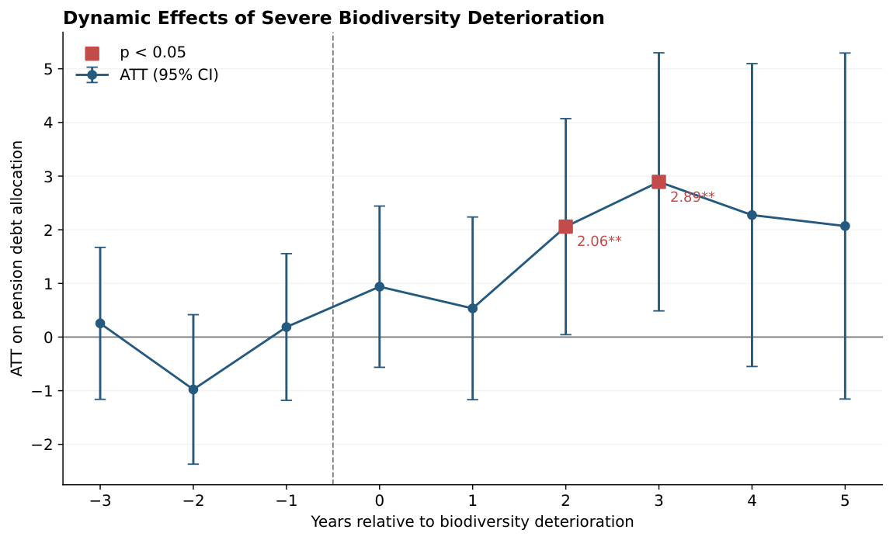
Figure 1. Dynamic effects of severe biodiversity deterioration on corporate pension debt allocation.
Notes: Preferred nine-control Stata csdid specification; 2004–2020, N = 12,243. Points are event-time ATTs and whiskers are pointwise 95% confidence intervals. Red squares indicate individual post-treatment coefficients with p < 0.05; dashed vertical line separates pre- and post-shock periods.

Table 3. Dynamic treatment effects: preferred Stata staggered DiD
Event time | ATT | SE | p-value | 95% CI
−3 | 0.256 | 0.723 | 0.724 | [−1.161, 1.672]
−2 | −0.976 | 0.711 | 0.170 | [−2.369, 0.417]
−1 | 0.188 | 0.698 | 0.788 | [−1.180, 1.555]
0 | 0.939 | 0.767 | 0.221 | [−0.564, 2.443]
+1 | 0.535 | 0.869 | 0.538 | [−1.168, 2.238]
+2 | 2.059 | 1.028 | 0.045 | [0.045, 4.073]
+3 | 2.893 | 1.228 | 0.018 | [0.488, 5.299]
+4 | 2.274 | 1.440 | 0.114 | [−0.549, 5.098]
+5 | 2.070 | 1.646 | 0.208 | [−1.155, 5.296]
Notes: Dependent variable: pnatd_w. Full nine-control specification. Pointwise inference; p-values are not adjusted for multiple comparisons.

4.2 Aggregated effects
Table 4 reports aggregate effects from the preferred Stata estimator. The dynamic post-treatment average is positive and significant at the 5% level (ATT = 1.795, p = 0.047), while the simple overall ATT is positive but imprecisely estimated (ATT = 1.288, p = 0.261). The values differ because the aggregation rules differ, rather than because the event-study coefficients are inconsistent. The variation across event time makes the dynamic profile useful for interpreting the findings.

Table 4. Aggregated effects: preferred Stata staggered DiD
Aggregation | ATT | SE | p-value | 95% CI
Simple overall ATT | 1.288 | 1.145 | 0.261 | [−0.956, 3.532]
Dynamic post-treatment average | 1.795 | 0.904 | 0.047 | [0.023, 3.567]
Dynamic pre-treatment average | −0.178 | 0.371 | 0.632 | [−0.905, 0.550]
Notes: Simple overall ATT is from estat simple; dynamic averages are from estat event, window(−3 5).

4.3 Supplementary entropy-balanced evidence
Figure 2 plots the cohort-specific entropy-balanced event-time estimates. The pre-treatment estimates at −3 and −2 are small relative to their uncertainty, while the omitted year −1 is the reference point. The event-time effect peaks at +2 (ATT = 3.900, p = 0.001). The year +3 estimate remains positive (ATT = 2.429), but is significant only at the 10% level (p = 0.091); the +4 and +5 estimates are also positive but not individually significant. The joint test of the two available pre-treatment effects yields χ²(2) = 0.383 (p = 0.826), which does not reject zero pre-treatment effects. These estimates support the main finding that the clearest positive association appears around the second and third years after the shock, subject to the conditional-inference qualification.
[INSERT FIGURE 2 HERE — Entropy-balanced event study; placed after its event-time interpretation.]
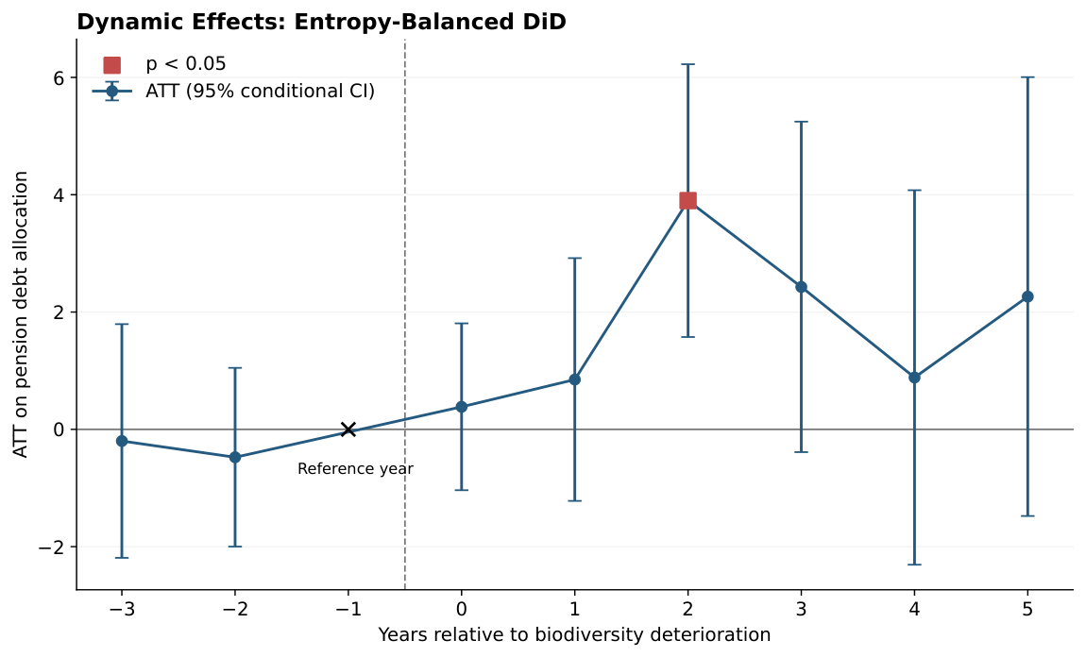
Figure 2. Dynamic effects from the cohort-specific entropy-balanced DiD.
Notes: Nine treatment cohorts (2007–2015); year −1 is an omitted reference, shown as a cross rather than an estimated ATT. Whiskers represent pointwise 95% conditional confidence intervals based on fixed entropy-balancing weights.
Figure 3 and Table 5 summarise the same supplementary estimates over post-treatment windows. The overall post-treatment ATT is 1.785 (p = 0.083). The immediate years 0–1 average is 0.617 (p = 0.429). The average for years +2 and +3 is 3.164 (p = 0.0095), with a 95% conditional confidence interval of [0.772, 5.556]. The broader +2 to +5 average is 2.369 (p = 0.078). Figure 3 shows the precision of these estimates: only the medium-term window has a 95% conditional confidence interval entirely above zero. These overlapping windows are descriptive aggregations, not independent tests.
[INSERT FIGURE 3 HERE — Entropy-balanced post-treatment windows; placed immediately before Table 5.]
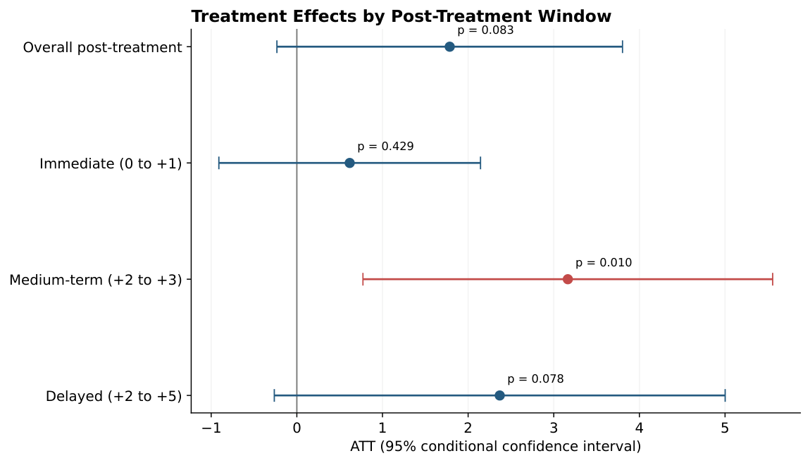
Figure 3. Entropy-balanced treatment effects across post-treatment windows.
Notes: Dots show average ATTs; horizontal whiskers show 95% conditional confidence intervals. The overall, immediate, medium-term and delayed windows overlap and should not be read as mutually exclusive samples.

Table 5. Supplementary entropy-balanced treatment effects
Window | ATT | Cond. SE | p-value | 95% CI
Overall (0 to +5) | 1.785 | 1.030 | 0.0829 | [−0.233, 3.803]
Immediate (0 to +1) | 0.617 | 0.779 | 0.4285 | [−0.910, 2.145]
Medium term (+2 to +3) | 3.164 | 1.221 | 0.0095 | [0.772, 5.556]
Delayed (+2 to +5) | 2.369 | 1.343 | 0.0777 | [−0.263, 5.001]
Notes: Conditional fixed-weight multiplier inference (999 draws). Original entropy weights and cohort support are not re-estimated.

4.4 Synthesis
The preferred staggered DiD and the supplementary entropy-balanced analysis point to a positive medium-term response in corporate pension debt allocation following severe biodiversity deterioration. The strongest evidence is concentrated around years +2 and +3 rather than the shock year itself. The simple overall Stata ATT is not statistically significant, and inference differs between estimators; the results are therefore best characterised as evidence of a dynamic response rather than a uniform post-treatment effect or a demonstrated causal mechanism.

Online Appendix: Supplementary event-time estimates

Table A1. Entropy-balanced event-time effects
Event time | ATT | Conditional SE | p-value
−3 | −0.199 | 1.016 | 0.8451
−2 | −0.475 | 0.777 | 0.5408
−1 | Reference | — | —
0 | 0.385 | 0.725 | 0.5959
+1 | 0.849 | 1.056 | 0.4211
+2 | 3.900 | 1.186 | 0.0010
+3 | 2.429 | 1.437 | 0.0911
+4 | 0.885 | 1.629 | 0.5871
+5 | 2.263 | 1.909 | 0.2357
Notes: Year −1 is omitted. Joint pre-treatment Wald test: χ²(2) = 0.383, p = 0.826. Conditional fixed-weight inference.
Additional code-review checks: (i) confirm the mapping from LOG_BIO_ALL_DOCS_COUNT_UNIQUE to disclosure_log_bio_all_docs_coun; (ii) verify the ln(1 + richness) transformation and fiscal-year merge; (iii) inspect the final occurrence-quality filters and year assignment; (iv) record GBIF download DOIs, the actual dictionary version and the final number of recovered firms; and (v) rotate any access credentials embedded in research scripts and replace them with environment variables.

Verification and reporting notes
Shock-construction steps and entropy-balancing details were checked against the available 01_Construct_Biodiversity_Variables.do and Part_C_M4_Sev5_Overall_Dynamic_Delayed_Complete.py programs. The Stata shock-construction program itself cautions that the reference period and onset rule should be checked against the final Python program; the inspected Python program uses the same 2004–2015 cutoff reference period and first-transition rule. The estimated cutoff is taken from the user-supplied Python output. This document does not independently reproduce the estimation from the underlying .dta file. The source files alone do not establish the precise GBIF geospatial extraction procedure or a causal mechanism; those aspects should be documented separately if required by the journal.

Table 2. Primary baseline regressions: disclosure and local genus richness (identical sample)
Variable | (1) Disclosure only | (2) Genus only | (3) Both
Biodiversity disclosure | 0.868***  (0.316) | — | 0.860***  (0.316)
Log rolling genus richness, 50 km | — | 4.439**  (1.856) | 4.416**  (1.849)
Firm size | -0.764  (1.201) | -0.517  (1.205) | -0.615  (1.198)
Pension size | -3.059***  (1.071) | -3.139***  (1.076) | -3.129***  (1.074)
Financial condition (Z-score) | -0.123  (0.240) | -0.121  (0.239) | -0.107  (0.240)
Pension funding | 20.943***  (3.073) | 20.938***  (3.084) | 21.100***  (3.080)
PBO / total assets | -1.765  (4.663) | -1.266  (4.663) | -1.226  (4.635)
Cash flow / total assets | 0.033  (2.138) | -0.112  (2.125) | 0.045  (2.121)
Five-year cash-flow volatility | 0.140  (10.096) | 0.722  (10.062) | 0.255  (10.088)
Firm fixed effects | Yes | Yes | Yes
Year fixed effects | Yes | Yes | Yes
Observations | 15,358 | 15,358 | 15,358
Firms | 1,324 | 1,324 | 1,324
R-squared | 0.6002 | 0.6006 | 0.6011
Table 3. Alternative 50-km biodiversity measures (four joint models)
Variable | (1) Species | (2) Genus | (3) Family | (4) Shannon
Biodiversity disclosure | 0.858***  (0.316) | 0.860***  (0.316) | 0.864***  (0.316) | 0.836***  (0.314)
Log species richness, 50 km | 2.682  (1.655) | — | — | —
Log rolling genus richness, 50 km | — | 4.416**  (1.849) | — | —
Log rolling family richness, 50 km | — | — | 4.178**  (2.053) | —
Rolling Shannon index, 50 km | — | — | — | 3.380**  (1.576)
Firm size | -0.650  (1.199) | -0.615  (1.198) | -0.687  (1.200) | -0.685  (1.197)
Pension size | -3.107***  (1.075) | -3.129***  (1.074) | -3.092***  (1.073) | -3.134***  (1.075)
Z-score | -0.115  (0.240) | -0.107  (0.240) | -0.108  (0.240) | -0.121  (0.239)
Funding | 21.052***  (3.081) | 21.100***  (3.080) | 21.073***  (3.075) | 21.111***  (3.075)
PBO / assets | -1.395  (4.650) | -1.226  (4.635) | -1.527  (4.652) | -1.688  (4.628)
Cash flow / assets | 0.037  (2.127) | 0.045  (2.121) | 0.051  (2.120) | -0.044  (2.125)
Cash-flow volatility, 5 years | 0.074  (10.074) | 0.255  (10.088) | 0.024  (10.072) | 0.086  (10.018)
Firm fixed effects | Yes | Yes | Yes | Yes
Year fixed effects | Yes | Yes | Yes | Yes
Observations | 15,358 | 15,358 | 15,358 | 15,358
Firms / clusters | 1,324 | 1,324 | 1,324 | 1,324
R-squared | 0.6006 | 0.6011 | 0.6008 | 0.6008
Within R-squared | 0.0267 | 0.0280 | 0.0272 | 0.0273
Table 4. Alternative controls and pension equity allocation
Variable | (5) Debt: A&C controls | (6) Equity: Rauh controls
Biodiversity disclosure | 0.974**  (0.470) | −0.585**  (0.294)
Rauh: firm size | — | −1.104  (1.041)
Rauh: pension size | — | 5.219***  (0.815)
Rauh: Z-score | — | −0.106  (0.254)
Rauh: funding | — | −15.465***  (2.528)
Rauh: PBO / assets | — | −3.338  (4.034)
Rauh: cash flow / assets | — | −0.553  (1.910)
Rauh: cash-flow volatility | — | 6.309  (9.171)
A&C: log market capitalisation | 0.529  (0.786) | —
A&C: leverage | 2.710  (3.651) | —
A&C: dividends / assets | 27.384  (16.677) | —
A&C: cash-flow volatility | 1.808  (1.248) | —
A&C: net operating loss indicator | −1.780  (1.522) | —
A&C: funding | 29.783***  (11.486) | —
A&C: funding squared | −8.318  (5.841) | —
A&C: pension horizon | 2.457***  (0.634) | —
Firm fixed effects | Yes | Yes
Year fixed effects | Yes | Yes
Observations | 7,196 | 15,299
Firms / clusters | 753 | 1,322
R-squared | 0.6456 | 0.6811
Within R-squared | 0.0306 | 0.0261
Notes: Coefficients with firm-clustered SEs in parentheses; *** p<0.01, ** p<0.05, * p<0.10. Models 5–6 have different effective samples despite sample_both restriction.
Notes: All three models use pnatd_w, seven Rauh controls, firm and fiscal-year fixed effects, and firm-clustered standard errors. Each has 15,358 observations and 1,324 firms. Table 3 presents alternative biodiversity measures; Table 4 presents alternative control and outcome specifications. Parentheses contain firm-clustered standard errors. * p < 0.10, ** p < 0.05, *** p < 0.01.

Appendix B reports the raw database variable names and the precise transformations visible in the supplied WRDS extraction code. Variables ending in _w were winsorised after the Python extraction; the source script does not specify winsorisation cutoffs or the Stata renaming, so these steps require confirmation. The script is a data-extraction and construction program, and does not establish that every optional downloaded field enters the estimation sample.

References added for biodiversity measurement
Akbari, A., Ng, L., Wang, T., and Zhu, N. (2025). Corporate Biodiversity Exposure and the Market Response to Earnings Announcements. ECGI Finance Working Paper No. 1086/2025 (December version).
Flammer, C., Giroux, T., and Heal, G. M. (2025). Biodiversity finance. Journal of Financial Economics, 164, 103987. https://doi.org/10.1016/j.jfineco.2024.103987
Giglio, S., Kuchler, T., Stroebel, J., and Zeng, X. (2026). Biodiversity risk. Review of Finance, 30, 131–161. https://doi.org/10.1093/rof/rfaf063
Lucey, B. M., Urquhart, A., and Vigne, S. (2025). Biodiversity, financial markets, and systemic risk: A synthesizing review. Journal of Climate Finance, 13, 100078. https://doi.org/10.1016/j.jclimf.2025.100078

Appendix B. Variable definitions and data sources
Definitions are transcribed or derived from the uploaded Stata code. Any formula, source dataset or transformation not established by that code is explicitly identified. Source labels distinguish GBIF-derived measures, Compustat accounting items, and researcher-constructed variables; disclosure-document collection provenance requires confirmation.
Regression / output variable | Raw field(s) | Exact construction or verification note | Data source
pnatd_w | pnatd | Direct Compustat pension debt-allocation percentage; Stata suffix _w indicates downstream winsorisation (cutoffs not in supplied Python). | WRDS Compustat comp.aco_pnfnda
pnate_w | pnate | Direct Compustat pension equity-allocation percentage; downstream winsorisation to confirm. | WRDS Compustat comp.aco_pnfnda
pnatr; pnato | pnatr; pnato | Direct real-estate and other pension asset-allocation fields; convenience aliases retained. | WRDS Compustat comp.aco_pnfnda
pension_allocation_total | pnate, pnatd, pnatr, pnato | Row sum of available allocation fields, min_count=1; descriptive check, not a baseline regressor. | WRDS Compustat pension; Python
rauh_size_w | at | SIZE_AT = ln(at) if at>0; subsequent Stata winsorisation. | WRDS Compustat comp.funda; Python
rauh_pension_size_w | pplao | LN_PENSION_ASSETS = ln(pplao) if pplao>0; subsequent winsorisation. | WRDS Compustat pension; Python
rauh_zscore_w | ebit, sale, re, act, lct, at | Z_SCORE_RAUH = 3.3×ebit/at + sale/at + 1.4×re/at + 1.2×(act−lct)/at, at>0; subsequent winsorisation. | WRDS Compustat funda; Python
rauh_funding_w | pplao, pbpro | FUNDING_STATUS_RAUH = (pplao−pbpro)/pbpro, pbpro>0; subsequent winsorisation. | WRDS Compustat pension; Python
rauh_pbo_assets_w | pbpro, at | PBO_TO_AT = pbpro/at, at>0; subsequent winsorisation. | WRDS Compustat pension and funda; Python
rauh_cf_assets_ta_w | ni, dp, ppc, at | RAUH_CASH_FLOW_TO_AT = (ni+dp+ppc)/at, at>0; subsequent winsorisation. | WRDS Compustat pension and funda; Python
rauh_sdcf_5y_w | oancf, at, gvkey, fyear | CFO_TO_LAG_AT = oancf / previous observed firm-year at; SD_CFO_RAUH_5Y = rolling five-observation sample SD (min_periods=5); subsequent winsorisation. | WRDS Compustat funda; Python
ac_size_w | mkvalt; prcc_f, csho | mve = mkvalt when positive, otherwise abs(prcc_f)×csho; SIZE_MVE = ln(mve), mve>0; subsequent winsorisation. | WRDS Compustat funda; Python
ac_leverage_w | dltt, mve | LEVERAGE_AC = dltt/(dltt+mve) if denominator>0; subsequent winsorisation. | WRDS Compustat funda; Python
ac_dividends_w | dv; dvc, dvp; at | DIVIDENDS_TA = dividends_total/at, at>0. dividends_total=dv if column exists; otherwise dvc+dvp if both exist, otherwise dvc. | WRDS Compustat funda; Python
ac_sdcf_w | oancf, ceq or seq, gvkey, fyear | CFO_TO_BOOK_EQUITY = oancf/ceq (or seq if ceq column absent), denominator>0; SDCF_AC = rolling five-observation sample SD, min_periods=5. | WRDS Compustat funda; Python
ac_nol_w | tlcf | NOL = 1 if tlcf>0; 0 if observed and not positive; missing if tlcf missing; subsequent winsorisation if applied. | WRDS Compustat funda; Python
ac_funding_w | pplao, pbpro | FUNDING_AC = pplao/pbpro, pbpro>0; subsequent winsorisation. | WRDS Compustat pension; Python
ac_funding2_w | pplao, pbpro | FUNDING_AC2 = (pplao/pbpro)^2 using the un-winsorised funding ratio; later processing to confirm. | WRDS Compustat pension; Python
ac_horizon_w | pbpro, ppsc | HORIZON = ln(pbpro/ppsc), both strictly positive; subsequent winsorisation. | WRDS Compustat pension; Python
LEVERAGE_TA | dltt, dlc, at | (zero-filled dltt + zero-filled dlc)/at, at>0; supplementary variable, not in reported baseline. | WRDS Compustat funda; Python
CFO_TO_AT | oancf, at | Operating cash flow / total assets if at>0; supplementary variable. | WRDS Compustat funda; Python
NO_SP_CREDIT_RATING | splticrm | Indicator equal to one if raw S&P credit rating is missing; generated only when splticrm column exists. | WRDS Compustat funda; Python
MARKET_RETURN_CRSP | vwretd; date or caldt | Calendar-year compounded monthly value-weighted CRSP index return: ∏(1+vwretd_m)−1; optional and not a baseline regressor. | WRDS CRSP msi / crsp_a_stock.msi
disclosure_log_bio_all_docs_coun | SEC filing sentences; BIO_ALL_DOCS_COUNT_UNIQUE | Candidate mapping: LOG_BIO_ALL_DOCS_COUNT_UNIQUE = ln(1+count of unique biodiversity-matched sentences); exact Stata renaming to verify. | SEC EDGAR 10-K, 10-Q, 8-K, DEF 14A; disclosure Python V7.1
ln_gbif_roll_genus_rich_50km | GBIF genusKey; occurrence year; latitude/longitude | ln(1+number of distinct genera in 10-year rolling window within 50 km of geocoded headquarters). | GBIF; GBIF Python V7/V8
ln_gbif_rich_50km | GBIF speciesKey; occurrence year; latitude/longitude | ln(1+species richness within 50 km); confirm exact rolling source field for this Stata name. | GBIF; GBIF Python V7/V8
ln_gbif_roll_family_rich_50km | GBIF familyKey; occurrence year; latitude/longitude | ln(1+distinct families in rolling ten-year window within 50 km). | GBIF; GBIF Python V7/V8
gbif_roll_shannon_index_50km | GBIF speciesKey, occurrence records | −Σ_s p_s ln(p_s) with p_s = share of species-identified occurrence records within 50 km, rolling ten-year window. | GBIF; GBIF Python V7/V8
sev5_50; g_sev5_50 | GBIF annual species richness, firm ID, year | Severe shock = bottom 5% of 3-year cumulative log-richness change; g_sev5_50 = first shock cohort. Exact final derivation follows the shock-construction program, not the WRDS script. | GBIF; researcher shock-construction code
records_lag1; records_cum3_pre | GBIF occurrence record counts, year | Observation-effort covariates for DiD; exact lags, cumulative window and transformations require shock-code verification. | GBIF; researcher
gvkey; cik; fyear; id | gvkey, cik, datadate, fyear | GVKEY is merge key; CIK matches EDGAR; pension year = year(datadate), funda year = reported fyear if available; id is downstream numeric firm index. | WRDS Compustat; Python/Stata

