LABORATORY EXERCISE 1

INITIALIZING A PROJECT USING CODEIGNITER WITH BOOTSTRAP INTEGRATION AND GITHUB VERSION CONTROL

Learning Objectives
By the end of this laboratory exercise, students should be able to:
- Learn how to install and configure CodeIgniter as a PHP framework for web application development.
- Understand the integration of Bootstrap for creating responsive and user-friendly web interfaces.
- Develop skills in setting up a project folder structure and linking CodeIgniter with Bootstrap templates.
- Gain practical experience in using GitHub for version control and project collaboration.
- Apply best practices for project initialization and version tracking in a development environment.

Prerequisite student experiences and knowledge
Before starting this exercise, students should have:
- Basic understanding of HTML, CSS, and PHP.
- Familiarity with databases and MySQL basics.
- Experience using a local web server (XAMPP/WAMP/LAMP).
- Knowledge of basic Git commands and GitHub usage.
- Ability to use a text editor/IDE such as Visual Studio Code.

Background
This exercise introduces students to initializing a web project using the CodeIgniter framework, a lightweight PHP MVC framework known for speed and simplicity. The integration of Bootstrap ensures that the project interface is responsive and visually appealing. Furthermore, using GitHub provides students with a professional approach to version control, ensuring project tracking, collaboration, and code management.

Materials/Resources
- Personal Computer with Internet Access
- XAMPP/WAMP/LAMP server installed
- CodeIgniter Framework (latest version)
- Bootstrap (via CDN or downloaded files)
- Visual Studio Code or any code editor
- Git and GitHub Account
- Web Browser (Chrome, Firefox, etc.)

Laboratory Activity
Step 1: Environment Setup
- Install and configure XAMPP/WAMP on your machine.
- Download and extract the latest version of CodeIgniter from your `htdocs` (XAMPP) or `www` (WAMP) directory.
- Rename the folder as ` ITE311-LASTNAME`.
- Run your local server and test the CodeIgniter installation by accessing:
http://localhost/ ITE311-LASTNAME

Step 2: Initialize Git Repository
- Open the project folder in your terminal or Git Bash.
- Run the following commands:
git init
git add .
git commit -m "Initial commit - CodeIgniter setup"
- Create a new repository on GitHub named WebSystem-ITE311.
- Link your local project to GitHub:
git remote add origin https://github.com/yourusername/ WebSystem-ITE311.git
git push -u origin main

Step 3: Integrate Bootstrap
- Download Bootstrap from [https://getbootstrap.com](https://getbootstrap.com) or use the CDN links.
- Navigate to `application/views` and create a new file `template.php`.
- Add Bootstrap CDN inside your template's `<head>` section.
- Test by creating a simple navigation bar using Bootstrap classes.

Step 4: Create a Home Controller and View
- Navigate to `application/controllers` and create a file named `Home.php`.
- Insert the following code:
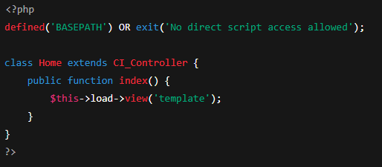
- In your browser, visit: http://localhost/ITE311-LASTNAME /index.php/home
- Open your web browser and navigate to http://127.0.0.1:8000 to see your basic homepage.

Step 5: Push Update Project to GitHub
- After Bootstrap integration and controller creation, push changes:
git add .
git commit -m "Added Bootstrap template and Home controller"
git push
Step 6: Push Update Project to GitHub
- Take screenshots of your running home page and GitHub repository.
- Insert them in your lab report under “Output/Results.”

Output / Results
- Screenshot of successful CodeIgniter setup.
- Screenshot of integrated Bootstrap layout.
- Screenshot of GitHub repository with pushed commits.
- The instructional manual should be printed, and the softcopy uploaded at the time of checking.

QUESTIONS:
- Why is it important to integrate Bootstrap when developing a web project in CodeIgniter?
- Integrating Bootstrap is important because it provides pre-designed and a responsive components saving development and time ensure its consistency across devices additionally in the CodeIgniter cab handled backend logic, in that bootstrap can also take care of frontend presentation creating solution.

- How does using GitHub improve the development and management of web applications?
- Github improves development and management where it provides a version control that tracks all changes, collaborating among members/teams and offering backup project. Also integrates a various development tools and provides issue tracking for project management.

- What steps did you perform to successfully set up and test the CodeIgniter framework on your local server?

- First is installing XAMPP for the local server environment
- Second is downloading and extracting CodeIgniter
- Third is renaming the folder appropriately to ITE311-ALBERCA
- Fourth is initializing the Git version control
- Fifth is integrating bootstrap in CDN template file
- Sixth is creating a Home Controller and View
- Seventh is testing the setup by accessing through wed browser where framework and bootstrap are work together

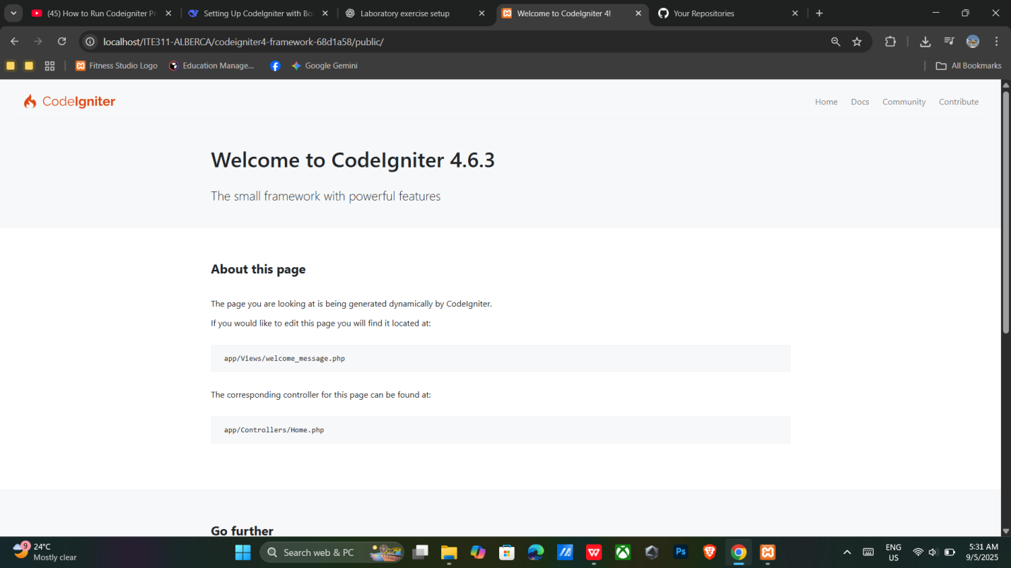
Output / Result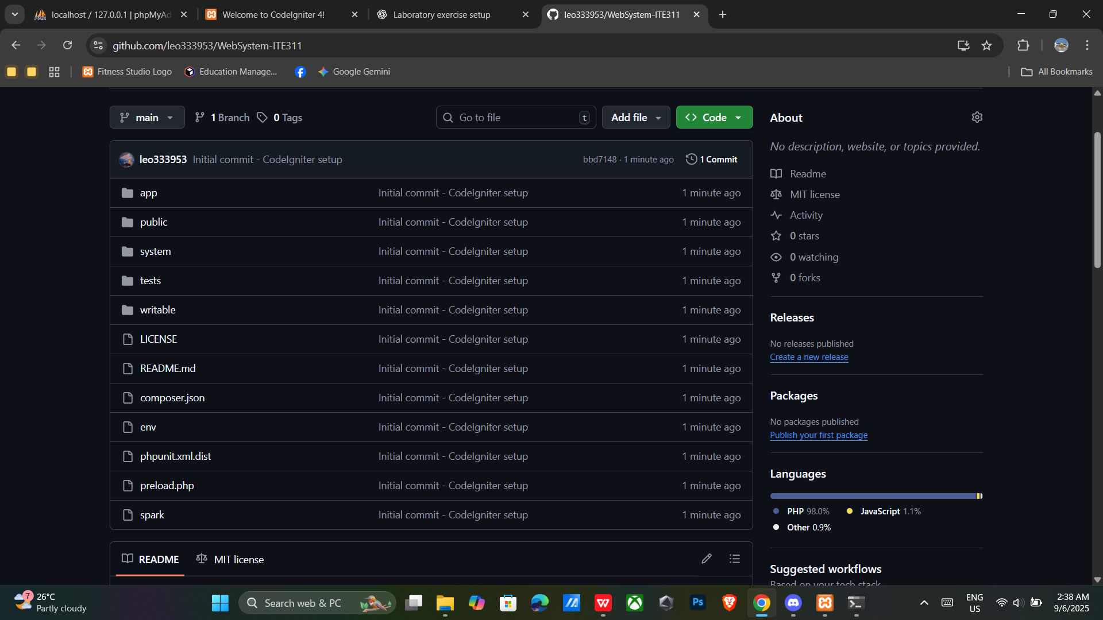

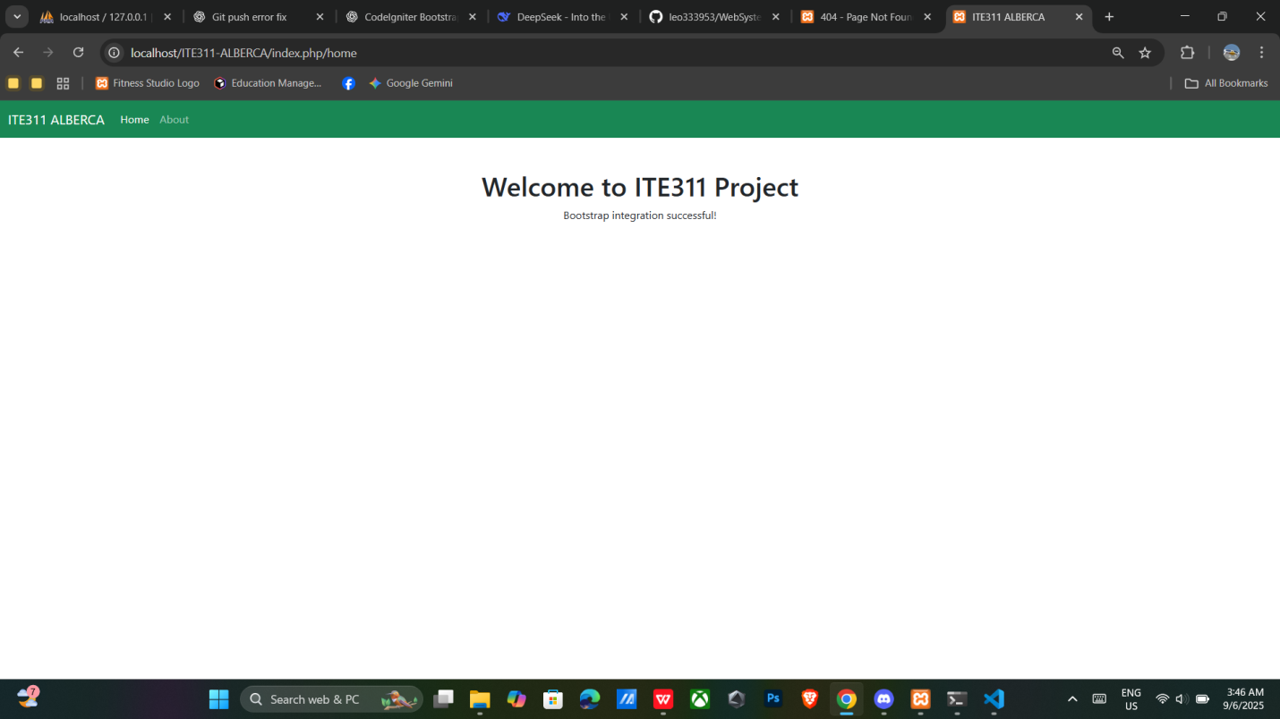
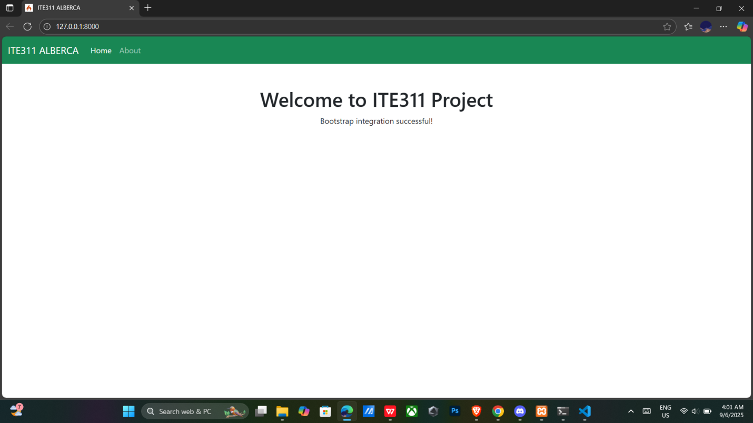

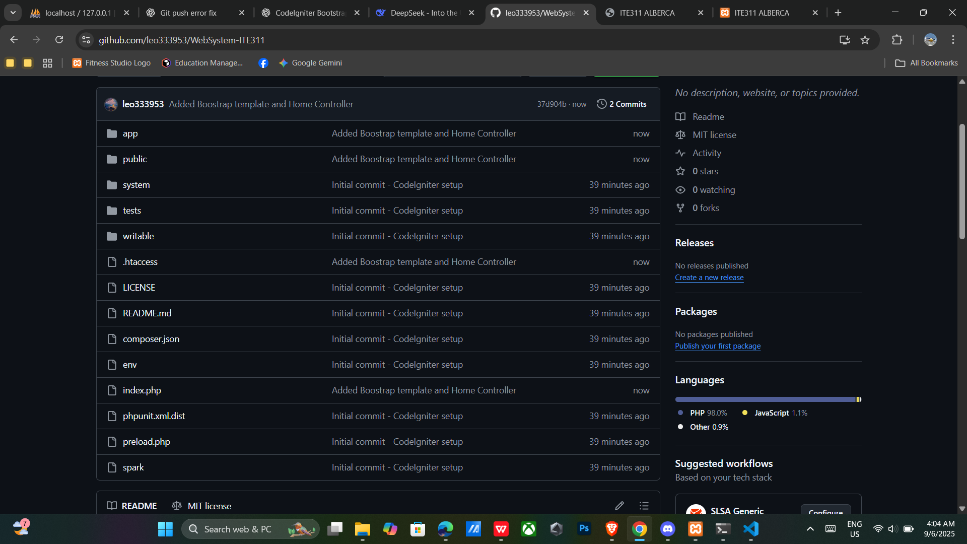

Conclusion

Integrating Bootstrap into a CodeIgniter project is essential, as it provides pre-designed, responsive components that save development time and ensure consistent design across all device sizes. Its mobile-first framework and utility classes enable quick UI development and prototyping, while CodeIgniter, with its lightweight MVC architecture, simplifies backend logic through features like routing, form validation, and database management. Together, they allow for the creation of clean, functional, and scalable web applications. Additionally, GitHub plays a crucial role in streamlining development by offering version control, collaboration tools, change tracking and integration with project management and deployment tools, making the overall workflow more organized, secure, and efficient.

