**Code and data online**

Github repo for all the data and mined association rules:

<https://github.com/leo42k/CourseRecommenderApp>

App link on jhubiostatistics.shinyapps.io:

<https://jhubiostatistics.shinyapps.io/courserecommenderapp>

No raw data stored online. We mined all interesting rules and store these rules.

**Why this app?**

There are a growing number of courses available in the Johns Hopkins University School of Public health. How do you decide which course is right for you? Different requirements vary from program to program. Besides, the course descriptions are usually concise and content is not available unless you have registered for that class. Currently, no similar app has been developed to our knowledge in JHSPH. Therefore, we develop a course recommendation app for students to help select their courses.

It’s free online and it’s open to everyone. For prospective students, they can use this app to search for their interested programs and get additional information about the curriculum plan. As for current students, it provides an alternative way to get recommended courses based on previous courses selected by peers from the same program.

**How to use this app: a user manual**

There are two main tabs on the app: the preference settings and the Recommender.

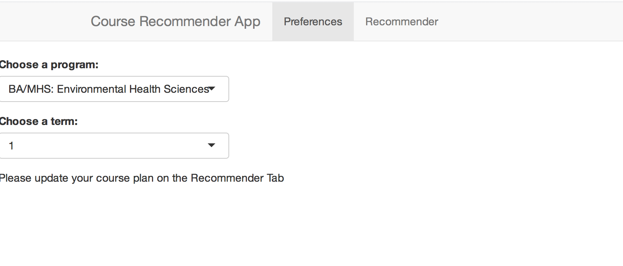

**1. “Preferences” tab**

Under the “Preferences” tab, users can search and select the program they are interested in and the term they need course recommendations for.

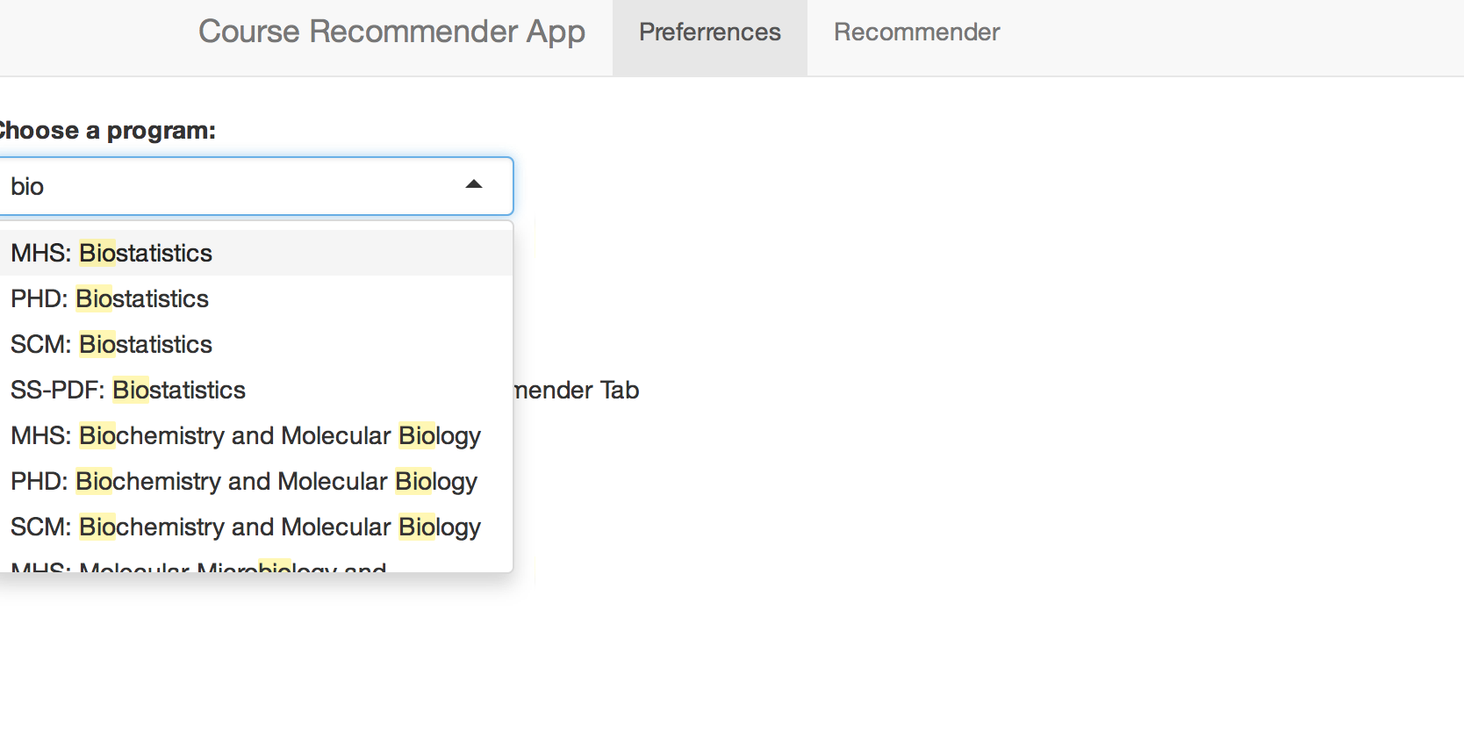

For example, we could choose “PHD: Biostatistics” and the 2nd term.

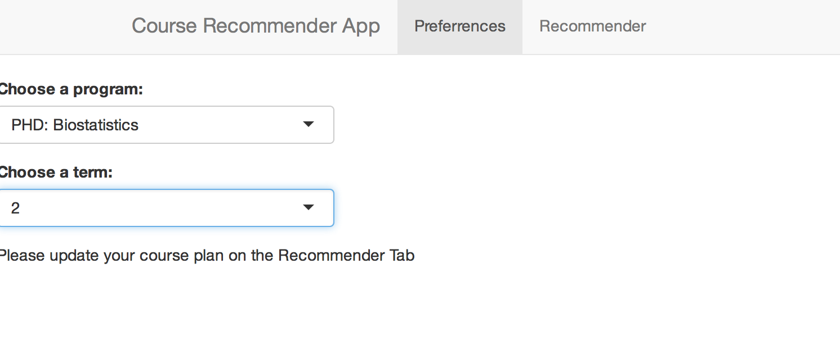

**2. “Recommender” tab**

After selecting program and term, the Recommender tab will provide the main functionalities of the recommender.

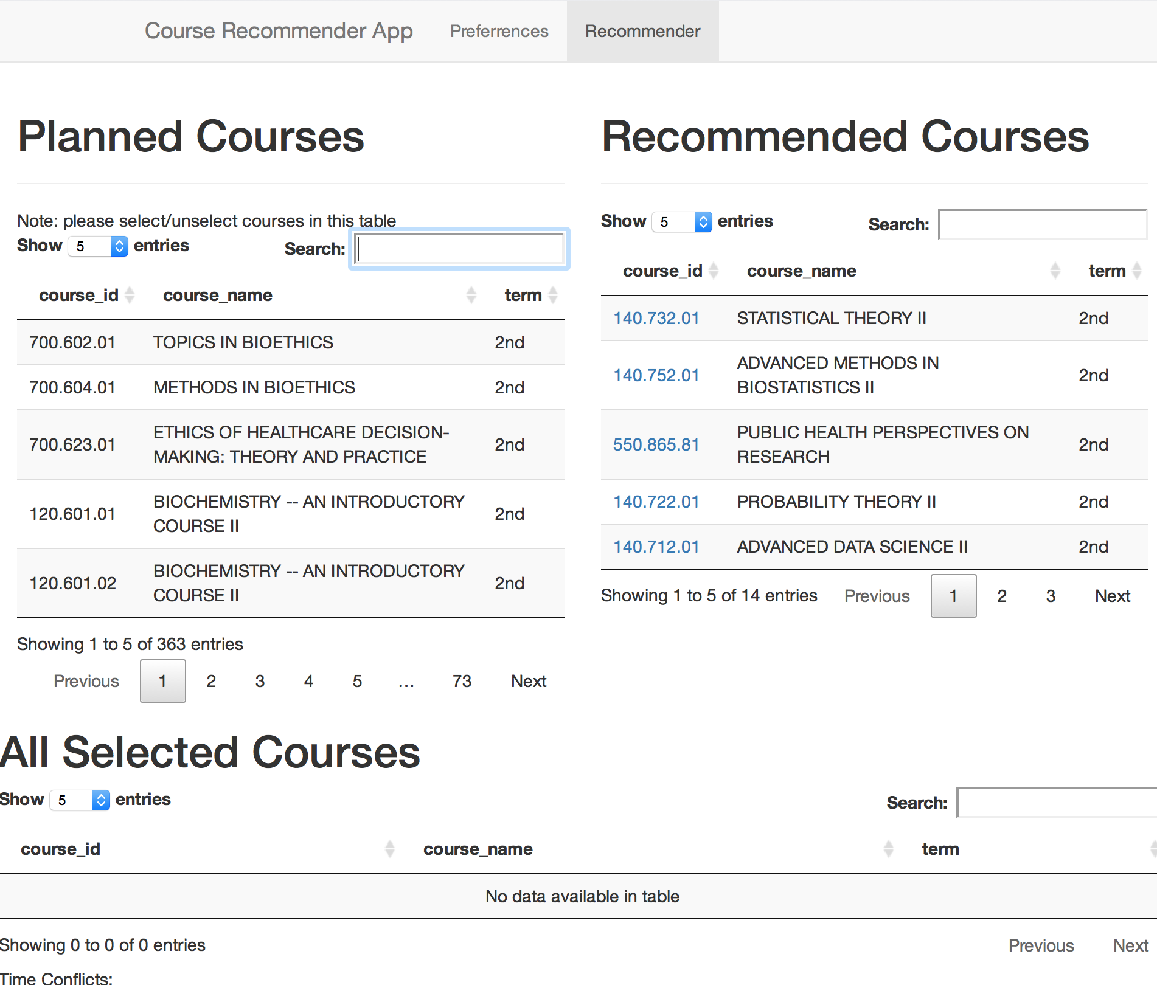

**2.1 “Planned Courses” area**

The upper left is “Planned Courses”.

Users are allowed to search, select and unselect courses for their plan.

**2.2 “Recommended Courses” area**

The upper right is “Recommended Courses”.

The courses users have selected will be crossed out so that they could easily view other recommendations.

Links to the course websites are provided in the “Recommended Courses” and “All Selected Courses” area. Users can click on any course number they are interested in and visit the course website.

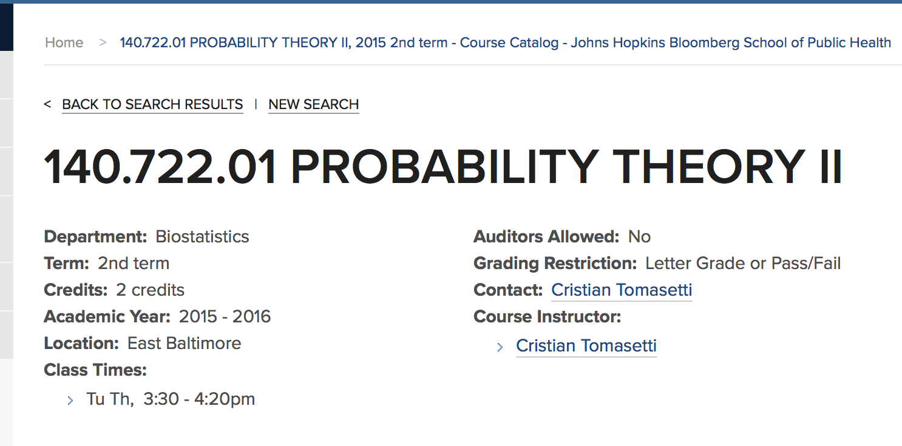

Recommendations are updated with every change in the “Planned Courses” area. For example, users can select “ADVANCED DATA SCIENCE II” in the “Planned Courses”. It is then crossed out in the recommendation area.

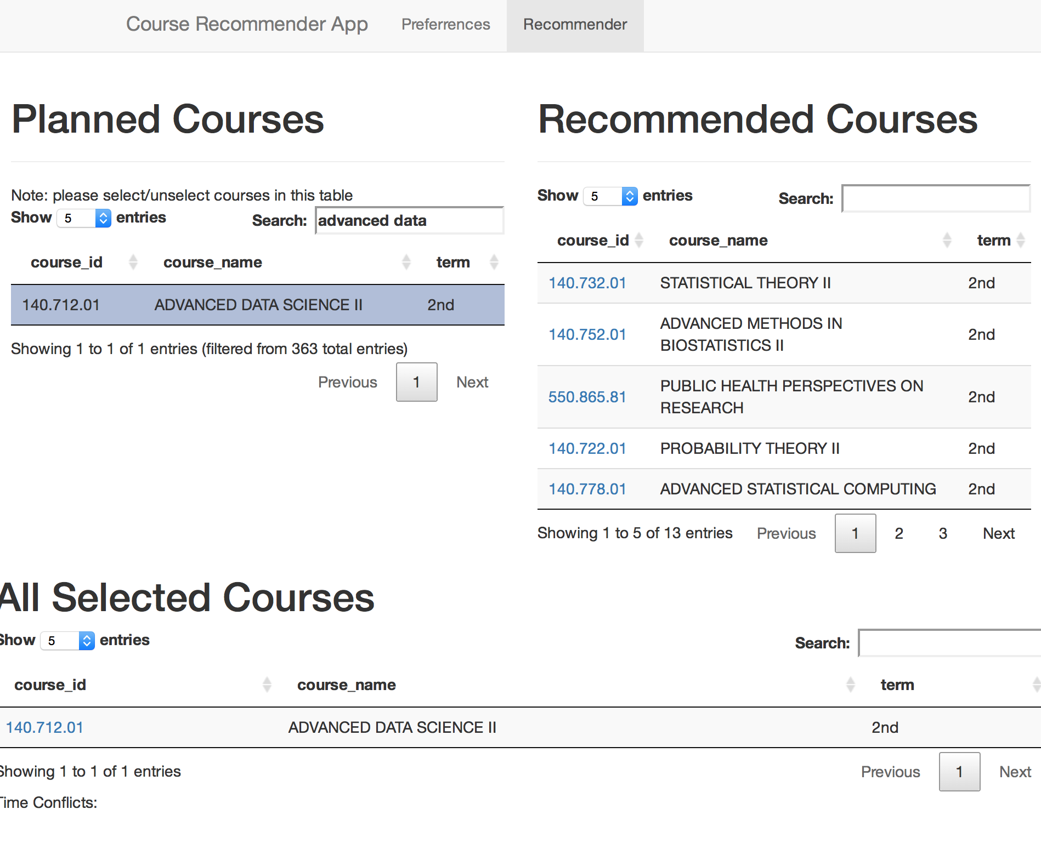

Another functionality is when users choose some course that is in the mined association rules the associated courses in that rule will be prioritized in the recommendations. For example, if a user chooses “STATISTICAL THEORY II”, then a probability course will be prioritized.

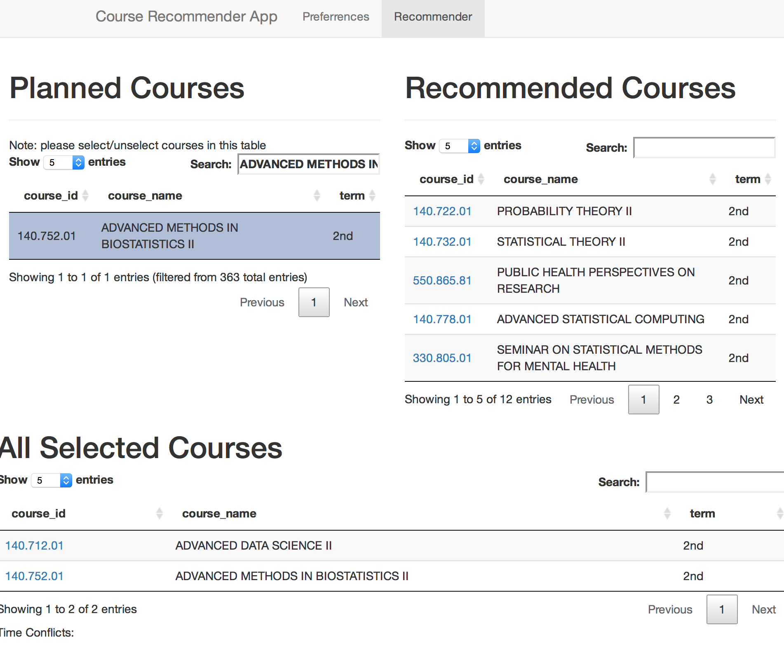

**2.3 “All Selected Courses” area**

The lower half is “All Selected Courses”.

Links to the course websites are provided in the “Recommended Courses” and “All Selected Courses” area.

The scheduling function is also provided in the “All Selected Courses” area. When there is time conflict between courses, the conflicted courses will be listed below. The courses selected later by users will rank higher in the “Time Conflicts” area so that they can easily decide whether keep the latest selected course.

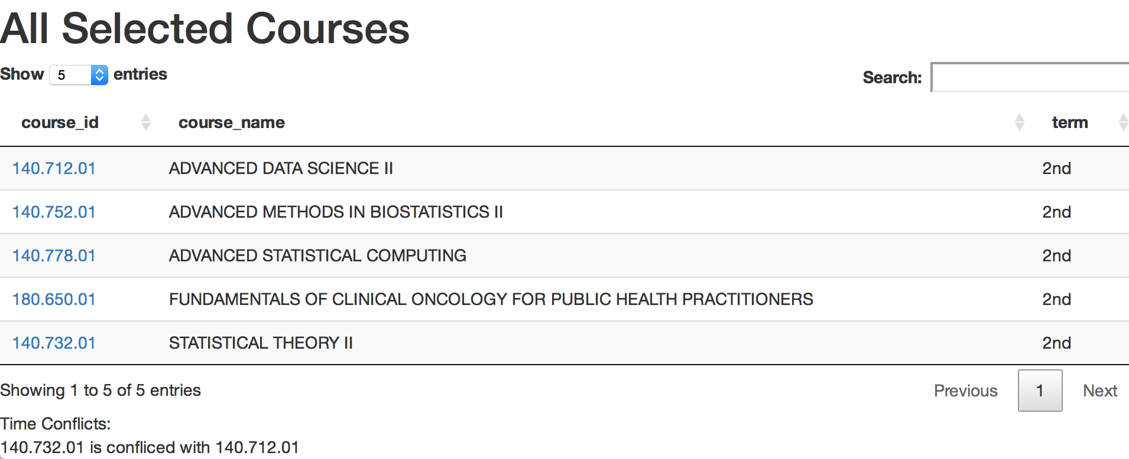

**Algorithms and discussions**

Our raw data consists of course enrollment information of 2015-2016 academic year for all JHSPH students. We have for each person, a random ID, the academic program he/she is in, all courses he/she takes for this academic year and the corresponding term of each course. We apply association rule mining method to this dataset to find “interesting rules”. Then we give recommendation based on the mined rules. We implement the association rule mining using R package “arules”, which applies “Apriori” algorithm to find the association rules.

The main functions of our App:

* Course recommendation: User select his academic program and current term. Then select courses he is interested in taking for the current term. Our App recommend courses he may also want to consider to take for the current term.
* Time conflict: Check if the recommended courses have time conflict.

Discussion:

Depends on what data we would be able to collect in the future, our future work may include:

* Extend our App to flexibly handle multi-year enrollment data. Need to make sure data of different years are consistent (e.g. Deal with bi-yearly courses or change time schedule of the same class).
* Extend our App to predict courses for next term based on current term preference. Need to develop new algorithm for prediction.