🚗 HH ASIA TYRE
Customer Getting Started Guide

Complete Step-by-Step Guide to Booking Your Appointment Online

https://hh-asia-tyre.vercel.app

Version 1.0 | April 2026

Table of Contents
1. Welcome to HH Asia Tyre
2. Quick Start - Book in 3 Minutes
3. Step 1: Choose Your Branch
4. Step 2: Enter Vehicle Details
5. Step 3: Select Your Services
6. Step 4: Pick Date & Time
7. Step 5: Enter Your Information
8. Step 6: Review & Confirm
9. Our Branch Locations
10. Services We Offer
11. Understanding Booking Status
12. Frequently Asked Questions
13. Need Help?

1. Welcome to HH Asia Tyre
HH Asia Tyre is your trusted automotive service partner with 6 branches across Metro Manila, Cavite, and Ilocos Norte. We specialize in tire services, oil changes, brake inspection, battery replacement, and general auto repair.

What You Can Do Online:
- Book appointments at any of our 6 branches
- Choose your preferred date and time
- Select specific services you need
- Get instant confirmation via email/SMS
- Track your booking status

Our Website Homepage
Visit https://hh-asia-tyre.vercel.app to get started:
Figure 1: HH Asia Tyre Homepage

2. Quick Start - Book in 3 Minutes

For First-Time Users:
Step 1: Visit our website
Go to: https://hh-asia-tyre.vercel.app
Step 2: Click "Book Now"
Located in the top navigation bar or homepage hero section
Step 3: Fill in 4 quick steps
Choose branch → Select services → Pick date & time → Enter your info
Step 4: Submit & Wait for Confirmation
You'll receive a booking reference number!

💡 Tip: Bookmark our website or install our mobile app for quick access!

3. Step 1: Choose Your Branch
When you click "Book Now", you'll see the branch selection screen. First, choose your region, then select a specific branch.

What You'll See:
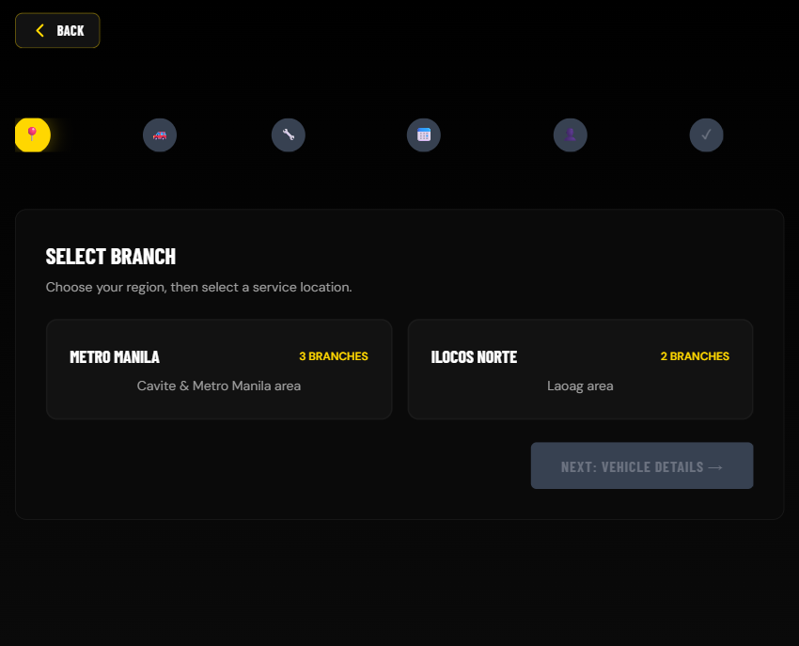
Figure 2: Region and Branch Selection

Available Regions:
Manila: Shows 5 branches (Alabang, Bicutan, Bacoor, Sucat x2)
Laoag: Shows 1 branch (Laoag City)

How to Select a Branch:
1. Click on your region (Manila or Laoag)
2. A list of branches will appear
3. Click on your preferred branch
4. Review branch details (address, hours, services)
5. Click "Next: Choose Services"

💡 Tip: All 6 branches are now open for online booking!

4. Step 2: Enter Vehicle Details
Next, enter your vehicle information so our technicians know what they'll be working on.
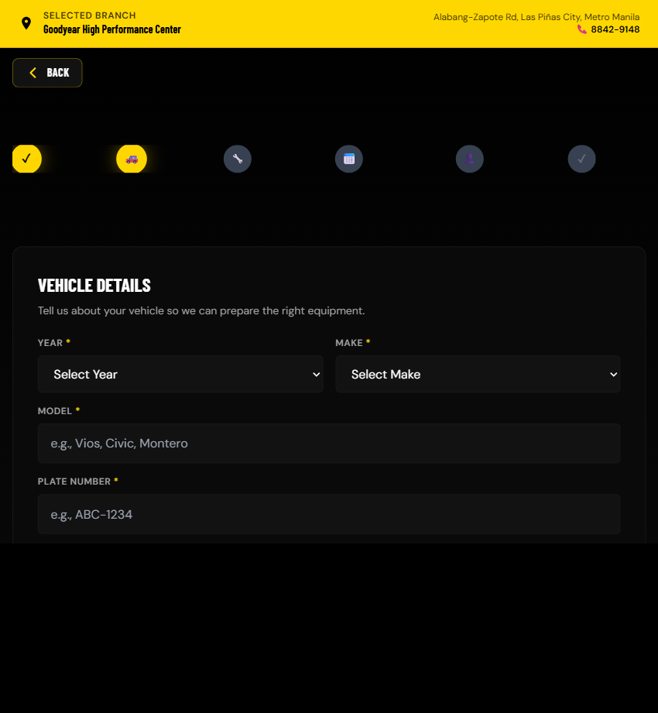
Figure 3: Vehicle Information Form

Required Information:
Field | Example
Year | 2024
Make | Toyota
Model | Fortuner
Plate Number | ABC 1234

5. Step 3: Select Your Services
Choose the services you need. You can select multiple services for your appointment.
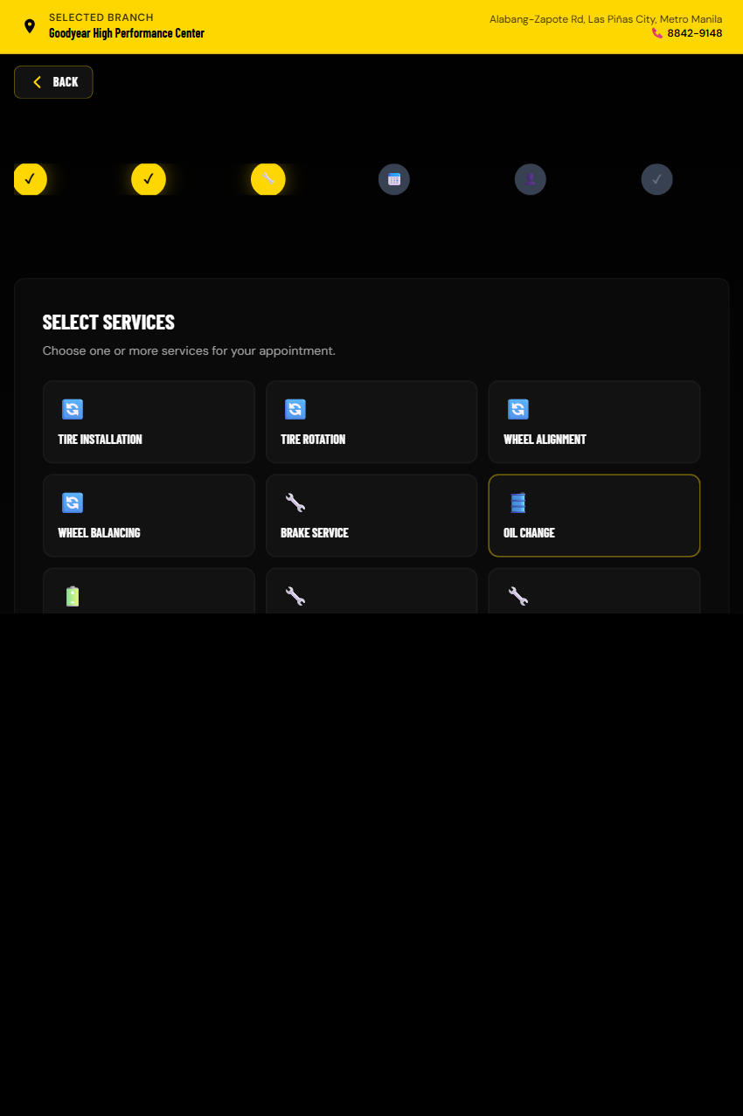
Figure 4: Service Selection

Available Services:
Service | Description | Est. Time
Tire Rotation | Even tire wear for longer life | ~30 min
Oil Change | Full oil & filter replacement | ~20 min
Brake Inspection | Safety check for brake system | ~45 min
Battery Replacement | Test & replace old batteries | ~30 min
Tire Replacement | New tires installation | ~45 min
General Maintenance | Multi-point vehicle check | ~60 min

⚠️ Note: Selecting multiple services may affect your appointment duration.

6. Step 4: Pick Date & Time
Choose your preferred appointment date and time. Available slots are shown in green.
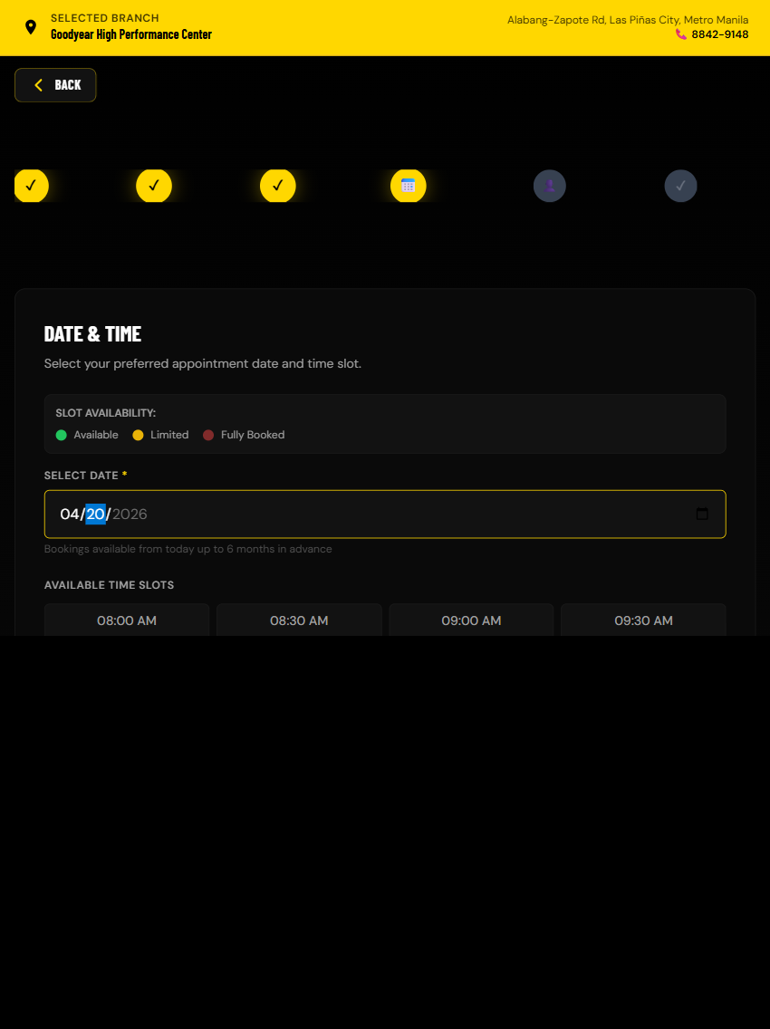
Figure 5: Date and Time Slot Selection

Available Options:
Dates: Today up to 6 months in advance
Times: 8:00 AM to 5:00 PM (hourly slots)

Understanding Time Slot Status:
Status | Color | Meaning
Open | Green | Available - Book now!
Full | Red | Already booked - Choose another time
Past | Gray | Time has passed - Cannot select

⚠️ IMPORTANT: Only 1 customer can book each time slot. Once booked, the slot shows "Full" immediately.

7. Step 5: Enter Your Information
Provide your contact details so we can send you booking confirmation and updates.
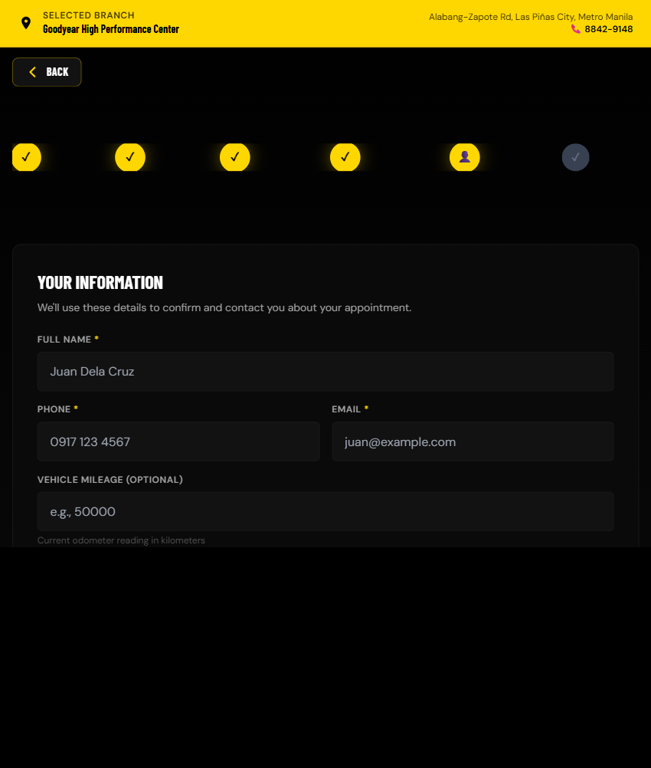
Figure 6: Customer Information Form

Required Information:
Field | Example
Full Name | Juan Dela Cruz
Email Address | juan.delacruz@email.com
Phone Number | 0917 123 4567
Vehicle Year | 2024
Vehicle Make | Toyota
Vehicle Model | Fortuner
Plate Number | ABC 1234

Validation Rules:
- Email must be valid format (name@domain.com)
- Phone must be Philippine number (starts with 09 or +63)
- Plate number is required

8. Our Branch Locations
We have 6 branches ready to serve you:

Metro Manila & Cavite (5 Branches)
Branch | Location | Phone | Hours
Alabang | Parañaque | 8334-2858 | Mon-Sat 8AM-6PM
Bicutan | Taguig | [Phone] | Mon-Sat 8AM-6PM
Bacoor | Cavite | (046) 417-8415 | Mon-Sat 8AM-6PM
Sucat (Goodyear) | Parañaque | 8828-8050 | Mon-Sat 8AM-6PM
Sucat (GT Radial) | Parañaque | 8828-8050 | Mon-Sat 8AM-6PM

Ilocos Norte (1 Branch)
Laoag City - Goodyear Servitek
Address: Bacarra Road, Laoag City, 2900 Ilocos Norte
Phone: (077) 772-3456 | 0917 123 4567
Hours: Mon-Sat 8AM-5PM

9. Understanding Booking Status
After submitting your booking, you can track its status. Here's what each status means:
Status | Icon | What It Means
Pending | ⏳ | Waiting for admin approval
Approved | ✅ | Confirmed, bay assigned
In Progress | 🔧 | Service being performed
Completed | ✓ | Service finished
Rejected | ❌ | Booking declined (see reason)
Cancelled | 🚫 | Booking cancelled by you or admin

10. Frequently Asked Questions
Q: How far in advance can I book?
A: You can book from today up to 6 months in advance.

Q: Why can't I select a time slot?
A: The slot is either already booked (shows "Full" in red), in the past (shows "Past" in gray), or outside operating hours.

Q: Can I book multiple services?
A: Yes! Select all services you need. The branch will estimate total time.

Q: How do I know my booking was successful?
A: You'll see a confirmation page with booking reference, receive email confirmation, and get SMS notification (if enabled).

Q: Do I need to pay when booking?
A: No payment is required to book. Pay at the branch after service.

Q: Can I book same-day appointments?
A: Yes! If there are available time slots remaining.

Q: What if I didn't receive my confirmation email?
A: Check your spam/junk folder, wait 5-10 minutes for email delays, verify you entered the correct email, or contact the branch to confirm booking.

11. Need Help?

Contact Us:
General Inquiries:
📧 Email: support@hh-asia.com
📞 Phone: (02) 8123-4567
💬 Viber: [Viber number]

Support Hours:
Monday - Saturday: 8:00 AM - 6:00 PM
Sunday: Closed

🚨 Emergency Roadside Assistance:
Hotline: 0917-HH-TYRE (0917-448-973)
Available 24/7 for emergencies

Thank you for choosing HH Asia Tyre! 🚗✨

Your trusted partner in automotive care

