Case A: Initial Condition (which is same as CaseB and Case C)

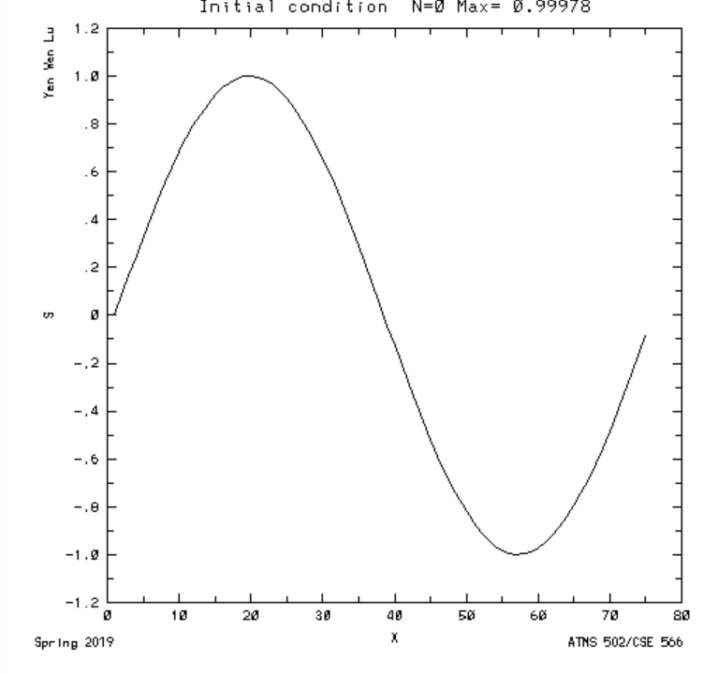

Case A: Time step = 50, S vs space

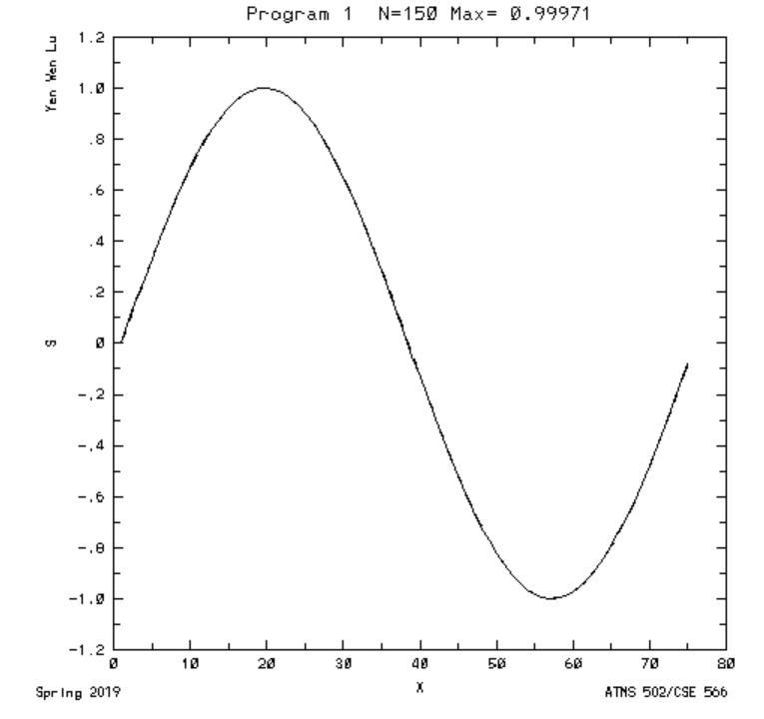

Case A: Smax vs time

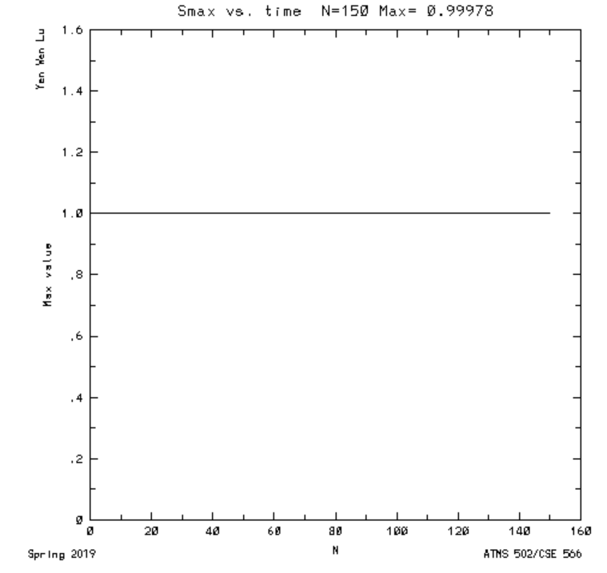

Case B: Time step = 90 (blowing up), S vs space

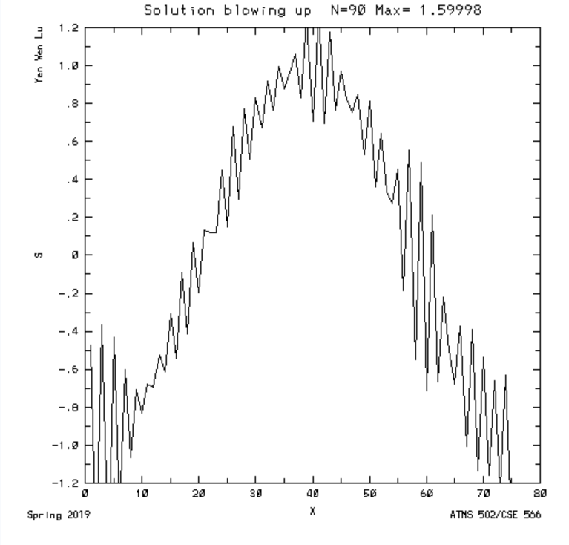

Case B: Smax vs time

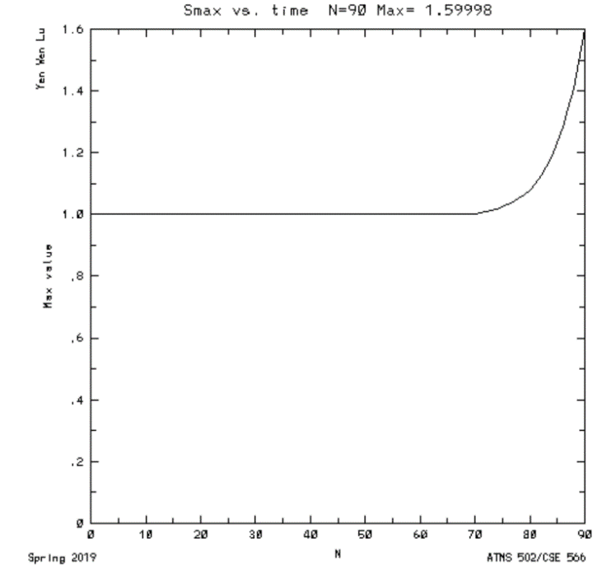

Case C: Time step = 20, S vs space

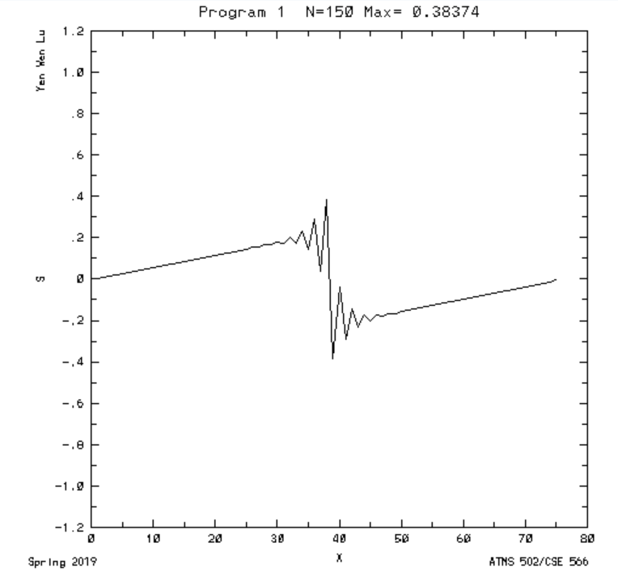

Case C: Smax vs time

