Homework 3

Computational Methods for Data Science

r11946013 簡立誠

Q1.

Q2.

Q3.

(a)

“h” will modify the probability of the points generated inside the area. Thus, if h increases, it takes more epochs to converge to .

“n” for estimating by calculating the ratio of the points generated inside the circle. Thus, the large “n” is, the more precise is.

(b)

The method finds a new point based on the previous simulated point, which may cause bias of the estimation.

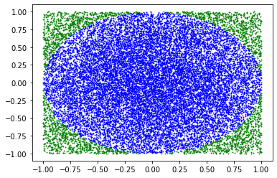For example, the following figure is the simulation of the given method, and is 3.4619 with generated 23109 points.

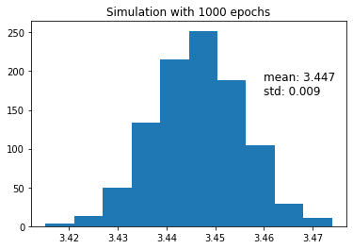

(c)

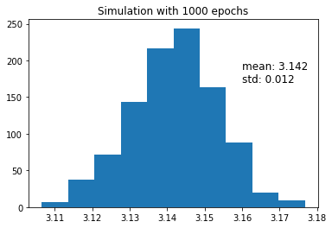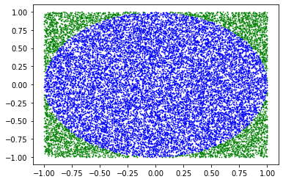the following figure is the simulation of my method, and is 3.136. And there is the histogram of estimation for 1000 epochs simulation. It shows that my method can accurately estimate which is close to 3.14.

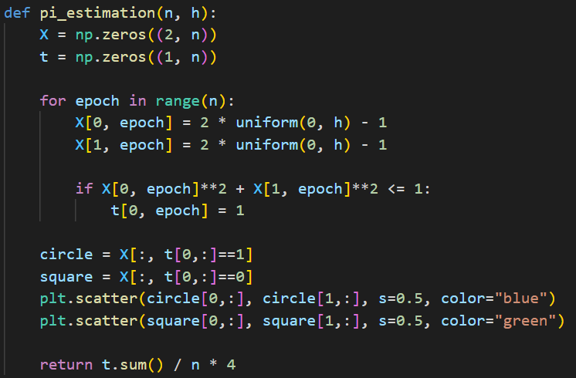code:

Q4.

Q5.

Q6.