**S&DS 363/563 and FES 758**

**Multivariate Statistics** **Homework #2**

**Principle Components Analysis**

**Due : Tuesday, 2/13/18 11:59pm on CANVAS**

***Be sure to check out sample programs in SAS and R at the bottom of the syllabus page***

[***http://reuningscherer.net/stat660/***](http://reuningscherer.net/stat660/)

*Answers should be complete and concise. You should turn in typed solutions. If you are working in a group, you may turn in one problem set per group (list all group members). If you want to insert equations into MS Word, use Insert 🡪 Objects 🡪 Microsoft Equation Editor 3.0. You may use any statistics program for calculations that you wish.*

**SAMPLE DATA SET**

**The example below is JUST FOR YOUR PRACTICE. NOTHING TO TURN IN HERE!**

The data set AirPollution.xls is an excel file that contains weather/pollution measurements on 42 consecutive days at one site in Los Angeles. Each day, measurements were taken at precisely 12 noon. There are seven variables :

Wind

Solar Radiation

Carbon Monoxide

Nitrogen Oxide

Nitrogen Dioxide

Ozone

Hydrogen Chloride

Your goal is to see if these measurements can be summarized in fewer than seven dimensions.

1). Compute the correlation matrix between all variables (SAS and SPSS will provide this for you as part of the PCA procedure – in SPSS, click on DESCRIPTIVES, in R use the cor() function.). Comment on relationships you do/do not observe.

**Correlation Matrix**

|  |  |  |  |  |  |  |  |  |
| --- | --- | --- | --- | --- | --- | --- | --- | --- |
|  |  | Wind | Radiation | CO | NO | NO2 | O3 | HC |
| Correlation | Wind | 1.000 | -.101 | -.194 | -.270 | -.110 | -.254 | .156 |
| Radiation | -.101 | 1.000 | .183 | -.074 | .116 | .319 | .052 |
| CO | -.194 | .183 | 1.000 | .502 | .557 | .411 | .166 |
| NO | -.270 | -.074 | .502 | 1.000 | .297 | -.134 | .235 |
| NO2 | -.110 | .116 | .557 | .297 | 1.000 | .167 | .448 |
| O3 | -.254 | .319 | .411 | -.134 | .167 | 1.000 | .154 |
| HC | .156 | .052 | .166 | .235 | .448 | .154 | 1.000 |

*There are some relationships – mostly between CO and other Oxygen-containing compounds.*

2). Perform Principle components analysis using the Correlation matrix (standardized variables). Think about how many principle components to retain. To make this decision look at

* Total variance explained by a given number of principle components
* The ‘eigenvalue > 1’ criteria
* The ‘scree plot elbow’ method
* Parallel Analysis : for the air pollution data, the first five threshold values for the Allen and Longman methods are provided below (based on n=42 observations, p=7 variables ) :

eigenval LONGMAN ALLEN

1 1.77411 1.78971

2 1.44221 1.52097

3 1.22756 1.32395

4 1.02647 1.16865

5 0.89682 1.03550

As you make this decision, keep in mind that the number of observations is somewhat small relative to the number of variables.

Here are SPSS results :

**Total Variance Explained**

|  |  |  |  |  |  |  |
| --- | --- | --- | --- | --- | --- | --- |
| Component | Initial Eigenvalues | | | Extraction Sums of Squared Loadings | | |
| Total | % of Variance | Cumulative % | Total | % of Variance | Cumulative % |
| 1 | 2.337 | 33.383 | 33.383 | 2.337 | 33.383 | 33.383 |
| 2 | 1.386 | 19.800 | 53.183 | 1.386 | 19.800 | 53.183 |
| 3 | 1.204 | 17.201 | 70.384 | 1.204 | 17.201 | 70.384 |
| 4 | .727 | 10.387 | 80.771 | .727 | 10.387 | 80.771 |
| 5 | .653 | 9.335 | 90.106 | .653 | 9.335 | 90.106 |
| 6 | .537 | 7.667 | 97.773 | .537 | 7.667 | 97.773 |
| 7 | .156 | 2.227 | 100.000 | .156 | 2.227 | 100.000 |

Extraction Method: Principal Component Analysis.

*An 80% threshold would argue for 4 components. The eigenvalue greater than 1 rule would argue for 3 components.*

*Scree plot is sort of double-jointed – elbow at two and four, which would argue for retaining one or three components.*

**

*For Parallel analysis, you can use SAS, R, or the SPSS Macro online. In MINITAB, do the following using the data provided in the table above.*

1. *Copy the data above into MINITAB.*
2. *Make two more variables – one which has the eigenvalues calculated by MINITAB (copy from output screen), one which is a counter for the eigenvalue number (here from 1 to 7) : see below*

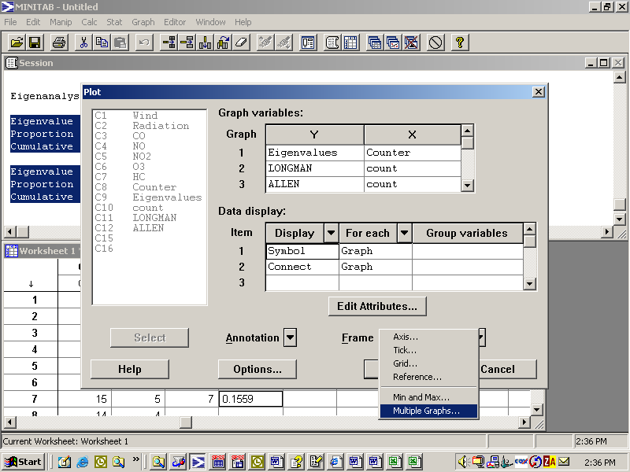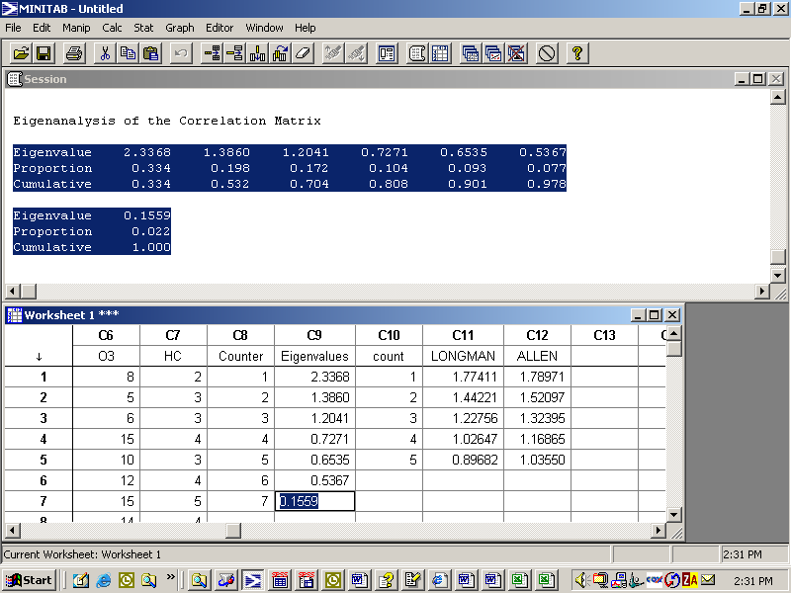

1. *Under* Graph 🡪 Plot*, input three Y,X combinations : Eigenvalues vs. Counter, Longman vs. count, Allen vs. Count. Under Frame, choose multiple graphs and indicate that the plots should be overlayed. Indicate that Symbols and Connect (i.e. lines) should be displayed for each plot. Use Edit Attributes to change colors, plot characters, etc.*

*Both parallel methods suggest retaining one principle component. Be aware that since the number of observations is small (only 44), the parallel procedures will more easily reject components with borderline eigenvalues. Also keep in mind that the parallel procedure assumes the variables have a normal distribution, a bit questionable here. I decide to keep three components since with three components, I can explain 70% of the variability in the data (only 33% of variability with one component – however, keeping one component is also a reasonable decision).*

3). For principle components you decide to retain, examine the loadings (principle components) and think about an interpretation for each component.

Variable PC1 PC2 PC3

Wind 0.237 -0.278 0.643

Radiatio -0.206 0.527 0.224

CO -0.551 0.007 -0.114

NO -0.378 -0.435 -0.407

NO2 -0.498 -0.200 0.197

O3 -0.325 0.567 0.160

HC -0.319 -0.308 0.541

*Component one is mostly CO, NO2. Component 2 is Radiation, NO, and Ozone. Component 3 is Wind, NO, HC. The division is not exact. However, with three measures, I can explain 70% of the variability.*

4). Write a paragraph summarizing your findings, and your opinions about the effectiveness of using principle components on this data.

*Not being a weather expert, I can’t say much about the interpretation of the factors beyond what was stated above. Given the relatively small number of observations, principle components was not entirely successful. Interpretations of the factors is somewhat difficult.*

**HOMEWORK ASSIGNMENT**

**PLEASE turn in the following answers for YOUR DATASET! If PCA is not appropriate for your data, use ONE of the datasets online (either DrugAttitudes.xls or NASAunderstory.xls** **described on the following pages).**

**List your name and a one sentence reminder of which dataset your are using.**

1). First, discuss whether your data seems to have a multivariate normal distribution. Make univariate plots (boxplots, normal quantile plots as appropriate). Then make transformations as appropriate. You do NOT need to turn all this in, but describe what you did. **THEN** make a chi-square quantile plot of the data. Turn in your chi-square quantile plot as appropriate and comment on what you see. **NOTE that multivariate normality is NOT a requirement for PCA to work!**

2). Compute the correlation matrix between all variables (SAS and SPSS will provide this for you as part of the PCA procedure – in SPSS, click on DESCRIPTIVES. In R use the cor() function.). Comment on relationships you do/do not observe. Do you think PCA will work well?

3). Perform Principle components analysis using the Correlation matrix (standardized variables). Think about how many principle components to retain. To make this decision look at

* Total variance explained by a given number of principle components
* The ‘eigenvalue > 1’ criteria
* The ‘scree plot elbow’ method (turn in the scree plot)
* Parallel Analysis : think about whether this is appropriate based on what you discover in number 1.

4). For principle components you decide to retain, examine the loadings (principle components) and think about an interpretation for each retained component if possible.

5) Make a score plot of the scores for at least two pairs of component scores (one and two, one and three, two and three, etc). Discuss any trends/groupings you observe. **As a bonus, try to make a 95% Confidence Ellipse for two of your components.** You might want to also try making a bi-plot if you’re using R.

6). Write a paragraph summarizing your findings, and your opinions about the effectiveness of using principle components on this data. Include evidence based on scatterplots of linearity in higher dimensional space, note any multivariate outliers in your score plot, comment on sample size relative to number of variables, etc.

**LOANER DATASETS**

**(if PCA is not appropriate for your data)**

The data set DrugAttitudes.xls is an excel file that contains attitudes of 38 people measured on 20 variables relating to drugs. Each question was measured on a 5 point scale where 1=Strongly Agree and 5 = Strongly Disagree. The variables were

|  |  |
| --- | --- |
| **legal** | All drugs should be made legal and freely available. |
| **dangerous** | As a general rule of thumb, most drugs are dangerous and should be used only with medical authorization. |
| **regret** | Drugs can cause people to say or do things they might later regret. |
| **unnatural** | Drugs are basically an "unnatural" way to enjoy life. |
| **notuse** | Even if my best friend gave me some hash, I probably wouldn't use it. |
| **psycho** | Experimenting with drugs is dangerous if a person has any psychological problems. |
| **trip** | I see nothing wrong with taking an LSD trip. |
| **stoned** | I admire people who like to get stoned. |
| **calm** | I wish I could get hold of some pills to calm me down whenever I get "up tight". |
| **high** | I would welcome the opportunity to get high on drugs. |
| **noaspirin** | I'd have to be pretty sick before I'd take any drug including an aspirin. |
| **relationship** | If people use drugs together, their relationships will be improved. |
| **drugscene** | In spite of what the establishment says, the drug scene is really "where it's at". |
| **caregivers** | People who regularly take drugs should not be given positions of responsibility for young children. |
| **experience** | People who make drug legislation should really have personal experience with drugs. |
| **fun** | People who use drugs are more fun to be with than those who don't use drugs. |
| **stupid** | Pep pills are a stupid way of keeping alert when there's important work to be done. |
| **lessalcohol** | Smoking marijuana is less harmful than drinking alcohol. |
| **sideeffects** | Students should be told about the harmful side effects of certain drugs. |
| **dope** | Taking any kind of dope is a pretty dumb idea. |

Your goal is to see if these measurements can be summarized in fewer than 20 dimensions. **NOTE that one variable may get imported as a text variable – this might cause you problems.**

*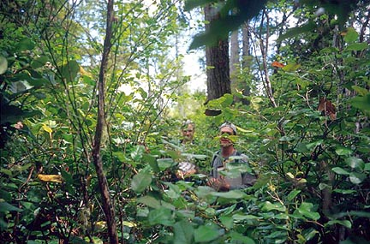****Superior National Forest understory data.*** *Thirty-two quaking aspen and thirty-one black spruce sites were studied. The dominant species in the site constituted 80-95% of the total tree density and basal area. For each plot, a two-meter diameter subplot was defined and the percent of ground coverage by plants under one meter in height was determined by species. This example examines the percentage cover in each plot of the 30 most prevalent understory species. The goal is to use PCA to examine if there are groups of species that tend to exhibit similar patterns of variation.*