S&DS 563 / F&ES 758b - Multivariate Statistics Homework #5 MANOVA and Multivariate GLM

Lanxin Jiang (lj345), Grace Sun (ys544), Chenglin Lu (cl939)

2018-04-07

The dataset obtained from the UCI Machine Learning Repository describes the chronic kidney disease status and blood measurement of patients from Apollo Hospitals in India. There are 400 observations in this dataset. For this homework, we will use two categorical factors: specific gravity(sg) of urine, and red blood cells(rbc); and two continuous: blood glucose random(bgr) and serum creatinine(sc). In problem 4, we will add another continuous variable: hemoglobin (hemo). All observations with missing values will be excluded, so there will be 203 patients for the analysis.

**1. For two categorical factors, make interaction plots for each of your response variables. Discuss what you see. If you only have one categorical factor, then provide some plot/discussion of which means are different for which response variables**

library(ggplot2)  
multiplot <- function(..., plotlist=NULL, file, cols=1, layout=NULL) {  
 library(grid)  
  
 # Make a list from the ... arguments and plotlist  
 plots <- c(list(...), plotlist)  
  
 numPlots = length(plots)  
  
 # If layout is NULL, then use 'cols' to determine layout  
 if (is.null(layout)) {  
 # Make the panel  
 # ncol: Number of columns of plots  
 # nrow: Number of rows needed, calculated from # of cols  
 layout <- matrix(seq(1, cols * ceiling(numPlots/cols)),  
 ncol = cols, nrow = ceiling(numPlots/cols))  
 }  
   
 if (numPlots==1) {  
 print(plots[[1]])  
  
 } else {  
 # Set up the page  
 grid.newpage()  
 pushViewport(viewport(layout = grid.layout(nrow(layout), ncol(layout))))  
  
 # Make each plot, in the correct location  
 for (i in 1:numPlots) {  
 # Get the i,j matrix positions of the regions that contain this subplot  
 matchidx <- as.data.frame(which(layout == i, arr.ind = TRUE))  
  
 print(plots[[i]], vp = viewport(layout.pos.row = matchidx$row,  
 layout.pos.col = matchidx$col))  
 }  
 }  
}  
Sys.setenv(JAVA_HOME="C:\\Program Files\\Java\\jre-9.0.4\\")  
library(rJava)  
library(RWeka)  
CKD <- read.arff("C:/Users/lanxin/Documents/GitHub/Chronic_Kidney_Disease/Chronic_Kidney_Disease/chronic_kidney_disease_full.arff")

#import dataset

CKD_hw5<-CKD[,c(3,6,10,12,15)]  
CKD.cc<-CKD_hw5[complete.cases(CKD_hw5),]  
CKD.cc$rbc<-as.factor(CKD.cc$rbc)  
write.csv(CKD.cc,file="C:/Users/lanxin/Documents/GitHub/Chronic_Kidney_Disease/HW5/CKDCC.csv")

par(mfrow=c(1,2))  
#this makes the plots  
interaction.plot(CKD.cc$sg,CKD.cc$rbc,CKD.cc$bgr, lwd=3,col=c("red","blue"),xlab="Specific Gravity",main="Interaction Plot for Blood Glucose Random")  
interaction.plot(CKD.cc$sg,CKD.cc$rbc,CKD.cc$sc, lwd=3,col=c("red","blue"),xlab="Specific Gravity",main="Interaction Plot for Serum Creatinine")

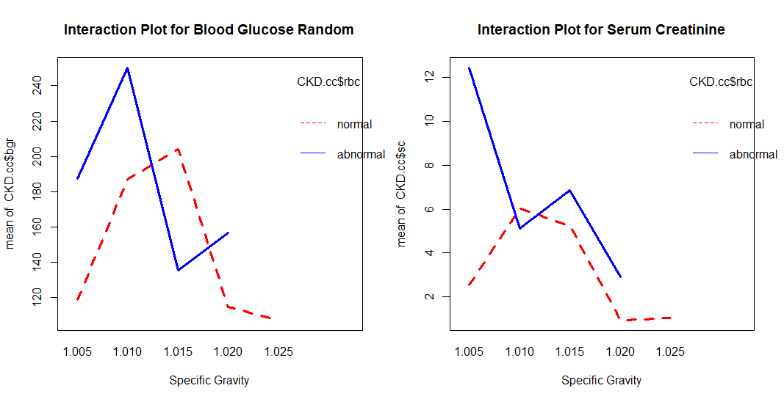

Red blood cells(rbc) is a binary variable (normal or abnormal) and specific gravity of urine (sg) is an ordinal variable.

These plots suggest that there may be an interaction between specific gravity and red blood cells on serum creatinine and blood glucose. Also suggests that there may not be much difference of RBC on serum creatinine and glucose value. Overall, it seems that normal red blood cells have higher serum creatinine concentration and specific gravity of urine. Two plots also indicate that When SG=1.025, there is no observation where red blood cell is abnormal.

1. **Run Two-Way MANOVA for these two categorical factors. Discuss your results, both univariate and multivariate. If only one categorical predictor, do one-way MANOVA.**

#fit linear model  
mod1=manova(as.matrix(CKD.cc[,3:4])~CKD.cc$sg + CKD.cc$rbc +CKD.cc$sg*CKD.cc$rbc)  
#get univariate results   
summary.aov(mod1)

## Response bgr :  
## Df Sum Sq Mean Sq F value Pr(>F)   
## CKD.cc$sg 4 301474 75368 21.6350 8.944e-15 ***  
## CKD.cc$rbc 1 16413 16413 4.7116 0.031174 *   
## CKD.cc$sg:CKD.cc$rbc 3 58801 19600 5.6264 0.001019 **   
## Residuals 194 675824 3484   
## ---  
## Signif. codes: 0 '***' 0.001 '**' 0.01 '*' 0.05 '.' 0.1 ' ' 1  
##   
## Response sc :  
## Df Sum Sq Mean Sq F value Pr(>F)   
## CKD.cc$sg 4 946.77 236.692 39.1767 < 2.2e-16 ***  
## CKD.cc$rbc 1 35.49 35.493 5.8748 0.0162770 *   
## CKD.cc$sg:CKD.cc$rbc 3 131.88 43.960 7.2762 0.0001193 ***  
## Residuals 194 1172.08 6.042   
## ---  
## Signif. codes: 0 '***' 0.001 '**' 0.01 '*' 0.05 '.' 0.1 ' ' 1

#get multivariate results summary.manova(mod1)   
summary.manova(mod1,test="Wilks")

## Df Wilks approx F num Df den Df Pr(>F)   
## CKD.cc$sg 4 0.40169 27.8795 8 386 < 2.2e-16 ***  
## CKD.cc$rbc 1 0.94029 6.1279 2 193 0.002629 **   
## CKD.cc$sg:CKD.cc$rbc 3 0.82604 6.4506 6 386 1.704e-06 ***  
## Residuals 194   
## ---  
## Signif. codes: 0 '***' 0.001 '**' 0.01 '*' 0.05 '.' 0.1 ' ' 1

mod1$coefficients

## bgr sc  
## (Intercept) 118.666667 2.533333  
## CKD.cc$sg1.010 68.196970 3.471212  
## CKD.cc$sg1.015 85.500000 2.700000  
## CKD.cc$sg1.020 -3.857843 -1.602451  
## CKD.cc$sg1.025 -11.393939 -1.524242  
## CKD.cc$rbcabnormal 68.833333 9.916667  
## CKD.cc$sg1.010:CKD.cc$rbcabnormal -5.543124 -10.798135  
## CKD.cc$sg1.015:CKD.cc$rbcabnormal -137.750000 -8.300000  
## CKD.cc$sg1.020:CKD.cc$rbcabnormal -26.864379 -7.958660  
## CKD.cc$sg1.025:CKD.cc$rbcabnormal NA NA

Univariate Results : For blood glucose, there are significant differences between either sg or rbc. Also, there, there is evidence on an interaction effect. The coefficients suggest that sg =1.010 or 1.015 have quite difference impact on bgr from sg=1.025.

Similar results are observed for serum creatinine, but rbc is no longer a significant factor. The coefficients also suggest when sg is higher if rbc is normal then the influence becomes negative, but the trend is different if rbc is abnormal.

Multivariate Results : The coefficient for sg=1.025*rbc=abnormal is NA, which corresponds to that When SG=1.025, there is no observation where red blood cell is abnormal. Either predictor and the interaction term are significant. Thus, there is strong interaction effect between specific gravity and the normality of red blood cells.

1. **Perform (multivariate) contrasts to compare levels of a particular factor or combinations of factors. Discuss your results. If you’re using SPSS/R, you won’t be able to do the multivariate contrasts.**

From the above coefficients, we can see that each category varies a lot. Thus, contrast for each pair is conducted is SAS. Also, since SG is an ordinal variable, we also test its linear effect via contrast. Following are the codes:

**data** CKDCC; set CKDCC;

trtcombine=trim(trim(sg) || trim(rbc)); **run**;

**proc** **sort** data=CKDCC;

by trtcombine;

ods rtf file="C:\Users\lanxin\Documents\GitHub\Chronic_Kidney_Disease\HW5\contrast.rtf";

**proc** **glm** data=CKDCC;

class trtcombine;

model bgr sc=trtcombine;

contrast 'Red blood cell: abnormal vs normal' trtcombine **1** -**1** **1** -**1** **1** -**1** **1** -**1** **0**;

contrast 'Specific Gravity: 1.005 vs 1.010' trtcombine **1** **1** -**1** -**1** **0** **0** **0** **0** **0**;

contrast 'Specific Gravity: 1.005 vs 1.015' trtcombine **1** **1** **0** **0** -**1** -**1** **0** **0** **0**;

contrast 'Specific Gravity: 1.005 vs 1.020' trtcombine **1** **1** **0** **0** **0** **0** -**1** -**1** **0**;

contrast 'Specific Gravity: 1.005 vs 1.025' trtcombine **1** **1** **0** **0** **0** **0** **0** **0** -**2**;

contrast 'Specific Gravity: 1.010 vs 1.015' trtcombine **0** **0** **1** **1** -**1** -**1** **0** **0** **0**;

contrast 'Specific Gravity: 1.010 vs 1.020' trtcombine **0** **0** **1** **1** **0** **0** -**1** -**1** **0**;

contrast 'Specific Gravity: 1.010 vs 1.025' trtcombine **0** **0** **1** **1** **0** **0** **0** **0** -**2**;

contrast 'Specific Gravity: 1.015 vs 1.020' trtcombine **0** **0** **0** **0** **1** **1** -**1** -**1** **0**;

contrast 'Specific Gravity: 1.015 vs 1.025' trtcombine **0** **0** **0** **0** **1** **1** **0** **0** -**2**;

contrast 'Specific Gravity: 1.020 vs 1.025' trtcombine **0** **0** **0** **0** **0** **0** **1** **1** -**2**;

contrast 'Specific Gravity linear effect' trtcombine **1** **1** **0.5** **0.5** **0** **0** -**0.5** -**0.5** -**2**;

contrast 'Specific Gravity: 1.010 vs the other ' trtcombine -**1** -**1** **3.5** **3.5** -**1** -**1** -**1** -**1** -**1**;

**run**;

ods rtf close;

The results are:

| **Contrast when dependent variable is bgr** | **DF** | **Contrast SS** | **Mean Square** | **F Value** | **Pr > F** |
| --- | --- | --- | --- | --- | --- |
| **Red blood cell: abnormal vs normal** | 1 | 8576.0814 | 8576.0814 | 2.46 | 0.1183 |
| **Specific Gravity: 1.005 vs 1.010** | 1 | 17915.3916 | 17915.3916 | 5.14 | 0.0244 |
| **Specific Gravity: 1.005 vs 1.015** | 1 | 1061.3400 | 1061.3400 | 0.30 | 0.5816 |
| **Specific Gravity: 1.005 vs 1.020** | 1 | 1246.7086 | 1246.7086 | 0.36 | 0.5504 |
| **Specific Gravity: 1.005 vs 1.025** | 1 | 9390.3978 | 9390.3978 | 2.70 | 0.1022 |
| **Specific Gravity: 1.010 vs 1.015** | 1 | 28804.3655 | 28804.3655 | 8.27 | 0.0045 |
| **Specific Gravity: 1.010 vs 1.020** | 1 | 110265.7943 | 110265.7943 | 31.65 | <.0001 |
| **Specific Gravity: 1.010 vs 1.025** | 1 | 270482.0584 | 270482.0584 | 77.64 | <.0001 |
| **Specific Gravity: 1.015 vs 1.020** | 1 | 13769.0057 | 13769.0057 | 3.95 | 0.0482 |
| **Specific Gravity: 1.015 vs 1.025** | 1 | 57978.9349 | 57978.9349 | 16.64 | <.0001 |
| **Specific Gravity: 1.020 vs 1.025** | 1 | 17453.2728 | 17453.2728 | 5.01 | 0.0263 |
| **Specific Gravity linear effect** | 1 | 31792.51932 | 31792.51932 | 9.13 | 0.0029 |
| **Specific Gravity: 1.010 vs the other** | 1 | 95140.73831 | 95140.73831 | 27.31 | <.0001 |

| **Contrast when the dependent variable is sc** | **DF** | **Contrast SS** | **Mean Square** | **F Value** | **Pr > F** |
| --- | --- | --- | --- | --- | --- |
| **Red blood cell: abnormal vs normal** | 1 | 123.2759346 | 123.2759346 | 20.40 | <.0001 |
| **Specific Gravity: 1.005 vs 1.010** | 1 | 15.5554427 | 15.5554427 | 2.57 | 0.1102 |
| **Specific Gravity: 1.005 vs 1.015** | 1 | 8.0736000 | 8.0736000 | 1.34 | 0.2491 |
| **Specific Gravity: 1.005 vs 1.020** | 1 | 129.9328323 | 129.9328323 | 21.51 | <.0001 |
| **Specific Gravity: 1.005 vs 1.025** | 1 | 188.0386466 | 188.0386466 | 31.12 | <.0001 |
| **Specific Gravity: 1.010 vs 1.015** | 1 | 2.7618784 | 2.7618784 | 0.46 | 0.4998 |
| **Specific Gravity:** **1.010 vs 1.020** | 1 | 215.1726299 | 215.1726299 | 35.61 | <.0001 |
| **Specific Gravity: 1.010 vs 1.025** | 1 | 453.4934807 | 453.4934807 | 75.06 | <.0001 |
| **Specific Gravity: 1.015 vs 1.020** | 1 | 204.3584967 | 204.3584967 | 33.82 | <.0001 |
| **Specific Gravity: 1.015 vs 1.025** | 1 | 376.6918395 | 376.6918395 | 62.35 | <.0001 |
| **Specific Gravity: 1.020 vs 1.025** | 1 | 17.4105315 | 17.4105315 | 2.88 | 0.0912 |
| **Specific Gravity linear effect** | 1 | 288.9091801 | 288.9091801 | 47.82 | <.0001 |
| **Specific Gravity: 1.010 vs the other** | 1 | 18.5395747 | 18.5395747 | 3.07 | 0.0814 |

The above contrast results suggest that when the dependent variable is blood glucose random, then sg =1.010 is quite different from all the other values of sg. Specific gravity = 1.015 is significantly different from sg=1.020 and sg=1.025.

When the dependent variable is serum creatinine, the normality of red blood cells is a significant factor. Sg= 1.005, 1.020 and 1. 025 is quite different from each other . Sg = 1.010 is significantly different from higher gravity.

Also, there is significantly linear effect of sg on both sc and bgr which indicates that we could treat sg as a continuous variable when it is necessary to reduce degrees of freedom.

1. **If applicable, add a continuous variable to your model and fit as a multiple-response generalized linear model. Before you fit the model, make some plots to see if there are linear relationships between your covariates and your responses.**

#relationship  
interaction.plot(CKD.cc$sg,CKD.cc$rbc,CKD.cc$hemo, lwd=3,col=c("red","blue"),xlab="Specific Gravity",main="Interaction Plot for Hemoglobain")

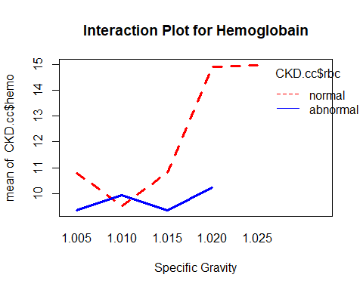

The above interaction plot shows that there may also be an interaction between specific gravity and red blood cells on hemoglobin. Generally patients with normal red blood cells will have higher concentration of hemoglobin.

#fit linear model  
mod1=lm(as.matrix(CKD.cc[,3:5])~CKD.cc$sg + CKD.cc$rbc +CKD.cc$sg*CKD.cc$rbc)  
#get univariate results   
mod1

##   
## Call:  
## lm(formula = as.matrix(CKD.cc[, 3:5]) ~ CKD.cc$sg + CKD.cc$rbc +   
## CKD.cc$sg * CKD.cc$rbc)  
##   
## Coefficients:  
## bgr sc hemo   
## (Intercept) 118.66667 2.53333 10.76667  
## CKD.cc$sg1.010 68.19697 3.47121 -1.24394  
## CKD.cc$sg1.015 85.50000 2.70000 0.04167  
## CKD.cc$sg1.020 -3.85784 -1.60245 4.14510  
## CKD.cc$sg1.025 -11.39394 -1.52424 4.20152  
## CKD.cc$rbcabnormal 68.83333 9.91667 -1.41667  
## CKD.cc$sg1.010:CKD.cc$rbcabnormal -5.54312 -10.79814 1.84009  
## CKD.cc$sg1.015:CKD.cc$rbcabnormal -137.75000 -8.30000 -0.04167  
## CKD.cc$sg1.020:CKD.cc$rbcabnormal -26.86438 -7.95866 -3.27288  
## CKD.cc$sg1.025:CKD.cc$rbcabnormal NA NA NA

summary(mod1)

## Response bgr :  
##   
## Call:  
## lm(formula = bgr ~ CKD.cc$sg + CKD.cc$rbc + CKD.cc$sg * CKD.cc$rbc)  
##   
## Residuals:  
## Min 1Q Median 3Q Max   
## -171.154 -23.309 -5.809 17.459 309.191   
##   
## Coefficients: (1 not defined because of singularities)  
## Estimate Std. Error t value Pr(>|t|)   
## (Intercept) 118.667 34.077 3.482 0.000614 ***  
## CKD.cc$sg1.010 68.197 36.326 1.877 0.061967 .   
## CKD.cc$sg1.015 85.500 38.099 2.244 0.025951 *   
## CKD.cc$sg1.020 -3.858 34.820 -0.111 0.911895   
## CKD.cc$sg1.025 -11.394 34.842 -0.327 0.744010   
## CKD.cc$rbcabnormal 68.833 53.880 1.278 0.202939   
## CKD.cc$sg1.010:CKD.cc$rbcabnormal -5.543 57.700 -0.096 0.923566   
## CKD.cc$sg1.015:CKD.cc$rbcabnormal -137.750 60.239 -2.287 0.023292 *   
## CKD.cc$sg1.020:CKD.cc$rbcabnormal -26.864 57.804 -0.465 0.642633   
## CKD.cc$sg1.025:CKD.cc$rbcabnormal NA NA NA NA   
## ---  
## Signif. codes: 0 '***' 0.001 '**' 0.01 '*' 0.05 '.' 0.1 ' ' 1  
##   
## Residual standard error: 59.02 on 194 degrees of freedom  
## Multiple R-squared: 0.3579, Adjusted R-squared: 0.3314   
## F-statistic: 13.52 on 8 and 194 DF, p-value: 1.705e-15  
##   
##   
## Response sc :  
##   
## Call:  
## lm(formula = sc ~ CKD.cc$sg + CKD.cc$rbc + CKD.cc$sg * CKD.cc$rbc)  
##   
## Residuals:  
## Min 1Q Median 3Q Max   
## -5.1500 -0.4309 -0.1309 0.1909 10.8955   
##   
## Coefficients: (1 not defined because of singularities)  
## Estimate Std. Error t value Pr(>|t|)   
## (Intercept) 2.533 1.419 1.785 0.07580 .   
## CKD.cc$sg1.010 3.471 1.513 2.295 0.02283 *   
## CKD.cc$sg1.015 2.700 1.587 1.702 0.09041 .   
## CKD.cc$sg1.020 -1.602 1.450 -1.105 0.27049   
## CKD.cc$sg1.025 -1.524 1.451 -1.050 0.29481   
## CKD.cc$rbcabnormal 9.917 2.244 4.420 1.64e-05 ***  
## CKD.cc$sg1.010:CKD.cc$rbcabnormal -10.798 2.403 -4.494 1.20e-05 ***  
## CKD.cc$sg1.015:CKD.cc$rbcabnormal -8.300 2.509 -3.309 0.00112 **   
## CKD.cc$sg1.020:CKD.cc$rbcabnormal -7.959 2.407 -3.306 0.00113 **   
## CKD.cc$sg1.025:CKD.cc$rbcabnormal NA NA NA NA   
## ---  
## Signif. codes: 0 '***' 0.001 '**' 0.01 '*' 0.05 '.' 0.1 ' ' 1  
##   
## Residual standard error: 2.458 on 194 degrees of freedom  
## Multiple R-squared: 0.4873, Adjusted R-squared: 0.4662   
## F-statistic: 23.05 on 8 and 194 DF, p-value: < 2.2e-16  
##   
##   
## Response hemo :  
##   
## Call:  
## lm(formula = hemo ~ CKD.cc$sg + CKD.cc$rbc + CKD.cc$sg * CKD.cc$rbc)  
##   
## Residuals:  
## Min 1Q Median 3Q Max   
## -6.4227 -1.0118 0.0318 1.1428 6.7500   
##   
## Coefficients: (1 not defined because of singularities)  
## Estimate Std. Error t value Pr(>|t|)   
## (Intercept) 10.76667 1.05275 10.227 < 2e-16 ***  
## CKD.cc$sg1.010 -1.24394 1.12224 -1.108 0.269041   
## CKD.cc$sg1.015 0.04167 1.17701 0.035 0.971797   
## CKD.cc$sg1.020 4.14510 1.07572 3.853 0.000158 ***  
## CKD.cc$sg1.025 4.20152 1.07641 3.903 0.000131 ***  
## CKD.cc$rbcabnormal -1.41667 1.66454 -0.851 0.395772   
## CKD.cc$sg1.010:CKD.cc$rbcabnormal 1.84009 1.78258 1.032 0.303234   
## CKD.cc$sg1.015:CKD.cc$rbcabnormal -0.04167 1.86102 -0.022 0.982161   
## CKD.cc$sg1.020:CKD.cc$rbcabnormal -3.27288 1.78579 -1.833 0.068375 .   
## CKD.cc$sg1.025:CKD.cc$rbcabnormal NA NA NA NA   
## ---  
## Signif. codes: 0 '***' 0.001 '**' 0.01 '*' 0.05 '.' 0.1 ' ' 1  
##   
## Residual standard error: 1.823 on 194 degrees of freedom  
## Multiple R-squared: 0.6416, Adjusted R-squared: 0.6268   
## F-statistic: 43.42 on 8 and 194 DF, p-value: < 2.2e-16

MANOVA tests from SAS output:

|  |
| --- |
| The SAS System |

The GLM Procedure

Multivariate Analysis of Variance

| **Characteristic Roots and Vectors of: E Inverse * H, where H = Type III SSCP Matrix for sg E = Error SSCP Matrix** | | | | |
| --- | --- | --- | --- | --- |
| **Characteristic Root** | **Percent** | **Characteristic Vector V'EV=1** | | |
| **bgr** | **sc** | **hemo** |
| **0.93766868** | **87.92** | 0.00065688 | 0.01168748 | -0.02534888 |
| **0.09219276** | **8.64** | -0.00019184 | 0.02924657 | 0.02382176 |
| **0.03659278** | **3.43** | 0.00102395 | 0.00393728 | 0.02417227 |

| **MANOVA Test Criteria and F Approximations for the Hypothesis of No Overall sg Effect H = Type III SSCP Matrix for sg E = Error SSCP Matrix  S=3 M=0 N=95** | | | | | |
| --- | --- | --- | --- | --- | --- |
| **Statistic** | **Value** | **F Value** | **Num DF** | **Den DF** | **Pr > F** |
| **Wilks' Lambda** | 0.45584060 | 14.64 | 12 | 508.28 | <.0001 |
| **Pillai's Trace** | 0.60362762 | 12.22 | 12 | 582 | <.0001 |
| **Hotelling-Lawley Trace** | 1.06645422 | 16.99 | 12 | 331.71 | <.0001 |
| **Roy's Greatest Root** | 0.93766868 | 45.48 | 4 | 194 | <.0001 |
| **NOTE: F Statistic for Roy's Greatest Root is an upper bound.** | | | | | |

| **Characteristic Roots and Vectors of: E Inverse * H, where H = Type III SSCP Matrix for rbc E = Error SSCP Matrix** | | | | |
| --- | --- | --- | --- | --- |
| **Characteristic Root** | **Percent** | **Characteristic Vector V'EV=1** | | |
| **bgr** | **sc** | **hemo** |
| **0.14737327** | **100.00** | 0.00048444 | 0.02249137 | -0.01420354 |
| **0.00000000** | **0.00** | 0.00112373 | -0.00690377 | 0.00435981 |
| **0.00000000** | **0.00** | 0.00013895 | 0.02130581 | 0.03966853 |

| **MANOVA Test Criteria and Exact F Statistics for the Hypothesis of No Overall rbc Effect H = Type III SSCP Matrix for rbc E = Error SSCP Matrix  S=1 M=0.5 N=95** | | | | | |
| --- | --- | --- | --- | --- | --- |
| **Statistic** | **Value** | **F Value** | **Num DF** | **Den DF** | **Pr > F** |
| **Wilks' Lambda** | 0.87155595 | 9.43 | 3 | 192 | <.0001 |
| **Pillai's Trace** | 0.12844405 | 9.43 | 3 | 192 | <.0001 |
| **Hotelling-Lawley Trace** | 0.14737327 | 9.43 | 3 | 192 | <.0001 |
| **Roy's Greatest Root** | 0.14737327 | 9.43 | 3 | 192 | <.0001 |

| **Characteristic Roots and Vectors of: E Inverse * H, where H = Type III SSCP Matrix for sg*rbc E = Error SSCP Matrix** | | | | |
| --- | --- | --- | --- | --- |
| **Characteristic Root** | **Percent** | **Characteristic Vector V'EV=1** | | |
| **bgr** | **sc** | **hemo** |
| **0.16792369** | **46.35** | 0.00017914 | 0.00273790 | 0.04027821 |
| **0.10979577** | **30.31** | 0.00045144 | 0.03076418 | 0.01073294 |
| **0.08453706** | **23.34** | 0.00113176 | -0.00731644 | -0.00753726 |

| **MANOVA Test Criteria and F Approximations for the Hypothesis of No Overall sg*rbc Effect H = Type III SSCP Matrix for sg*rbc E = Error SSCP Matrix  S=3 M=-0.5 N=95** | | | | | |
| --- | --- | --- | --- | --- | --- |
| **Statistic** | **Value** | **F Value** | **Num DF** | **Den DF** | **Pr > F** |
| **Wilks' Lambda** | 0.71137413 | 7.80 | 9 | 467.43 | <.0001 |
| **Pillai's Trace** | 0.32066059 | 7.74 | 9 | 582 | <.0001 |
| **Hotelling-Lawley Trace** | 0.36225652 | 7.70 | 9 | 298.55 | <.0001 |
| **Roy's Greatest Root** | 0.16792369 | 10.86 | 3 | 194 | <.0001 |
| **NOTE: F Statistic for Roy's Greatest Root is an upper bound.** | | | | | |

The above results show that rbc and sg has significant effect on hemoglobin univariately, and also it would affect the multivariate model significantly..

1. **Check model assumptions by making a chi-square quantile plot of the residuals. Modify your model as appropriate based on your findings.**

source("http://www.reuningscherer.net/STAT660/R/CSQPlot.r.txt")  
#run the function  
CSQPlot(mod1$residuals, label="residuals")

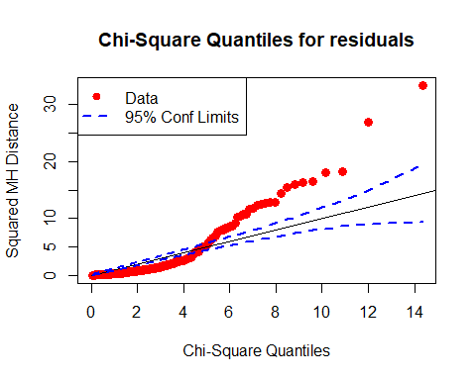

The above chi-square quantiles plot for residuals show that the residuals don’t follow a multivariate distribution. Then we check normality for each variable.

#check normality for each variable  
#check QQ plot for some numeric variables  
gg.qqplot <- function (variable, title, data) {  
ggplot(data, aes_string(sample=variable)) + ggtitle(title) + stat_qq()  
}  
p2 <- gg.qqplot("bgr", "Blood Glucose Random",CKD.cc)  
p3 <- gg.qqplot("hemo", "Hemoglobin",CKD.cc)  
p4 <- gg.qqplot("sc", "Serum Creatinine",CKD.cc)  
multiplot( p2, p3, p4, cols=2)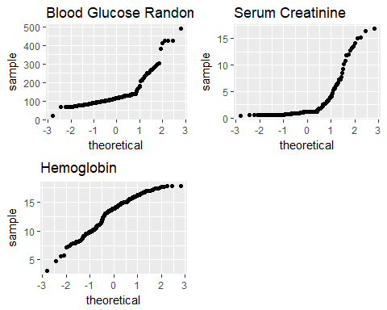

The above plots indicate that none of the response is normal. Then we perform power transformations which uses the MLE approach of Box and Cox (1964) to select a transformation of multivariate response for normality.

library(car)  
trans <- powerTransform(as.matrix(CKD.cc[,3:5])~CKD.cc$sg + CKD.cc$rbc +CKD.cc$sg*CKD.cc$rbc, family="bcPower")  
summary(trans)

## bcPower Transformations to Multinormality   
## Est Power Rounded Pwr Wald Lwr bnd Wald Upr Bnd  
## bgr -0.1808 -0.33 -0.3587 -0.0028  
## sc -0.3608 -0.33 -0.4848 -0.2368  
## hemo 1.5556 1.56 1.1639 1.9473  
##   
## Likelihood ratio tests about transformation parameters  
## LRT df pval  
## LR test, lambda = (0 0 0) 124.7737 3 0  
## LR test, lambda = (1 1 1) 630.0641 3 0

transformedY <- bcPower(with(CKD.cc, cbind(sc,hemo,bgr)),coef(trans, round=TRUE))  
 colnames(transformedY)<-c("sc","hemo","bgr")  
 mod3=lm(transformedY~CKD.cc$sg + CKD.cc$rbc +CKD.cc$sg*CKD.cc$rbc)  
 summary(mod3)

## Response sc :  
##   
## Call:  
## lm(formula = sc ~ CKD.cc$sg + CKD.cc$rbc + CKD.cc$sg * CKD.cc$rbc)  
##   
## Residuals:  
## Min 1Q Median 3Q Max   
## -0.97649 -0.32389 0.04737 0.33153 1.63983   
##   
## Coefficients: (1 not defined because of singularities)  
## Estimate Std. Error t value Pr(>|t|)   
## (Intercept) 0.6234 0.2553 2.442 0.01551 *   
## CKD.cc$sg1.010 0.4998 0.2722 1.836 0.06786 .   
## CKD.cc$sg1.015 0.3951 0.2855 1.384 0.16790   
## CKD.cc$sg1.020 -0.8084 0.2609 -3.098 0.00223 **  
## CKD.cc$sg1.025 -0.7780 0.2611 -2.980 0.00325 **  
## CKD.cc$rbcabnormal 1.0572 0.4037 2.619 0.00952 **  
## CKD.cc$sg1.010:CKD.cc$rbcabnormal -1.2039 0.4323 -2.785 0.00589 **  
## CKD.cc$sg1.015:CKD.cc$rbcabnormal -0.7664 0.4514 -1.698 0.09110 .   
## CKD.cc$sg1.020:CKD.cc$rbcabnormal -0.1700 0.4331 -0.392 0.69519   
## CKD.cc$sg1.025:CKD.cc$rbcabnormal NA NA NA NA   
## ---  
## Signif. codes: 0 '***' 0.001 '**' 0.01 '*' 0.05 '.' 0.1 ' ' 1  
##   
## Residual standard error: 0.4422 on 194 degrees of freedom  
## Multiple R-squared: 0.6475, Adjusted R-squared: 0.633   
## F-statistic: 44.55 on 8 and 194 DF, p-value: < 2.2e-16  
##   
##   
## Response hemo :  
##   
## Call:  
## lm(formula = hemo ~ CKD.cc$sg + CKD.cc$rbc + CKD.cc$sg * CKD.cc$rbc)  
##   
## Residuals:  
## Min 1Q Median 3Q Max   
## -0.61918 -0.02703 0.00592 0.04029 0.27639   
##   
## Coefficients: (1 not defined because of singularities)  
## Estimate Std. Error t value Pr(>|t|)  
## (Intercept) 1.646261 0.048654 33.836 < 2e-16  
## CKD.cc$sg1.010 -0.082886 0.051865 -1.598 0.11165  
## CKD.cc$sg1.015 -0.005325 0.054397 -0.098 0.92213  
## CKD.cc$sg1.020 0.138253 0.049715 2.781 0.00596  
## CKD.cc$sg1.025 0.139641 0.049747 2.807 0.00551  
## CKD.cc$rbcabnormal -0.068429 0.076928 -0.890 0.37483  
## CKD.cc$sg1.010:CKD.cc$rbcabnormal 0.109832 0.082384 1.333 0.18404  
## CKD.cc$sg1.015:CKD.cc$rbcabnormal -0.029846 0.086009 -0.347 0.72896  
## CKD.cc$sg1.020:CKD.cc$rbcabnormal -0.105898 0.082532 -1.283 0.20098  
## CKD.cc$sg1.025:CKD.cc$rbcabnormal NA NA NA NA  
##   
## (Intercept) ***  
## CKD.cc$sg1.010   
## CKD.cc$sg1.015   
## CKD.cc$sg1.020 **   
## CKD.cc$sg1.025 **   
## CKD.cc$rbcabnormal   
## CKD.cc$sg1.010:CKD.cc$rbcabnormal   
## CKD.cc$sg1.015:CKD.cc$rbcabnormal   
## CKD.cc$sg1.020:CKD.cc$rbcabnormal   
## CKD.cc$sg1.025:CKD.cc$rbcabnormal   
## ---  
## Signif. codes: 0 '***' 0.001 '**' 0.01 '*' 0.05 '.' 0.1 ' ' 1  
##   
## Residual standard error: 0.08427 on 194 degrees of freedom  
## Multiple R-squared: 0.5628, Adjusted R-squared: 0.5448   
## F-statistic: 31.22 on 8 and 194 DF, p-value: < 2.2e-16  
##   
##   
## Response bgr :  
##   
## Call:  
## lm(formula = bgr ~ CKD.cc$sg + CKD.cc$rbc + CKD.cc$sg * CKD.cc$rbc)  
##   
## Residuals:  
## Min 1Q Median 3Q Max   
## -3254.1 -368.2 -122.2 207.4 6771.7   
##   
## Coefficients: (1 not defined because of singularities)  
## Estimate Std. Error t value Pr(>|t|)   
## (Intercept) 1137.92 693.06 1.642 0.1022   
## CKD.cc$sg1.010 1230.37 738.80 1.665 0.0975 .  
## CKD.cc$sg1.015 1593.37 774.86 2.056 0.0411 *  
## CKD.cc$sg1.020 -52.91 708.18 -0.075 0.9405   
## CKD.cc$sg1.025 -198.74 708.63 -0.280 0.7794   
## CKD.cc$rbcabnormal 1150.54 1095.82 1.050 0.2951   
## CKD.cc$sg1.010:CKD.cc$rbcabnormal 310.21 1173.52 0.264 0.7918   
## CKD.cc$sg1.015:CKD.cc$rbcabnormal -2460.62 1225.16 -2.008 0.0460 *  
## CKD.cc$sg1.020:CKD.cc$rbcabnormal -447.76 1175.63 -0.381 0.7037   
## CKD.cc$sg1.025:CKD.cc$rbcabnormal NA NA NA NA   
## ---  
## Signif. codes: 0 '***' 0.001 '**' 0.01 '*' 0.05 '.' 0.1 ' ' 1  
##   
## Residual standard error: 1200 on 194 degrees of freedom  
## Multiple R-squared: 0.334, Adjusted R-squared: 0.3065   
## F-statistic: 12.16 on 8 and 194 DF, p-value: 4.834e-14

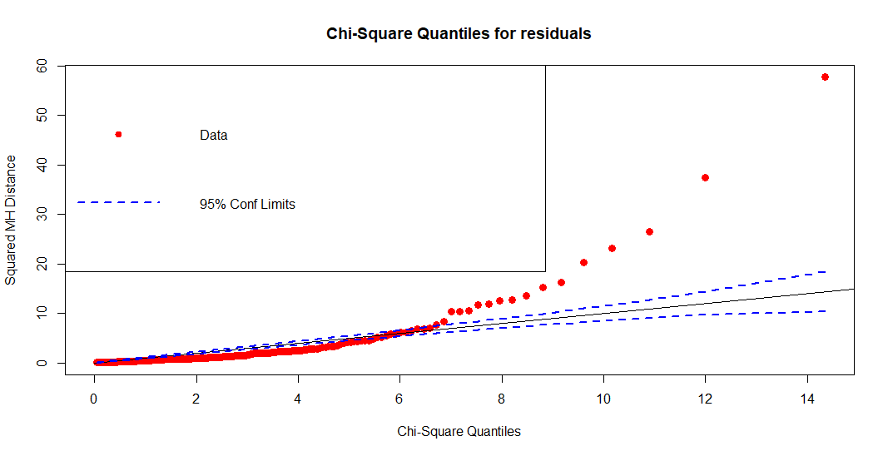

By power transformation, the modified model doesn’t fulfill the model assumptions because the above chi-square plot becomes better, but still indicates the residuals deviate from normal distribution. But we didn’t come up with better approaches to modify our model. Thus, we suggest that non-parametric MANOVA (MRPP) should be a reasonable approach.