1.Check out from git, url is below

<https://github.com/zengyh/MavenSpringMvcDemo.git>

2.Build with maven, then put the war to server such as tomcat.

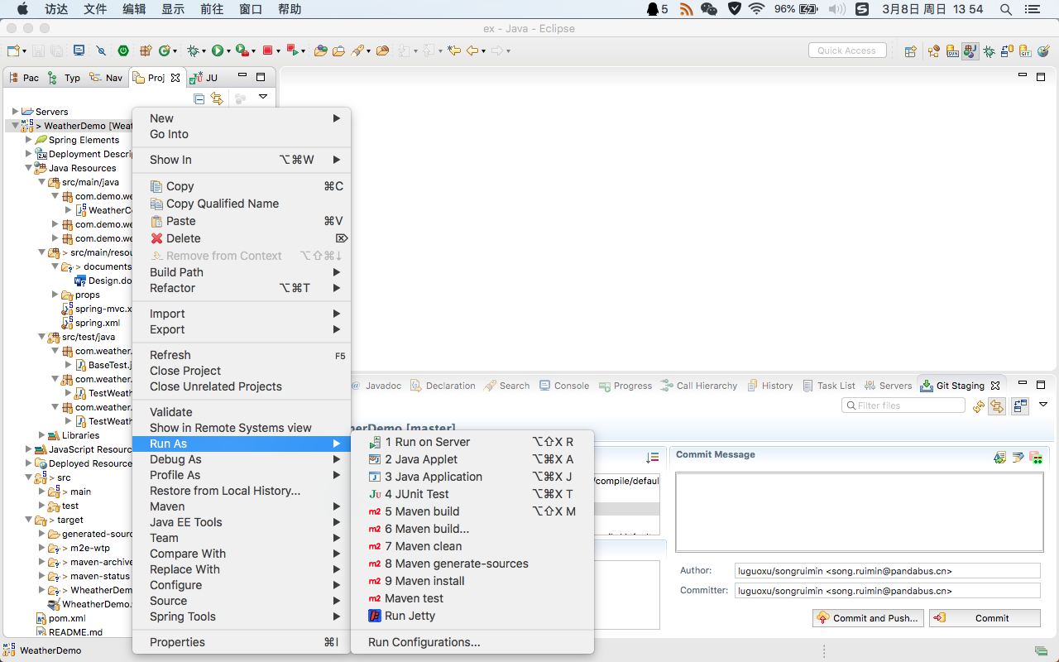

3.Or just run in develop tools

4.Type url in browser, see the result

