A Major Project Proposal on
CampusEase: A College Automation System
Submitted in Partial Fulfillment of the Requirements for the Degree of Bachelors of Engineering in IT and Software
under Pokhara University
Submitted by:
Abhay Chaudhary, 201401
Aadar Ghimire, 201601
Ganesh Kumar Pun, 201514
Prakriti Sharma, 201527

Under the Supervision of
Anish Pokharel
Date:
28th June 2025

Department of Information Technology
NEPAL COLLEGE OF
INFORMATION TECHNOLOGY
Balkumari, Lalitpur, Nepal

ABSTRACT
Our college automation system aims to improve efficiency and communication among administrators, instructors, students, and secretaries by streamlining academic administration through modern educational technology. It provides a framework to optimize various administrative procedures, enhancing operational efficiency.
A key component is student information management, which ensures accurate records of student profiles, academic performance, and attendance. Automation reduces manual workload and errors, leading to precise data handling.
The academic scheduling feature automates class schedule creation and faculty allocation, ensuring better use of resources and a more organized learning environment. Faculty management tools support performance tracking, teaching assignments, and feedback collection, improving teaching quality.
Another major feature is online payment integration, offering secure, user-friendly methods for fee payments. This makes transactions faster and more convenient for students and parents while reducing administrative burden.
Overall, this project aims to develop a reliable, efficient, and user-friendly college automation system that simplifies management processes and enhances the educational experience for all users. We believe this will lead to better resource optimization, improved services, and increased satisfaction within the academic community.
Keywords: College Automation, Academic Administration, Student Information Management, Academic Scheduling, Faculty Management, Online Payment Integration, Operational Efficiency, Resource Optimization, Administrative Procedures, Educational Technology.

TABLE OF CONTENTS
1. INTRODUCTION 1
1.1. PROBLEM STATEMENT 5
1.2 PROJECT OBJECTIVES 5
1.3 SIGNIFICANCE OF STUDY 6
1.4 SCOPE AND LIMITATIONS 7
1.4.1. SCOPE: 7
1.4.1 LIMITATIONS: 7
3. LITERATURE REVIEW 8
2.1. EXISTING PLATFORMS 10
3. METHODOLOGY 13
3.1. SOFTWARE DEVELOPMENT LIFE CYCLE 13
4.TOOLS AND TECHNOLOGIES 16
4.1. TOOLS TO BE USED 16
4.2. TECHNOLOGIES 16
4.3. PROGRAMMING LANGUAGES 16
5. SYSTEM DESIGN AND UML MODELS 19
5.1. USE CASE DIAGRAM 19
5.2 . Activity Diagram 20
5.3. SEQUENCE DIAGRAM 23
5.4. DATA FLOW DIAGRAM 31
6. TASK DONE SO FAR 33
7 .TASK REMAINING 34
8. PROPOSED DELIVERABLES 34
9. PROJECT TASK AND TIME SCHEDULE 35
10.BIBLIOGRAPHY 36

LIST OF TABLES
Table 1 : Tools to be used 16

LIST OF FIGURES
Figure 1 : Incremental Model 13
Figure 2 : Usecase Diagram for CampusEase 19
Figure 3 : Activity Diagram for Admin 21
Figure 4 : Activity Diagram for User 22
Figure 5 : Sequence Diagram for Admin 24
Figure 6 : Sequence Diagram for Secretary 27
Figure 7 : 0-Level Data Flow Diagram 31
Figure 8 : 1-Level Data Flow Diagram 32
Figure 9 : Gantt Chart for CampusEase 35

LIST OF ABBREVIATION
ID Identity
LMS Learning Management System
TAM Technology Acceptance Model
SIS Student Information System
ERP Enterprise Resource Planning
VCS Version Control System
DB Database
JS JavaScript
SPAs Single-Page Applications
CLI Command Line Interface
DOM Document Object Model
I/O Input/Output
APIs Application Programming Interface
JSON JavaScript Object Notation
NoSQL Not Only Structured Qurey Language
HTTP Hypertext Transfer Protocol
UML Unified Modeling Language
QA Quality Assurance
DFD Data Flow Diagram

INTRODUCTION
In today’s fast-paced digital era, educational institutions are increasingly turning to automation to modernize operations and enhance service delivery. College automation systems represent a fundamental shift in how institutions operate, interact with stakeholders, and manage information. These systems are transforming higher education by redefining the roles of key participants administrators, faculty, students, and general secretaries and are proving instrumental in streamlining operations, increasing transparency, and enabling better decision-making. The integration of these systems significantly reduces the reliance on manual processes, minimizes human error, and enhances the accuracy and efficiency of academic and administrative tasks.
By embracing automation technologies, colleges and universities can ensure that their internal systems keep pace with modern educational demands and stakeholder expectations. Whether it is simplifying student admissions, managing faculty workloads, or organizing institutional events, automation provides an integrated platform that brings clarity and consistency to every operational layer.
For college administrators, automation systems are powerful tools that simplify and centralize the management of institutional resources and processes. These systems help administrators handle complex tasks such as student record management, faculty coordination, staff deployment, performance evaluation, and class scheduling with greater efficiency and minimal human intervention.
Student data, which traditionally involved maintaining large volumes of paperwork, can now be digitized and accessed in real-time. This not only reduces storage requirements but also ensures faster retrieval and better data security. Administrators can analyze student perfor mance data across different departments, identify trends, and generate comprehensive reports that support data-driven decision-making.
Furthermore, automation enhances the ability of administrators to monitor compliance with academic regulations, accreditation standards, and internal policies. With integrated dash boards and reporting tools, administrators can instantly review departmental performance, faculty workloads, and student feedback. Scheduling processes, once time-consuming and prone to conflicts, are now optimized through intelligent scheduling algorithms that reduce overlaps and ensure efficient use of classrooms and faculty time.
Through automation, administrators are empowered to focus more on strategic development and innovation, rather than being bogged down by routine administrative tasks. This leads to improved governance, resource optimization, and overall institutional growth.
From a student’s perspective, college automation systems drastically enhance the quality and convenience of academic life. One of the primary benefits is the simplification of routine tasks such as class registration, assignment submission, access to academic records, and real time notifications about schedules, exams, and announcements. With a centralized student portal, learners can view their timetables, submit coursework, monitor their grades, and even communicate with faculty—all from a single platform.
This level of accessibility and transparency reduces confusion, saves time, and ensures that students are better informed and prepared. Additionally, performance tracking features allow students to regularly assess their progress and take proactive steps to address areas needing improvement. This promotes a culture of self-directed learning and accountability.
Real-time updates and mobile accessibility mean that students are constantly connected to institutional developments. Whether it’s about changes in class timings, event notices, or urgent circulars, students receive instant alerts, reducing dependency on physical notice boards or third-party communication.
Automation also improves student engagement and satisfaction. By reducing administrative hurdles and enhancing visibility into academic progress, it fosters a more organized and supportive learning environment. When students can focus on their studies without the burden of dealing with bureaucratic delays, academic success and retention rates are likely to improve.
Faculty members are among the most crucial stakeholders in any educational institution. Traditionally burdened by paperwork, time-consuming grading, and class management tasks, faculty now benefit immensely from automation. These systems enable automatic grade computation, attendance tracking, syllabus planning, and lecture scheduling, which allows educators to dedicate more of their time and energy toward teaching and research.
With automation, faculty can efficiently manage their courses, upload teaching materials, post assignments, and provide feedback through a single integrated platform. They can also use analytics tools to track student engagement and performance, which helps in tailoring instructional methods to meet diverse learning needs.
Moreover, automation enhances communication between departments and staff, enabling better coordination and collaborative planning. For instance, when faculty from different departments are jointly managing interdisciplinary programs, a centralized system ensures seamless integration and data sharing.
Another major advantage is the improved documentation of faculty activities and achievements, which is critical for appraisals, promotions, and institutional audits. Automation thus supports both academic quality assurance and professional development.
By freeing educators from administrative overload, automation enables them to innovate in their teaching methods, participate in research more actively, and contribute to the continuous improvement of academic standards.
General Secretaries often handle a wide range of responsibilities, from organizing events to overseeing student welfare and managing institutional logistics. Automation plays a pivotal role in simplifying and enhancing these functions.
With automated systems, event planning becomes more streamlined. Tasks such as venue booking, resource allocation, scheduling, and participant registration can be done quickly and accurately. Notifications and reminders can be sent out automatically, reducing the likelihood of miscommunication or missed deadlines.
Resource management is another area that benefits significantly. Through automation, general secretaries can monitor and allocate institutional assets such as labs, equipment, transportation, and support staff. This ensures that resources are used optimally and wastage is minimized.
Communication also improves, as general secretaries can use centralized platforms to issue notices, collect feedback, and coordinate with other departments. This contributes to smoother execution of academic and extracurricular activities and supports the institution’s reputation for organization and professionalism.
Automation empowers general secretaries to be more effective leaders and facilitators within their institutions, enhancing the overall campus experience for both staff and students.

1.1. PROBLEM STATEMENT
Issues with resource allocation, communication bottlenecks, and inefficient administrative procedures provide obstacles for educational institutions. These issues make it difficult to plan lessons, handle student records, organize faculty assignments, and facilitate good stakeholder communication. Students also have challenges when registering in the automation system, enrolling in the classes, renewing ID cards and gaining access to academic resources, all of which negatively affect their overall experience. Academic staff members are overburdened with administrative duties like attendance recording, assigning assignments, etc. that take time away from their primary duties of teaching and research.
General secretaries tasked with communication, event planning, and data management lack efficient tools to optimize their responsibilities, affecting institutional coordination and support. To address these challenges, there is a need for comprehensive college automation systems that integrate student information management, academic scheduling and communication tools. Such systems will enhance efficiency, transparency, and collaboration within educational institutions, optimizing resources and improving stakeholder experiences.

1.2 PROJECT OBJECTIVES
Following are the objectives of this project:
- To develop an interactive web application with a user-friendly search interface.
- To Automate tasks like student management, attendance management, events planning, etc.
- To keep all the records of the students and staffs.

1.3 SIGNIFICANCE OF STUDY
Researching college automation has important consequences for academic institutions looking to improve productivity and update administrative procedures. Colleges that implement automation systems stand to gain a great deal from it, including increased operational efficiency from the simplification of manual processes like scheduling, attendance monitoring, and registration. College staff may devote more time and resources to value-added activities by automating these processes, which will ultimately improve the overall efficiency of academic operations. Additionally, automation improves the student experience by optimizing processes like grading and course registration, which increases student satisfaction and retention rates.
Furthermore, automation guarantees efficient administration and accuracy of data, minimizing errors related to human data entry and enabling trustworthy reporting for college administrators to make well-informed decisions. Another benefit of automation is cost savings, as it reduces operating costs by eliminating the need for paperwork and physical labor. Automation also makes it easier to obtain information in real time, giving administrators, teachers, and students access to rapid updates on schedules, events, and academic progress. This enhances communication and transparency among the college community. In addition, studying automation in college gives students the necessary technological knowledge and gets them ready for the needs of the digital age, which improves their workforce readiness.
Finally, because automated systems are flexible and scalable, universities can effectively handle expanding student bodies and changing curriculum. In conclusion, research into college automation is important because it may optimize administrative procedures, enhance student services, and get educational institutions ready for a world driven by technology.

1.4 SCOPE AND LIMITATIONS
The scope of this project is to provide users with all the services through a web-based networking service. In this project, a web app is developed where users of the college are able to ask and answer questions, as well as upload and download notes and many more.

1.4.1. SCOPE:
- The targeted audience are the administration, faculty, student, and General secretaries of the college.
- This web app can be modified and used for various colleges/schools or even universities.

1.4.1 LIMITATIONS:
- This is only a web app, not an android app.
- Designed for a single institution; not yet scalable for multi-campus use.
- Initial setup requires manual data entry of departments, courses, and users.

LITERATURE REVIEW
In today’s ever-evolving digital era, online platforms have drastically transformed the higher education landscape. The rise of digital technologies has significantly impacted how colleges and universities manage administrative tasks, deliver academic content, and interact with students. These platforms have led to the development of robust college automation systems and learning management systems (LMS), streamlining operations, improving communication, and enhancing the overall educational experience for all stakeholders involved.
Online platforms have revolutionized college administration by automating traditionally manual and time-consuming tasks. Systems like Ellucian Banner and Oracle PeopleSoft Campus Solutions are widely used in educational institutions around the world to manage student records, admissions, financial aid, course scheduling, grading, and faculty coordination. These platforms provide real-time access to data, ensuring accuracy, efficiency, and transparency in administrative processes. By reducing paperwork and eliminating redundant workflows, college automation systems allow administrators to focus more on strategic planning and institutional growth.
Similarly, Learning Management Systems (LMS) such as Moodle, Blackboard, Google Class room, and Canvas have transformed the teaching and learning process. These platforms serve as digital classrooms, enabling instructors to share materials, assign tasks, track attendance, provide assessments, and engage students through forums, quizzes, and multimedia content. Students benefit from 24/7 access to course materials, real-time feedback, progress tracking, and the flexibility to learn at their own pace. The adoption of these platforms has also made remote learning, hybrid models, and flipped classrooms more feasible and effective.

Theoretical frameworks support the use of these platforms in education. Constructivist learning theory emphasizes active student participation in constructing knowledge, which aligns with the interactive features of modern LMS. Connectivism, a theory suited for the digital age, highlights the importance of technology in learning networks and knowledge sharing, which is facilitated through collaborative tools in platforms like Moodle and Blackboard. The Technology Acceptance Model (TAM) also explains how perceived usefulness and ease of use influence the adoption of technology among educators and students.
Numerous case studies and research findings highlight the success of these platforms. For example, institutions using Ellucian Banner reported enhanced enrollment management and improved data-driven decision-making. Blackboard users have noted increased student engagement and course completion rates. Moodle, being open-source and customizable, is widely adopted in developing countries, offering cost-effective solutions for academic institutions.
However, the successful implementation of these systems requires proper training, technical support, and change management strategies. Without adequate preparation and user engagement, institutions may face resistance to adoption, underutilization of features, or technical setbacks.
In summary, the literature reveals that online platforms play a vital role in modernizing college operations and enhancing the educational experience. They offer institutions the tools to operate efficiently, deliver quality education, and respond to the changing needs of the academic community. As digital transformation continues to shape education, the importance of well-integrated college automation and learning management systems will only grow, making them indispensable to the future of higher education.

2.1. EXISTING PLATFORMS
Ellucian Banner, which is extensively adopted by higher education institutions for its comprehensive suite of integrated solutions. Student info management, financial operations, and human resources are all covered. Administrators can efficiently manage student records, including registration, grades, transcripts, and degree audits, with the Student Information System (SIS) component of Ellucian Banner. The financial module helps with budgeting, accounting, financial reporting, and procurement, ensuring optimized and transparent financial operations. Human resources manage employee records, payroll, benefits, recruitment, and professional development. Additionally, Ellucian Banner has a financial aid module that automates the financial aid application, evaluation, and distribution processes. The comprehensive integration and scalability of Ellucian Banner make it suitable for large institutions despite its high implementation and maintenance costs. [1]
Blackboard, which is primarily recognized as a learning management system (LMS), also offers significant administrative automation features. The goal is to enhance the student learning experience while supporting administrative tasks. The course management feature allows for the creation, delivery, and management of online and hybrid courses, including content management and assessment tools. Forums, messaging, announcements and virtual classrooms are communication tools that facilitate interaction between students and faculty. The student performance tracking tools provided by Blackboard help educators monitor and analyze student performance. The focus on enhancing the learning experience and robust support for various learning modalities make Blackboard a versatile choice. However, its primary focus on academic functions rather than comprehensive administrative automation can be a challenge for smaller institutions. Potential costs can also be a challenge. [2]
Oracle PeopleSoft Campus Solutions is a robust ERP (Enterprise Resource Planning) system known for its flexibility and extensive customization capabilities, making it ideal for large and complex institutions. It handles a wide range of administrative and academic functions. Academic guidance and student records are handled by the student administration tools. Academic advising tools support degree planning and student progress tracking. Communication and interactions with students, teachers, staff, and former students are handled by the campus community module, boosting community involvement. Various administrative tasks like registration, financial aid applications, and personal information updates can be facilitated by PeopleSoft's self-service portals for students and staff. Data flow and operational efficiency can be ensured by strong integration with other Oracle products. The high cost of implementation and upkeep, as well as the substantial IT resources required for customization and support, are significant concerns, but PeopleSoft's extensive capabilities make it an intimidating choice for large organizations. [3]
Moodle stands out as an open-source learning management system that also supports administrative automation. It's a hit because of its adaptability, value, and solid community backing. Course management in Moodle lets you create and manage online courses, with multimedia integration, assessments, and discussion boards. Tools for role assignments and permissions are provided for tracking student, faculty, and staff data. Tools for managing grades, tracking progress, and generating reports can be found in the gradebook module. The extensive library of plugins for Moodle allows customization and integration with other administrative systems. Users can access course materials and administrative functions on the go with the platform's mobile app, which ensures that they can access course materials and administrative functions on the go. The open-source nature and community support of Moodle make it a powerful tool for both learning and administrative automation. [4]
Modern educational institutions need college automation systems to improve administrative efficiency, academic experience, and overall operational effectiveness. There are distinct advantages for each system, including Ellucian Banner, Blackboard, Oracle PeopleSoft Campus Solutions, and Moodle. These systems are instrumental in driving forward a new era of academic and administrative excellence, from comprehensive and scalable solutions like Ellucian Banner and Oracle PeopleSoft to user-friendly and cost-effective options like Blackboard and Moodle.
2.2. Comparison Between the Existing System and Our System
While LMS platforms offer effective online learning solutions, they come with limitations such as cost, complexity in setup and operation, limited customization, and integration challenges. Whereas, our college automation platform offers an effortless experience by integrating all essential functions into one user-friendly system. With automated processes, advanced communication tools, and robust security measures, it enhances efficiency, transparency, and collaboration across the institution. Scalable, customizable, and continuously updated, it ensures a tailored solution that meets evolving needs while prioritizing data security and compliance.

3. METHODOLOGY
In this section we have described the method that we are using to meet the requirement of the project.

3.1. SOFTWARE DEVELOPMENT LIFE CYCLE
The model used for development of the project is the Iterative model of SDLC. Iterative model is simple and emphasizes on initial and simple implementation and with progress in the project it gains more features. It is advantageous since it has a unique feature of repetitive nature i.e. during development phase one can go back to check out the previous works without any complications and flaws can be improved if any. Further explanation about the model has been described below.
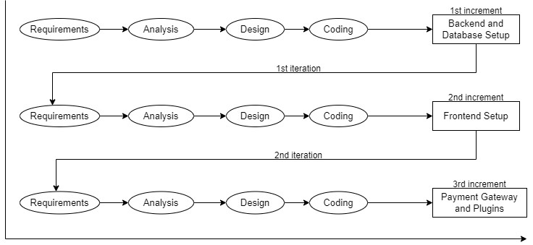
Figure 1 : Incremental Model

3.1.1. Analysis Phase
In this phase, all the essential requirements are analyzed. By this stage, the necessary requirement for further analysis of the project is gathered from the end-user, the internet and teachers. As a result, final specification of the project is established.

3.1.2. Design Phase
In this phase, the specifications gathered are designed as per the requirement. Further the database models, technical requirements and the logic are implemented in the project.

3.1.3. Implementation Phase
After the analysis and design, coding is done according to the specifications. Coding in progress, leading to a working system in this phase.

3.1.4. Testing Phase
Once the system is developed, a series of tests will be performed in order to identify and eliminate bugs and errors. As of now, some functionalities have been developed and tested. In this phase, any necessary changes are applied to ensure a complete and successful system.

3.2. WHY ITERATIVE AND INCREMENTAL MODEL?
Iterative development is a widely used software engineering process where a system is built in small, manageable increments rather than being developed as a whole in a single phase. Each increment focuses on implementing one or more features or functionalities that are integrated into the existing system. As a result, the software evolves over time, gradually becoming a more refined, complete, and functional version of itself. This approach is particularly effective for large or complex projects where requirements may change during development. Instead of trying to define and implement all requirements at the outset—which can be risky and inflexible—iterative development allows for continuous refinement. After each increment, the system can be reviewed and evaluated, and feedback from users or stakeholders can guide adjustments or enhancements in the next cycle. One of the major advantages of iterative development is its adaptability. Since requirements often change as projects progress, this approach ensures that new or modified needs can be addressed in future iterations without extensive rework. It also helps in identifying issues early in the development process, reducing the risk of major failures at later stages. By delivering working software in stages, iterative development improves transparency, allows for better resource management, and ensures that the system aligns more closely with user expectations and evolving business goals. This makes it an ideal choice for modern software projects where flexibility, continuous improvement, and user involvement are key to success.

4.TOOLS AND TECHNOLOGIES

4.1. TOOLS TO BE USED
TOOLS | PURPOSE
Visual Studio Code | Text Editor
Github | To manage Source Code (VCS)
Draw.io | To create models or diagrams
MS Word | For Documentation

Table 1: Tools to be used

4.2. TECHNOLOGIES
- Rest API is used as a functioning backend.
- JSON is used to transmit data objects consisting of key-value pairs.

4.3. PROGRAMMING LANGUAGES
In our project development, we employed Angular for frontend development and Node.js for backend development. MongoDB was selected as our database for managing data and its models. As a result, the combination of these technology stacks is strong enough to implement all of the project's stated objectives.

4.3.1. Angular
Angular is a powerful open-source front-end framework developed by Google for building dynamic and responsive single-page applications (SPAs). It is based on Type-script, a superset of JavaScript, and follows a component-based architecture that divides the user interface into reusable, modular parts called components. Angular offers features like two-way data binding, dependency injection, and routing, which make development more efficient. It also provides a Command Line Interface (CLI) that helps automate tasks like creating components and building projects. Angular’s use of directives, services, and a Virtual DOM-like change detection system ensures high performance and maintainability of large-scale web applications.
4.3.2 .Node.js
Node.js is a runtime environment and framework for executing JavaScript code server-side, outside of a browser. Built on Chrome's V8 JavaScript engine, Node.js is designed to build scalable network applications. It uses an event-driven, non-blocking I/O model, making it lightweight and efficient for handling multiple concurrent connections. Node.js applications are typically composed of modules and packages, managed via the npm (Node Package Manager) ecosystem. This modular approach allows developers to use and share reusable components, facilitating rapid development. Node.js is widely used for building server-side applications, APIs, real-time communication tools, and microservices, offering a versatile platform for modern web development.

4.3.3. Mongo DB
MongoDB is a NoSQL database known for its flexibility, scalability, and performance. It uses a document-oriented data model, storing data in JSON-like documents for easy schema flexibility. MongoDB supports high availability and scalability through features like replication and sharding, making it suitable for handling large volumes of data and high throughput operations.

4.3.4 .Postman API
Postman is a popular collaboration tool used for developing, testing, and managing APIs(Application Programming Interfaces). It provides a user-friendly interface that allows developers to easily send requests to APIs, inspect responses, and automate tests. With Postman, you can perform various HTTP methods like GET, POST, PUT, and DELETE, making it ideal for testing RESTful APIs. It also supports features such as environment variables,scripting, and automated test collections, which help streamline API development and debugging. Postman is widely used by developers and QA teams to ensure API functionality, performance, and security.

5. SYSTEM DESIGN AND UML MODELS

5.1. USE CASE DIAGRAM
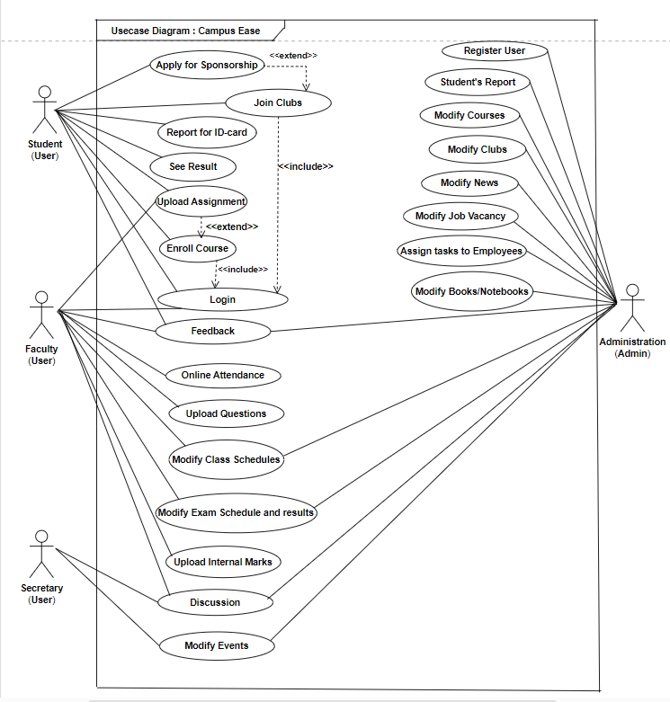
Figure 2: Usecase Diagram for CampusEase

The use case diagram for the project "Campus Ease" represents a detailed view of the interactions between various users and the system. It includes four main actors: Student, Faculty, Secretary, and Administration, each with specific roles and functionalities. Students can perform a variety of academic and campus-related activities such as logging into the system, enrolling in courses, uploading assignments, viewing results, applying for sponsorship's, joining clubs, reporting for ID-cards, and providing feedback. Some actions are interdependent; for example, enrolling in a course includes login, and uploading an assignment extends from the course enrollment process. Similarly, applying for sponsorship extends from the activity of joining clubs.
The Faculty users are responsible for academic operations such as uploading questions, marking online attendance, uploading internal marks, modifying class and exam schedules, participating in discussions, and giving feedback. Like students, faculty members also need to log in to access these features. The Secretary role is more administrative and focuses on event coordination and communication, such as modifying events, joining discussions, and submitting feedback.
The Administration (Admin) actor holds the highest level of access, managing system-wide data and settings. Admin functionalities include registering users, generating student reports, modifying courses, clubs, job vacancies, news, and books/notebooks, and assigning tasks to employees.

5.2 . Activity Diagram
An activity diagram is a behavioral UML diagram that represents the dynamic flow of control or data within a system. It illustrates the sequence of actions or activities that occur in response to a particular process or use case. In this project, activity diagrams are used to show how users interact with various features of the system, such as logging in, joining a club, posting events, or managing users. Each diagram begins with an initial node and follows a series of actions connected by control flows, which may include decision points, parallel activities, and an end node. For example, in the login process, the user enters their credentials, and based on the validation result, the system either grants access or displays an error message. These diagrams help in visualizing the logic of complex processes, making it easier to identify potential issues and design efficient workflows. They are particularly useful during system design and analysis phases to ensure clear communication among developers and stakeholders.with specific functionalities based on their roles. For instance, Students can register or log in, join clubs, and view available events or announcements. Club Leaders are responsible for creating and managing events, as well as communicating with members. Admins handle user management, approve clubs, post announcements, and oversee overall system operations. The use case diagram provides a high-level view of the system's scope and user interactions, making it easier to understand user expectations and plan the development accordingly. It serves as a foundational tool for system analysis and design.
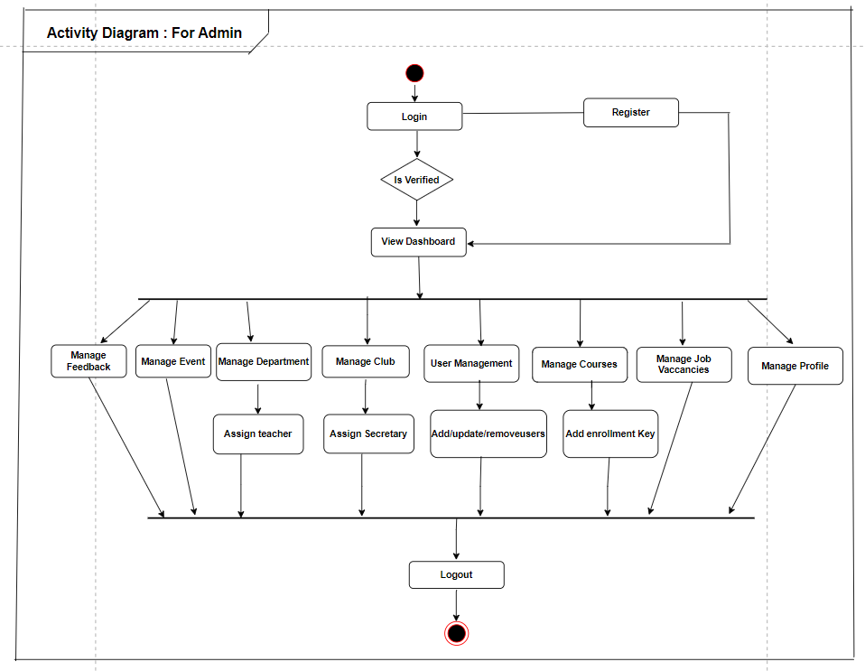
Figure 3: Activity Diagram for Admin
The Activity Diagram for Admin illustrates the flow of tasks that the admin performs to manage the system. It begins with the admin logging in and navigating to various management modules. The admin can approve or reject sponsorship requests, add or update events, manage assignments by creating tasks and setting deadlines, and oversee academic records by updating or verifying student performance. The admin can also handle ID card reports for lost or damaged IDs, view and manage feedback, and monitor attendance records for accuracy. The diagram represents the sequence of actions and decision points the admin takes to smooth operation of the platform.
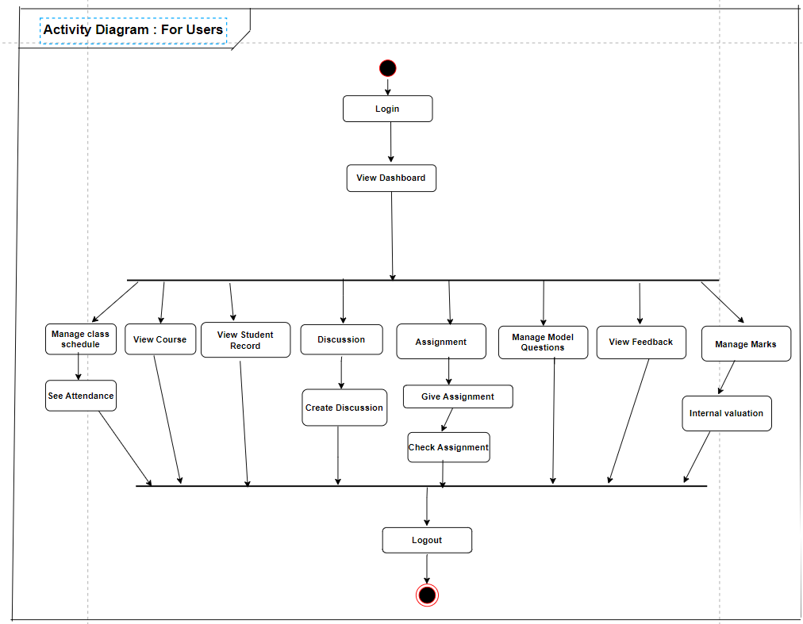
Figure 4: Activity Diagram for User
The User Activity Diagram illustrates the sequence of actions a Users performs within the system. The process begins with login and viewing the dashboard, from where the teacher can manage class schedules, view courses, access student records, create and participate in discussions, give and check assignments, manage model questions, view feedback, and handle marks through internal evaluations. The teacher can also see attendance while managing schedules. After completing tasks, the teacher logs out, completing the workflow. The diagram shows how teachers navigate between academic and administrative functions efficiently.

5.3. SEQUENCE DIAGRAM
A sequence diagram is a type of UML diagram that models the interaction between different objects or components in a system over time. It focuses on the order of messages exchanged to perform a specific function or process. In this project, sequence diagrams are used to illustrate how different parts of the system such as users, interfaces, and backend processes communicate with each other to complete tasks like user registration, login, event creation, or feedback submission. Each diagram includes objects (represented as vertical lifelines) and the messages exchanged between them (represented as horizontal arrows). The sequence flows from top to bottom, showing the timing and sequence of operations. For instance, during the login process, the user sends credentials to the system, the system verifies the details from the database, and then responds with either a success or failure message. These diagrams are essential for understanding how components interact in real-time and are valuable for both design and debugging purposes during software development.
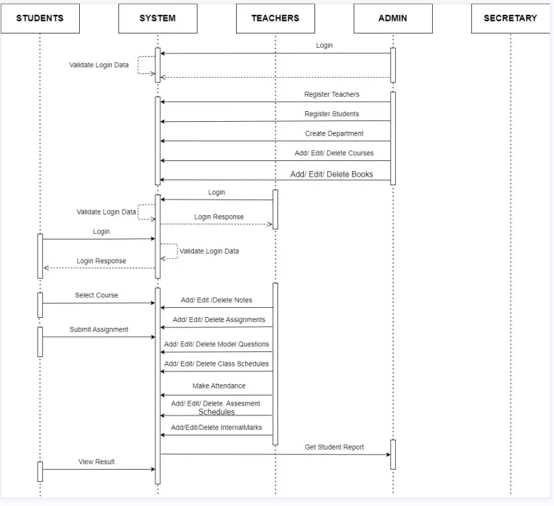
Figure 5: Sequence Diagram for Admin
The Admin Sequence Diagram illustrates the flow of actions between the admin, system, and other users. The admin starts by logging into the system, where login data is validated.Once authenticated, the admin can perform key tasks such as registering teachers, registering students, creating departments, and adding, editing, or deleting courses and books. The diagram highlights how the admin sends commands, and the system responds by updating records or providing feedback, ensuring smooth administrative control over core academic and organizational data

Functional Breakdown by User Roles
1. Students
Student users can interact with the system through these functions:
• Login Process:
– Validate Login Data (system verification)
– Login (credential submission)
– Login Response (system feedback)
• Course Interaction:
– Select Course (enrollment/registration)
– Submit Assignment (upload completed work)
• Academic Progress: View Result (access grades/scores)
2. Teachers
Teacher users have comprehensive system access with duplicate login entries (possibly indicating multiple authentication points):
• Authentication:
– Login (two instances shown, may need consolidation)
– Login Response
– Validate Login Data
• User Management:
– Register Teachers (add new faculty)
– Register Students (enroll new learners)
• Academic Structure:
– Create Department (establish academic units)
– Add/Edit/Delete Courses (manage curriculum)
• Learning Resources:
– Add/Edit/Delete Books (library management)
– Add/Edit/Delete Notes (instructional materials)
– Add/Edit/Delete Assignments (coursework)
– Add/Edit/Delete Model Questions (sample/exam prep)
• Scheduling:
– Add/Edit/Delete Class Schedules (timetables)
– Add/Edit/Delete Assessment Schedules (exam calendars)
• Student Evaluation:
– Make Attendance (track participation)
– Add/Edit/Delete InternalMarks (record grades)
3. Admin
Administrative functions are shown minimally:
Reporting:
Get Student Report (generate academic records)

4. Secretary
This section is currently empty (placeholder for future development), suggesting planned functionality for administrative support staff.
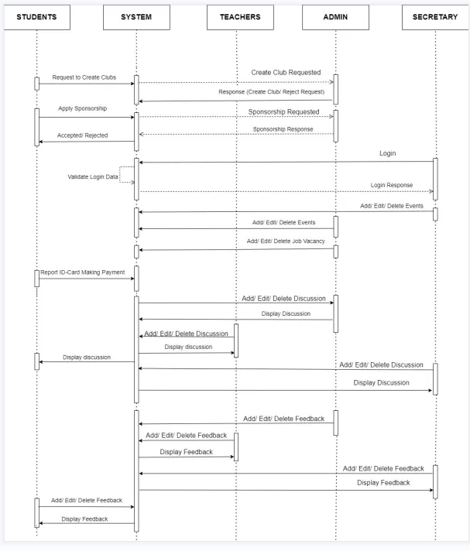
Figure 6 : Sequence Diagram for Secretary

This figure represents a system sequence diagram focusing on the Secretary’s role in a Student Administration System, showing interactions between Students, System, Teachers, Admin, and Secretary roles.
Functional Breakdown by Interaction
1. Club Management
• Student Initiation:
– Request to Create Clubs (student proposal)
– Create Club Requested (system acknowledgment)
– Response (Create Club/Report Request) (approval/denial feedback)
• Sponsorship Process:
– Apply Sponsorship (funding request)
– Sponsorship Requested (system recording)
– Accepted/Rejected (decision notification)
– Sponsorship Response (final outcome communication)

2. Authentication
Login Process (shared with other roles):
• Login (credential submission)
• Validate Login Data (system verification)
• Login Response (access grant/denial)
3. Event Management Event Coordination:
• Add/Edit/Delete Events (duplicate entries suggest multiple event types)
• (Note: The repetition may indicate separate event categories)
4. Job Postings
Career Services:
Add/Edit/Delete Job Vacancy (employment opportunity management)
5. Administrative Tasks
ID Card Processing:
Disport ID: Card Making Payment (typo likely means ”Dispatch ID” - issuing student IDs with payment processing)
6. Discussion Management
Forum Moderation:
• Three identical cycles of:
– Add/Edit/Delete Discussion (content management)
– Display Discussion (content visibility)
• (Repetition may indicate different discussion categories or a diagram error)
7. Feedback Handling
Feedback Administration:
• Three identical cycles of:
– Add/Edit/Delete Feedback (comment management)
– Display Feedback (comment visibility)
• (Repetition may indicate different feedback channels or a diagram error)

5.4. DATA FLOW DIAGRAM

5.4.1. 0-Level DFD
The 0-Level Data Flow Diagram shows boundaries of the system and also depicts the flow of information among entities. The diagrammatic representation is as below:
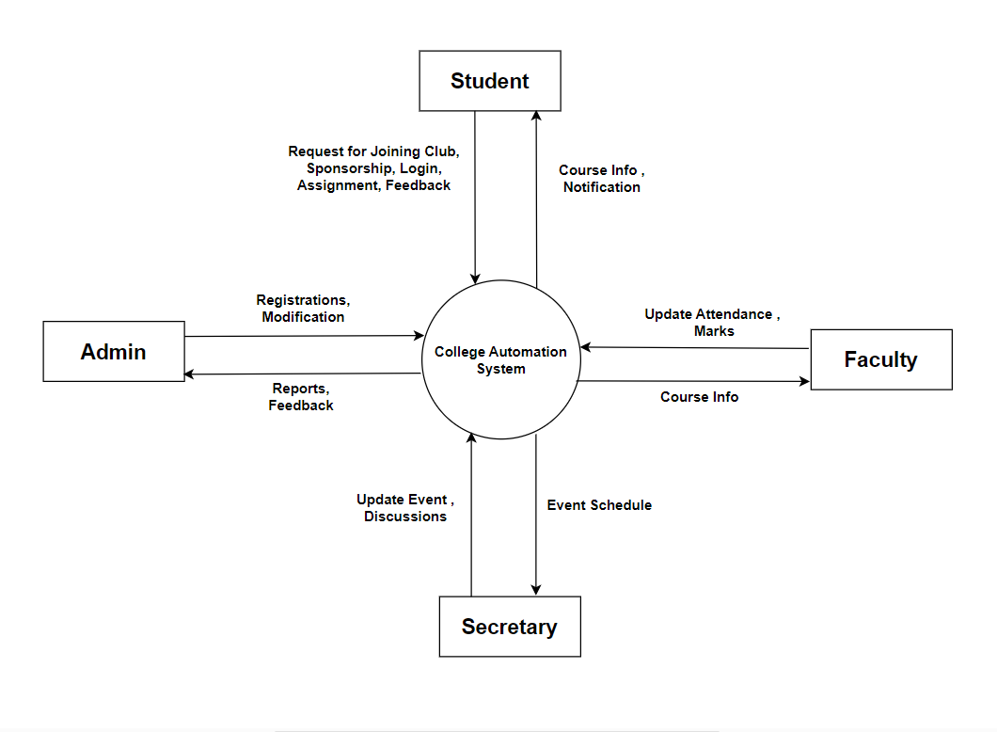
Figure 7: 0-Level Data Flow Diagram

This diagram shows how the Automation System connects with students, faculty, admin, and the secretary. Students enroll in courses and upload assignments, faculty upload internal marks, admin manage entity and update information, and the secretary handles event updates. The system processes these inputs to keep academic and administrative operations running smoothly.

5.4.2. 1-Level DFD
The diagrammatic representation of 1-Level DFD is as below:
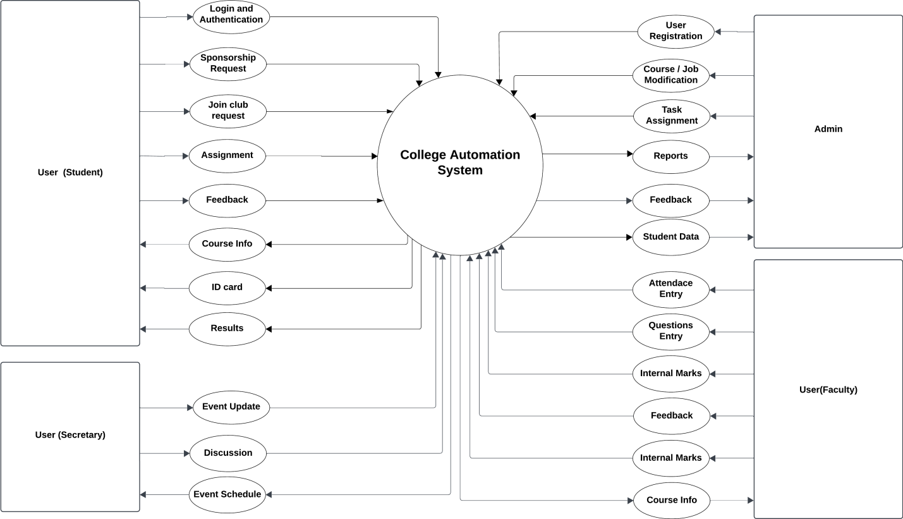
Figure 8: 1-Level Data Flow Diagram
In the Data Flow Diagram (Level 1) of the Campus Ease system, the major data flows represent the exchange of information between different users and the system processes. The Student entity sends various inputs to the system such as login information, assignment submissions, feedback, sponsorship requests, and club joining requests. In return, students receive outputs like exam results, system notifications, ID cards, and course-related information. The Faculty members contribute data by sending attendance records, exam or assignment questions, internal marks, feedback, and class or exam schedules. They receive notifications and course-related updates from the system. The Secretary sends event-related updates and participates in discussions, while receiving the finalized event schedules in return. The Admin plays a central role by sending critical information such as user registrations, modifications to courses, clubs, and job vacancies, as well as assigning tasks to faculty and staff. The Admin receives data such as student reports, feedback, and general student information from the system.

6. TASK DONE SO FAR
(a) Implemented a secure user login system for authentication and access control.
(b) Developed user management features for creating, updating, and managing user accounts.
(c) Designed modules for department and course management to support academic structure.
(d) Integrated event management for adding, scheduling, and tracking events.
(e) Developed job vacancy management for posting and managing employment opportunities.
(f) Implemented a discussion forum to facilitate communication among users.
(g) Added a feedback system for collecting user suggestions and opinions.
(h) Introduced an enroll key feature to enable secure course enrollment
(i) Integrated Khalti for seamless online payment processing.
(j) Provided functionality for sponsorship management, including request handling and approvals.
(k) Developed assignment management features to allow task creation, submission, and evaluation.

7 .TASK REMAINING
1. Improving admin section
2. Adding admission section
3. Adding notification
4. Attendance with face recognition

8. PROPOSED DELIVERABLES
- Provides an intuitive interface for students, faculty, and administrators.
- Enables digital recording and monitoring of student attendance.
- Allows students to register for courses and faculty to manage them.
- Generates performance reports and dashboards for academic insights.
- Facilitates collection of feedback from students about courses and faculty.
- Supports uploading, tracking, and grading of assignments.
- Allows users to view and download their digital ID cards.
- Enables students to join and manage participation in various college clubs.
- Manages creation, registration, and scheduling of campus events.
- Provides access to previous or model question papers for exam preparation.

9. PROJECT TASK AND TIME SCHEDULE
The project schedule has been designed as per the requirements, listing various tasks with their approximate duration, ensuring debugging and testing are to be completed prior to project completion.

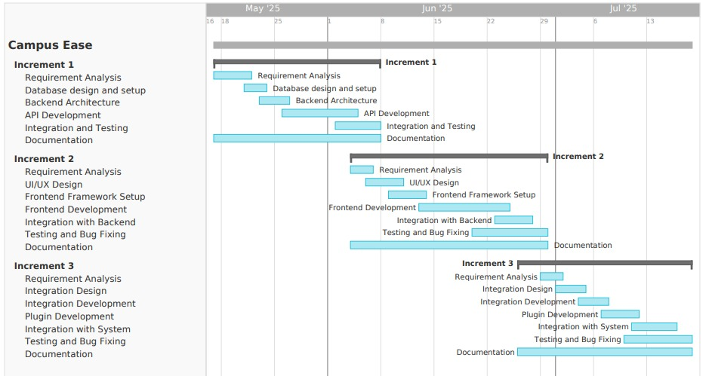
Figure 9 : Gantt Chart for CampusEase

10.BIBLIOGRAPHY
[1] Ellucian, Banner. [Online]. Available: https://www.ellucian.com/emea-ap/solutions/ellucian-banner
[2] Blackboard, Blackboard Learn | Blackboard.com. [Online]. Available: https://www.blackboard.com/teaching-learning/learning-management/blackboard-learn
[3] Oracle, PeopleSoft Campus Solutions. [Online]. Available: https://www.oracle.com/industries/higher-education/campus-solutions.html
[4] Moodle, Moodle - Open-source learning platform, 2023. [Online]. Available: https://moodle.org/
[5] T. D. Olsen, SDLC Project Management, 2012. [Online]. Available: https://archive.org/details/isbn_9781475131369/mode/2up
[6] R. Bahsoon and M. Balaji, Fundamentals of Software Engineering. Pearson, 2023. [Online]. Available: https://www.pearson.com/en-us/subject-catalog/p/fundamentals-of-software-engineering/P200000003499/9780133056990
[7] GeeksforGeeks, Software Development Life Cycle (SDLC), 2023. [Online]. Available: https://www.geeksforgeeks.org/software-development-life-cycle-sdlc/
[8] Node.js, Node.js - JavaScript runtime built on Chrome's V8 JavaScript engine, 2023. [Online]. Available: https://nodejs.org/
[9] Angular, Angular - The modern web developer's platform, 2023. [Online]. Available: https://angular.io/
[10] MongoDB, MongoDB - The developer data platform, 2023. [Online]. Available: https://www.mongodb.com/
[11] GeeksforGeeks, Unit Testing, 2023. [Online]. Available: https://www.geeksforgeeks.org/unit-testing/
[12] Red Hat, What is a REST API?, 2023. [Online]. Available: https://www.redhat.com/en/topics/api/what-is-a-rest-api
[13] IEEE, Standard for Software and System Test Documentation, IEEE Std 829-2008, pp. 1–120, 2008. [Online]. Available: https://ieeexplore.ieee.org/document/5165257

