A Major Project Mid-term Report on

**CampusEase: A College Automation System**

Submitted in Partial Fulfillment of the Requirements for the Degree of **Bachelors of Engineering in IT Engineering**

under **Pokhara University**

Submitted by:

**Abhay Chaudhary, 201401**

**Aadar Ghimire, 201601**

**Ganesh Kumar Pun, 201514**

**Prakriti Sharma, 201527**

Date:

19th June 2025



**Department of Information Technology**

**NEPAL COLLEGE OF  
INFORMATION TECHNOLOGY**

Balkumari, Lalitpur, Nepal

**ABSTRACT**

College automation seeks to improve efficiency and communication among administrators, instructors, students, and general secretaries by optimizing academic administration using cutting-edge electronic solutions. Our solution provides an all-inclusive framework to optimize several administrative processes, which boosts overall efficiency.

The management of student information, keeping current records of academic standings, attendance, and student information are important elements. Because of this automation, handling of information is accurate and timely while reducing administrative responsibilities and errors.

Academic scheduling modules optimize faculty allocation and resource use by automating the construction and management of class schedules, creating a more efficient and well-organized learning environment. Faculty management tools optimize performance evaluation, teaching assignment scheduling, and feedback gathering while offering practical insights to improve instruction and foster a positive learning environment.

Furthermore, the incorporation of online payment options guarantees safe, effective, and convenient financial transactions by optimizing the procedure. Teachers, parents, and students all benefit from an improved user experience and a reduction in administrative workload.

Our project's goal is to create a reliable, effective, and user-friendly college administration system that optimizes administrative processes and improves learning for all parties involved. We believe that this automation will have a major positive impact on resource management, overall satisfaction in the academic community, and operational efficiency.

**Keywords:** College Automation, Academic Administration, Student Information Management, Academic Scheduling, Faculty Management, Online Payment Integration, Operational Efficiency, Resource Optimization, Administrative Procedures, Educational Technology.

I

Table of Contents

**1. INTRODUCTION 3**

**2. PROBLEM STATEMENT 8**

**3. OBJECTIVES 9**

**4. SIGNIFICANCE OF STUDY 10**

**5. SCOPE AND LIMITATIONS 11**

**5.1. SCOPE: 11**

**5.2. LIMITATIONS: 11**

**6. LITERATURE REVIEW 12**

**6.1. EXISTING PLATFORMS 12**

**7. METHODOLOGY 15**

**7.1. SOFTWARE DEVELOPMENT LIFE CYCLE 15**

**7.1.1. Analysis Phase 16**

**7.1.2. Design Phase 16**

**7.1.3. Implementation Phase 16**

**7.1.4. Testing Phase 16**

**8. TOOLS AND TECHNOLOGIES 17**

**8.1. TOOLS TO BE USED 17**

**8.2. TECHNOLOGIES 17**

**8.3. PROGRAMMING LANGUAGES 17**

**9. SYSTEM DESIGN AND UML MODELS 19**

**9.1. USE CASE DIAGRAM 19**

**9.2. DATA FLOW DIAGRAM 20**

**9.2.1. 0-Level DFD 20**

**10. PROPOSED DELIVERABLES 21**

**11. PROJECT TASK AND TIME SCHEDULE 22**

**BIBLIOGRAPHY 23**

**II**

**LIST OF TABLES**

**Table 1: Tools to be used ………………………………………………………………………17**

III

**LIST OF FIGURES**

**Fig1: Incremental Model……………………………………………………………….15**

**Fig2: Use Case Diagram for CampusEase ……………………………………………19**

**Fig3: 0-Level DFD Diagram …………………………………………………………...20**

**Fig4: Gantt Chart ………………………………………………………………………22**

IV

# 1. INTRODUCTION

In today’s digital era, college automation systems are transforming higher education by redefining the roles of key stakeholders—administrators, faculty, students, and general secretaries. These systems enhance operational efficiency, transparency, and decision-making while reducing manual effort and errors.

For Administrators, automation streamlines student record management, faculty coordination, performance monitoring, and scheduling. By leveraging real-time data, administrators can identify trends, assess policy effectiveness, and make informed decisions that promote institutional growth and compliance with academic standards.

For Students, automation simplifies class registration, assignment submission, and access to academic updates. Real-time notifications, timetables, and performance tracking empower students to manage their academic journey effectively, reducing stress and promoting success. Enhanced transparency fosters a more supportive learning environment.

For Faculty, administrative tasks such as grade management, attendance tracking, and scheduling are automated, allowing them to focus more on teaching and research. Centralized systems also improve interdepartmental communication and collaboration, encouraging innovation and continuous improvement in instructional quality.

For General Secretaries, automation enhances departmental operations through better event planning, resource allocation, and communication. It ensures the effective use of facilities, tools, and personnel, contributing to the smooth execution of institutional functions.

College automation is no longer optional—it is essential. These systems promote informed decision-making, streamline processes, and support a culture of collaboration and innovation. As institutions continue to adopt automation technologies, they are better positioned to deliver high-quality, efficient, and future-ready education.

# 2. PROBLEM STATEMENT

Issues with resource allocation, communication bottlenecks, and inefficient administrative procedures provide obstacles for educational institutions. These issues make it difficult to plan lessons, handle student records, organize faculty assignments, and facilitate good stakeholder communication. Students also have challenges when registering in the automation system, enrolling in the classes, renewing ID cards and gaining access to academic resources, all of which negatively affect their overall experience. Academic staff members are overburdened with administrative duties like attendance recording, assigning assignments, etc. that take time away from their primary duties of teaching and research.

General secretaries tasked with communication, event planning, and data management lack efficient tools to optimize their responsibilities, affecting institutional coordination and support. To address these challenges, there is a need for comprehensive college automation systems that integrate student information management, academic scheduling and communication tools. Such systems will enhance efficiency, transparency, and collaboration within educational institutions, optimizing resources and improving stakeholder experiences.

# 3. OBJECTIVES

Following are the objectives of this project:

1. To develop an interactive web application with a user-friendly search interface.
2. To upload and download necessary assignments and notes.
3. To allow students to see their performance and assignment.
4. Automate tasks like student management, attendance management, events planning, etc.
5. To keep all the records of the students and staffs.

# 4. SIGNIFICANCE OF STUDY

Researching college automation has important consequences for academic institutions looking to improve productivity and update administrative procedures. Colleges that implement automation systems stand to gain a great deal from it, including increased operational efficiency from the simplification of manual processes like scheduling, attendance monitoring, and registration. College staff may devote more time and resources to value-added activities by automating these processes, which will ultimately improve the overall efficiency of academic operations. Additionally, automation improves the student experience by optimizing processes like grading and course registration, which increases student satisfaction and retention rates.

Furthermore, automation guarantees efficient administration and accuracy of data, minimizing errors related to human data entry and enabling trustworthy reporting for college administrators to make well-informed decisions. Another benefit of automation is cost savings, as it reduces operating costs by eliminating the need for paperwork and physical labor. Automation also makes it easier to obtain information in real time, giving administrators, teachers, and students access to rapid updates on schedules, events, and academic progress. This enhances communication and transparency among the college community. In addition, studying automation in college gives students the necessary technological knowledge and gets them ready for the needs of the digital age, which improves their workforce readiness.

Finally, because automated systems are flexible and scalable, universities can effectively handle expanding student bodies and changing curriculum. In conclusion, research into college automation is important because it may optimize administrative procedures, enhance student services, and get educational institutions ready for a world driven by technology.

# 5. SCOPE AND LIMITATIONS

The scope of this project is to provide users with all the services through a web-based networking service. In this project, a web app is developed where users of the college are able to ask and answer questions, as well as upload and download notes and many more.

## 5.1. SCOPE:

1. The targeted audience are the administration, faculty, student, and General secretaries of the college.
2. This web app can be modified and used for various colleges/schools or even universities.

## 5.2. LIMITATIONS:

1. This is only a web app, not an android app.
2. Need of stable internet connectivity.

# 6. LITERATURE REVIEW

In today’s ever-changing digital landscape, online platforms have revolutionized the way we do everything from managing administrative tasks to delivering content to engaging with students and hearing their feedback. In this literature review, we’ll look at how online platforms have changed college administration and how they’re changing learning management. We’ll explore theories, practices and success stories from popular platforms like Ellucian Banner, Blackboard, Oracle PeopleSoft Campus Solutions and Moodle.

## 6.1. EXISTING PLATFORMS

**1. Ellucian Banner,** which is extensively adopted by higher education institutions for its comprehensive suite of integrated solutions. Student info management, financial operations, and human resources are all covered. Administrators can efficiently manage student records, including registration, grades, transcripts, and degree audits, with the Student Information System (SIS) component of Ellucian Banner. The financial module helps with budgeting, accounting, financial reporting, and procurement, ensuring optimized and transparent financial operations. Human resources manage employee records, payroll, benefits, recruitment, and professional development. Additionally, Ellucian Banner has a financial aid module that automates the financial aid application, evaluation, and distribution processes. The comprehensive integration and scalability of Ellucian Banner make it suitable for large institutions despite its high implementation and maintenance costs. [1]

**2. Blackboard**, which is primarily recognized as a learning management system (LMS), also offers significant administrative automation features. The goal is to enhance the student learning experience while supporting administrative tasks. The course management feature allows for the creation, delivery, and management of online and hybrid courses, including content management and assessment tools. Forums, messaging, announcements and virtual classrooms are communication tools that facilitate interaction between students and faculty. The student performance tracking tools provided by Blackboard help educators monitor and analyze student performance. The focus on enhancing the learning experience and robust support for various learning modalities make Blackboard a versatile choice. However, its primary focus on academic functions rather than comprehensive administrative automation can be a challenge for smaller institutions. Potential costs can also be a challenge. [2]

**3. Oracle PeopleSoft Campus Solutions** is a robust ERP (Enterprise Resource Planning) system known for its flexibility and extensive customization capabilities, making it ideal for large and complex institutions. It handles a wide range of administrative and academic functions. Academic guidance and student records are handled by the student administration tools. Academic advising tools support degree planning and student progress tracking. Communication and interactions with students, teachers, staff, and former students are handled by the campus community module, boosting community involvement. Various administrative tasks like registration, financial aid applications, and personal information updates can be facilitated by PeopleSoft's self-service portals for students and staff. Data flow and operational efficiency can be ensured by strong integration with other Oracle products. The high cost of implementation and upkeep, as well as the substantial IT resources required for customization and support, are significant concerns, but PeopleSoft's extensive capabilities make it an intimidating choice for large organizations. [3]

**4. Moodle** stands out as an open-source learning management system that also supports administrative automation. It's a hit because of its adaptability, value, and solid community backing. Course management in Moodle lets you create and manage online courses, with multimedia integration, assessments, and discussion boards. Tools for role assignments and permissions are provided for tracking student, faculty, and staff data. Tools for managing grades, tracking progress, and generating reports can be found in the gradebook module. The extensive library of plugins for Moodle allows customization and integration with other administrative systems. Users can access course materials and administrative functions on the go with the platform's mobile app, which ensures that they can access course materials and administrative functions on the go. The open-source nature and community support of Moodle make it a powerful tool for both learning and administrative automation. [4]

Modern educational institutions need college automation systems to improve administrative efficiency, academic experience, and overall operational effectiveness. There are distinct advantages for each system, including **Ellucian Banner, Blackboard, Oracle PeopleSoft Campus Solutions**, and **Moodle**. These systems are instrumental in driving forward a new era of academic and administrative excellence, from comprehensive and scalable solutions like Ellucian Banner and Oracle PeopleSoft to user-friendly and cost-effective options like Blackboard and Moodle.

**6.2. Comparison Between the Existing System and Our System**

While LMS platforms offer effective online learning solutions, they come with limitations such as cost, complexity in setup and operation, limited customization, and integration challenges. Whereas, our college automation platform offers an effortless experience by integrating all essential functions into one user-friendly system. With automated processes, advanced communication tools, and robust security measures, it enhances efficiency, transparency, and collaboration across the institution. Scalable, customizable, and continuously updated, it ensures a tailored solution that meets evolving needs while prioritizing data security and compliance.

# 7. METHODOLOGY

In this section we have described the method that we are using to meet the requirement of the project.

## 7.1. SOFTWARE DEVELOPMENT LIFE CYCLE

The model used for development of the project is the Iterative model of SDLC. Iterative model is simple and emphasizes on initial and simple implementation and with progress in the project it gains more features. It is advantageous since it has a unique feature of repetitive nature i.e. during development phase one can go back to check out the previous works without any complications and flaws can be improved if any. Further explanation about the model has been described below.

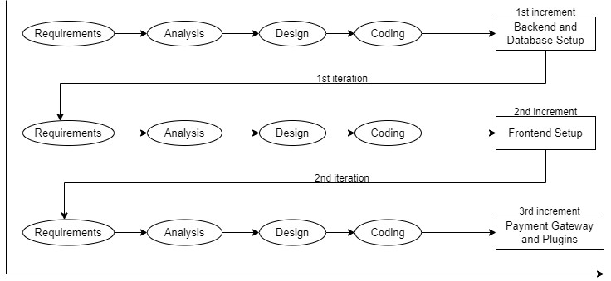

*Fig1: Incremental Model*

### 7**.1.1. Analysis Phase**

In this phase, all the essential requirements are analyzed. By this stage, the necessary requirement for further analysis of the project is gathered from the end-user, the internet and teachers. As a result, final specification of the project is established.

### 7.1.2. Design Phase

In this phase, the specifications gathered are designed as per the requirement. Further the database models, technical requirements and the logic are implemented in the project.

### 7.1.3. Implementation Phase

After the analysis and design, coding is done according to the specifications. Coding in progress, leading to a working system in this phase.

### 7.1.4. Testing Phase

Once the system is developed, a series of tests will be performed in order to identify and eliminate bugs and errors. As of now, some functionalities have been developed and tested. In this phase, any necessary changes are applied to ensure a complete and successful system.

**WHY ITERATIVE AND INCREMENTAL MODEL?**

Iterative development is a method or process for creating software in small and frequent increments. Each increment refers to the incorporation of one or more features or functionality into the system under development. The system to evolve becomes a more polished and comprehensive version of itself with each increment. Rather than developing an entire application or software in one go, which can be extremely difficult as the project size grows and requirements change, following the principles helps to cope with changing system requirements as new requirements can be dealt with in new increments of development.

# 8. TOOLS AND TECHNOLOGIES

## 8.1. TOOLS TO BE USED

|  |  |
| --- | --- |
| **TOOLS** | **PURPOSE** |
| Visual Studio Code | Text Editor |
| Github | To manage Source Code (VCS) |
| Draw.io | To create models or diagrams |
| MS Word | For Documentation |

*Table 1: Tools to be used*

## 8.2. TECHNOLOGIES

1. Rest API is used as a functioning backend.
2. JSON is used to transmit data objects consisting of key-value pairs.

## 8.3. PROGRAMMING LANGUAGES

In our project development, we employed React for frontend development and Node.js for backend development. MongoDB was selected as our database for managing data and its models. As a result, the combination of these technology stacks is strong enough to implement all of the project's stated objectives.

**8.3.1. React**

React is a popular JavaScript library used for building user interfaces, particularly single-page applications where content updates dynamically without reloading the entire page. Developed by Meta (formerly Facebook), React follows a component-based architecture, meaning the UI is divided into reusable and independent pieces called components. It uses a special syntax called JSX, which allows developers to write HTML-like code directly within JavaScript, making the structure of the UI easier to visualize. One of React’s core features is the Virtual DOM, which improves performance by updating only the parts of the page that actually change.

**8.3.2 Node.js**

Node.js is a runtime environment and framework for executing JavaScript code server-side, outside of a browser. Built on Chrome's V8 JavaScript engine, Node.js is designed to build scalable network applications. It uses an event-driven, non-blocking I/O model, making it lightweight and efficient for handling multiple concurrent connections. Node.js applications are typically composed of modules and packages, managed via the npm (Node Package Manager) ecosystem. This modular approach allows developers to use and share reusable components, facilitating rapid development. Node.js is widely used for building server-side applications, APIs, real-time communication tools, and microservices, offering a versatile platform for modern web development.

**8.3.3 Mongo DB**

MongoDB is a NoSQL database known for its flexibility, scalability, and performance. It uses a document-oriented data model, storing data in JSON-like documents for easy schema flexibility. MongoDB supports high availability and scalability through features like replication and sharding, making it suitable for handling large volumes of data and high throughput operations.

# 9. SYSTEM DESIGN AND UML MODELS

## 9.1. USE CASE DIAGRAM

A use case diagram summarizes the relationship and use cases between user and the system. There are altogether three actors: user, system and admin. The below figure depicts the relationship between these actors.

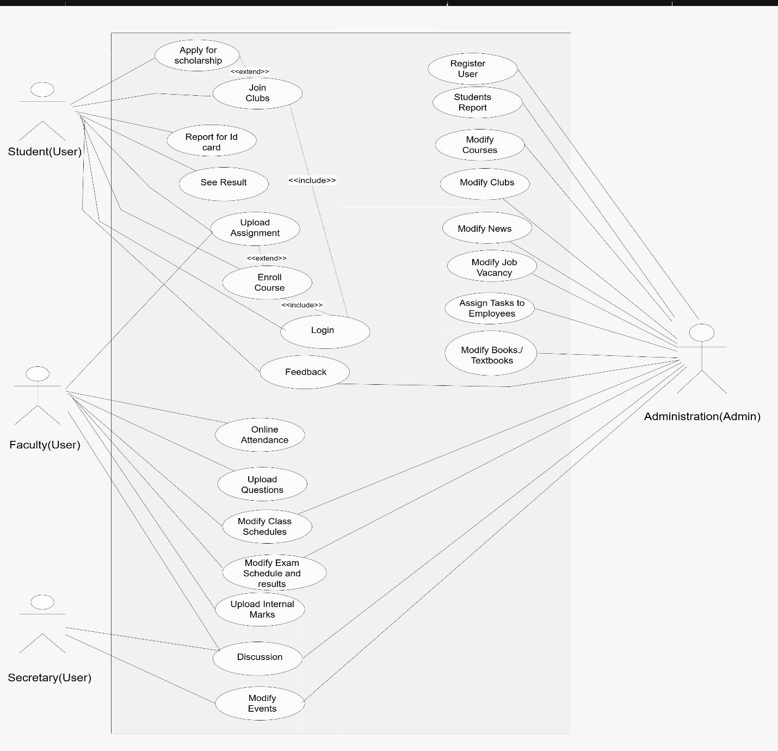

*Fig 2: Use Case Diagram for CampusEase*

## 9.2. DATA FLOW DIAGRAM

### 9.2.1. 0-Level DFD

The 0-Level Data Flow Diagram shows boundaries of the system and also depicts the flow of information among entities. The diagrammatic representation is as below:

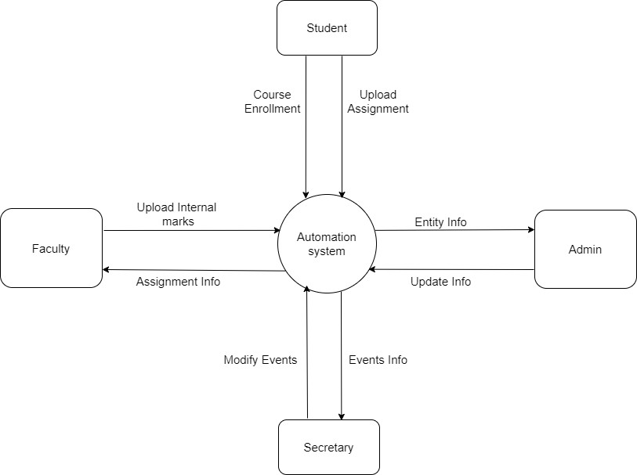

*Fig3: 0-Level Data Flow Diagram*

# 10. PROPOSED DELIVERABLES

1. Provides an intuitive interface for students, faculty, and administrators.
2. Enables digital recording and monitoring of student attendance.
3. Allows students to register for courses and faculty to manage them.
4. Generates performance reports and dashboards for academic insights.
5. Facilitates collection of feedback from students about courses and faculty.
6. Supports uploading, tracking, and grading of assignments.
7. Allows users to view and download their digital ID cards.
8. Enables students to join and manage participation in various college clubs.
9. Manages creation, registration, and scheduling of campus events.
10. Provides access to previous or model question papers for exam preparation.

# 11. PROJECT TASK AND TIME SCHEDULE

The project schedule has been designed as per the requirements, listing various tasks with their approximate durations, ensuring debugging and testing are to be completed prior to project completion.

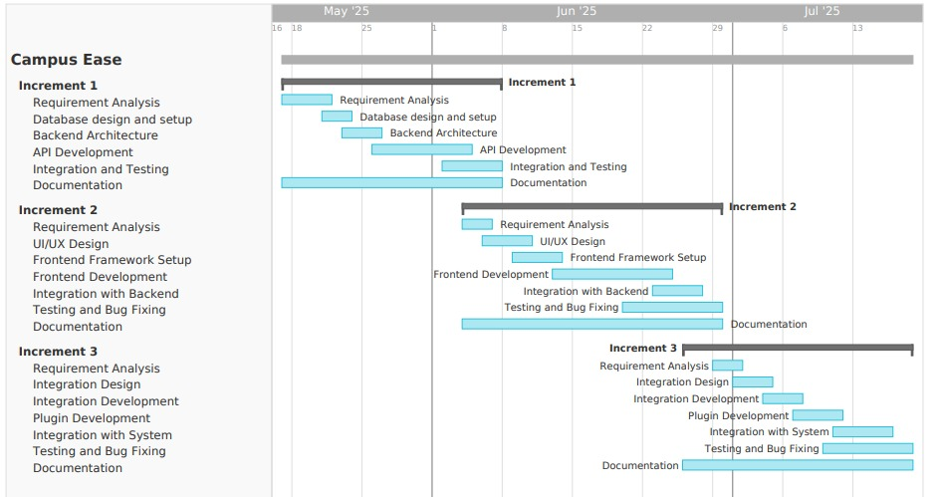

*Fig4: Gantt Chart for CampusEase*

# 

# BIBLIOGRAPHY

[1] Ellucian,"Banner,"Ellucian, [Online].

Available:<https://www.ellucian.com/emea-ap/solutions/ellucian-banner>

[2] Blackboard, "Blackboard Learn | Blackboard.com," [Online]. Available: [https://www.blackboard.com/teaching-learning/learning-management/blackbo ard-learn](https://www.blackboard.com/teaching-learning/learning-management/blackboard-learn)

[3]Oracle, "PeopleSoft Campus Solutions," Oracle, [Online]. Available: <https://www.oracle.com/industries/higher-education/campus-solutions.html>.

[4]Moodle, "Moodle - Open-source learning platform," 2023. [Online].

Available: <https://moodle.org/>

[5] T. D. Olsen, "SDLC Project Management," 2012. [Online]. Available: <https://archive.org/details/isbn_9781475131369/mode/2up>

[6] R. Bahsoon and M. Balaji, "Fundamentals of Software Engineering," Pearson, 2023. [Online]. Available:[https://www.pearson.com/en-us/subject-catalog/p/fundamentals-of-software-en](https://www.pearson.com/en-us/subject-catalog/p/fundamentals-of-software-en%20) [gineering/P200000003499/9780133056990](https://www.pearson.com/en-us/subject-catalog/p/fundamentals-of-software-engineering/P200000003499/9780133056990)

[7] GeeksforGeeks, "Software Development Life Cycle (SDLC)," 2023.

[Online]. Available:

[**https://www.geeksforgeeks.org/software-development-life-cycle-sdlc/**](https://www.geeksforgeeks.org/software-development-life-cycle-sdlc/)

[8] Node.js, "Node.js - JavaScript runtime built on Chrome's V8 JavaScript engine," 2023. [Online]. Available: <https://nodejs.org/>

[9] Angular, "Angular - The modern web developer's platform," 2023. [Online]. Available: <https://angular.io/>

[10] MongoDB, "MongoDB - The developer data platform," 2023. [Online]. Available: <https://www.mongodb.com/>

[11] GeeksforGeeks, "Unit Testing," 2023. [Online]. Available:

<https://www.geeksforgeeks.org/unit-testing/>

[12] Red Hat, "What is a REST API?," 2023. [Online]. Available: <https://www.redhat.com/en/topics/api/what-is-a-rest-api>

[13] IEEE, "Standard for Software and System Test Documentation," IEEE Std 829-2008, pp. 1-120, 2008. [Online]. Available: <https://ieeexplore.ieee.org/document/5165257>