**Project: 3D Aquarium Simulation**

**Author**: Leonardo Afonso Oliveira Luís  
**Number**: 114093

**URLs**

* **GitHub**: [Aquarium-ThreeJs](https://github.com/leoaoluis/Aquarium-ThreeJs)
* **Live Site (Netlify)**: [3D Aquarium Simulation](https://aquariumprojectua.netlify.app/)

**Illustrative Image**

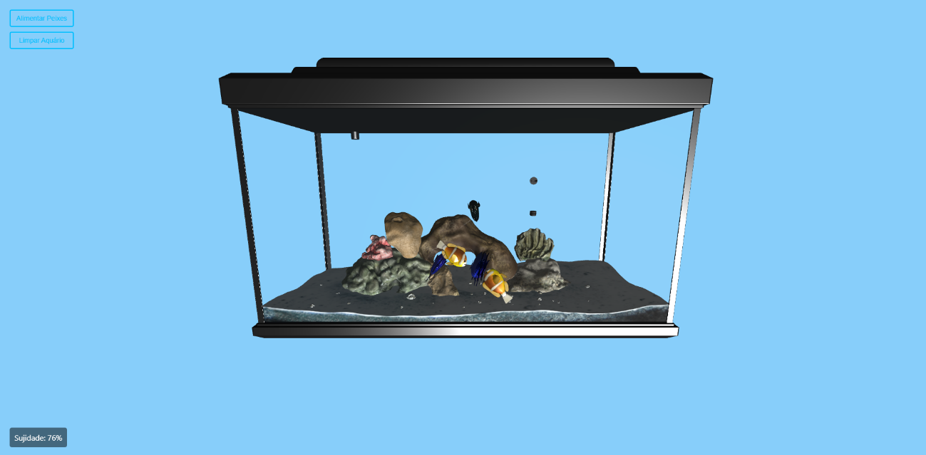

**Objectives**

The goal of this project is to create an interactive 3D aquarium simulation using Three.js. The system allows the user to observe the aquarium from an external perspective and navigate through the first-person view of a fish inside. The aquarium evolves over time and requires user interaction to maintain it.

Key objectives include:

* Implementation of an external and internal (first-person) view of the aquarium.
* Simulation of fish movement with varied behaviors.
* Interactivity to clean the aquarium and feed the fish.
* Visual effects like water dirtiness and refraction distortion.
* Creation of a simple interface for interaction with the environment.

**What is already done**

* **Aquarium Structure**: The aquarium has been modeled in 3D and loaded with textures and materials using OBJLoader2 and MTLLoader.
* **Animated Fish**: Three types of fish with movement animations inside the aquarium.
* **Basic Interactivity**: The user can clean the aquarium and control the external view with the mouse.
* **Visual Effects**: The aquarium simulates dirtiness over time, but the user can’t see this change yet in the water (in progress).
* **Deployment on Netlify**: The project is deployed on Netlify and is available online.

**What is left to do**

* **Improve Fish Movement**: While the fish are already moving, their behavior and smoothness can be further enhanced for more realistic animations.
* **Visual Improvements**: The dirt effect on the aquarium glass needs to be properly visualized, including animations when the user clicks the clean button to reset the dirt level.
* **Additional Effects**: More interactions can be added, such as changing the water color, feeding the fish to impact their behavior, dynamic lighting effects, and interactive events in the aquarium.
* **UI Refinement**: The user interface needs to be polished to make it more intuitive and user-friendly.
* **Adaptive Fish Behavior**: Improve the dynamic behavior of the fish based on whether they are fed or hungry.
* **Refraction Shader**: Implement a refraction shader to simulate underwater vision distortion when viewing through the aquarium glass.