B1/S and B2/S are both explosive rules in which every cell dies in every generation.

If a rule includes B1, it is fertile. In this case, the pattern consisting of a single live cell is a growth pattern.After k steps starting from this pattern, the minimum bounding box will contain (2k+1) x (2k+1) cells, and will have a single live cell at each of its four corners, so on the B1/S because all the living cells die,the middle cell from previous generation ends up being dead.

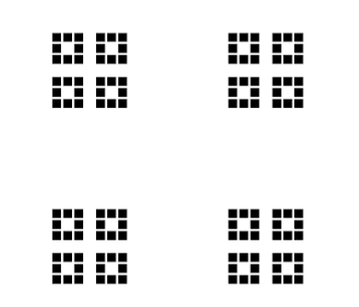

If a rule includes B2, it is fertile. If the rule also includes B1, this follows from the previous case, otherwise, the pattern consisting of a 2x2 block of live cells is a growth pattern.

After k steps starting from this pattern,the minimum bounding box will contain (2k+2) x (2k+2) cells, and will have two adjacent live cells at the center of each of its edges, the remaining cells on each edge of the bounding box will be non-live, leading the same pattern to propagate outwards by one more unit in the following time step.

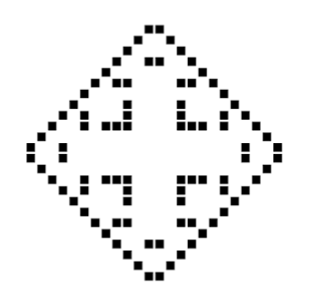

Rule B2/S is a life-like cellular automaton called Seeds in which only dead cells with exactly two live neighbors will turn into live cells on the next generation. Even though all the living cells die in every generation (turning every pattern into a phoenix), most patterns are still exploding quadratically.

B1/S - Rule 8

B2/S - Rule 32