|  |
| --- |
| Report |

Assignment 2

*1DV701*

|  |
| --- |
| *Author: Leonardo Pedro*  *Semester:* Spring 2020  *Email: lr222qp@student.lnu.se* |



Contents

1 Problem 1 I

2 Problem 2 I

3 Problem 3 I

# Problem 1

The screenshots below show some HTML and PNG files in a directory hierarchy that tests the web server.

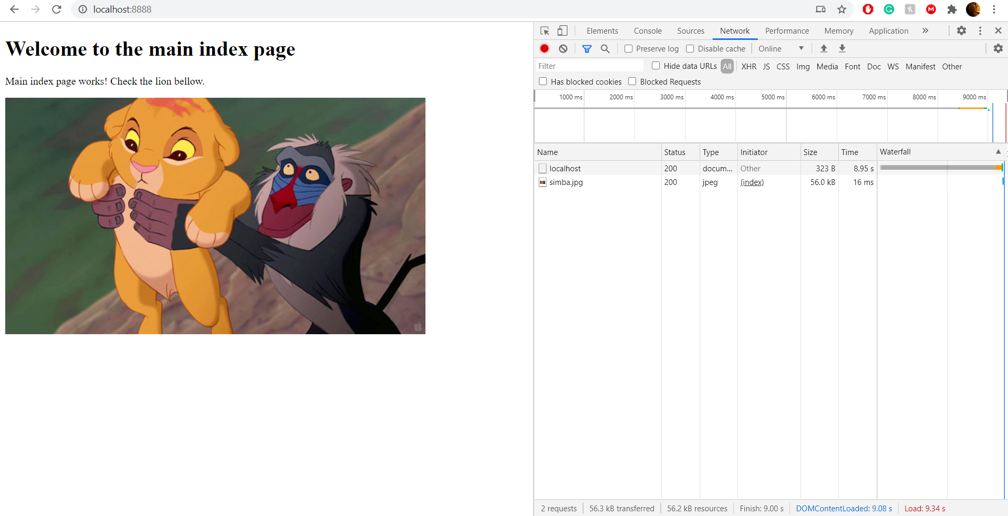

Fig 1. Webserver index page

Figure 1 shows the Webserver index page working succesfully with the PNG file and HTML text using the GET method.

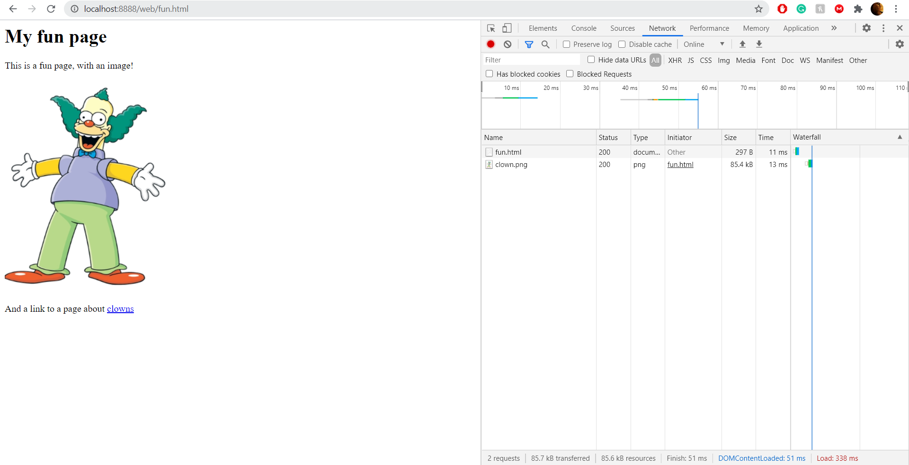Fig 2. GET an HTML file by giving the URL link

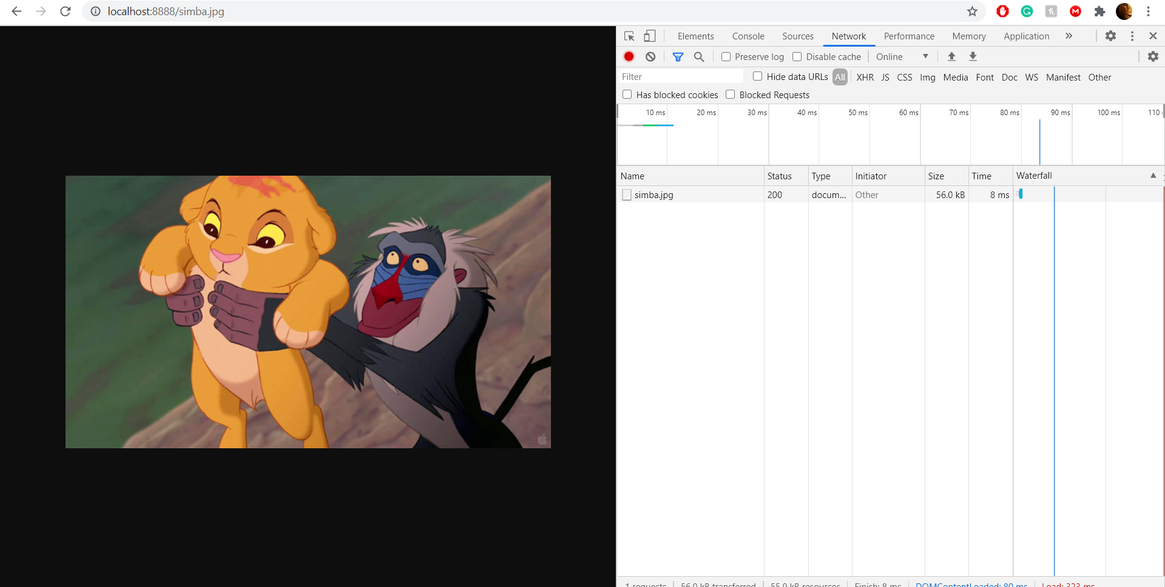

Fig 3. GET a PGN file to the Webserver page

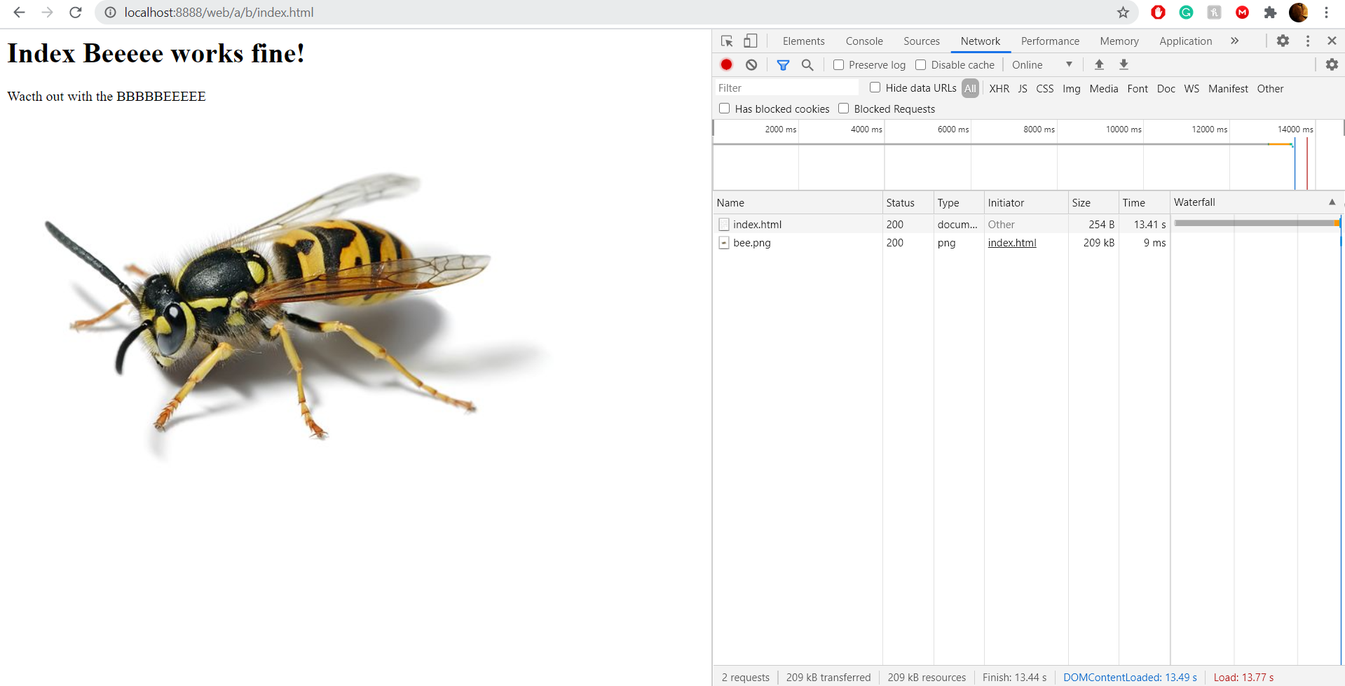

Fig 4. GET a PNG file and HTML text from a subdirectory

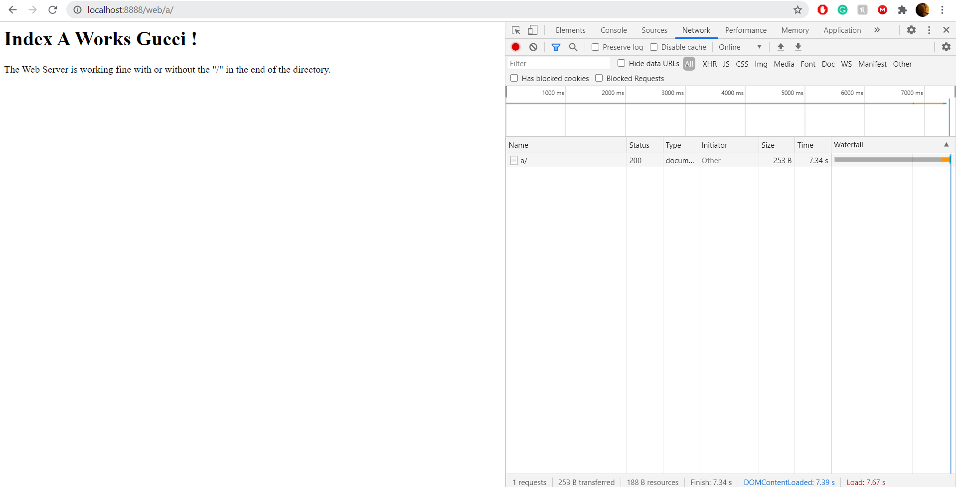

Fig 5. GET an HTML file from a subdirectory using the “/” in the end

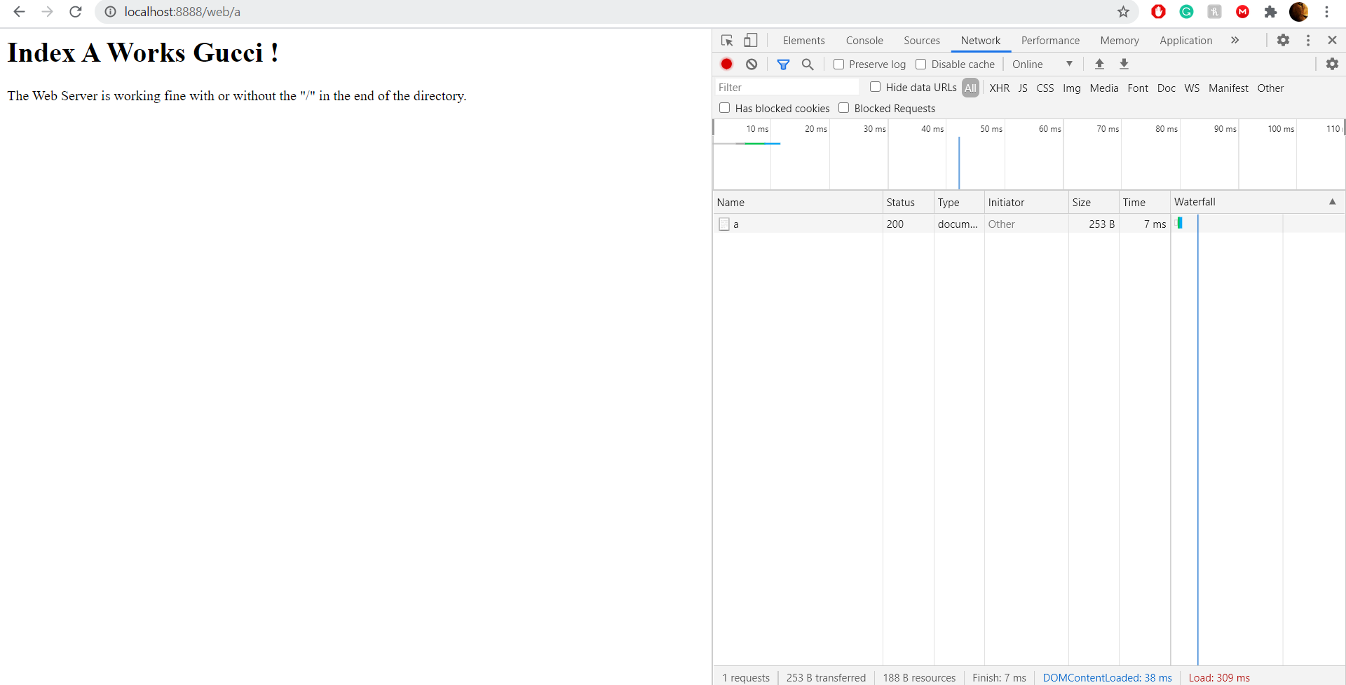

Fig 6. GET an HTML file from a subdirectory **NOT** using the “/” in the end

# Problem 2

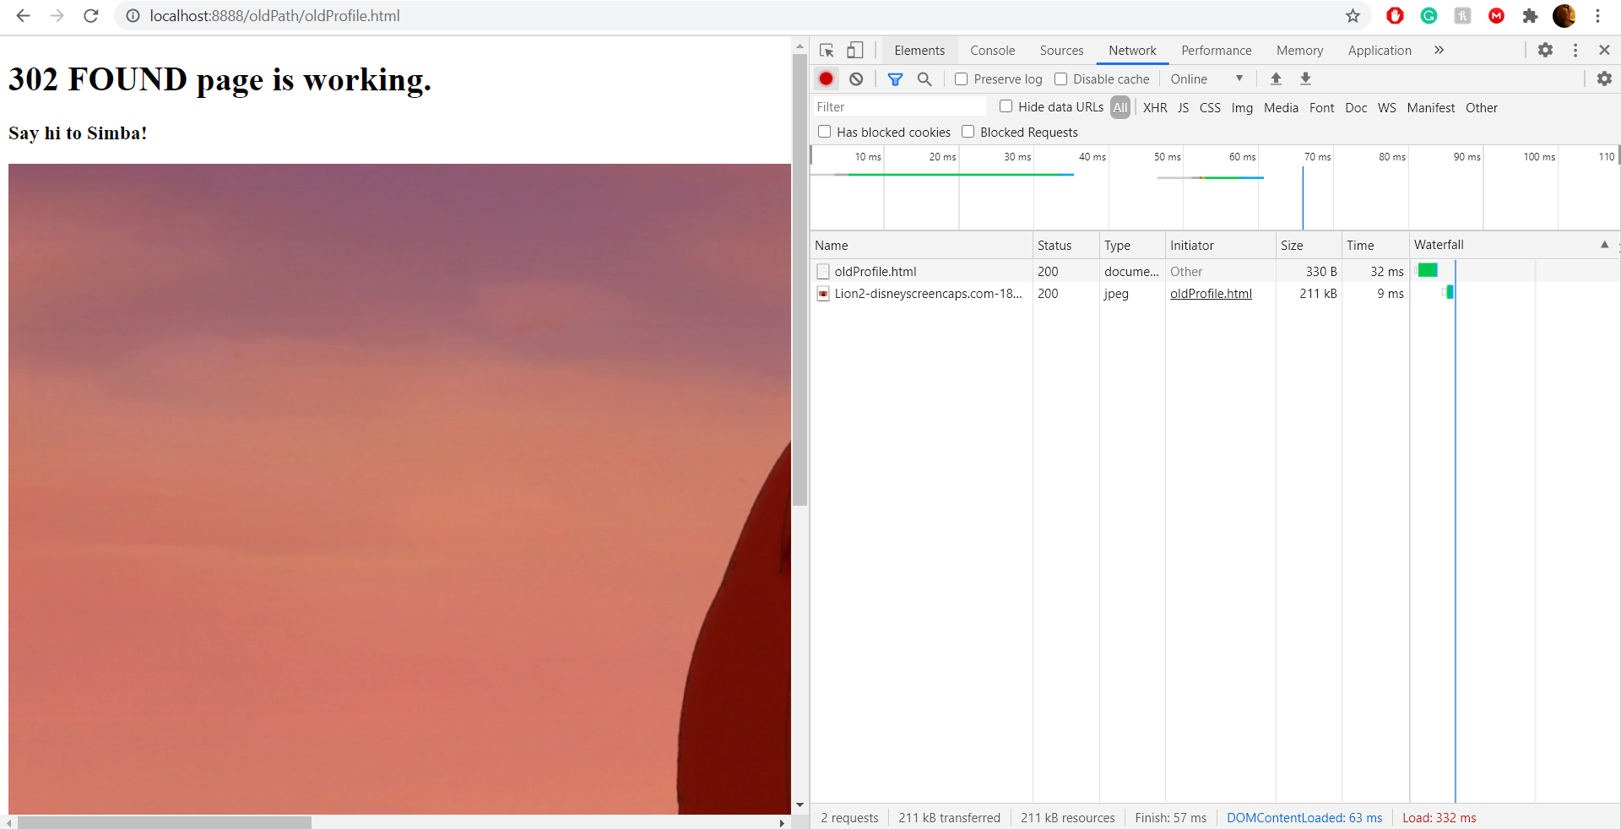

Fig 7. 302 Found

Fig 7 shows the response status code 302 Found from the HTTP Protocol that redirects our search in the URL link to the corresponding path successfully.

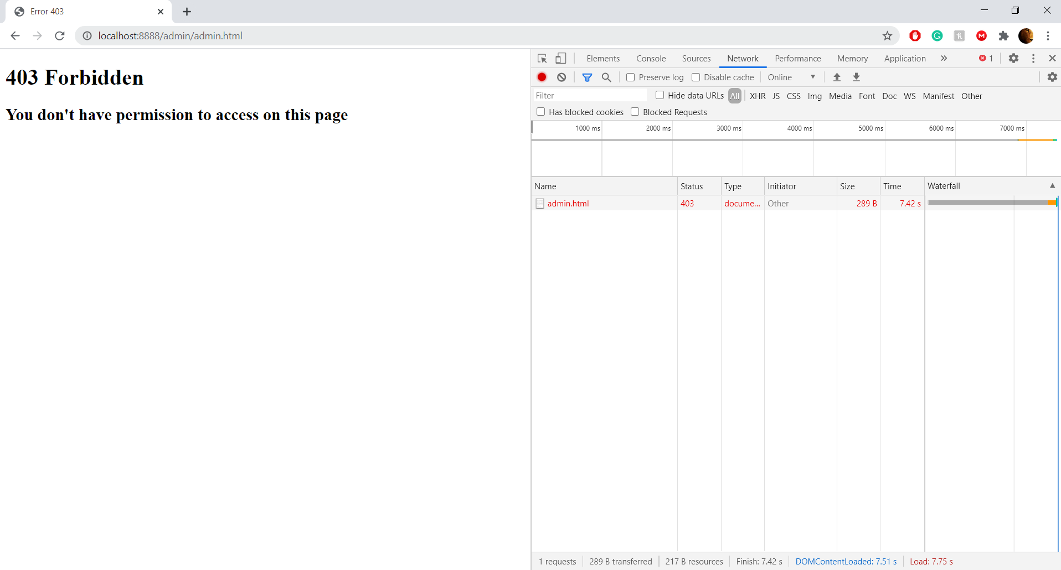

Fig 8. 403 Forbidden

Fig 8 shows the response status code 403 Forbidden from the HTTP Protocol meaning that the Webserver receives the request but forbids the access of the user to that resource.

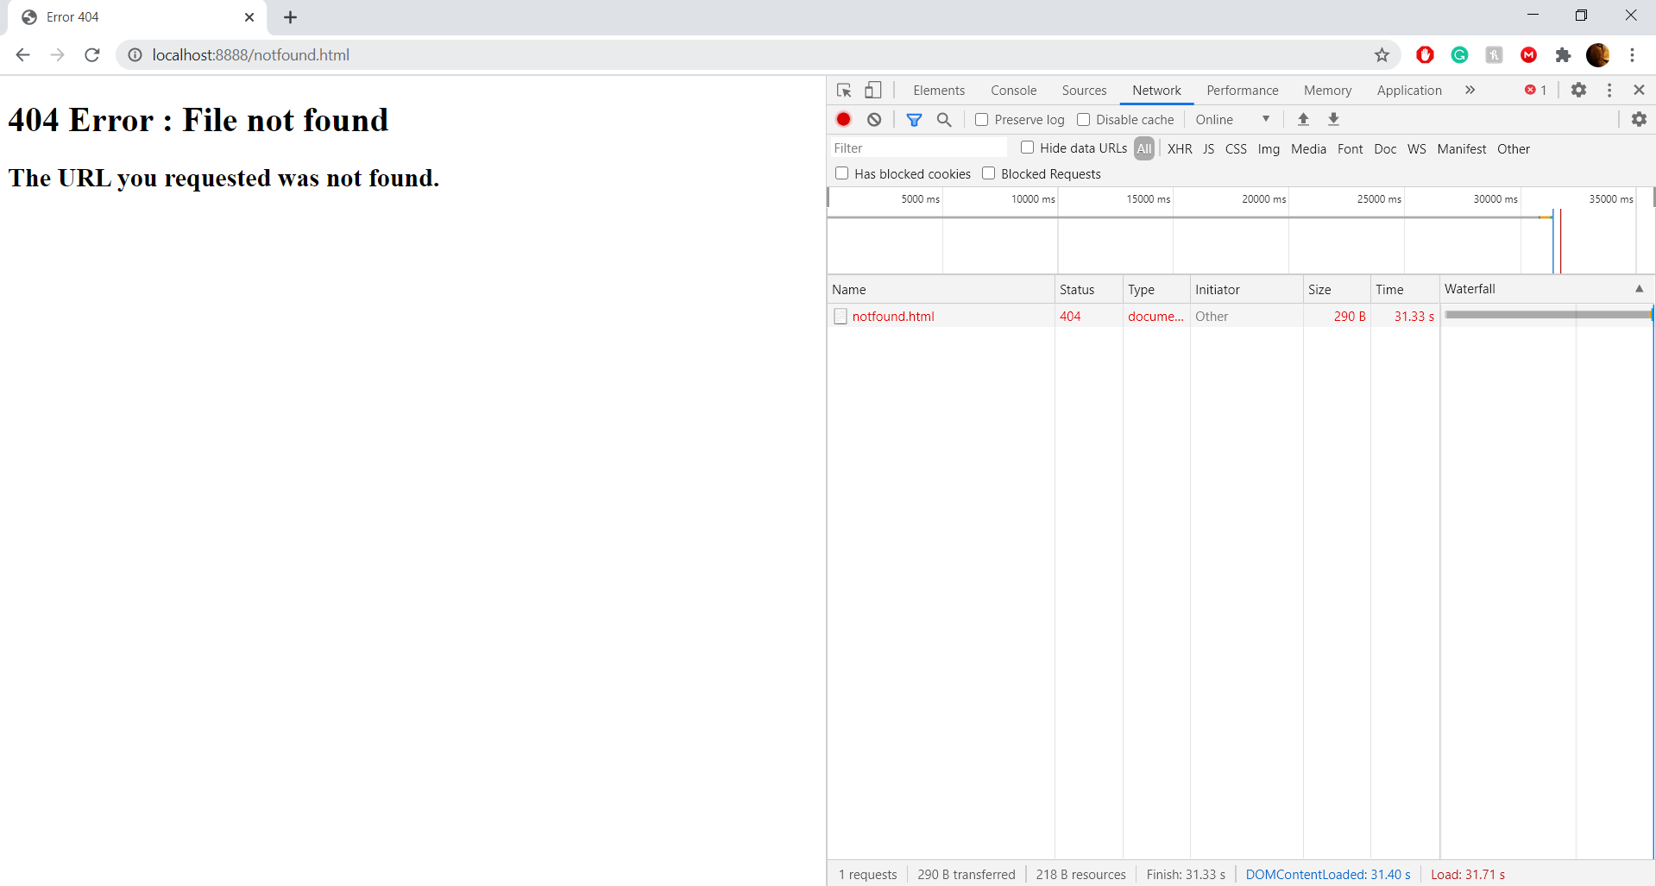

Fig 9. 404 Not Found

Fig 9 shows the response status code 404 Not Found from the HTTP Protocol meaning the client can comunicate with the webserver but the server cant find what was requested.

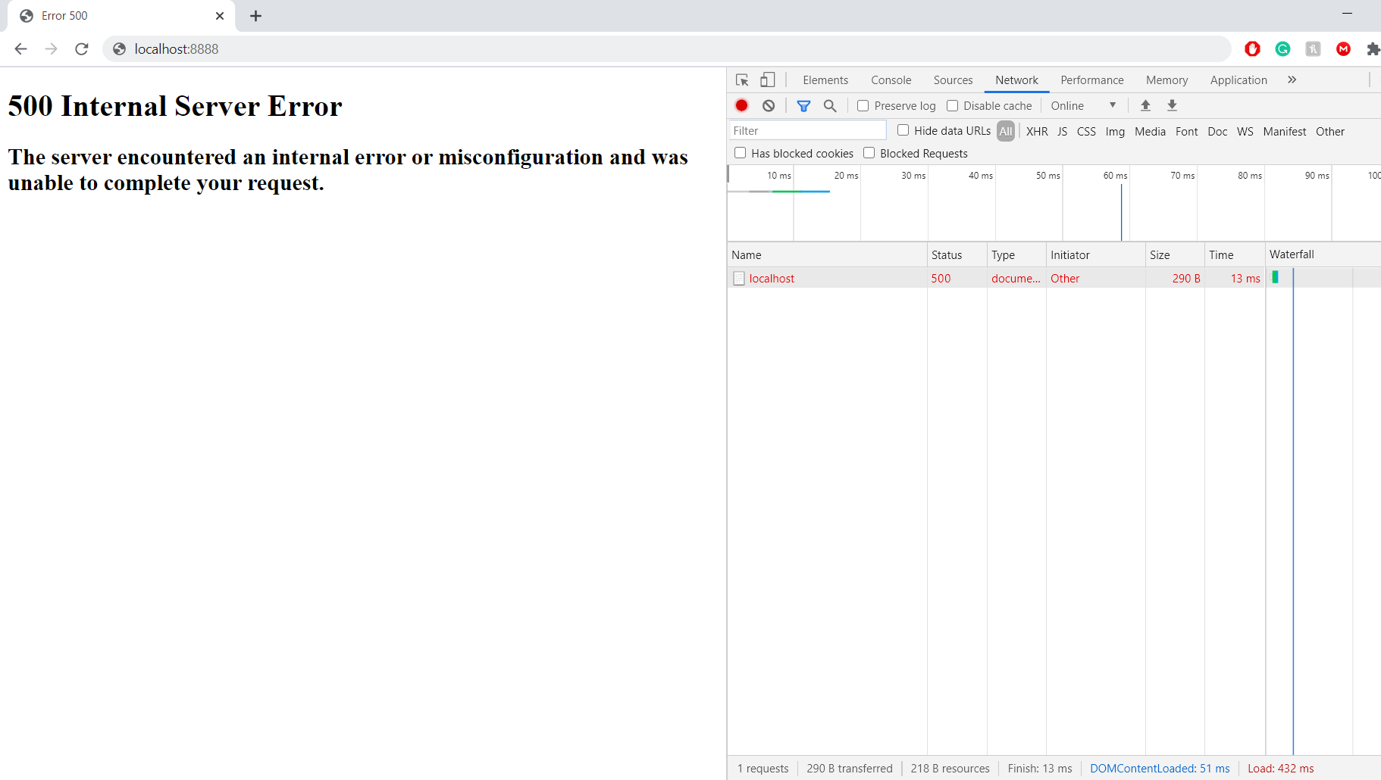

Fig 10. 500 Internal Server Error

Fig 10 shows the response status code 500 Internal Server Error from the HTTP Protocol that is triggered when something unexpected happens inside the server.

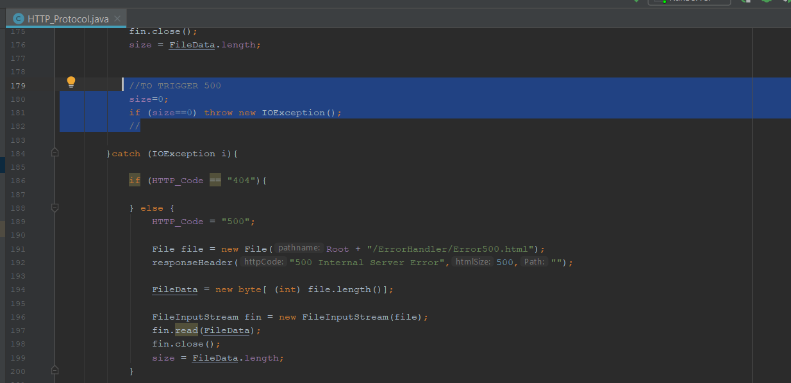

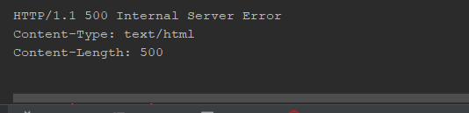

Fig 11. Code that trigers the internal error

Fig 11 shows a piece of code that trigers the server to throw the 500 Internal Server Error.

# Problem 3

In this exercise i had troubles with the PUTTY software since my connection was getting denied. After alot of searching and try to make sure I could bridge the client to the webserver I failed on this task.

I investigated a lot and despite of not having the screenshots here to prove it I understand what was asked to do. Using the telnet to connect to the server and getting all the html data into the console.

